Fetching Test Data from MySQL DB

Prerequisite: Make sure you have MySQL installed and Database & Tables are created

- Install the desired libraries from pip by below command
pip install PyMySQL==0.7.11
pip install robotframework-databaselibrary pymysql
- Use “LoadTestDataMySQL” keyword to load test data from MySQL table.

- Use below Keyword from Database Library to connect to MySQL Database:-
Keyword Name: Connect To Database Using Custom Params s
Parameter 1: pymysql (Fixed for MySQL)
Parameter 2: Connection String :-
database='app_testdata', user='root', password='init1234', host='127.0.0.1', port=3306
(default port for MySQL is 3306 , default host IP for MySQL is 127.0.0.1)
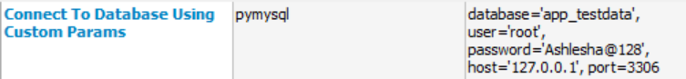
- Create Tables using below commands in MySQL:-
Create table testdata (TCID VARCHAR(50),TDesc VARCHAR(100),TDescVal VARCHAR(100));

- Insert data into table using following commands:-
Insert into testdata(TCID,TDesc,TDescVal) values ('TC001','APPURL','google.com');
Insert into testdata(TCID,TDesc,TDescVal) values ('TC001', ‘PROJECTNAME’,’HSL’);
- Use following query to fetch test data from table :-
SELECT TDesc,TDescVal FROM <tableName> where TCID = “<TCID>”;

- Assign these values to a ${dTestData} dictionary and use the test data from this dictionary.
Ex. log ${dTestData["Address"]}

