Running Robot Test Cases in Parallel – pabot
Does your UI automation takes lot of time to complete its full run?
Were you wondering if there was a way to speed this up & also utilize all the CPU & resources of the automation system?
Sounds familiar? pabot seems to be the answer to these problems if you are using Robot Framework.
Most of the test cases in your script would be independent of each other which could be run in parallel.
For e.g, logging into gmail & clicking on various buttons, searching a keyword & composing a mail could be different task. But this need not be done sequentially, all these can be done in parallel, thus saving lots of time.
Unless you want to send a mail & check your ‘Sent Mail’ Folder for the same mail which would be a sequential operation.
Got the idea.
So, to make your UI automation faster use the pabot library for robot.

How to setup pabot:
- Please refer the section What is the setup involved? of blog Selenium Up & Running with Robot Framework for initial setup.
- After initial setup you need to install robotframework-pabot library. use pip install robotframework-pabot . This will install both robotframework-pabot and robotremoteserver.
- verify robotframework-pabot is installed successfully
- pip show robotframework-pabot
- ---
- Name: robotframework-pabot
- Version: 0.31
- Location: c:\python27\lib\site-packages
- Requires: robotframework, robotremoteserver

pabot command line options:
Along with below options it also supports regular pybot options like –include ,–exclude, –outputdir
root@desktop:/home/xyz# pabot --help
A parallel executor for Robot Framework test cases.
Version 0.31.

Supports all Robot Framework command line options and also following
options (these must be before normal RF options):

--verbose
more output

--command [ACTUAL COMMANDS TO START ROBOT EXECUTOR] --end-command
RF script for situations where pybot is not used directly

--processes [NUMBER OF PROCESSES]
How many parallel executors to use (default max of 2 and cpu count)

--resourcefile [FILEPATH]
Indicator for a file that can contain shared variables for
distributing resources.

--pabotlib
Start PabotLib remote server. This enables locking and resource
distribution between parallel test executions.

--pabotlibhost [HOSTNAME]
Host name of the PabotLib remote server (default is 127.0.0.1)

--pabotlibport [PORT]
Port number of the PabotLib remote server (default is 8270)

--suitesfrom [FILEPATH TO OUTPUTXML]
Optionally read suites from output.xml file. Failed suites will run
first and longer running ones will be executed before shorter ones.

--argumentfile[INTEGER] [FILEPATH]
Run same suite with multiple argumentfile options.
For example "--argumentfile1 arg1.txt --argumentfile2 arg2.txt".
I will be using –processor and –outputdir options in my example test case.
How to run testcases with pabot:
I am using fast.com as web application to demonstrate on how to use Pabot library.
Test Scenario includes 3 test suites which are independent of each other. That means they are eligible for parallel run using pabot.
- suite 1: open google and search
*** Settings ***
Library Selenium2Library

*** Test Cases ***
TC_Google_App1
Launch Browser

*** Keywords ***
Launch Browser
Open Browser https://www.google.co.in/?gws_rd=ssl
sleep 5s
Maximize Browser Window
Input Text xpath=.//input[@name='q'] Tieto
Click Button xpath=.//input[contains(@value,'Google Search')]
Page Should Contain Link xpath=.//a[contains(.,'Tieto provides IT services to accelerate your business')]
Close Browser
2. suite 2: check the search time of the searched text
*** Settings ***
Library Selenium2Library

*** Test Cases ***
TC_Google_App2
Launch Browser

*** Keywords ***
Launch Browser
Open Browser https://www.google.co.in/?gws_rd=ssl
sleep 5s
Maximize Browser Window
Input Text xpath=.//input[@name='q'] Google
Click Button xpath=.//input[contains(@value,'Google Search')]
${TC_SEARCHTIME} Get Text xpath=.//*[@id='resultStats']
Log ${TC_SEARCHTIME}
Close Browser

Create these test suite files and save it in one folder/directory.
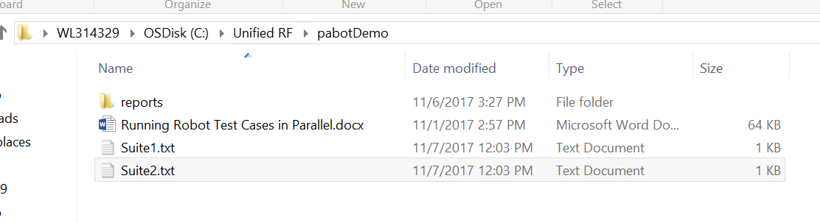
Go to the directory where the test cases are saved and run below command
pabot --processes 2 --outputdir C:\Unified_RF\pabotDemo\reports *.txt

Below is the output of the run you can clearly see that 3 processes are spawned and each processes is working one suite in parallel and once the test case is completed processes is killed to free up the cpu. Also see that the reports are saved under output directory specified in the command.
C:\Unified_RF\pabotDemo>pabot --processes 2 --outputdir C:\Unified_RF\pabotDemo\reports *.txt
2017-11-06 16:15:40.417000 [PID:19828] [1] EXECUTING Suites.Suite2
2017-11-06 16:15:40.417000 [PID:14048] [0] EXECUTING Suites.Suite1
2017-11-06 16:15:55.621000 [PID:19828] [1] still running Suites.Suite2 after 15.
0 seconds (next ping in 20.0 seconds)
2017-11-06 16:15:55.626000 [PID:14048] [0] still running Suites.Suite1 after 15.
0 seconds (next ping in 20.0 seconds)
2017-11-06 16:16:00.738000 [PID:19828] [1] PASSED Suites.Suite2 in 20.1 seconds
2017-11-06 16:16:01.245000 [PID:14048] [0] PASSED Suites.Suite1 in 20.6 seconds
Output: C:\pabotDemo\reports\output.xml
Log: C:\pabotDemo\reports\log.html
Report: C:\pabotDemo\reports\report.html
Elapsed time: 0 minutes 21.179

Observe that in the Robot report page time taken to execute all three test case using pabot command is less than the total time take to execute all suites if run individually using conventional pybot command.
