Playwright Assignment - Test Screenshots
JavaScript Playwright | Chromium | 18 October 2026

Run summary: 3 passed, 1 skipped. The full Urban Ladder purchase flow is skipped unless account credentials are configured.

Playwright UI Runner - Results
UI run summary: 3 passed, 1 skipped. The skipped test is the complete Urban Ladder purchase flow, which requires a personal account.

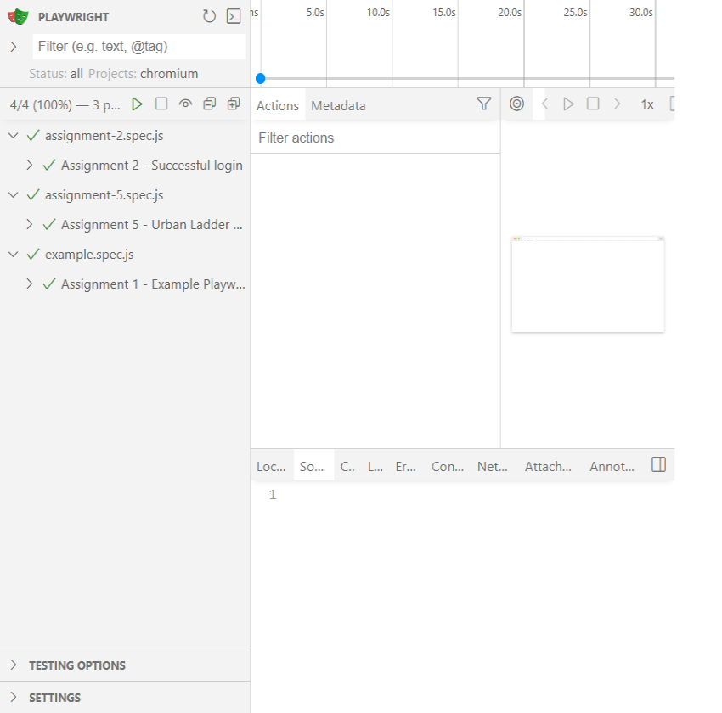
Assignment 1 - Example Login Page
The practice login page was opened and the username, password, and submit controls were verified visible.

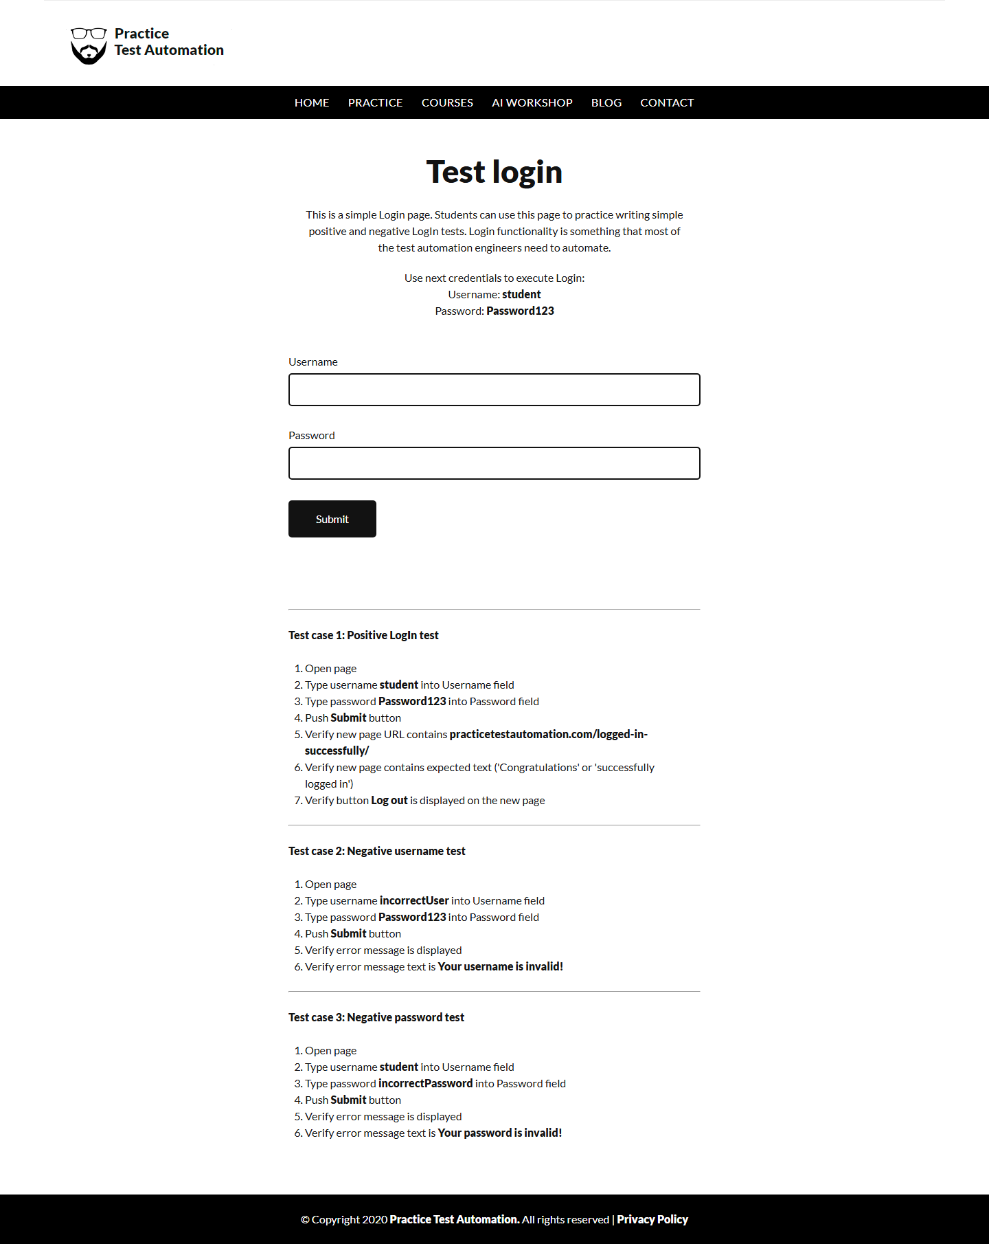
Assignment 2 - Successful Login
The demo credentials were submitted, and the successful-login page and confirmation message were verified.

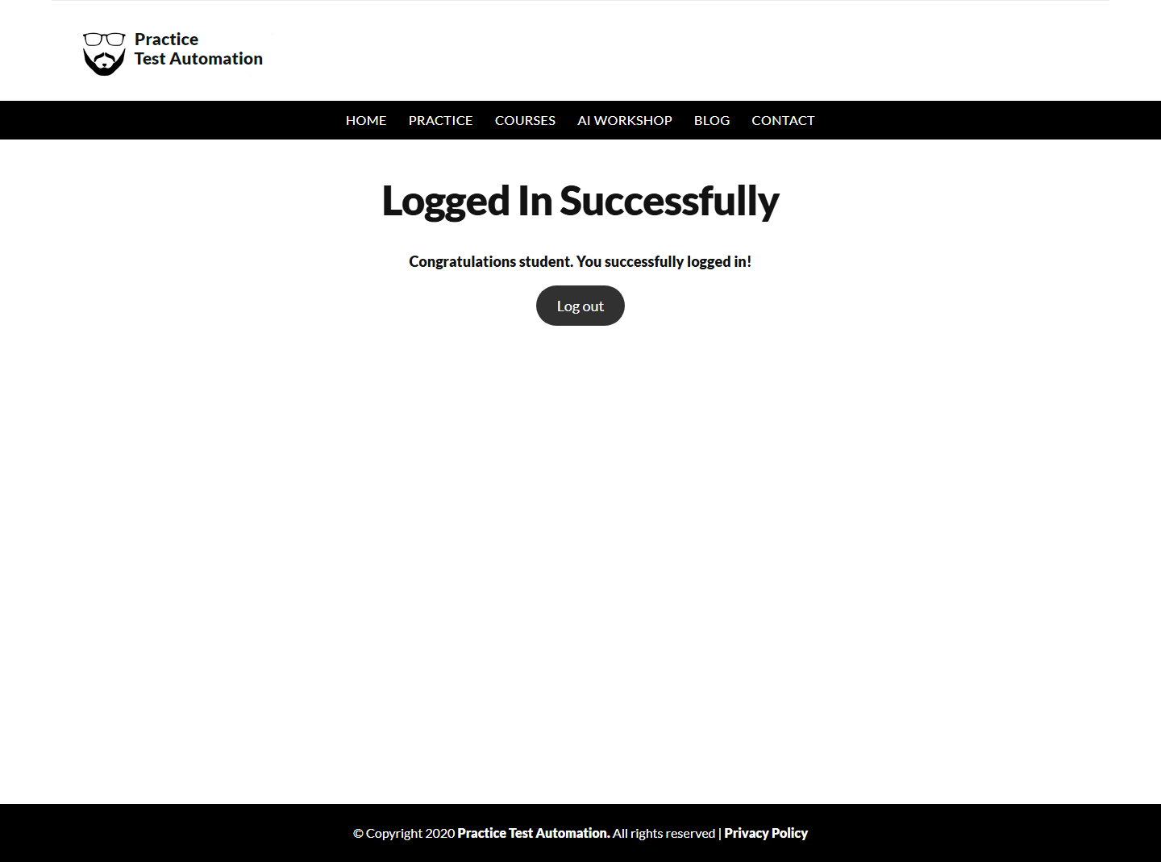
Assignment 5 - Urban Ladder Sign-in Screen
The profile menu opened the live sign-in screen successfully. The account-dependent purchase journey was skipped; no credentials were provided.

