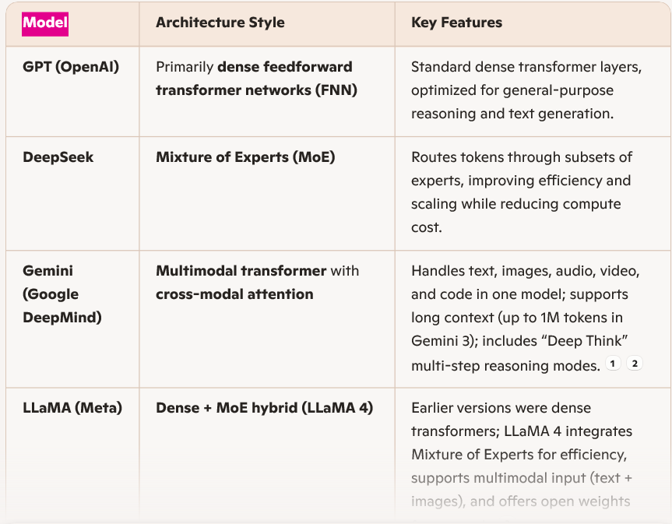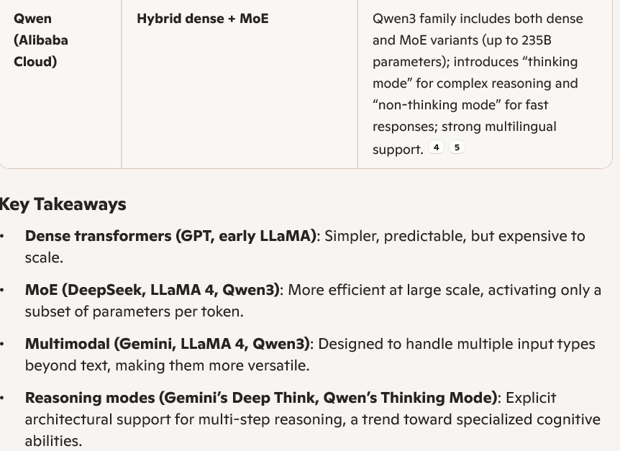

Different AI architectures reflect trade-offs between efficiency, scalability, and capability. Let’s break down the main styles you mentioned:
1. Dense Feedforward Transformers (FNN)
- Used by: GPT (OpenAI), early LLaMA versions
- How it works: Every token passes through the same full set of parameters in each layer.
- Strengths: Predictable performance, strong generalization, stable training.
- Weaknesses: Computationally expensive at very large scales since all parameters are always active.
2. Mixture of Experts (MoE)
- Used by: DeepSeek, LLaMA 4, Qwen3 (MoE variants)
- How it works: Instead of activating all parameters, the model routes each token
• through a small subset of “experts.”
- Strengths: Efficient scaling—can train and serve models with hundreds of billions of parameters while only using a fraction per token.
- Weaknesses: Routing adds complexity; sometimes less consistent output compared to dense models.
3. Multimodal Transformers
- Used by: Gemini (Google DeepMind), LLaMA 4, Qwen3
- How it works: Incorporates specialized attention mechanisms to handle multiple input types (text, images, audio, video, code).
- Strengths: Versatility—can process and reason across different modalities in one model.
- Weaknesses: Training is more complex; requires massive multimodal datasets.
4. Specialized Reasoning Modes
- Used by: Gemini (“Deep Think”), Qwen (“Thinking Mode”)
• How it works: Architectures include explicit support for multi-step reasoning, sometimes with longer context windows (Gemini 3 supports up to 1M tokens).
- Strengths: Better at complex problem-solving and step-by-step logic.
- Weaknesses: Slower inference; may require more compute for reasoning tasks.
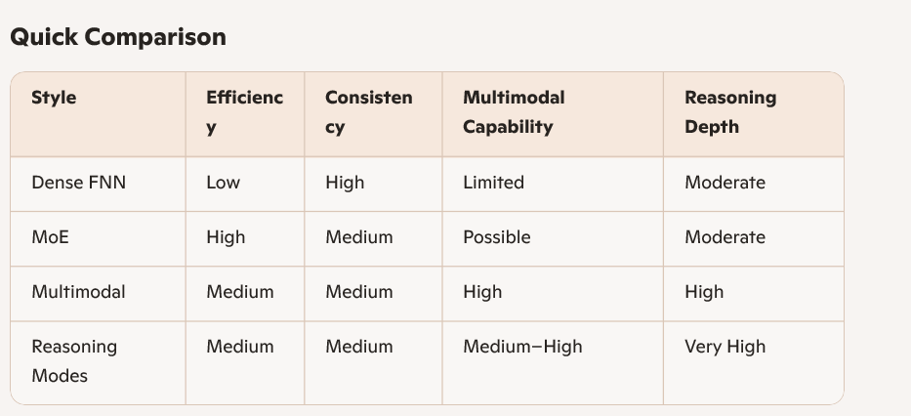In short:
- GPT sticks with dense transformers for reliability.
- DeepSeek pushes MoE for efficiency.
- Gemini focuses on multimodality and reasoning.
- LLaMA evolved from dense to hybrid MoE + multimodal.
- Qwen blends dense and MoE, with explicit reasoning modes.
Why OpenAI (GPT) sticks with dense transformers
- Reliability: Dense models activate all parameters, so outputs are more consistent across tokens.
- Generalization: Easier to fine-tune for broad tasks without worrying about routing errors.
- Trade-off: Extremely expensive to scale—every token uses billions of parameters, which drives up compute costs.
Why DeepSeek embraces MoE
- Efficiency: MoE allows training models with hundreds of billions of parameters while only activating a fraction per token.
- Cost advantage: Much cheaper to run at scale compared to dense models.
- Trade-off: Routing adds complexity, and outputs can be less stable—sometimes weaker on tasks requiring uniform consistency.
Why Google (Gemini) focuses on multimodality + reasoning
- Vision: Build a single model that can handle text, images, audio, video, and code.
- Reasoning depth: Features like “Deep Think” allow multi-step logical processing.
- Trade-off: Training multimodal models is harder, requiring massive diverse datasets and specialized infrastructure.
Why Meta (LLaMA) evolved from dense → hybrid MoE
- Open research: Dense models (LLaMA 1–3) were simpler and easier to release as open weights.
- Scaling: LLaMA 4 integrates MoE to keep up with efficiency trends while adding multimodal support.
- Trade-off: Balances openness with efficiency, but MoE complexity makes deployment trickier for smaller labs.
Why Alibaba (Qwen) blends dense + MoE with “thinking modes”
- Flexibility: Offers both dense and MoE variants, letting users choose between speed and depth.
- Reasoning: “Thinking mode” explicitly supports step-by-step logic, while “non-thinking mode” prioritizes fast responses.
- Trade-off: More versatile, but managing two modes adds complexity for developers.
Big Picture
- Dense = stability, but costly.
- MoE = efficiency, but less consistent.
- Multimodal = versatility, but harder to train.
- Reasoning modes = deeper logic, but slower inference.
That’s why OpenAI prioritizes reliability, DeepSeek prioritizes efficiency, Google prioritizes versatility, Meta balances openness with efficiency, and Alibaba prioritizes flexibility.
Would you like me to map these choices to business strategy (e.g., why OpenAI charges premium prices vs. why DeepSeek markets itself as cost-efficient)? That’s where the architectural decisions really connect to competitive positioning.

