Automation Practice Project Report

# Project Title: System Information Report Script

# Objective

Automate the collection of system and network information for troubleshooting.

# Tools & Environment

- Operating System: Windows  
- Script Type: Bash  
 Script / Code Snippet

@echo off

echo Collecting system information...

systeminfo > %USERPROFILE%\Desktop\SystemReport.txt

ipconfig /all >> %USERPROFILE%\Desktop\SystemReport.txt

echo Report saved on Desktop as SystemReport.txt

pause

# Steps Performed

1. Opened Notepad and pasted the batch script.

2.Saved the file with a .bat extension (e.g., SystemReport.bat).

3.Right-clicked the .bat file and selected **Run as Administrator**.

4.Observed the Command Prompt window execute the script.

5.Verified that SystemReport.txt was created on the Desktop.

6.Opened the report to confirm that system information and network details were .

# Results

- Output generated: System report is generated on the desktop

**Issue Faced:**  
Script did not run properly when double-clicked because administrative privileges were required for some commands (systeminfo, ipconfig /all).

**Fix applied:**  
Right-clicked the .bat file and selected **Run as Administrator**. Verified that the report was successfully created on the Desktop.

**Future improvement:**

Automatically include the current date and time in the filename (e.g., SystemReport_2025-09-05.txt).Add additional checks such as disk usage or memory status.Redirect errors to a separate log file to make troubleshooting easier.

# Key Learning

Learned how to use batch/shell scripting to automate IT support tasks.

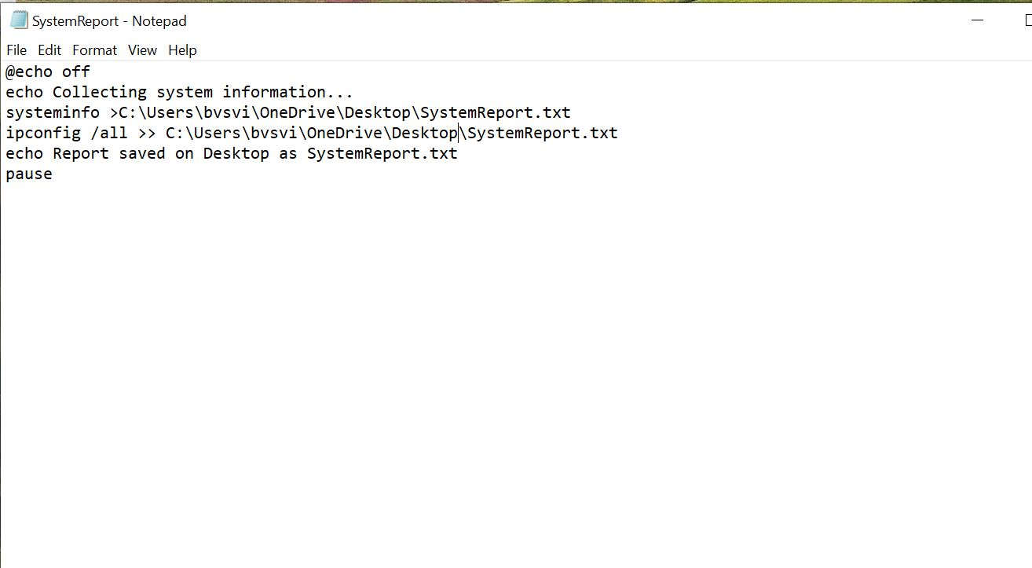 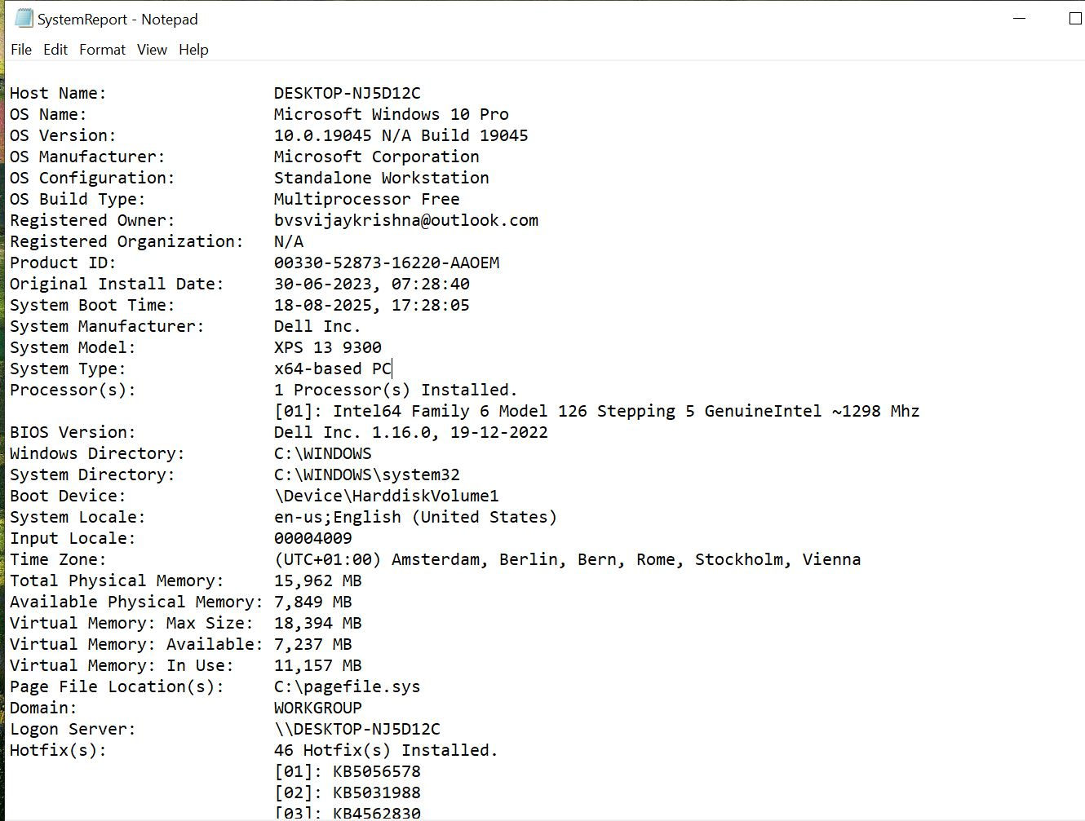

Fig : 1. systemreport bat file Fig:2.Output of the Automation script