Teachures Developer Improvement Plan

Prepared for | Teachures development team
Prepared on | June 24, 2026
Website tested | https://teachures.com
Source inputs | BRD plus QA sessions for student, tutor, admin, course creation, and video upload flows
Security note | Passwords, admin secrets, and sensitive credentials are intentionally excluded.

Plain-English summary
The platform has a usable foundation, but it is not ready for production training delivery yet. The most urgent blockers are: payment success does not enroll students, required OTP/MFA registration controls are missing, password recovery and key routes are broken, mobile navigation fails, and video upload/playback/security cannot be completed because tutor video upload did not persist.

Recommended Delivery Order
Priority | Fix group | Why this comes first | Developer acceptance target
P0 | Student enrollment and checkout | All learning, progress, video, quiz, and certificate flows depend on a valid enrollment record. | After a successful free or paid checkout, the student appears in My Learning and can open the course lesson page.
P0 | Auth and registration compliance | The BRD requires phone/address, OTP verification, and optional MFA. Current signup grants access too early. | Student signup verifies phone OTP before dashboard access and supports MFA setup/login challenge.
P0 | Video upload persistence | The main project purpose is secure training video delivery. Tutor upload currently fails to persist. | Tutor can upload MP4/video lesson, reload editor, and still see the lesson as VIDEO with playable media.
P1 | Broken routes and navigation | Broken routes damage trust and block routine student tasks. | /forgot-password, /dashboard, /student/leaderboard, and mobile menu all work.
P1 | Catalog and dashboard data accuracy | Students should not see fake or contradictory learning states. | Search/filter results are accurate; dashboard cards match real enrollments only.
P1 | Video security controls | Once upload and playback work, content protection must match the BRD. | Student playback uses signed/encrypted streaming, visible dynamic watermark, no direct public file URL, and session controls.
P2 | Instructor/admin polish and analytics | These are important but less blocking than learning access and video delivery. | Instructor pages use one dashboard shell; analytics values match real account data.

P0 Fix 1 - Checkout Must Create Enrollment
Observed failure:
- $0 mock checkout shows Payment Successful, but the student still sees 0 enrolled courses.
- Learning URL still returns Not enrolled after payment success.
- Checkout is visible while unauthenticated, which creates confusing access-control behavior.
Recommended implementation:
- Require authenticated student session before final checkout action.
- On payment success, perform an atomic backend operation: verify payment/free checkout, create enrollment, mark course access active, generate receipt/invoice, and return a JSON success payload.
- Make the operation idempotent so repeated callback/button clicks do not create duplicate enrollments.
- Redirect the student to /student/my-courses or the course learn URL only after enrollment exists.
- Log payment/enrollment failures with a correlation ID visible to support/admin.
Acceptance test | Expected result
Student completes $0 checkout for Mock Test Course. | Payment success creates enrollment; course appears in My Learning.
Student clicks Start Learning after checkout. | Course lesson page opens instead of Not enrolled.
Student refreshes My Learning. | Enrollment remains visible after refresh/logout/login.
Unauthenticated user opens checkout. | User is redirected to login before pay/enroll controls are actionable.

P0 Fix 2 - Registration, OTP, and MFA
Observed failure:
- Student registration only asked for name, email, and password.
- No phone number, address, OTP, or MFA step appeared.
- Dashboard access was granted immediately after signup.
Recommended implementation:
- Update student registration to collect required BRD fields: name, email, phone number, address, password, and terms/privacy consent.
- Send OTP to phone and block dashboard access until OTP is verified.
- Add optional MFA enrollment after first login and support OTP challenge on login when MFA is enabled.
- Add rate limits, resend cooldown, OTP expiry, and safe error messages.
- Store verified phone state separately from user profile data.
Acceptance test | Expected result
Register without phone/address. | Form blocks submission with field-level validation.
Register with valid details. | OTP step appears before dashboard access.
Enter invalid OTP. | Access remains blocked and error is shown.
Enter valid OTP. | Account becomes verified and student dashboard opens.
Enable MFA. | Next login requires second factor.

P0 Fix 3 - Tutor Video Upload and Curriculum API
Observed failure:
- Tutor could create a course and open the lesson editor.
- Generated lesson Demo Video Security Playback remained ARTICLE after attempted upload/save.
- After Save Lesson, curriculum area showed Error loading curriculum.
- Console indicated the sections endpoint returned HTML instead of JSON, likely the login page after session expiry.
- Reload redirected tutor to /login, and the video update did not persist after relogin.
- curriculum.js also logs ReferenceError: courseId is not defined for bank questions and cohorts.
Recommended implementation:
- Keep tutor session valid during multipart upload; if session expires, return 401 JSON and display a clear re-login message without corrupting the editor state.
- Make the lesson update endpoint persist type=VIDEO, video metadata, storage URL/key, file MIME type, file size, duration if available, and processing status.
- Return JSON for all API paths used by curriculum.js, including errors. Never return full login HTML to fetch() calls.
- Fix JavaScript globals by using one course identifier consistently, such as window.COURSE_ID, instead of undefined courseId.
- Add upload progress, max file size/type validation, and server-side validation for video/* files.
- Add a post-save verification refresh that fetches the lesson and displays a success toast only after the lesson is stored as VIDEO.
Acceptance test | Expected result
Tutor uploads a small MP4 and clicks Save Lesson. | Modal closes with success; lesson row icon/type becomes VIDEO.
Tutor refreshes editor. | Lesson remains VIDEO and attached video metadata is still present.
Tutor session expires during upload. | Frontend receives 401 JSON and asks for login; no misleading success state appears.
curriculum.js loads editor. | No ReferenceError appears for courseId; sections, question bank, and cohorts load or show empty states.

P1 Fixes - Routes, Mobile Navigation, Catalog, and Dashboard
Area | Observed failure | Recommended fix | Acceptance criteria
Forgot password | /forgot-password returns Cannot GET. | Build password reset request and token reset pages. | Forgot Password opens, sends reset email/OTP, and handles expired tokens safely.
Checkout cancel | Cancel points to /dashboard, which is broken. | Route to /student/dashboard or prior course detail depending on auth state. | Cancel always lands on a valid page.
Leaderboard | /student/leaderboard returns Cannot GET. | Implement route or update link to existing gamification page. | Full Board link loads a leaderboard page.
Mobile navigation | Menu button renders 0 x 0; nav links are hidden. | Fix responsive header/menu button size, aria labels, and open/close state. | Courses, About, Login, and Register are reachable on mobile.
Catalog search | No-result search still shows Mock Test Course. | Filter courses on query and show empty state. | Nonsense search shows no results.
Catalog filters | Category chips activate but do not filter. | Wire filters to backend/frontend category data. | Design filter hides non-design courses or shows empty state.
Student dashboard | Dashboard cards conflict with My Learning state. | Drive dashboard course cards from enrollment records only. | Dashboard and My Learning show the same enrollment count.

P1 Fix - Video Security and Non-Recordability
Important technical reality
A normal browser application cannot fully prevent OS-level screen recording by itself. The realistic production approach is DRM or encrypted streaming, signed short-lived media URLs, session controls, and dynamic visible watermarking with trainee identity. These controls do not make piracy impossible, but they reduce casual downloading and make leaks traceable.

Requirement | Recommended implementation | Acceptance test
No direct download | Do not expose public MP4 URLs. Use signed short-lived URLs or HLS/DASH with protected segments. | Developer tools/network should not reveal a reusable public video URL.
Encrypted streaming | Use HLS with AES-128 or a DRM provider where feasible. | Media requests use segmented/encrypted stream; direct file download fails without auth.
Dynamic watermark | Overlay moving watermark with student name, email, and optionally phone/user ID. | During playback, watermark is visible and changes position periodically.
Browser controls | Use controlsList=nodownload, disablePictureInPicture where appropriate, and block obvious context-menu download actions. | No visible download button; right-click does not expose a saveable direct file.
Session tracking | Limit active sessions per user or detect concurrent playback. | Second session invalidates first or prompts user/admin depending on policy.
Progress tracking | Record watch progress server-side and resume playback. | Student leaves mid-lesson and returns to the saved timestamp.

P2 Fixes - Instructor/Admin Consistency
- Instructor Earnings and Privacy pages should use the same instructor dashboard shell/sidebar as the rest of the instructor portal.
- Instructor analytics should not show demo revenue values that conflict with $0 earnings.
- Admin should have clear user approval, account deactivation, password reset, activity reports, payment reports, and content moderation workflows.
- AI curriculum generation should show a preview before saving and respect scope instructions such as one section / one lesson.
- Add audit logs for admin approval, course publish, lesson upload, payment success, and account deletion actions.

Suggested Developer Backlog
Backlog ID | Owner area | Task | Priority | Done when
DEV-001 | Backend / Payments | Create enrollment record on successful checkout. | P0 | Learning access works after checkout.
DEV-002 | Frontend / Auth | Require login before checkout final action. | P0 | Unauthenticated checkout redirects to login.
DEV-003 | Auth | Add phone/address fields plus OTP verification. | P0 | Unverified users cannot access dashboard.
DEV-004 | Auth | Add optional MFA setup and login challenge. | P0 | MFA users must pass second factor.
DEV-005 | Backend / Content | Fix multipart video lesson update endpoint. | P0 | Video lesson persists after reload.
DEV-006 | Frontend / Curriculum | Replace Add Section prompt() with modal. | P0 | Section creation works in all browsers.
DEV-007 | Frontend / Curriculum | Fix undefined courseId usage. | P0 | No courseId ReferenceError in console.
DEV-008 | Routing | Implement /forgot-password. | P1 | Password reset flow works.
DEV-009 | Routing | Fix /dashboard and /student/leaderboard links. | P1 | No Cannot GET pages from UI links.
DEV-010 | Frontend / Mobile | Fix mobile header menu. | P1 | Nav is usable at mobile viewport.
DEV-011 | Frontend / Catalog | Implement real search and category filtering. | P1 | No-result and category results are correct.
DEV-012 | Backend / Video Security | Implement signed/encrypted playback and watermarking. | P1 | Student video has watermark and no reusable public URL.
DEV-013 | QA / DevOps | Create seeded regression course with video, quiz, and certificate. | P1 | QA can run full end-to-end regression repeatedly.

Regression Test Checklist After Fixes
- Register new student with required fields; verify OTP blocks dashboard until completed.
- Log in with invalid credentials and confirm safe error handling.
- Use Forgot Password and complete a reset with a valid token.
- Enroll in a free course; verify My Learning, dashboard, and learn page all show access.
- Run checkout cancel and failed-payment paths.
- Create and approve a new tutor from admin.
- Create a course, add section, upload video lesson, refresh editor, and verify persistence.
- Publish course and enroll student.
- Play video as student; inspect watermark, no download button, network media URLs, and progress save/resume.
- Complete quiz/progress gate and verify certificate issuance.
- Test public pages, catalog search/filter, and mobile menu at phone width.
- Confirm admin/user analytics match real database values.

Evidence Screenshots Included

Admin approval succeeded for the new tutor.
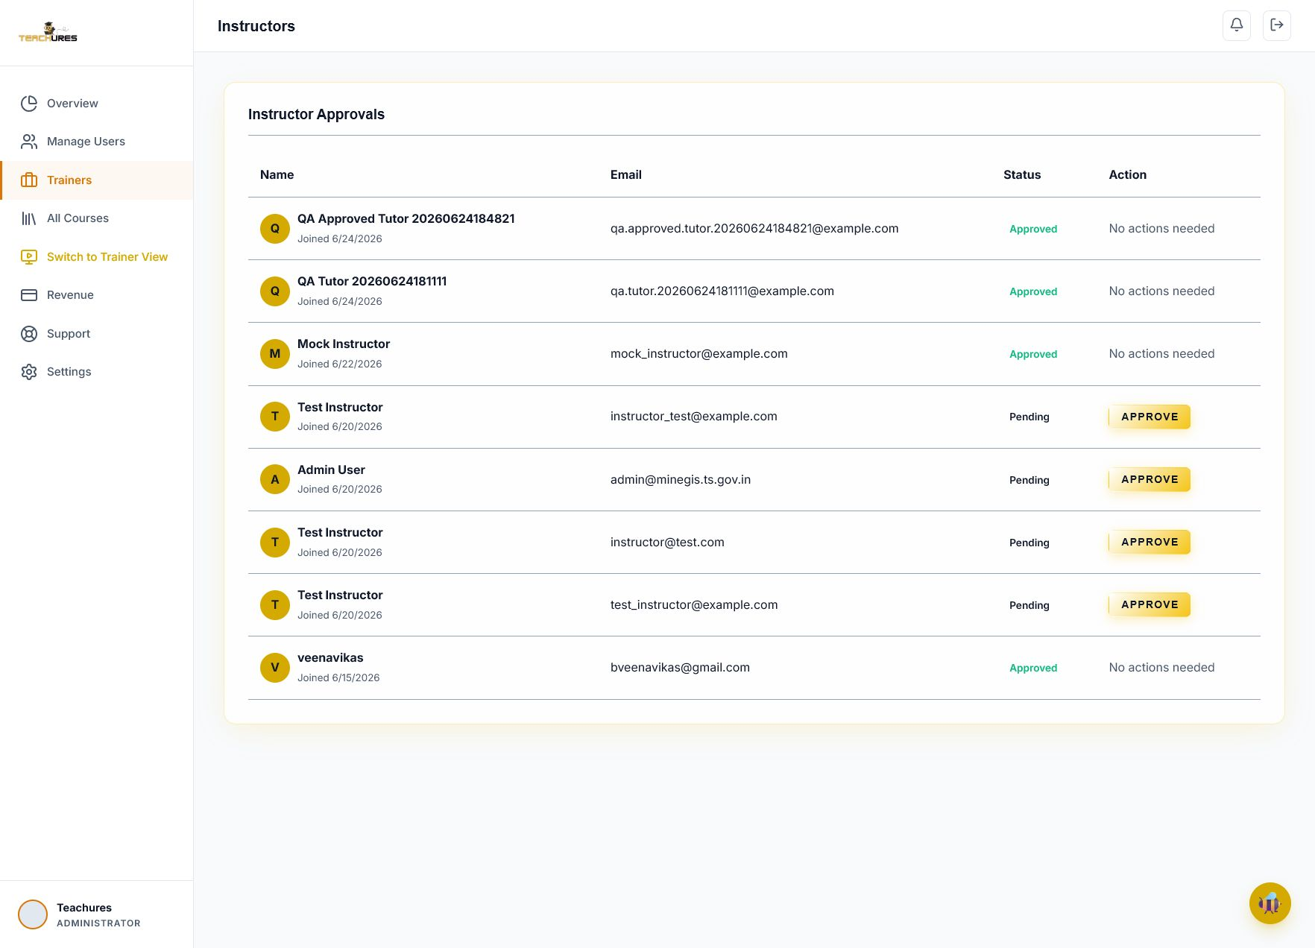

Tutor dashboard content appeared while URL still showed /login.
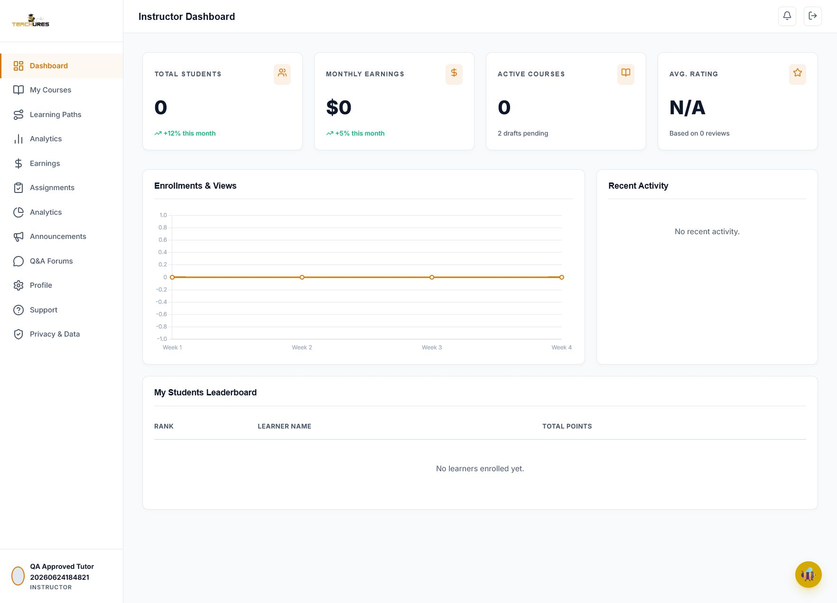

AI curriculum generated the requested QA lesson plus extra content.
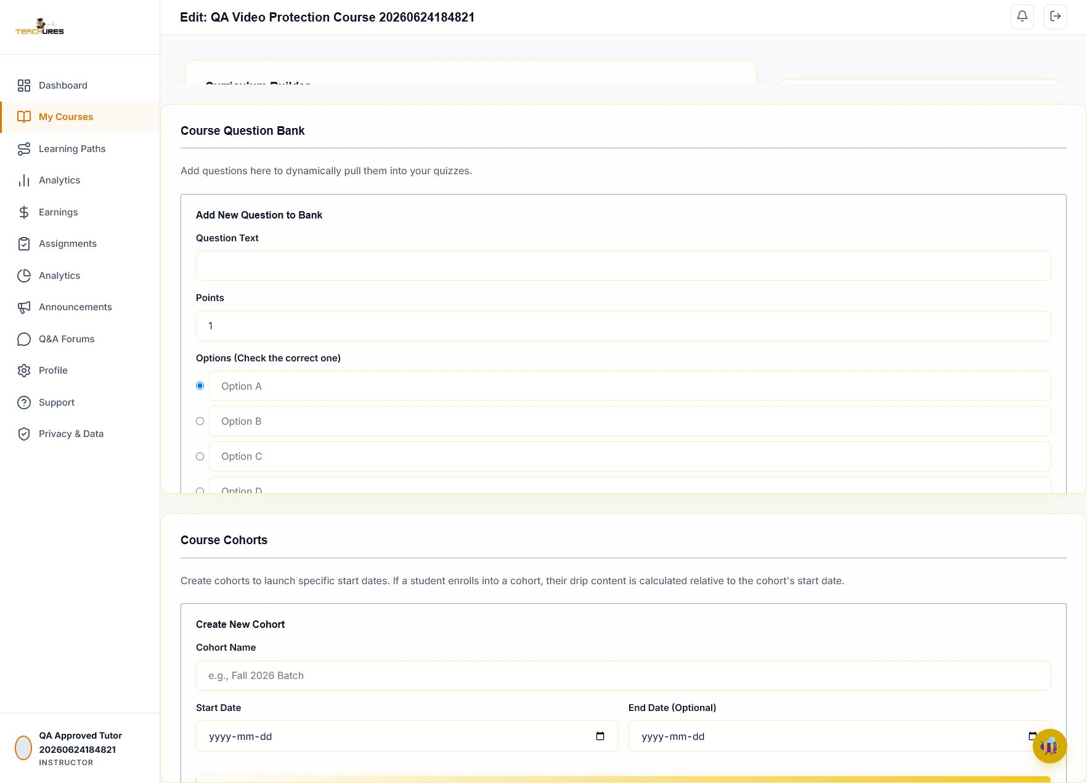

Video upload field visible; automation upload was blocked.
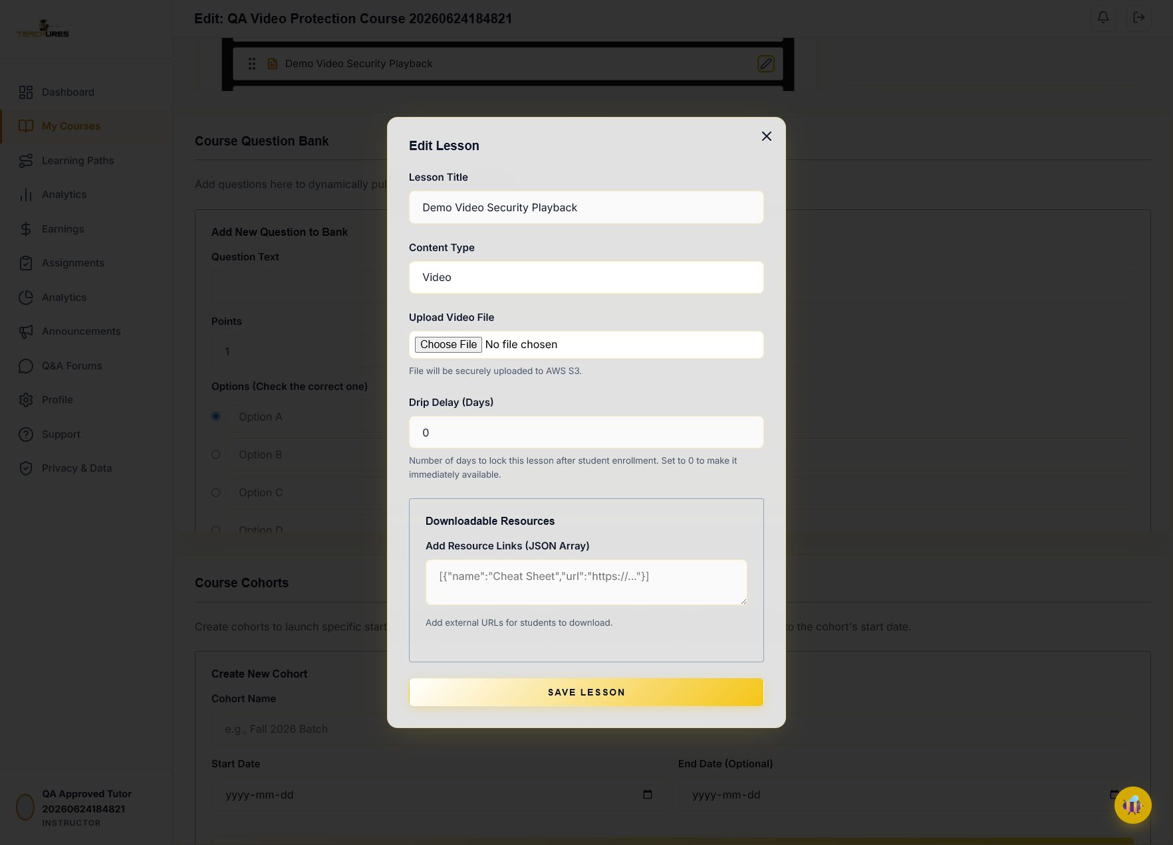

After Save Lesson, curriculum displayed Error loading curriculum.
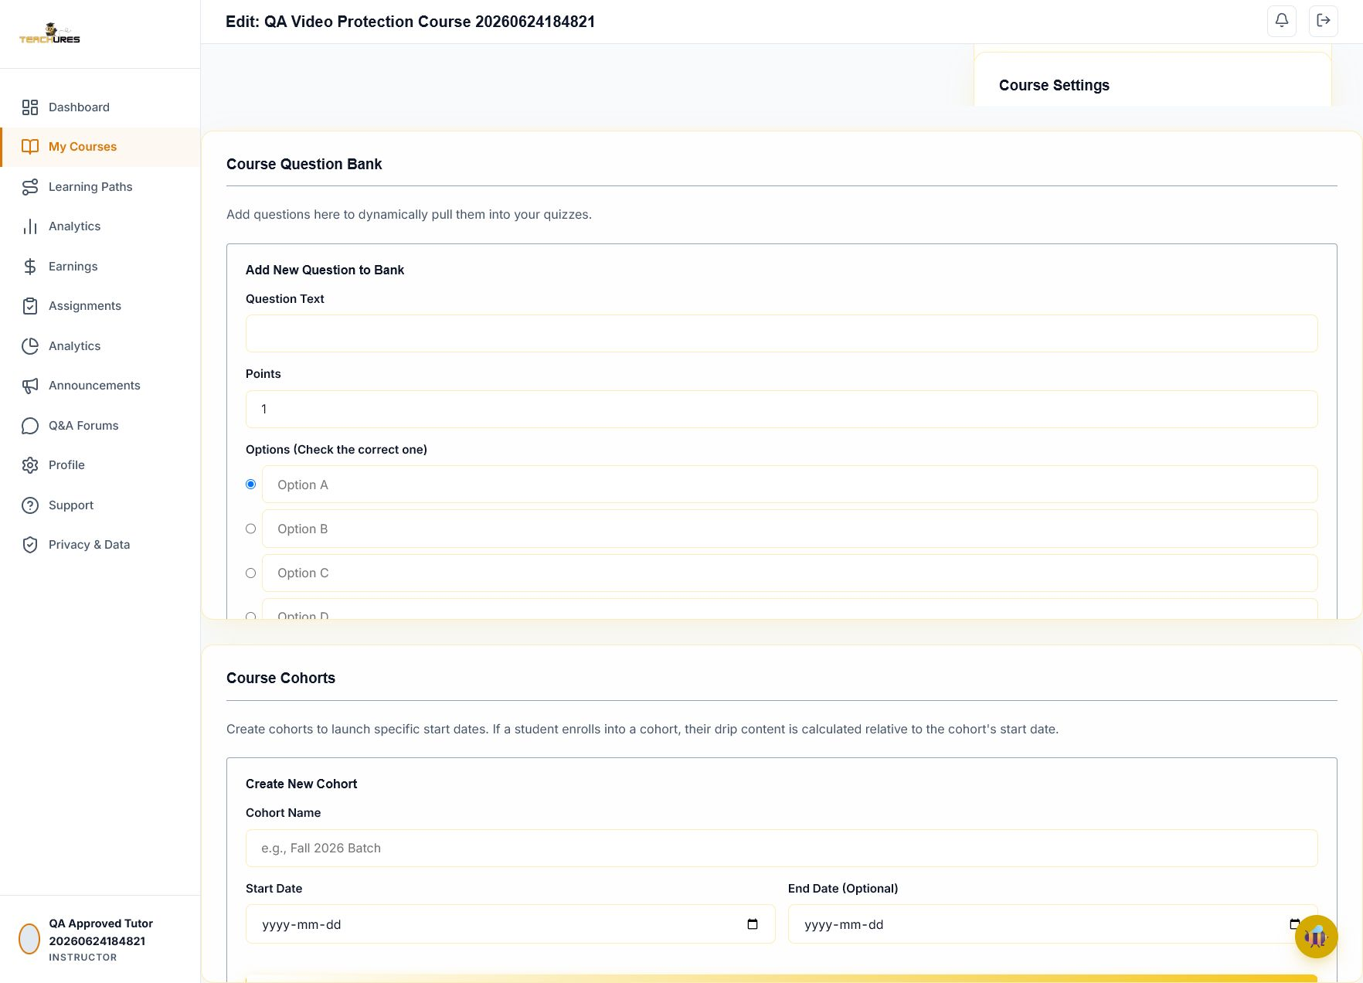

Reload after upload attempt redirected to login.
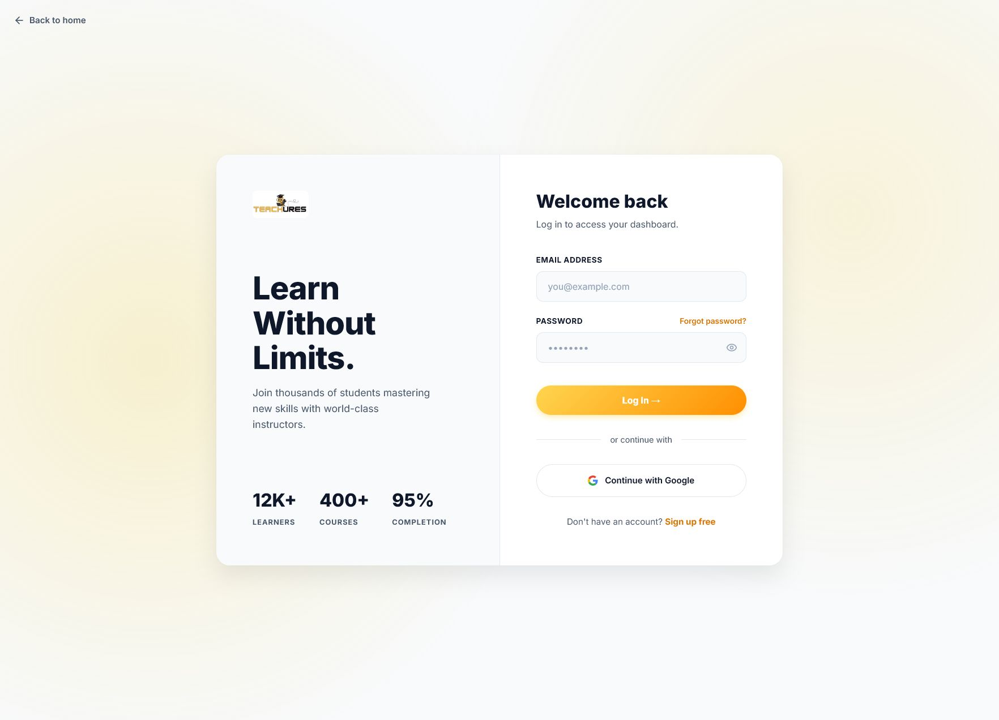

After relogin, lesson remained ARTICLE, proving upload did not persist.


Developer Notes
- Use JSON-only API responses for frontend fetch() endpoints, including unauthenticated and validation-failure paths.
- Add automated tests for payment-to-enrollment and video upload persistence before retesting manually.
- Keep QA test accounts and seeded courses clearly marked so production users do not see test content.
- Do not treat controlsList=nodownload as DRM; it is a user-interface hint only.
- Add server-side authorization checks to every course, lesson, video, quiz, certificate, and admin endpoint.

