

**USER’S**

**MANUAL**

**Physician Locator**

Prepared by: Amrish Patel

June, 2017

**Revision Sheet**

|  |  |  |
| --- | --- | --- |
| **Release No.** | **Date** | **Revision Description** |
| Rev. 0 | 6/29/17 | User’s Manual Created |
| Rev. 1 | 6/30/17 | Added project information and screenshot |
|  |  |  |
|  |  |  |
|  |  |  |
|  |  |  |

**USER'S MANUAL**

**TABLE OF CONTENTS**

Page #

1.0 GENERAL INFORMATION 1-1

1.1 System Overview 1-1

1.2 Acronyms and Abbreviations 1-1

2.0 SYSTEM SUMMARY 2-1

2.1 System Configuration 2-1

2.2 User Access Levels 2-1

3.0 GETTING STARTED 3-1

3.1 Setting up MySQL 3-1

3.2 Create the database 3-4

3.3 Setting up database tables 3-4

3.4 Adding/Removing MySQL Users 3-5

4.0USING the CLIENT APPLICATION 4-1

4.1 Settings 4-1

4.1.1 Server 4-1

4.1.2 Username 4-1

4.1.3 Password 4-1

4.1.4 Database Name 4-1

4.1.5 Database Table 4-1

4.1.6 Equipment Table 4-1

4.1.7 Save most recent queries 4-1

4.2 Connect/Disconnection to database 4-1

4.3 Student Information 4-1

4.3.1 Add Record 4-2

4.3.2 Update Record 4-2

4.3.3 Clear Fields 4-2

4.4 Equipment Rental 4-2

4.5 Query 4-2

4.5.1 Save Query 4-2

4.5.2 Load Query 4-2

4.5.3 Query Results 4-2

4.5.4 Save Query Results 4-3

4.5.5 Change Query Results Display 4-3

5.0 USING the CONVERSION APPLICATION 5-1

5.1 Connect 5-1

5.2 Convert 5-1

5.3 Report 5-1

5.4 Disconnect 5-1

**1.0 GENERAL INFORMATION**

# GENERAL INFORMATION

## 1.1 System Overview

## 1.2 Acronyms and Abbreviations

DSS - Disability Support Services. Provides services to students who have disabilities.

IP – Internet Protocol. A number address that is unique for every computer on a network.

LAN – Local Area Network. This is a network of computers that are located in close vicinity.

MySQL – This is a free SQL database used to store all information for each student.

**2.0 SYSTEM SUMMARY**

# SYSTEM SUMMARY

## 2.1 About

The Physician Locator feature allows you to locate physicians. It provides results based on user input of geographical location and physician specialty. This Physician Locator is also not intended to act as a tool to verify the credentials, qualifications, competence or skill of any physician. LifeCell reserves the right to remove any physician from this Physician Locator at any time, for any reason, and without prior notice. You are solely responsible for all communications and interactions with health care providers you contact as a result of this Physician Locator.

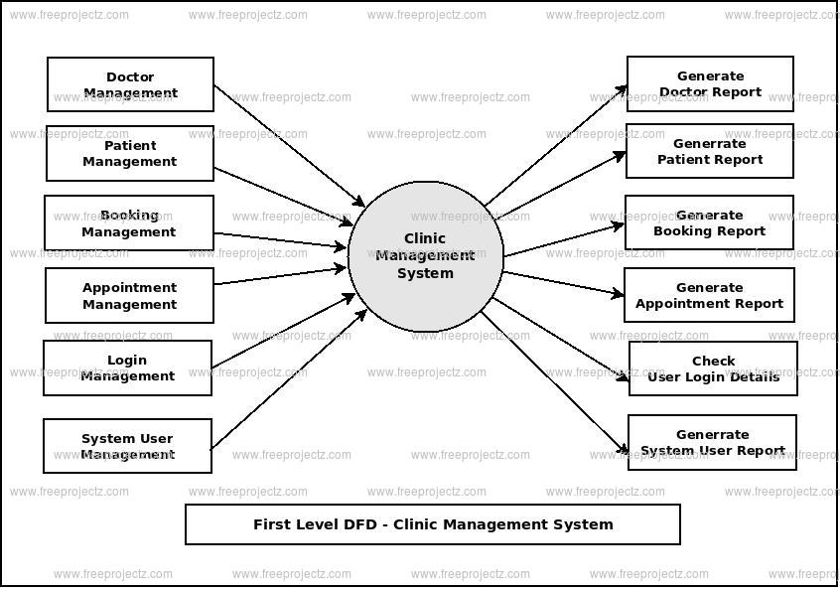

## 2.2 User Access Levels

There are two different types of users as depicted in the image above. Admin Users are PLS employees who have authority to view and change physician’s information within the database. PLS Employees refer to employees who have permission to read physician’s records, but not change any of them. The Admin Users are still PLS employees, but are part of the administration of PLS.

**3.0 GETTING STARTED**

# GETTING STARTED

## 3.1 Setting up SQLSERVER

## 3.2 Create the database

## 3.3 Setting up database tables

## 3.4 Adding/Removing Users

**4.0 USING THE CLIENT APPLICATION**

# USING the CLIENT APPLICATION

## 4.1 Settings

Changing the settings to fit the current user is the first step that should be taken by a new user to the computer before using the application. The settings can be access from the “Settings” menu in the main application window. There are seven (7) settings that can be changed to fit the current user’s needs. When the settings are changed, the changes will be saved even when the program is restarted. Users may need to contact the network administrator to find out all of the details for these settings.

### 4.1.1 Server

The IP address of the computer on the LAN that is running the MySQL server. You may either type the IP address of the database server or the network name of the computer

### 4.1.2 Username

The name of the current user that was setup in the MySQL server by the Administrator specifically for the current user

### 4.1.3 Password

The password that corresponds to the current user that was setup in the MySQL server by the Administrator specifically for the current user

### 4.1.4 Database Name

The name of the database specified in section 3.2 when MySQL was being setup

### 4.1.5 Database Table

The name of the student information table that was added to the database in section 3.3 when MySQL was being setup

### 4.1.6 Equipment Table

The name of the equipment table that was added to the database in section 3.3 when MySQL was being setup

### 4.1.7 Save most recent queries

If this box is checked queries that are made will be saved so that the next time the user returns to the query form, the previous credentials will still be displayed. If it is not checked a new query form will be blank.

## 4.2 Connect/Disconnection to database

To be able to access the database the user must connect to it through the “Connect” menu found under the “Database” menu. When the user is finished with their task they can disconnect from the database using the “Disconnect” menu under the “Database” menu.

## 4.3 Student Information

Student information is stored in three (3) parts. The first is the basic personal information, contact information and services provided which all three wrapped up into one is also called student information. The second is Equipment Rental. This tab is where information is stored regarding any equipment the student might have rented from the university. The final is Case Notes. Case Notes are any kind of notes that will help the user better understand the student’s case. Once the appropriate information has been filled out the student records can be added to the database or edited via the function described in this section.

### 4.3.1 Add Record

Once all of the data fields are filled in on the main application window (i.e. Student Information, Equipment Rental, and Case Notes) the record can be added to the database from the “Add” menu under the “Student” menu on the main form.

### 4.3.2 Update Record

After a record has been loaded and information has been changed the user can update the record by clicking on “Update” under the “Student” menu.

### 4.3.3 Clear Fields

This is a convenience feature that will clear all fields in the main form. When the user selects “Clear Fields” under the “Student” menu, they will be prompted to confirm the clear. If they user selects “yes” the information will be cleared, otherwise nothing will happen.

## 4.4 Equipment Rental

Once a record has been loaded into the main form the user can add, edit, or remove equipment entries from the database for that particular student. This can be done one of two ways: the menu items under the “Equipment” menu, or by right clicking in the Equipment Rental list box. To edit and remove records the user must have a record selected, however to add a record the user does not.

## 4.5 Query

To be able to search the database for a particular student, or a group of students that meet a certain criteria, the user must select “Query” from the “Student” menu. This will bring up a new dialog box with all of the same fields that are on the main form. To search the database type in the desired criteria in the fields on the query form then click the “OK” button on the bottom left of the form. Once this is done a new dialog box will come up showing the results.

### 4.5.1 Save Query

What this does is save the criteria that are currently entered in the query form into a file on the hard disc specified by the user. This allows common queries to be saved so the user does not have to type in the same information every time. To save a query the user must click the “Save” button on the query form after the desired query criteria has been filled in.

### 4.5.2 Load Query

To retrieve the search criteria from a saved query the user will select “Load” from the query form, then choose the file name and location of the query to load.

### 4.5.3 Query Results

Once the search criteria have been entered and the user clicks “OK” on the query form all of the results that match the search will be shown in the query results form. From here the user can either double click, or single click then click the “OK” button to load the record data into the main form.

### 4.5.4 Save Query Results

Once a query has been performed and the user can choose to save the query results. To do so they will click the “Save” button on the query results form. Saving the query results will save all of the information for each student that was successfully found based on that query (i.e. all of the students in the query results). This data is save in a Microsoft Excel compatible XML format and can be further edited to remove unwanted columns via Excel.

### 4.5.5 Change Query Results Display

In the query results form the user can select which columns they want displayed by right clicking in the list view and selecting the menu item corresponding to the field they want to see.

**5.0 USING THE CONVERSION APPLICATION**

# overview of APPLICATION

## 5.1 User Management

## 5.1.1 Registration

User will fill up the registration form with details such as username, password, email address, etc. and these details will be saved in the database table.

The registration form will also make sure that duplicate username and email addresses are not saved by verifying whether username and email address must not exists in the table.

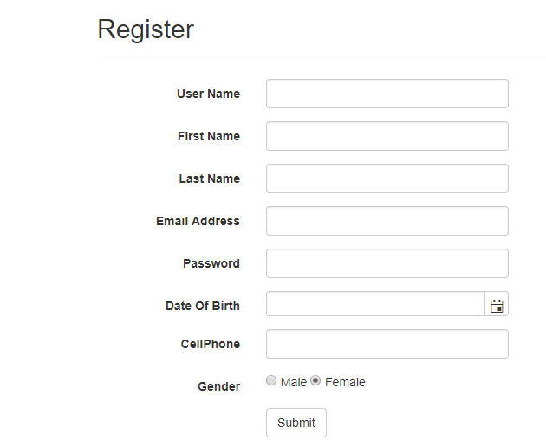

## 

## 5.1.2 Login Page

This is a main login page, after registration user has to log in using their username and password.

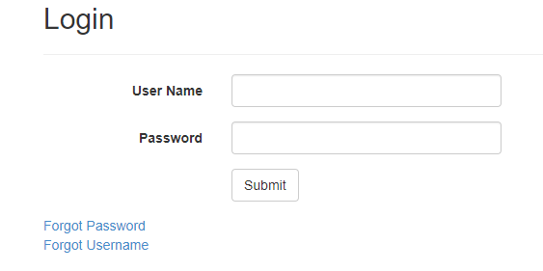

## 5.1.3 Forgot Password

Incase user forgot his/her password then using this screen he/she recover his/her password.

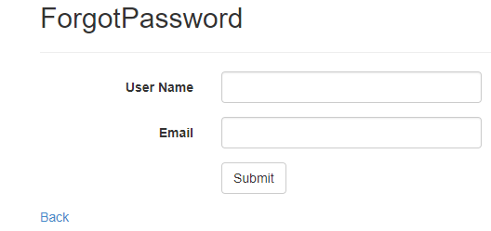

## 5.1.4 Forgot User Name



## 5.2 Convert

### This function converts the Access records to the new MySQL database format. Depending on the amount of records and speed of the computer, this can take several minutes. To assure that the program has not locked up, a progress bar has been implemented to show function progress.

## 5.3 Report

### This function should be run after the completion of the convert function. It creates a Notepad text file in the grandparent directory of the conversion application that lists the DawgTag numbers of all student records and equipment records that contain data formats which the conversion application could not convert easily.

## 5.4 Disconnect

### Disconnects the conversion application from both the Microsoft Access input database and the MySQL output database.