Superstore Sales Data Import,
Power Query & Data Cleaning
Week 1 Project Report — Power BI Desktop

Name: Veeneshwari R
Roll No :E25DA044
Department: Bsc Data Science And Aritificial Intelligence

Introduction

Retail organizations generate large volumes of transactional data every day, covering customer orders, shipping details, products, regions, and profitability. Before this data can be used for meaningful analysis, it must be imported into a business intelligence tool, inspected for quality issues, and transformed into a clean, consistent format. This report documents Week 1 of a Power BI project built around the Superstore Sales dataset, a widely used retail sales dataset containing order-level details such as Order ID, Order Date, Ship Date, Customer, Segment, Region, Product, Sales, and Profit.
The objective of this stage of the project was to import the raw Superstore CSV file into Power BI Desktop using Power Query, inspect its structure and data types, standardize text formatting across categorical fields, engineer a new date-based attribute, and load a clean data model ready for further modeling and DAX work in later stages. The sections below walk through each step of this process as it was carried out in Power BI Desktop and the Power Query Editor, supported by screenshots captured directly from the working session.
By the end of this stage, the raw file was successfully connected, previewed, cleaned, and loaded into the Power BI data model, forming the foundation on which the Week 2 dashboard and DAX measures will be built.

Step 1: Connecting to the Data Source and Previewing the File
The process began in Power BI Desktop by using the "Get Data" option to connect to the Superstore Sales dataset, which was stored locally as a CSV file (Sample super data.csv). Power Query's Get Data dialog opened a preview window that displayed the file path, the detected file origin (Unicode UTF-8), the delimiter (Comma), and the data type detection setting (based on the first 200 rows).
The preview grid confirmed that the file contained the expected 21 columns, including Row ID, Order ID, Order Date, Ship Date, Ship Mode, Customer ID, Customer Name, Segment, Country/Region, City, State/Province, Postal Code, Region, and Product ID, along with more than 999 rows of transactional data. Reviewing this preview at the outset made it possible to confirm that the delimiter and encoding had been detected correctly before the file was loaded into the query editor for cleaning.
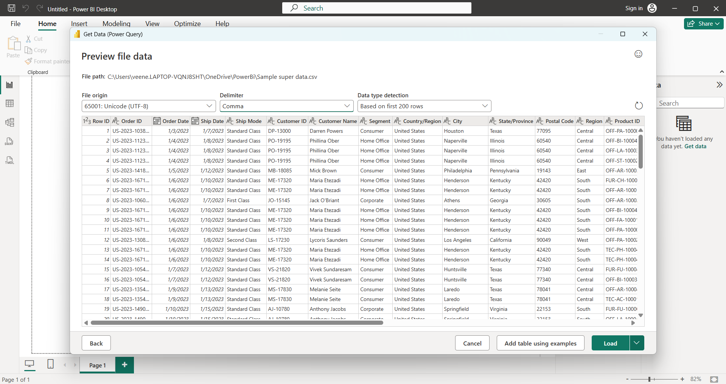

- Confirmed the correct file path and delimiter (Comma) before loading.
- Verified 21 columns and 999+ rows were detected in the source file.
- Data type detection was set to scan the first 200 rows automatically.

Step 2: Promoting Headers, Setting Column Types, and Standardizing Text
After loading the file into the Power Query Editor, the first row of the dataset was promoted to become the column headers, and Power Query automatically assigned initial data types to each column (for example, Row ID as a whole number, Order Date and Ship Date as dates, and the remaining descriptive fields as text).
To standardize the categorical fields, the Transform tab's text options were used. Right-clicking a column such as Ship Mode opened the Transform menu, from which the UPPERCASE option was applied. This converted values such as "Standard Class" and "First Class" into a consistent uppercase format ("STANDARD CLASS", "FIRST CLASS"), removing inconsistencies in casing that can otherwise cause categories to be treated as distinct values during later grouping or visualization.

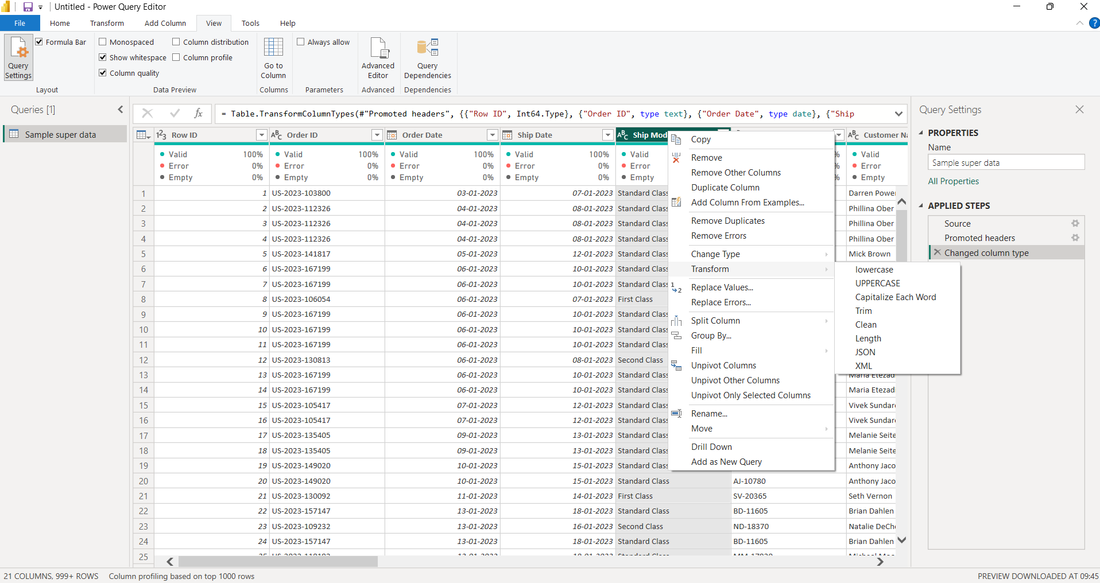
.
- Promoted the first row of the CSV to column headers.
- Reviewed and confirmed automatically detected data types for each column.
- Standardized the Ship Mode column to uppercase text for consistency.

Step 3: Setting the Order Date Locale and Data Type (Date/Time)
The Order Date column initially required a locale-aware type conversion because the source values could be interpreted differently depending on regional date formats (for example, day/month/year versus month/day/year). Using the "Change Type with Locale" option, the Date/Time data type was selected together with the English (India) locale, and Power Query displayed sample input values (such as "29 March 2016 14:45") to confirm how the raw text would be parsed under this setting.
This intermediate step ensured that the date and time values embedded in the text column were interpreted using an unambiguous, explicit locale rather than relying on the system default, reducing the risk of dates being silently misread.
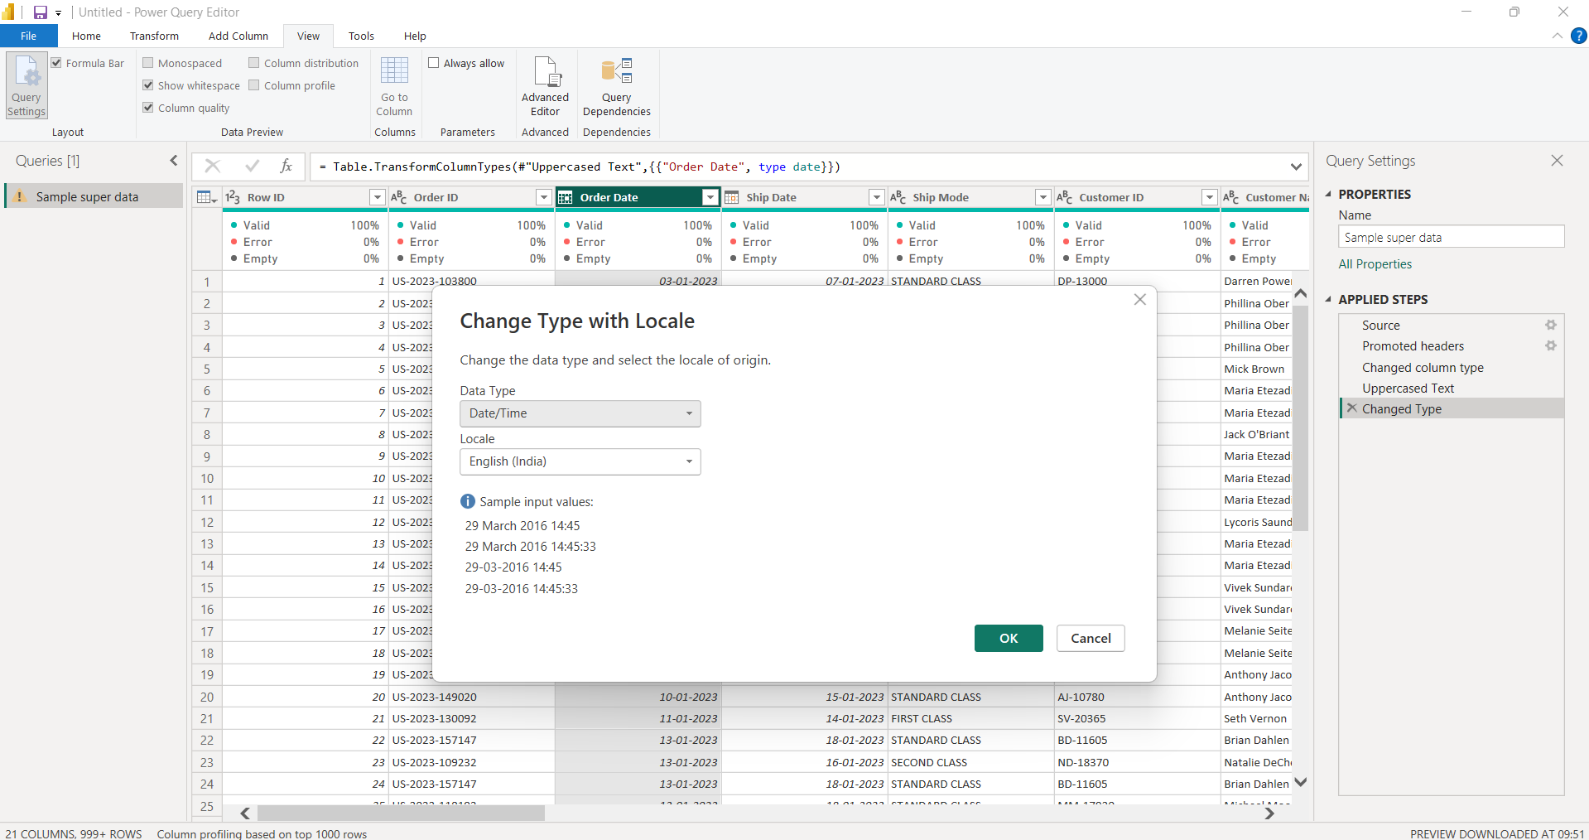

- Opened Change Type with Locale for the Order Date column.
- Selected Date/Time as the target data type.
- Applied the English (India) locale to correctly parse the source date strings.

Step 4: Refining Order Date to a Pure Date Type (English - United States)
Building on the previous step, the Order Date column was converted a second time using Change Type with Locale, this time selecting the Date data type (rather than Date/Time) together with the English (United States) locale. Power Query's sample input preview confirmed the resulting formats, such as "3/29/2016", "Tuesday, March 29, 2016", "March 29", and "March 2016", verifying that the column now represented a clean calendar date without a time component.
Removing the time portion and re-confirming the locale at this stage ensured that Order Date would behave consistently as a pure date field for later time-intelligence calculations, such as extracting year, quarter, month, and day attributes in subsequent steps of the project.
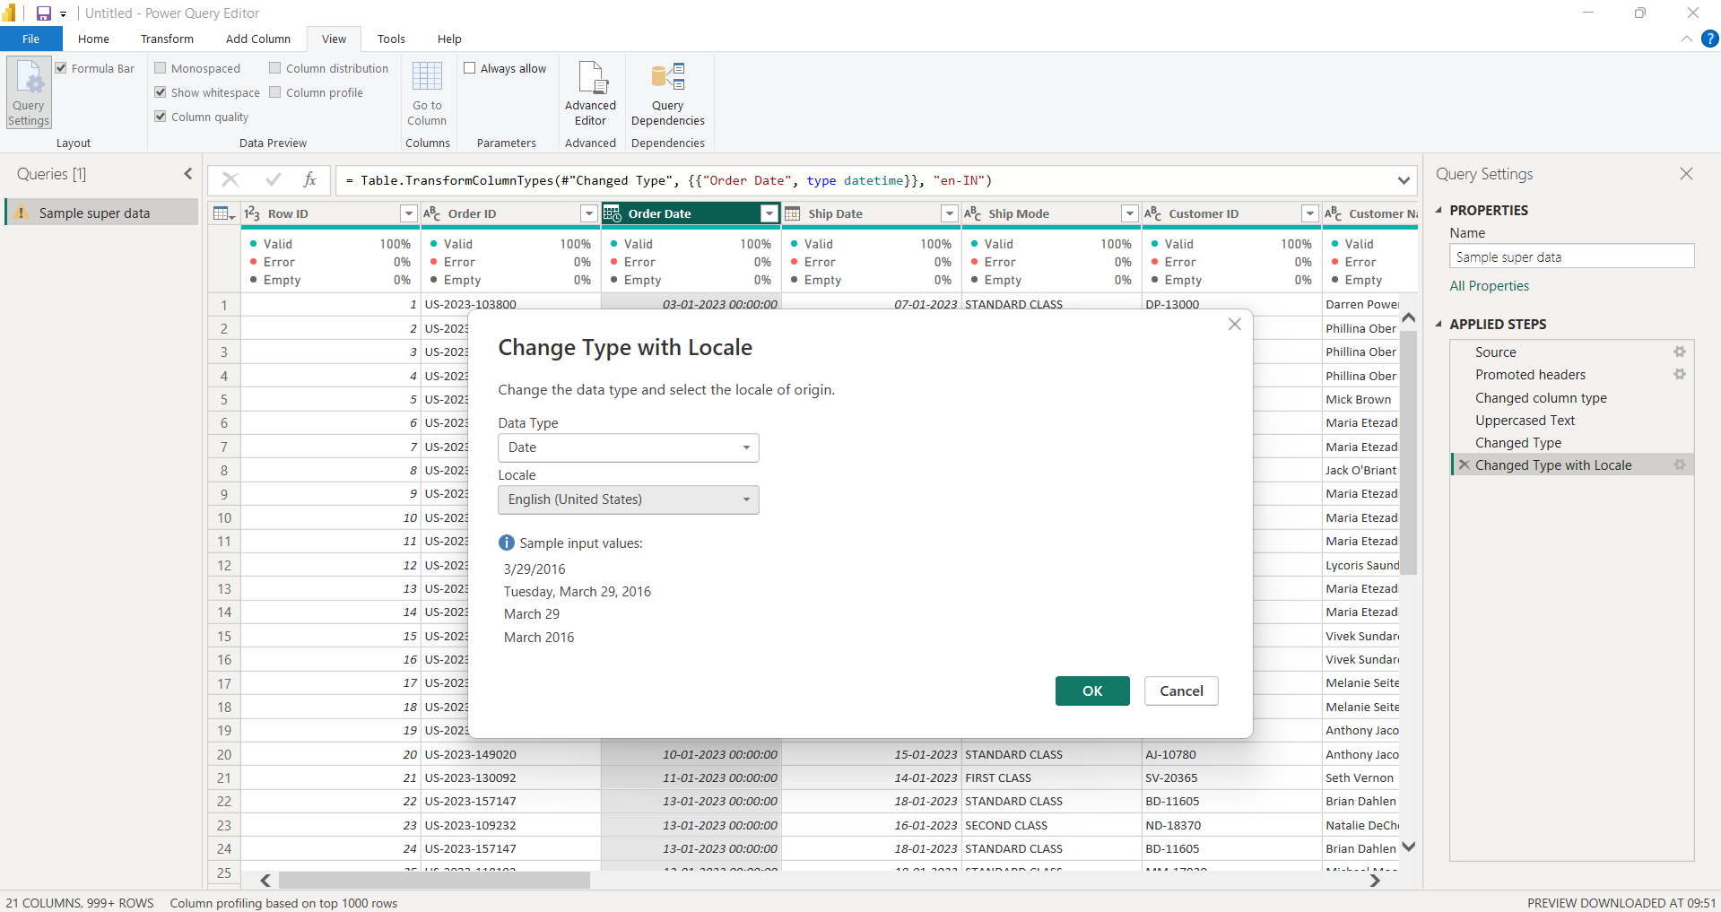
.
- Converted Order Date from Date/Time to a pure Date type.
- Applied the English (United States) locale for final parsing.
- Verified sample date formats before confirming the change.

Step 5: Duplicating the Date Column and Extracting the Day Attribute
To begin building temporal attributes for later analysis, the Order Date column was duplicated, creating a new column named "Order Date - Copy". This duplicate column was then transformed using the Date.Day function, which extracted only the day-of-month component (an integer value) from each date, while leaving the original Order Date column untouched.
This step demonstrates the pattern used to engineer additional date-based fields (day, month, quarter, year, and day of week) without losing the original date column, which remains available for date-level calculations and relationships in the data model. The formula bar confirmed the underlying M code generated automatically by the UI: Table.TransformColumns(#"Reordered Columns", {{"Order Date - Copy", Date.Day, Int64.Type}}).
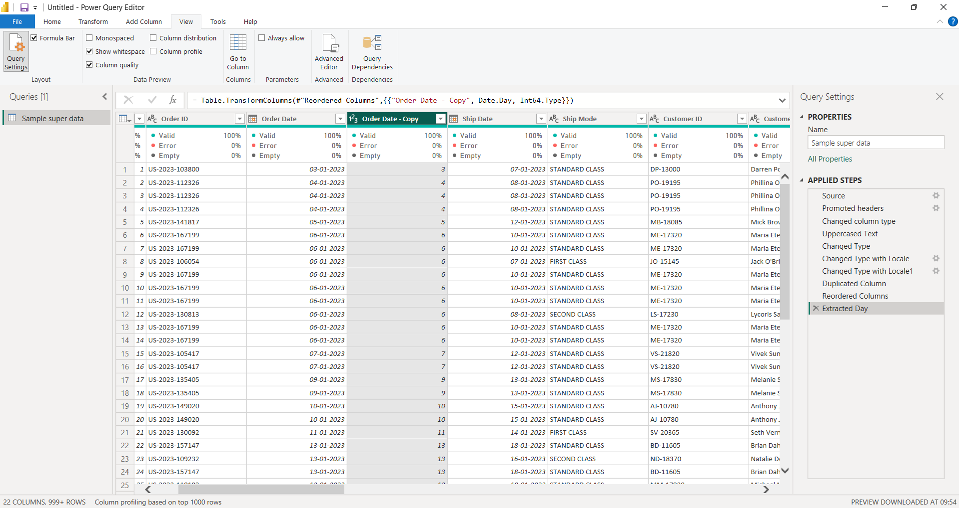
- Duplicated the Order Date column to preserve the original values.
- Applied the Date.Day function to extract the day-of-month as an integer.
- Confirmed the auto-generated M code in the formula bar.

Step 6: Closing and Applying the Query to Load the Data Model
Once all cleaning and transformation steps were complete — promoting headers, correcting data types, standardizing text case, setting the Order Date locale, and extracting the day attribute — the final step was to commit these changes to the Power BI data model. This was done using the "Close & Apply" command on the Home tab of the Power Query Editor.
Selecting Close & Apply executed the full sequence of applied steps recorded in the Query Settings pane (Source, Promoted headers, Changed column type, Uppercased Text, Changed Type, Changed Type with Locale, Changed Type with Locale1, Duplicated Column, Reordered Columns, and Extracted Day) against the entire dataset, and loaded the resulting 22-column, 999+ row table — named "Sample super data" — into the Power BI report environment, ready for relationships and DAX measures in Week 2.
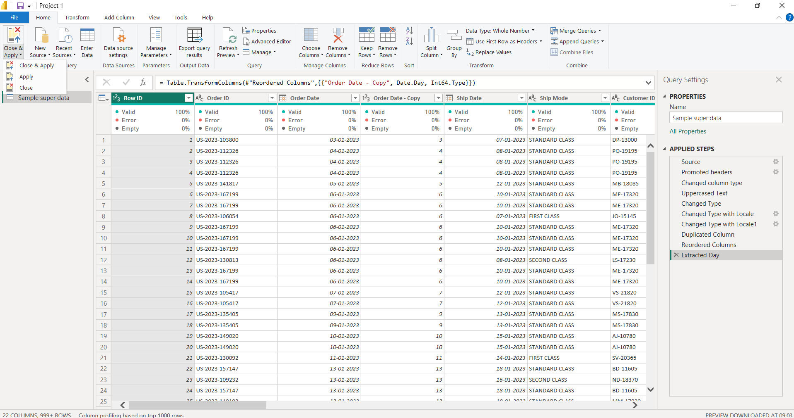

- Reviewed the full list of applied steps in the Query Settings pane.
- Selected Close & Apply from the Home ribbon.
- Loaded the cleaned, 22-column dataset into the Power BI data model.

Conclusion
Week 1 of the Superstore Sales project established a clean, reliable foundation for the analytics work to follow. The raw CSV file was connected and previewed to confirm its structure, headers were promoted and data types were reviewed, categorical text fields were standardized to a consistent case, and the Order Date field was carefully converted through an explicit locale-aware process to guarantee accurate date parsing. A duplicated date column was then used to engineer a new Day attribute, demonstrating the general pattern that will be extended to Month, Quarter, Year, and Day-of-Week fields as the date dimension is built out further.
Finally, applying Close & Apply committed every transformation step to the Power BI data model, producing a cleaned and structured table ready for the next phase of the project. With the dataset now properly typed, standardized, and enriched with temporal attributes, the project is well positioned to move into Week 2, where table relationships, a dedicated DAX measures table, and an interactive Superstore Sales Dashboard featuring KPI cards, stacked bar charts, line charts, and decomposition trees will be constructed on top of this clean data foundation.
Overall, this stage reinforced a core principle of business intelligence work: the quality and reliability of any downstream dashboard or analysis depends directly on the rigor applied during data import and cleaning. The steps documented here — inspection, type correction, locale-aware date handling, and attribute extraction — represent a repeatable workflow that can be applied to future datasets brought into Power BI.

