Clicking ‘Job Details’ from the job list will display the incorrect time and row numbers. (A unit job will also display ‘Rows’ instead of ‘Units’).   
(Not Fixed)

After making job, before starting:

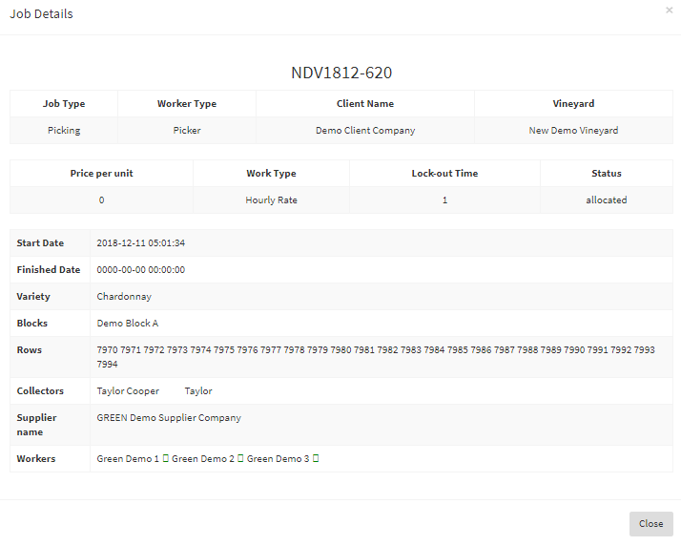 Before starting the job, the job details still display a ‘Start Date’. The time displayed is not  
 relevant to the job.

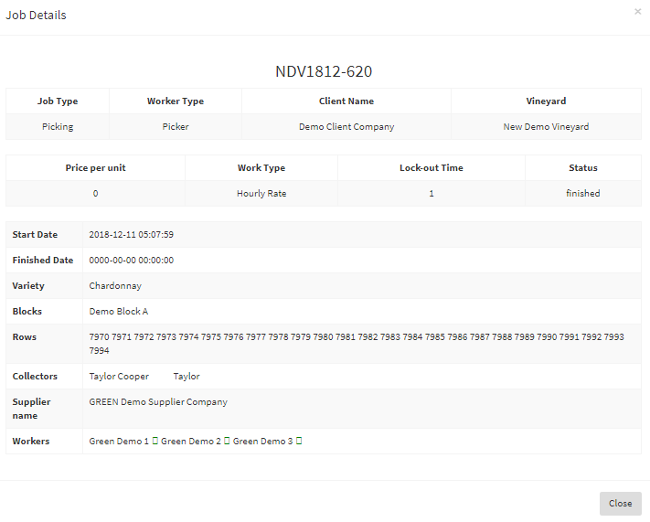  
  
After starting and finishing the job:  
   
 The date of the job is correct but the time the job started is incorrect.  
 The ‘Finished Date’ is not displayed even after the job has been finished.  
 The row numbers that are displayed are incorrect and are the same for every job.

The correct time when the job started and finished:

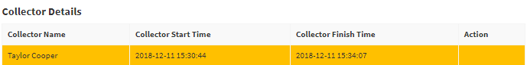Below is the correct time that the job had started and finished. It is the time that should be  
 displayed in the ‘Job Details’.