An Internship Report
Of
Cisco Networking Academy Virtual Internship Program

Submitted
To

School of Computer Science and Engineering
IILM University, Greater Noida, U.P.

In partial fulfilment of the requirement of degree of
B.Tech (Computer Science and Engineering)


By

Roll Number of Student: 25SCS1003003599
Name of Student: VEER GUPTA
Batch: 2025-2029

CANDIDATE'S DECLARATION
I, VEER GUPTA, do hereby declare that the internship report titled "Cisco Networking Academy Virtual Internship Program" has been completed by me to fulfil the requirement for the award of the degree of Bachelor of Technology in Computer Science and Engineering. All the references have been quoted and I have not taken as such any material from any other source. I affirm to you that this report is my own and has not been submitted to any other institute for any degree/diploma requirement and further I shall be solely responsible for any kind of copyright violation in this regard.

Signature:-
Student Name: VEER GUPTA
Roll No.: 25SCS1003003599

ACKNOWLEDGEMENT
I am using this opportunity to express my gratitude to everyone who supported me throughout the Internship Program. I am thankful for their aspiring guidance, invaluably constructive criticism and friendly advice during this work. I am sincerely grateful to them for sharing their truthful and illuminating views on a number of issues related to this work.
I would like to thank the Cisco Networking Academy team and IILM University for providing me the opportunity and the structured platform to learn and gain hands-on exposure in the domain of AI-assisted network troubleshooting and diagnostics. I am also thankful to my instructor, Ms. Swati Vashisht, and the faculty of the School of Computer Science & Engineering for their continuous support and encouragement.
I express my gratitude to my parents for their blessings.

Signature:-
Student Name: VEER GUPTA
Roll No.: 25SCS1003003599

TABLE OF CONTENTS
1. Candidate's Declaration i
2. Acknowledgement ii
3. Internship Completion Certificate -
4. Project Description 1
4.1 Introduction 1
4.2 Organization Profile 1
4.3 Problem Statement 1
4.4 Project Objectives 2
4.5 Scope of the Project 2
4.6 Technologies and Tools Used 3
4.7 System Architecture 3
4.8 Methodology 4
4.9 Expected Outcomes 5
4.10 Certificates of Completion and Communication Proof 5
5. Bibliography/References 7

3. INTERNSHIP COMPLETION CERTIFICATE
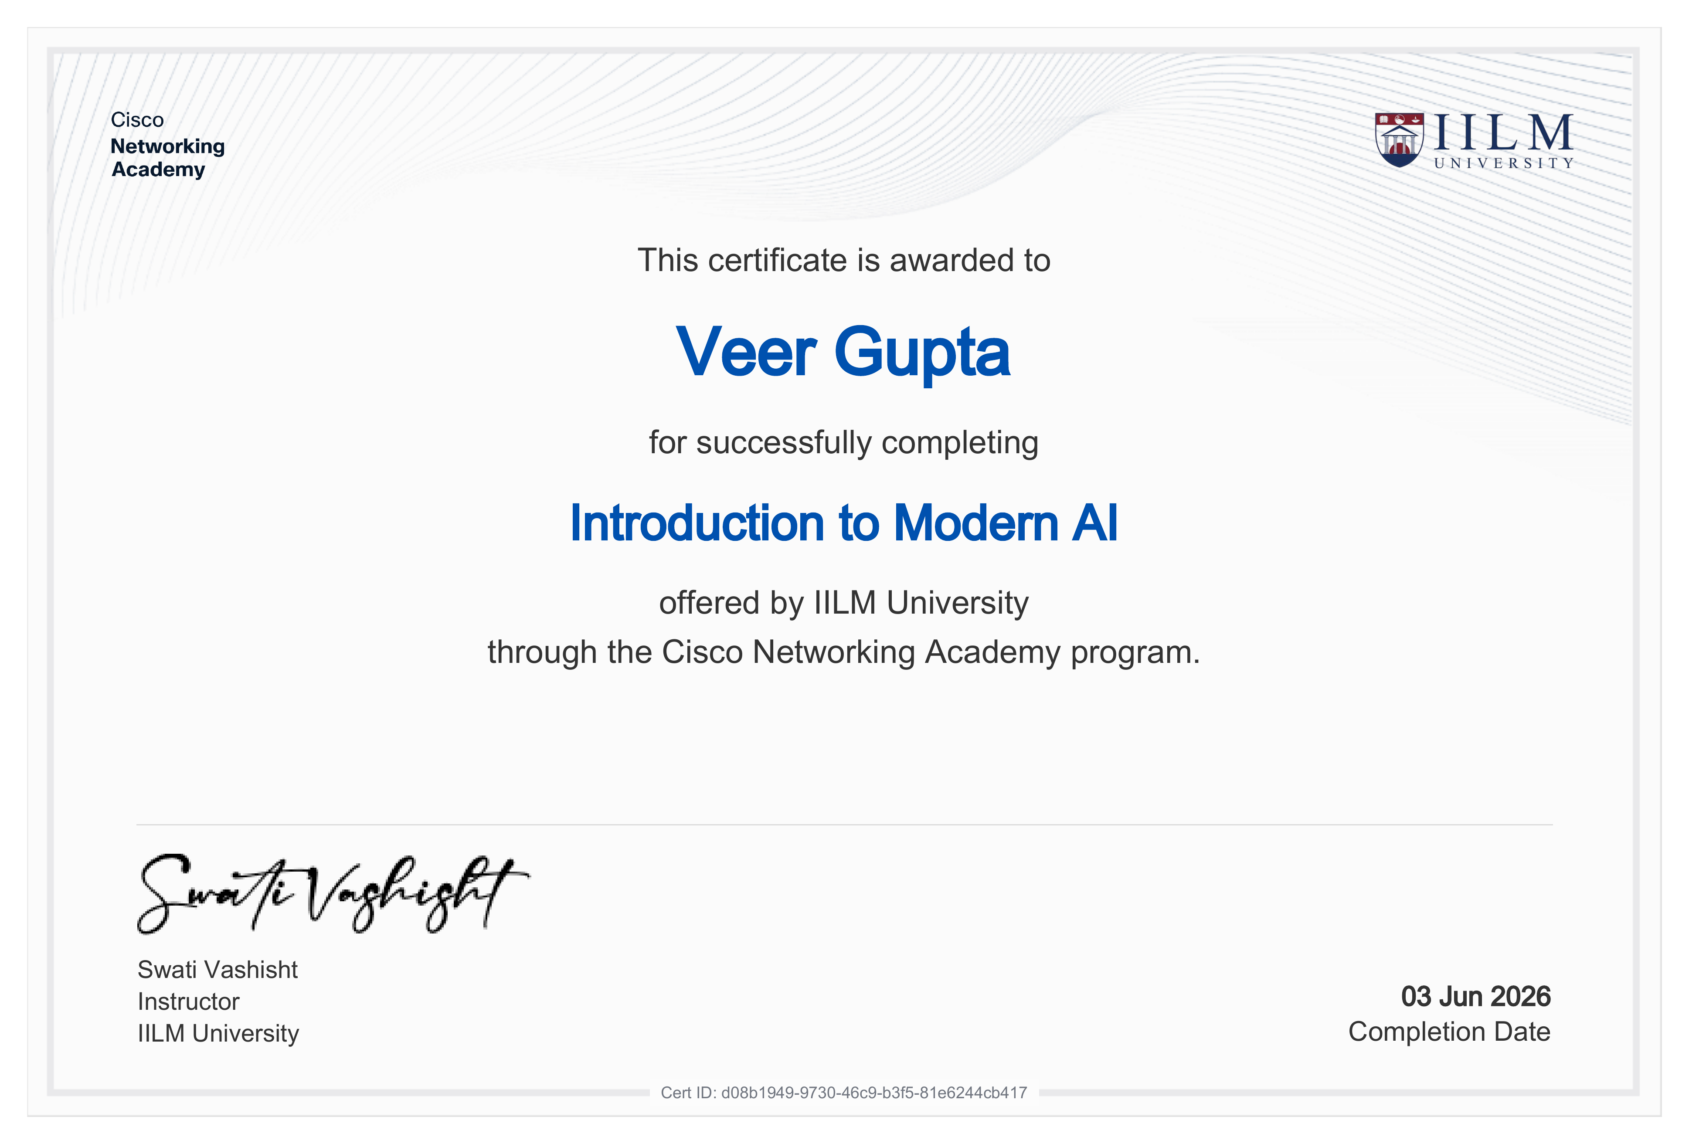
Certificate 1 of 3 – Introduction to Modern AI

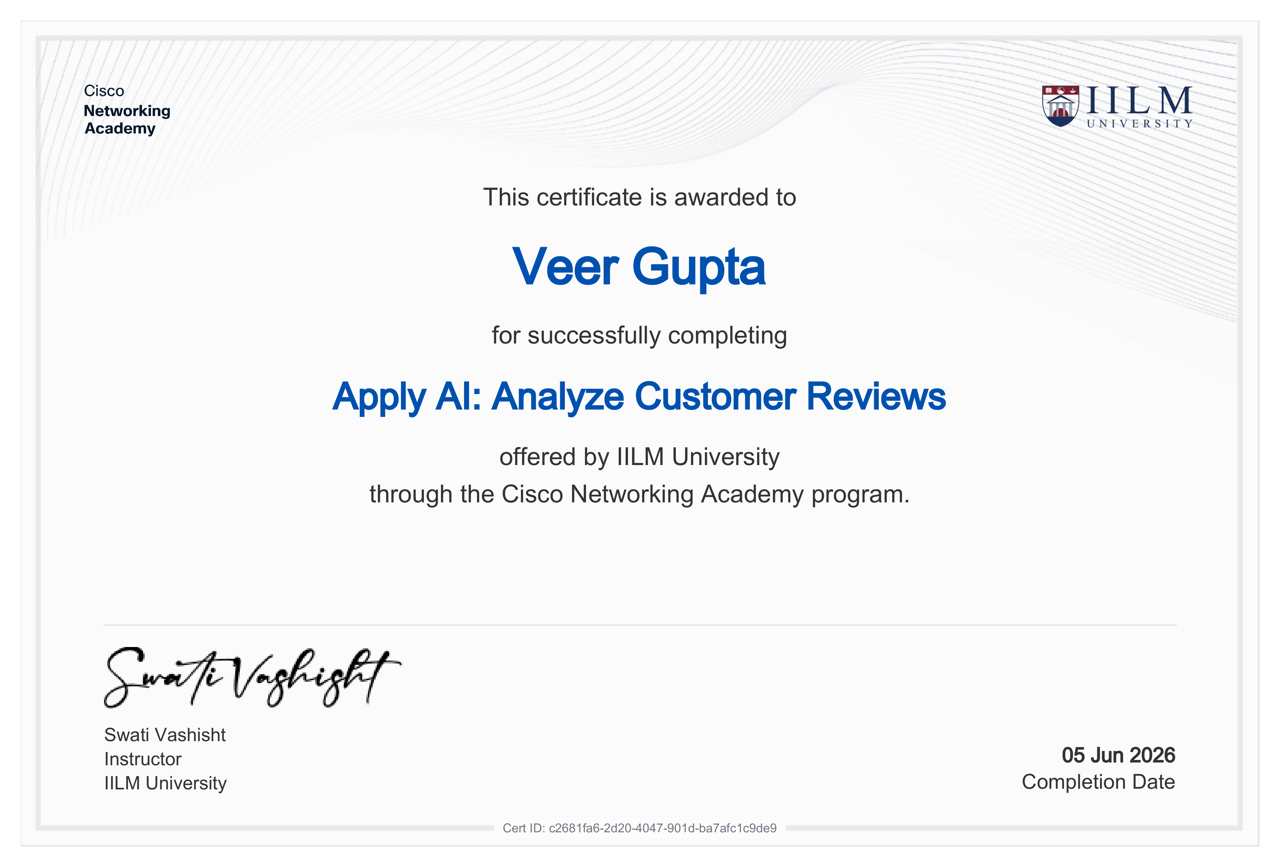
Certificate 2 of 3 – Apply AI: Analyze Customer Reviews

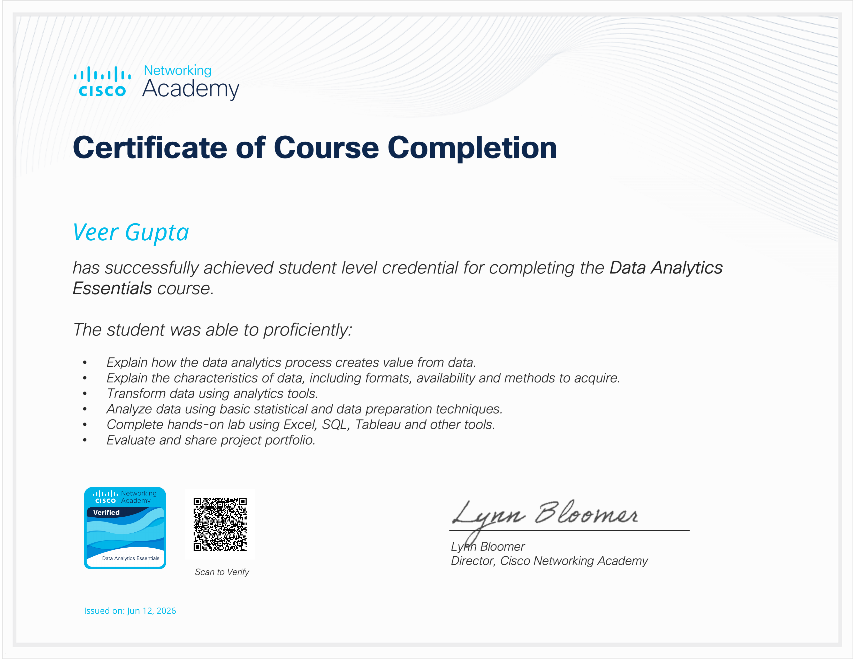
Certificate 3 of 3 – Data Analytics Essentials

4. PROJECT DESCRIPTION
4.1 Introduction
This report presents a detailed account of the 9-week Virtual Internship Program (VIP) undertaken through Cisco Networking Academy, in partnership with IILM University, Greater Noida, in the domain of "AI-Assisted Network Troubleshooting and Diagnostics." The internship was carried out from May 15, 2026 to July 15, 2026 as part of the requirement of the Bachelor of Technology (Computer Science and Engineering) programme at IILM University. The primary aim of this internship was to build a strong practical foundation in computer networking, data analytics, and applied artificial intelligence, and to apply these skills to a real-world problem: helping network engineers diagnose connectivity faults faster and more reliably.
The internship combined three structured Cisco Networking Academy courses — Introduction to Modern AI, Data Analytics Essentials, and Apply AI: Analyze Customer Reviews — with a self-directed capstone project, NetSage AI, an AI-assisted network troubleshooting and diagnostic system. On successful completion of all three courses, verified digital credentials were issued by Cisco Networking Academy through IILM University.
4.2 Organization Profile
Cisco Networking Academy is a global IT skills and career-building program that has trained millions of students worldwide in networking, cybersecurity, data, and emerging-technology skills. At IILM University, Greater Noida, the program is delivered through the School of Computer Science & Engineering under the guidance of instructor Ms. Swati Vashisht, giving students access to Cisco's curriculum, hands-on labs, and industry-recognized digital credentials. The Academy's mission is to bridge the gap between classroom learning and industry-ready skills, partnering with Cisco's global academy network to prepare students for real-world technology careers in networking and artificial intelligence.
4.3 Problem Statement
Students and junior network engineers can often run the correct diagnostic commands on a network device but struggle to connect an observed symptom to its true underlying root cause. A single connectivity issue reported by a user, such as one PC being unable to reach another, could stem from any of several causes: a VLAN misconfiguration, a gateway mismatch, a DHCP failure, a routing problem, a DNS issue, an incorrectly configured access-control list (ACL), a NAT misconfiguration, or a physically down interface. Without a structured way to narrow down these possibilities, troubleshooting becomes slow, inconsistent, and heavily dependent on individual experience. The problem addressed by this internship project was to design and build an AI-assisted decision-support system that can take in troubleshooting evidence — a symptom description, the network topology, and the output of relevant "show" commands — and recommend a probable root cause and next diagnostic step, while keeping a qualified human reviewer in the loop before any diagnosis is accepted as final.
4.4 Project Objectives
- To complete structured Cisco Networking Academy coursework in modern AI concepts, data analytics, and applied AI, culminating in verified digital credentials.
- To design a deterministic, rule-based diagnostic engine capable of recognising common network fault patterns (VLAN, DHCP, gateway, ACL, DNS, NAT, and wireless issues).
- To build a complementary NLP/AI diagnostic engine, using Google's Gemini API, that ranks candidate root causes by similarity when no deterministic rule matches the evidence.
- To combine both engines into a single hybrid decision that reports a root cause, confidence level, OSI layer, supporting evidence, and a recommended next command.
- To implement a human-in-the-loop review workflow that allows a reviewer to Accept, Edit, or Reject every AI-generated diagnosis before it is treated as confirmed.
- To build a 30-case network-troubleshooting dataset spanning ACL, DHCP, DNS, Gateway/IP, NAT, VLAN, and Wireless fault categories.
- To develop a Responsible AI Analytics Dashboard that tracks AI-human agreement, category and severity breakdowns, and maintains a full audit trail of every review decision.
4.5 Scope of the Project
The scope of this internship spans two complementary tracks. The first is structured coursework delivered by Cisco Networking Academy, covering the fundamentals of modern AI, the data-analytics lifecycle, and the application of AI techniques to unstructured text such as customer reviews. The second is the design and development of NetSage AI, a decision-support tool for troubleshooting Cisco-style Packet Tracer and lab network scenarios, combining a deterministic rule engine with an NLP-based diagnostic engine behind a Streamlit dashboard. The project is intentionally scoped as a decision-support and simulation/lab-based learning tool: it recommends a probable root cause and fix, but it does not directly modify configurations on any live network device, and it was not deployed to any production network. All evaluation was carried out against a purpose-built 30-case synthetic dataset rather than a live enterprise network.
4.6 Technologies and Tools Used
- Programming Language: Python
- AI / Diagnosis Engine: Google Generative AI (Gemini API)
- Rule Engine: Deterministic Python pattern-matching logic
- Dashboard / UI Framework: Streamlit
- Data Handling: pandas
- Configuration Management: python-dotenv
- Learning Platform: Cisco Networking Academy courseware (Introduction to Modern AI, Data Analytics Essentials, Apply AI: Analyze Customer Reviews)
4.7 System Architecture
The architecture of NetSage AI can be summarised in the following layers:
- Evidence Layer: Symptom description, network topology, and Cisco show-command output submitted through the dashboard.
- Rule Engine Layer: A deterministic Python engine that matches the submitted evidence against known network fault patterns.
- AI / NLP Engine Layer: A Gemini-powered similarity-matching engine that ranks the Top-3 candidate diagnoses when no deterministic rule applies.
- Hybrid Decision Layer: Combines the outputs of both engines into a single verdict — root cause, confidence, OSI layer, supporting evidence, and next diagnostic command.
- Human Review Layer: A reviewer inspects the AI's diagnosis and explicitly Accepts, Edits, or Rejects it before it is treated as confirmed.
- Logging & Analytics Layer: Every decision is written to a Review History log and a Responsible AI Corrections Log, feeding a live analytics dashboard.
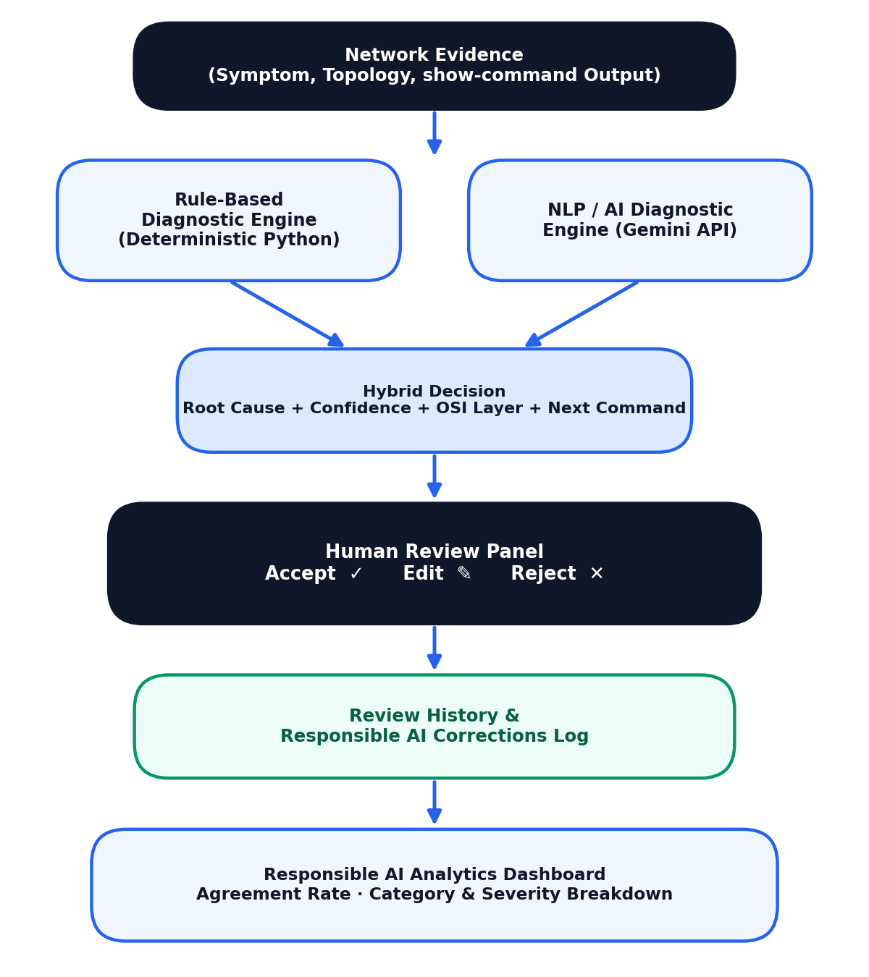
Figure 4.1: NetSage AI System Architecture and Workflow
4.8 Methodology
The internship followed a structured, week-wise methodology combining Cisco Networking Academy coursework with hands-on development of the NetSage AI capstone project, as summarized in the table below.
Week | Module | Description
1 | Networking & AI Foundations | Cisco Networking Academy orientation, OSI model refresher, and Introduction to Modern AI concepts.
2 | Data Analytics Essentials | Data formats, acquisition, statistical analysis, and hands-on labs using Excel, SQL, and Tableau.
3 | Applying AI to Real Data | Apply AI: Analyze Customer Reviews coursework, covering NLP and similarity-based analysis techniques.
4 | Case Dataset Design | Design and construction of the 30-case network-troubleshooting dataset (symptom, evidence, expected fault, OSI layer, severity).
5 | Rule-Based Diagnostic Engine | Development of a deterministic Python rule engine for VLAN, DHCP, gateway, and ACL fault detection.
6 | NLP / AI Diagnostic Engine | Integration of the Gemini API for similarity-based Top-3 candidate diagnosis ranking.
7 | Hybrid Decision & Review | Combining both engines into a hybrid verdict and building the Accept / Edit / Reject human-review panel.
8-9 | Dashboard, Testing & Capstone | Development of the Responsible AI Analytics dashboard, final evaluation, and capstone demonstration.

Note: This was an unpaid, learning-focused internship program.
Each course concluded with graded assessments and hands-on labs, culminating in verified digital credentials. In parallel, the capstone project progressed from dataset design through to a fully working, evaluated prototype.
4.9 Expected Outcomes
- Verified digital credentials in Introduction to Modern AI, Data Analytics Essentials, and Apply AI: Analyze Customer Reviews from Cisco Networking Academy.
- Practical understanding of building a rule-based diagnostic engine and integrating it with an LLM-based similarity-matching engine.
- Hands-on experience designing a human-in-the-loop review workflow for AI-assisted decision support.
- Ability to design and populate a structured troubleshooting dataset spanning multiple network fault categories.
- Skill in building an interactive Streamlit dashboard with live analytics, charts, and audit logging.
- A working, demonstrable prototype (NetSage AI), evaluated at 100% rule-based diagnostic accuracy and 83.33% Top-1 / 90.00% Top-3 NLP diagnostic accuracy across the 30-case dataset.
4.10 Certificates of Completion and Communication Proof
The verified digital certificates issued by Cisco Networking Academy through IILM University for all three completed courses — Introduction to Modern AI, Data Analytics Essentials, and Apply AI: Analyze Customer Reviews — are attached in Chapter 3 of this report. The corresponding skill badges earned on completion of each course, and a screenshot of the NetSage AI diagnosis and human-review workflow developed during the capstone project, are attached below as further proof of work completed.
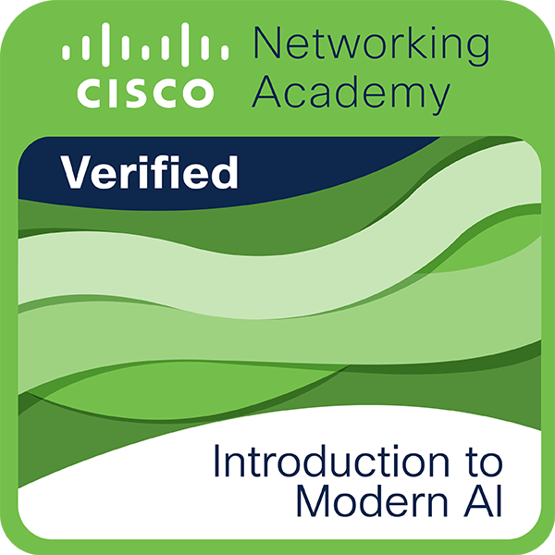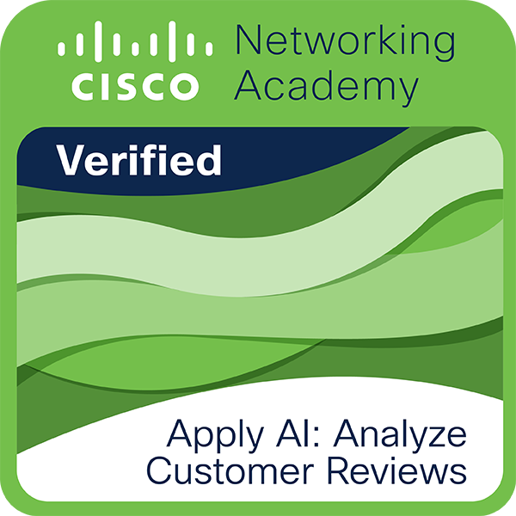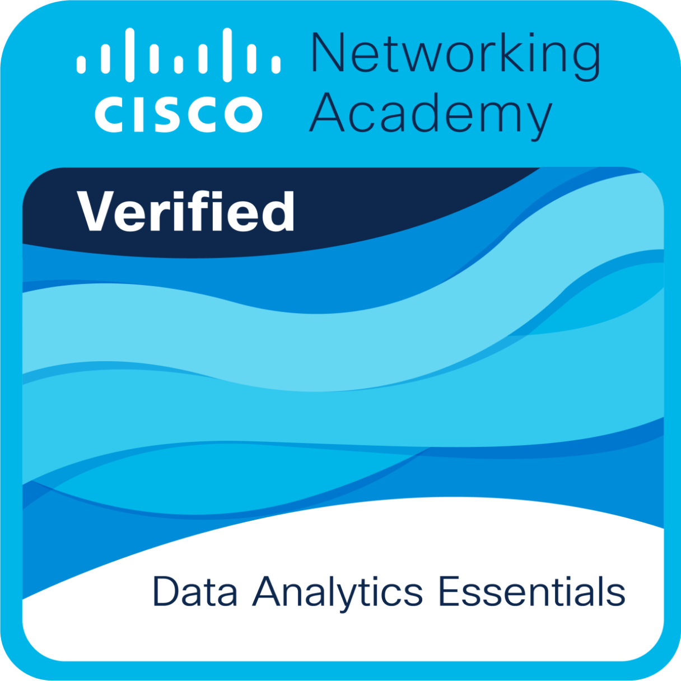
Cisco Networking Academy skill badges earned on course completion

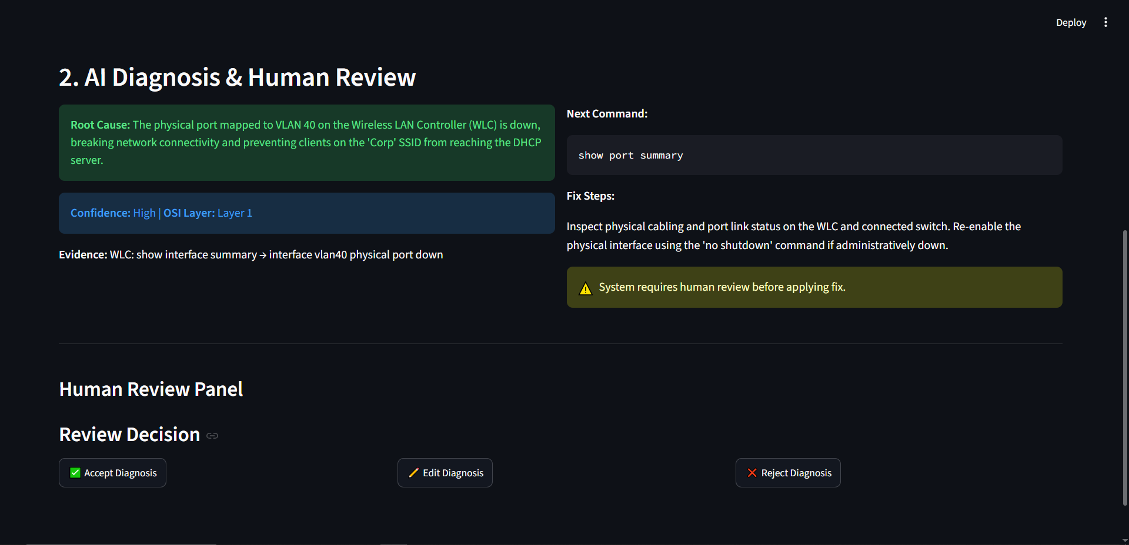
NetSage AI — AI Diagnosis & Human-in-the-Loop Review workflow

5. BIBLIOGRAPHY/REFERENCES
Cisco Networking Academy, "Introduction to Modern AI," Certificate ID: d08b1949-9730-46c9-b3f5-81e6244cb417, issued through IILM University, June 2026.
Cisco Networking Academy, "Apply AI: Analyze Customer Reviews," Certificate ID: c2681fa6-2d20-4047-901d-ba7afc1c9de9, issued through IILM University, June 2026.
Cisco Networking Academy, "Data Analytics Essentials," issued through IILM University, June 12, 2026.
Google AI for Developers, “Gemini API Documentation,” https://ai.google.dev/
Streamlit Documentation, https://docs.streamlit.io/
pandas Documentation, https://pandas.pydata.org/docs/
Cisco Networking Academy, https://www.netacad.com/

