## Workflow Diagram

The diagram below illustrates the step-by-step workflow for this process:

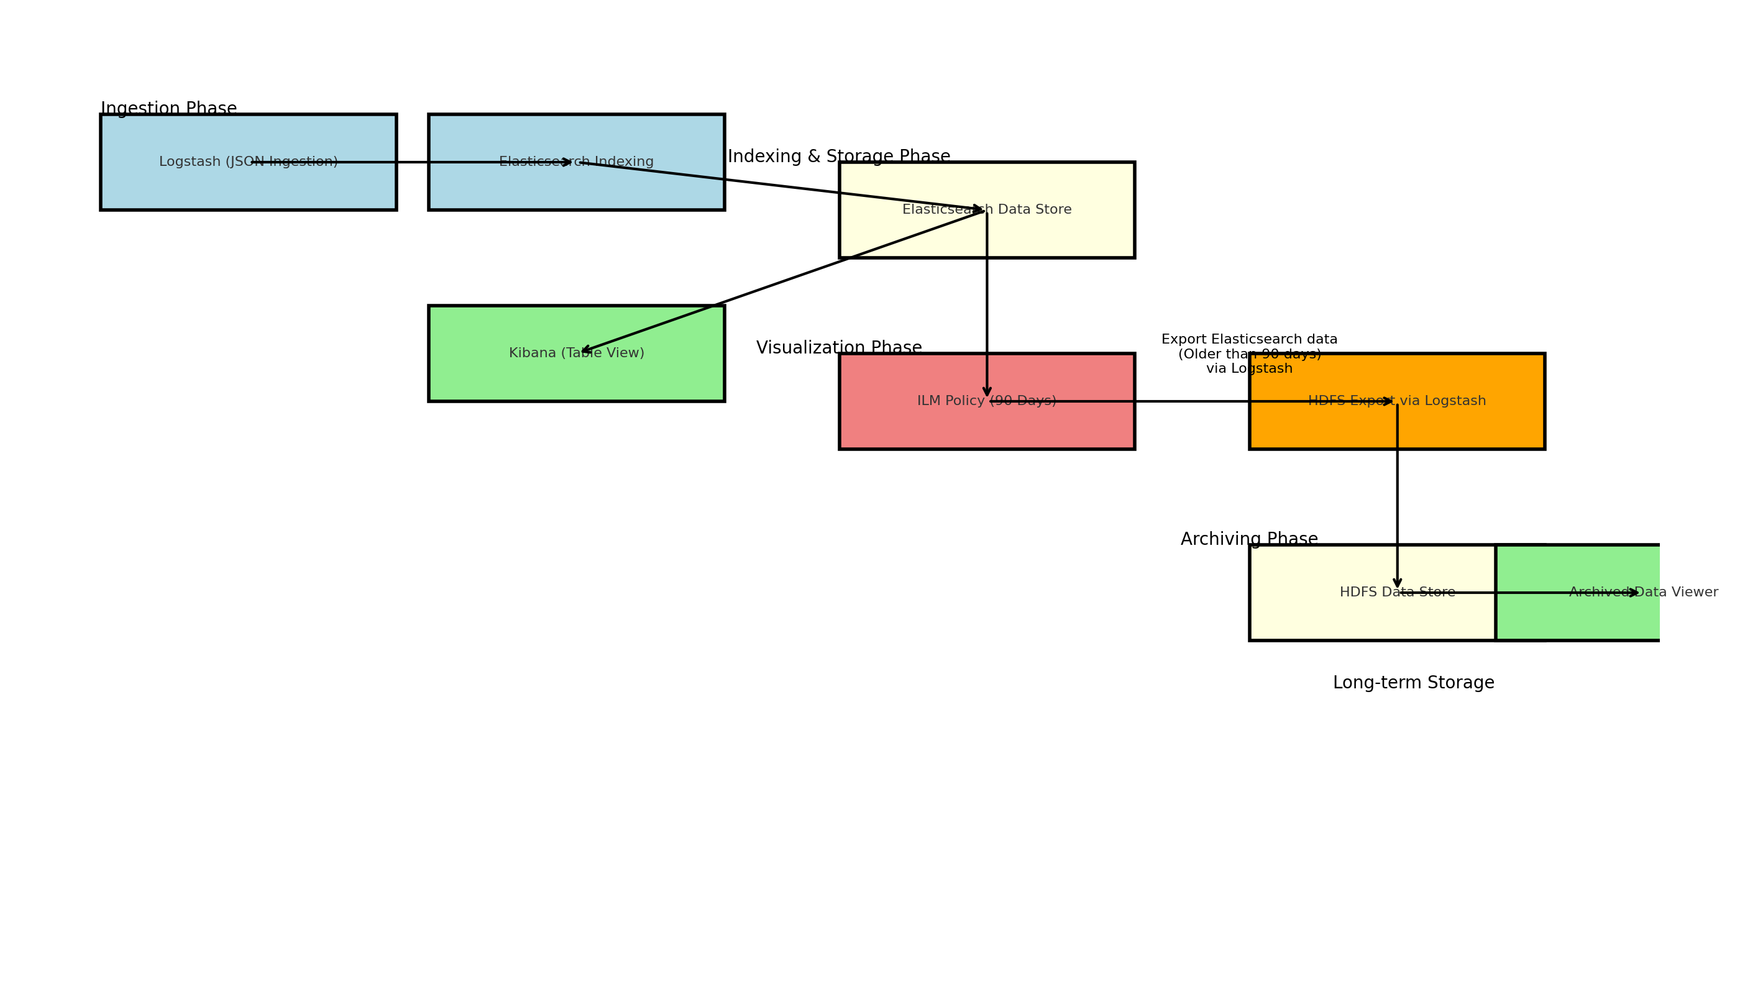

## Diagram Description

1. **Logstash (JSON Ingestion)**: The process starts with Logstash ingesting JSON data from various sources such as files, APIs, or message queues. Logstash processes and formats the data before sending it to Elasticsearch.

2. **Elasticsearch Indexing**: The ingested data is indexed in Elasticsearch, making it searchable and available for further processing.

3. **Elasticsearch Data Store**: Indexed data is stored in Elasticsearch for easy querying and retrieval.

4. **Kibana (Table View)**: Kibana is used to visualize the data stored in Elasticsearch. It allows users to query the data using SQL and view it in a tabular format.

5. **ILM Policy (90 Days)**: An Index Lifecycle Management (ILM) policy is applied to manage the lifecycle of data. Data older than 90 days is marked for archival.

6. **HDFS Export via Logstash**: Using Logstash, the archived data is exported from Elasticsearch to HDFS. The HDFS output plugin writes the data in JSON format to the specified HDFS directory.

7. **HDFS Data Store**: The exported data is stored in HDFS for long-term storage and archiving.

8. **Archived Data Viewer**: Archived data can be retrieved and viewed using appropriate HDFS tools for analysis or restoration.

## Creating a Data Table Visualization in Kibana

