EX NO: 1 NAME:
DATE: REG NO:
Solving Problems Using AI

Aim:
To design and implement a simple AI-based rule-based problem solving system that diagnoses common computer issues based on user-provided symptoms such as power status, display availability, and beep sounds.
Code:
Code
# Simple AI Problem Solving using Rule-Based System
print("=== Simple AI Problem Solver ===")

# Collect symptoms from user
power = input("Is the computer turning ON? (yes/no): ").strip().lower()
screen = input("Is there any display on the screen? (yes/no): ").strip().lower()
beeps = input("Do you hear any beep sounds? (yes/no): ").strip().lower()

# Rule-based reasoning
if power == "no":
print("\nProblem: POWER ISSUE")
print("Suggested Solution: Check power cable, SMPS, or wall socket.")
elif power == "yes" and screen == "no":
print("\nProblem: DISPLAY ISSUE")
print("Suggested Solution: Check monitor, display cable, or graphics card.")
elif power == "yes" and screen == "yes" and beeps == "yes":
print("\nProblem: HARDWARE ERROR")
print("Suggested Solution: RAM or motherboard issue. Re-seat RAM.")
else:
print("\nProblem: SOFTWARE ISSUE")
print("Suggested Solution: Try restarting, run antivirus, or reinstall OS.")
Sample Input and Output
Sample Run 1
Input
Is the computer turning ON? (yes/no): no
Is there any display on the screen? (yes/no): no
Do you hear any beep sounds? (yes/no): no
Output
Problem: POWER ISSUE
Suggested Solution: Check power cable, SMPS, or wall socket.
Sample Run 2
Input
Is the computer turning ON? (yes/no): yes
Is there any display on the screen? (yes/no): no
Do you hear any beep sounds? (yes/no): no
Output
Problem: DISPLAY ISSUE
Suggested Solution: Check monitor, display cable, or graphics card.
Sample Run 3
Input
Is the computer turning ON? (yes/no): yes
Is there any display on the screen? (yes/no): yes
Do you hear any beep sounds? (yes/no): yes
Output
Problem: HARDWARE ERROR
Suggested Solution: RAM or motherboard issue. Re-seat RAM.

Result:
Thus, the above program is verified and executed successfully.

EX NO: 2 NAME:
DATE: REG NO:

Solving Problems Using AI

Aim:
To develop a simple AI-based rule-based system that suggests suitable daily activities based on the current weather condition and temperature provided by the user.
Code:
# AI Weather Activity Advisor (Simple Rule-Based AI)
print("=== AI Weather Activity Advisor ===")
# Taking inputs
weather = input("How is the weather? (sunny/rainy/cloudy/cold): ").strip().lower()
temperature = int(input("Enter the temperature in Celsius: "))
# Decision making using rules
if weather == "sunny" and temperature > 25:
print("\nSuggested Activity: Go for a walk or outdoor sports 😊")
elif weather == "cloudy" and 20 <= temperature <= 25:
print("\nSuggested Activity: A perfect day for a picnic 🌤️")
elif weather == "rainy":
print("\nSuggested Activity: Stay indoors and read a book 📚")
elif temperature < 15:
print("\nSuggested Activity: Drink something hot and stay warm ☕")
else:
print("\nSuggested Activity: You can choose any light indoor activity!")

Sample Run 1
Input
How is the weather? (sunny/rainy/cloudy/cold): sunny
Enter the temperature in Celsius: 30
Output
Suggested Activity: Go for a walk or outdoor sports.
Sample Run 2
Input
How is the weather? (sunny/rainy/cloudy/cold): cloudy
Enter the temperature in Celsius: 22
Output
Suggested Activity: A perfect day for a picnic.
Result:
Thus, the above program is verified and executed successfully.

EX NO: 3 NAME:
DATE: REG NO:
Propositional Logic and Reasoning

Aim:
To design and implement a Propositional Logic Evaluator using Python that performs logical operations such as AND, OR, NOT, Implication, and Biconditional based on the truth values of given propositions.
Code:
# Simple Propositional Logic and Reasoning Program
print("=== Propositional Logic Evaluator ===")
# Taking truth values for propositions
P = input("Enter truth value for P (true/false): ").strip().lower()
Q = input("Enter truth value for Q (true/false): ").strip().lower()
# Convert input to boolean
P = True if P == "true" else False
Q = True if Q == "true" else False
# Logical reasoning
print("\n---- Results ----")
print("P AND Q:", P and Q)
print("P OR Q:", P or Q)
print("NOT P:", not P)
print("P → Q (Implication):", (not P) or Q)
print("P ↔ Q (Biconditional):", P == Q)

Sample Run 1
Input
Enter truth value for P (true/false): true
Enter truth value for Q (true/false): true
Output
---- Results ----
P AND Q: True
P OR Q: True
NOT P: False
P → Q (Implication): True
P ↔ Q (Biconditional): True

Result:
Thus, the above program is verified and executed successfully.

EX NO: 4 NAME:
DATE: REG NO:

Expert System in Prolog

Aim:
To develop a simple medical expert system in Prolog that diagnoses possible diseases based on user-reported symptoms.
Code:
% --- Knowledge Base ---
disease(cold) :-
symptom(runny_nose),
symptom(sneezing),
symptom(sore_throat).
disease(flu) :-
symptom(fever),
symptom(body_ache),
symptom(fatigue).
disease(allergy) :-
symptom(sneezing),
symptom(itchy_eyes),
symptom(runny_nose).
% --- User Interaction ---
ask(Question) :-
write('Do you have '), write(Question), write('? (yes/no) '),
read(Response),
(Response == yes -> assert(symptom(Question)) ; fail).
start :-
write('--- Simple Medical Expert System ---'), nl,
(ask(runny_nose) ; true),
(ask(sneezing) ; true),
(ask(sore_throat) ; true),
(ask(fever) ; true),
(ask(body_ache) ; true),
(ask(fatigue) ; true),
(ask(itchy_eyes) ; true),
(disease(D) ->
write('Based on your symptoms, you may have: '), write(D), nl
; write('No diagnosis could be made.'), nl).
Output:
?- start.
--- Simple Medical Expert System ---
Do you have runny_nose? (yes/no) yes.
Do you have sneezing? (yes/no) yes.
Do you have sore_throat? (yes/no) no.
Do you have fever? (yes/no) no.
Do you have body_ache? (yes/no) no.
Do you have fatigue? (yes/no) no.
Do you have itchy_eyes? (yes/no) no.
Based on your symptoms, you may have: cold
true.
Result:
Thus, the above program is verified and executed successfully.

EX NO: 5 NAME:
DATE: REG NO:
Working on Uninformed Search
Aim:
To implement Depth-First Search (DFS) in Prolog for traversing a graph and finding a path from a start node to a goal node.
Code:
% --- Define the graph ---
edge(a, b).
edge(a, c).
edge(b, d).
edge(b, e).
edge(c, f).
edge(e, g).
% --- Depth-First Search (DFS) ---
dfs(Start, Goal, Path) :-
dfs_helper(Start, Goal, [Start], RevPath),
reverse(RevPath, Path).
dfs_helper(Goal, Goal, Path, Path).
dfs_helper(Current, Goal, Visited, Path) :-
edge(Current, Next),
\+ member(Next, Visited),
dfs_helper(Next, Goal, [Next|Visited], Path).

Output:

?- dfs(a, g, Path).
Path = [a, b, e, g]
true.
This shows DFS found a path from a to g by exploring depth-first order: a → b → d (dead end), backtrack → e → g (goal found).

Result:
Thus, the above program is verified and executed successfully.

EX NO: 6 NAME:
DATE: REG NO:
Working on Uninformed Search - II
Aim:
To implement Breadth-First Search (BFS) in Prolog for traversing a graph and finding a path from a start node to a goal node.
Code:
% --- Define the graph ---
edge(a, b).
edge(a, c).
edge(b, d).
edge(b, e).
edge(c, f).
edge(e, g).
% --- Breadth-First Search (BFS) ---
bfs(Start, Goal, Path) :-
bfs_helper([[Start]], Goal, RevPath),
reverse(RevPath, Path).
bfs_helper([[Goal|RestPath]|_], Goal, [Goal|RestPath]).
bfs_helper([CurrentPath|OtherPaths], Goal, Path) :-
CurrentPath = [CurrentNode|_],
findall([NextNode|CurrentPath],
(edge(CurrentNode, NextNode), \+ member(NextNode, CurrentPath)),
NewPaths),
append(OtherPaths, NewPaths, UpdatedPaths),
bfs_helper(UpdatedPaths, Goal, Path).
Output:
?- bfs(a, g, Path).
Path = [a, b, e, g]
true.

Result:
Thus, the above program is verified and executed successfully.

EX NO: 7 NAME:
DATE: REG NO:
Working on Informed Search -I
Aim:
To implement an Informed Search algorithm that uses heuristic values to efficiently find a path from a start state to a goal state.
Code:
% ---------- Informed Search ----------
informed_search(Start, Goal, Path) :-
search([node(Start, [])], Goal, RevPath),
reverse(RevPath, Path).
search([node(Goal, Path)|_], Goal, [Goal|Path]).
search([node(State, Path)|Rest], Goal, Sol) :-
findall(
node(Next, [State|Path]),
( move(State, Next),
\+ member(Next, Path)
),
Children
),
append(Rest, Children, Open),
sort_open(Open, Sorted),
search(Sorted, Goal, Sol).
sort_open(Open, Sorted) :-
map_list_to_pairs(hval, Open, P),
keysort(P, SP),
pairs_values(SP, Sorted).
hval(node(State,_), H) :-
h(State, H).
% ---------- Problem Definition ----------
move(a,b).
move(b,c).
move(a,c).
h(a,2).
h(b,1).
h(c,0).
Execution Query:
informed_search(a, c, Path).
Output:
Path = [a, c]

Result:
Thus, the above program is verified and executed successfully.

EX NO: 8 NAME:
DATE: REG NO:

Working on Informed Search-II
Aim:
To implement the Hill Climbing Search algorithm and demonstrate how heuristic-based local search works.
Code:
% ---------- Hill Climbing Search ----------
hill_climb(Start, Goal, Path) :-
climb(Start, Goal, [Start], RevPath),
reverse(RevPath, Path).
climb(Goal, Goal, Path, Path).
climb(State, Goal, Visited, Path) :-
findall(
Next,
( move(State, Next),
\+ member(Next, Visited)
),
Neighbours
),
best(Neighbours, Best),
climb(Best, Goal, [Best|Visited], Path).
% select node with minimum heuristic value
best([X], X).
best([X,Y|Rest], Best) :-
h(X, HX),
h(Y, HY),
( HX =< HY ->
best([X|Rest], Best)
;
best([Y|Rest], Best)
).
% ---------- Problem Definition ----------
move(a,b).
move(a,c).
move(b,d).
move(c,d).
h(a,3).
h(b,2).
h(c,1).
h(d,0).
Execution Query:
hill_climb(a, d, Path).
Output:
Path = [a, c, d]
Result: Thus, the above program is verified and executed successfully.
EX NO: 9 NAME:
DATE: REG NO:
Working with Prolog
Aim:
To implement the Minimax algorithm for a simple game tree and demonstrate decision-making in adversarial (two-player) games.
Code:
/* Simple Minimax Program */
% Leaf nodes with values
leaf(l1, 3).
leaf(l2, 5).
leaf(l3, 2).
leaf(l4, 9).
% Tree structure
child(n1, l1).
child(n1, l2).
child(n2, l3).
child(n2, l4).
child(root, n1).
child(root, n2).
% Minimax definition
% Base case: leaf node
minimax(Node, _, Value) :-
leaf(Node, Value).
% MAX player
minimax(Node, max, Value) :-
findall(V,
( child(Node, C),
minimax(C, min, V)
),
Values),
max_list(Values, Value).
% MIN player
minimax(Node, min, Value) :-
findall(V,
( child(Node, C),
minimax(C, max, V)
),
Values),
min_list(Values, Value).
Execute Query:
minimax(root, max, Value).
Output:
Value = 3.

Result:
Thus, the above program is verified and executed successfully.
EX NO: 10 NAME:
DATE: REG NO:

Working on Control Structures in Prolog
Aim:
To demonstrate and illustrate the use of basic control structures and logical constructs in Prolog programming.
Code:
/* Simple Control Structures Demo */
/* -------- Facts -------- */
rich(alice).
rich(bob).
healthy(alice).
sick(bob).
bird(tweety).
bat(bruce).
/* -------- AND (,) -------- */
/* happy if rich AND healthy */
happy(X) :-
rich(X),
healthy(X).
/* -------- OR (;) -------- */
/* can fly if bird OR bat */
can_fly(X) :-
bird(X) ;
bat(X).
/* -------- IF-THEN (->) -------- */
/* grade pass if >= 50 */
grade(Marks, pass) :-
Marks >= 50, !.

grade(Marks, fail) :-
Marks < 50.
/* -------- IF-THEN-ELSE (-> ;) -------- */
/* check age */
check_age(Age, Status) :-
( Age >= 18 ->
Status = adult
;
Status = minor
).
/* -------- Negation (\+) -------- */
/* not happy */
not_happy(X) :-
\+ happy(X).
/* -------- CUT (!) -------- */
/* max of two numbers */
max(X, Y, X) :-
X >= Y, !.
max(X, Y, Y) :-
X < Y.
/* -------- FAIL and Backtracking -------- */
/* print all list elements */
print_all(L) :-
member(X, L),
write(X),
nl,
fail.
print_all(_).
/* -------- Recursion -------- */
/* factorial */
factorial(0, 1).
factorial(N, F) :-
N > 0,
N1 is N - 1,
factorial(N1, F1),
F is N * F1.
Execution Query:
happy(alice),
can_fly(tweety),
grade(70, G),
check_age(20, A),
not_happy(bob),
max(10,5,M),
print_all([1,2,3]),
factorial(5,F).
Output:
1
2
3
G = pass,
A = adult,
M = 10,
F = 120
Result:
Thus, the above program is verified and executed successfully.
EX NO: 11 NAME:
DATE: REG NO:
Working on Recursion in Prolog
Aim:
To implement factorial program using recursive method in prolog.
Code:
/* Recursive factorial program */
factorial(0, 1). % Base case
factorial(N, F) :- % Recursive case
N > 0,
N1 is N - 1,
factorial(N1, F1),
F is N * F1.

Execution Query:
factorial(5, F).

Output:
F = 120

Result:
Thus, the above program is verified and executed successfully.

EX NO: 12 NAME:
DATE: REG NO:

Supervised Learning
Aim:
To implement a Supervised learning in Python to predict students marks based on study hours.

Code:
/*Problem: Predict marks based on study hours. This is supervised learning (regression) because data is labeled. */
/* Supervised Learning using Linear Regression */
from sklearn.linear_model import LinearRegression
import numpy as np
# Training data (Hours studied -> Marks obtained)
X = np.array([1, 2, 3, 4, 5]).reshape(-1, 1) # input
Y = np.array([35, 40, 50, 60, 75]) # output (labels)
# Create model
model = LinearRegression()
# Train model
model.fit(X, Y)
# Predict marks for 6 hours of study
hours = np.array([[6]])
prediction = model.predict(hours)
print("Predicted marks for 6 hours study:", prediction[0])

Output:
Predicted marks for 6 hours study: 82.0

Result:
Thus, the above program is verified and executed successfully.

EX NO: 13 NAME:
DATE: REG NO:

Simple Bayesian Learning Program
Aim:
To implement a simple Bayesian Learning program in Python that uses Bayes’ Theorem to predict whether to “Play” or “No Play” based on the given weather condition.

Code:
# Weather Prediction Example
# Training data
data = [
("Sunny", "Play"),
("Sunny", "Play"),
("Rainy", "No Play"),
("Overcast", "Play"),
("Rainy", "No Play")
]
# Count classes
play_count = 0
noplay_count = 0
for item in data:
if item[1] == "Play":
play_count += 1
else:
noplay_count += 1
total = len(data)
# Calculate prior probabilities
p_play = play_count / total
p_noplay = noplay_count / total
# User input
print("Enter weather (Sunny / Rainy / Overcast):")
weather = input()
# Count feature occurrences
play_weather = 0
noplay_weather = 0
for item in data:
if item[0] == weather and item[1] == "Play":
play_weather += 1
if item[0] == weather and item[1] == "No Play":
noplay_weather += 1
# Likelihoods
if play_count != 0:
p_weather_play = play_weather / play_count
else:
p_weather_play = 0
if noplay_count != 0:
p_weather_noplay = noplay_weather / noplay_count
else:
p_weather_noplay = 0
# Bayes calculation
final_play = p_play * p_weather_play
final_noplay = p_noplay * p_weather_noplay
# Output
print("\nProbability of Play:", round(final_play, 4))
print("Probability of No Play:", round(final_noplay, 4))
# Decision
if final_play > final_noplay:
print("\nPrediction: Play")
else:
print("\nPrediction: No Play")

Output:

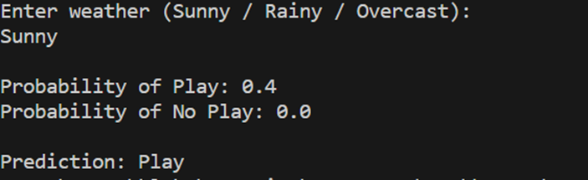

Result:
Thus, the above program is verified and executed successfully.

EX NO: 14 NAME:
DATE: REG NO:

Linear models for clustering (k-means)
Aim:
To implement a simple linear clustering program using the K-Means algorithm in Python to group data points into clusters based on their similarity.
Code:
# Simple K-Means Clustering Program
# Beginner Friendly - No Libraries Needed
# Sample Data Points (1D values)
data = [2, 4, 10, 12, 3, 20, 30, 11, 25]
# Number of clusters
k = 2
# Initial cluster centers (first two values)
c1 = data[0]
c2 = data[1]
print("Initial Centers:", c1, c2)
# Run clustering for few iterations
for step in range(5):
cluster1 = []
cluster2 = []
# Assign points to nearest center
for value in data:
if abs(value - c1) < abs(value - c2):
cluster1.append(value)
else:
cluster2.append(value)

# Update centers
if cluster1:
c1 = sum(cluster1) / len(cluster1)
if cluster2:
c2 = sum(cluster2) / len(cluster2)
print("\nStep", step + 1)
print("Cluster 1:", cluster1)
print("Cluster 2:", cluster2)
print("New Centers:", round(c1, 2), round(c2, 2))
print("\nFinal Clusters:")
print("Cluster 1:", cluster1)
print("Cluster 2:", cluster2)
Output:
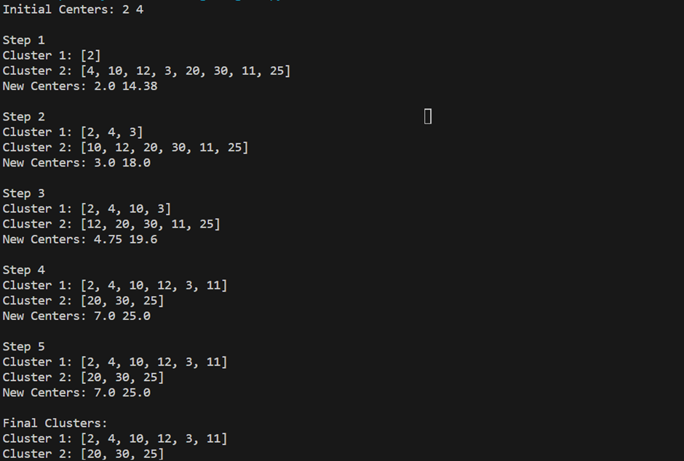
Result:
Thus, the above program is verified and executed successfully.
EX NO: 15 NAME:
DATE: REG NO:
Reinforcement learning
Aim:
To implement a simple Reinforcement Learning program in Python that trains an agent to choose actions based on rewards and penalties to learn an optimal decision-making policy.
Code:
# Simple Reinforcement Learning Program
# Agent learns by trial and error
# Possible actions
actions = ["Left", "Right"]
# Rewards for actions
rewards = {
"Left": -1, # Penalty
"Right": 1 # Reward
}
# Initialize knowledge (Q-values)
Q = {
"Left": 0,
"Right": 0
}
# Learning rate
alpha = 0.5
# Training episodes
episodes = 10
print("Training Agent...\n")
# Learning process
for i in range(episodes):
for action in actions:
# Update Q-value
Q[action] = Q[action] + alpha * (rewards[action] - Q[action])
print("Episode", i + 1, "Q-values:", Q)
# Final decision
best_action = max(Q, key=Q.get)
print("\nBest Action Learned:", best_action)

Output:
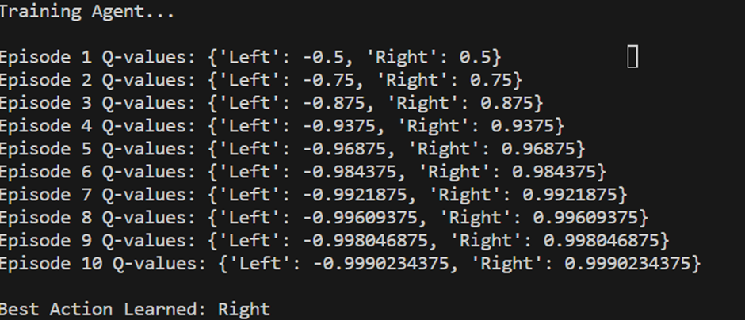

Result:
Thus, the above program is verified and executed successfully.

