Date: Name:
Roll No:
Lab 01:MQTT Publisher: Develop a program to publish sensor data (e.g., temperature, humidity) from Node MCU to an MQTT broker hosted on a cloud platform

Aim:
To write a code to publish sensor data from Node MCU to an MQTT broker hosted on a cloud platform.

Procedure:
Step 1: Start
- Initialize the program.
Step 2:Initialize Hardware
- Initialize the Serial Monitor with a baud rate of 9600 (for communication).
- Initialize the DHT22 sensor on a specified pin (Pin 19 in your case).
Step 3: Setup
- Begin Serial communication using Serial.begin(9600);.
- Initialize the DHT22 sensor with dht.begin();.
Step 4: Read Sensor Data
- In the loop:
  - Read Humidity:
    - Call dht.readHumidity() to get the current humidity value and store it in a variable h.
  - Read Temperature:
    - Call dht.readTemperature() to get the current temperature value and store it in a variable t.
Step 5: Display Data
- Print the humidity value on the Serial Monitor:
  - Print the string "HUMIDITY= ".
  - Print the value of h (humidity value).
  - Print a percentage sign (%).
  - Print a newline character (\n) to move to the next line.

- Print the temperature value on the Serial Monitor:
  - Print the string "TEMPERATURE= ".
  - Print the value of t (temperature value).
  - Print the unit (°C).
Step 6: Pause
- Wait for 500 milliseconds using delay(500); to prevent continuous spamming of data, giving the sensor time to settle.
Step 7: Repeat
- Return to step 4 and repeat the process indefinitely (as the loop is continuous).
Step 8: End
- The program continues running indefinitely until manually stopped.

Code:

#include "DHT.h" DHT dht(19,DHT22);
void setup()
{

Serial.begin(9600); dht.begin();
}
void loop()
{

}

Output:
float h = dht.readHumidity(); float t = dht.readTemperature(); Serial.print("HUMIDITY= "); Serial.print(h ); Serial.print("% \n");
Serial.print("TEMPERATURE="); Serial.print(t);
Serial.print("%*c "); delay(500);

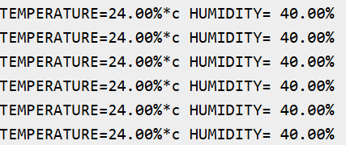

Result:
Thus the result was obtained successfully.

Date: Name:
Roll No:
Lab 02:MQTT Subscriber: Create a program to subscribe to MQTT topics on Node MCU

Aim:
To write a code to create a program to subscribe to MQTT topics on Node MCU.

Procedure:
Step 1:Start
- Initialize the program.
Step 2: Wi-Fi Connection
- Initialize the Wi-Fi connection with the SSID "Wokwi-GUEST".
- Wait for the Wi-Fi connection to be established. If the Wi-Fi is not connected, it will continue trying every 100 milliseconds (while (WiFi.status() != WL_CONNECTED) delay(100);).
Step 3: Serial Communication Setup
- Initialize Serial communication with a baud rate of 115200 for debugging and status output.
Step 4: MQTT Client Setup
- Set the MQTT server to "127.0.0.1" (localhost) on port 1883.
- Set the callback function that will handle the incoming MQTT messages.
Step 5: MQTT Callback Function
- The callback function listens to messages sent to the MQTT topic "room/light".
- If a message is received on the topic "room/light":
  - If the message content is "on", the LED (connected to pin 13) is turned ON (set HIGH).
  - If the message content is "off", the LED is turned OFF (set LOW).
Step 6: Pin Setup
- Configure pin 13 (connected to the LED) as an output pin using pinMode(led, OUTPUT);.
Step 7: Loop to Maintain Connection
- In the loop() function:

  - If the MQTT client is not connected, attempt to connect to the MQTT broker (client.connect("ESP8266")).
  - After connection, it continuously calls client.loop() to keep the connection active and handle any incoming messages.
Step 8: End
- The program runs continuously and waits for messages on the MQTT topic "room/light" to control the LED.

Code:

#include "PubSubClient.h" #include "WiFi.h"
const char* ssid = "Wokwi-GUEST", *mqtt_server = "127.0.0.1"; const int led = 13;
WiFiClient espClient; PubSubClient client(espClient); void setup() {
WiFi.begin(ssid, "");
while (WiFi.status() != WL_CONNECTED) delay(100); Serial.begin(115200);
client.setServer(mqtt_server, 1883); client.setCallback([](char* t, byte* p, unsigned int l) {
if (String(t) == "room/light") digitalWrite(led, String((char*)p) == "on" ? HIGH : LOW);
});
pinMode(led, OUTPUT);

}
void loop() {
if (!client.connected()) while (!client.connect("ESP8266")) delay(5000); client.loop();
}

Output:
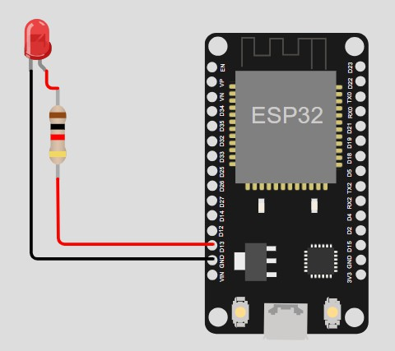

Result:
Thus the result was obtained successfully.

Date: Name:
Roll No:
Lab 3: HTTP Client: Implement an HTTP client on NodeMCU to send sensor data to a cloud-based server

Aim:
To write a code to implement an HTTP client on NodeMCU to send sensor data to a cloud-based server.

Procedure:
Step 1: Start Program
- Begin execution of the program.
Step 2: Wi-Fi Connection
- Initialize Wi-Fi: Use the provided SSID "Wokwi-GUEST" and an empty password to connect to the Wi-Fi network.
- Check Wi-Fi Status: Continuously check if the ESP device is connected to the Wi-Fi network.
  - If not connected, wait 100 milliseconds and check again until connected (WiFi.status() != WL_CONNECTED).
Step 3: Serial Communication Setup
- Initialize Serial communication at a baud rate of 115200 for debug output and status messages.
Step 4: Set MQTT Server
- Set up the MQTT client to connect to the MQTT broker located at "127.0.0.1" (localhost) on port 1883.
Step 5: Define MQTT Callback Function
- Define a callback function that will be called whenever a message is received from the MQTT broker.
- The callback checks if the received topic is "room/light".
  - If the message payload is "on", the LED on pin 13 is turned ON (HIGH).
  - If the message payload is "off", the LED on pin 13 is turned OFF (LOW).
Step 6: Set Pin Mode for LED

- Configure pin 13 as an output pin using pinMode(led, OUTPUT) so the LED can be controlled via software.
Step 7: Main Loop
- Check MQTT Connection: In the loop(), check if the MQTT client is connected. o If not connected, attempt to connect to the MQTT broker using
client.connect("ESP8266Client").
- Handle MQTT Communication: Call client.loop() to process incoming messages and maintain the MQTT connection.
Step 8: Repeat
- The process continues in the loop() function, where the device waits for MQTT messages to control the LED.
Step 9: End
- The program runs continuously and listens for MQTT messages to control the LED.

Code:

#include "PubSubClient.h" #include "WiFi.h"
const char* ssid = "Wokwi-GUEST", *mqtt_server = "127.0.0.1"; const int led = 13;
WiFiClient espClient; PubSubClient client(espClient); void setup() {
WiFi.begin(ssid, "");
while (WiFi.status() != WL_CONNECTED) delay(100); Serial.begin(115200);
client.setServer(mqtt_server, 1883); client.setCallback([](char* t, byte* p, unsigned int l) {
if (String(t) == "room/light") digitalWrite(led, String((char*)p) == "on" ? HIGH : LOW);
});
pinMode(led, OUTPUT);

}
void loop() {
if (!client.connected()) client.connect("ESP8266Client"); client.loop();
}

Output:

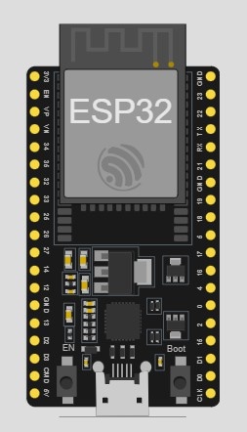

Result:
Thus the result was obtained successfully.

Date: Name:
Roll No:
Lab 04: OTA Updates: Set up Over-The-Air (OTA) firmware updates for Node MCU to enable remote updating of firmware from a cloud server without physical access.

Aim:
To write a code to set up Over-The-Air (OTA) firmware updates for Node MCU to enable remote updating of firmware from a cloud server without physical access.

Procedure:
Step 1: Start Program
- The program begins execution.
Step 2: Wi-Fi Connection
- Connect to Wi-Fi:
  - The ESP connects to a Wi-Fi network using the given SSID "Wokwi-GUEST" and an empty password.
  - It keeps trying to connect to Wi-Fi until the connection is successful. It checks the connection status every 500 milliseconds (while (WiFi.status() != WL_CONNECTED) delay(500);).
Step 3: Serial Communication
- Initialize Serial communication at a baud rate of 115200 for printing debug messages and logs.
Step 4: Wi-Fi Connection Success
- Once the Wi-Fi is connected, it prints "WiFi connected" to the Serial Monitor.
Step 5: Check for Firmware Update
- The function checkForUpdate() is called to check if a new firmware version is available.
  - Create HTTPClient Object: An HTTPClient object is created to interact with the server.
  - Request the Current Version:
    - It sends a GET request to the URL http://ota.hacker4hire.com/current_version.txt to get the latest version of the firmware.

  - Compare Versions:
    - The current version of the firmware (hardcoded as 2023092001) is compared to the version received from the server (new_version).
    - If the current version does not match the new version, it proceeds to the next step to download and install the firmware update.
Step 6: Download and Install Firmware Update
- Update Firmware:
  - The function updateFirmware() is called with the URL of the new firmware, which is dynamically constructed using the new version number: http://ota.hacker4hire.com/firmware.<new_version>.bin.
  - HTTPClient:
    - A new HTTPClient object is created to handle the download.
  - Firmware Update:
    - The httpUpdate.update(http, url) function attempts to download and install the firmware from the given URL.
  - Check Update Success:
    - If the update is successful (HTTP_UPDATE_OK), the message "Update success. Rebooting..." is printed to the Serial Monitor, and the ESP is rebooted using ESP.restart().
    - If the update fails, the message "Update failed" is printed to the Serial Monitor.
Step 7: End of setup()
- After checking and potentially updating the firmware, the setup() function ends.
Step 8: Repeat in loop()
- The loop() function is an empty loop with a delay of 10 seconds (delay(10000);).
- This allows the program to check for updates periodically (every 10 seconds) and handle any further updates if necessary.

Code:

#include <WiFi.h> #include <HTTPClient.h> #include <HTTPUpdate.h>

const char* ssid = "Wokwi-GUEST"; const char* password = "";
String version_url = "http://ota.hacker4hire.com/current_version.txt";

String firmware_url = "http://ota.hacker4hire.com/firmware"; unsigned long current_version = 2023092001, new_version = 0;

void setup() { Serial.begin(115200); WiFi.begin(ssid, password);
while (WiFi.status() != WL_CONNECTED) delay(500); Serial.println("WiFi connected");
checkForUpdate();
}

void checkForUpdate() { HTTPClient http; http.begin(version_url); if (http.GET() > 0) {
new_version = http.getString().toInt(); if (current_version != new_version) {
updateFirmware(firmware_url + "." + String(new_version) + ".bin");
}
}
http.end();
}

void updateFirmware(String url) { HTTPClient http;
if (httpUpdate.update(http, url) == HTTP_UPDATE_OK) { Serial.println("Update success. Rebooting..."); ESP.restart();
} else {
Serial.println("Update failed");
}
}

void loop() { delay(10000); } // Check for updates every 10 seconds

Output:

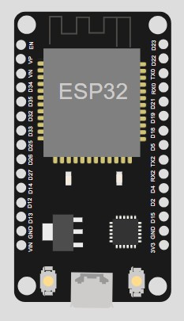

Result:
Thus the result was obtained successfully.

Date: Name:
Roll No:
Lab 5: Security Measures: Secure communication between Node MCU and cloud services using TLS/SSL encryption and implement authentication mechanisms

Aim:
To write a code to secure communication between Node MCU and cloud services using TLS/SSL encryption and implement authentication mechanisms.

Procedure:
Step 1: Start the Program
- Begin the program execution.
Step 2: Initialize Serial Communication
- Start serial communication at a baud rate of 115200 for debugging and status outputs.
Step 3: Connect to Wi-Fi
- Use the Wi-Fi credentials provided (ssid = "Wokwi-GUEST" and password = "") to connect to the Wi-Fi network.
- Continuously check the Wi-Fi connection status every 500 milliseconds.
- Once Wi-Fi is connected, print the message "Wi-Fi connected!" to the Serial Monitor.
Step 4: Set Up Secure HTTPS Client
- Create a WiFiClientSecure object called client, which will handle the secure connection to the server.
- Set the root CA certificate for the secure connection using client.setCACert(rootCACertificate). This certificate is required to verify the server's identity during the secure connection.
Step 5: Attempt to Connect to the Server
- Host & Port: The code simulates connecting to a server using host = "example.com" and port = 443 (HTTPS port).
- Connect to Server: Try to establish a secure connection with the server by calling client.connect(host, port).
  - If the connection is successful, proceed to send the HTTP request.

  - If the connection fails, print "Connection to server failed!" to the Serial Monitor.
Step 6: Send HTTP GET Request
- If the connection to the server is established, send a basic HTTP GET request to the server using the following headers:
  - GET / HTTP/1.1 — A simple GET request to the root path.
  - Host: example.com — The host header indicating the domain of the server.
  - Connection: close — Indicates that the server should close the connection after the response.
- The HTTP GET request is sent using client.println().
Step 7: Read and Print Server Response
- After sending the request, the program checks whether the client is still connected or has available data to read (client.connected() or client.available()).
- If data is available, it reads the response line by line and prints it to the Serial Monitor using client.readStringUntil('\n').
  - This simulates receiving and displaying the server's response.
Step 8: Close the Connection
- After reading the server's response, the client connection is closed by calling client.stop().
- Print "Disconnected from server." to indicate that the connection was successfully closed.
Step 9: End setup()
- Once the HTTP request is sent, the connection is closed, and the program ends the setup() function.
Step 10: Idle Loop
- The loop() function does nothing (it’s empty in this case). The program only performs actions in the setup() function.
Step 11: End
- The program ends execution after completing the setup(), since the loop() function does not perform any actions.

Code:

#include <WiFi.h>
#include <WiFiClientSecure.h>

// Wi-Fi credentials
const char* ssid = "Wokwi-GUEST"; // Default Wi-Fi for Wokwi const char* password = ""; // No password for Wokwi Wi-Fi

// Simulated server and certificate
const char* host = "example.com"; // Dummy host for simulation const int port = 443; // HTTPS port
const char* rootCACertificate = \
"-----BEGIN CERTIFICATE \n" \
"...Your CA Certificate. \n" \
"-----END CERTIFICATE ";

WiFiClientSecure client;

void setup() { Serial.begin(115200);
Serial.println("Connecting to Wi-Fi. ");

// Connect to Wokwi simulated Wi-Fi WiFi.begin(ssid, password);
while (WiFi.status() != WL_CONNECTED) { delay(500);
Serial.print(".");
}
Serial.println("\nWi-Fi connected!");

// Simulate secure connection client.setCACert(rootCACertificate); Serial.println("Attempting to connect to server..."); if (client.connect(host, port)) { Serial.println("Connected to server!");
client.println("GET / HTTP/1.1\r\nHost: example.com\r\nConnection: close\r\n\r\n");
while (client.connected() || client.available()) { if (client.available()) {
Serial.println(client.readStringUntil('\n')); // Simulated server response
}
}
client.stop();
Serial.println("Disconnected from server.");
} else {
Serial.println("Connection to server failed!");
}
}

void loop() {
// No action in loop
}

Output:

Result:
Thus the result was obtained successfully.

Date: Name:
Roll No:
Lab 6: Cloud-triggered Actions: Create a program on NodeMCU to perform specific actions (e.g., turn on/off an LED) based on commands received from a cloud-based IoT platform.

Aim:
To write a code to create a program on NodeMCU to perform specific actions (e.g., turn on/off an LED) based on commands received from a cloud-based IoT platform.

Procedure:
Step 1: Initialize LED pin
- Define the LED pin number as 4 (pin 4 on the microcontroller).
- In the setup() function, configure pin 4 as an output pin using the pinMode() function. This prepares the pin to control the LED.
Step 2: Start the main loop
- Enter the loop() function, which will continuously run as long as the program is active.
Step 3: Turn the LED OFF
- Use the digitalWrite() function to set the LED pin (pin 4) to HIGH.
- The LED will be OFF because the ESP8266 uses an active-low configuration (i.e., the LED turns on when the voltage is LOW, and turns off when the voltage is HIGH).
Step 4: Wait for 1 second
- Use the delay(1000) function to pause for 1000 milliseconds (1 second).
Step 5: Turn the LED ON
- Use the digitalWrite() function again to set the LED pin to LOW.
- The LED will be ON because the ESP8266 is using an active-low configuration.
Step 6: Wait for 1 second
- Use the delay(1000) function again to pause for 1 second.
Step 7: Repeat the cycle
- The loop() function will repeat steps 3-6 indefinitely, continuously turning the LED on and off every second.

Code:

#define LED 4 void setup() {
pinMode(LED, OUTPUT); // LED pin as output.
}
void loop() {
digitalWrite(LED, HIGH);// turn the LED off.(Note that LOW is the voltage level but actually

//the LED is on; this is because it is acive low on the ESP8266. delay(1000); // wait for 1 second.
digitalWrite(LED, LOW); // turn the LED on. delay(1000); // wait for 1 second.
}

Output:
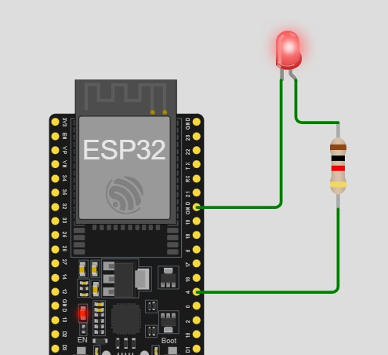

Result:
Thus the result was obtained successfully.

Date: Name:
Roll No:
Lab 07: Real-time Data Streaming: Develop a program to stream real-time sensor data from Node MCU to a cloud-based database (e.g., Firebase Real time Database, AWS Dynamo DB).

Aim:
To write a code to develop a program to stream real-time sensor data from Node MCU to a cloud-based database (e.g., Firebase Real time Database, AWS Dynamo DB).

Procedure:
Step 1: Start the Serial Communication
- In the setup() function, initialize serial communication by calling Serial.begin(115200);.
  - This establishes communication between the Arduino board and the Serial Monitor at a baud rate of 115200, allowing data to be sent and received.
Step 2: Begin the main loop
- Enter the loop() function, which will continuously run as long as the program is active.
Step 3: Read sensor data
- Use the analogRead(A0) function to read the analog value from pin A0 (which simulates a sensor). This function returns an integer value between 0 and 1023, corresponding to the voltage level on that pin.
  - The value is stored in the variable sensorData.
Step 4: Send the data to the Serial Monitor
- Use Serial.print("Sensor Data: "); to send the label "Sensor Data: " to the Serial Monitor.
- Then, use Serial.println(sensorData); to send the actual sensor data value (sensorData) to the Serial Monitor.
  - This will print the sensor reading to the Serial Monitor in a new line.
Step 5: Wait for 2 seconds
- Use the delay(2000); function to pause for 2000 milliseconds (2 seconds).
  - This means the next reading will be sent after a 2-second delay.

Step 6: Repeat the cycle
- The loop() function will continue to repeat, taking a new reading from the sensor every 2 seconds and printing it to the Serial Monitor.

Code:
void setup() {
Serial.begin(115200); // Start Serial Monitor
}

void loop() {
int sensorData = analogRead(A0); // Simulated Sensor Data Serial.print("Sensor Data: ");
Serial.println(sensorData);

delay(2000); // Send data every 2 seconds
}

Output;
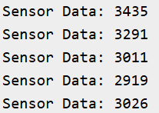

Result:
Thus the result was obtained successfully.

Date: Name:
Roll No:
Lab 08: Data Visualization: Interface Node MCU with a cloud-based data visualization platform (e.g., Thing Speak, Grafana) to visualize sensor data in real-time.

Aim:
To write a code for interface Node MCU with a cloud-based data visualization platform (e.g., Thing Speak, Grafana) to visualize sensor data in real-time.

Procedure:
Step 1: Start Serial Communication
- In the setup() function, initialize serial communication by calling Serial.begin(115200);.
  - This establishes communication between the Arduino and the Serial Monitor with a baud rate of 115200, enabling data transfer.
Step 2: Enter the main loop
- Enter the loop() function, which will execute repeatedly as long as the program is running.
Step 3: Read sensor data
- Use analogRead(A0) to read the analog value from pin A0, which simulates a sensor input (such as a potentiometer connected to A0).
- The function returns an integer value between 0 and 1023, where 0 represents 0V and 1023 represents 3.3V (assuming the board is running at 3.3V logic). This value is stored in the sensorValue variable.
Step 4: Convert the sensor value to voltage
- Convert the raw sensorValue into a corresponding voltage using the formula:
- float voltage = sensorValue * (3.3 / 1023.0);
- This formula scales the sensor value (0-1023) to a voltage range of 0 to 3.3V.
- The result is stored in the voltage variable as a floating-point number.
Step 5: Print the sensor value to the Serial Monitor
- Use Serial.print("Sensor Value: "); to print the label "Sensor Value: " to the Serial Monitor.

- Use Serial.println(sensorValue); to print the actual sensorValue to the Serial Monitor, followed by a newline.
Step 6: Print the voltage to the Serial Monitor
- Use Serial.print("Voltage: "); to print the label "Voltage: " to the Serial Monitor.
- Use Serial.println(voltage); to print the calculated voltage to the Serial Monitor, followed by a newline.
Step 7: Wait for 2 seconds
- Use delay(2000); to pause for 2000 milliseconds (or 2 seconds). This prevents continuous printing, ensuring that the sensor data is updated every 2 seconds.
Step 8:Repeat the cycle
- The loop() function will repeat from step 3, continuously reading sensor data, converting it to voltage, and printing the values to the Serial Monitor every 2 seconds.

Code:
void setup() {
Serial.begin(115200); // Start Serial Monitor
}

on A0)
void loop() {
// Simulating sensor data
int sensorValue = analogRead(A0); // Read simulated sensor data (e.g., potentiometer float voltage = sensorValue * (3.3 / 1023.0); // Convert to voltage

// Print the sensor data and voltage to the Serial Monitor Serial.print("Sensor Value: "); Serial.println(sensorValue);
Serial.print("Voltage: "); Serial.println(voltage);

delay(2000); // Wait for 2 seconds before the next reading
}

Output:
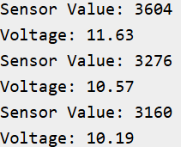

Result:
Thus the result was obtained successfully.

Date: Name:
Roll No:
Lab 9: Device Shadowing: Implement device shadowing functionality on NodeMCU to synchronize device states and configurations with a cloud-based IoT platform.

Aim:
To write a code to implement device shadowing functionality on NodeMCU to synchronize device states and configurations with a cloud-based IoT platform.

Procedure:
Step 1: Define Device State
- At the beginning of the program, a boolean variable deviceState is defined and initialized to false, representing the initial state of the device (i.e., the device is OFF).
Step 2: Start Serial Communication
- In the setup() function:
  - Initialize serial communication using Serial.begin(115200); to enable communication with the Serial Monitor at a baud rate of 115200.
  - Print the message "Device Shadow Simulation Started" to the Serial Monitor using Serial.println("Device Shadow Simulation Started");.
  - Call the printDeviceState() function to print the initial state of the device (which is OFF).
Steep 3: Main Loop (Simulate Device Shadow Update)
- Enter the loop() function, which will run continuously.
- Wait for 5 seconds:
  - Call delay(5000); to wait for 5 seconds, simulating an update interval for the device's shadow state.
- Toggle Device State:
  - Change the deviceState by negating it: deviceState = !deviceState;. This toggles the state between true (ON) and false (OFF).
- Simulate Sending Device State to Cloud (Update Device Shadow):
  - Call the updateDeviceShadow(deviceState) function, which simulates sending the device state (ON or OFF) to the cloud.

  - The current value of deviceState (ON or OFF) is passed as a parameter to the function.
- Print Current Device State:
  - Call the printDeviceState() function again to print the updated device state to the Serial Monitor.
Step 4: Update Device Shadow (Simulated Cloud Update)
- The updateDeviceShadow() function:
  - Takes a boolean parameter state that represents the device state (either true or false).
  - Prints a message "Updating shadow to: ON" if the state is true, or "Updating shadow to: OFF" if the state is false.
  - This simulates the action of sending the device state update to the cloud.
Step 5: Print Current Device State
- The printDeviceState() function:
  - Prints "Current Device State: ON" if deviceState is true, and "Current Device State: OFF" if deviceState is false.
Step 6: Repeat the Process
- After 5 seconds, the loop() function repeats, toggling the device state again, updating the simulated shadow (sending to cloud), and printing the updated state.

Code:
bool deviceState = false; // Simulating device state (light ON/OFF) void setup() {
Serial.begin(115200); // Start Serial Monitor Serial.println("Device Shadow Simulation Started"); printDeviceState(); // Print initial state

}

void loop() {
delay(5000); // Wait for 5 seconds (simulating shadow update interval)

deviceState = !deviceState; // Toggle device state (ON/OFF) updateDeviceShadow(deviceState); // Simulate sending state to cloud printDeviceState(); // Print current state
}

// Function to simulate sending device shadow update

void updateDeviceShadow(bool state) { Serial.print("Updating shadow to: "); Serial.println(state ? "ON" : "OFF");
}

// Function to print current device state void printDeviceState() { Serial.print("Current Device State: ");
Serial.println(deviceState ? "ON" : "OFF");
}

Output:
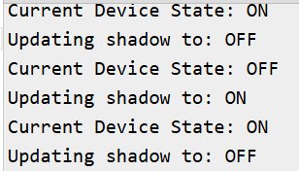

Result:
Thus the result was obtained successfully.

Date: Name:
Roll No:
Lab 10: Integration with IoT Platforms: Integrate Node MCU with popular cloud-based IoT platforms (e.g., AWS IoT, Google Cloud IoT Core) to leverage their services for IoT applications.

Aim:
To write a code to Integrate Node MCU with popular cloud-based IoT platforms (e.g., AWS IoT, Google Cloud IoT Core) to leverage their services for IoT applications.

Procedure:
Step 1: Import Necessary Libraries
- Import the random library to generate random numbers that simulate sensor data.
- Import the time library to control the time interval between sensor data readings.
Step 2: Define the log_sensor_data() Function
- Inside this function, an infinite loop (while True) is created to repeatedly simulate and print sensor data.
  - The loop will keep running indefinitely, mimicking the continuous monitoring of a sensor.
Step 3: Generate Simulated Sensor Data
- In each iteration of the loop, the random.randint(50, 100) function is used to generate a random integer between 50 and 100. This simulates the sensor value reading, where the value could be anywhere in this range.
- The generated value is stored in the variable sensor_value.
Step 4: Print the Sensor Data
- The print() function is used to print the message "Sensor Data: {sensor_value}" to the console.
- The {sensor_value} is replaced by the actual generated value, making the output appear as "Sensor Data: <random_value>" each time.
Step 5: Wait for 5 Seconds
- The time.sleep(5) function pauses the execution of the program for 5 seconds before generating and printing the next simulated sensor value.
- This ensures that the data is printed at a frequency of every 5 seconds.

Step 6: Repeat the Process
- The loop (while True) will repeat this process indefinitely. After 5 seconds, a new random sensor value is generated, printed, and the cycle continues.

Code:
import random import time
# Simulated Sensor Data Printing def log_sensor_data():
while True:
sensor_value = random.randint(50, 100) # Simulated sensor value print(f"Sensor Data: {sensor_value}")

time.sleep(5) # Adjust frequency

# Start Logging Sensor Data (printing instead of saving to a file) log_sensor_data()

Output:

Sensor Data: 79
Sensor Data: 85
Sensor Data: 67
Sensor Data: 92

Result:

Thus the result was obtained successfully.

Date: Name:
Roll No:
Lab 11: MQTT Publisher: Develop a Python script on Raspberry Pi to publish data from sensors connected to GPIO pins to an MQTT broker hosted on a cloud platform

Aim:
To write a code to develop a Python script on Raspberry Pi to publish data from sensors connected to GPIO pins to an MQTT broker hosted on a cloud platform.

Procedure:
Step 1: Import Necessary Libraries
- json is imported to convert data to a JSON format, which is commonly used in IoT applications.
- time is imported to manage delays between sensor data publishing.
- random is imported to generate random sensor values for simulation.
Step 2: Define the publish_sensor_data() Function
- This function simulates the publishing of sensor data to an MQTT broker. It will send 5 messages, each containing a randomly generated sensor value.
Step 3: Loop to Simulate Sending 5 Messages
- The function uses a for _ in range(5) loop to simulate publishing 5 sensor messages. The loop will run 5 times, sending 5 separate sensor data points.
Step 4: Generate Simulated Sensor Data
- Inside the loop, the random.randint(50, 100) function is used to generate a random integer between 50 and 100, which simulates a sensor reading.
- The generated sensor value is stored in the variable sensor_value.
Step 5: Create Data Dictionary
- A dictionary data = {"value": sensor_value} is created, where the key "value" stores the generated sensor value. This dictionary simulates the structure of the data being sent (e.g., to an MQTT broker).
Step 6: Simulate Publishing to MQTT Broker
- The print(f"Publishing Sensor Data: {json.dumps(data)}") line simulates publishing the data (sensor value) as a JSON string.
  - The json.dumps(data) function converts the data dictionary into a JSON-formatted string.

  - The resulting JSON string is printed to the console, simulating the publishing of data to an MQTT broker.
Step 7: Wait for 3 Seconds
- The time.sleep(3) function pauses the program for 3 seconds before sending the next message.
  - This simulates the delay between sending sensor data, mimicking the time it might take for the sensor to collect new data or for the data to be sent to the broker.
Step 8: Repeat for 5 Messages
- Steps 4–7 repeat 5 times, simulating the sending of 5 messages with sensor data.
Step 9: End of Function
- After 5 iterations, the function publish_sensor_data() finishes, and the program ends.

Code:
import json import time import random

# Simulated MQTT Publish Function def publish_sensor_data():
for _ in range(5): # Simulate sending 5 messages
sensor_value = random.randint(50, 100) # Generate random sensor value data = {"value": sensor_value}

# Simulate publishing to an MQTT broker print(f"Publishing Sensor Data: {json.dumps(data)}")

time.sleep(3) # Simulate delay

publish_sensor_data()

Output:

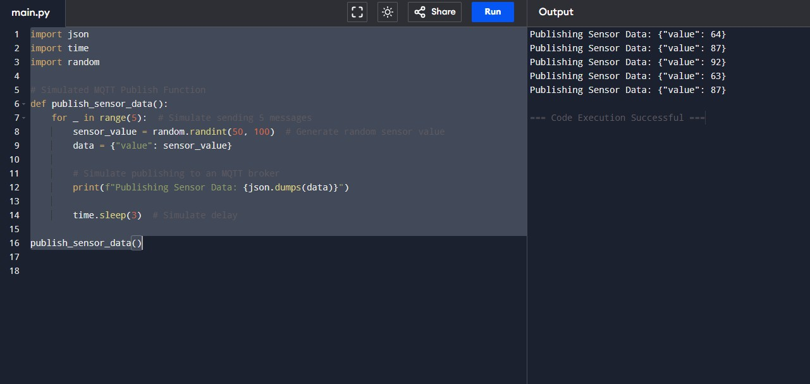

Result:
Thus the result was obtained successfully.

Date: Name:
Roll No:
Lab 12: MQTT Subscriber: Create a Python script to subscribe to MQTT topics on Raspberry Pi and take actions based on messages received from a cloud-based MQTT broker.

Aim:
To write a code to create a Python script to subscribe to MQTT topics on Raspberry Pi and take actions based on messages received from a cloud-based MQTT broker.

Procedure:
Step 1: Initialize Sensor Data
- Create a list called sensor_data, which contains dictionaries representing sensor readings. Each dictionary has a value key representing the sensor's measurement.
Step 2: Set the Alert Threshold
- Define a constant called ALERT_THRESHOLD and assign it a value of 75. This value will act as the threshold, and any sensor value exceeding this threshold will trigger an alert.
Step 3: Start Data Processing Loop
- Start a loop that will iterate over the sensor_data list, one item at a time. Each item represents a sensor reading (a dictionary containing the key value).
Step 4: Extract the Sensor Value
- Inside the loop, for each sensor reading, extract the value associated with the value key in the dictionary and store it in the variable sensor_value.
Step 5: Print the Sensor Value
- Print the sensor value to indicate that the sensor reading has been received and is being processed.
Step 6: Check for Threshold Exceedance
- Compare the sensor_value with the predefined ALERT_THRESHOLD (75).
  - If the sensor_value is greater than the threshold, print a message: "Threshold exceeded! Alert!"
  - If the sensor_value is less than or equal to the threshold, no alert is triggered, and nothing additional happens.
Step 7: Simulate Message Delay

- Add a 2-second delay using time.sleep(2) to simulate the time between receiving sensor readings. This allows you to process the data step by step, simulating the reception of messages over time.
Step 8: Repeat for All Sensor Data
- Continue the loop, processing each sensor value one at a time. If any sensor value exceeds the threshold, an alert will be printed.
Step 9: End of Process
- The loop finishes once all sensor data has been processed. The algorithm stops here.

Code:
import json import time

# Simulated Sensor Data sensor_data = [
{"value": 65},
{"value": 80}, # Exceeds threshold
{"value": 70},
{"value": 90} # Exceeds threshold
]

ALERT_THRESHOLD = 75 # Adjust as needed

# Simulate receiving messages for data in sensor_data:
sensor_value = data["value"]
print(f"Received Sensor Data: {sensor_value}")

if sensor_value > ALERT_THRESHOLD: print("Threshold exceeded! Alert!")

time.sleep(2) # Simulate message delay

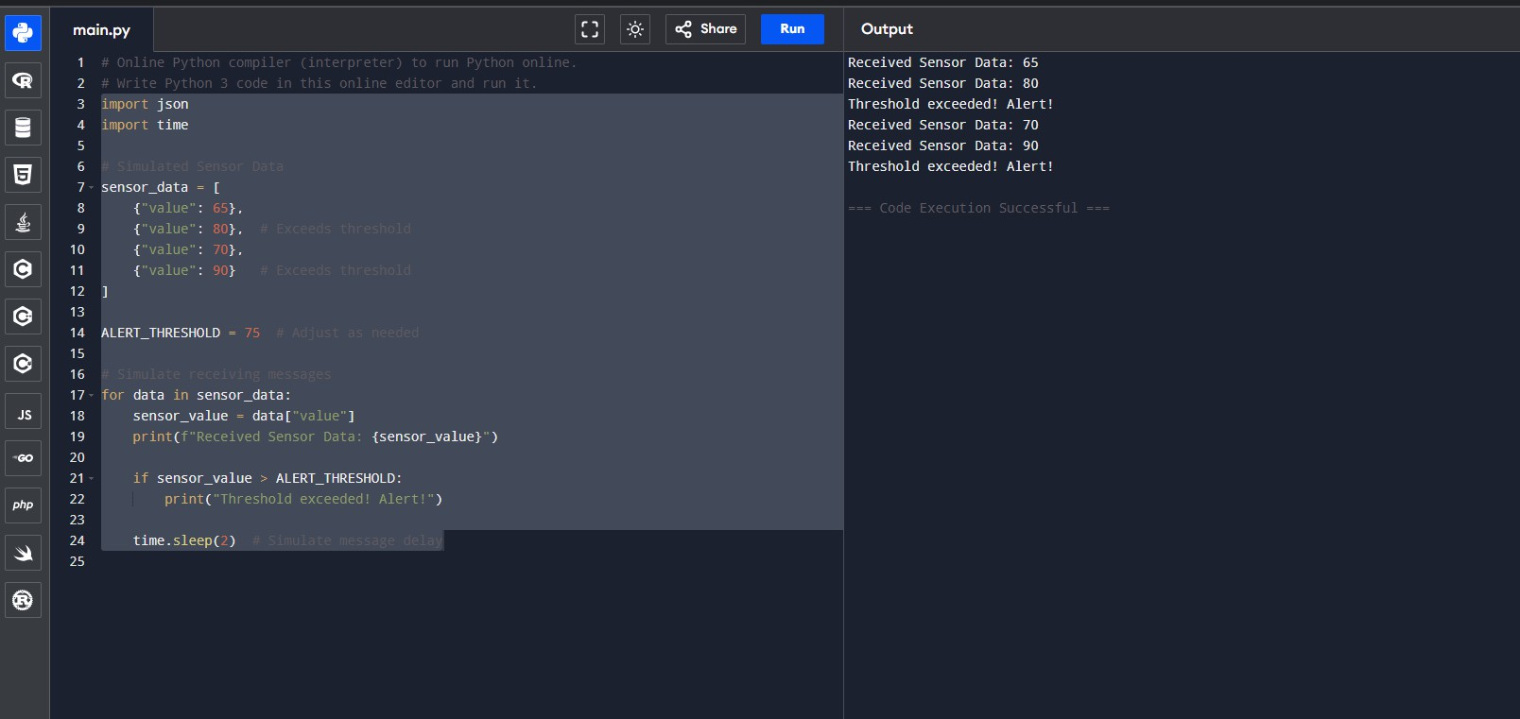
Output:

Result:
Thus the result was obtained successfully.

Date: Name:
Roll No:
Lab 13: HTTP Server: Implement an HTTP server on Raspberry Pi to receive sensor data from Node MCU or other IoT devices and store it in a cloud-based database.

Aim:
To write a code to implement an HTTP server on Raspberry Pi to receive sensor data from Node MCU or other IoT devices and store it in a cloud-based database.

Procedure:
Step 1: Simulate Incoming Sensor Data
- A string sensor_data is created, simulating the incoming data in JSON format (as if received from an HTTP POST request). The JSON string contains a key "value" with the value 85, representing the sensor reading.
Step 2: Parse the JSON Data
- Use the json.loads() method to parse the JSON string into a Python dictionary. This converts the string into a structure that can be easily accessed and manipulated.
Step 3: Extract the Sensor Value
- Extract the value associated with the key "value" from the parsed JSON data using the
.get() method. The .get() method ensures that if the key doesn't exist, it will return 0 (the default value), preventing any errors.
Step 4: Print the Sensor Data
- Print the extracted sensor value to simulate receiving the sensor data and outputting it for monitoring purposes.
Step 5: Check for Threshold Exceedance
- Compare the extracted sensor_value with a predefined threshold (75).
  - If the sensor_value is greater than 75, print a message indicating that the threshold has been exceeded and an alert should be triggered.
  - If the sensor_value is less than or equal to 75, print a message indicating that the sensor data is within the safe range.
Step 6: End the Process

- The algorithm finishes after checking the threshold and printing the appropriate messages.

Code:
import json
# Simulated incoming sensor data (as if received from a POST request) sensor_data = '{"value": 85}'
# Parse JSON data
data = json.loads(sensor_data) sensor_value = data.get("value", 0)

# Process the data
print(f"Received Sensor Data: {sensor_value}")

if sensor_value > 75:
print("Threshold exceeded! Alert!") else:
print("Sensor data within safe range.")

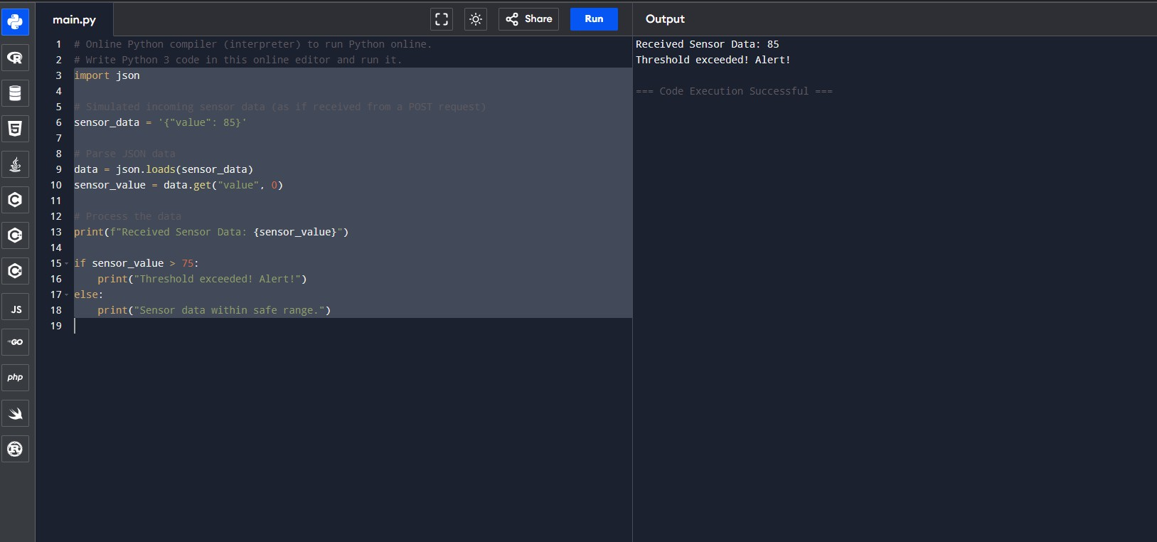
Output:

Result:
Thus the result was obtained successfully.
Date: Name:
Roll No:
Lab 14: Data Logging to Cloud Storage: Write a Python script to log sensor data (e.g., temperature, humidity) from Raspberry Pi to a cloud-based storage service (e.g., Google Cloud Storage, AWS S3).

Aim:
To write a code to log sensor data (e.g., temperature, humidity) from Raspberry Pi to a cloud-based storage service (e.g., Google Cloud Storage, AWS S3).

Procedure:
Step 1: Simulate Sensor Data Generation
- Define a function get_sensor_data() that simulates receiving sensor data. It generates a random integer between 50 and 100, which represents the sensor value.
Step 2: Set the Alert Threshold
- Define a constant ALERT_THRESHOLD with a value of 75. This is the threshold that determines whether the sensor value is considered too high.
Step 3: Run for a Fixed Number of Iterations
- Use a for loop to repeat the process 10 times. This will simulate receiving 10 sensor readings.
Step 4: Get Sensor Data
- Inside the loop, call the get_sensor_data() function to generate a new sensor reading. The result is stored in the data variable (which is a dictionary containing a value key).
Step 5: Extract Sensor Value
- Extract the actual sensor value from the dictionary with data["value"] and store it in the sensor_value variable.
Step 6: Print Received Sensor Data
- Print the received sensor value to simulate monitoring the sensor data in real time.
Step 7: Check if Sensor Value Exceeds the Threshold
- Compare the sensor_value to the ALERT_THRESHOLD (75).

  - If the sensor_value is greater than the threshold, print "Threshold exceeded!
Alert!" to notify that the sensor reading is too high.
  - If the sensor_value is less than or equal to 75, no alert is printed, and the process moves on.
Step 8: Simulate Delay Between Readings
- Use time.sleep(3) to introduce a 3-second delay before the next iteration. This simulates the time delay between receiving consecutive sensor readings.
Step 9: Repeat for 10 Iterations
- The loop will repeat 10 times, processing 10 sensor readings, each time checking if the sensor value exceeds the threshold and printing appropriate messages.
Step 10: End the Process
- After the 10 iterations, the program ends.

Code:
import json import time import random

# Simulated Sensor Data Function def get_sensor_data():
return {"value": random.randint(50, 100)} # Simulating a sensor

# Alert Threshold ALERT_THRESHOLD = 75

# Run for a fixed time
for _ in range(10): # Runs 10 times data = get_sensor_data() sensor_value = data["value"]

print(f"Received Sensor Data: {sensor_value}")

if sensor_value > ALERT_THRESHOLD: print("Threshold exceeded! Alert!")

time.sleep(3) # Simulate delay between readings

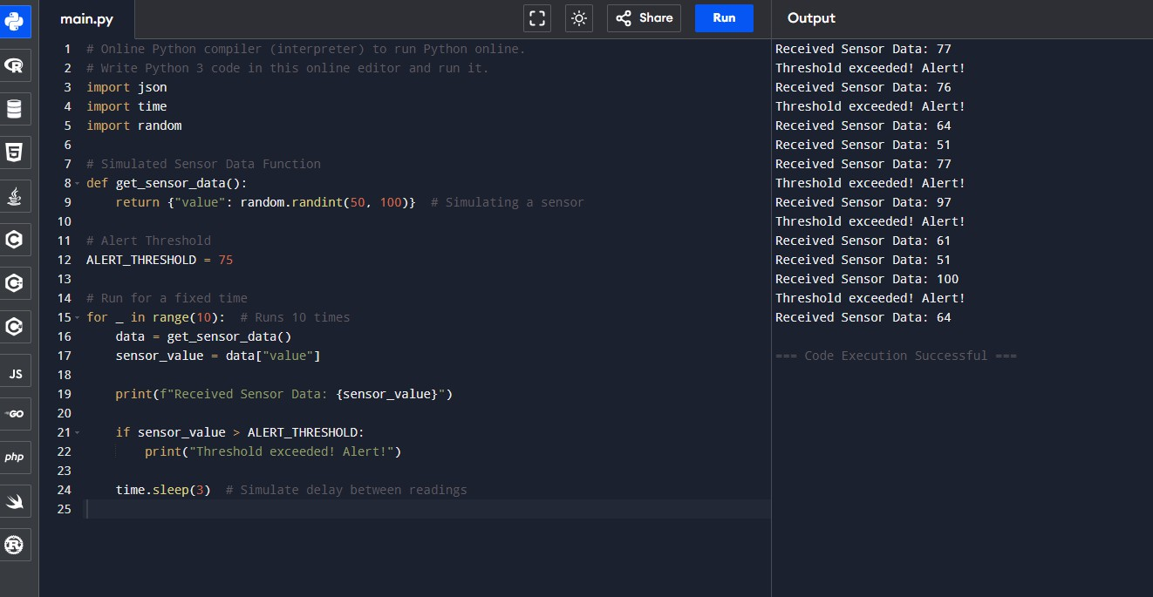
Output:

Result:
Thus the result was obtained successfully.

Date: Name:
Roll No:
Lab 15: Real-time Data Analytics: Develop a Python script to perform real-time analytics on sensor data received from Node MCU or other devices and send alerts or notifications based on predefined thresholds.

Aim:
To write a code to perform real-time analytics on sensor data received from Node MCU or other devices and send alerts or notifications based on predefined thresholds.

Procedure:
Step 1: Simulate Sensor Data Generation
- Define a function get_sensor_data() that simulates a sensor reading. The function returns a dictionary with a key "value", where the value is a random integer between 50 and 100. This mimics the variation in sensor readings.
Step 2: Set the Alert Threshold
- Define a constant ALERT_THRESHOLD and assign it a value of 75. This threshold will be used to determine whether the sensor data is considered too high and should trigger an alert.
Step 3: Start a Loop for Fixed Iterations
- Use a for loop to repeat the process 10 times (as specified by the range 10). This simulates 10 sensor readings.
Step 4: Simulate Receiving Sensor Data
- In each iteration of the loop, call the function get_sensor_data() to simulate receiving sensor data. The returned dictionary is stored in the variable data.
Step 5: Extract the Sensor Value
- From the data dictionary, extract the sensor value by accessing the "value" key (data["value"]) and store it in the variable sensor_value.
Step 6: Print the Received Sensor Data
- Print the sensor value to the console to show the received data (this simulates monitoring the sensor output).
Step 7: Check if the Sensor Value Exceeds the Threshold
- Compare the sensor_value with the ALERT_THRESHOLD (75):

  - If the sensor_value is greater than 75, print "Threshold exceeded! Alert!" to notify that the sensor value is too high.
  - If the sensor_value is less than or equal to 75, no alert is triggered, and the program proceeds without printing an alert.
Step 8: Simulate a Delay Between Readings
- Call time.sleep(3) to simulate a 3-second delay between each sensor reading. This represents the time it might take to receive new data or simulate the process of polling sensors periodically.
Step 9: Repeat the Process for 10 Iterations
- The loop will execute 10 times, processing 10 sensor readings and checking whether each reading exceeds the threshold.
Step 10: End the Program
- Once all 10 iterations are completed, the program finishes.

Code:
import json import time import random

# Simulated Sensor Data Function def get_sensor_data():
return {"value": random.randint(50, 100)} # Simulating a sensor

# Alert Threshold ALERT_THRESHOLD = 75

# Run for a fixed time
for _ in range(10): # Runs 10 times data = get_sensor_data() sensor_value = data["value"]

print(f"Received Sensor Data: {sensor_value}")

if sensor_value > ALERT_THRESHOLD: print("Threshold exceeded! Alert!")

time.sleep(3) # Simulate delay between readings

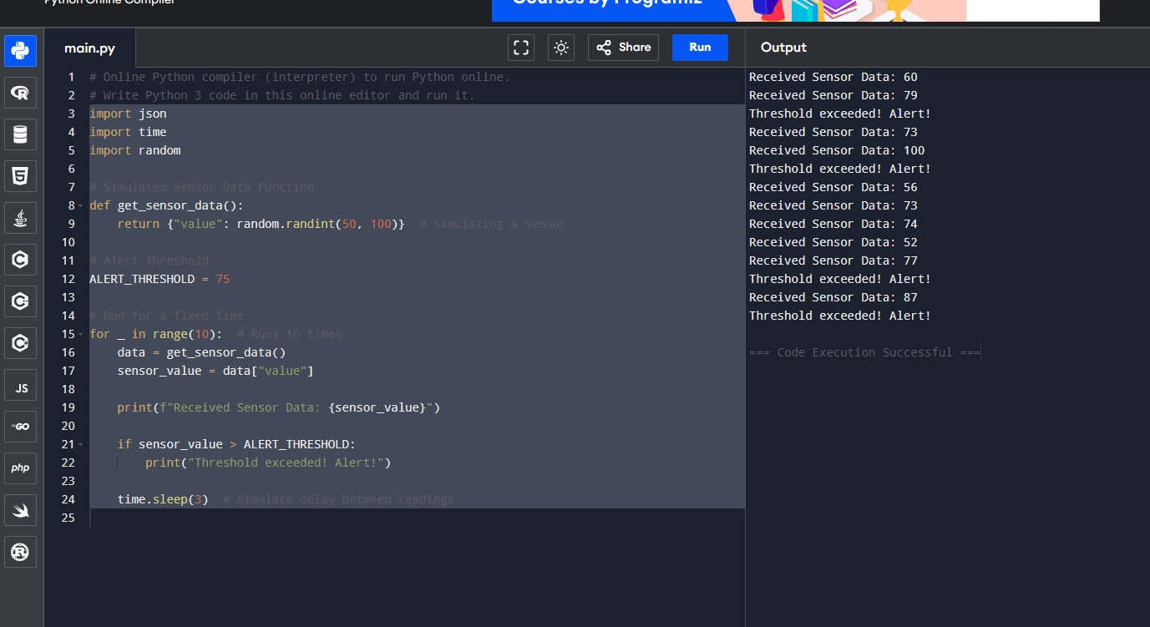
Output:

Result:
Thus the result was obtained successfully.

