

SRM INSTITUTE OF SCIENCE AND TECHNOLOGY
Ramapuram, Chennai FACULTY OF SCIENCE AND HUMANITIES

PG Department of Computer Applications

PRACTICAL RECORD

NAME :

REGISTER NO. :

COURSE : M.C.A

SEMESTER / YEAR : II / I

SUBJECT CODE : PGI25D05J

SUBJECT NAME : Generative AI and Large Language Models

APRIL 2026


SRM INSTITUTE OF SCIENCE AND TECHNOLOGY
Ramapuram, Chennai
FACULTY OF SCIENCE AND HUMANITIES

PG Department of Computer Applications

BONAFIDE CERTIFICATE

This is to certify that the bonafide record work is done by in

the subject Generative AI and Large Language Models [PGI25D05J] at SRM Institute of Science and Technology, Ramapuram, Chennai in April 2026.

STAFF IN CHARGE HEAD OF THE DEPARTMENT

Submitted for the University Practical Examination held at SRM Institute of Science and Technology, Ramapuram, Chennai, on .

INTERNAL EXAMINER 1 INTERNAL EXAMINER 2

INDEX

SL NO: | DATE | TITLE | PAGE NO: | SIGNATURE OF THE FACULTY
1 | 09-12-25 | Python Programs for AI-Powered Content Creation | 3
2 | 16-12-25 | Python program to build a simple customer support system using Generative AI | 5
3 | 16-12-25 | Python program to explore the key components of LangChain with LLMs | 7
4 | 23-12-25 | Python program to understand retrieval and vector-based search using LangChain | 10
5 | 23-12-25 | Python Program to Demonstrate three types of retrievers using LangChain. | 12
6 | 13-01-26 | Python Program for Combined Memory System | 15
7 | 13-01-26 | Python Program to  write code and execute Using LLM | 18
8 | 20-01-26 | Python Program to Automate EDA with Generative AI | 20
9 | 20-01-26 | Python program to cover the core stages of data science pipeline using a dataset | 23
10 | 03-02-26 | Implement LLM Terminology using Python Program | 26
11 | 03-02-26 | Python Program to deploy LLM as an API with FastAPI | 28
12 | 10-02-26 | Python program using LangSmith and PromptWatch | 30
13 | 17-02-26 | Python Program to Explore the Current State of Generative AI | 33
14 | 17-02-26 | Python Program for Economic Consequences and Impact on Creative Industries & Advertising | 35
15 | 10-03-26 | Python Program for Misinformation Detection and Cybersecurity | 37

Register No:
Date: Name:

EX 1 : Text generation using Gen AI
# Install required libraries first (run in terminal):
# pip install torch transformers from transformers import pipeline def offline_text_generation():
# Load a small, efficient model locally
generator = pipeline("text-generation", model="gpt2") # Prompt for generation
prompt = "artificial intelligence" # Generate text
output = generator(prompt, max_length=100, num_return_sequences=1) print("Generated Text:\n")
print(output[0]['generated_text']) if name == " main ":
offline_text_generation()

Output:

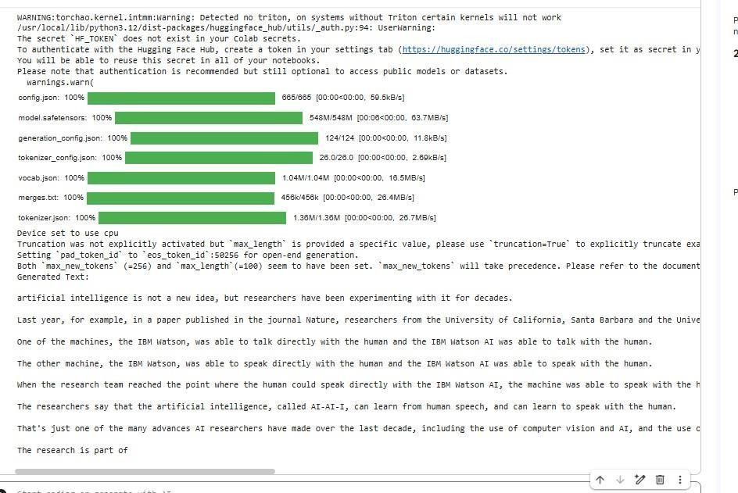

Register No:
Date: Name:

EX 2: Customer service chatbot

def simple_service_chatbot():
print("Hello! Welcome to our service. How can I help you today?") while True:
user_input = input("You: ").lower()
if "hello" in user_input or "hi" in user_input:
print("Bot: Hi there! How can I assist you with our services?")
elif "product" in user_input and ("information" in user_input or "details" in user_input):
print("Bot: We offer various products. Could you specify product you're interested in
?")
elif "support" in user_input or "issue" in user_input:
print("Bot: I can connect you to a support agent. Please provide your contact
number.”)
elif "hours" in user_input or "open" in user_input:
print("Bot: Our service hours are Monday to Friday, 9 AM to 5 PM.") elif "contact" in user_input:
print("Bot: You can reach us at service@example.com or call us at 1-800-SERVICE.") elif "thank" in user_input:
print("Bot: You're welcome! Is there anything else?") elif "bye" in user_input or "exit" in user_input:
print("Bot: Goodbye! Thank you for using our service.") break
else:
print("Bot: I'm sorry, I didn't quite understand. Can you please ask a different question?")
# To run the chatbot, simply call the function: simple_service_chatbot()

Output:

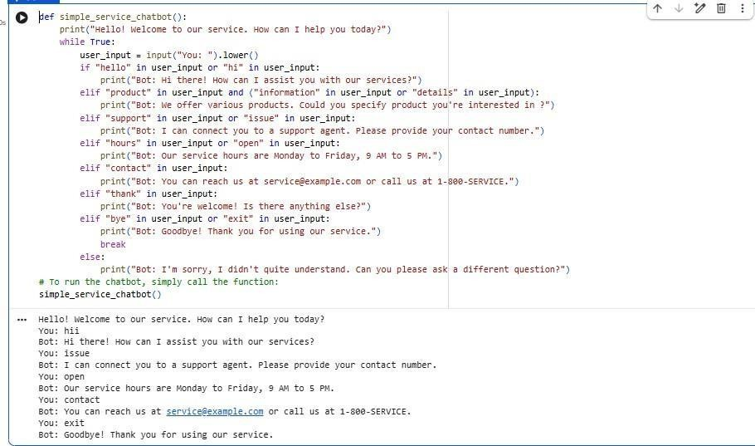

Register No:
Date: Name:

EX 3: Key components of LangChain
!pip install -q langchain langchain-community
from langchain_core.prompts import PromptTemplate
from langchain_core.output_parsers import StrOutputParser from langchain_community.llms import FakeListLLM
from langchain_core.runnables import RunnablePassthrough # 1. Fake LLM
llm = FakeListLLM( responses=[
"LangChain is a framework for building applications using Large Language Models.", "Its main components are PromptTemplate, Models, Chains, Memory, and Agents."
])
# 2. Prompt Template prompt = PromptTemplate( input_variables=["topic"],
template="Explain {topic} in simple terms."
)
# 3. Output Parser
parser = StrOutputParser()
# 4. Runnable Chain (NEW WAY) chain = (
{"topic": RunnablePassthrough()}
| prompt
| llm
| parser
)
# 5. Run the Chain

print("Response 1:") print(chain.invoke("LangChain")) print("\nResponse 2:") print(chain.invoke("LangChain components"))

Output:
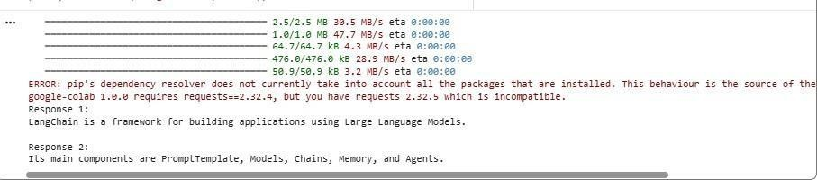

Register No:
Date: Name:

EX 4 :Retrieval using vector based LangChain

get_ipython().system('pip install -qU langchain-community sentence-transformers faiss-cpu') from langchain_community.vectorstores import FAISS
from langchain_community.embeddings import HuggingFaceEmbeddings

emb = HuggingFaceEmbeddings()
docs = ["AI is transforming the world.", "Python is great for ML.", "LangChain supports vector search."]
vs = FAISS.from_texts(docs, emb)
query = "machine learning with python" results = vs.similarity_search(query, k=2)

for r in results: print(r.page_content)

Output:

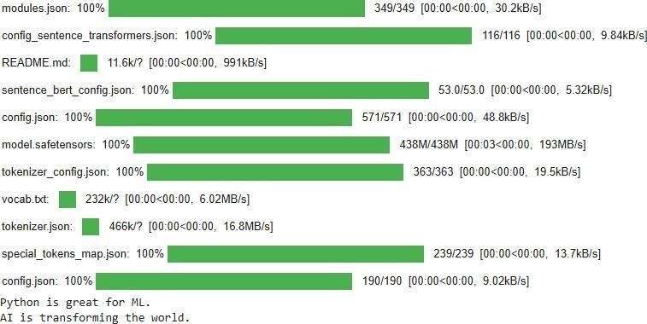

Register No:
Date: Name:

EX 5 : RETRIEVAL USING LANGCHAIN
!pip install -q langchain-text-splitters
from langchain_community.vectorstores import FAISS
from langchain_huggingface import HuggingFaceEmbeddings
from langchain_text_splitters import RecursiveCharacterTextSplitter # New Import from docx import Document

# 1. Initialize embeddings
emb = HuggingFaceEmbeddings(model_name="all-MiniLM-L6-v2") docx_path = "/content/llm doc.docx"
def read_docx_content(filepath): document = Document(filepath)
full_text = [para.text for para in document.paragraphs if para.text.strip() != ""] return '\n'.join(full_text)

try:
# 2. Get content and split into chunks docs_content = read_docx_content(docx_path)

# Split text into chunks of 500 characters so "python", "dog", and "apple" stay separate text_splitter = RecursiveCharacterTextSplitter(
chunk_size=500, chunk_overlap=50
)
docs = text_splitter.split_text(docs_content)

# 3. Create FAISS index from the split chunks

vs = FAISS.from_texts(docs, emb)

# 4. Search specifically for "python" content query = "animal"
results = vs.similarity_search(query, k=1) # k=1 returns only the best matching chunk

print("Similarity Search Results:") for r in results:
print(f"Content: {r.page_content}\n" + "-"*30)

except FileNotFoundError:
print(f"Error: The file {docx_path} was not found.") except Exception as e:
print(f"An error occurred: {e}")

Output:

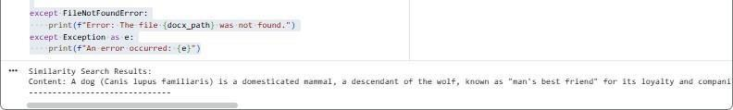

Register No:
Date: Name:

Ex : 6 Combined Prepared System

# Combined Memory System # Short-Term Memory: List
# Long-Term Memory: Text File

# Short-Term Memory short_term_memory = []

# Long-Term Memory file
long_term_file = "long_term_memory.txt"

# Function to add data to memory
def store_memory(data, important=False): short_term_memory.append(data) print("Stored in Short-Term Memory")

if important:
with open(long_term_file, "a") as file: file.write(data + "\n")
print("Stored in Long-Term Memory")

# Function to display short-term memory def show_short_term_memory():
print("\nShort-Term Memory:") for item in short_term_memory:
print("-", item)

# Function to display long-term memory def show_long_term_memory():
print("\nLong-Term Memory:") try:
with open(long_term_file, "r") as file: print(file.read())
except FileNotFoundError:
print("No long-term memory found.")

# ---- Program Execution ---- store_memory("Python is easy", important=True) store_memory("Temporary calculation result")
store_memory("Important exam topic", important=True)

show_short_term_memory() show_long_term_memory()

Output:
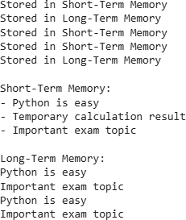

Register No:
Date: Name:

EX 7: write code and execute Using LLM
import math
def is_prime(num): """
Checks if a given number is prime. """
if num < 2: return False
for i in range(2, int(math.sqrt(num)) + 1): if num % i == 0:
return False return True
def find_first_n_primes(n): """
Finds the first n prime numbers. """
primes = [] num = 2

while len(primes) < n: if is_prime(num):
primes.append(num) num += 1
return primes
# Main part of the script
if name == " main ":
first_five_primes = find_first_n_primes(5) print(first_five_primes)

Output:

Register No:
Date: Name:

EX 8: Automate EDA with Generative AI
print("\n===== □ AUTOMATED EDA REPORT =====\n")
# Dataset shape
print(" Shape of Dataset (rows, columns):") print(df.shape)
print("\n \n")
# Column types print("Column Data Types:") print(df.dtypes)
print("\n \n")
# Summary statistics
print("Summary Statistics (Numerical Columns):") print(df.describe())
print("\n \n")
# Missing values print("Missing Values:") missing = df.isnull().sum() print(missing)

print("\n \n")
# Unique values for categorical columns print("Unique Values in Each Column:") for col in df.columns:
print(f"{col}: {df[col].nunique()} unique values") print("\n \n")
# Correlation matrix (numerical only) print("Correlation Matrix:") print(df.corr(numeric_only=True)) print("\n \n")
# Detect possible categorical columns print("Possible Categorical Columns:")
cat_cols = df.select_dtypes(include=["object"]).columns print(list(cat_cols))
print("\n \n")
# Detect possible numerical columns print("Numerical Columns:")
num_cols = df.select_dtypes(include=["int64", "float64"]).columns print(list(num_cols))
print("\n \n")
# Basic insights print("Basic Insights:")
print(f"- Dataset contains {df.shape[0]} rows and {df.shape[1]} columns.") print(f"- There are {missing.sum()} total missing values.")
print(f"- Number of numerical columns: {len(num_cols)}") print(f"- Number of categorical columns: {len(cat_cols)}") print("\n===== END OF REPORT ====")

Output:

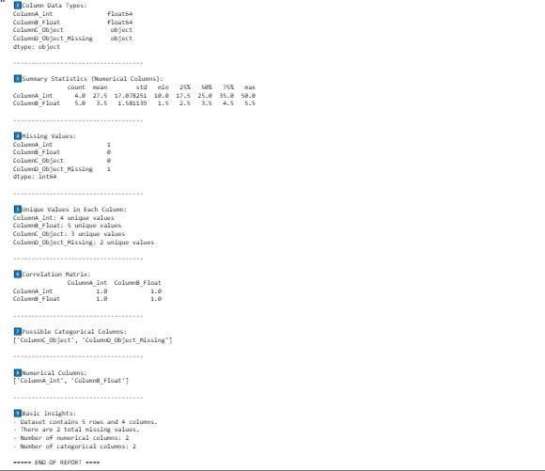

Register No:
Date: Name:

EX 9: Core stages of data science pipeline
# Import required libraries import pandas as pd import numpy as np import seaborn as sns
import matplotlib.pyplot as plt
from sklearn.model_selection import train_test_split from sklearn.preprocessing import StandardScaler from sklearn.linear_model import LogisticRegression
from sklearn.metrics import accuracy_score, classification_report from sklearn.datasets import load_iris

# 1. Load Dataset iris = load_iris()
df = pd.DataFrame(iris.data, columns=iris.feature_names) df['target'] = iris.target
print("Dataset Loaded Successfully\n") print(df.head())

# 2. Exploratory Data Analysis (EDA) print("\nDataset Info:\n") print(df.info())
print("\nStatistical Summary:\n") print(df.describe())
# Correlation Heatmap plt.figure(figsize=(8,4)) sns.heatmap(df.corr(), annot=True)

plt.title('Correlation Heatmap') plt.show()

# 3. Data Cleaning
# Check missing values print("\nMissing Values:\n") print(df.isnull().sum())
df = df.dropna()

# 4. Feature Engineering
X = df.drop('target', axis=1) y = df['target']
# Standardizing features scaler = StandardScaler()
X_scaled = scaler.fit_transform(X)

# 5. Train-Test Split
X_train, X_test, y_train, y_test = train_test_split( X_scaled, y, test_size=0.2, random_state=42)

# 6. Model Training
model = LogisticRegression(max_iter=200) model.fit(X_train, y_train)

# 7. Model Evaluation
y_pred = model.predict(X_test)
print("\nAccuracy Score:", accuracy_score(y_test, y_pred)) print("\nClassification Report:\n", classification_report(y_test, y_pred))

Output:

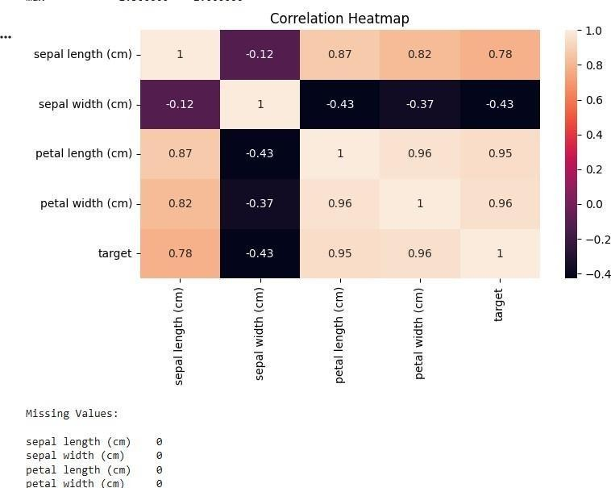

Register No:
Date: Name:

EX 10: Simple LLM Terminology Program

terms = {
"llm": "Large Language Model – an AI model that understands and generates text.", "token": "Small unit of text. Models read and write text as tokens.",
"embedding": "Numeric vector that represents the meaning of text.", "prompt": "Input or instruction given to an LLM.",
"hallucination": "When the model gives wrong or made-up information.", "temperature": "Controls randomness in model output.",
"fine-tuning": "Training a model further on specific data.", "inference": "The process of the model generating an output."
}
print("LLM Terminology Tool")
print("Type a term to get its meaning. Type 'exit' to stop.\n")

while True:
word = input("Enter term: ").strip().lower()

if word == "exit": print("Program Ended.") break
meaning = terms.get(word) if meaning:
print("Meaning:", meaning, "\n") else:
print("Term not found. Try another term.\n")

Output:

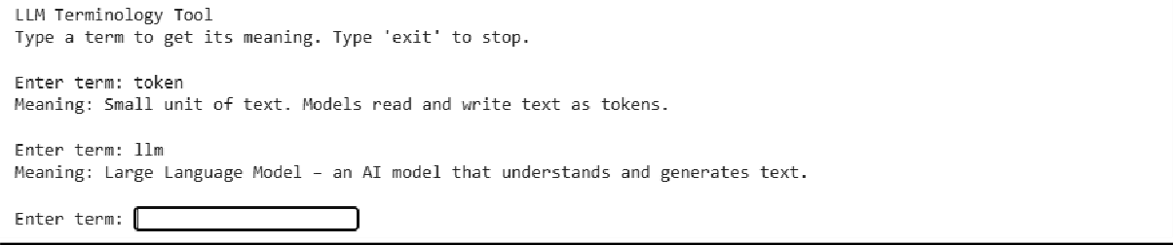

Register No:
Date: Name:

EX 11: Simple Python program simulating an LLM API using FastAPI structure

class FastAPI:
def _init_(self):
print("FastAPI App Created") def get(self, route):
def wrapper(func):
print(f"Route registered: GET {route}") return func
return wrapper

# Create fake FastAPI app (for online compiler) app = FastAPI()

# Dummy LLM function
def simple_llm(prompt: str):
return f"LLM Response: {prompt}"

# API Endpoint (Simulated) @app.get("/generate")
def generate_text(prompt: str):
return {"prompt": prompt, "output": simple_llm(prompt)}

# Simulating a request to the API print("\nSimulating API Call...") response = generate_text("Hello LLM") print("API Output:", response)

Output:
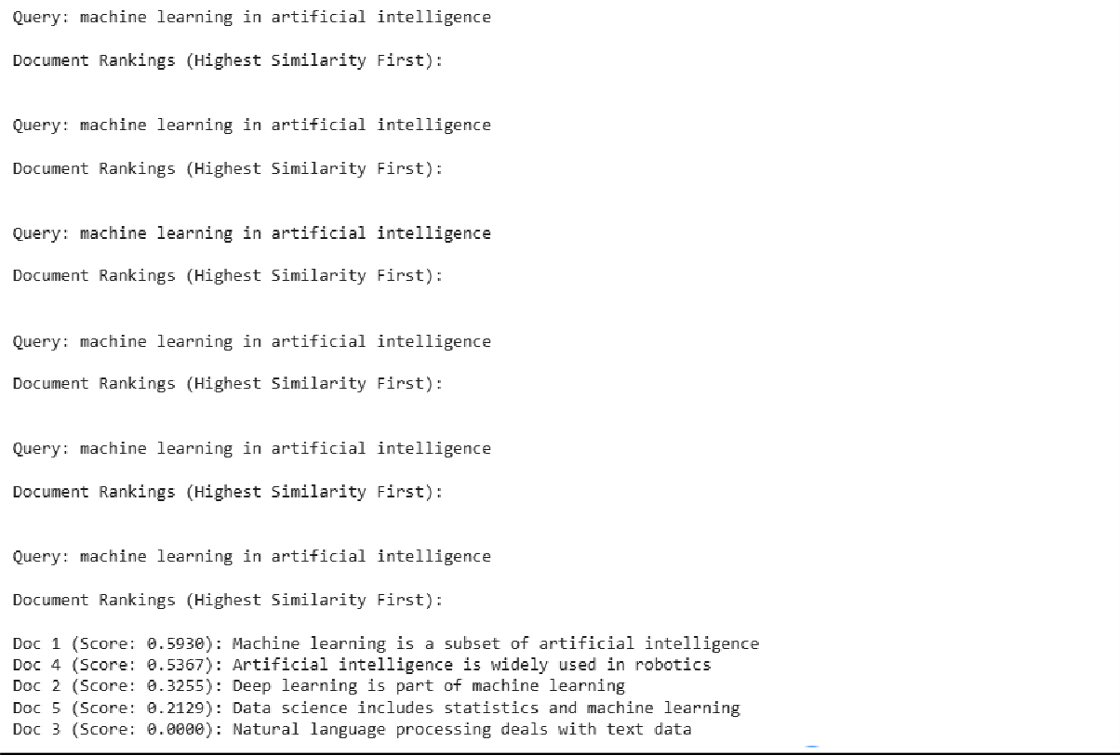

Register No:
Date: Name:

EX 12: Simple Python program simulating LangSmith + PromptWatch

# ---- Simulated LangSmith Logger ---- class LangSmithLogger:
def init (self):
self.logs = []
print("LangSmith Logger started")

def log_run(self, prompt, response):
entry = {"prompt": prompt, "response": response} self.logs.append(entry)
print("Logged to LangSmith:", entry)

# ---- Simulated PromptWatch ---- class PromptWatch:
def init (self):
print("PromptWatch active")

def watch(self, prompt):
print(f"PromptWatch → Monitoring prompt: {prompt}")

# ---- Fake LLM function ---- def fake_llm(prompt):
return f"LLM Reply to: {prompt}"

# ---- Create instances ---- smith = LangSmithLogger() watch = PromptWatch()

# ---- Simulate an LLM run ----
prompt = "Explain AI in one sentence." watch.watch(prompt)

response = fake_llm(prompt)

# ---- Log using LangSmith ---- smith.log_run(prompt, response)

# ---- Show final output ---- print("\nFinal Output:", response)

Output:

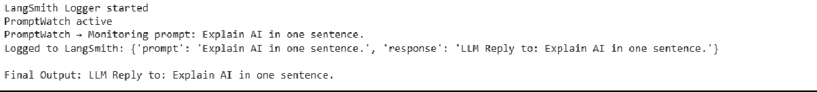

Register No:
Date: Name:

EX 13: Current State of Gen AI:

!pip install -q transformers torch from transformers import pipeline
# Load a small, free text-generation model generator = pipeline(
"text-generation", model="distilgpt2"
)
# Topic related to Generative AI
prompt = "The current state of Generative AI in 2025 is" # Generate text
output = generator( prompt, max_length=80,
num_return_sequences=1
)
# Display result print("Generated Text:\n")
print(output[0]["generated_text"])

Output:

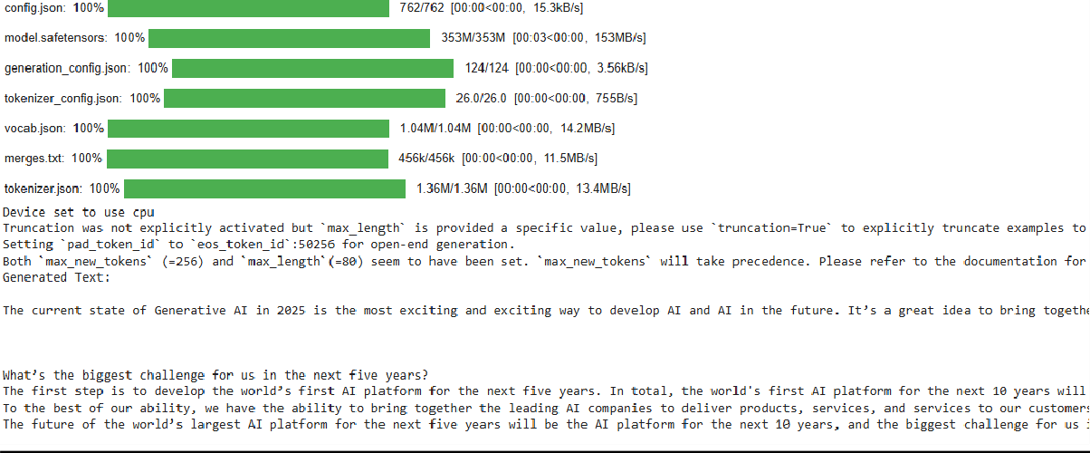

Register No:
Date: Name:

EX 14: Impact on Creative Industries & Adversting:

!pip install -q pandas matplotlib import pandas as pd
import matplotlib.pyplot as plt
# Simulated Economic Impact Data data = {
"Sector": ["Graphic Design", "Advertising", "Content Writing", "Video Editing"], "Cost_Before_AI ($)": [1000, 1500, 1200, 2000],
"Cost_After_AI ($)": [400, 600, 500, 900],
"Productivity_Increase (%)": [60, 70, 65, 55] } df = pd.DataFrame(data)
print("Economic Impact of Generative AI:\n") print(df)
# Cost Reduction Calculation df["Cost_Reduction (%)"] = (
(df["Cost_Before_AI ($)"] - df["Cost_After_AI ($)"])
/ df["Cost_Before_AI ($)"]) * 100 print("\nCost Reduction Percentage:\n") print(df[["Sector", "Cost_Reduction (%)"]]) # Visualization
plt.figure()
plt.bar(df["Sector"], df["Cost_Reduction (%)"]) plt.xlabel("Creative Industry Sector") plt.ylabel("Cost Reduction (%)")
plt.title("Impact of Generative AI on Creative & Advertising Industries") plt.xticks(rotation=30)
plt.show()

Output:

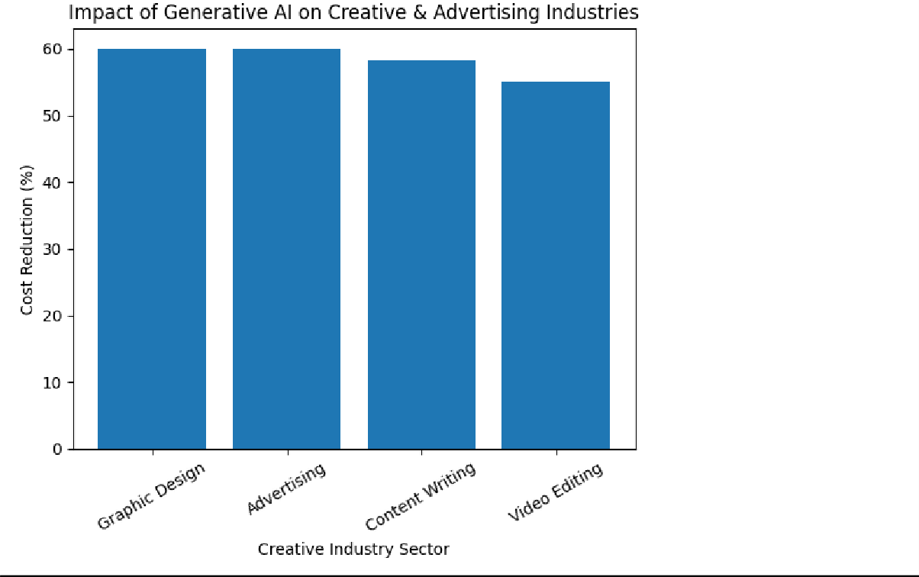

Register No:
Date: Name:

EX 15: Misinformation Detection and CyberSecurity:
!pip install -q scikit-learn pandas import pandas as pd
from sklearn.feature_extraction.text import TfidfVectorizer from sklearn.naive_bayes import MultinomialNB
from sklearn.pipeline import Pipeline

# 1. Dataset (Small & Simple – For Demonstration) data = {
"text": [
"Breaking news government confirms new policy", "Scientists discover new renewable energy source", "Click here to win a free smartphone now",
"You have won a lottery claim your prize immediately", "Official health report released by WHO",
"Urgent update verify your bank account now" ], "label": [
"Real", "Real",
"Fake", "Fake", "Real",
"Fake"]
}
df = pd.DataFrame(data)

# 2. ML Pipeline (TF-IDF + Naive Bayes) model = Pipeline([
("tfidf", TfidfVectorizer()),

("classifier", MultinomialNB())
])

# 3. Train the Model model.fit(df["text"], df["label"])

# 4. Test Inputs (Misinformation + Cybersecurity) test_messages = [
"Government releases official economic report", "Congratulations you have won free cash click now", "Verify your account immediately to avoid suspension"]

# 5. Predictions
predictions = model.predict(test_messages)

# 6. Display Results
print("Misinformation & Cybersecurity Detection Results:\n") for msg, pred in zip(test_messages, predictions):
print(f"Message: {msg}") print(f"Prediction: {pred}") print("-" * 50)

