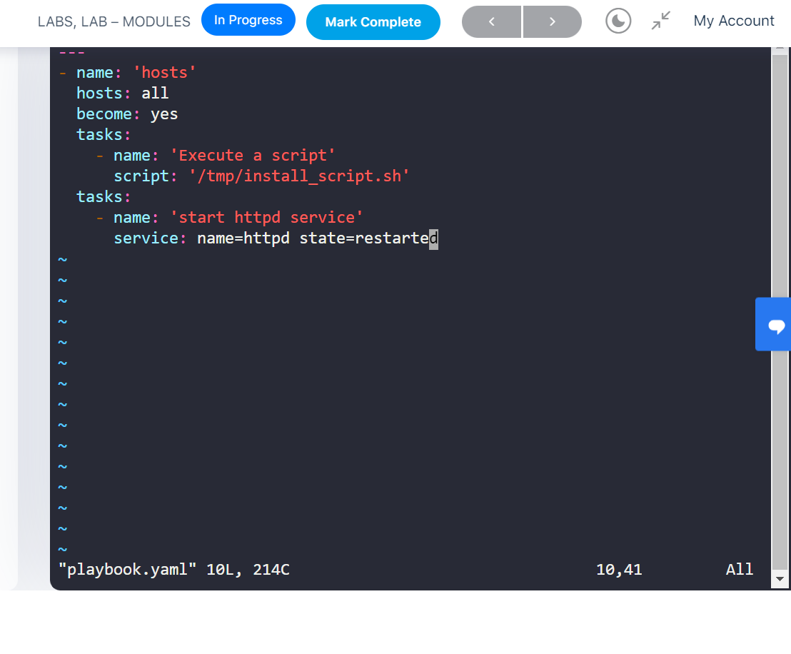

Lindeinfile Module

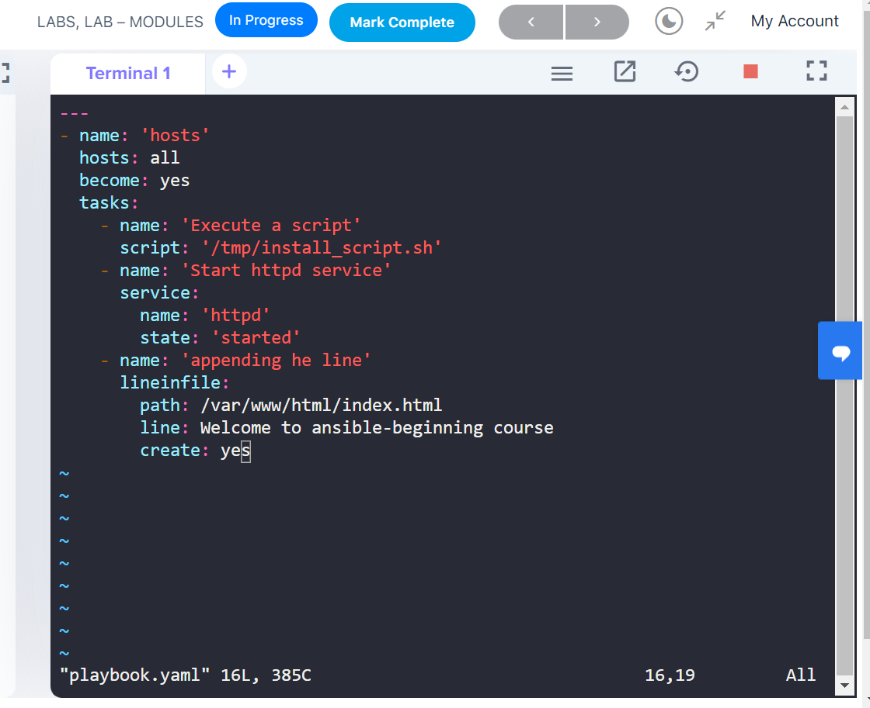

User Module

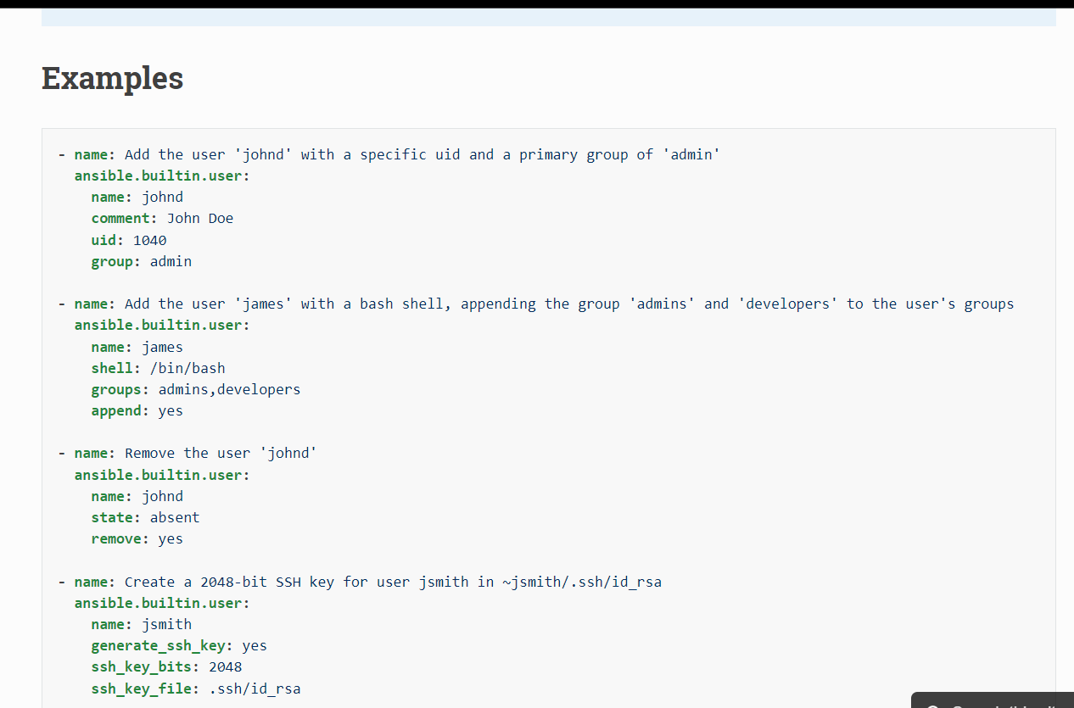

Defining Variables

Loop or with_item directives

---

- name: Install packages via yum

hosts: localhost

become: true

vars:

packages_to_install:

- package1

- package2

- package3

tasks:

- name: Install packages via yum

yum:

name: "{{ item }}"

state: present

with_items: "{{ packages_to_install }}"

**example: with_item directive to install packages using playbook in localhost via yum**

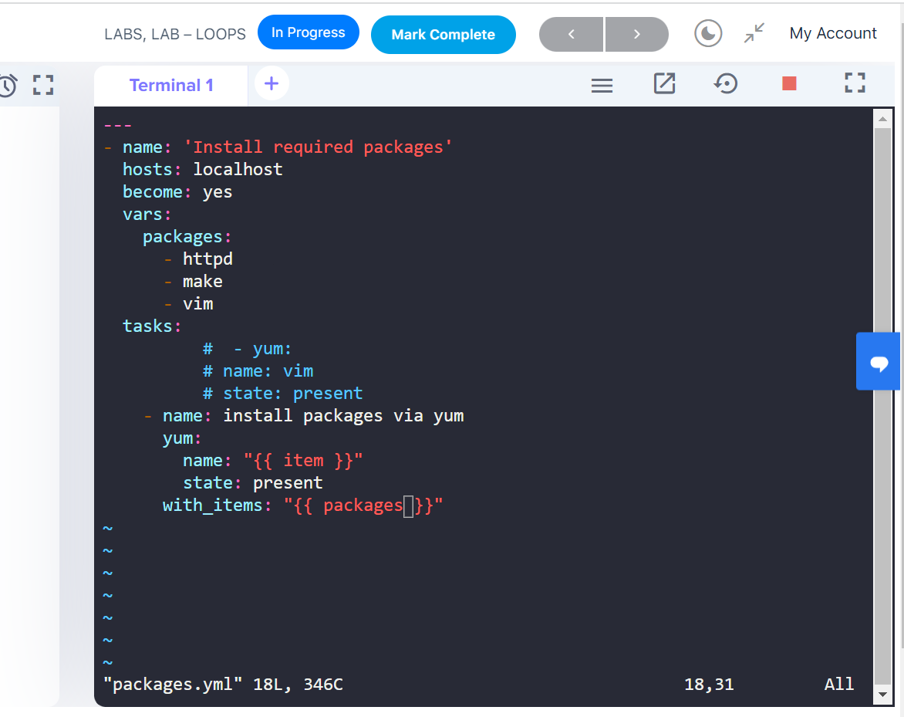

Ansible Roles

Roles: In ansible roles are the type of module which is used to deploy like DB server, application server, monitor server, web server.

Example: play book that uses a single role

- name: Deploy web application

hosts: web_servers

become: true

roles:

- myapp_web

Note:

. all the pre requisite softwares , application installation & starting application service all this task are defined in a myapp_web playbook, and the playbook will be sitting in roles default location

. ansible galaxy is a place where we can find ready made roles play books

“https://galaxy.ansible.com/home”

Example 2: A playbook that uses multiple roles

- name: Deploy web and database servers

hosts: webservers:dbservers

become: true

roles:

- myapp_web

- myapp_db

Example 3: A playbook that uses variables in a role

- name: Configure web servers

hosts: webservers

become: true

roles:

- role: myapp_web

vars:

http_port: 8080

https_port: 8443

Using copy module

ss

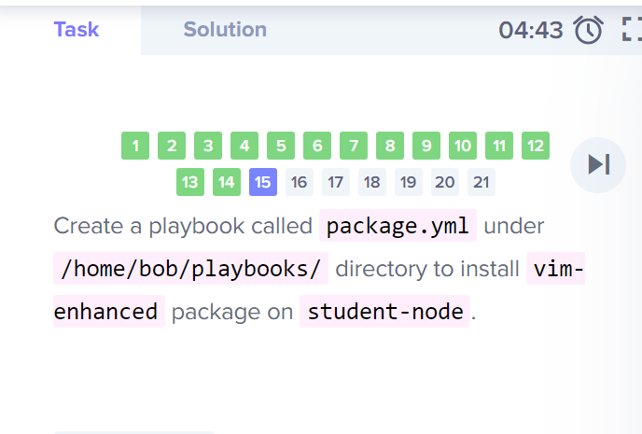

---

- hosts: all

become: true

tasks:

- name: Copy file with owner and permissions on node01

copy:

src: /usr/src/condition/blog.txt

dest: /opt/condition/blog.txt

owner: bob

group: bob

mode: "0640"

when: inventory_hostname == "node01"

- name: Copy file with owner and permissions on node02

copy:

src: /usr/src/condition/story.txt

dest: /opt/condition/story.txt

owner: sam

group: sam

mode: "0400"

when: inventory_hostname == "node02"

