1. CREATING AN EKS CLUSTER

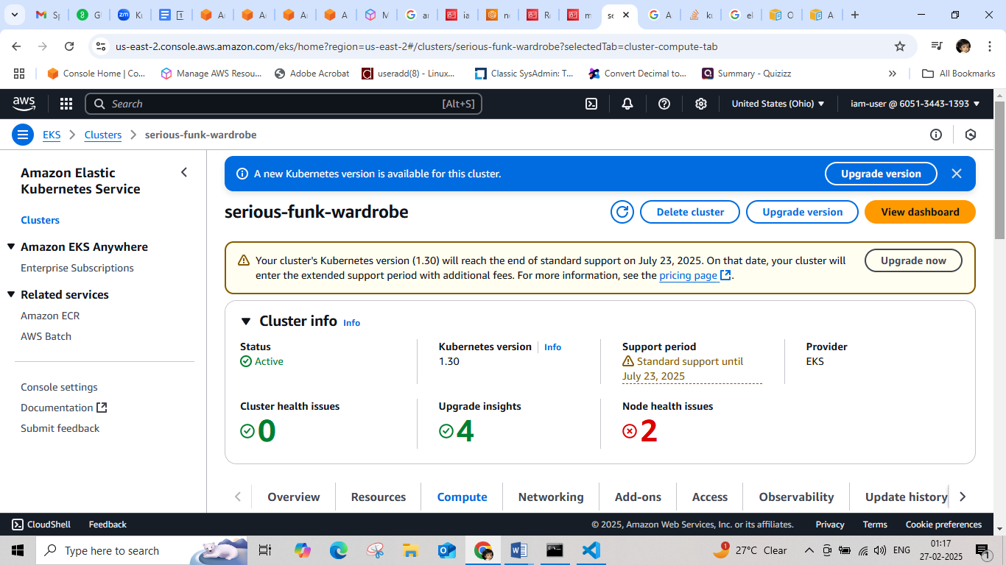

1. CONFIGURE CLUSTER IN LOCAL MACHINE

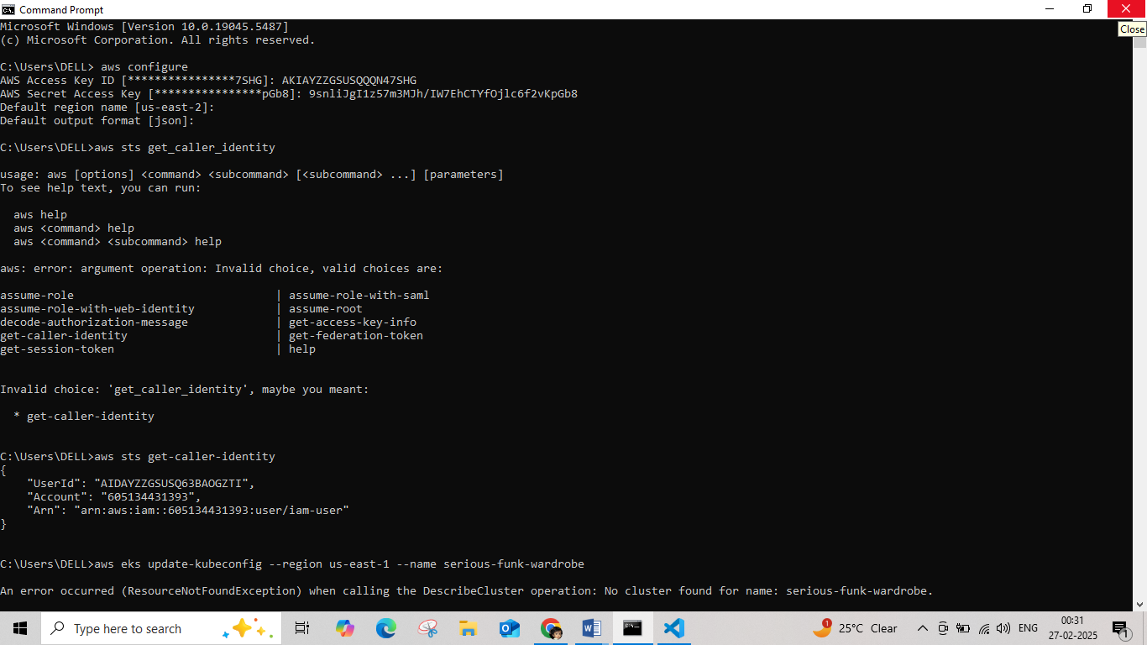

1. DEPLOYING AND EXPOSING NGINX APPLICATION

