Loops:

* Loops are used to run a single statement in a multiple times.
* There are four types of loops in java.

1. For loop.
2. While loop.
3. Do while loop.
4. For each loop. (Uses in arrays.)

Syntax: (for loop)

For (int i=0; i<=10; i++){

Process (Logic)

}

Steps:

1. We have to use keyword for.

2. Then we have to initialize variable.

3. Then we have give condition for looping then we have to increment or decrement the variable based on the requirement.

Example:

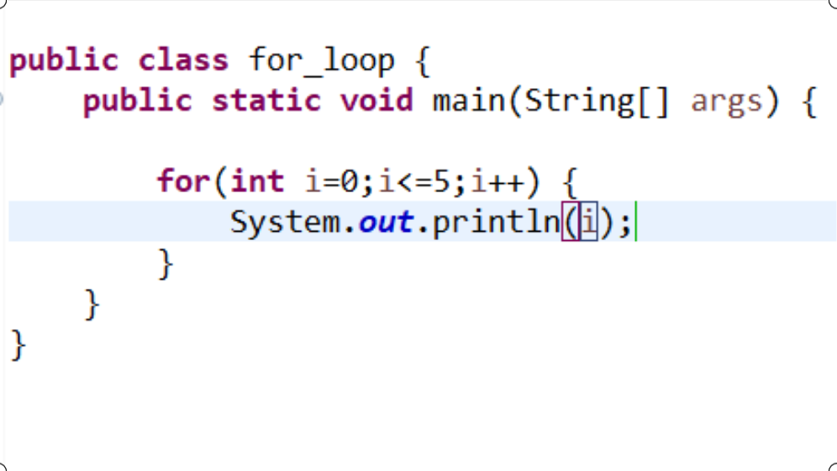

Output:

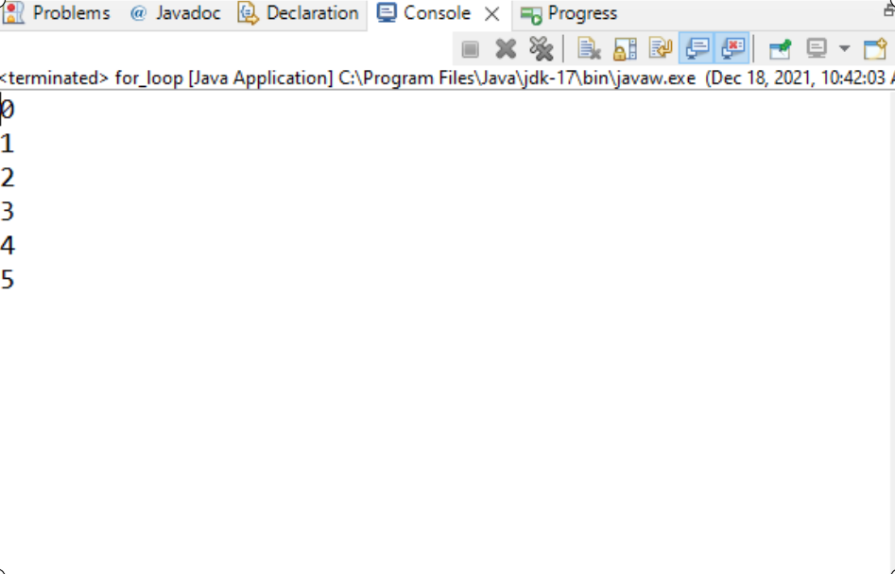

* In above syntax I initialize a variable I =0 and given an condition what is run the loop till I <=5 then I increment the value of i.
* Observer out put it will print 0 to 5 then condition is false its come out of loop.

Syntax: (While loop)

Int I=0;

While (I<=5) {

Process…..

I++;

}

* It same as for loop but when we use while loop and for loop is when we know the starting and ending of the loop we use for loop.
* When we don’t know starting and ending of the loop then we can use while loop.

Example:

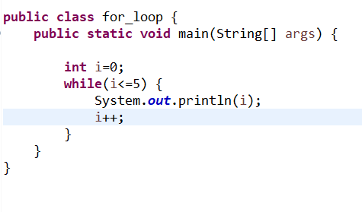

Output:

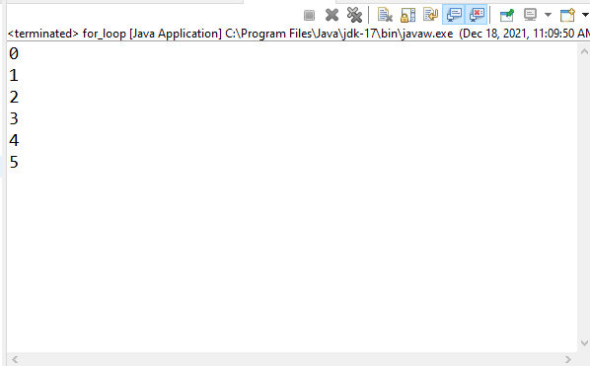

* Here first it will check condition then it will run the loop based on the given condition.

Example 2:

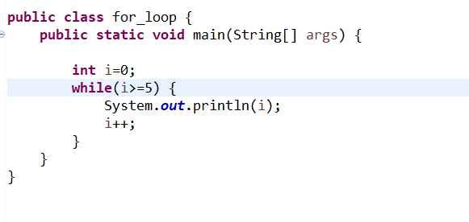

Output:

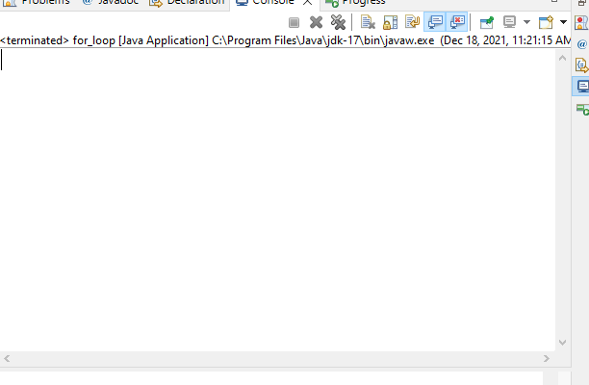

* It will not print any output because the condition what we give is false so it will not print any output see above picture.

Syntax: (do. While)

* It will almost equal to while loop the main difference between if condition in while is false is not go inside loop but it’s not in do while here first it will run the process or logic at least one time then it will check the condition.

Syntax: (do. While)

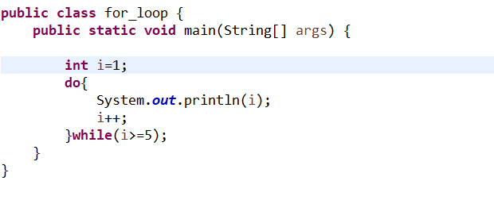

Output:

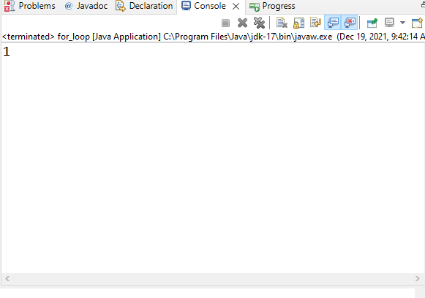

Arrays:

Java array is an object which contains elements of a similar data type.

The elements of an array are stored in a contiguous memory location.

Declaration:

Int array [] =new int [5]; 1st way

Int array [] = {1, 2, 3, 4, 5}; 2nd way

* Arrays are using indexing to get and set that’s why arrays can allow duplicate values to store.

For each loop:

For each loop is another array traversing technique like for, while, do. While loop.

* It starts with the keyword for like a normal for-loop.
* Instead of declaring and initializing a loop counter variable, you declare a variable that is the same type as the base type of the array, followed by a colon, which is then followed by the array name.
* In the loop body, you can use the loop variable you created rather than using an indexed array element.

Example:

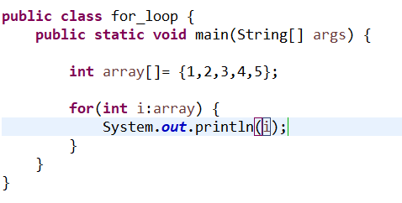

Output:

