SIMATS ENGINEERING (SAVEETHA SCHOOL OF ENGINEERING)
Department of Computer Science and Engineering

ASSESSMENT TOOL 1 – EXPERIMENTS

Course Code: | CSA06 | Course Title: | Design and Analysis of Algorithms
CO3: Articulation
(BL4, BL5)
 |  |  | Assessment Tool 1 – Experiments
CO Assessed: |  | Assessment:
 | 40% of CIA
 |  |  | 100
Weightage: |  | Total Marks:
CO3 Statement: | Design Divide and Conquer algorithms for Merge Sort, Quick Sort, Binary Search and Matrix Multiplication
Student Name: | Y. Veera Reddy | Reg. No.: | 192211898
 | AI &ML/ 2024
 |  |  | 06-08-2026
Section / Batch: |  | Date:
Instructions to Students
- Answer the following question. Total Marks: 100.
- Write the algorithm and execute the code for the given experiment.
- Follow a well-structured, systematic approach to design and implement an optimal solution.
- Provide insightful analysis with accurate validation, supported by clear documentation including diagrams, code, and results.

Question Type | Focus Area | Questions
 | Design and Code for Divide and Conquer Algorithms: Merge  Sort, Quick Sort, Binary Search, and Matrix Multiplication | Q1
Experiments

SECTION A – Experiments

Code of Conduct
I Y. Veera Reddy / 192211898(Name / Reg No) certify that this submission is my original work and that I have adhered to the guidelines specified for this assessment. I understand that any violation of academic integrity rules will result in disciplinary action.
Signature of the Student: Y. Veera Reddy

PYTHON BINARY VS LINEAR SEARCH:

import time
def linear_search(arr, key):
for i in range(len(arr)):
if arr[i] == key:
return i
return -1
def binary_search(arr, key):
low = 0
high = len(arr) - 1
while low <= high:
mid = (low + high) // 2
if arr[mid] == key:
return mid
elif arr[mid] < key:
low = mid + 1
else:
high = mid - 1
return -1
n = int(input())
arr = list(map(int, input().split()))
key = int(input())
start = time.perf_counter()
linear_result = linear_search(arr, key)
end = time.perf_counter()
linear_time = end - start
arr.sort()
start = time.perf_counter()
binary_result = binary_search(arr, key)
end = time.perf_counter()
binary_time = end - start
print("Linear Search Result:", linear_result)
print("Linear Search Time:", linear_time)
print("Binary Search Result:", binary_result)
print("Binary Search Time:", binary_time)
if linear_time < binary_time:
print("Linear Search is faster for this input.")
else:
print("Binary Search is faster for this input.")
OUTPUT :

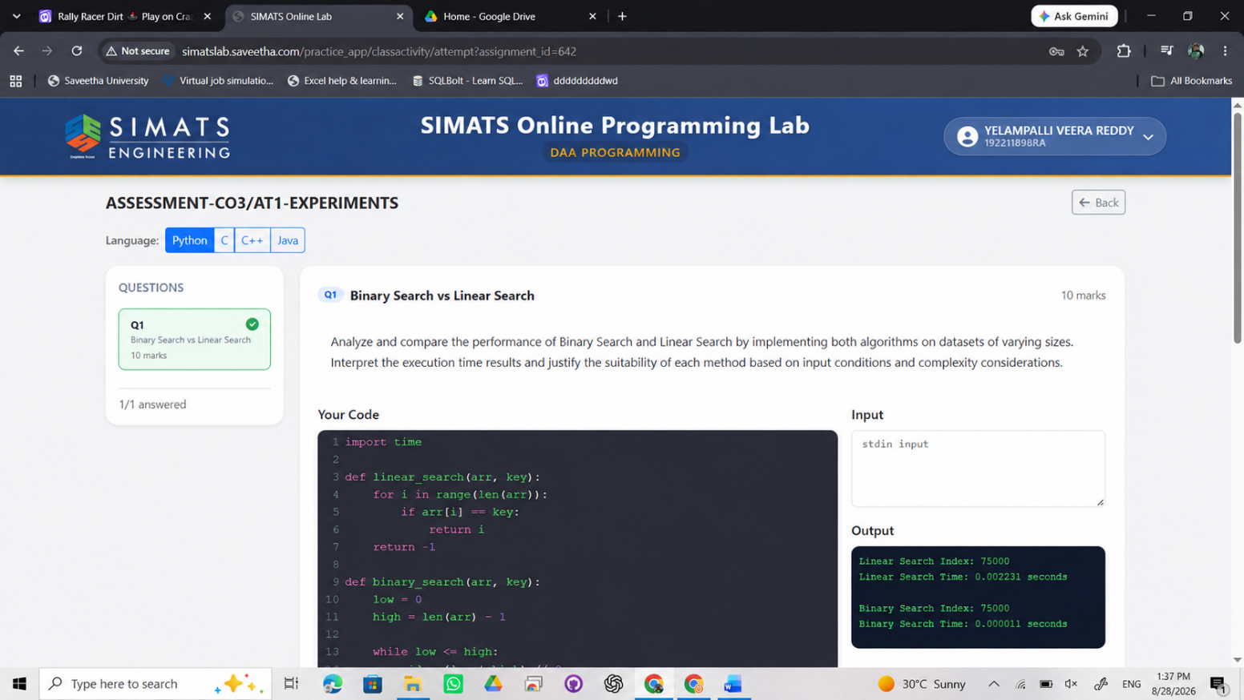

RUBRICS FOR CALCULATION

 | Experiments
Criteria | Weightage | Level 4 –  Exemplary | Level 3 –  Proficient | Level 2 –  Developing | Level 1 –  Beginning
Understa nding of  Concepts | 25% | Demonstrates thorough understanding and  effectively integrates multiple concepts/technologies | Good understanding with proper  integration of most concepts | Basic understanding;  limited or partial integration | Poor understanding  ; unable to integrate concepts
Experime ntal  Design | 30% | Well-planned, systematic  implementation with optimal solution | Correct implementatio  n with minor issues | Basic implementation with errors or inefficiencies | Incorrect or incomplete  implementatio  n
Use of Tools | 20% | Effective and advanced use of  tools/technologies with proper configuration | Appropriate use of tools  with correct execution | Limited or inconsistent use of tools | Incorrect or minimal use of tools
Analysis  of  Results | 15% | Insightful analysis with accurate  interpretation and validation of results | Good analysis with  reasonable interpretation | Basic analysis with limited insights | Poor or incorrect  analysis of results
Documen tation | 10% | Clear, well-structured documentation with diagrams, code, and  results | Organized documentation with necessary  details | Basic documentation  with missing details | Poor or incomplete  documentatio  n

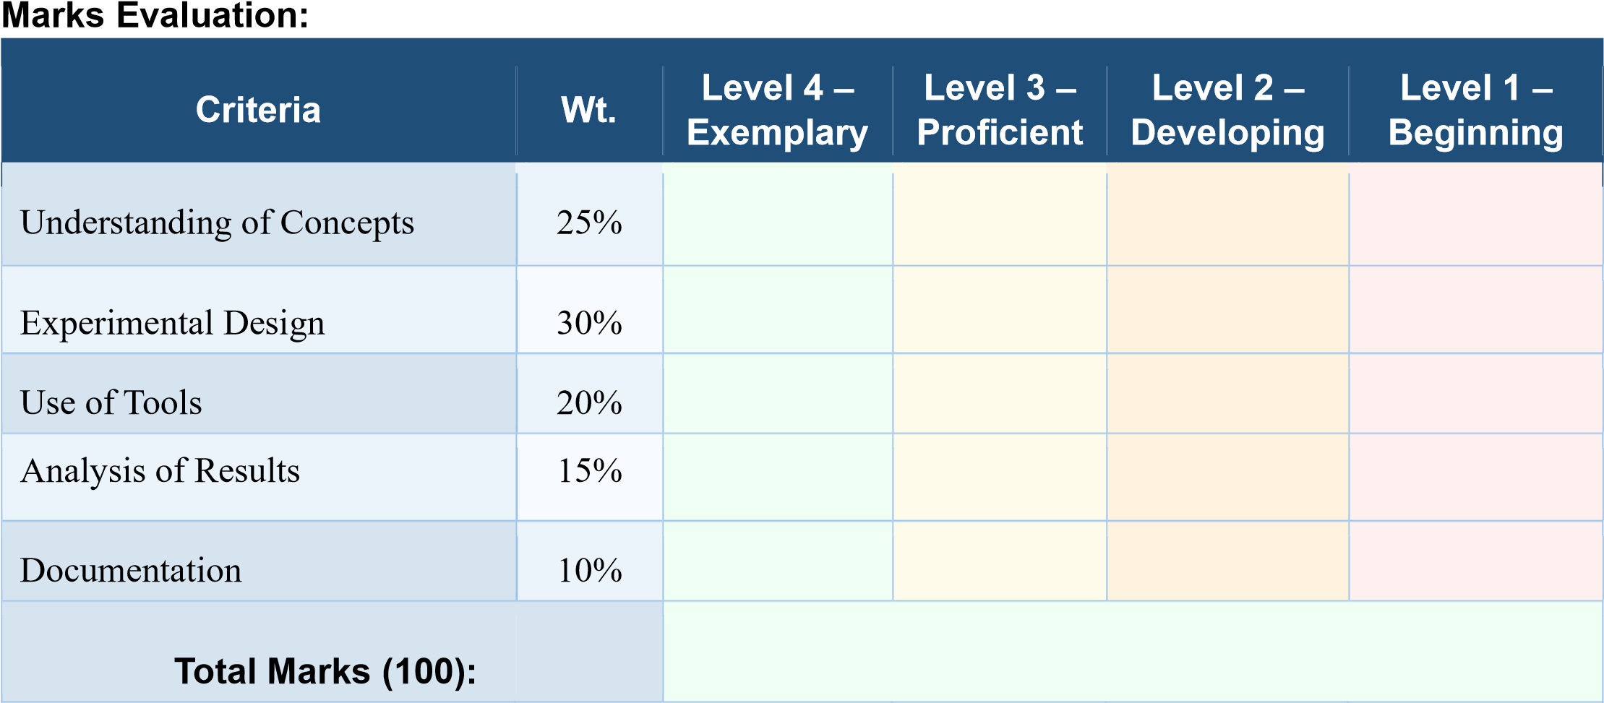

Faculty In-charge | Course Coordinator | Head of Department
Name: | Name: | Name:
Signature:  _______________ | Signature:  _______________ | Signature:  _______________
Date:  ___________________ | Date:  ___________________ | Date:  ___________________

