Enterprise Dashboards
Last Updated: March 24th 2021

Table of Contents
Overview 3
Field List 4
Customizing the Cost Fields in the Dashboard 6
Understanding the Visuals 7
Visual by Visual Breakdown 8
Billing Summary 8
Cost Summary 11
Compute Summary 14
Storage Summary 17
Reserved Instance & Savings Plan Summary 21
Expiring RI/SP Tracker 24
OPTICS Explorer 24
MoM Pivot 25
Customizing the OPTICS Explorer Controls 25
Additional Resources 26

Overview
The goal of the Enterprise Dashboards is to remove the complexities of cost & usage analysis, and provide enterprises with a clear understanding of something, to enable them to make the right business decisions quickly. The Enterprise Dashboard are made up of multiple templates known as modules to help you gain insight into different aspects of your cost and usage as well as enable your teams to better understand the cost of their applications and opportunities to optimize. Every dashboard complements the other modules so you can grow your reporting analytics and gain additional insight. Using separate modules provides greater flexibility, allowing you to customize existing modules and take advantage of the new templates without overwriting your existing customizations. If the dashboards were in a single report it would overwrite all customizations each time you create the latest template.
- The Cost Intelligence Dashboard is an interactive, customizable and business accessible QuickSight dashboard to help customers create the foundation for their own Cost Management and Optimization reporting tool.
- The Data Transfer Dashboard allows your organization to understand their data transfer cost and usage across all AWS products so you can take action on optimization opportunities.

Interested in getting the dashboards in a single view? Below are a few options available today. We recommend option 1 or 2 since it offers the most consistent experience for your teams.
- Embedding the dashboards
  - High effort, full customization, most consistent experience
- Adding the latest module visuals to your Cost Intelligence Dashboard
  - Medium effort, full customization, consistent experience
- Leveraging the dashboard as is without customization
  - Low effort, least customization, inconsistent experience
- Recreating your customization with each module release
  - High effort, full customization, inconsistent experience
Notes:
- This QuickSight dashboard is not an official AWS dashboard and should be used as a self-service tool. We recommend validating your data by comparing the aggregate ungrouped Payer and Linked Account spend for a prior month.
- The Athena views are updated to reflect any additions in the cost and usage report. Periodically check the lab to confirm you are using the latest views.

Field List
The table below provides a list of all fields in the Dashboard Template
Field | Field From | QuickSight Data Set(s) | Notes – Added for All QuickSight Calculated Fields
year | Athena View | 1|2|3|4
month | Athena View | 1|2|3|4
billing_period | Athena View | 1|2|3|4|5
usage_date | Athena View | 1|2|3|4|5
payer_account_id | Athena View | 1|2|3|4|5
linked_account_id | Athena View | 1|2|3|4
invoice_id | Athena View | 1
charge_type | Athena View | 1|4|5
charge_category | Athena View | 1
purchase_option | Athena View | 1|2
ri_sp_arn | Athena View | 1
ri_sp_end_date | Athena View | 1
ri_sp_term | Athena View | 1
ri_sp_offering | Athena View | 1
ri_sp_payment | Athena View | 1
product_code | Athena View | 1|4|5
product_name | Athena View | 1|5
service | Athena View | 1
product_family | Athena View | 1
usage_type | Athena View | 1|5
operation | Athena View | 1|4|5
item_description | Athena View | 1
availability_zone | Athena View | 1
region | Athena View | 1|4|6
instance_type_family | Athena View | 1
instance_type | Athena View | 1
platform | Athena View | 1
tenancy | Athena View | 1
processor | Athena View | 1
processor features | Athena View | 1
database_engine | Athena View | 1
product_group | Athena View | 1
product_from location | Athena View | 1
product_to_location | Athena View | 1|
from_location | Athena View | 5
to_location | Athena View | 5
data_transfer_type | Athena View | 5
current_generation | Athena View | 1
legal_entity | Athena View | 1
billing_entity | Athena View | 1
pricing_unit | Athena View | 1|4
resource_id_count | Athena View | 1
resource_id | Athena View | 4|5
usage_quantity | Athena View | 1|2|4|5
Tbs | Athena View | 5
unblended_cost | Athena View | 1|3|4|5
amortized_cost | Athena View | 1|2
blended_cost | Athena View | 5
ri_sp_trueup | Athena View | 1
ri_sp_upfront_fees | Athena View | 1
unblended_rate | Athena View | 5
blended_view | Athena View | 5
public_ondemand_rate | Athena View | 5
public_cost | Athena View | 1|4|5
billing_period_mapping | Athena View | 1
payer_account_id_mapping | Athena View | 1
ri_sp_arn_mapping | Athena View | 1
Cost_Unblended | QuickSight Calculation | 1 | Invoiced cost
Cost_Amortized | QuickSight Calculation | 1 | Amortized cost (i.e. RI/SP upfront fees spread over the life time of the term)
Cost | QuickSight Calculation | 1|2|3|4|5 | The Cost field is used in all aggregate cost visualizations except the billing summary that calls out the Invoiced and Amortized Cost
Cost_Public | QuickSight Calculation | 1|4 | Public OnDemand cost equivalent – Note that this value is not populated for all services and you will want to validate if using for any new visuals
RI_SP True Up Cost | QuickSight Calculation | 1 | Returns any RI/SP upfront fees to the account that purchased the pricing model to eliminate double billing
RI_SP Upfront Fees | QuickSight Calculation | 1 | The upfront fee for an RI/SP
% Coverage | QuickSight Calculation | 1|2 | Used to show the % Coverage by Usage Quantity. Create or update this field if you want to change the field to use Cost instead of usage
Account | QuickSight Calculation | 1|2|3|4|5 | Update this field from linked_account_id to your account name after you add in your mapping document
Avg Daily Run Rate | QuickSight Calculation | 1 | Avg daily cost for each month by the number of days
Days | QuickSight Calculation | 1 | Calculates the days in each month
EBS Volume | QuickSight Calculation | 1 | Removes the region from the usage_type to provide a clean list of EBS Volume types
Group By Fields | QuickSight Calculation | 1 | Calculated off of the GroupBy Parameter for use in the OPTICS Explorer
Product_Family Group | QuickSight Calculation | 1 | Combines the product_family and the product_group field so that any field that if an item doesn’t have a product_family it pulls the product_group field
RI_SP % savings | QuickSight Calculation | 1 | % Savings over On Demand you can filter to include or exclude unused costs
RI_SP Savings | QuickSight Calculation | 1 | Savings over On Demand for the used portion of an RI or SP
RI_SP Terms | QuickSight Calculation | 1 | Combines the various terms (payment type, purchase option, etc.) together into a single field
RI_SP Type | QuickSight Calculation | 1 | Combines the identifier for the type of RI or SP into a single field
RI_SP Unused Cost | QuickSight Calculation | 1 | Cost of the unused portion of an RI or SP. NOTE: Unused SP/RI does not mean waste and can be cheaper to have some unused at times.
RI_SP Fees | QuickSight Calculation | 1 | Upfront costs of an RI or SP
S3 Storage Class | QuickSight Calculation | 1|4 | Separates the storage class from the operation field for a single S3 storage class field
Total RI_SP Savings | QuickSight Calculation | 1 | RI_Unused Cost combined with the RI_SP Savings
Unit Cost | QuickSight Calculation | 1 | Divides your cost by usage_quantity
Avg Hourly Cost | QuickSight Calculation | 2 | Calculates your average compute hourly cost for an EC2 instance
Avg Spot Savings | QuickSight Calculation | 2 | Estimates your average Spot savings over On Demand. Note that Spot doesn’t have a public cost so we use the average On Demand Cost as an estimate
On Demand Unit Cost | QuickSight Calculation | 2 | Divides your On Demand cost by usage_quantity
RI/SP Unit Cost | QuickSight Calculation | 2 | Divides your RI and SP cost by usage_quantity
Spot Unit Cost | QuickSight Calculation | 2 | Divides your Spot cost by usage_quantity

Notes:
- Data sets align with the Quick Sight Data Sets so 1-4 are from the Cost Intelligence Dashboard and data set 5 is from the Data Transfer Dashboard.
- All QuickSight Calculated Fields will have a “=” next to them in the field list. To view the calculation, follow the steps 3 in the Advanced Setup 2 – Customize your summary_view Cost Value of the Modify Cost Intelligence Dashboard.
- Add any additional tag values or fields into your queries by including them before the first sum or approx_distinct field and then add another group by field at the bottom.
- The ‘resource_id_count’ counts the distinct resources by the summary_view query. We recommend using this query only at the most granular level or removing from the view

Customizing the Cost Fields in the Dashboard
The Cost Intelligence dashboard uses calculated fields for all cost related fields used in the visual to allow you to customize to your organizations requirements without having to edit every visual. If interested in customizing the cost values simply edit the following cost fields below and all others will update accordingly. For example, if you wanted to add a 0.5% service fee you would edit the fields below to include ({Field} * 0.005).
Fields:
- Cost_Unblended
- Cost_Amortized
- Cost_Public
- RI_SP True Up Cost
- RI_SP Upfront Fees

Notes
- Review the field list table to see the corresponding data sets
- Calculation should be added to Cost for all data sets outside of the Summary
- Cost Unblended = Cost_Amortized + RI_SP True Up Cost + RI_SP Upfront Fees

Understanding the Visuals
To understand what each visual represents you can click on the visual to see the following information:
- Select Visualize on the left navigation to see the data set used.
- Select Field wells in the top center bar to drop down the field wall and see the various fields in the visual and update to include any additional groupings.
- Select Filter on the left navigation to see the various filters for that visual and click on the various filters to see the logic used.

Visual by Visual Breakdown

Billing Summary
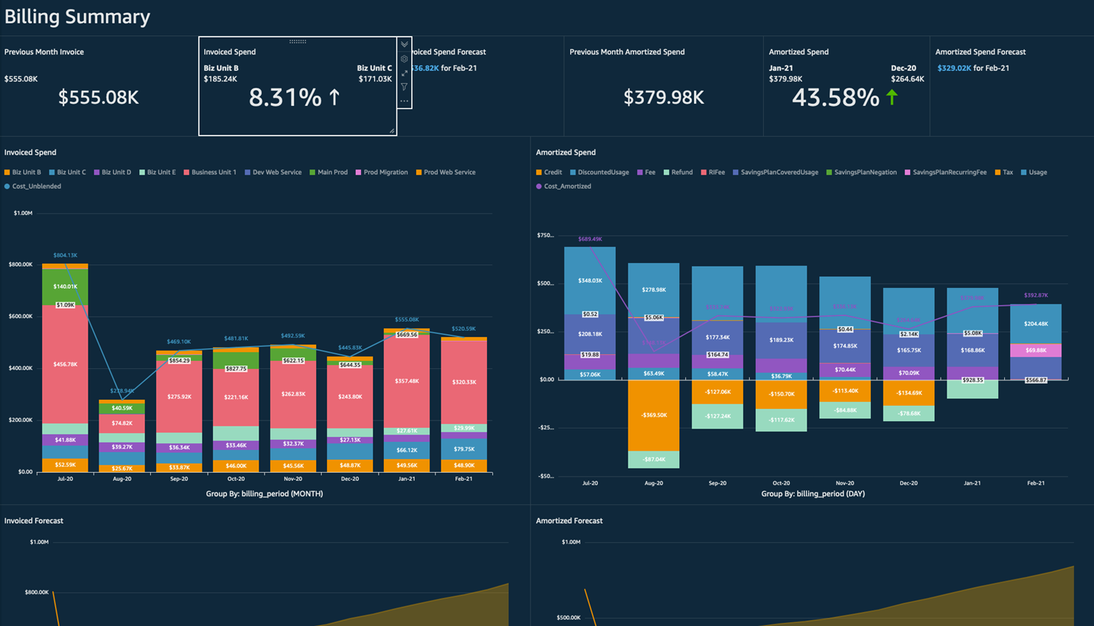
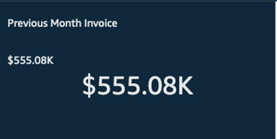 | The invoiced amount from the previous month. Simply a representation of the sum of the previous month's invoice amount for everything.
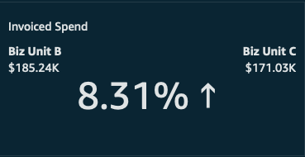 | The trends in invoiced spending from the previous month compared to this month. In this case, overall invoiced amount is up 52.61%, where Biz Unit C was the biggest change last month, Main Prod is the biggest change this month.
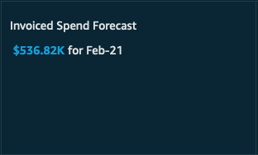 | QuickSight is forecasting that spend will be $370.11K for all of the current month. For more information on QuickSight's forecasting, click here.
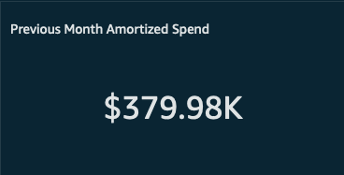 | This is the amortized spend in the previous month, meaning the true cost of running all applications and workloads. This number includes any RI/SP fees amortized evenly over the months of the term, and discounts/credits applied to the accounts that used them.
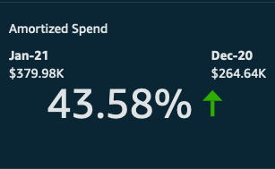 | The change in amortized spend between the previous month and the month prior to that.
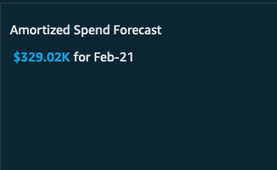 | QuickSight is forecasting that amortized spend will be $326K for all of the current month. For more information on QuickSight's forecasting, click here.
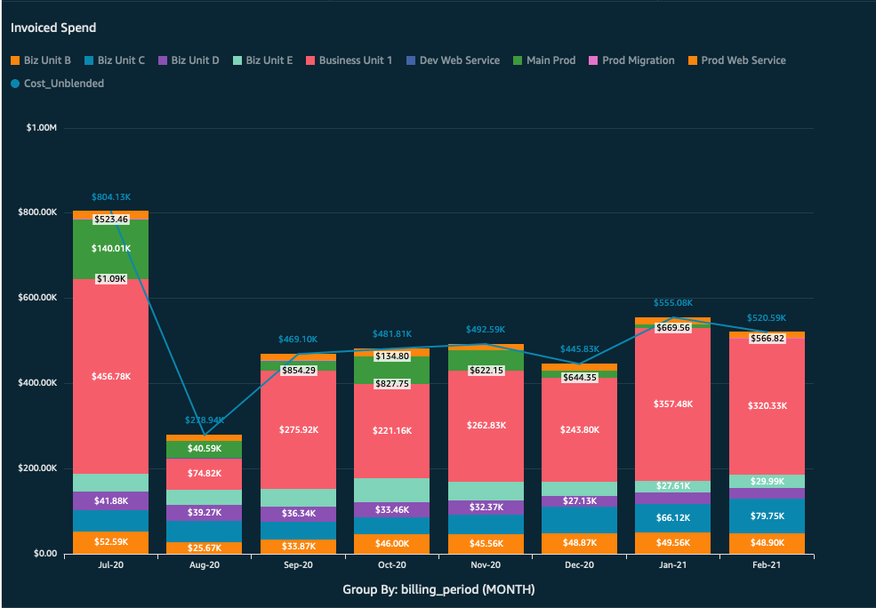 | This graph shows the invoice spend over time. The line represents the total, and the sections of the bars represent any of the following; Account ID, Payer Account, Region, Service, or Charge Type. Grouping by Charge Type, for example, will let a customer see when a refund or credit was applied and how it affected the overall invoiced amount. Grouping by Service will let a customer see which service was invoiced the most in any given month, and how that has changed over time.
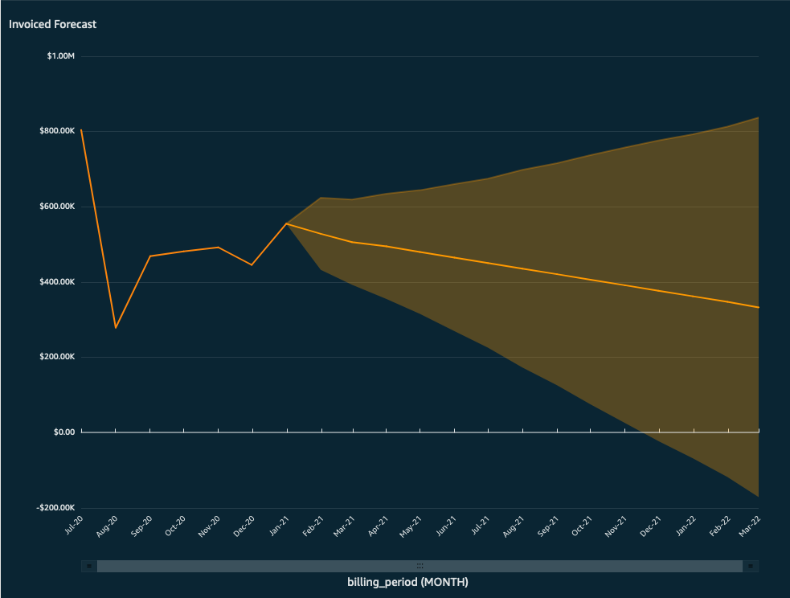 | This uses QuickSight's forecasting feature to forecast the total invoice amount into the future. The shaded area represents the confidence interval, meaning the forecasting amount, in reality, is likely to fall within the shaded area. The further away from the center line the less confident the model is. More information on forecasting in QuickSight.
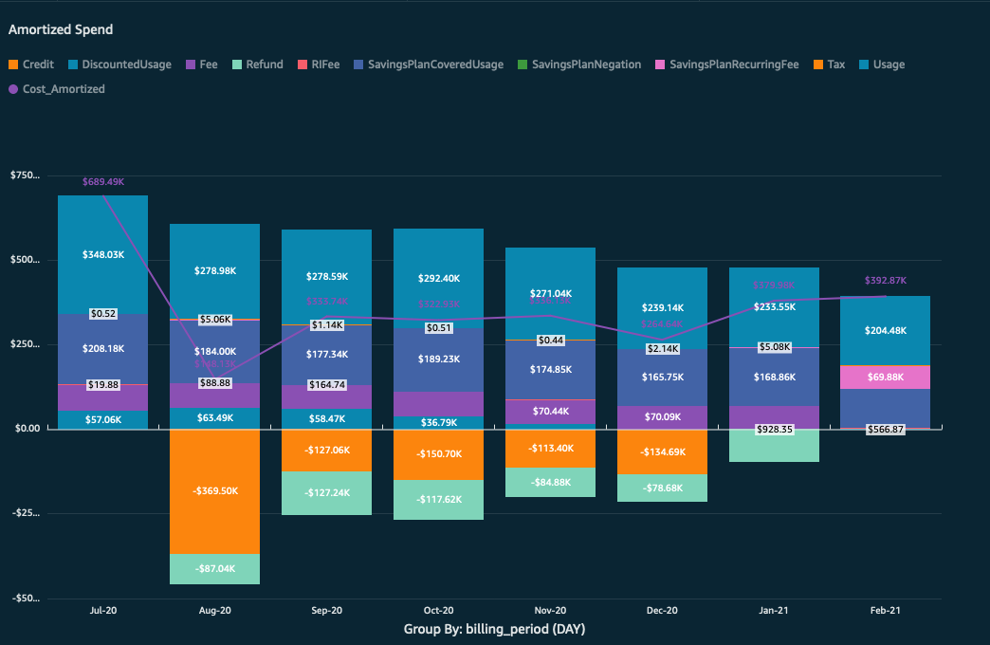 | This graph shows the amortized spend over time. The line represents the total, and the sections of the bars represent any of the following; Account ID, Payer Account, Region, Service, or Charge Type. Grouping by Account, for example, will let customers see the true cost of running their applications in that account, based only on usage and an amortization of upfront fees. The application of the upfront fees to each account is based on how much of an RI/SP that account used, even if that RI/SP was purchased in another account.
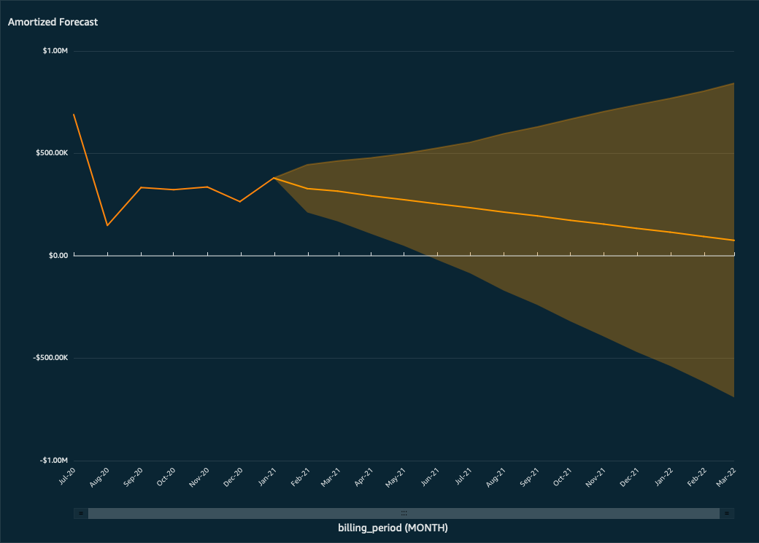 | This uses QuickSight's forecasting feature to forecast the total amortized amount into the future. The shaded area represents the confidence interval, meaning the forecasting amount, in reality, is likely to fall within the shaded area. The further away from the center line the less confident the model is. More information on forecasting in QuickSight.

Cost Summary
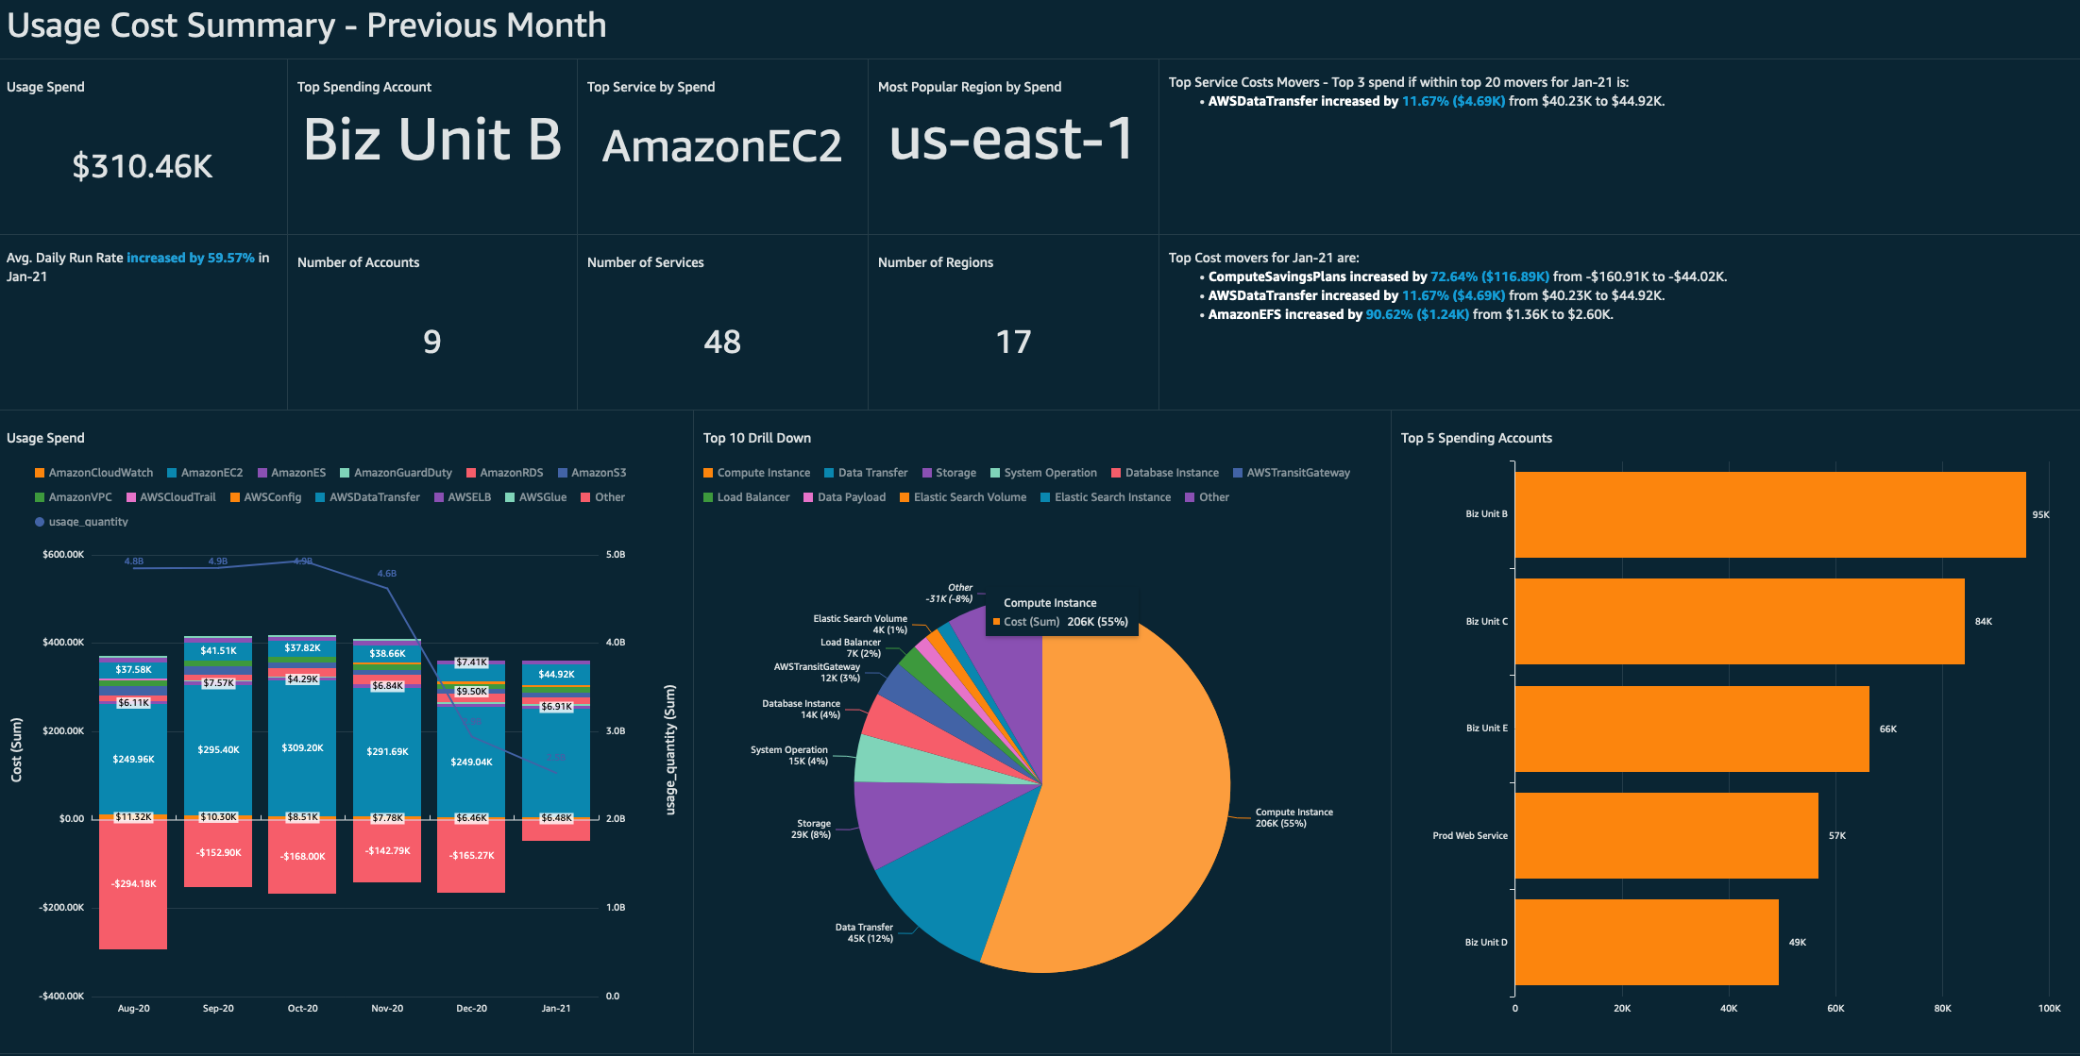
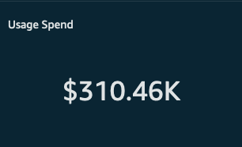 | The usage spend is the amount of money a customer spent in the previous month only on their usage. This is useful to figure out how much it costs to run applications, independent of fees and market place purchases.
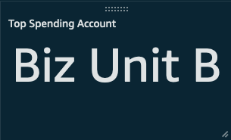 | In the previous month, the linked account "Main Prod" was the top spending account by usage.
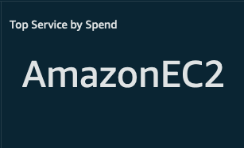 | In the previous month, Amazon EC2 was the top service by spend.
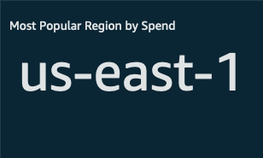 | The most spend went to this region in the previous month.
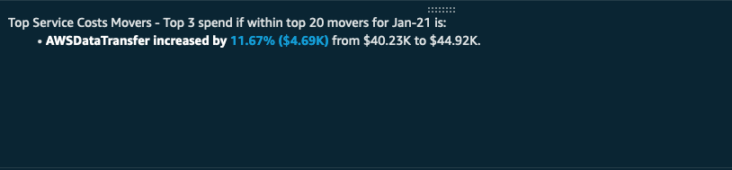 | This visual uses the QuickSight Trend Group feature to lists the most expensive of the top 20 cost movers in the previous month. The difference in cost might not be as high as others, but the total spend is higher.
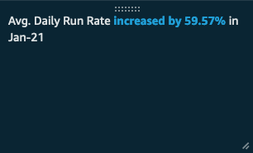 | The average daily run rate (the total usage cost divided by the average number of days in a month) has increased this month when compared to last month.
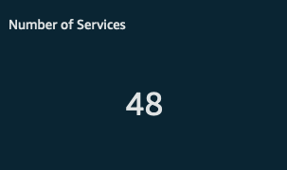 | The number of accounts that were linked in the CUR in the previous month.
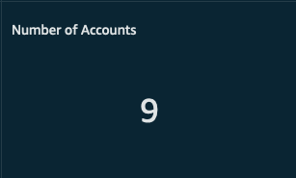 | The number of services used in the previous month. Customers should keep an eye on this number as it changes over time. Innovation and modernizing often involve using more AWS services than before.
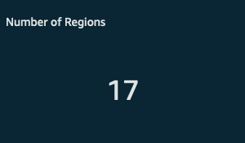 | The number of regions the customer has deployed services to in the previous month. Taking advantage of all of AWS regions helps customers with high availability and running applications as close to the end user as possible.
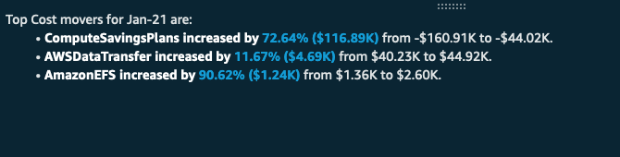 | These are the top cost movers for the current month compared to the previous. These are ranked by the size of the difference in cost, not by the total amount of spend.
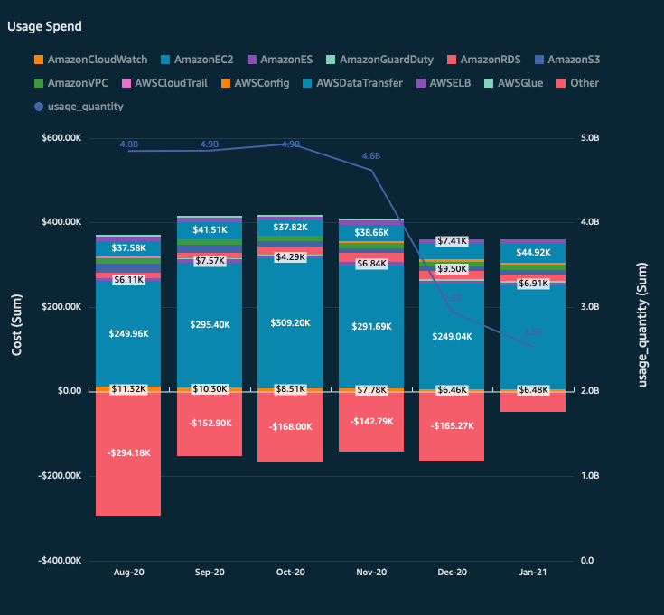 | This visualization compared usage quantity to usage spend. The line part of the graph is the usage quantity, which is an amalgamation of total GB stored, instance hours, Lambda function, etc. The goal is to see which direction things are trending. If usage is going up and spend is going up, there might be opportunity to look for more cost-optimization. In general, we'd expect costs to go up with usage, at least a little, but if a customer saw big differences between the two, they should start looking at some other visualizations in the dashboard to figure out whether or not they're cost-optimized. The bar stacks can represent linked accounts, purchase option, and service by default.
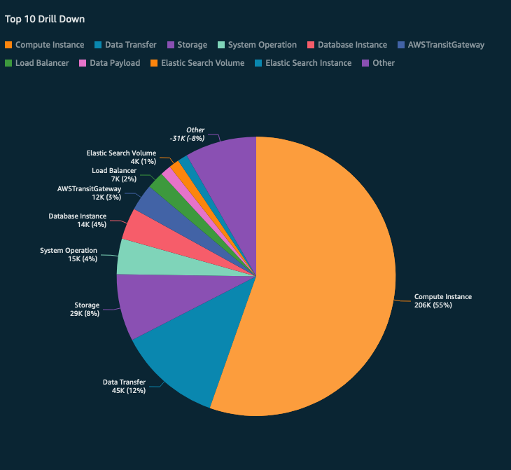 | A drill down of the top 10 accounts, services, product group, or region. Groups of usage that don't fall into the top 10 are summed together into the 'other' category.
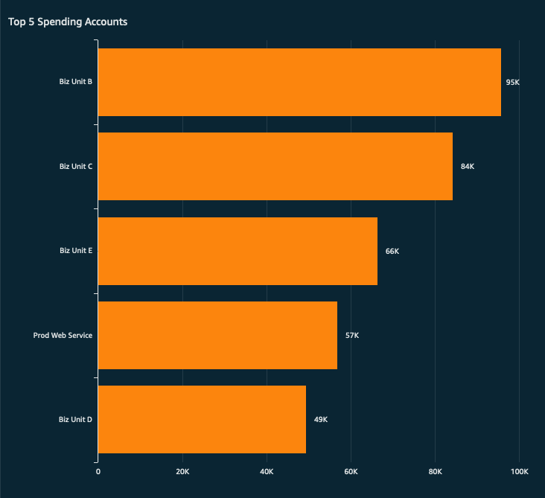 | These are the top five accounts by usage spend.
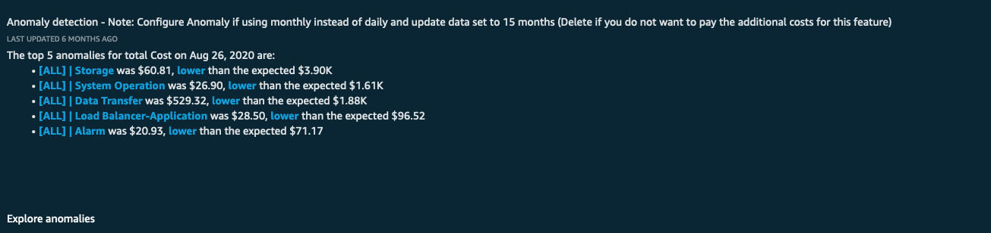 | The anomaly detection visualization uses QuickSight's Anomaly Detection capabilities to surface any suspected anomalous cost and usage patterns. Customers can explore the anomalies further and see visualizations of where and when the anomalies occur, and insight into which accounts and services are responsible. This capability has its own pricing which is detailed here.
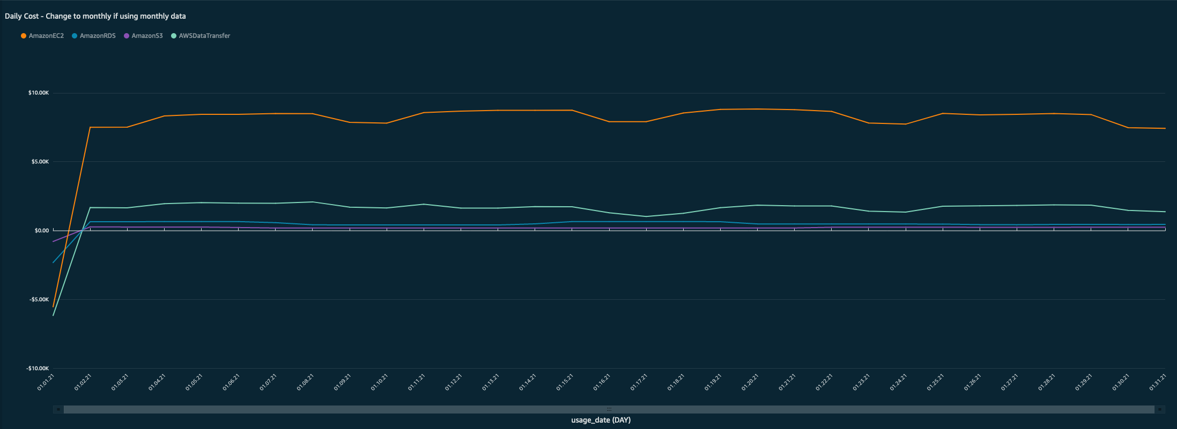 | This line graph displays the sum of the usage cost per day, and can be grouped by service, account, product group, or charge type by default. Customers can look for spikes in usage by service or account. Spikes in usage often account for higher AWS bills that expected.

Compute Summary
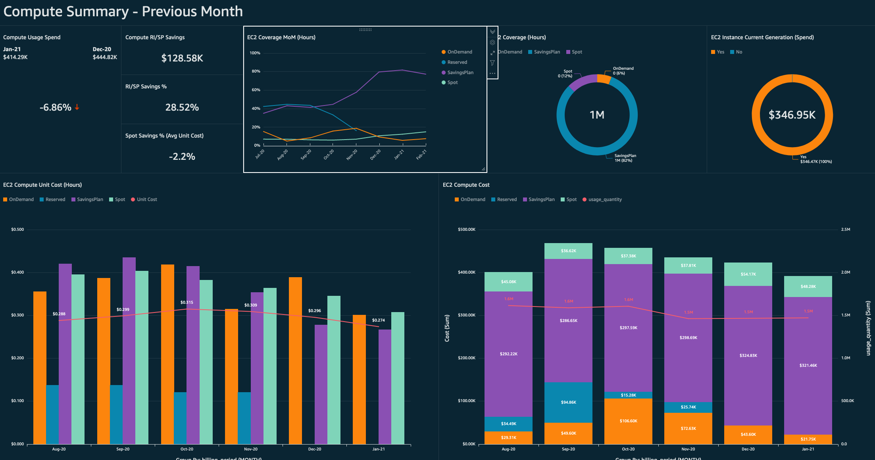
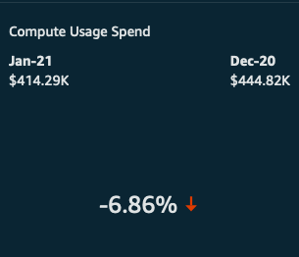 | The compute usage spend displays the amount of spend in the previous two months that was spent on Compute usage only. It will also display a percent change in the prior month to the one previous to that.
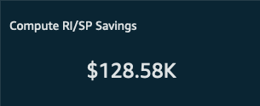 | This amount is how much was saved in the prior month using Compute RIs and SPs.
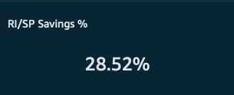 | This percentage is derived by dividing the sum of all cost in the previous month by the sum of the public on-demand pricing for the same usage. The result is the difference in what you actually spent on Compute in the prior month to what the same usage would've cost using public on demand pricing, as a percentage.
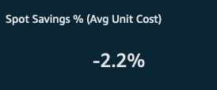 | This shows a percentage derived by dividing the on demand unit cost by the average Spot unit cost. The on demand unit cost is the overall cost divided by the usage quantity. In effect, this visual tells you how much you saved using Spot when compared to the on demand equivalent of usage.
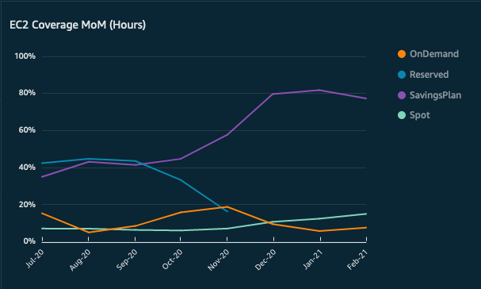 | This shows the percentage of coverage, month-over-month, of compute the purchase options reserved instances, savings plan, Spot, and on demand. That is to say, the amount of compute usage that was covered by one of these four purchase options for the given month.
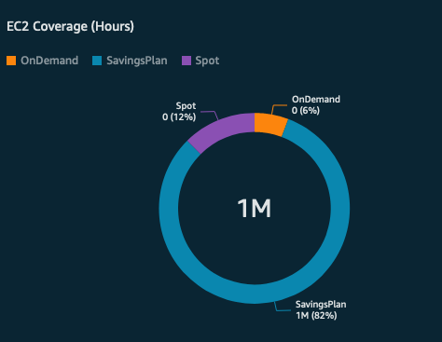 | This graph shows only the previous month's coverage, by hours, of each of the four purchase options; reserved instances, Spot, savings plans, and on demand.
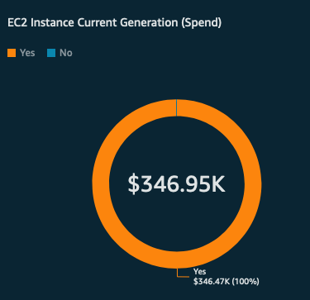 | This is a breakdown of all EC2 Instance spend, in the previous month, by instance generation. Instance generation is broken up into two groups; current generation and previous generations. Customers who have a lot of spend on previous generation instances should consider upgrading their instances.
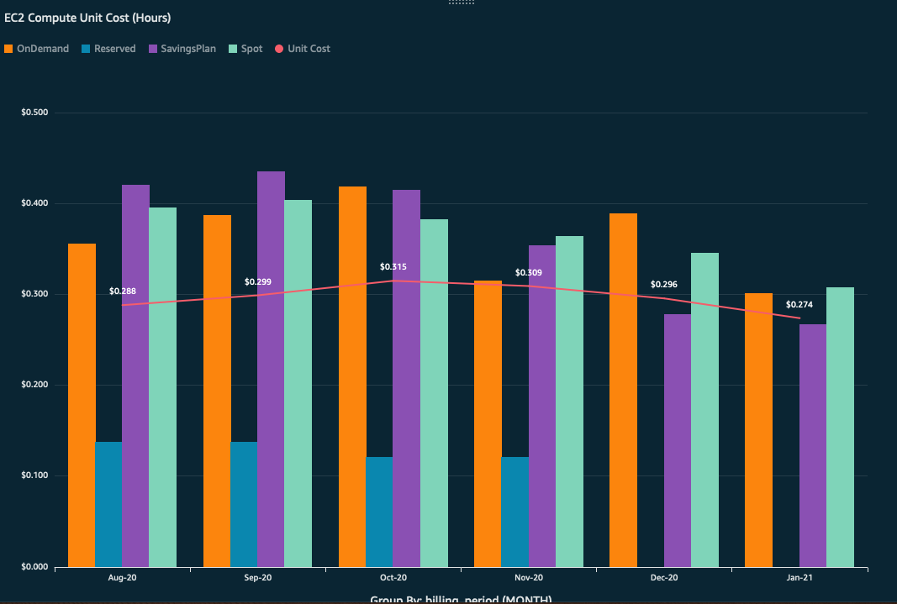 | This visualization is to be used in combination with the one below. The line part of this graph shows the unit cost of running EC2 Compute per hour. Customers can compare how their per hour average cost of EC2 (or their unit costs) with their overall spend across the four purchase options. If a customer's unit costs are going up, they might want to look for opportunities to use more Spot, RIs, and/or SPs. One should compare the unit cost with the usage quantity in the graph below.
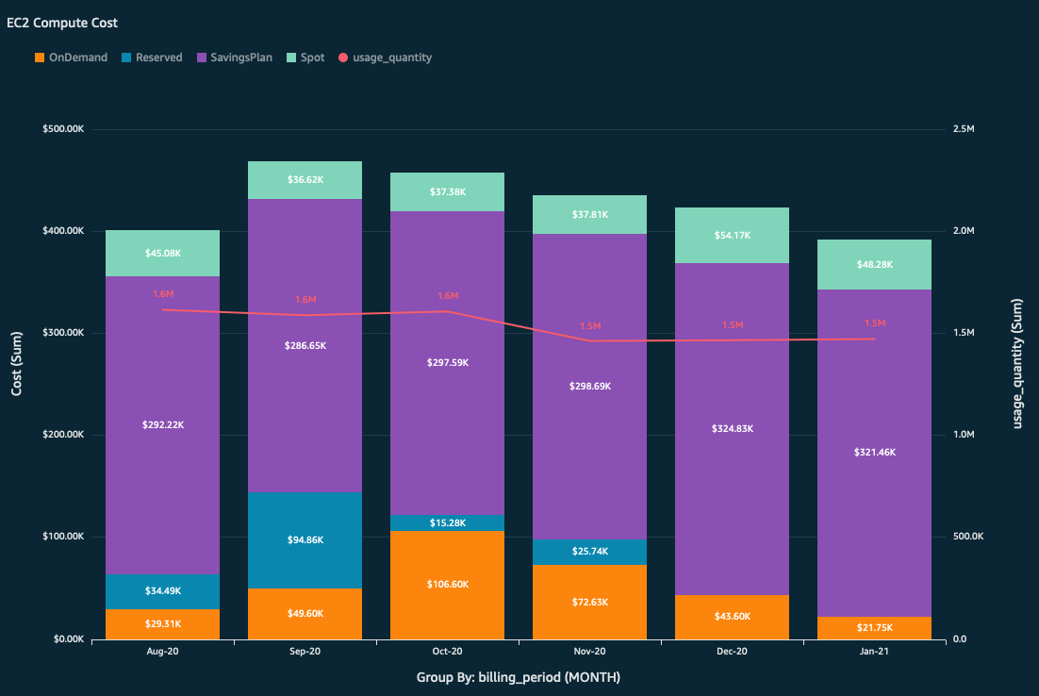 | This visualization is to be used in combination with the one above. The red line is the total number of hours of EC2 run during the given month. The bar graph represents the amount spend per purchase option. Customers can compare their unit costs in the previous graph to their usage quantity in this graph. As their usage of EC2 increases, their unit costs should stay flat or go down. That will only happen if they are making good use of SPs, RIs, and Spot.
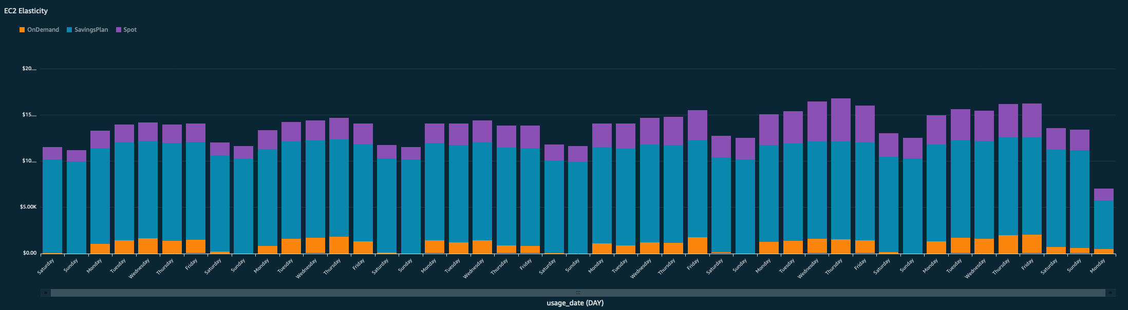 | This graph shows the EC2 elasticity over the past few weeks. Each bar represents a day, and it is grouped by purchase option. You can use this to see if you have instances running on the weekends when you don't think there should be (because, perhaps, you are a bank).

Storage Summary
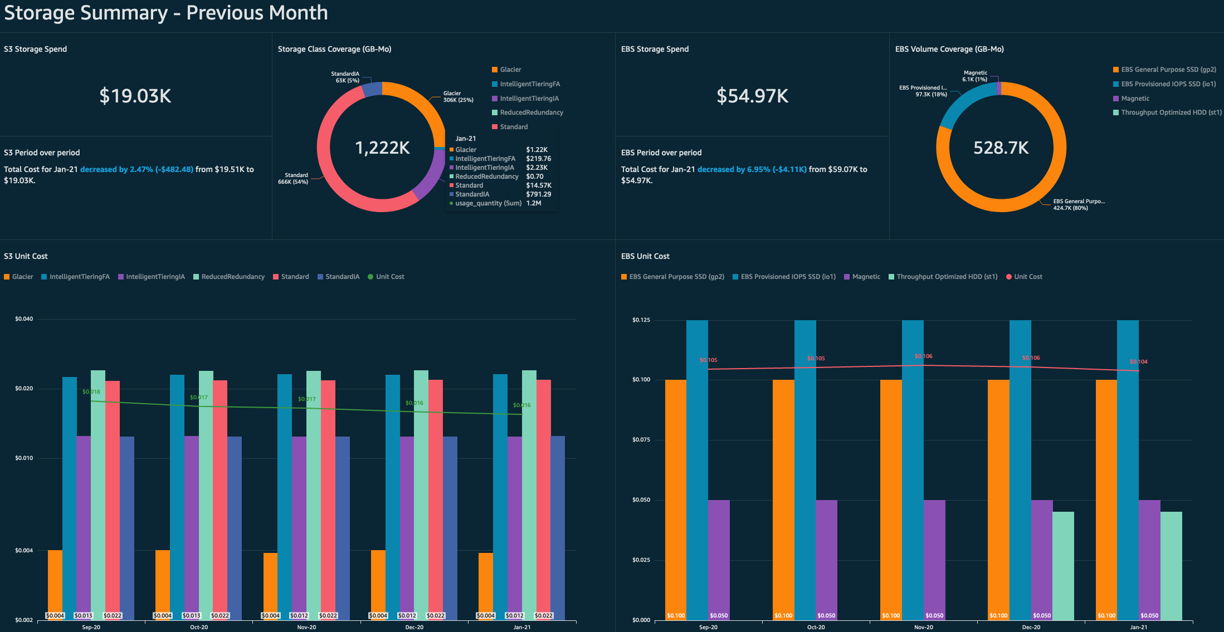
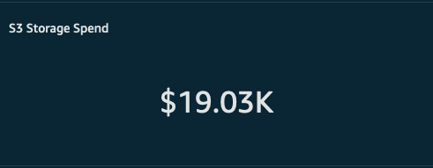 | This visualization details how much was spent on S3 storage only in the previous month. No other costs go into this number such as fees or marketplace purchases.
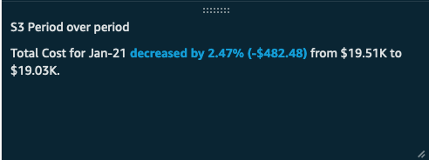 | This visual shows you how the cost of your S3 services has changed from the prior month compared to the month prior to that.
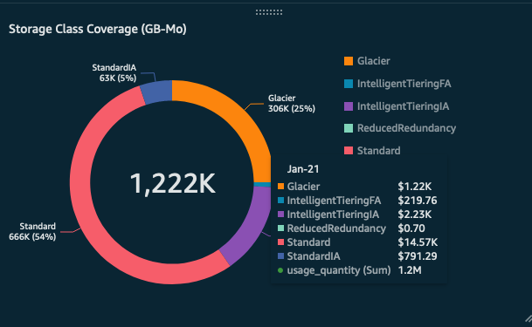 | You can use this graph to see how many GBs were spread across the different S3 storage tiers, including Glacier, in the previous month. Customers might look for opportunities to save by storing more in Glacier or using Intelligence Tiering.
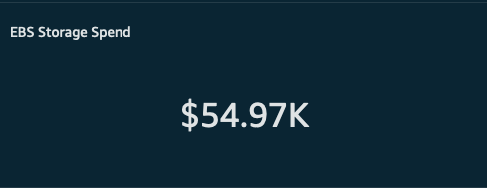 | This represent the total cost of EBS storage in the prior month.
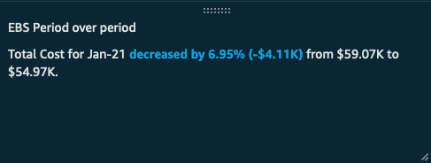 | This visual shows you how the cost of your EBS storage has changed from the prior month compared to the month prior to that.
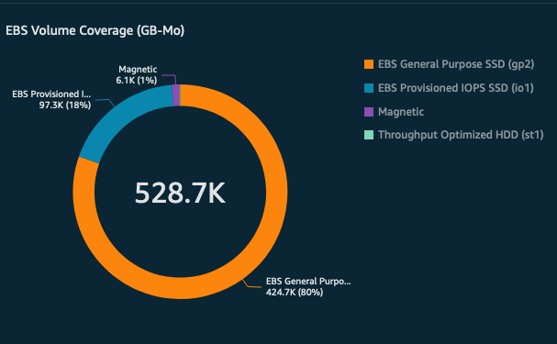 | This shows a breakdown of spend by EB2 Volume type. You can look for opportunities to cost optimize by shifting spend to slower or cheaper types of EBS Storage.
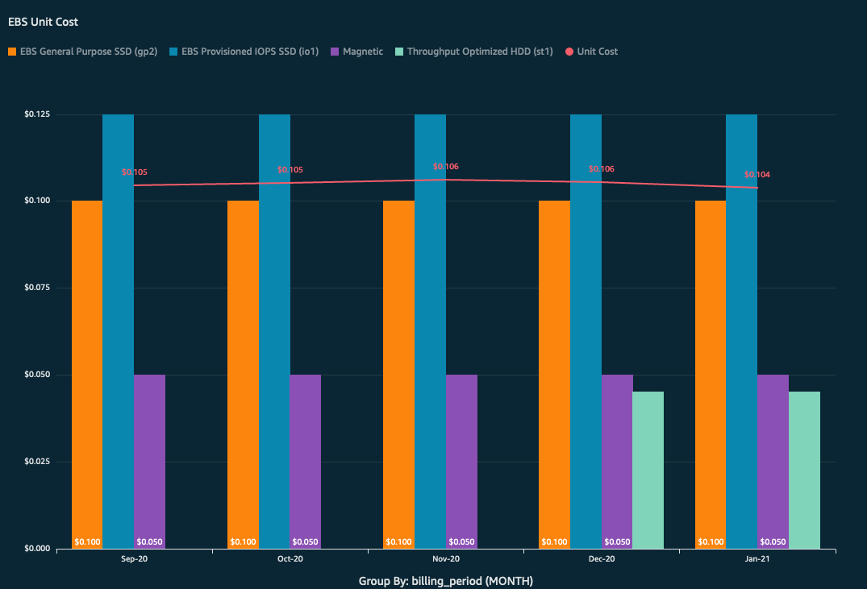 | This visualization is meant to be used in conjunction with the one below. The green line represents the unit cost of storage, per GB. This is derived by dividing the total cost on storage by the number of GB stored. You can compare the trend of your unit cost to your spend. If unit costs are rising, it might make sense to explore using more Glacier or less expensive storage tiers.
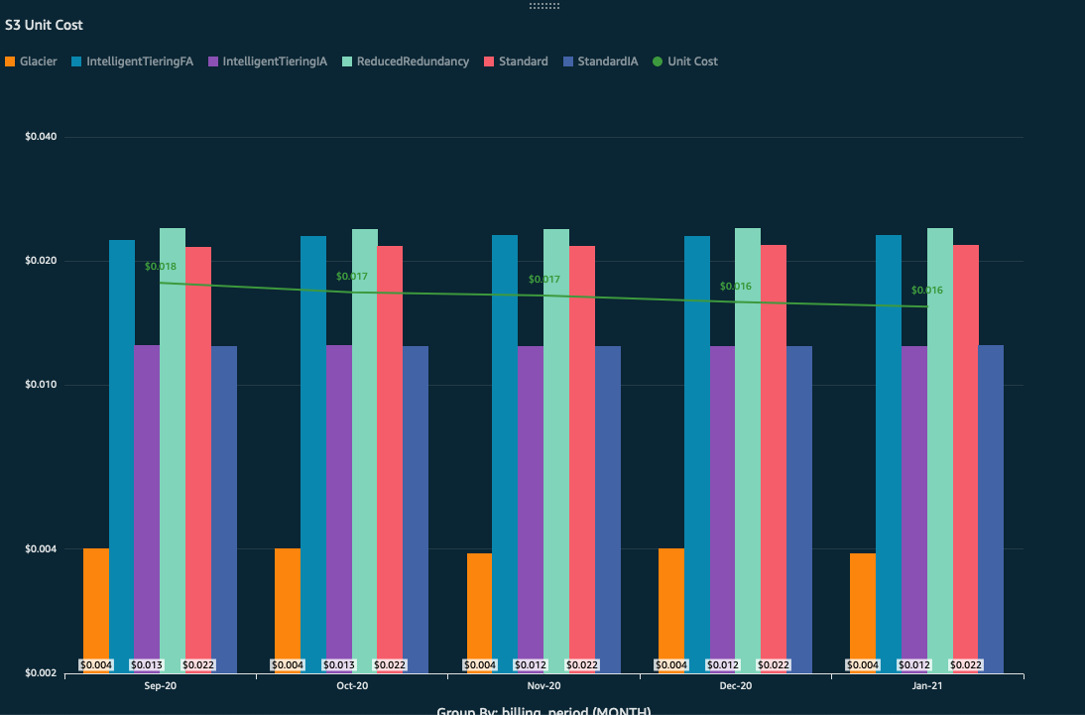 | This graph shows the total number of GB stored on EBS (the green trend line) compared to the overall spend on the different EBS Storage types. As total number of GB decreases, we expect the total amount of spend to decrease as well. If the customer is making more cost-optimized EBS Service storage choices, the usage line in this graph might go up, but the unit cost in the graph above might stay flat or go down.
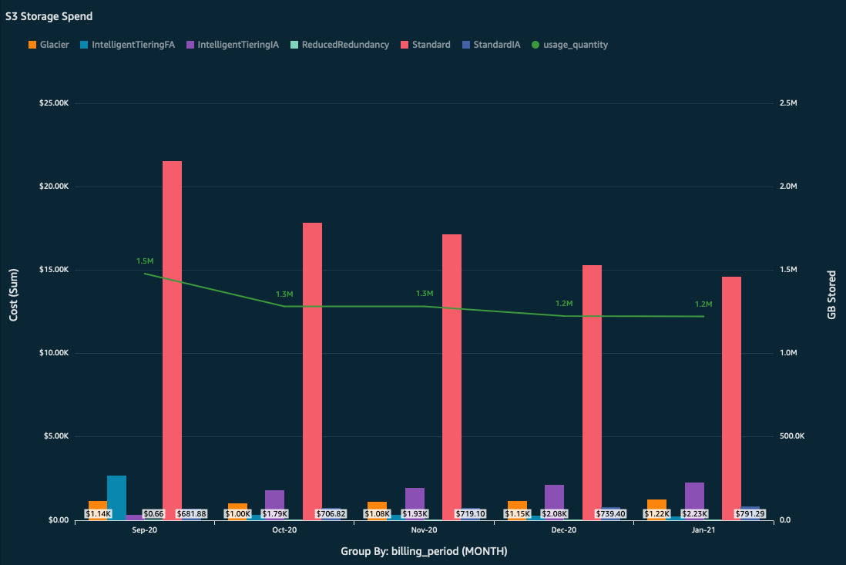 | This visualization is meant to be used in conjunction with the one above. The green line represents the total number of GB stored in S3. The bars show you how much you're spending per storage tier or class. You should compare the trend of how many GB you are storing to the unit cost per GB (above) and make sure unit costs are staying flat or going down. One can accomplish this usually by taking more advantage of Intelligent Tiering, Glacier, and other less expensive storage tiers (at the expense of being slower).
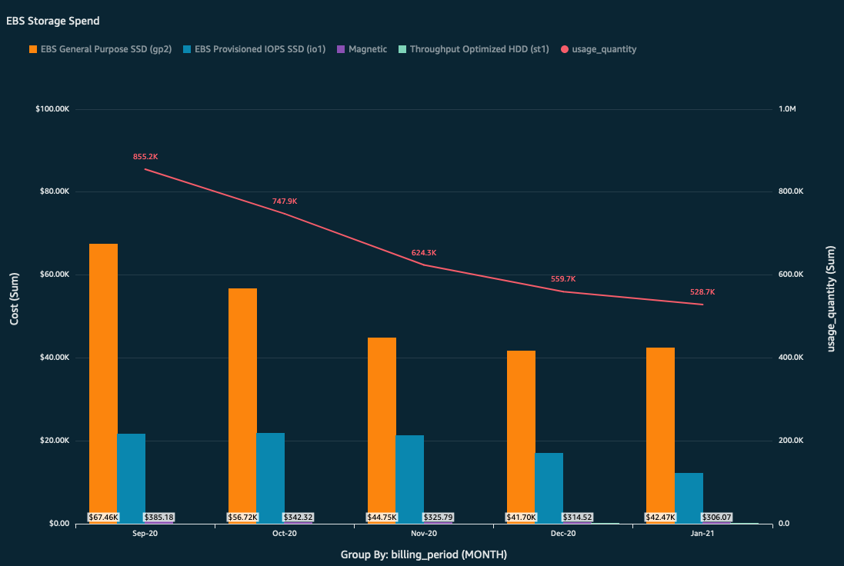 | This graph shows the total number of GB stored on EBS (the green trend line) compared to the overall spend on the different EBS Storage types. As total number of GB decreases, we expect the total amount of spend to decrease as well. If the customer is making more cost-optimized EBS Service storage choices, the usage line in this graph might go up, but the unit cost in the graph above might stay flat or go down.
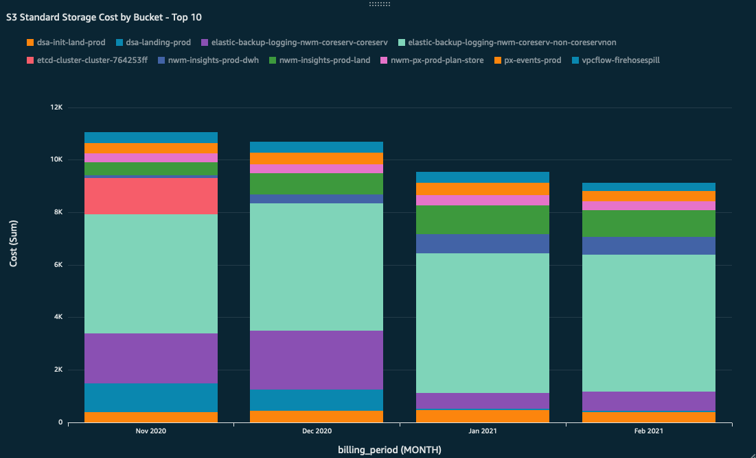 | This graph shows you the cost of each bucket, and how that has changed over time. Helpful to compare this graph to the one next to it on the Dashboard to see how the amount being stored compares to the cost on a bucket-by-bucket basis.
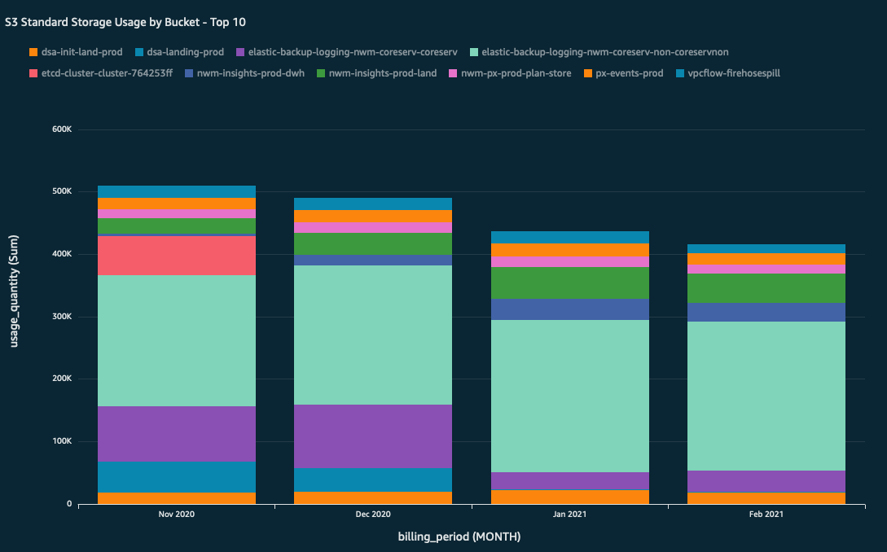 | This graph shows you the total number of GB stored in each bucket, and how that has changed over time. Helpful to compare this graph to the one next to it on the Dashboard to see how the amount being stored compares to the cost on a bucket-by-bucket basis.

Reserved Instance & Savings Plan Summary
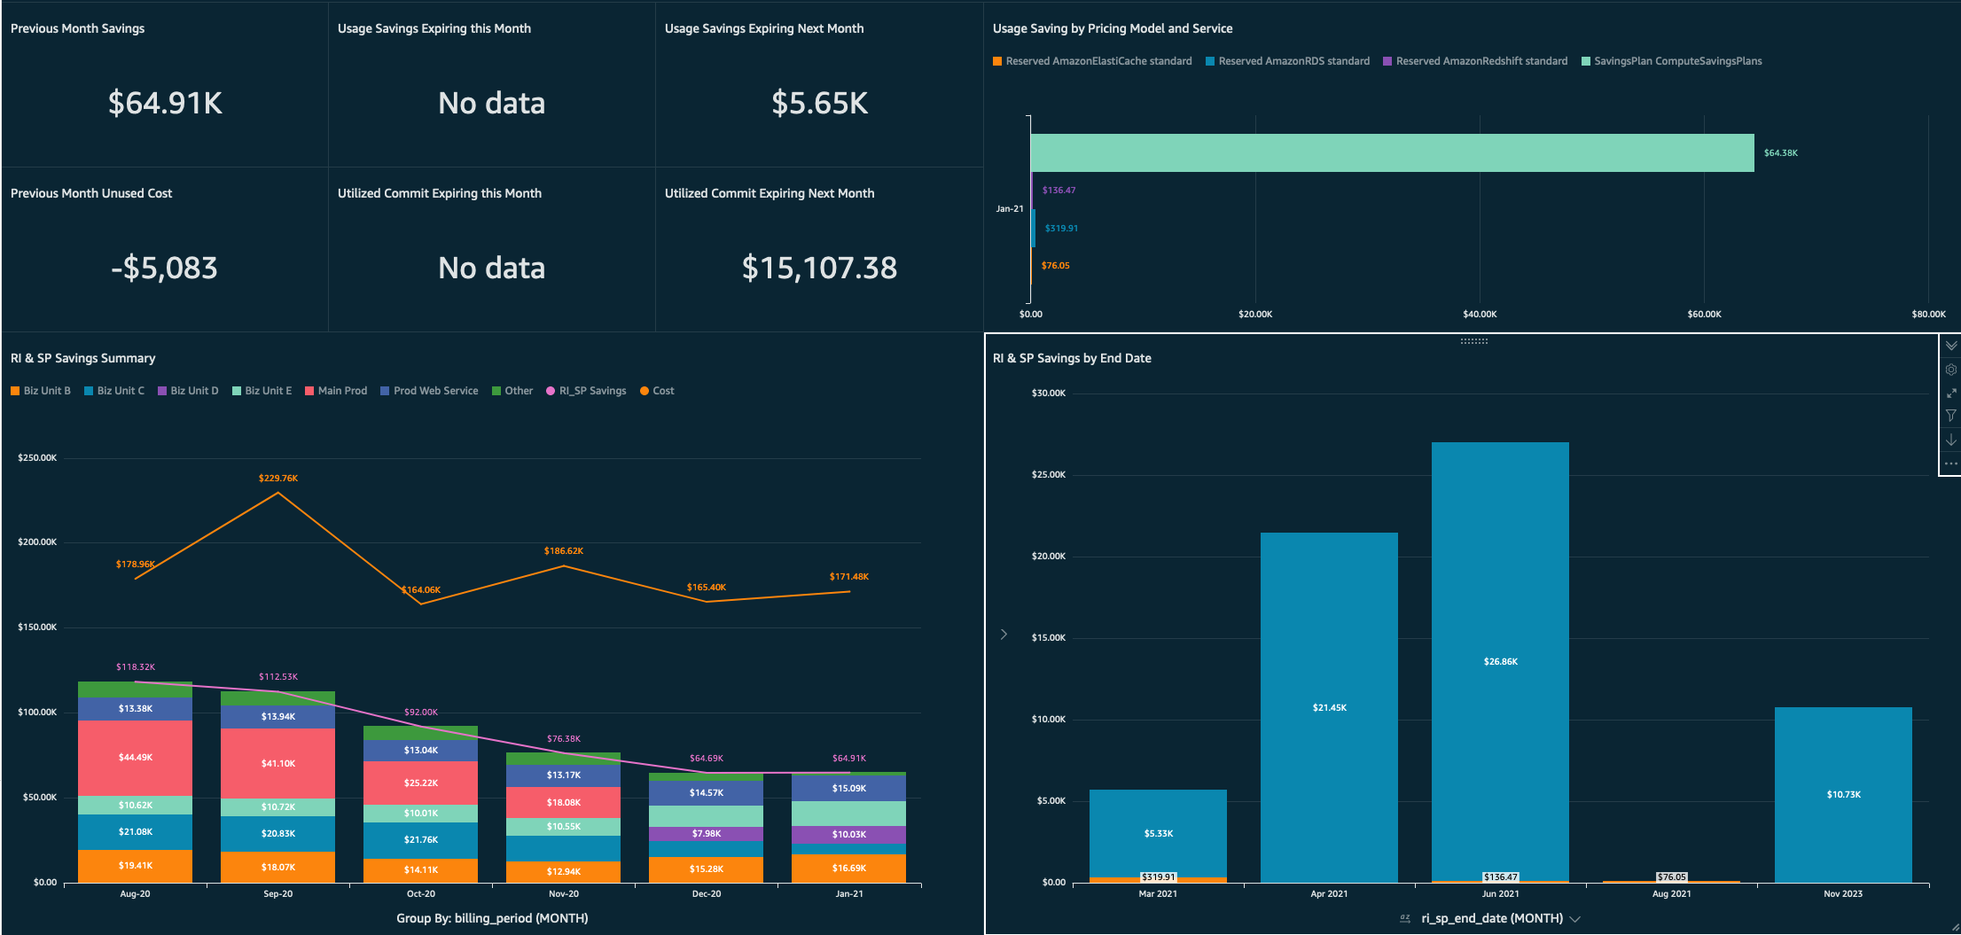
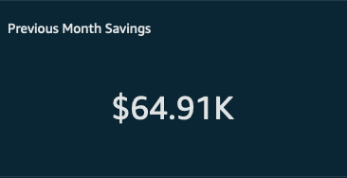 | This is how much was saved in the prior month by using Savings Plans and Reserved Instances. If this number is negative, then you didn't use enough of your RIs and/or SPs to see any savings, and it would have been less expensive for you to use On Demand.
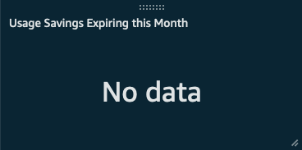 | This number represents how much savings is going to expire this month. This is savings realized by using RIs and SPs. It also means one of them is going to expire this month, and that you should renew to make sure your bill doesn't go up by this amount next month.
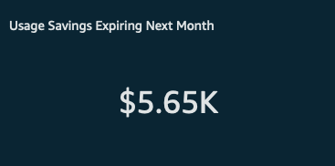 | This number will show you how much savings is going to expire next month. This is savings realized by using RIs and SPs. It also means one of them is going to expire next month, and that you should renew to make sure your bill doesn't go up this amount two months from now.
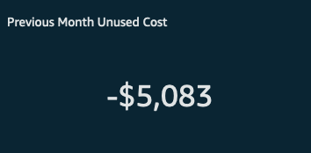 | This is how much money you spent on RIs and Savings Plans that didn't get used. If the number is $0, that means you used all of your RIs and SPs in the previous month.
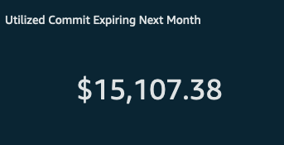 | This number is how much you've committed in cost to RIs and SPs that is expiring this month.
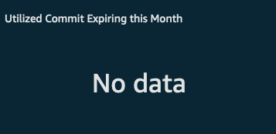 | This number is how much you've committed in cost to RIs and SPs that is expiring next month.
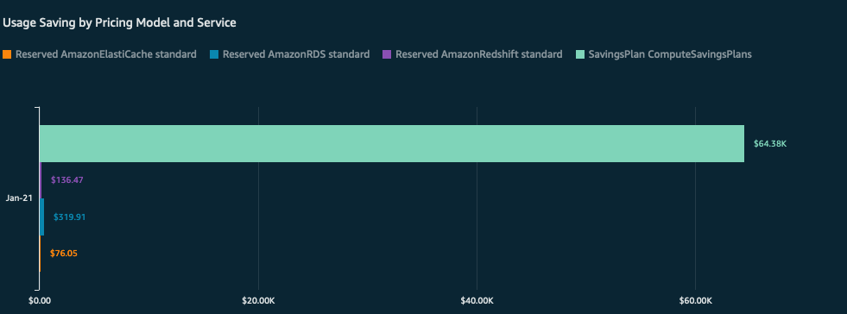 | This graph is showing you the savings you are seeing, based on usage or RIs and SPs, grouped by service. This way, you can see which services are savings the most.
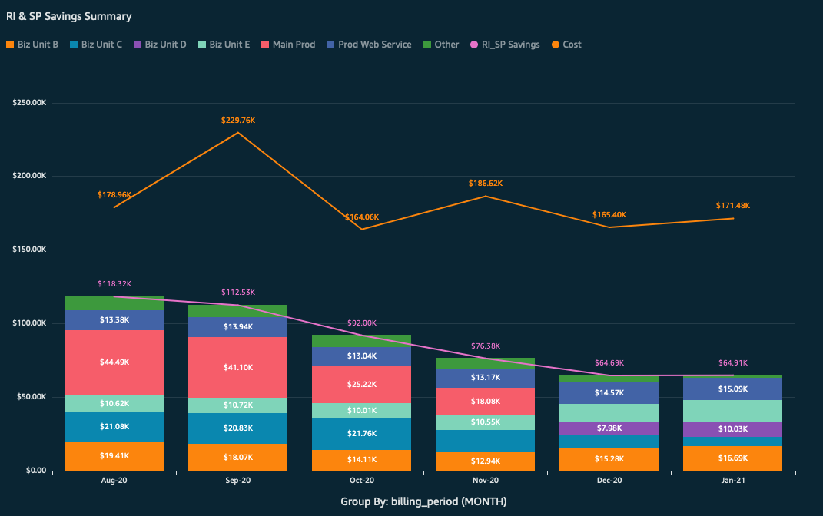 | This graph shows the RI and SP savings amount (as a pink trend line) compared to which accounts saw the savings. There is also a trend line in orange that displays the overall usage cost for the time period. This graph lets you see how much savings each linked account gets. You can use this visualization to generate reports to each account owner, or to business owners about their spend and savings. Accounts that use more RIs and SPs will see more savings.
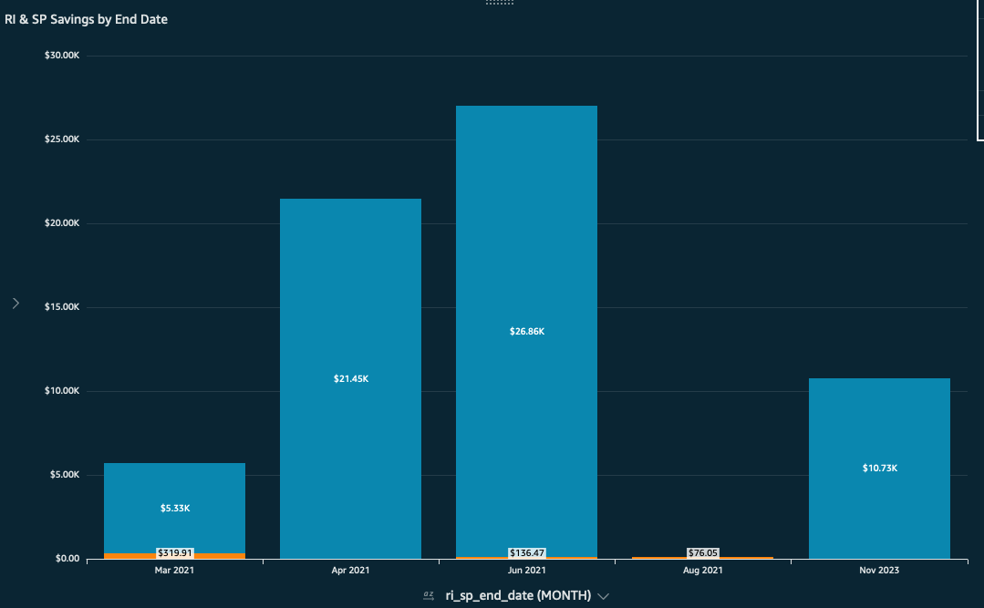 | This visualization is a graph telling you when your RIs and SPs are expiring, and how much savings will be expiring along with it. If you do nothing, these will be the amounts your bill goes up and when they will go up. Use this graph to help stay on top of renewals.
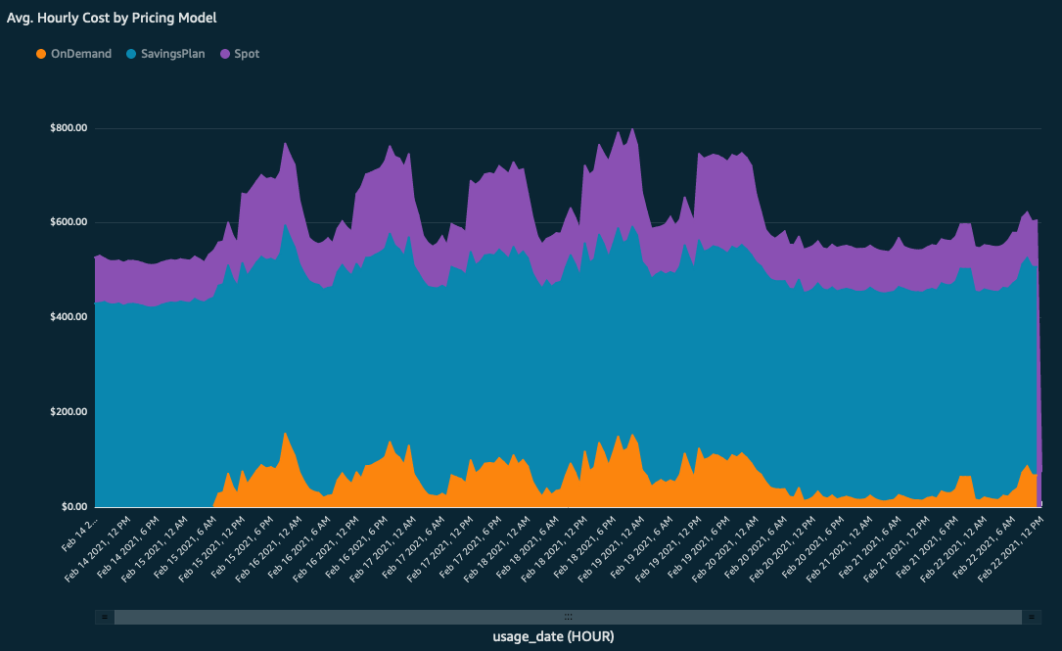  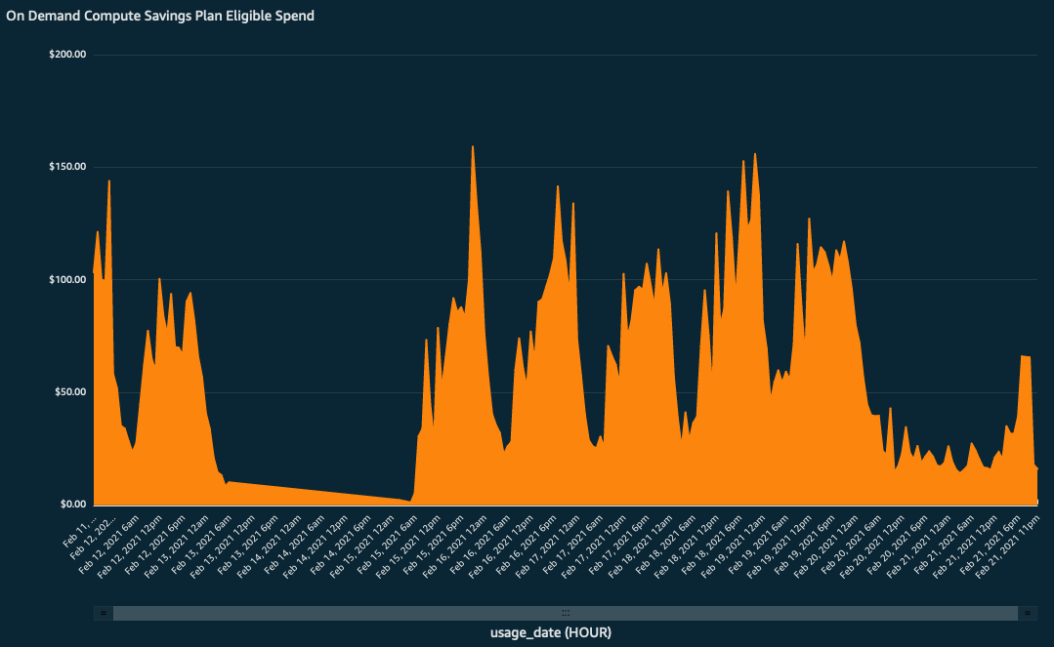 | These two visualizations together represent the opportunity you have to save more with a savings plan. The graph on the left shows the average hourly cost of Compute services, separated by pricing model. The orange section represents the On Demand spend and is blown up for the graph on the right. This On Demand spend is Savings Plan eligible which means if the graph never dips below a certain cost over a given period of time, you might want to commit that amount to a savings plan to see more savings.

Expiring RI/SP Tracker
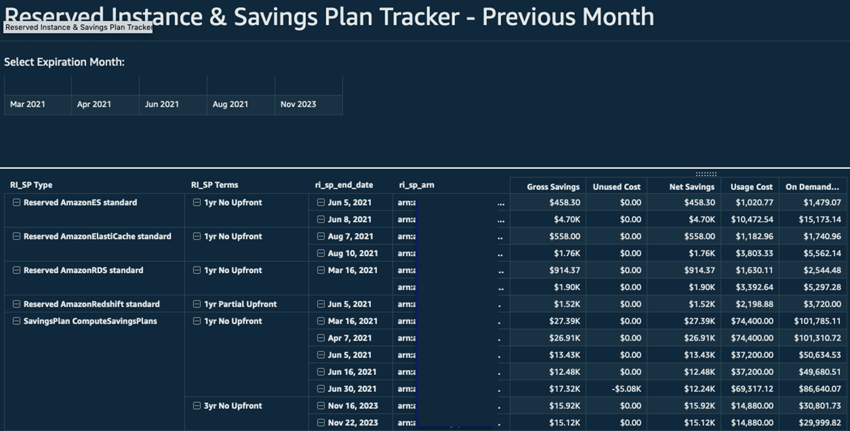
This tab shows a pivot table of all of the RIs and SPs, when they expire, what their term is, what their ID is, what was committed or how much they cost, how much On Demand equivalent usage they incurred, and how much you saved. Use this to quickly get a report of the status of RIs and SPs.

OPTICS Explorer
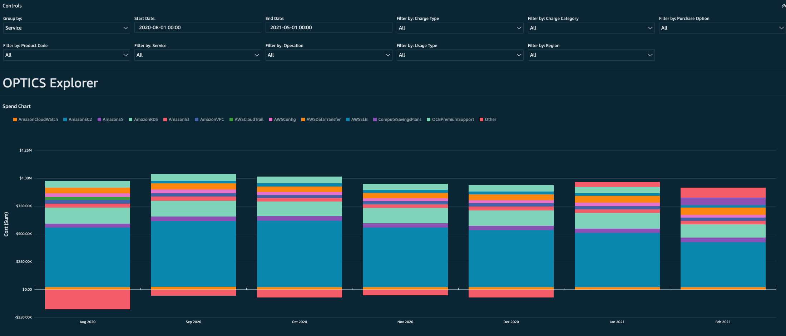
This is the Optics Explorer which is an ad hoc query tool to further query your data. Expand the control section on the top to input sorting groups and filters as well as a date range. The graph below will display the information over time as a stacked bar graph. Useful for customizing queries and testing out custom visualizations before building permanent versions in the dashboard.

MoM Pivot
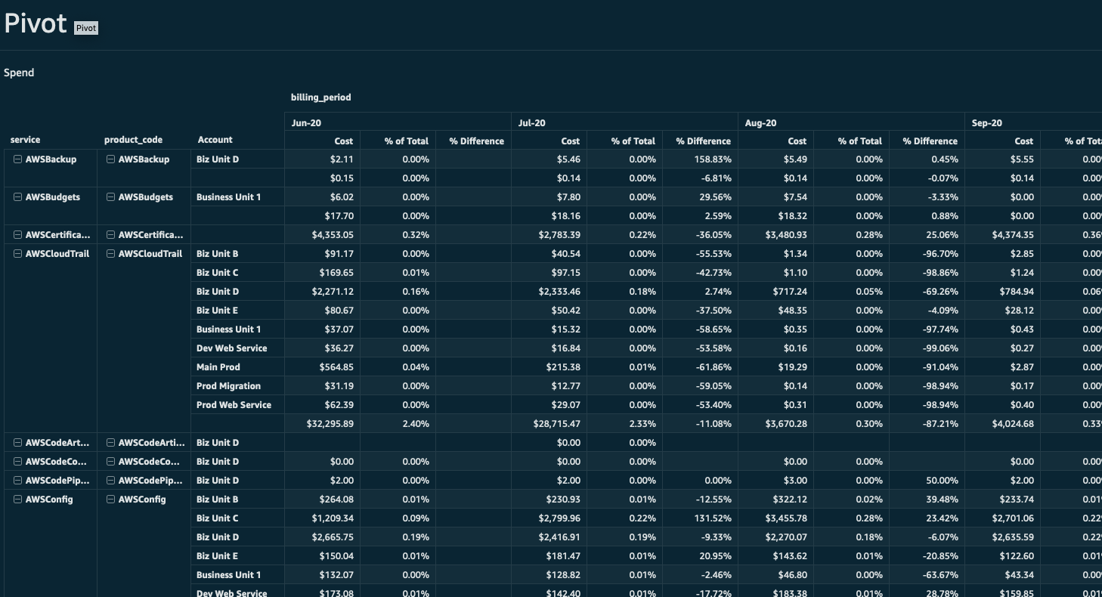
The MoM Pivot is a pivot table of both spend and usage, grouped by month.

Customizing the OPTICS Explorer Controls
The OPTICS Explorer uses QuickSight controls to allow your teams to Group or Filter fields.
- Customizing the Filter by: controls
- The Filter by: controls uses the standard process documented in the Setting Up Parameter in Amazon QuickSight User Guide.
- Customizing the Group by: Control
- To update the Group by: Control first select the drop-down arrow next to the Group by header in the Controls field and select Edit
- Next add your desired values to the Define specific values box with one value per line then select Apply
- Finally edit the Group By Fields calculated field by scrolling to the bottom of the calculation and adding the following between {charge_category}, and service)
- ${GroupBy}=('Your added grouping defined in the previous step’),({corresponding field to map to}),
Note:
- Parameters and Controls can be used on any report. We recommend adding a control for the full dashboard for your business units or organization groupings.

Additional Resources
For more information visit the following User Guides:
- Cost and Usage Reports User Guide
- QuickSight User Guide

