**INSTITUTE HOSTEL LEAVE FORM**

Name of the Hostel Inmate : P.Veera Abhiram

Inmate Phone No : 7396941375

Hostel Name : Ashoka

Room No : 320

Reason for leave : Family Function

Date of Journey (exit from hostel) : 31.03.2023

Return Date : 05.04.2023

Destination (Complete Address) : 6-6-95/1B, siva rama Krishna nagar, 2nd lane, badvel,Kadapa, Andhra Pradesh-516227

Parents / Guardian Mobile No : Father : 7386663335

Mother : 9441052785

Inmate’s Signature : 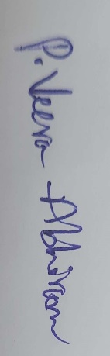

Approval of Wardens :

In the event of unplanned stays (Rules 4 to 6) text of Message to be acknowledged by parent / guardian

I, --------------------------------- Parent / Guardian of ------------------------------ hereby acknowledge that my ward has reached my place safely and we take responsibility of his / her well being.

For parents not comfortable with English, they may text eh equivalent of above in their native language. HO Phone No : 8778400261