**Aditya Jaiswal**

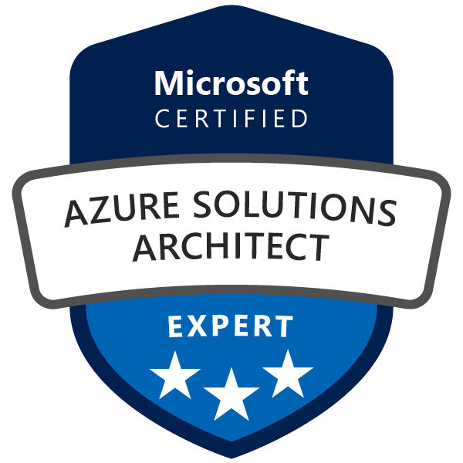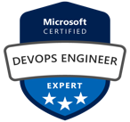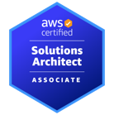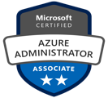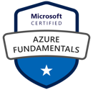

**Total Exp: 5 Years**

**Relevant: 5+ Years**

**Ph: +91 1234567890**

**Email: abc@gmail.com**

**Noida**

# PROFFESIONAL SUMMARY

* A qualified and result-oriented professional with overall 5 years of experience in IT Industry, as a DevOps Engineer with hands-on experience supporting, Automating, and optimizing mission critical deployments in production server & cloud. Building, Deploying, Source code management, leveraging configuration management, CI/CD, and DevOps processes. Strong hands on experience in IAC tools like Terraform and Ansible.
* Certified Microsoft Azure **Solution Architect** Expert (AZ-305), Microsoft Azure **DevOps** **Engineer** Expert

(AZ-400) & AWS Solution **Architect** Associate (SAA-C03)

# TECHNICAL SKILLS

|  |  |
| --- | --- |
| Version Control | Azure Repos & Git |
| Build Tool | Maven, NodeJS(Basics) |
| Continuous Integration Tool | Azure Pipelines & Jenkins |
| Containerization | Azure Container Registry (ACR) & Docker |
| Configuration Management Tool | Ansible |
| Container Orchestration tool | OpenShift, Azure Kubernetes Service (AKS) |
| Cloud Technology | Azure, Azure DevOps |
| Scripting/Command-Line | Shell Scripting |
| Infrastructure Provisioning Tools | Terraform |
| Security Tools | Trivy, OWASP Dependency Check |
| Code Quality Check Tool | SonarQube |

# WORK EXPERIENCE

**Current Organization:**

**Capgemini Technology Services India Ltd**

**Designation: Consultant -** July 2019 –Present

|  |  |  |
| --- | --- | --- |
| **Role** | **Project** | **Tools Used** |
| Azure DevOps Engineer | Cloud DevOps | **Azure DevOps** àAzure Pipeline, Service Connection, SelfHosted Agent, Azure Boards, Azure Artifacts  **Azure Cloud** à VM, VNET, Subnet, NSGs, ACR, AKS, Load  Balancer, Azure AD, Azure Functions etc **IaC** à Terraform & ARM templates |
| **Key Contributions:**   * Experience in creating Azure CI/CD Pipeline **(Build & Release)** from scratch using both Classic editor and **YAML** method * Integrate various tools across Pipeline stages such as **SonarQube**, **OWASP**, **Trivy** as per requirement * Used **Maven** & MS Build as a build tool for Java & DotNet project respectively. * Experienced with both Azure MS Hosted Build Agent & **Self-Hosted** Agent configuration. * Performed security checks for vulnerabilities on application using **OWASP** Dependency checks * Artifacts management using Azure **Artifacts** in Azure DevOps * Container Image Vulnerability detection using AquaSec Trivy * Created **Terraform** & **ARM** template for provisioning Azure Infrastructure such as **VM** & **private AKS** cluster through Azure Pipeline. * Experience on Azure PaaS Service like WebApp, Functions & Logic Apps (Serverless) * Used **Azure KeyVault** to store Service Principal Client ID & Client Secret for AKS. * Good Experience with User & Group **Access** Management in Azure DevOps for Organization & Project Scope. * Experience with Azure **RBAC** on Subscription & Resource level * Performed various **PoCs** and provided **Coaching** Services to the Clients as per their CI/CD Project requirements to achieve good **DevSecOps** approach. | | |

**Previous Organization:**

**XYZ Consultancy Services Limited –** Bangalore

**Designation: IT Analyst –** Nov 201X to Apr 202X

|  |  |  |
| --- | --- | --- |
| **Role** | **Project** | **Tools Used** |
| DevOps Engineer | Q_DEVOPS | Gitlab, Jenkins, Maven, SonarQube, Selenium, Nexus, Docker, Grafana, OpenShift, Jira & Confluence |
| **Key Contribution:**   * Experience in using **GIT** and **Jenkins** to create a **Maven** Build jobs for continuous integration. * Experience in automating **CI** & **CD** pipeline using Jenkins for all build and deployments. * Configured **SonarQube** for source code analysis. * Configured **Nexus** Repository for deploying the Artifacts. * Experience in writing **playbooks** for deployment in Docker Container using **Ansible**. * Experience in creating **Docker** Images using Docker file * Good knowledge on **Ansible Playbooks** and **YAML** Scripting. * High-Level knowledge about **Kubernetes**, since it is introduced in our environment recently. | | |

# CERTIFICATIONS

|  |  |  |
| --- | --- | --- |
| **Code** | **Certification Name** | **Completion Date** |
| AZ-305 | Microsoft Certified Azure Solution Architect Expert | Feb-2023 |
| SAA-C03 | AWS Solution Architect Associate | Oct-2022 |
| AZ-400 | Microsoft Certified Azure DevOps Engineer Expert | May-2022 |
| AZ-104 | Azure Administrator Associate | Dec-2021 |
| AZ-900 | Azure Fundamentals | Sep-2021 |
| EX-300 | RED HAT CERTIFIED ENGINEER (**RHCE**) | Aug-2018 |
| EX-200 | RED HAT CERTIFIED SYSTEM ADMINISTRATOR (**RHCSA**) | Apr-2017 |

# ACHIEVEMENTS

* **Customer Delight** à Received for doing multiple POCs and getting good feedback & appreciation from engagements
* **Europe India Awards for Q4 2021** à Value Creator from Cloud DevOps for Q4 2021
* **3 times Hero Of The Cluster** à Received for good work performance in project in a Quarter

# ACADEMIC QUALIFICATIONS

|  |  |  |  |
| --- | --- | --- | --- |
| **Year** | **Degree** | **University/Board** | **Percentage %** |
| 2019 | BTECH - Computer Science Engineering | AKTU | XX% |
| 2014 | School Name | CBSE | XX% |
| 2012 | Cambridge Public School | CBSE | XX% |

# PERSONAL DETAILS

* Marital Status: Unmarried
* DOB: 20th Aug 1998
* Hobbies: Badminton, Cricket, Painting & doing POCs on any Cloud DevOps topics
* Present Location: Bangalore
* Nationality: Indian