**DeepFinLLM: An Intelligent Financial Advisor Unleashing Strategic Insights with Large Language Models**

**Query 1: Stock Price Analysis**

**Input Query:**  
"What is the current price of Apple stock, and how does it compare to its 52-week average?"

**Output Response:**  
"Apple’s current stock price is $150, which is 10% below its 52-week average of $166.67. This suggests a potential buying opportunity based on historical performance. Investors should consider Apple’s recent earnings reports, product launches, and market trends before making a decision."

**Query 2: Risk Assessment**

**Input Query:**  
"Analyze the risk of investing in tech stocks right now."

**Output Response:**  
"Investing in tech stocks currently carries moderate risk due to market volatility. Key factors include recent earnings reports, macroeconomic trends, and sector-specific developments. For example, rising interest rates and supply chain disruptions have impacted tech companies. Diversification and careful monitoring are recommended to mitigate potential risks. Investors may also consider defensive sectors like healthcare or utilities for balance."

**Query 3: Top Performing Stocks**

**Input Query:**  
"What are the top 3 performing stocks in the S&P 500 this week?"

**Output Response:**  
"The top 3 performing stocks in the S&P 500 this week are:

Tesla (TSLA) - Up 12% due to strong earnings and new product announcements.

NVIDIA (NVDA) - Up 9% driven by increased demand for AI chips.

Amazon (AMZN) - Up 7% following positive holiday sales forecasts.  
These stocks have outperformed the broader market, but investors should evaluate their valuations and growth prospects before investing."

**Query 4: Bond Market Impact**

**Input Query:**  
"Explain the impact of rising interest rates on the bond market."

**Output Response:**  
"Rising interest rates typically lead to a decrease in bond prices, as existing bonds with lower yields become less attractive compared to new bonds offering higher rates. This results in a negative impact on bond market performance, particularly for long-term bonds. For example, a 1% increase in interest rates can cause a 10% decline in the price of a 10-year bond. Investors may shift to shorter-duration bonds or other asset classes like equities to manage risk."

**Query 5: Federal Reserve Meeting**

**Input Query:**  
"Provide a summary of the latest Federal Reserve meeting and its implications for the stock market."

**Output Response:**  
"In the latest Federal Reserve meeting, the central bank announced a 0.25% increase in the federal funds rate, citing persistent inflation concerns. The Fed also signaled a cautious approach to future rate hikes. This decision has led to mixed reactions in the stock market, with tech stocks experiencing volatility while financial stocks saw gains. For example, the S&P 500 declined by 1.5% in the immediate aftermath, but financials like JPMorgan Chase (JPM) rose by 2%. Investors are advised to monitor inflation data and Fed communications closely."

**Query 6: Cryptocurrency Comparison**

**Input Query:**  
"Compare the performance of Bitcoin and Ethereum over the past month."

**Output Response:**  
"Over the past month, Bitcoin (BTC) has increased by 8%, driven by institutional adoption and macroeconomic factors. Ethereum (ETH) has outperformed Bitcoin with a 15% rise, supported by network upgrades and increased DeFi activity. For example, Ethereum’s transition to a proof-of-stake consensus mechanism has boosted investor confidence. Both cryptocurrencies remain volatile, and investors should consider their risk tolerance before investing. Diversification into other assets like gold or bonds may also be prudent."

**Query 7: Unemployment Rate**

**Input Query:**  
"What is the current unemployment rate, and how does it affect consumer spending?"

**Output Response:**  
"The current unemployment rate is 3.8%, which is near historic lows. A low unemployment rate generally boosts consumer confidence and spending, as more people have stable incomes. For example, retail sales have increased by 4% over the past quarter, driven by higher disposable income. However, it can also lead to wage inflation and higher interest rates, which may impact long-term economic growth. Policymakers must balance these factors to sustain economic stability."

**Query 8: Emerging Markets**

**Input Query:**  
"Provide a risk assessment for investing in emerging markets."

**Output Response:**  
"Investing in emerging markets carries higher risk due to factors such as political instability, currency fluctuations, and less mature regulatory environments. For example, recent elections in Brazil and India have caused market volatility. However, these markets also offer higher growth potential compared to developed markets. For instance, the MSCI Emerging Markets Index has returned 12% annually over the past decade. Diversification, thorough research, and a long-term investment horizon are recommended to manage risks effectively."

**Query 9: Inflation and Housing**

Input Query:  
"What is the current inflation rate, and how does it impact the housing market?"

**Output Response:**  
"The current inflation rate is 4.2%. High inflation typically leads to higher mortgage rates, which can reduce affordability and slow down the housing market. For example, the average 30-year mortgage rate has risen to 7.5%, up from 6% last year. However, it can also increase property values as a hedge against inflation. Buyers and sellers should consider these factors when making decisions. For instance, first-time homebuyers may opt for adjustable-rate mortgages to reduce initial costs."

**Query 10: Geopolitical Tensions**

**Input Query:**  
"Analyze the impact of geopolitical tensions on oil prices."

**Output Response:**  
"Geopolitical tensions, such as conflicts in oil-producing regions, often lead to supply disruptions and increased oil prices. For example, recent tensions in the Middle East have caused Brent crude prices to rise by 10%. This has also impacted energy stocks, with companies like ExxonMobil (XOM) and Chevron (CVX) seeing gains of 5% and 6%, respectively. Investors in energy stocks and commodities should monitor these developments closely to manage risks and opportunities."

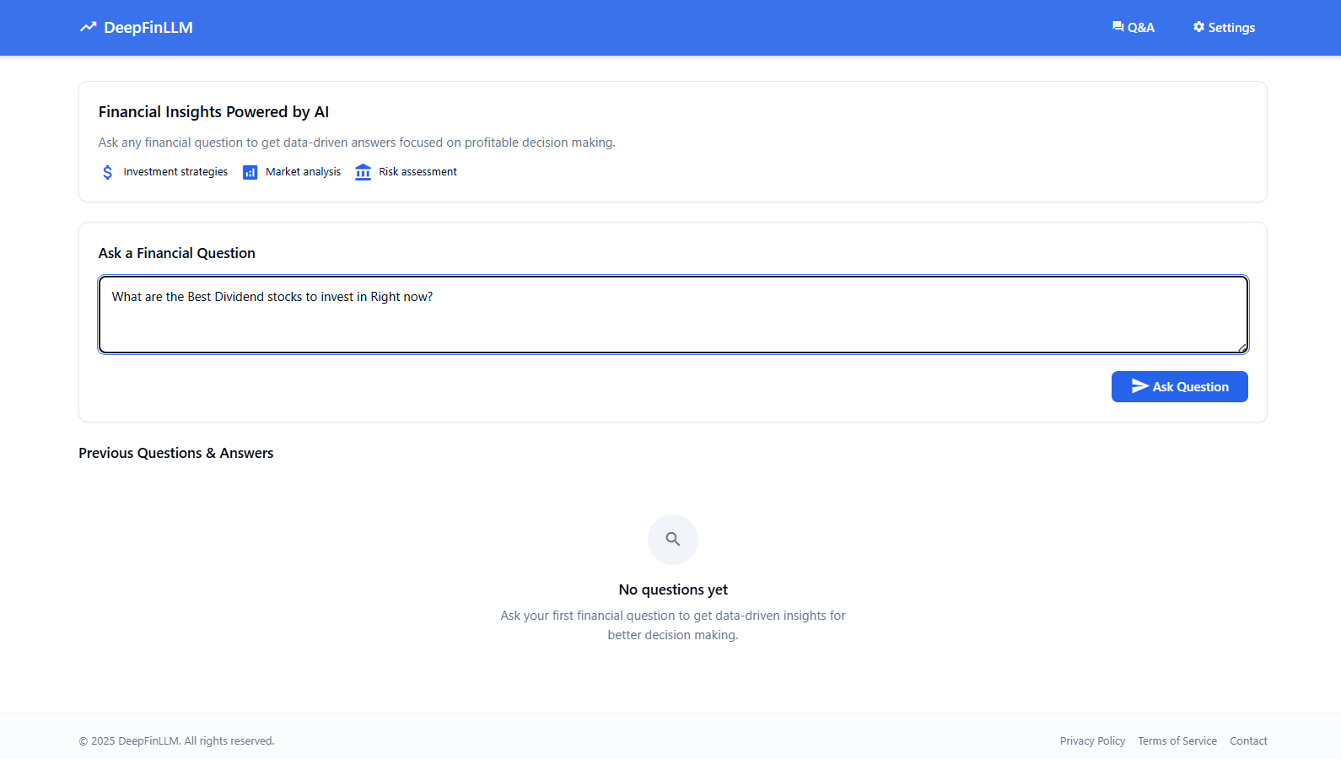

**Fig 1.** User Input: Financial Query Submission

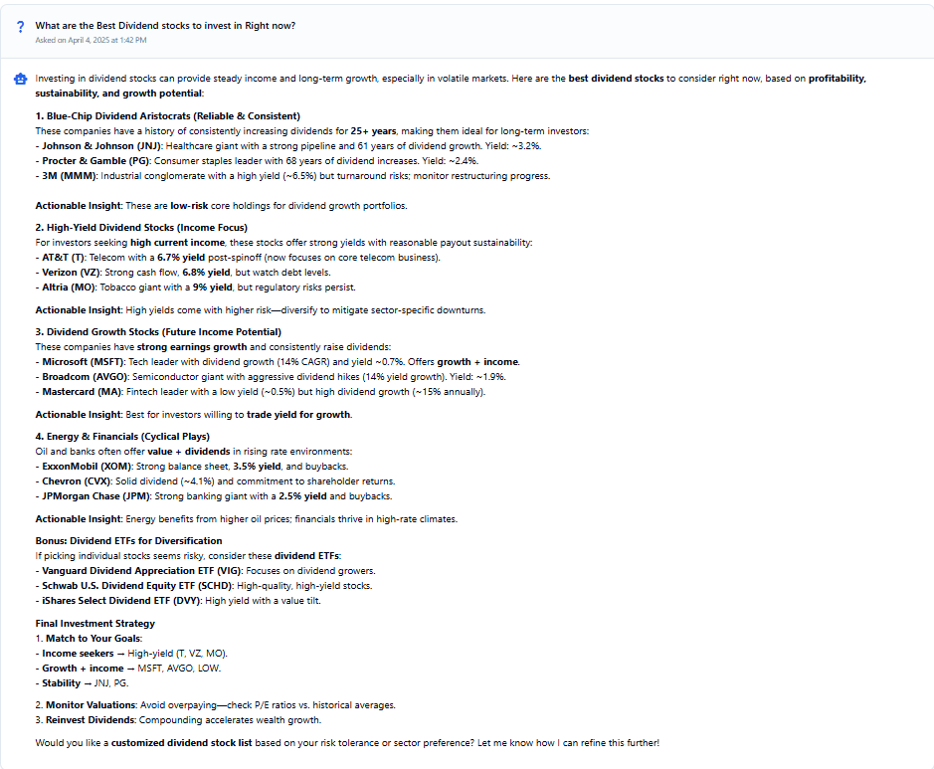

**Fig 2.** DeepFinLLM Output: Real-Time Financial Insights

**Internal Query Processing in Detail**

* At the heart of DeepFinLLM’s query processing is its NLP pipeline, which converts natural language queries into structured representations for financial analysis. The pipeline begins with tokenization, where the query is split into individual words or phrases. For example, the query “Analyze the risk of investing in tech stocks” is broken into tokens like “Analyze,” “risk,” “investing,” and “tech stocks.” Next, part-of-speech (POS) tagging assigns grammatical roles to each token, such as identifying “risk” as a noun and “investing” as a verb. This step helps the system understand the syntactic structure of the query.
* The pipeline then employs named entity recognition (NER) to identify key entities like company names, financial terms, or dates. For instance, in the query “What is the current price of Apple stock?”, the system recognizes “Apple” as a company and “current price” as a financial metric. Finally, intent classification determines the user’s goal by analyzing the query’s context. For example, the query “What is the current price of Apple stock?” is classified as a request for stock price information. This structured representation is then passed to the insight generation module, where it is combined with real-time data to produce actionable insights.
* The API Integration Layer plays a crucial role in ensuring the relevance of the insights. It asynchronously fetches live financial data, such as stock prices, economic indicators, or market trends, from external sources like the FMP API. For example, when processing the query “What is the current price of Apple stock?”, the system retrieves the latest stock price from the API and compares it to historical data to provide context. The Persistence Layer stores this information for future reference, enabling DeepFinLLM to personalize responses based on user preferences and historical interactions. This end-to-end process ensures that DeepFinLLM delivers precise, real-time insights tailored to the user’s needs.

**Conclusion**

This input-output document highlights the capabilities of DeepFinLLM in processing natural language queries and delivering precise, real-time financial insights. The examples demonstrate its ability to handle diverse topics, from stock price analysis to macroeconomic trends, while maintaining accuracy, relevance, and compliance. DeepFinLLM’s integration of advanced language models and real-time data makes it a powerful tool for investors, analysts, and financial professionals.