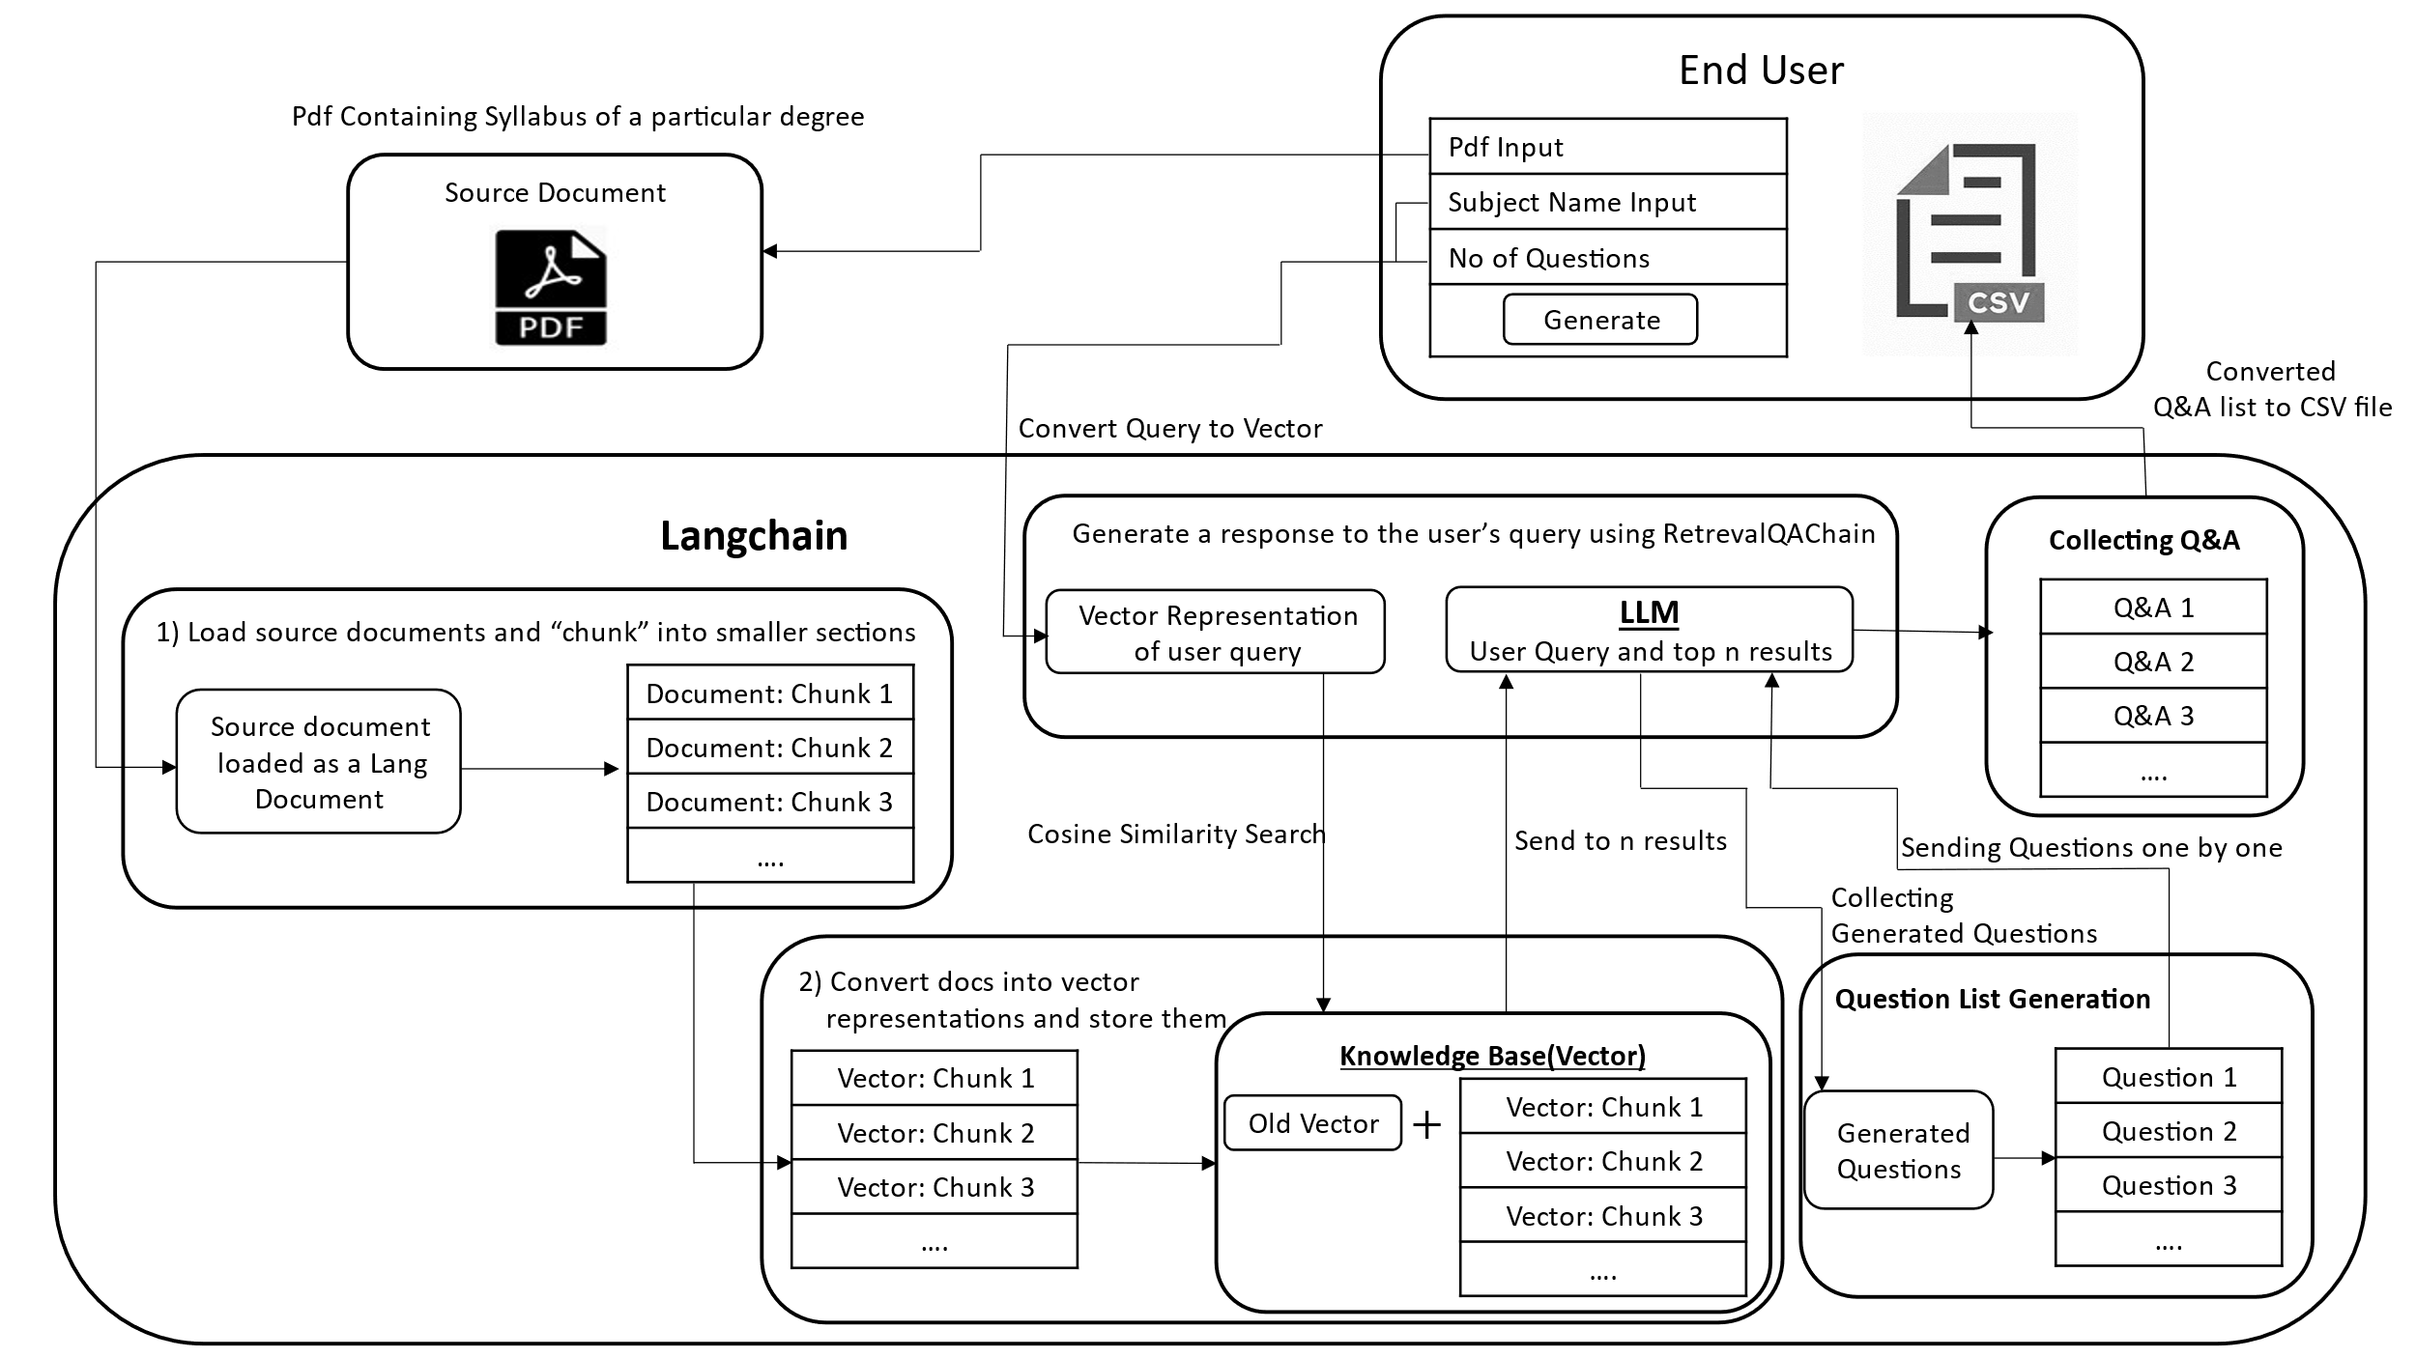

**Fig. 1.** The proposed methodology which includes loading and chunking the document, converting chunks to vector representations, performing cosine similarity search with user queries, and using a language model to generate and return the final answers.

**Fig. 2**. BLEU scores for long answers

**Fig. 3.** BLEU scores for short answers