RAWDRIVE STUDIO GUIDE
RawDrive User Manual
A simple, visual guide for dashboard, galleries, uploads, sharing, design, and FaceID.
Best for studio operators
Use this guide when training team members, setting up a new gallery, or checking the right workflow before client delivery.

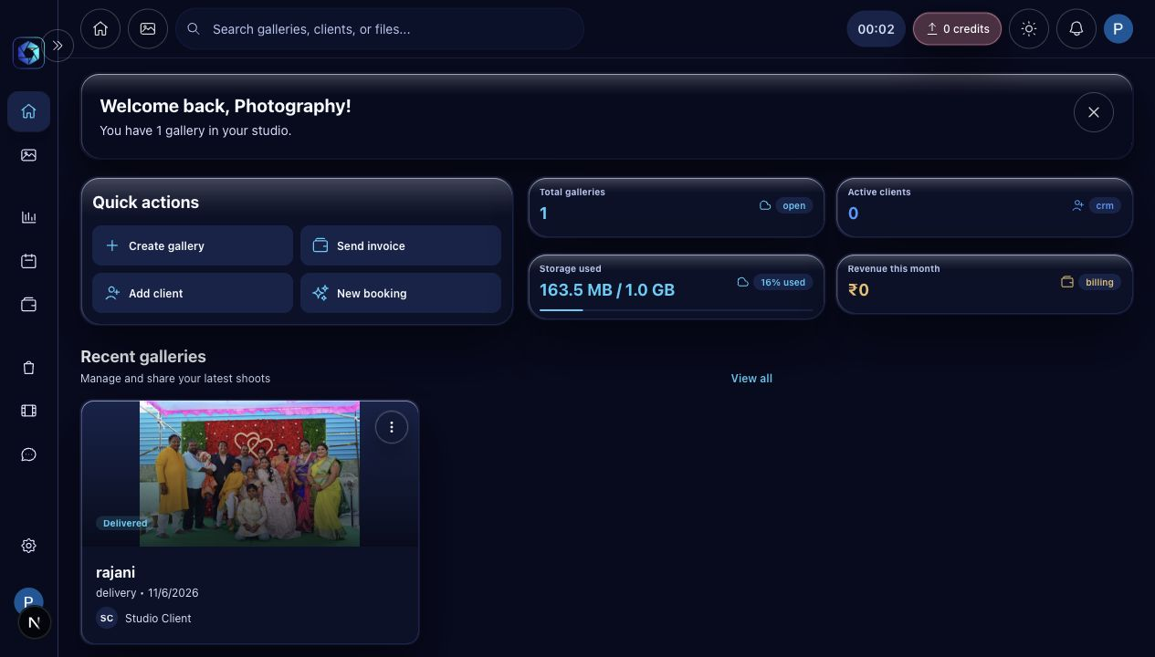
Dashboard view used in this manual.
Prepared for RawDrive studios | June 2026

QUICK START

The complete gallery flow
RawDrive is organized around a simple studio flow. Start on the dashboard, create a gallery, upload photos, style the public view, then share the finished link with clients.
1 | Open dashboard | Check storage, recent galleries, and quick actions.
2 | Create gallery | Choose Delivery for client photos or Proofing for selections.
3 | Upload photos | Select files or folders, then keep the upload dashboard open until completion.
4 | Design public view | Set cover, mobile cover, grid columns, and folder layout.
5 | Share with clients | Publish, copy the gallery link, and set an access window if needed.
6 | Use FaceID | Sync gallery photos, review detected people, and let clients search by selfie.

Operator rule
Keep uploads running until all files are complete. You can work in other RawDrive screens, but keep the browser session open while large folders finish.

DASHBOARD

Read the studio at a glance

The dashboard shows storage, galleries, quick actions, and recent work.
- Use Quick actions for Create gallery, Add client, Send invoice, and New booking.
- Watch storage usage before large uploads so client delivery is not blocked.
- Open recent galleries directly from the dashboard card.
GALLERIES

Create and manage client galleries
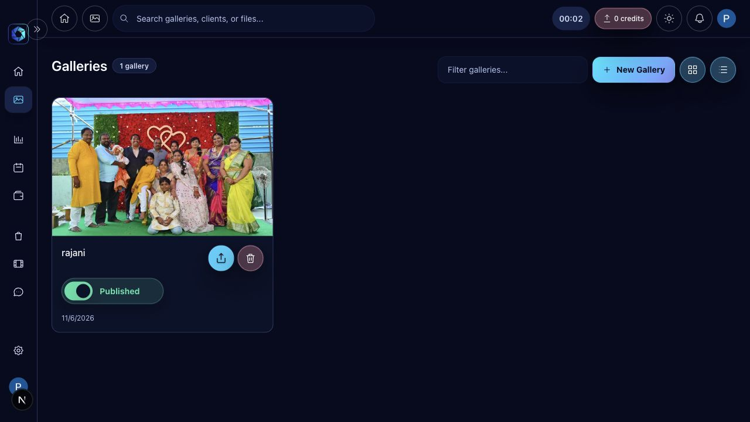
The Galleries screen is the central list of published and draft galleries.
- Click New Gallery to start a client delivery or proofing gallery.
- Use the publish toggle only when the gallery is ready for clients.
- Use the card menu for actions such as share, cover, phone cover, and delete.

GALLERY WORKSPACE

Upload, organize, and prepare delivery
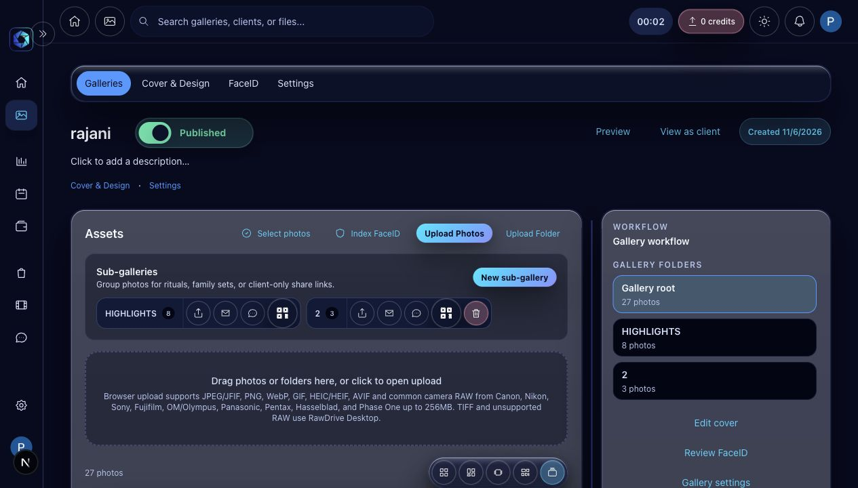
The gallery workspace contains upload tools, sub-galleries, and workflow links.
- Use Upload Photos for selected files and Upload Folder for complete camera folders.
- Create sub-galleries for highlights, rituals, family sets, or client-only collections.
- Keep manual photo order when you rearrange images by mouse.
- Open workflow links on the right for cover design, FaceID, settings, and delivery.
Upload status
When uploads are active, use the persistent upload panel to watch progress, cancel active uploads, or retry failed items.

COVER AND DESIGN

Style the public gallery
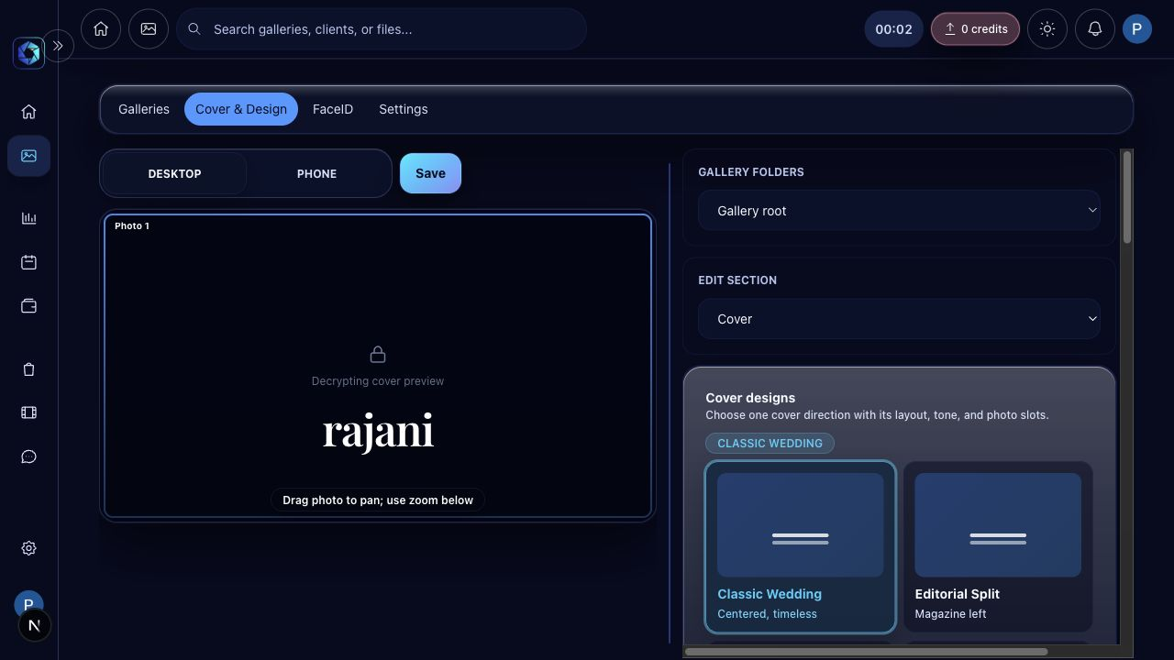
Cover and Design controls gallery presentation for desktop and mobile.
- Set the root gallery desktop and phone cover images from the root folder.
- Use folder-specific grid settings when a sub-gallery is selected.
- Preview grid columns before saving so the public gallery feels balanced.
- Keep the cover safe zone readable on mobile by centering faces and titles.

SHARING

Publish, protect, and share access
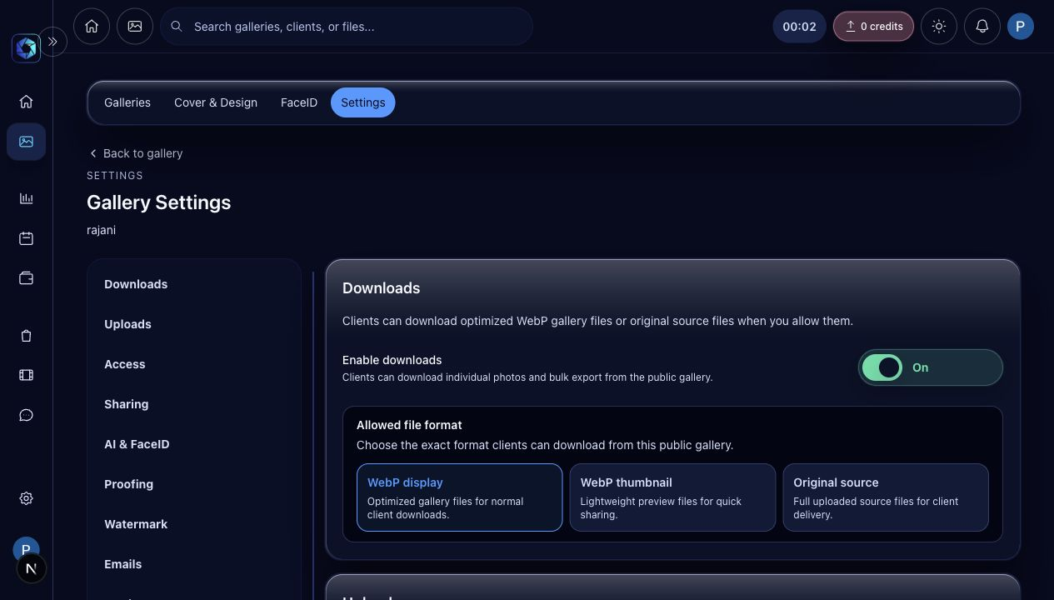
Settings lets you publish the gallery, set access windows, and share with another RawDrive account.
- Use No expiry only when clients should keep access indefinitely.
- Choose 30, 60, 90 days, or a custom date for controlled delivery windows.
- Shared accounts can be given access while storage billing stays with the selected workspace.
- Ask the recipient to create a RawDrive account before sharing with their email.

FACEID

Help clients find themselves
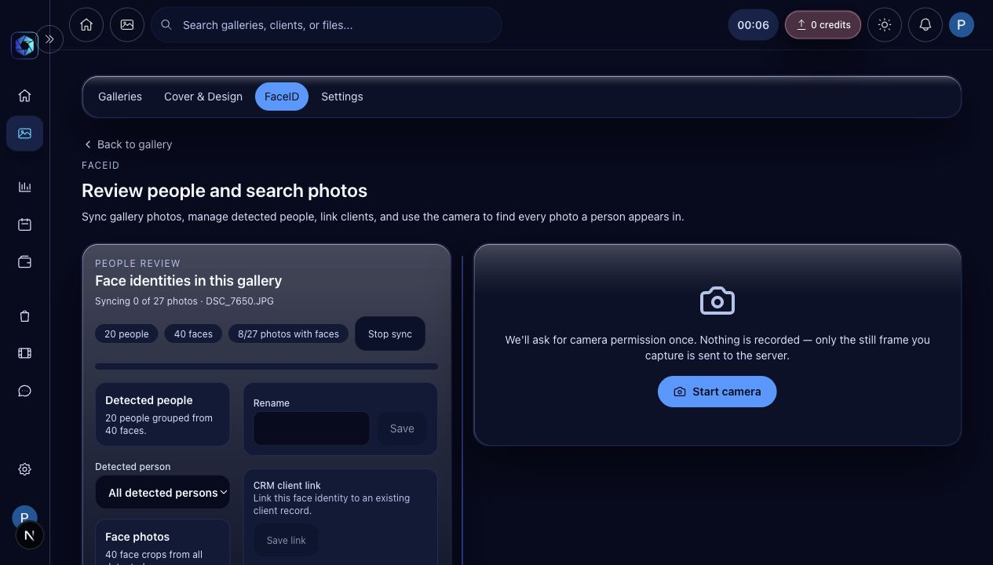
FaceID syncs gallery photos and lets clients search by captured selfie.
- Click Sync now after upload to index gallery faces.
- Review detected people and rename clear identities when useful.
- Clients can use Capture and search from the public gallery to find their own photos.
- If new photos are uploaded later, run sync again so FaceID includes them.

DAILY CHECKLIST

Before sharing a finished gallery
- All uploads completed and failed items retried or dismissed.
- Gallery photos appear in the expected order.
- Cover image and mobile cover are centered and readable.
- Grid settings are saved for the selected folder.
- Gallery is published only after final review.
- Share link opens correctly in client view.
- FaceID sync completed for all required folders.
Support note
If a JPEG upload warns about camera-authored trailer data, the file is still a normal camera JPEG. Retry after the latest upload fix is deployed.

