**Create EC2 On AWS**

**Step 1:**First, log into your AWS ACCOUNT and click on **“services”** present on the left of the AWS management console, i.e. the primary screen. From the drop-down menu of options, tap on **“EC2”**.

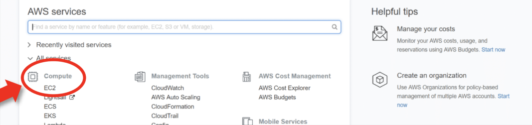

**Step 2:**Click on the launch instance click on the launch instance, after clicking on it you will be redirected to a launch page where we can create an instance.

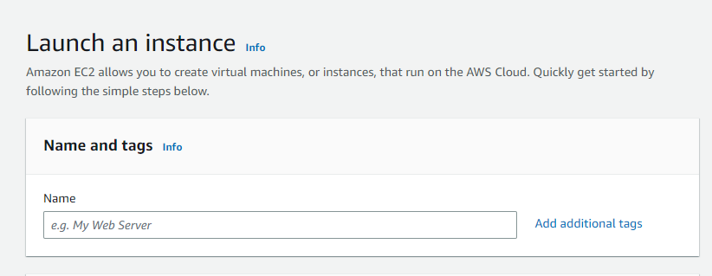

**Step 3:**Select AMI – Required operating system from the available.

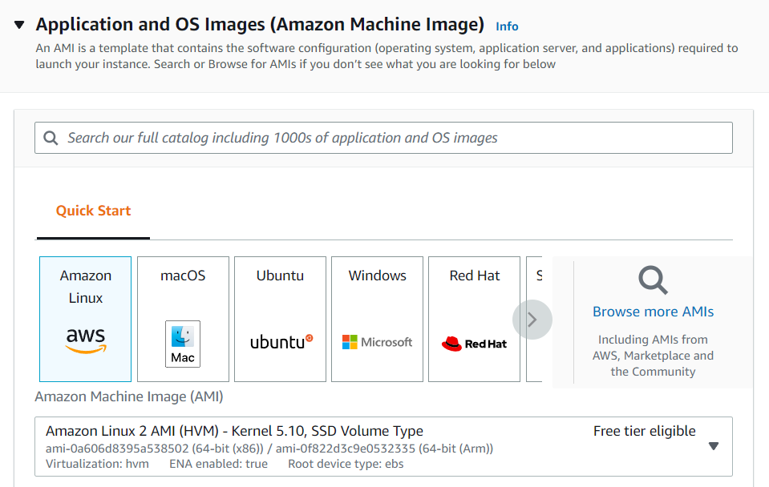

***Step 4:*** From the available storage specifications, select a free tier-eligible storage service. The instance type includes the no.of CPUs required and the Memory required for your application.

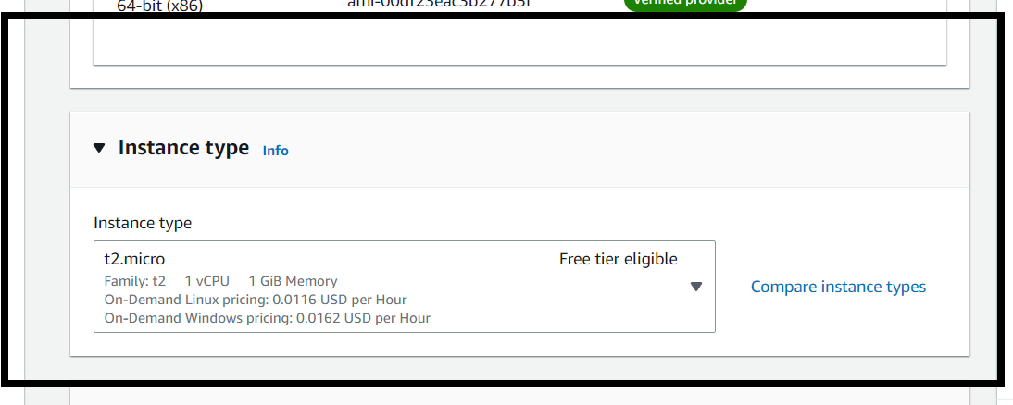

**Step 4:**Now, create a key-value pair, by clicking on “Create new key pair”. A window will pop up for creating key pair as shown below. The key value pair plays a major role while connecting to the EC2-Instance it will act as an SSH-KEY to connect to the instance. Create Key-PairEnter name>>Select “.pem” and create.

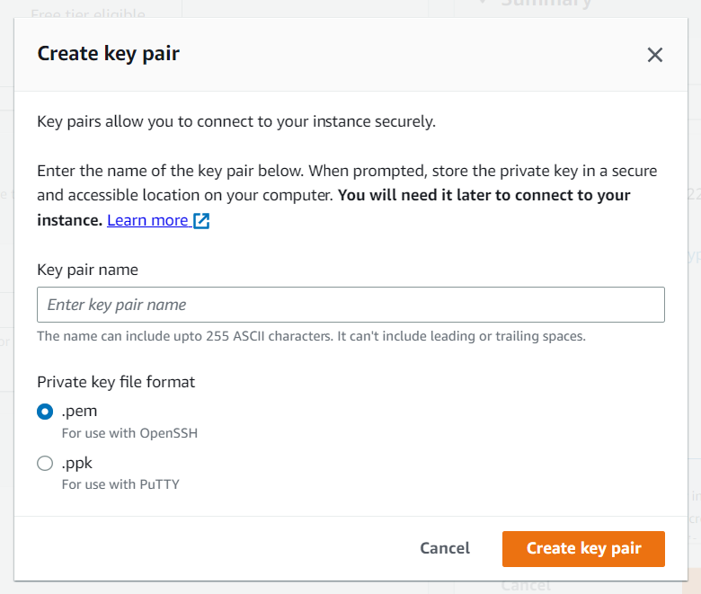

**Step 5:**Keep the network settings as default settings. StorageAs should be according to Free tier eligible. Keep it as default.

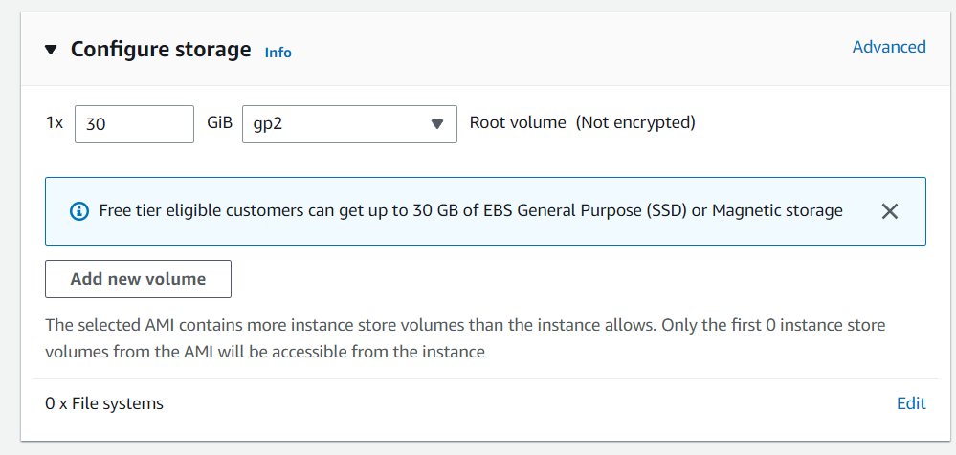

**Step 6:**Launching Instance At last, click on “Launch instance”. That’s it, an instance will be created.

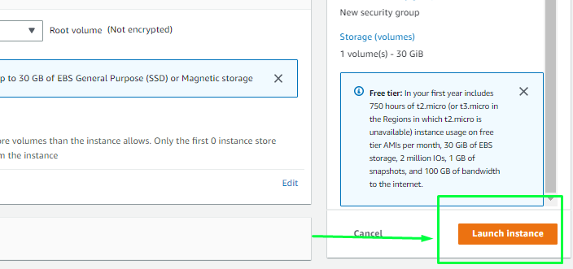

**Steps to Connect VSCODE using SSH-KEY**

**Step 1:**Select the server to which you want to connect and click on the connect button at the top of that instance as shown in the image below.

**Step 2:**Copy the SSH key which is right following the example it will act as a key-pair to connect to EC2-Instance.

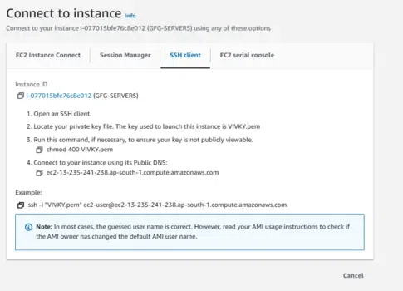

**Step 3:**