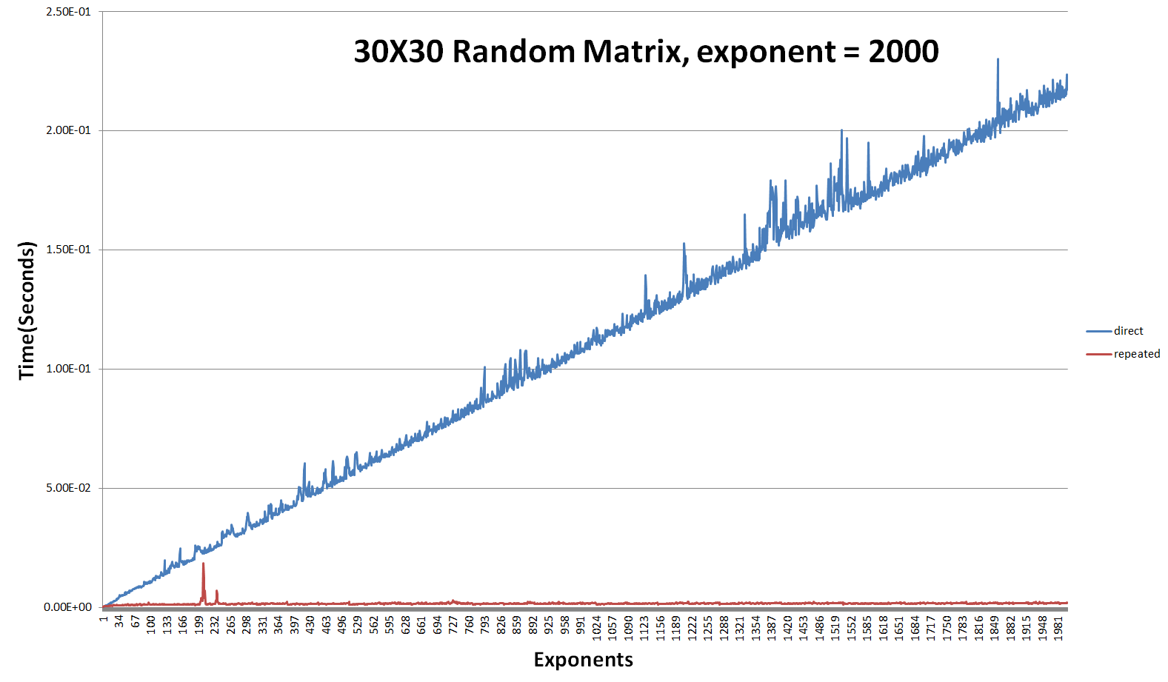

The input matrix has random values ranging from -5.0 to 5.0. In the above graph, the calculation time of the direct multiplication significantly increases in the linear process, but the calculation time of the repeated squaring multiplication remains constant. The reason why repeated squaring multiplication is faster is that this algorithm divides the task into $\log_{2}{(exponent)}$-many smaller tasks.

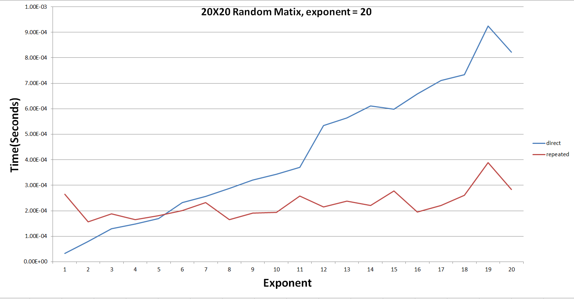

However, if the value of exponents is small, direct multiplication is faster that the repeated squaring algorithm(in the case of a 20x20 matrix, direct multiplication is faster till exponent becomes 6). This is because, the code of direct multiplication is much simpler than that of the repeated multiplication.

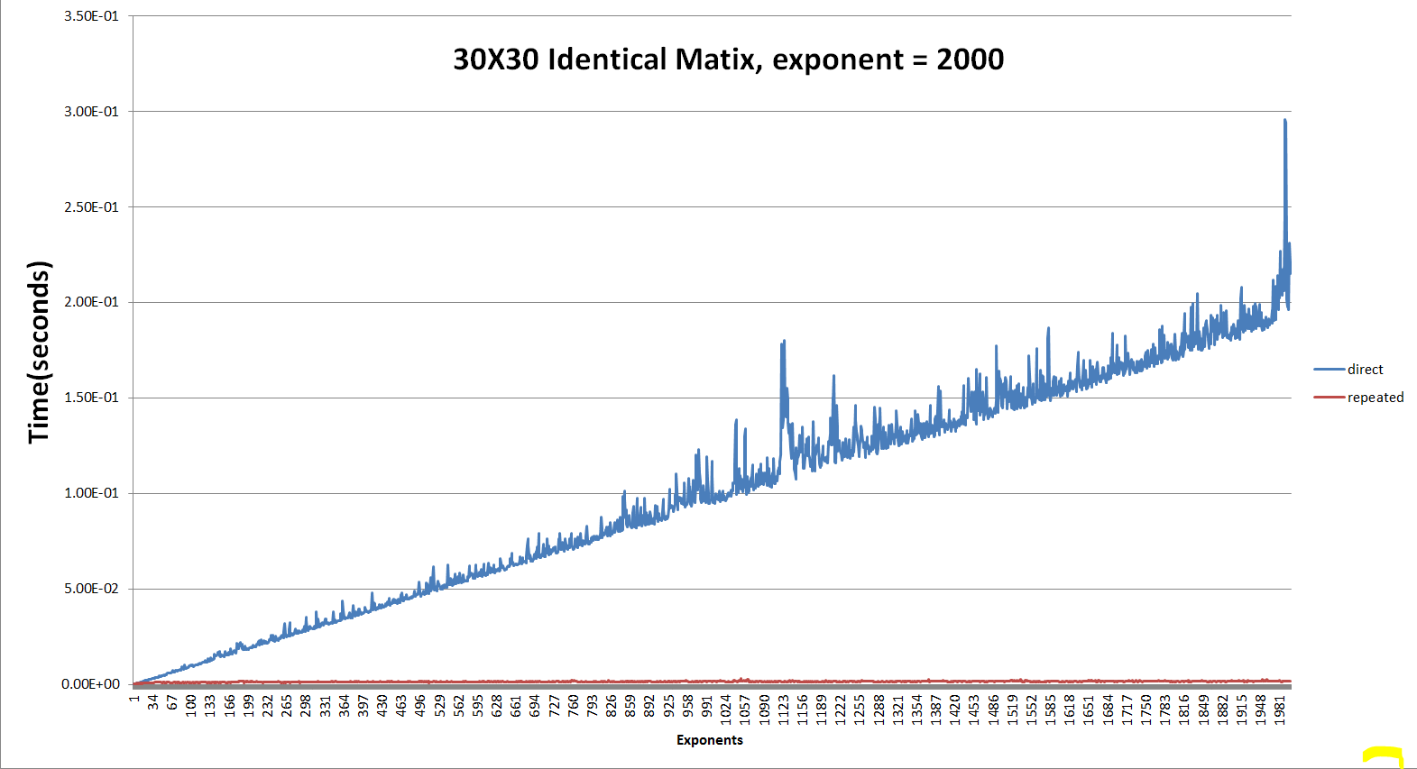

What if the matrix is simple? Even though, the input matrix is 30x30 identical matrix, the calculation time of direct multiplication is increased in the linear process, and repeated squaring algorithm remains constant.

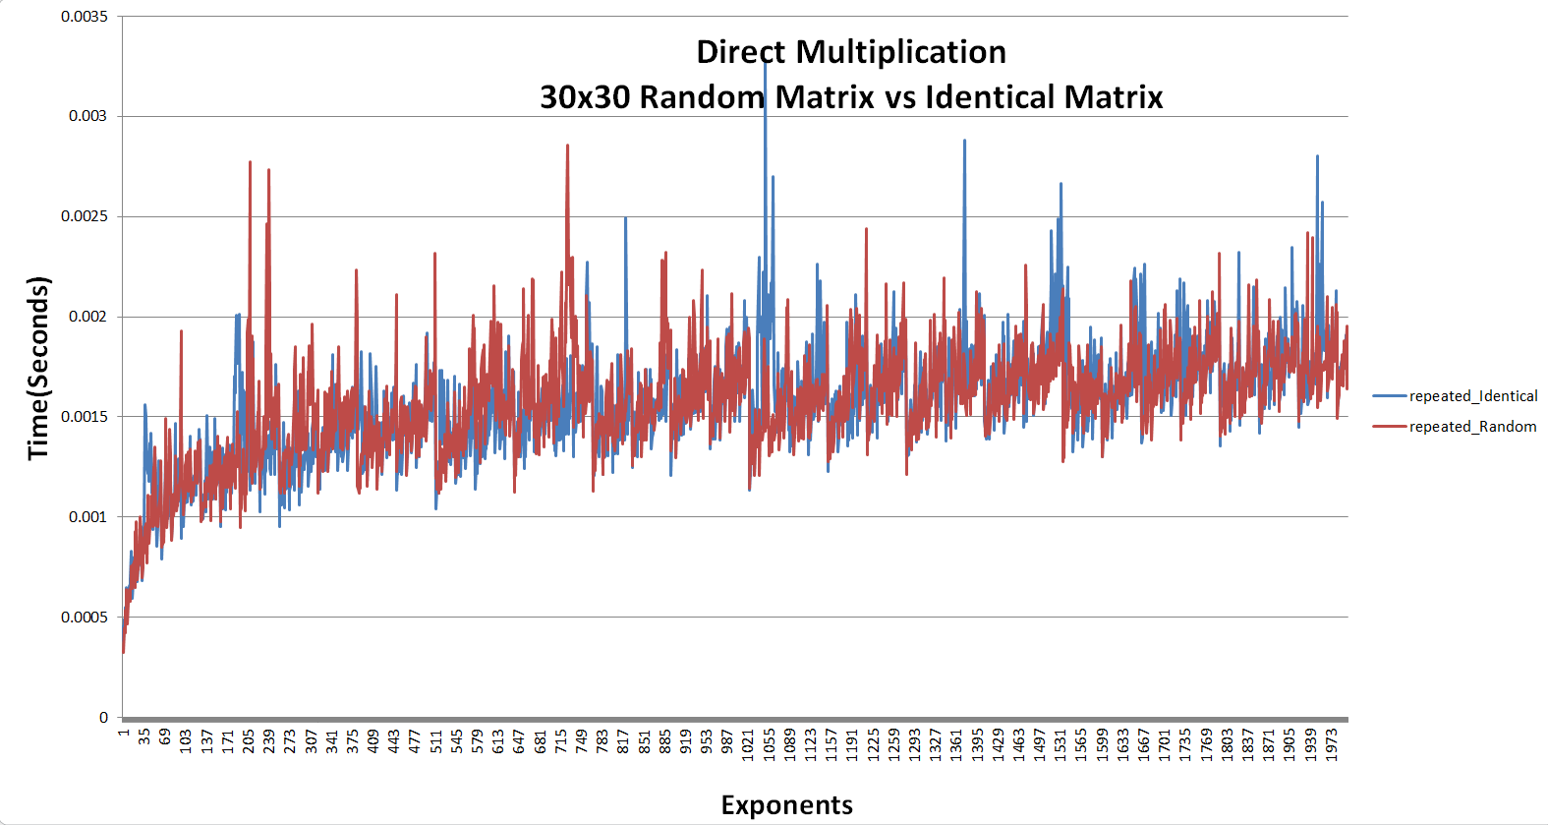

It seems that the calculation time of the repeated squaring multiplication does not depend on how simple the matrix is.

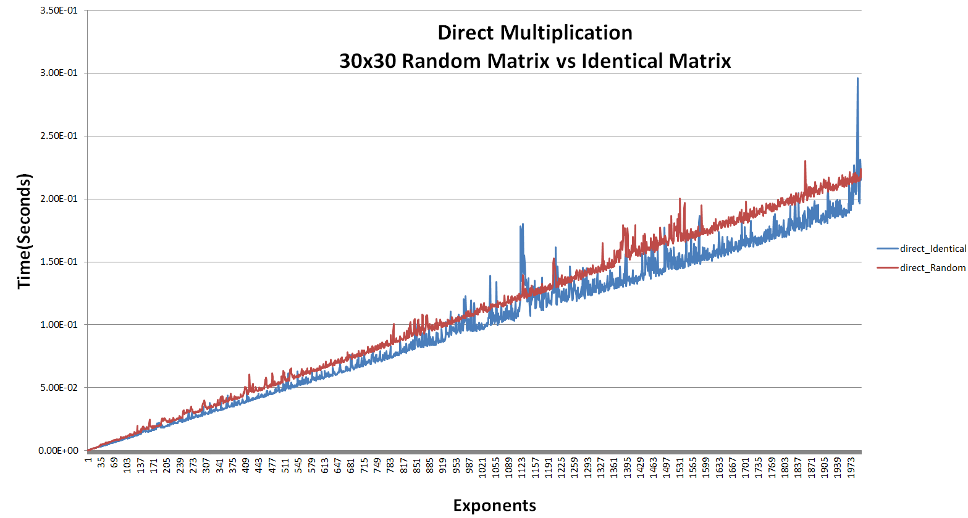

Meanwhile, the calculation time of direct multiplication is related to the simplicity of the input matrix. When the input matrix is an identical matrix, the calculation speed is slightly faster.