Week9_FinalProject2_KoppulaVeera

Veera Koppula

August 04 2021

##Data importing and cleaning steps are explained in the text and follow a logical process. Outline your data preparation and cleansing steps. My original data set collected from CDC website has 27.9M rows. Here are the steps I have followed. I have downloaded a CSV format from the resource location <https://data.cdc.gov/Case-Surveillance/COVID-19-Case-Surveillance-Public-Use-Data/vbim-akqf> Following are the data columns that are present.

## New names:  
## * `` -> ...2  
## * `` -> ...3  
## * `` -> ...4  
## * `` -> ...5  
## * `` -> ...6

## # A tibble: 13 x 1  
## ...2   
## <chr>   
## 1 Variable   
## 2 cdc_report_dt   
## 3 cdc_case_earliest_dt   
## 4 pos_spec_dt   
## 5 onset_dt   
## 6 current_status   
## 7 sex   
## 8 age_group   
## 9 race_ethnicity_combined  
## 10 hosp_yn   
## 11 icu_yn   
## 12 death_yn   
## 13 medcond_yn

I have removed from the original dataset where data is either empty, marked as “Missing”/“Uknown” from the columns cdc_case_earliest_dt,pos_spec_dt,onset_dt,current_status,sex,age_group,race_ethinicity_combined,hosp_yn,icu_yn,death_yn and medcond_yn. Essentially I have removed all null,missing or unknown (uncollected values). This brought up the total rows down to 481,381 rows. This data has been saved into a csv format as filename “COVID-19_Case_Surveillance_Public_Use_Data.csv”

After the filtering out of the missing(uncollected valies), current_status column has same value “Labroratiry-confirmed case” in all rows. per the data dictionary provided by cdc data source, cdc recommends to use “cdc_case_earliest_dt” instead of “cdc_report_dt” also, I fee; “pos_spec_dt” which shows when first speciman was collected, has a real no bearing on the analysis of impact of confounding factors on the outcome of covid infection. as to further clean my data, I have decided to drop these 3 columns from my data set

## [1] "cdc_case_earliest_dt" "cdc_report_dt"   
## [3] "pos_spec_dt" "onset_dt"   
## [5] "current_status" "sex"   
## [7] "age_group" "race_ethnicity_combined"  
## [9] "hosp_yn" "icu_yn"   
## [11] "death_yn" "medcond_yn"

## [1] "cdc_case_earliest_dt" "onset_dt"   
## [3] "sex" "age_group"   
## [5] "race_ethnicity_combined" "hosp_yn"   
## [7] "icu_yn" "death_yn"   
## [9] "medcond_yn"

##With a clean dataset, show what the final data set looks like. However, do not print off a data frame with 200+ rows; show me the data in the most condensed form possible.

## [1] "cdc_case_earliest_dt" "onset_dt"   
## [3] "sex" "age_group"   
## [5] "race_ethnicity_combined" "hosp_yn"   
## [7] "icu_yn" "death_yn"   
## [9] "medcond_yn"

## 'data.frame': 481381 obs. of 9 variables:  
## $ cdc_case_earliest_dt : chr "2020/12/28" "2021/01/11" "2021/01/06" "2021/01/07" ...  
## $ onset_dt : chr "2020/12/28" "2021/01/11" "2021/01/06" "2021/01/07" ...  
## $ sex : chr "Female" "Male" "Female" "Female" ...  
## $ age_group : chr "10 - 19 Years" "20 - 29 Years" "50 - 59 Years" "20 - 29 Years" ...  
## $ race_ethnicity_combined: chr "White, Non-Hispanic" "Hispanic/Latino" "Black, Non-Hispanic" "White, Non-Hispanic" ...  
## $ hosp_yn : chr "No" "No" "No" "No" ...  
## $ icu_yn : chr "No" "No" "No" "No" ...  
## $ death_yn : chr "No" "No" "No" "No" ...  
## $ medcond_yn : chr "No" "No" "Yes" "No" ...

## cdc_case_earliest_dt onset_dt sex age_group race_ethnicity_combined  
## 1 2020/12/28 2020/12/28 Female 10 - 19 Years White, Non-Hispanic  
## 2 2021/01/11 2021/01/11 Male 20 - 29 Years Hispanic/Latino  
## 3 2021/01/06 2021/01/06 Female 50 - 59 Years Black, Non-Hispanic  
## 4 2021/01/07 2021/01/07 Female 20 - 29 Years White, Non-Hispanic  
## 5 2021/01/13 2021/01/13 Male 50 - 59 Years Hispanic/Latino  
## 6 2021/01/12 2021/01/12 Male 50 - 59 Years Black, Non-Hispanic  
## hosp_yn icu_yn death_yn medcond_yn  
## 1 No No No No  
## 2 No No No No  
## 3 No No No Yes  
## 4 No No No No  
## 5 No No No Yes  
## 6 No No No Yes

##What do you not know how to do right now that you need to learn to import and cleanup your dataset?

I have managed to cleanup most of the data and removed the null values. I am trying to look at summarizing values to extract metadata that represents the combination of elements properly to calculate outcomes of hospitalization(hosp_yn), ICU admittance (icu_yn) and death (deat_yn)

##Discuss how you plan to uncover new information in the data that is not self-evident.

There are some complicating elements like Mask mandate, Social distancing, lockdowns and Vaccination could have overlap impact on outcome of cases. I am looking on to filterout the information that could confound the information in the collected data source, that might have got impacted outcome of the cases with same sax/age/race and comorbidities.

##What are different ways you could look at this data to answer the questions you want to answer?

##   
## Attaching package: 'dplyr'

## The following objects are masked from 'package:stats':  
##   
## filter, lag

## The following objects are masked from 'package:base':  
##   
## intersect, setdiff, setequal, union

## ── Attaching packages ─────────────────────────────────────── tidyverse 1.3.1 ──

## ✓ ggplot2 3.3.5 ✓ purrr 0.3.4  
## ✓ tibble 3.1.2 ✓ stringr 1.4.0  
## ✓ tidyr 1.1.3 ✓ forcats 0.5.1  
## ✓ readr 1.4.0

## ── Conflicts ────────────────────────────────────────── tidyverse_conflicts() ──  
## x dplyr::filter() masks stats::filter()  
## x dplyr::lag() masks stats::lag()

I could look at this data to collect the factors that could influence serious outcomes or at the same time probably factors that would have prevented serious outcomes. However given the complex factors that could contribute tp serious outcomes (such as the social/economic status of the patient), geographical location, unknown progression of novel virus etc could probably make the summary of data as inconclusive or provide partial model that would give predictability of outcomes.

##Do you plan to slice and dice the data in different ways, create new variables, or join separate data frames to create new summary information? Explain.

I have divided the data into 2 seperate data frames without any impact because of infection , and rows with a positive test leading to some impact as hospitalizaiton or ICU admittance or death. Based on these 2 data frames calculated a new variable “Impact” that sets if the postive infection led to an impact or not. Have combined the data back into an updated data frame. Also while doing things, I have changed the type of data of cdc_case_earliest_dt and onset_dt to date type from charaterset for future usage.

##How could you summarize your data to answer key questions?

I could slice and summarize the data frame by the predictors such as sex/age and comorbities along with the date of infection identification (with possible overlay factors) to answer the key question of predictability of Hospitalization/ICU or death.

##What types of plots and tables will help you to illustrate the findings to your questions? Ensure that all graph plots have axis titles, legend if necessary, scales are appropriate, appropriate geoms used, etc.). 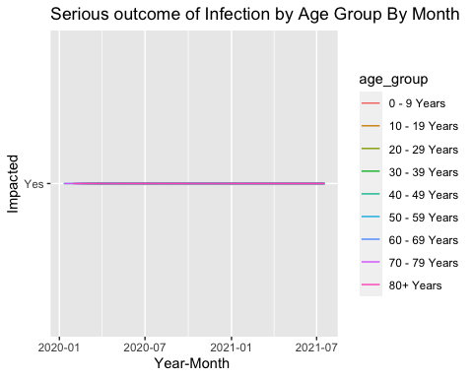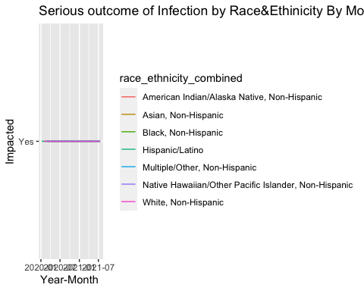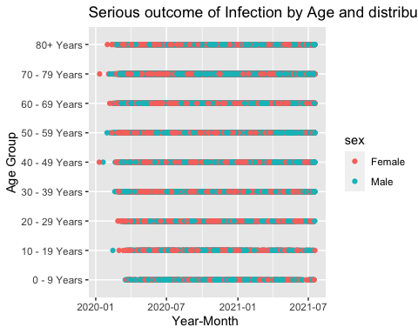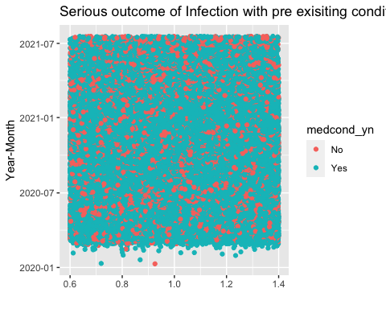

Arranging a plot by Age shows 0-9yrs and 70+yrs have been the most vulnerable group - which is expected as they are the most immune compromised Looking at data by Race/Ethnicity - looks like white, non-Hispanic are more prone for worse outcomes with the virus infection Distribution of serious outcomes is almost equally distributed by sex across the age ranges When plotted all the cases distribution against pre-exisiting conditions, it looks like there is a strong correlation between pre-exisiting conditions and serious outcomes of infection.

##What do you not know how to do right now that you need to learn to answer your questions?

finding another data set and gleaning the information to connect from the new data source that contains the factors that could influence virus spread/intesity of the infection to multiple rows in the cdc captured data set from above.

##Do you plan on incorporating any machine learning techniques to answer your research questions? Explain. I am looking at predticting the serious impact outcome using a regression model, especially using comorbities as an indicator