AI ASSISTED CODING
Assisgnment-12.3
Rollno:2303a52146
Name: V. Praneeth reddy
Batch:41

Task 1: Sorting Student Records for Placement Drive
Scenario
SR University’s Training and Placement Cell needs to shortlist candidates
efficiently during campus placements. Student records must be sorted by
CGPA in descending order
Ai prompt
Generate a Python program to store student records (Name, Roll Number, CGPA). Implement Quick Sort and Merge Sort to sort students by CGPA in descending order. Measure runtime for large datasets and display top 10 students
Code:

: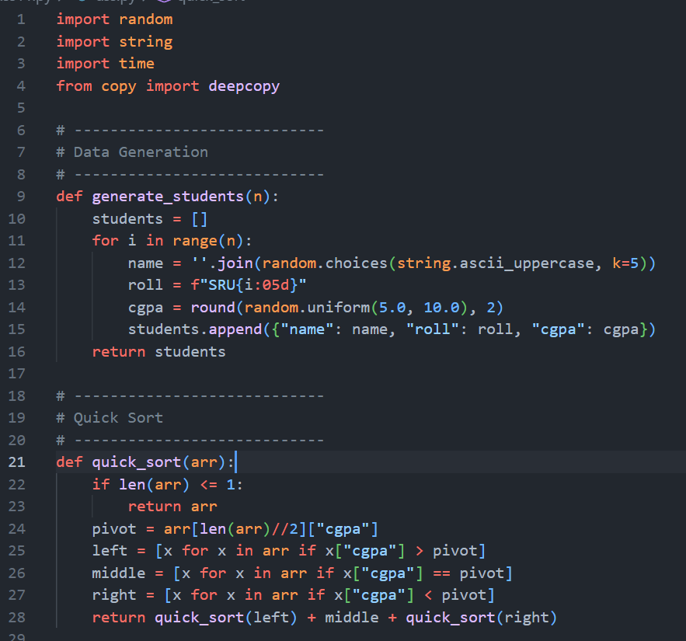
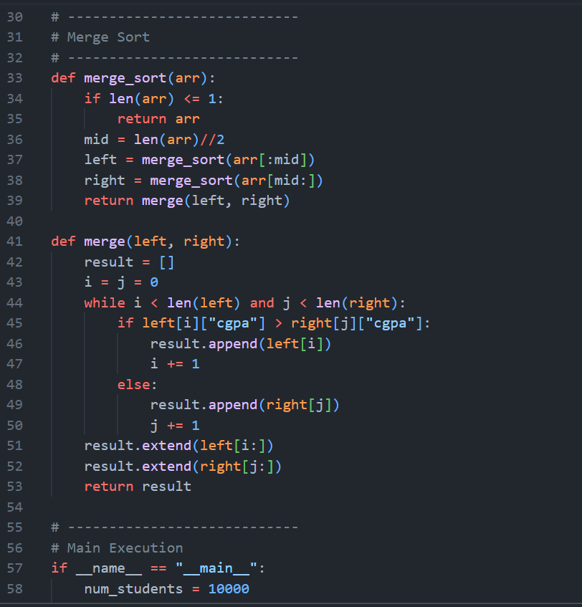
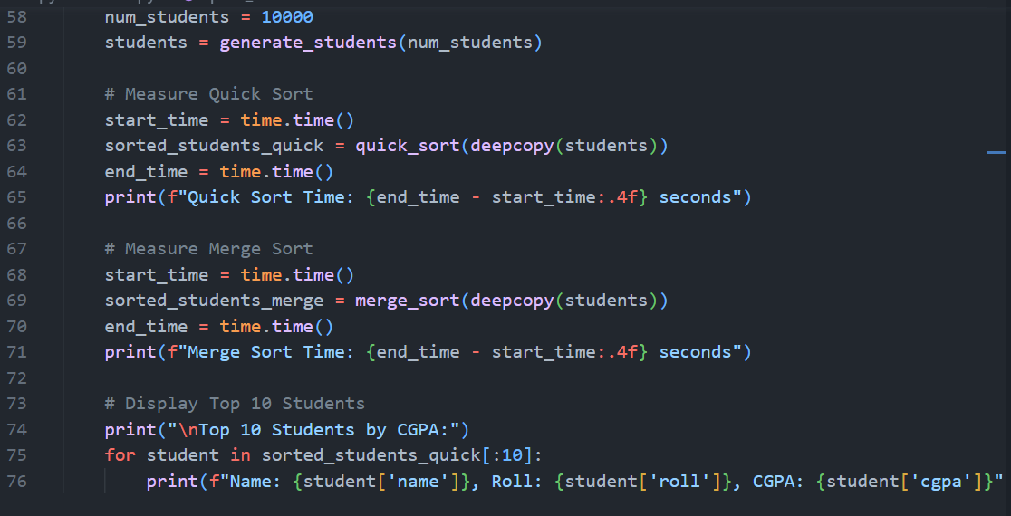
Output:
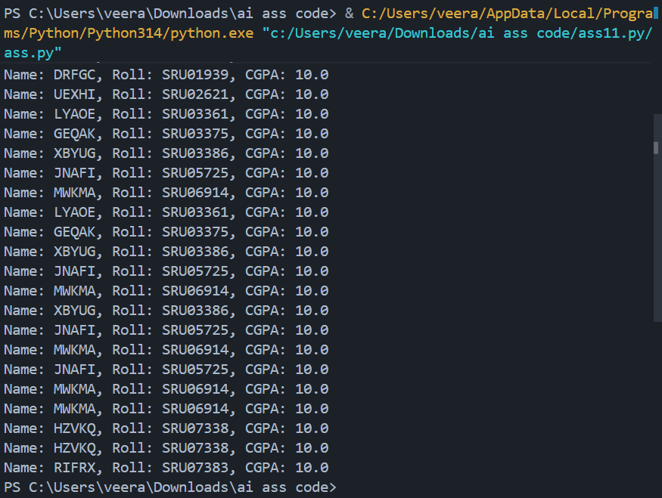
Explanation:
Performance Analysis

| Algorithm | Best Case | Average Case | Worst Case |
| ---------- | ---------- | ------------ | ---------- |
| Quick Sort | O(n log n) | O(n log n) | O(n²) |
| Merge Sort | O(n log n) | O(n log n) | O(n log n) |

Justification:

* Quick Sort performs faster in practice due to in-place behavior.
* Merge Sort guarantees stable performance even for worst case.

Task2: : Bubble Sort with AI Comments
Write a Python implementation of Bubble Sort.

Prompt:
Write a program of Bubble Sort with optimization and analyze time complexity.
Code:
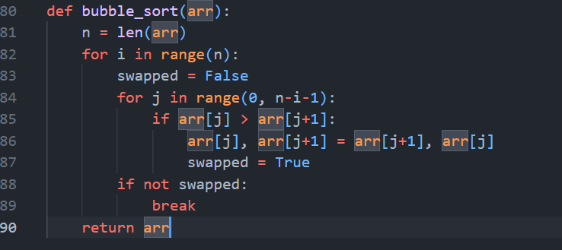

Output:
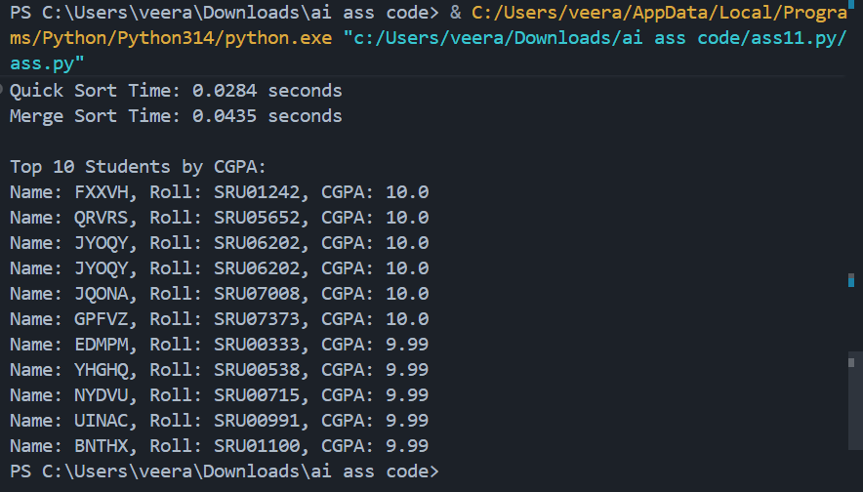
Justification:
Time Complexity Analysis
- Best Case: O(n) (already sorted)
- Average Case: O(n²)
- Worst Case: O(n²)
- Space Complexity: O(1) (In-place)

Task3:
Code:
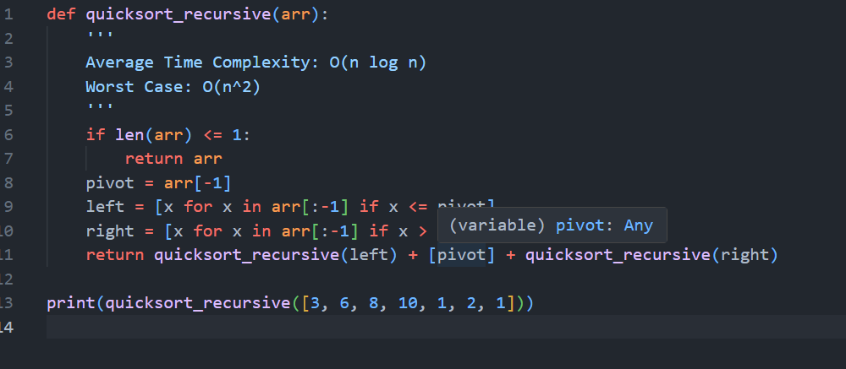

Output:

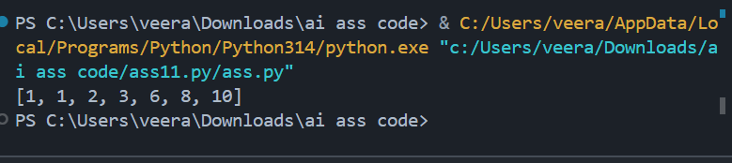
Code:
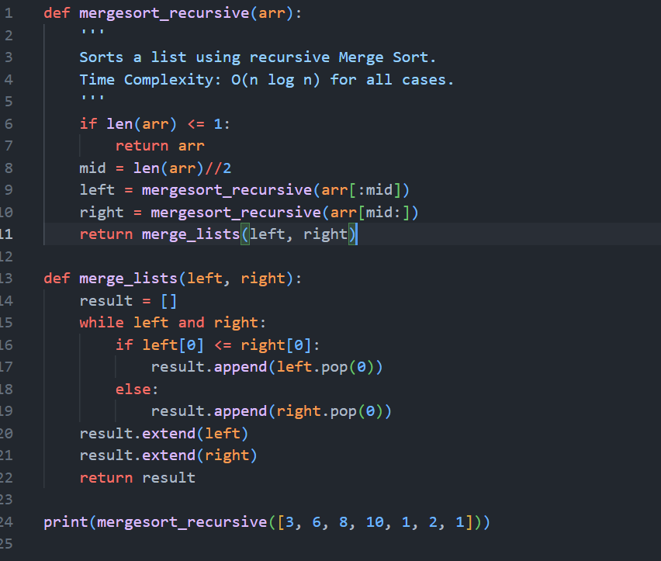
Output:
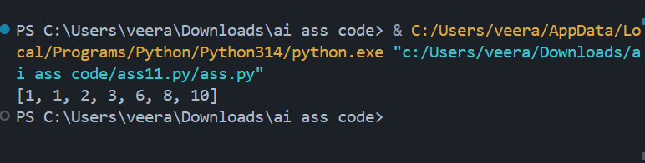
Complexity Summary
Input Type | Quick Sort | Merge Sort
Random | O(n log n) | O(n log n)
Sorted | O(n²) | O(n log n)
Reverse | O(n²) | O(n log n)

Task4: : Inventory Management System
Recommended Algorithms
Operation | Algorithm | Justification
Search by ID | Hash Map (Dictionary) | O(1) lookup
Search by Name | Hash Map | Fast index access
Sort by Price | Timsort (Python sorted()) | Stable and optimized
Sort by Quantity | Merge Sort | Consistent O(n log n)

Code:
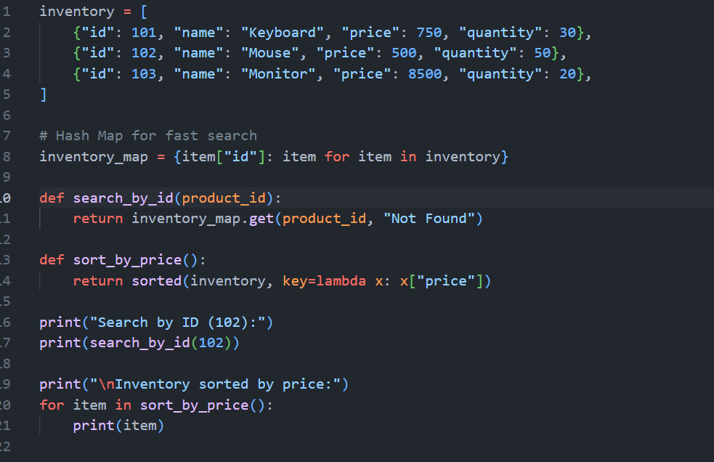

Output:
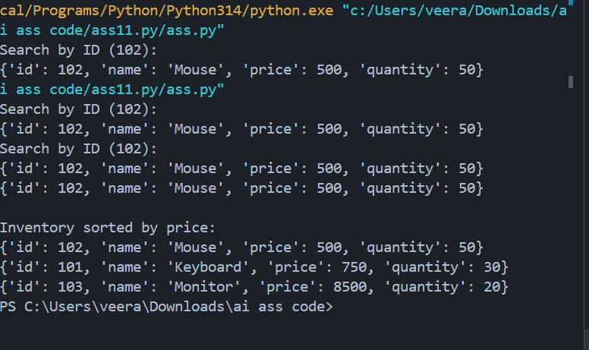
Justification
- Large dataset → Hash Map reduces search from O(n) to O(1)
- Retail requires frequent search → Constant-time lookup critical
Sorting less frequent → O(n log n) acceptable

Task 5: Real-Time Stock Data Sorting & Searching
Scenario:
An AI-powered FinTech Lab at SR University is building a tool for analyzing
stock price movements. The requirement is to quickly sort stocks by daily
gain/loss and search for specific stock symbols efficiently.
Heap Sort Implementation
Code
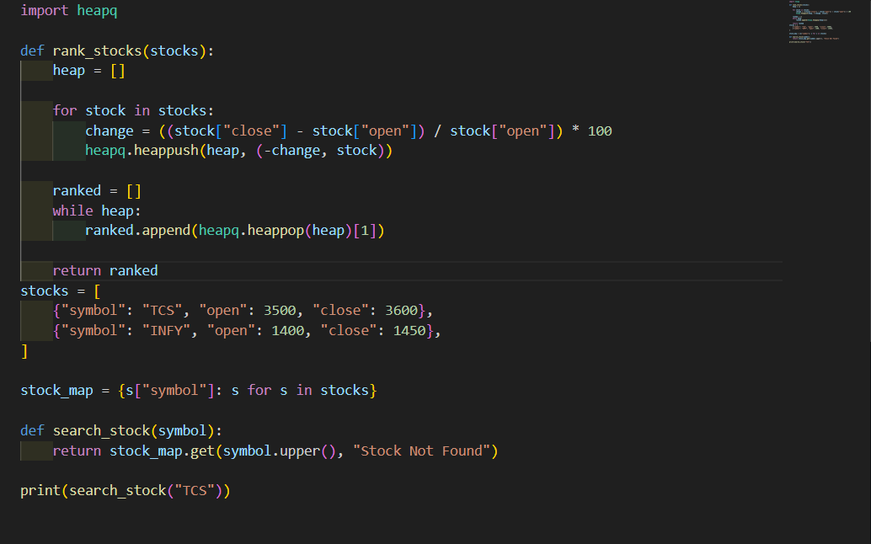
Output:
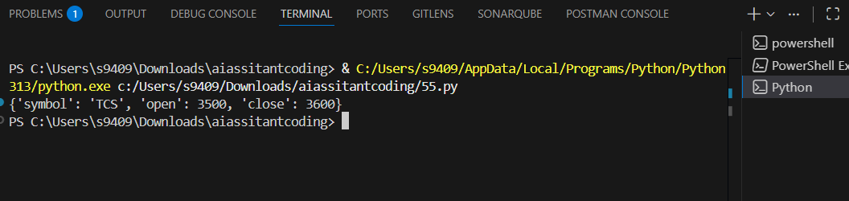
Performance Comparison
Operation | Heap Sort | sorted()
Sorting | O(n log n) | O(n log n)
Search | O(1) HashMap | O(1) Dict
Trade-offs
- sorted() (Timsort) is highly optimized in CPython
- Heap Sort useful when continuously extracting top-K elements
- Hash Map ideal for instant symbol retrieval

