AI ASSISTED CODING
Assisgnment-13.4
Rollno:2303a52146
Name: V. Praneeth reddy
Batch:41

Task 1:
Refactoring Data Transformation Logic
Scenario:
Verbose loop used for numerical transformation.
AI Prompt Used
Refactor this Python loop into a more Pythonic approach using list comprehension while preserving output.
Legacy Code: 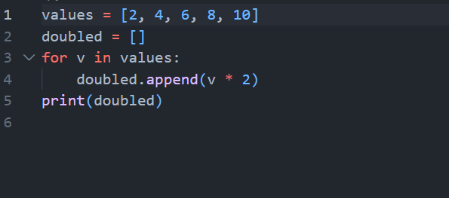
Refactored code:
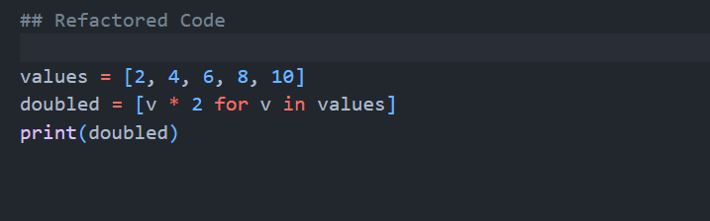

Output:
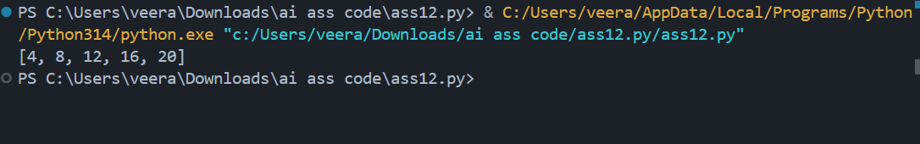
Explanation:

* Removed explicit loop.
* Used list comprehension.
* More readable.
* Fewer lines.
* Same time complexity: O(n).
* Maintains behavior.

Task2:
Improving Text Processing Code Readability
Scenario:
Repeated string concatenation inside loop.
AI Prompt Used
Suggest a more efficient method to build a sentence from a list of words in Python.
Legacy Code:
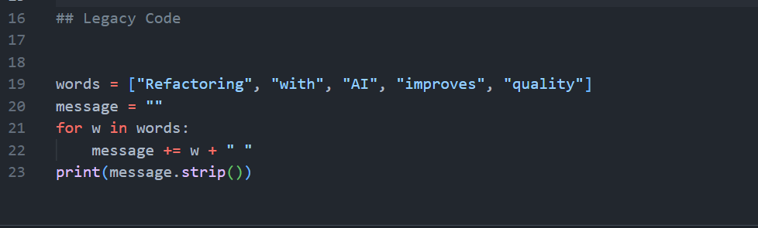
Refactored code:
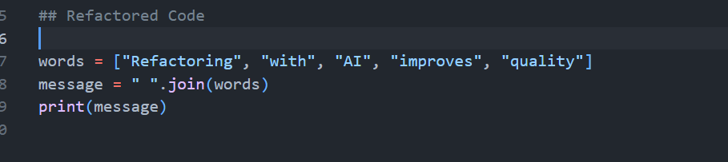

Output:
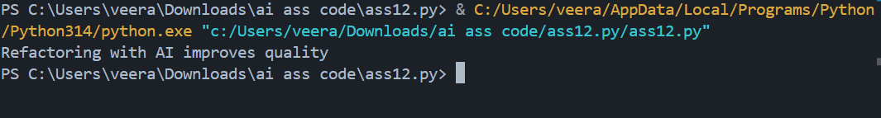
Explanation

* Used join() method.
* Avoids repeated string concatenation.
* More efficient (strings are immutable).
* Cleaner and more readable.
* Preserves exact output.

Task 3:
Safer Access to Configuration Data
Scenario:
Manual key existence check in dictionary.Code:
AI Prompt Used:
Refactor dictionary key checking using safer access methods in Python.

Legacy code:
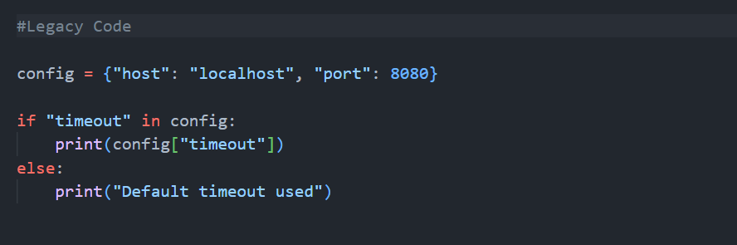
Refactored Code:
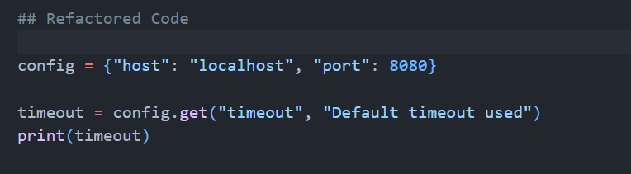

Output:
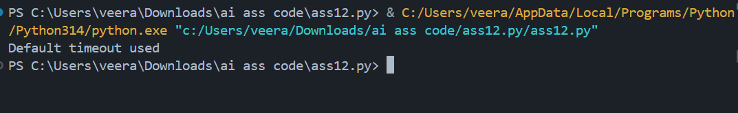
Explanation:
* Used .get() method.
* Avoids explicit conditional check.
* Prevents KeyError.
* More scalable and concise.
* Behavior unchanged.

Task 4:
Refactoring Conditional Logic for Scalability
Scenario:
Multiple if–elif statements for operation handling.Code:
AI Prompt Used
Replace multiple if-elif conditions with a more scalable approach using mapping techniques.
Legacy code:

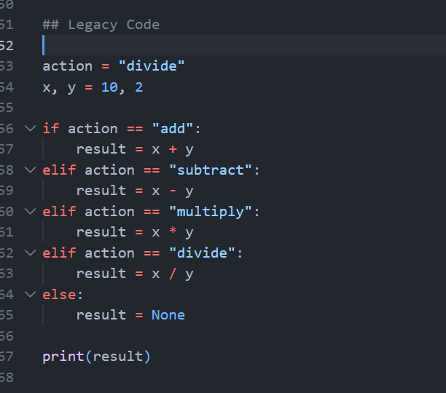
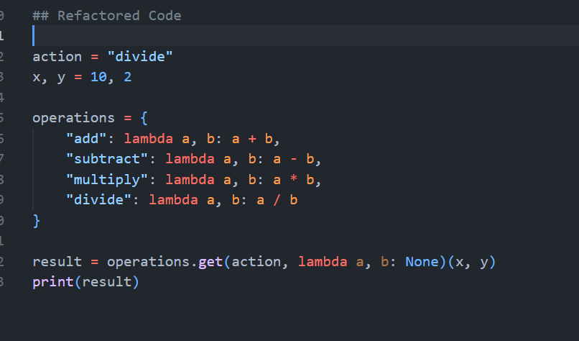

Output:
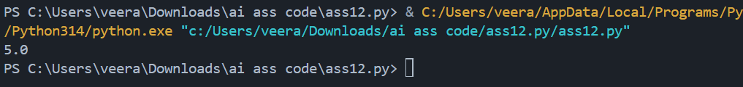
Explanation:
* Used dictionary mapping.
* Easy to extend (add new operation).
* Eliminates long conditional chains.
* Improves scalability.
* Follows open-closed principle.

Task 5:
Simplifying Search Logic in Collections
Scenario:
Manual loop for searching item in list.
AI Prompt Used:
Refactor this manual search loop into a more concise Pythonic approach.
Code
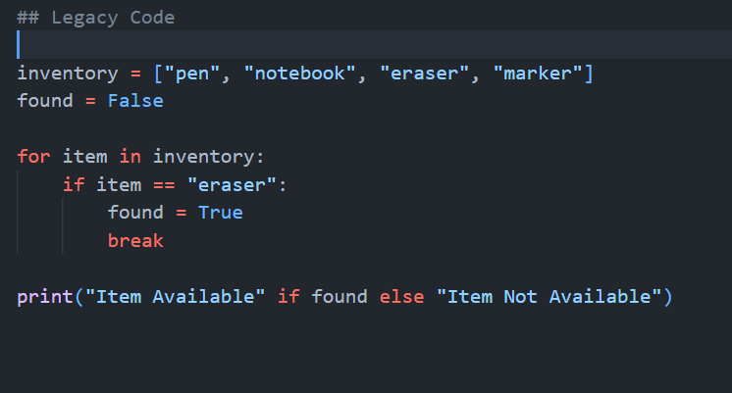
Refactored code:
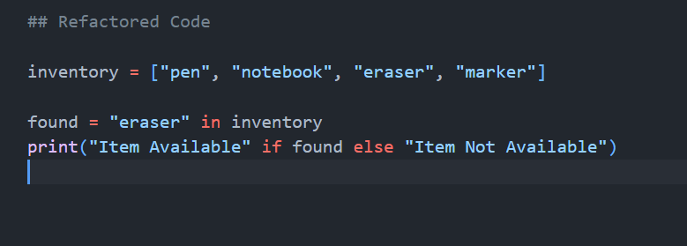
Output:
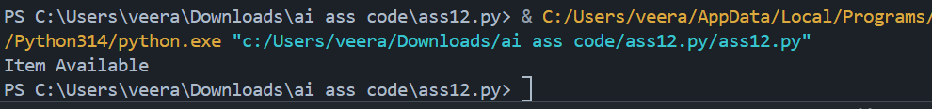
Explanation

* Used in membership operator.
* Cleaner and more readable.
* Eliminates unnecessary loop.
* Efficient (O(n)).
* Same behavior maintained.

