AI Assistant lab-21.3

Name : V.PRANEETH
Rollno : 2303A52146

Batch : 41

TASK 1 – AI-Assisted Expense Tracker Initial prompt:
Create a simple Python expense tracker to store daily expenses with category and amount.
Initial code:
expenses = []

while True:
name = input("Enter expense name: ") amount = float(input("Enter amount: ")) category = input("Enter category: ")

expenses.append((name, amount, category))

choice = input("Add more? (y/n): ") if choice == 'n':
break

print("Expenses:", expenses)

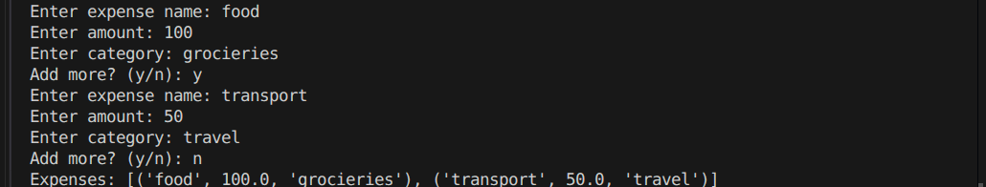

Improvement prompt:
Improve the expense tracker with monthly summary, input validation, and functions.
Improved code
def add_expense(expenses):
name = input("Enter expense name: ")

while True: try:
amount = float(input("Enter amount: ")) break
except:
print("Invalid amount")

category = input("Enter category: ")
expenses.append({"name": name, "amount": amount, "category": category})

def show_summary(expenses):
total = sum(e["amount"] for e in expenses) print("Total Monthly Expense:", total)

expenses = [] while True:
add_expense(expenses)
choice = input("Add more? (y/n): ") if choice == 'n':
break

show_summary(expenses)

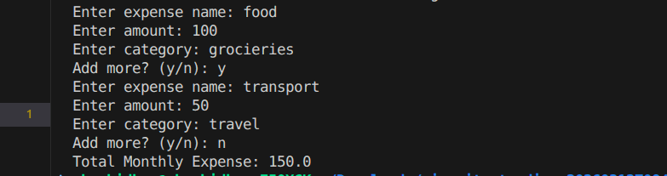
Justification
- Functions → modular design
- Validation → avoids runtime errors
- Summary → real-world usability

TASK 2 – Git Version Control (Student Grade Calculator)

Initialize Repo,Initial Code,Create Branch
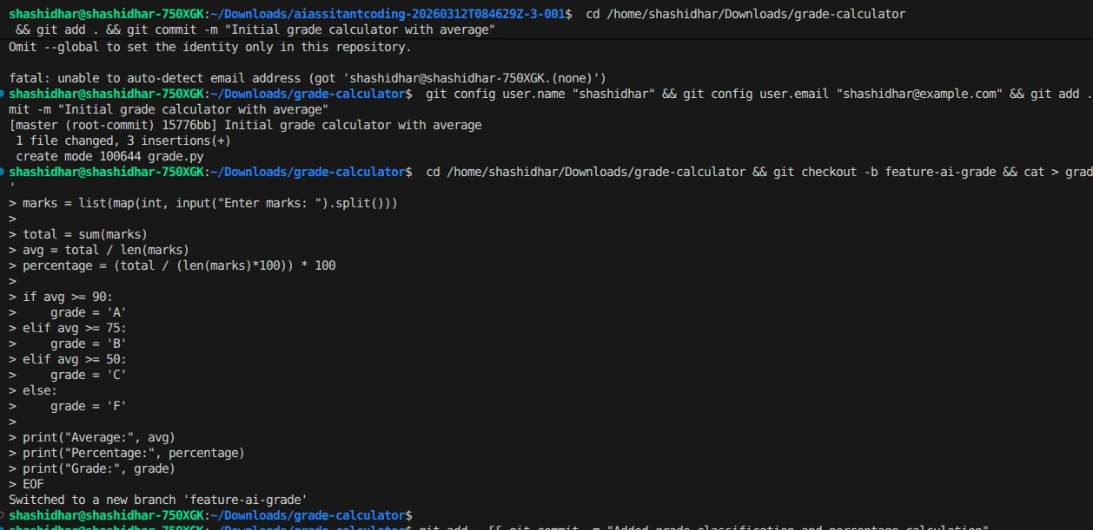
Ai prompt
Add grade classification and percentage calculation to the program. Updated

marks = list(map(int, input("Enter marks: ").split()))

total = sum(marks)
avg = total / len(marks)
percentage = (total / (len(marks)*100)) * 100

if avg >= 90: grade = 'A'
elif avg >= 75: grade = 'B'
elif avg >= 50: grade = 'C'
else:
grade = 'F'

print("Average:", avg) print("Percentage:", percentage) print("Grade:", grade)

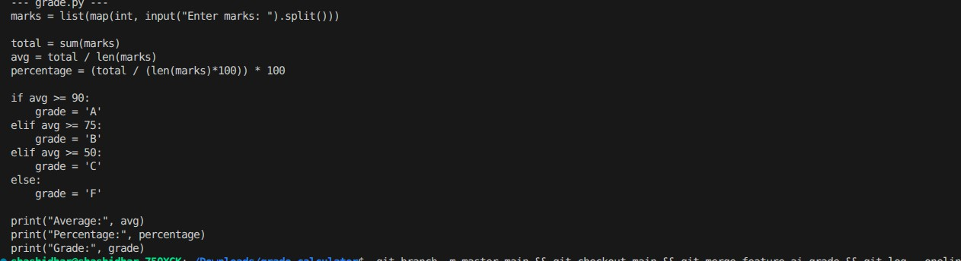
Commit + Merge

Justification
- Branching → safe feature development
- Merge → integration workflow
- AI → faster feature addition

TASK 3 – AI Commit Messages (Password Validation)

import re

password = input("Enter password: ")

if len(password) < 8: print("Weak password")
elif not re.search(r'[!@#$%^&*]', password): print("Add special character")
else:

print("Strong password")

Prompt
Generate commit message for adding password validation with length and special character rules.
AI Commit Message
Human Version
Added strong password validation rules

Justification
- AI → more structured (uses “feat:” convention)
- Human → less descriptive

TASK 4 – Quiz Management System (Pair Programming)

Student A Code
questions = {
"Capital of India?": "Delhi", "2+2?": "4"
}

for q in questions: ans = input(q + " ")
if ans == questions[q]: print("Correct")
else:
print("Wrong")
AI Prompt (Student B)
Add score calculation and input validation to quiz program.
Final code
questions = {
"Capital of India?": "Delhi", "2+2?": "4"
}

score = 0

for q in questions:
ans = input(q + " ").strip()

if ans.lower() == questions[q].lower(): print("Correct")
score += 1 else:
print("Wrong") print("Final Score:", score)
Git Workflow



Output:

Justification
- Score → measurable output
- Validation → better UX
- Collaboration → real Git workflow

