AI ASSISTED CODING
Assisgnment-10.3
Rollno:2303a52146
Name: V. Praneeth reddy
Batch:41

Task1:
Code befor review:
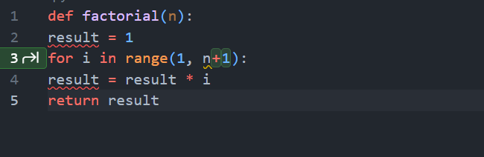

Prompt to review code:
Review the following Python function and identify any logical errors. Explain the bug and provide a corrected version:

def factorial(n):
result = 1
for i in range(1, n):
result = result * i
return result
code after review:
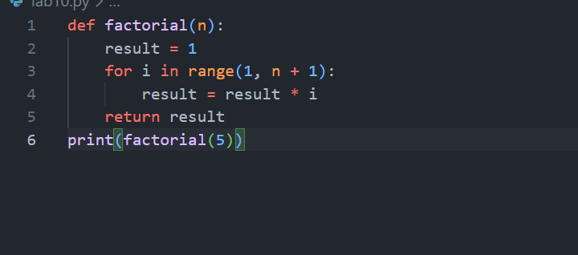
Output:
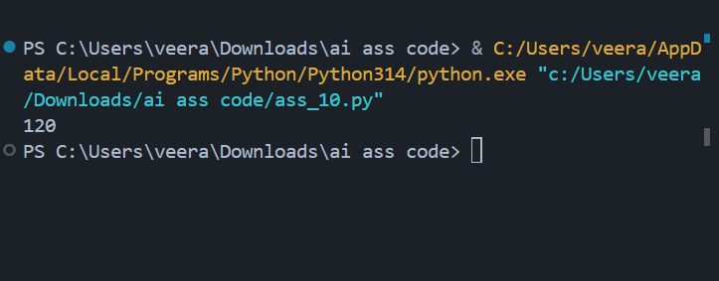

Justification:
Zero-shot works because the task is clear and standard. AI already knows factorial logic and can detect off-by-one errors without examples.

Task2:
Code befor review:
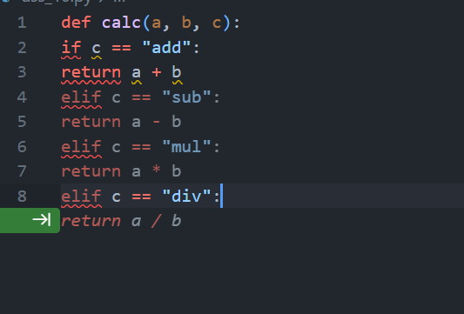

Prompt to review code:
Critique the following function for readability, naming, and documentation. Then rewrite it with:
- descriptive names
- docstring
- input validation
- division-by-zero handling

def calc(a, b, c):
if c == "add":
return a + b
elif c == "sub":
return a - b
elif c == "mul":
return a * b
elif c == "div":

code after review:
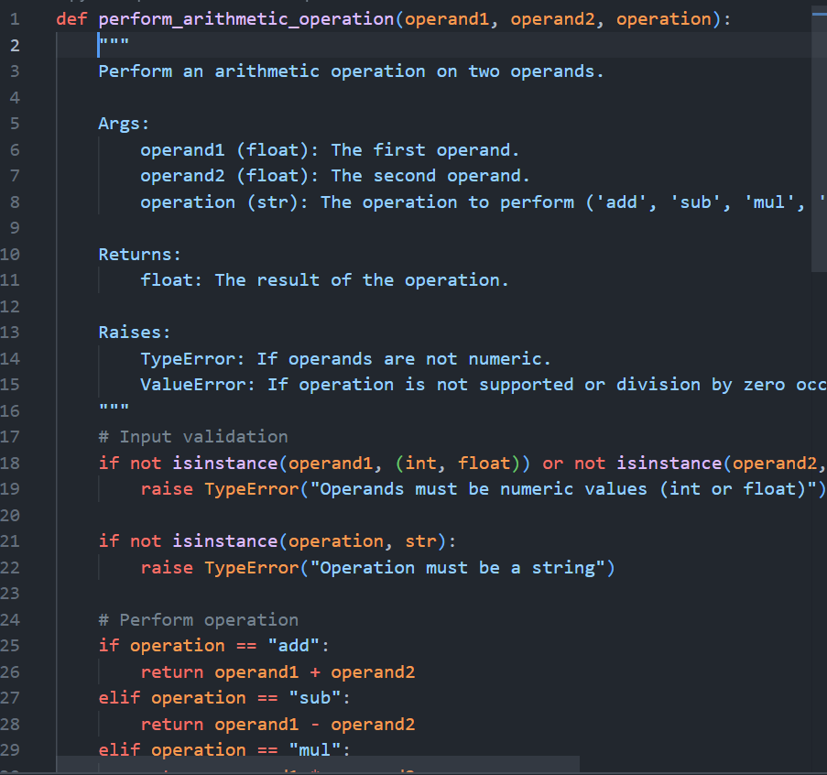

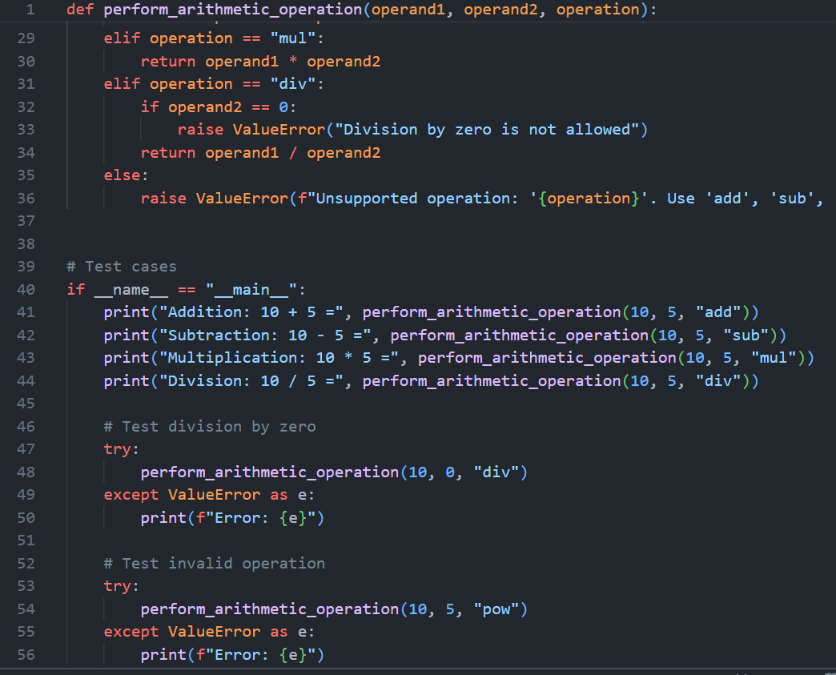

Ouput:
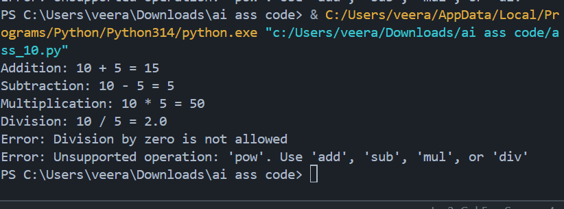

Justification:
This structured prompt ensures AI performs analysis + improvement + robustness instead of just rewriting.
Task3:
Code befor review:
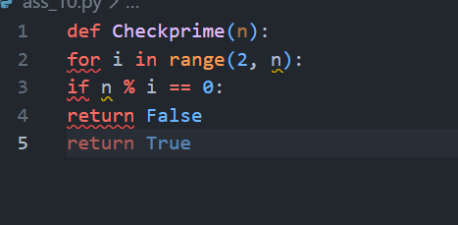
Prompt to review code:

Check this Python function for PEP8 violations. List all violations and then provide a corrected version that follows PEP8 while keeping functionality unchanged.

def Checkprime(n):
for i in range(2, n):
if n % i == 0:
return False
return True
code after review:

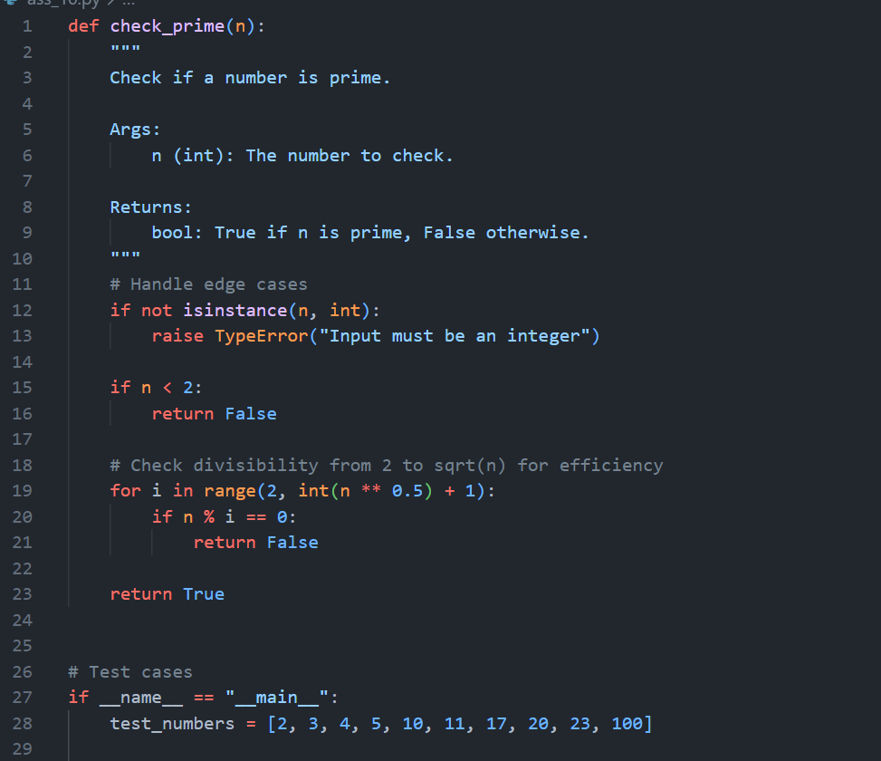
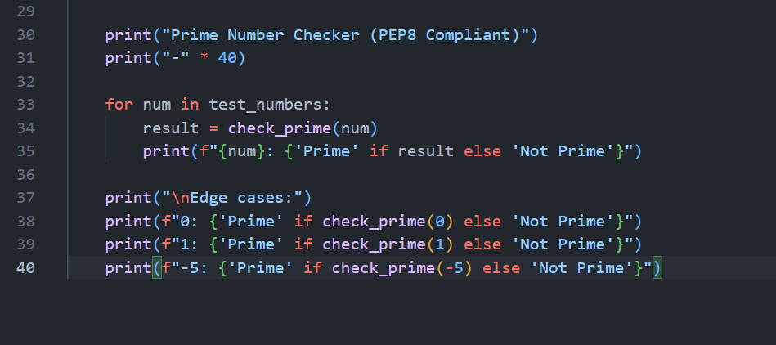

Output:
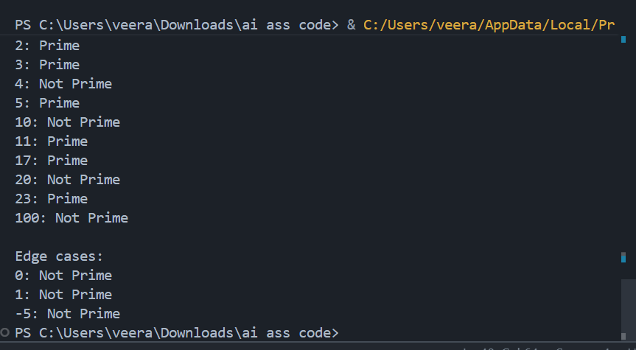
Justification:
Specifying list violations first forces AI to show understanding instead of blindly rewriting.

Task4:
Code befor review:
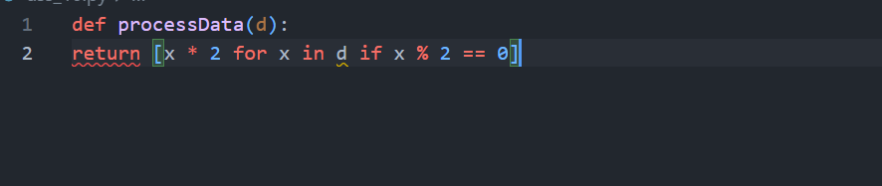

Prompt to review code:
Act as a senior code reviewer. Review this function and comment on:
1. Naming clarity
2. Reusability
3. Edge cases
4. Improvements

Then provide a refactored version with:
- type hints
- validation
- configurable multiplier

Code:
def processData(d):
return [x * 2 for x in d if x % 2 == 0]

code after review:
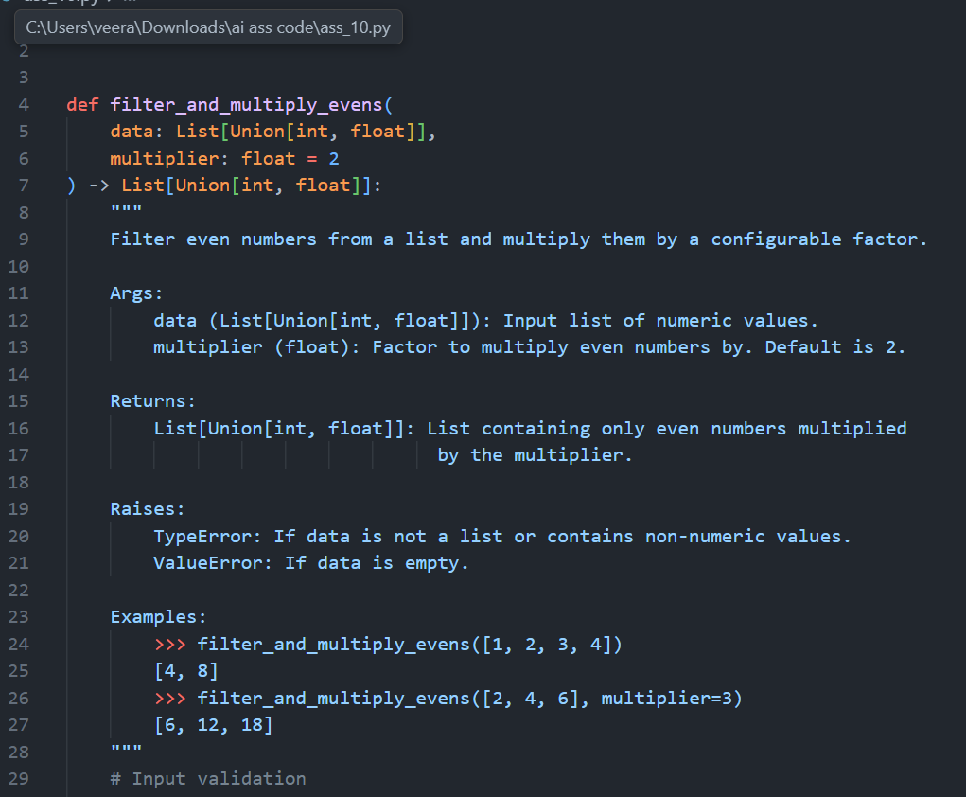
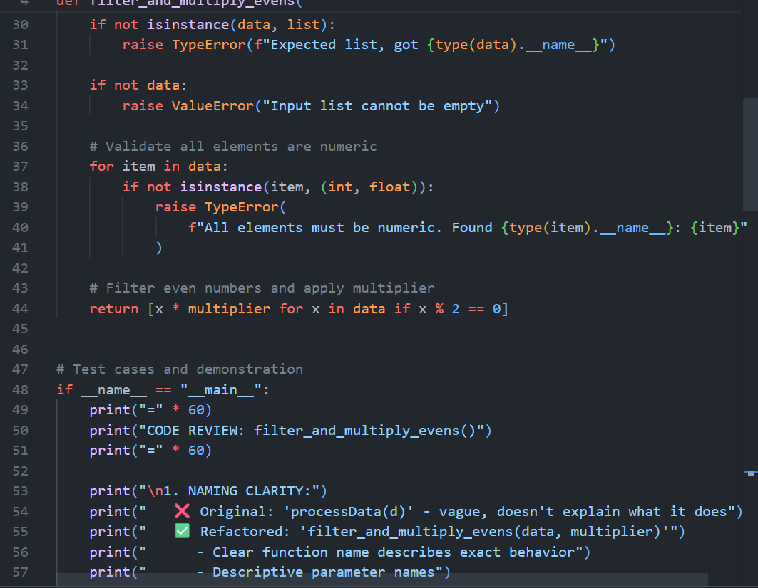
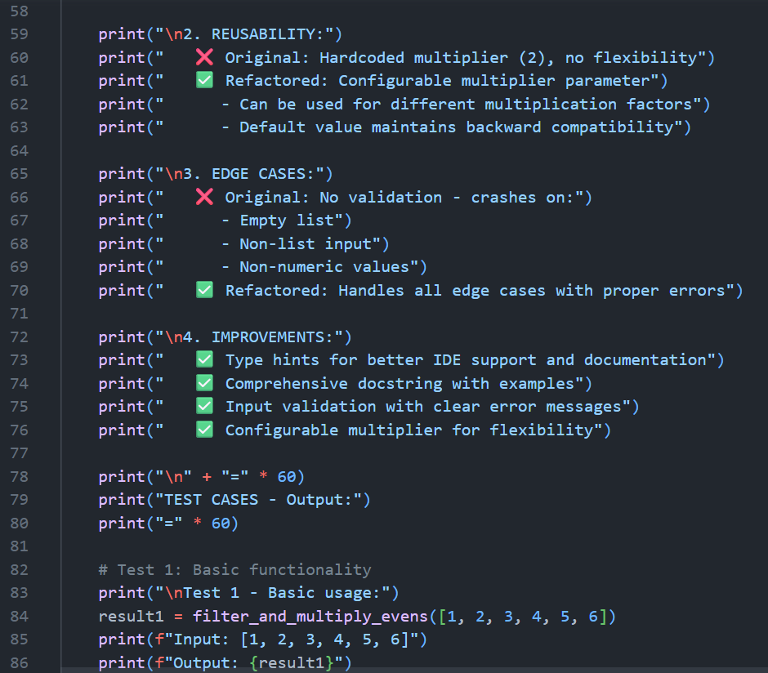
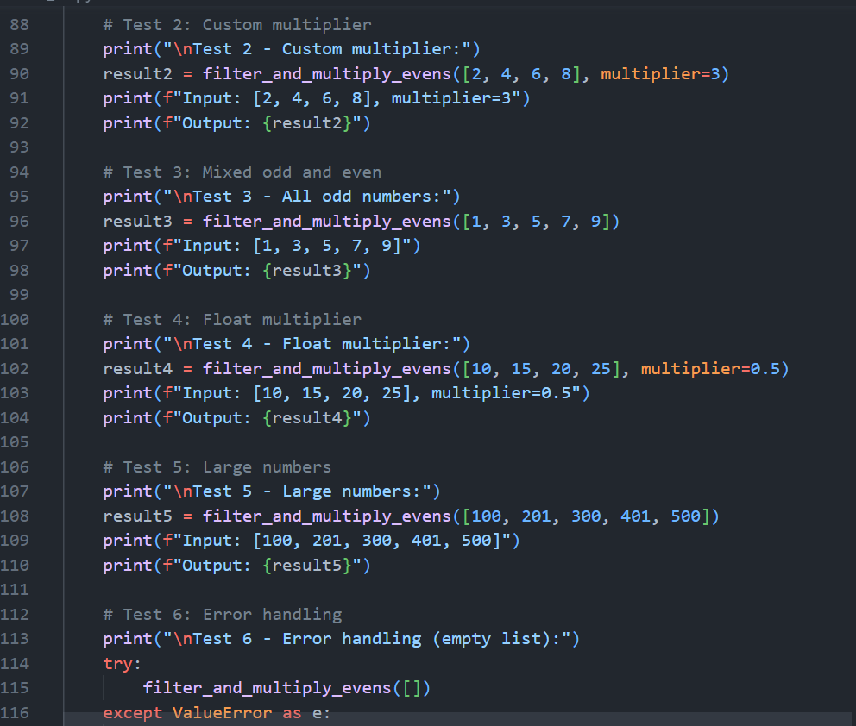
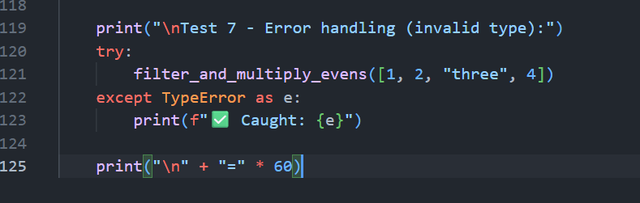

Ouput:
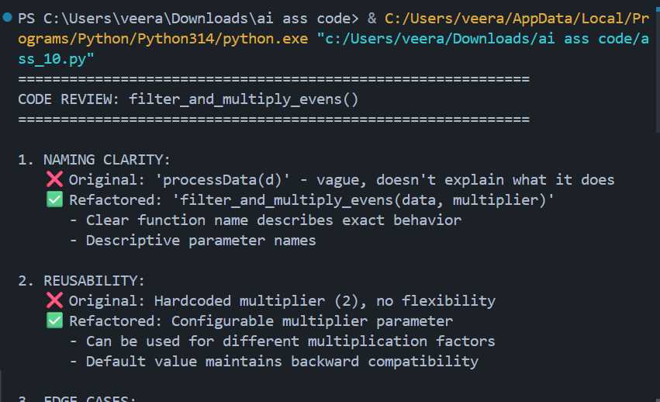
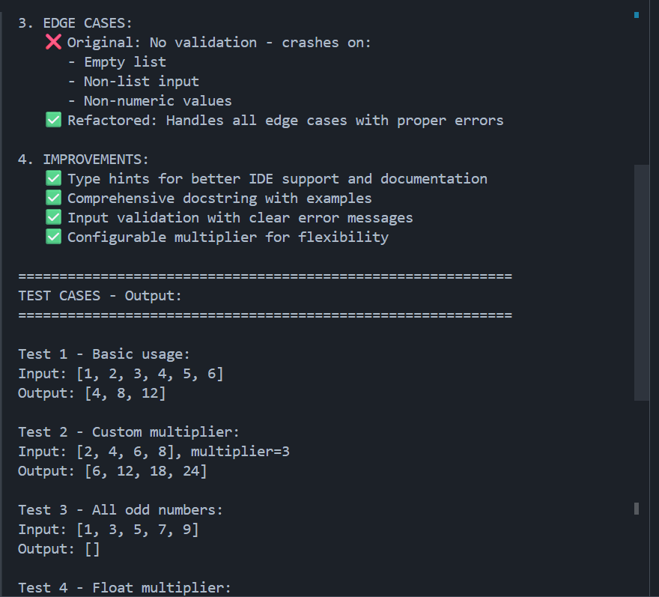
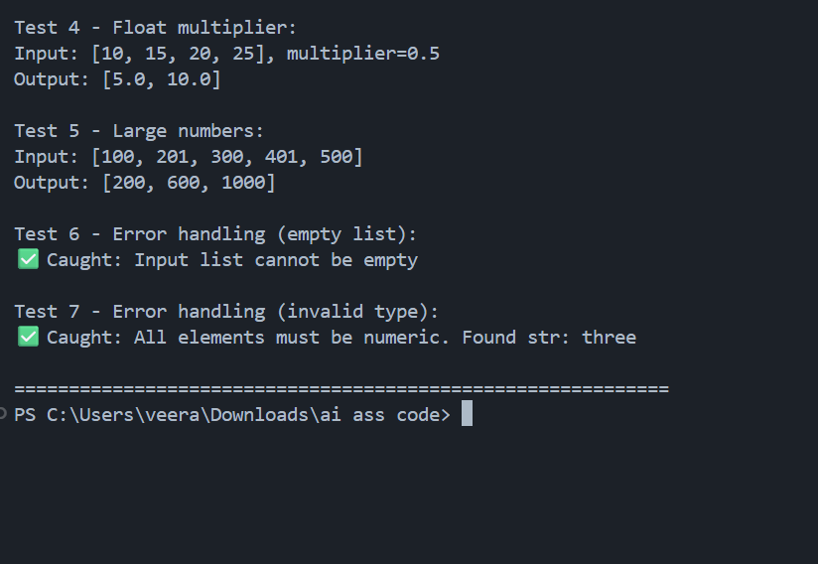
Justification:
Role-based prompts (“Act as a senior reviewer”) improve response quality and realism.

Task5:
Code befor review:
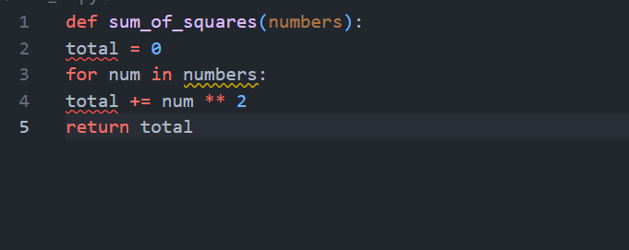

Prompt to review code:
Analyze this function’s time complexity and suggest optimizations for large datasets. Provide a faster version and explain why it is faster.

def sum_of_squares(numbers):
total = 0
for num in numbers:
total += num ** 2
return total
code after review:

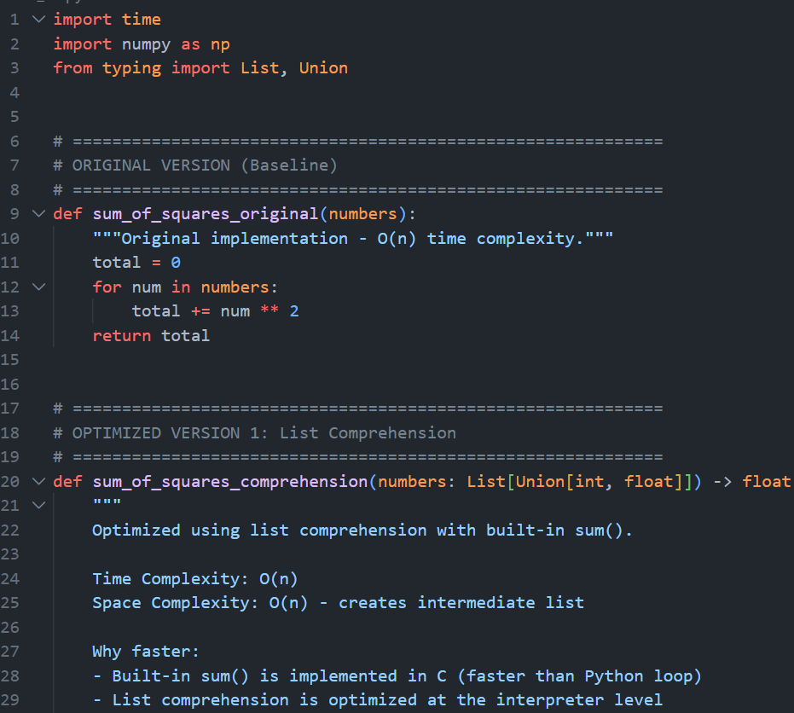
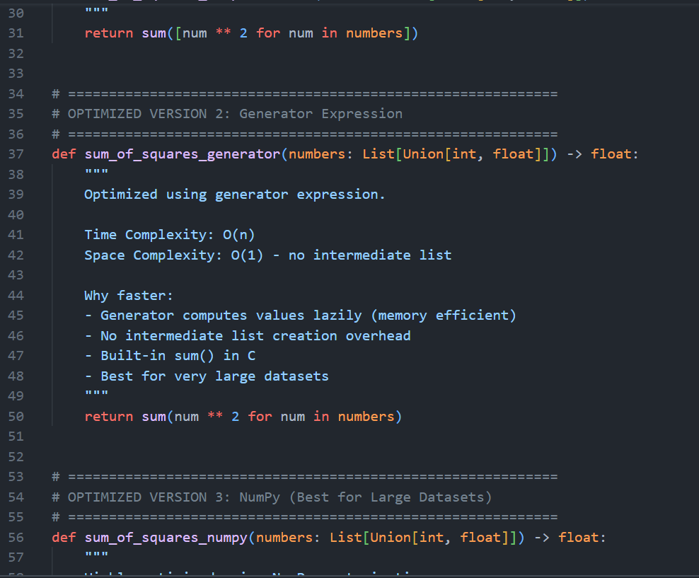
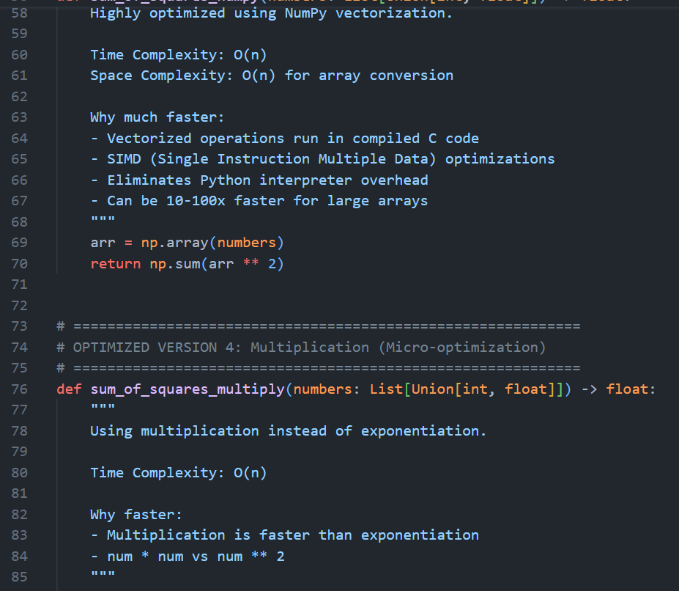
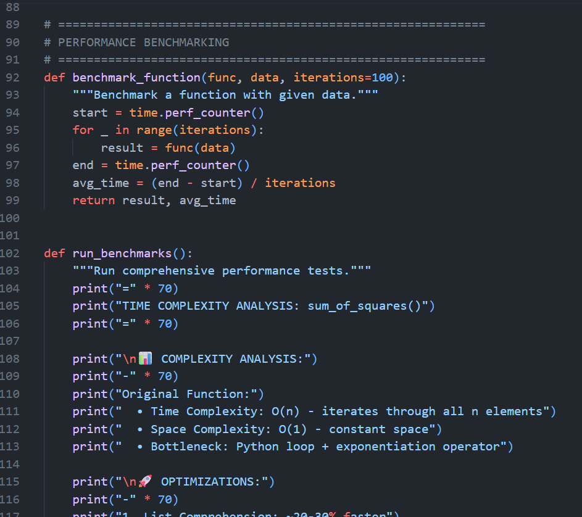
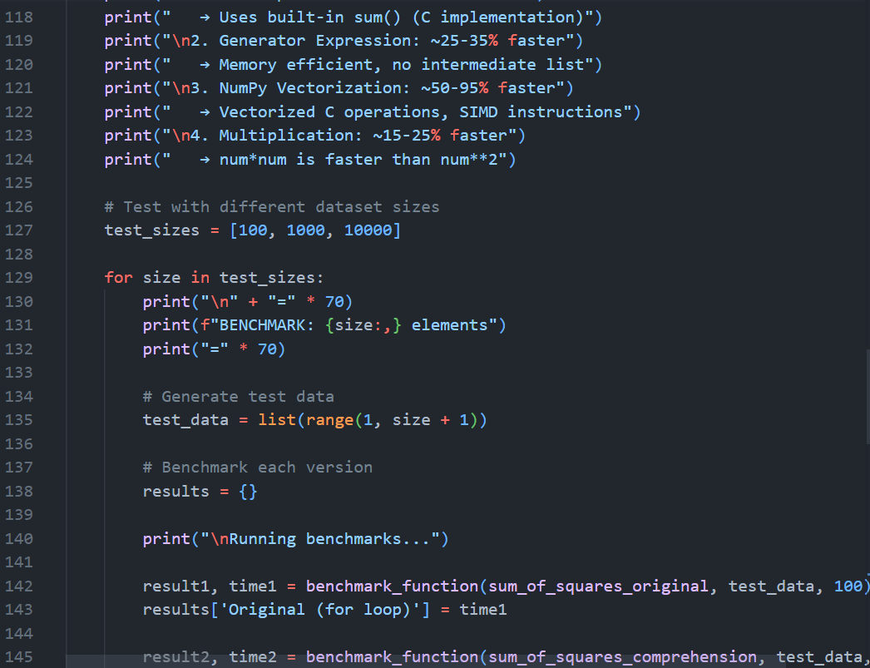
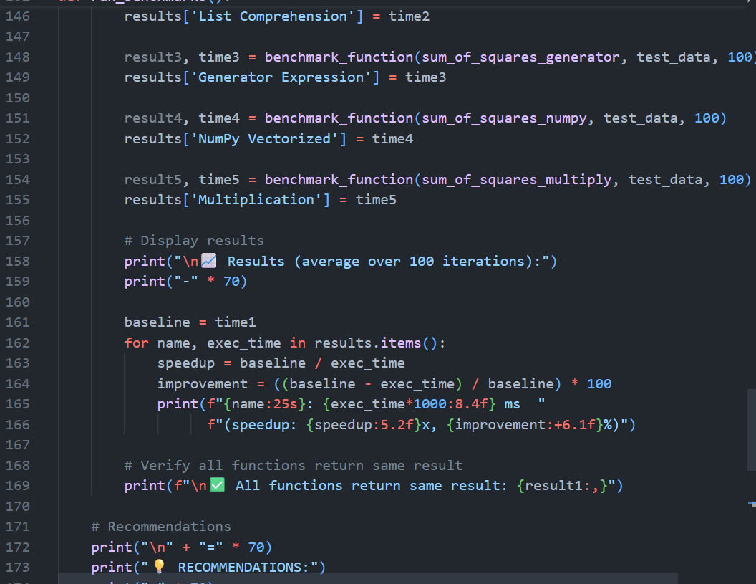
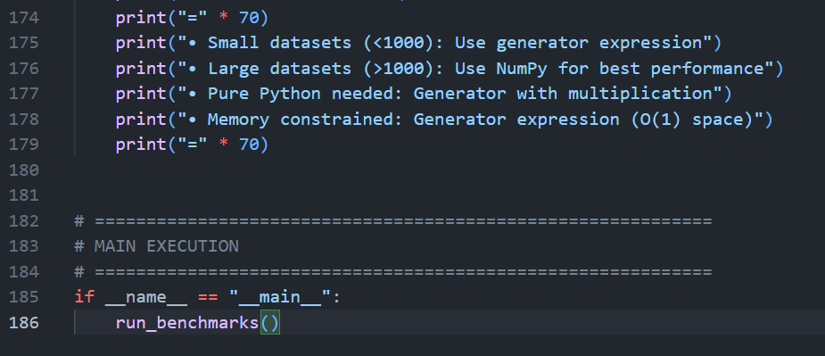
Output:
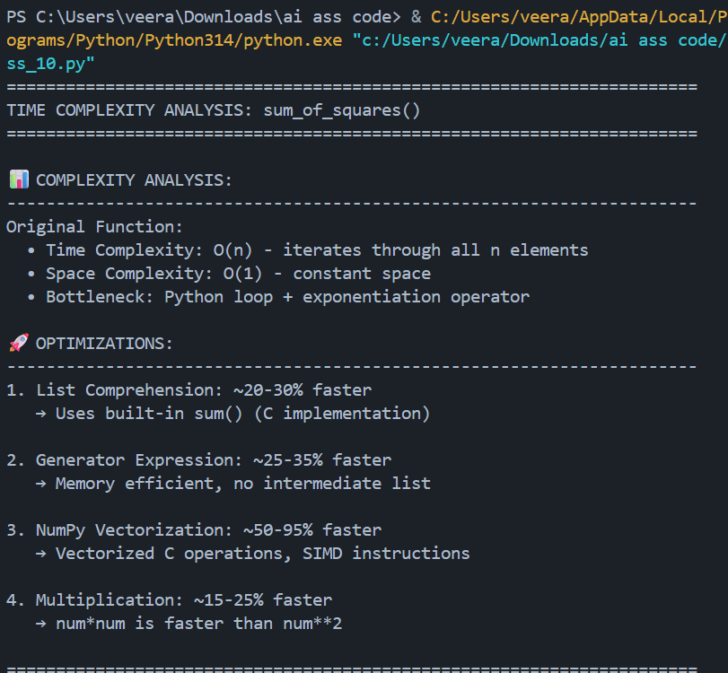
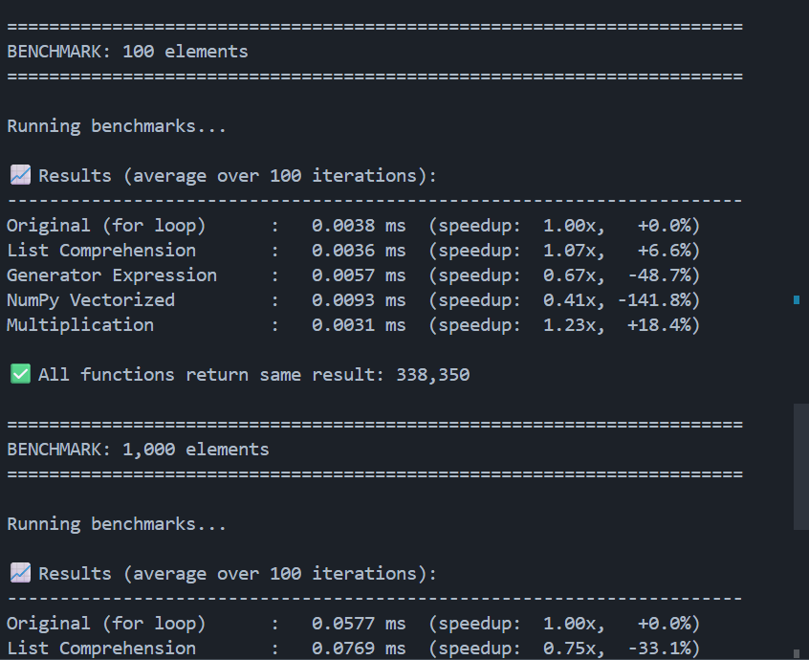
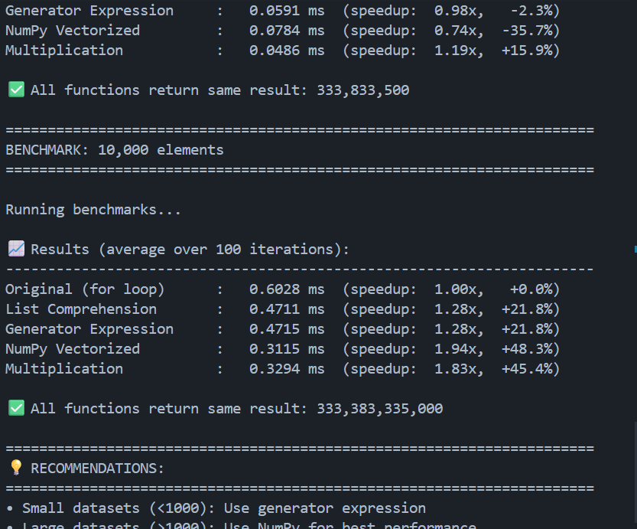
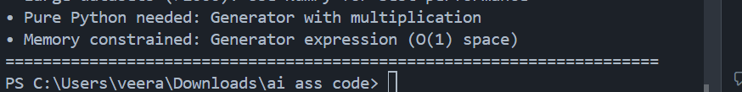

Justification:
Asking for complexity + explanation + code ensures deeper reasoning instead of surface improvement.

