Contents

1. Order Management: 2

i. Application Start 2

ii. Post Orders 2

iii. Get All Orders 2

iv. Get Order by ID 3

v. Delete Order By ID 3

vi. Maven Build 5

vii. Yaml 5

2. Inventory Management 6

viii. Application Start 6

ix. Get Products 7

x. Get Product by ID 7

xi. Post Product by ID 8

xii. Post Multi Product 8

xiii. Put update Product 9

xiv. Delete Product by ID 9

xv. Maven Build 10

xvi. Yaml 10

3. Global Exception 11

4. JWT 11

5. Checking Product inv for Quantity 11

# Order Management:

## Application Start

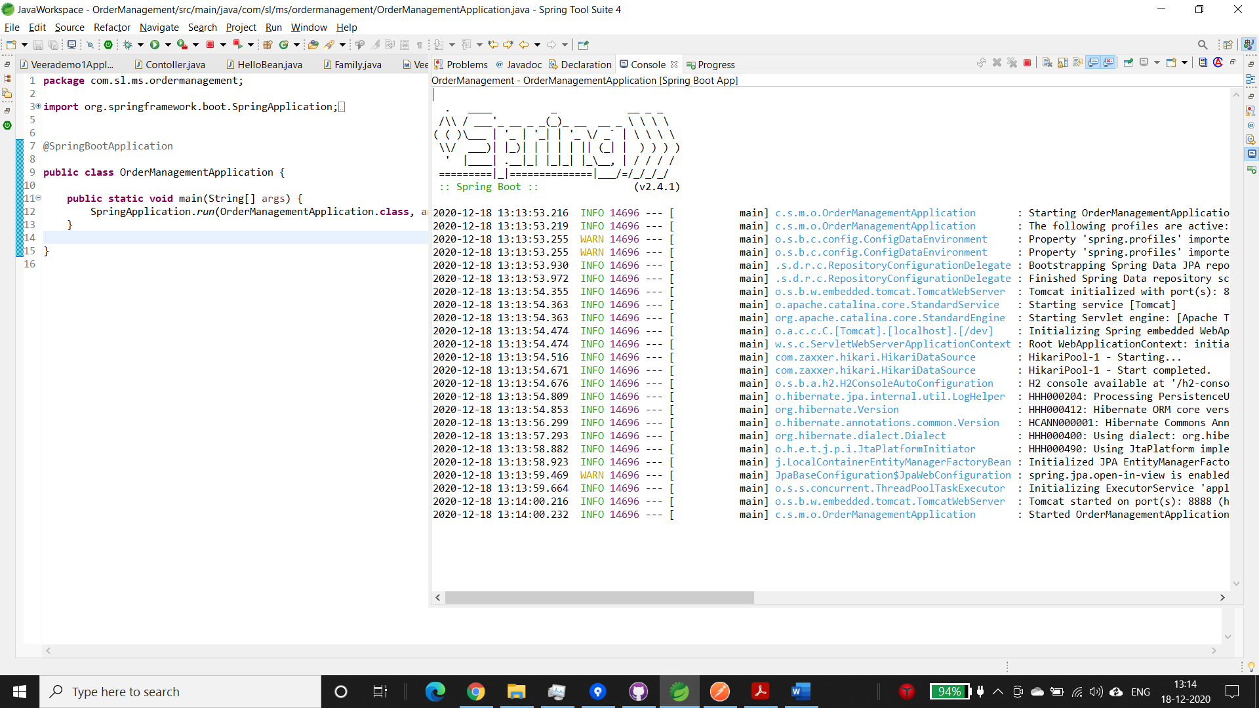

## Post Orders

Posting Orders with 5 items in the same request

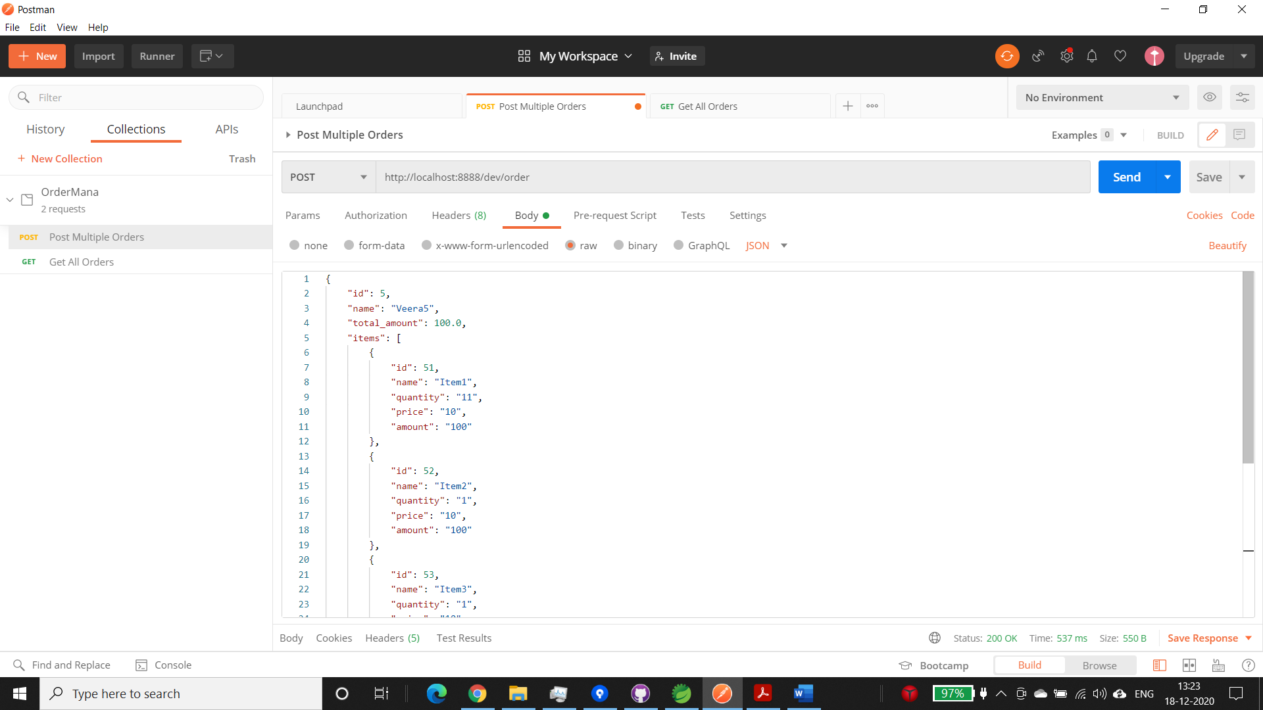

## Get All Orders

All order listed with their items

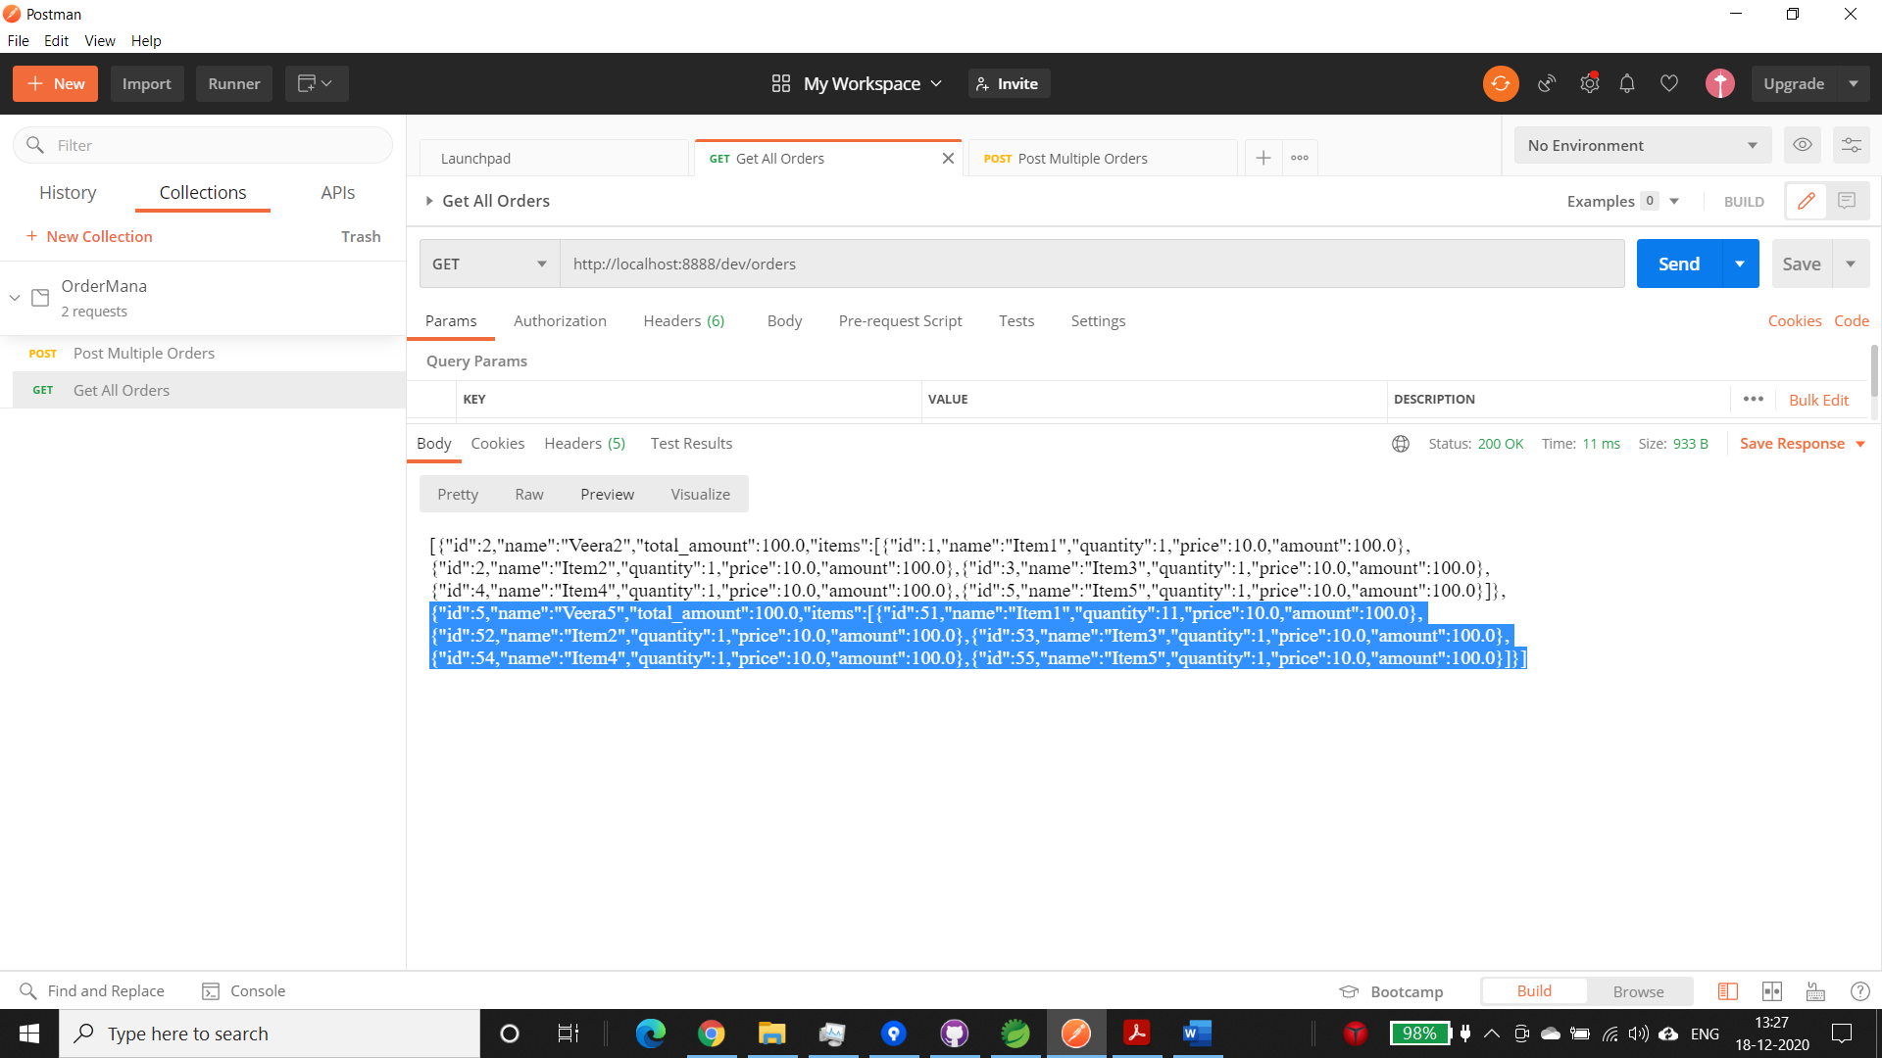

## Get Order by ID

Only order with ID 5 is listed

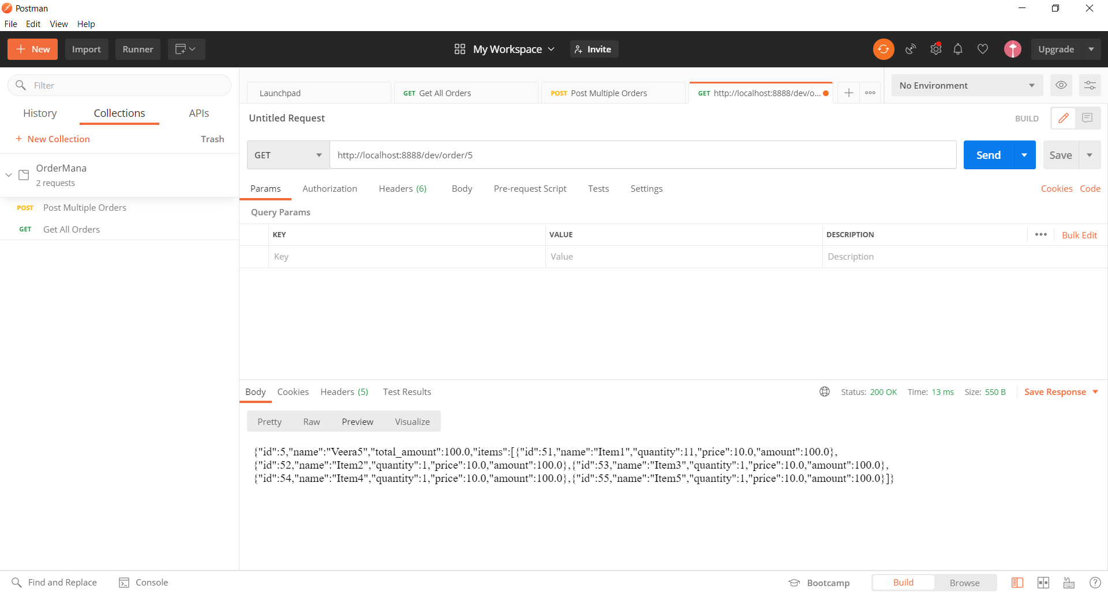

## Delete Order By ID

Delete Order 5. Getting all order to make sure it is deleted

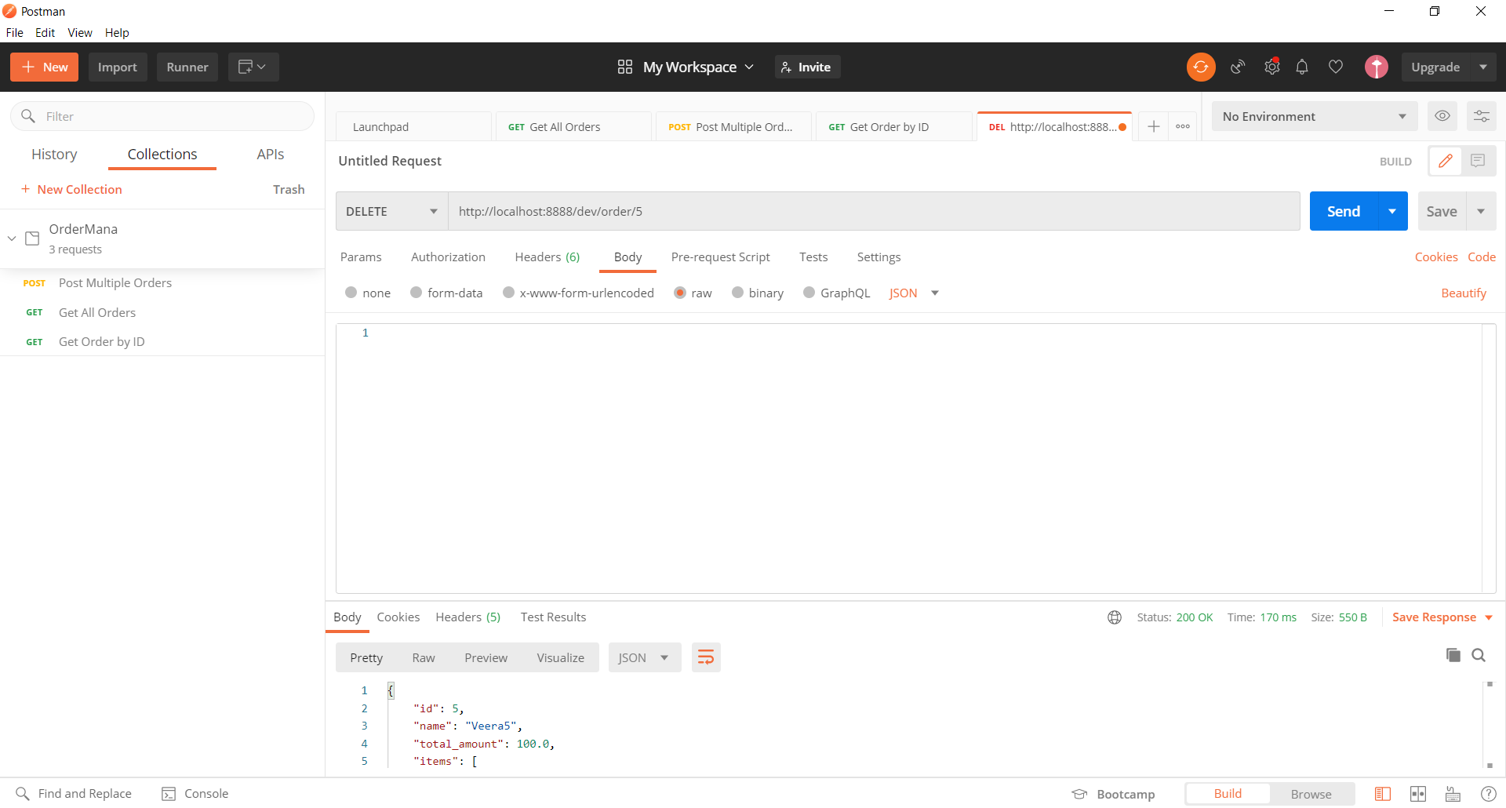

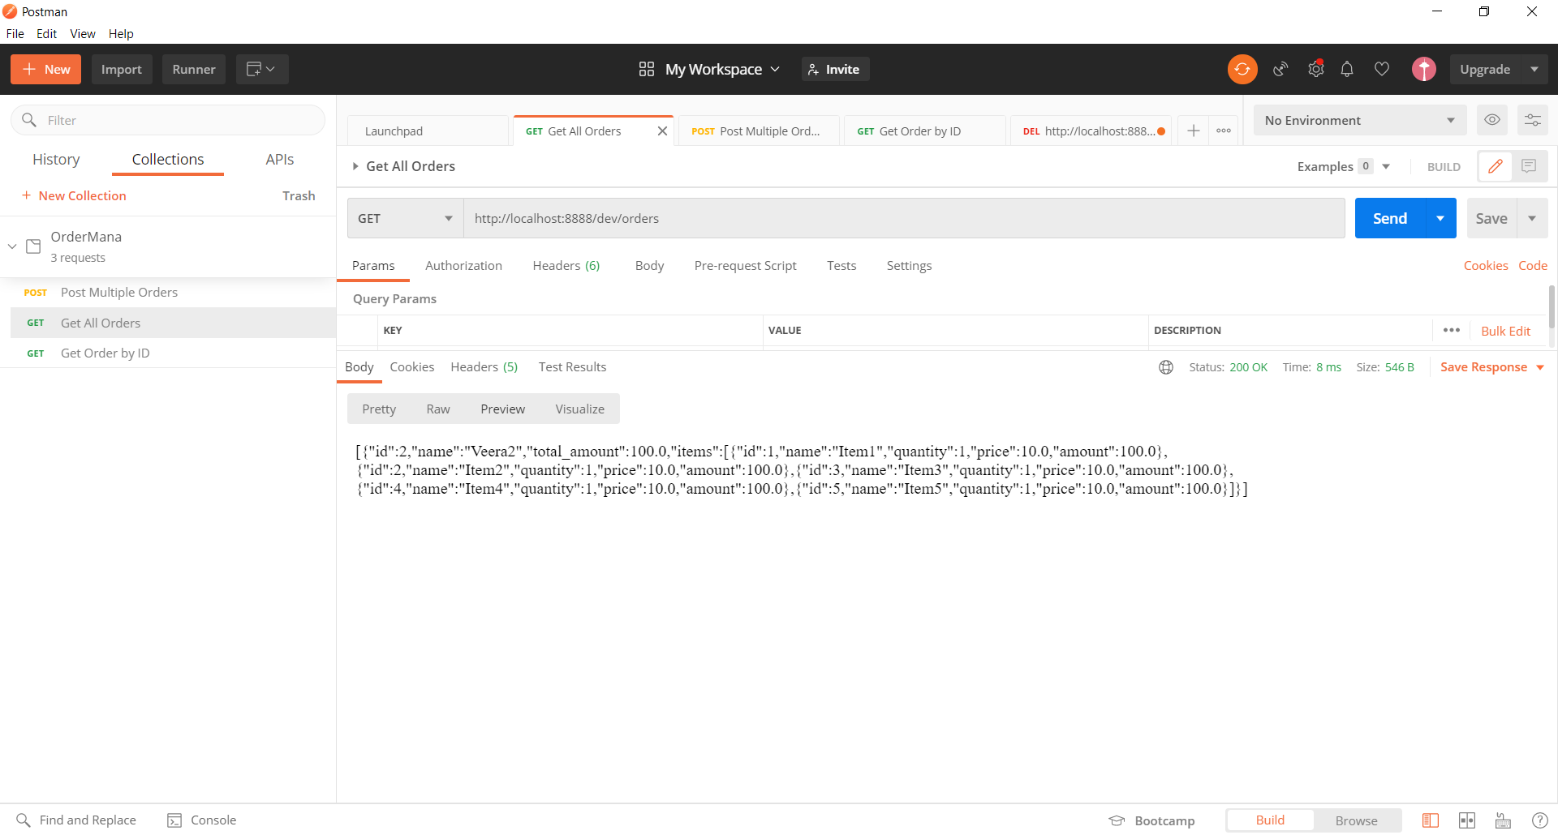

## Maven Build

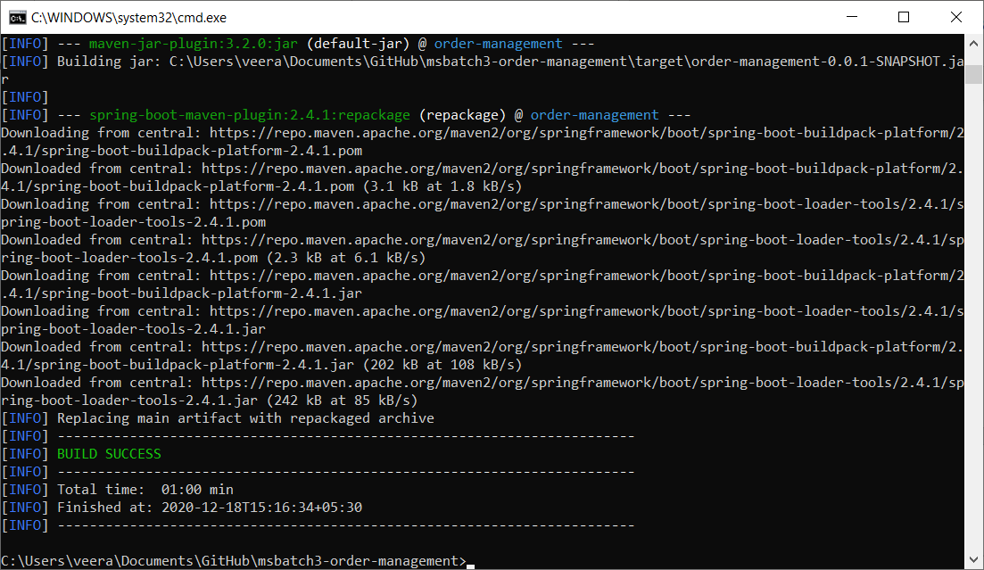

## Yaml

Yaml file default profile is dev

context & port is defined.

Postman url contains /dev

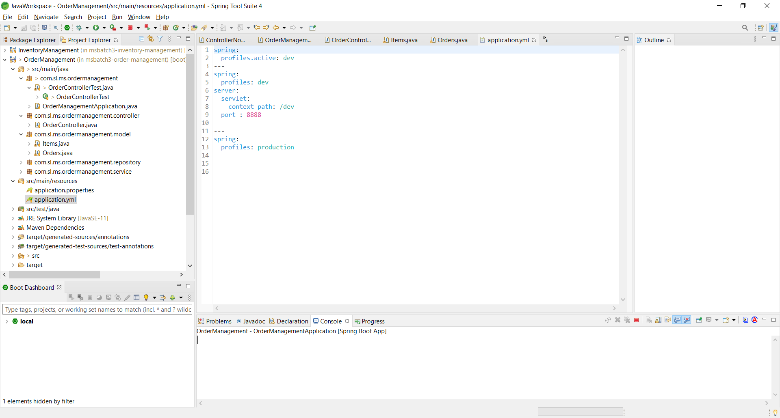

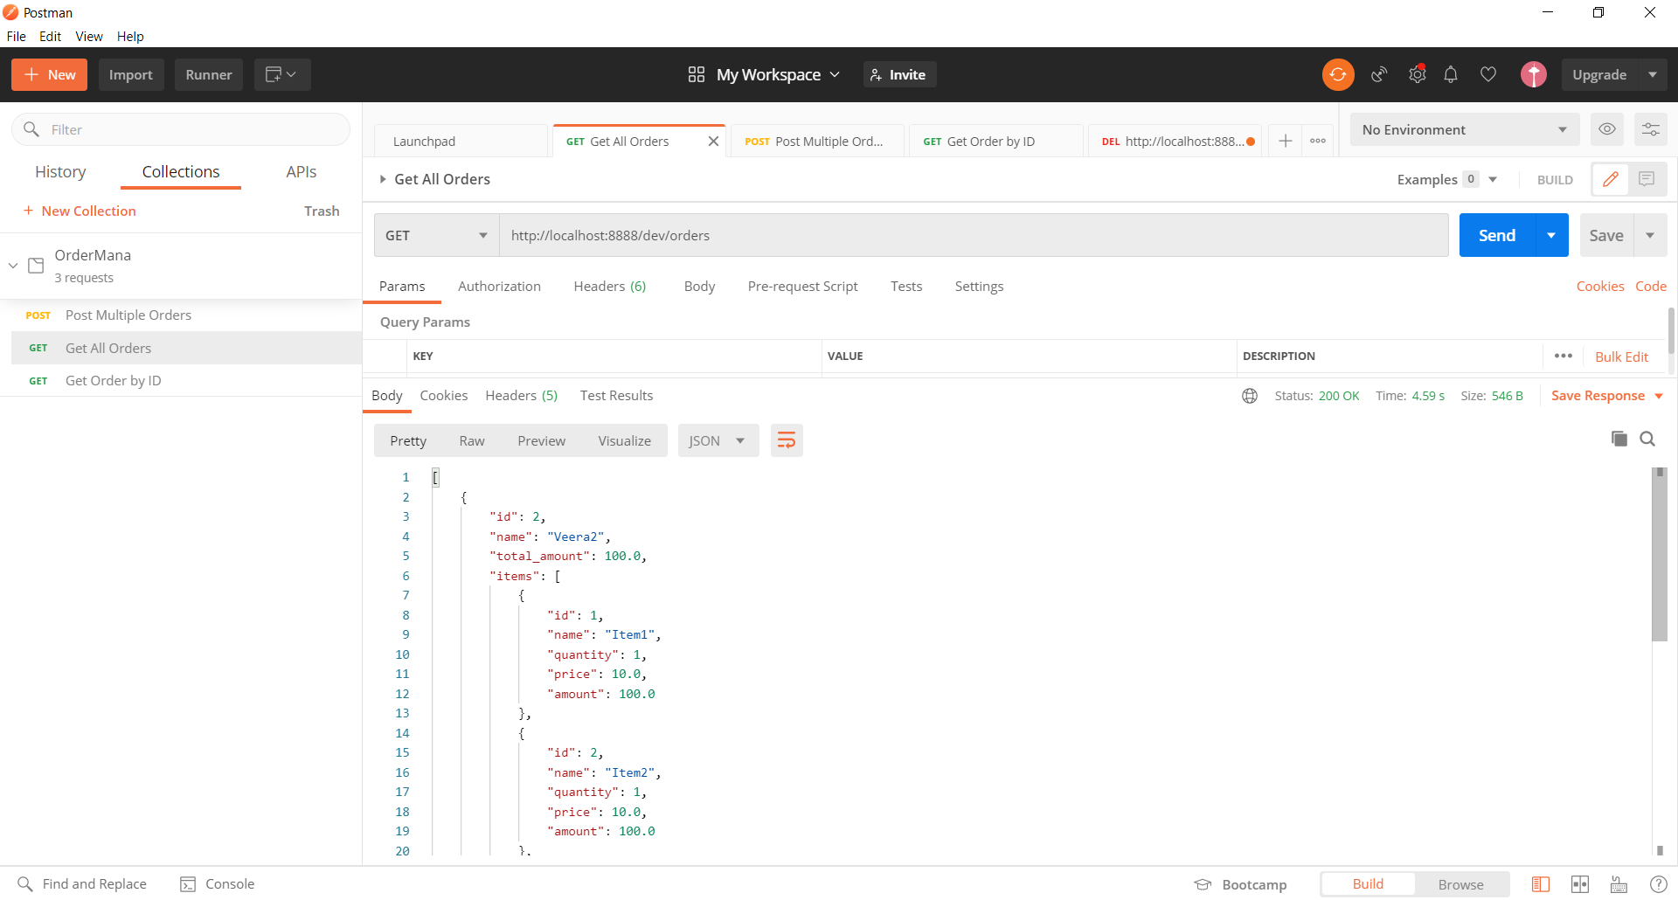

# Inventory Management

## Application Start

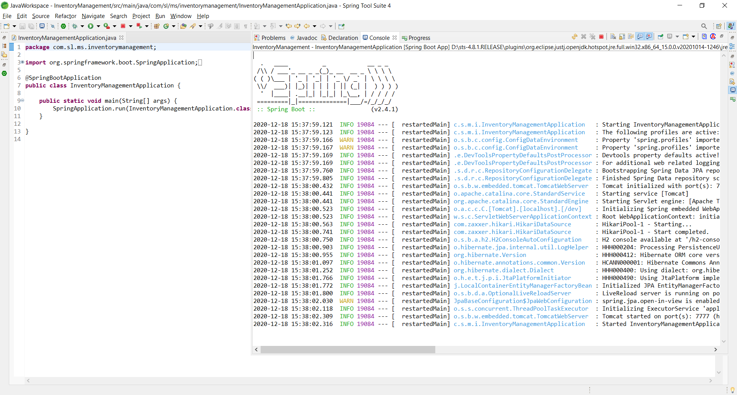

## Get Products

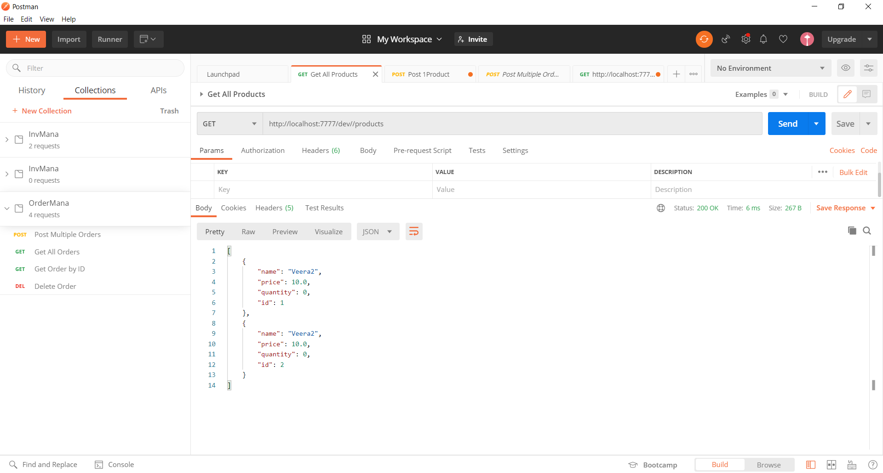

## Get Product by ID

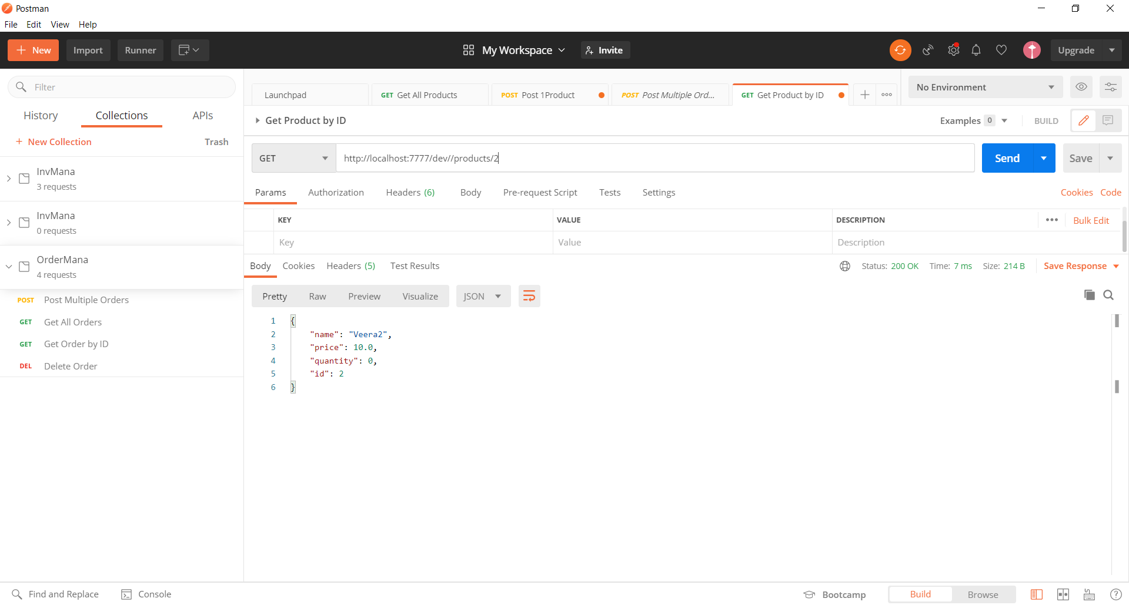

## Post Product by ID

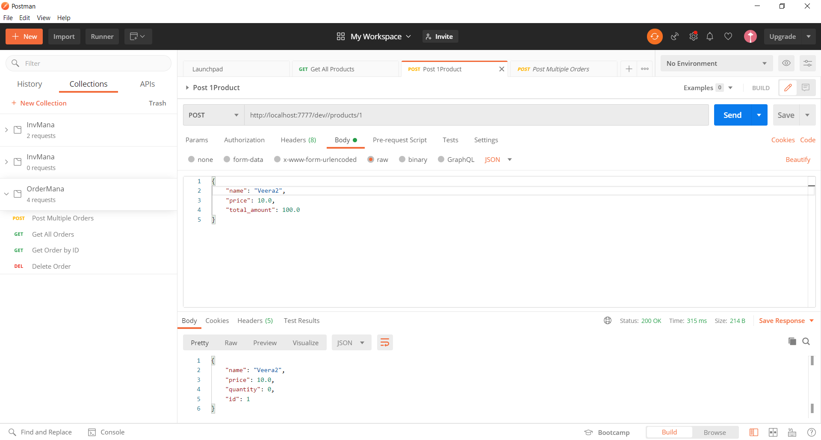

## Post Multi Product

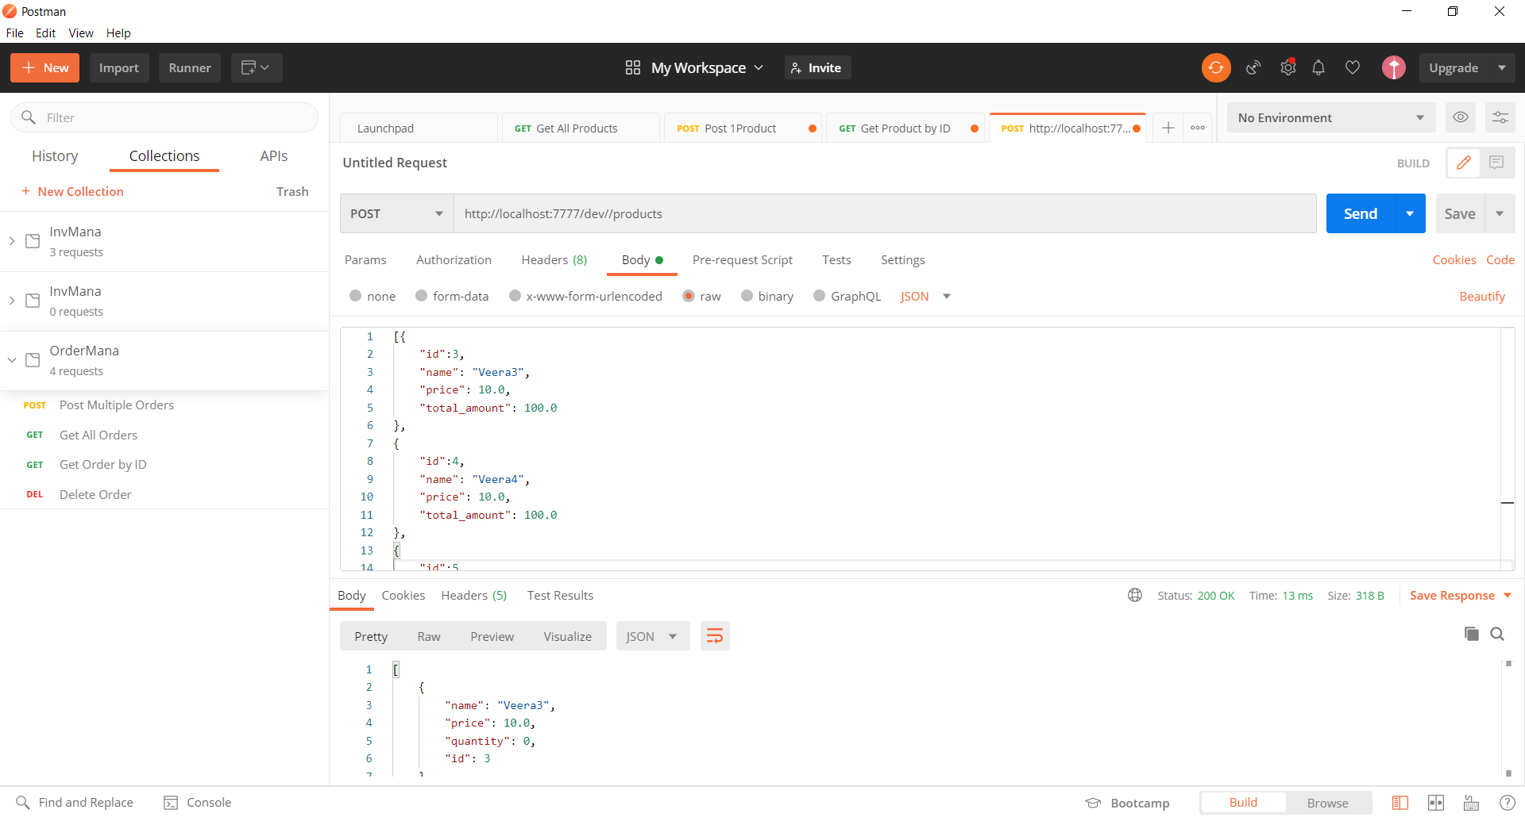

## Multifile upload

2 files uploaded and result with all the products

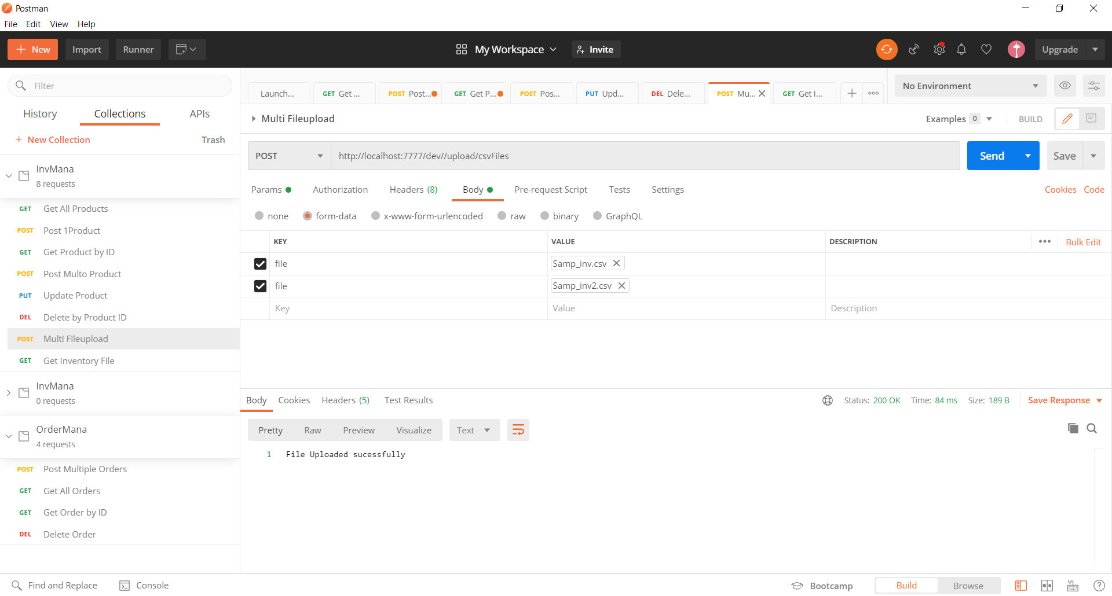

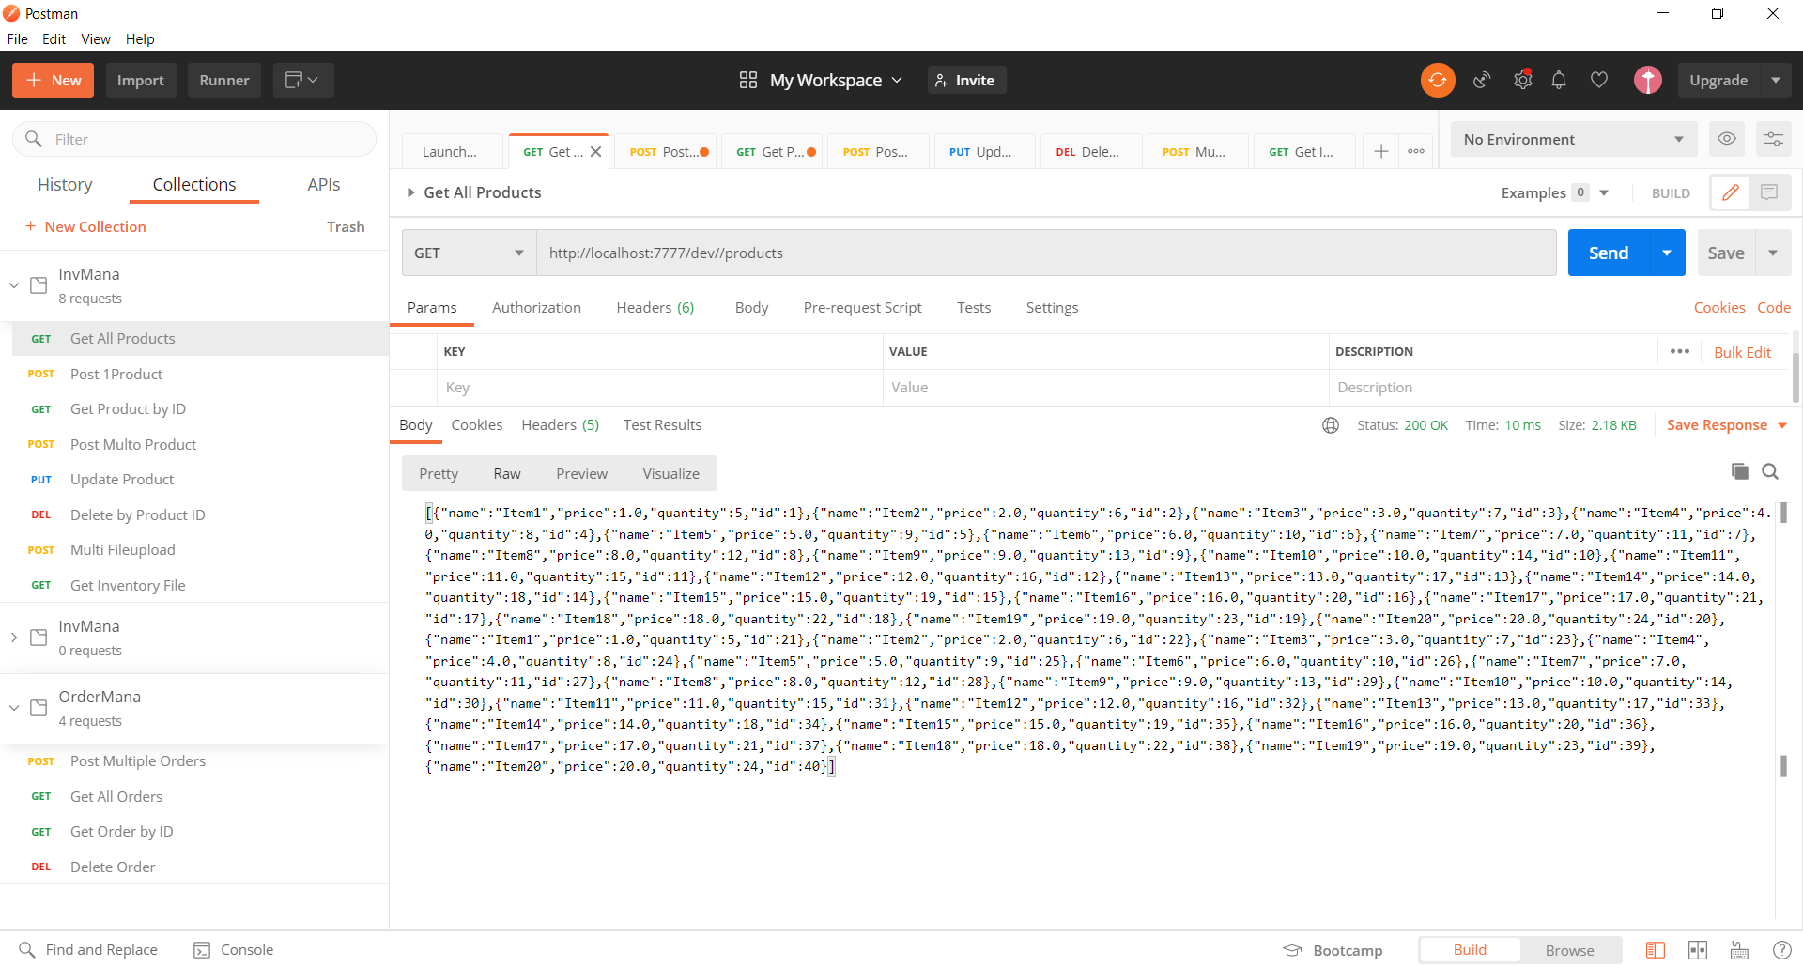

## Put update Product

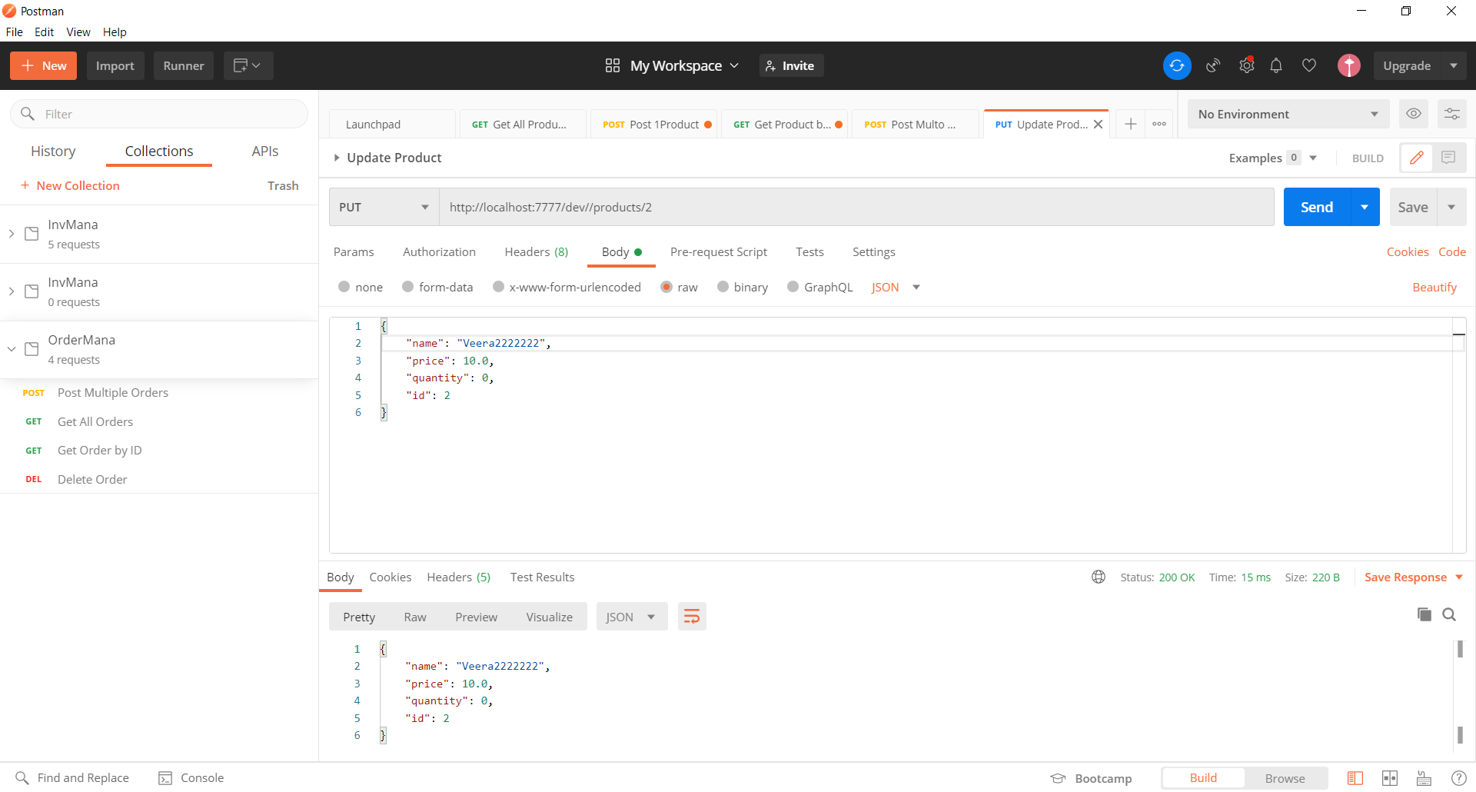

## Delete Product by ID

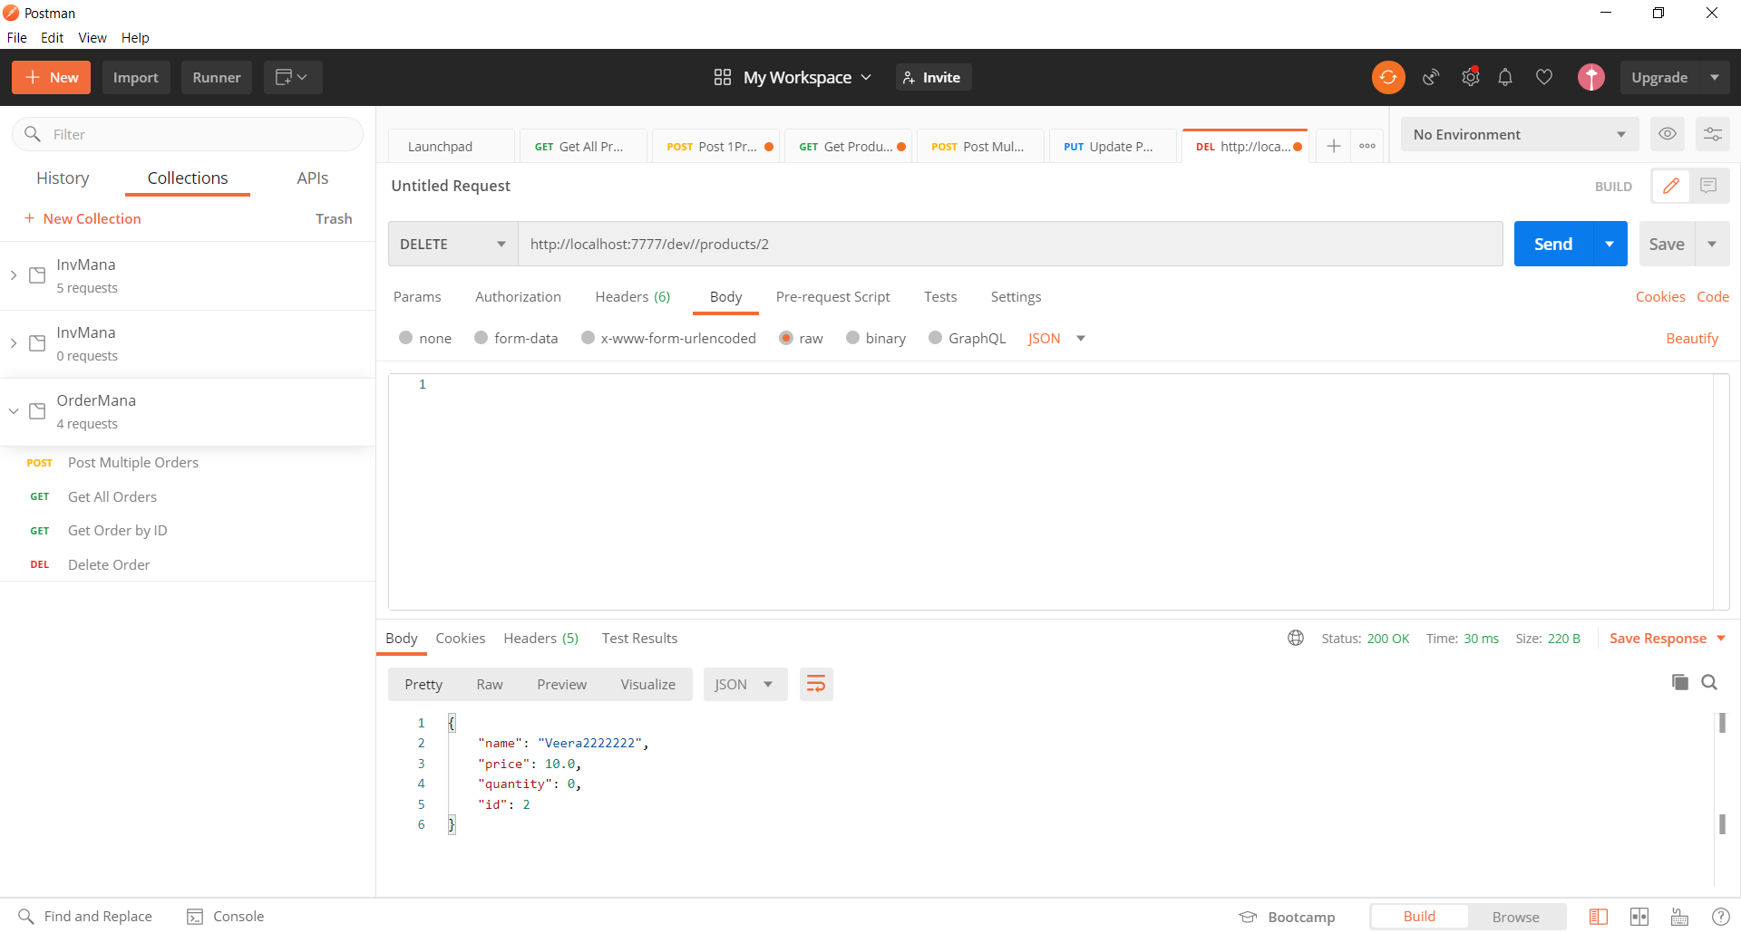

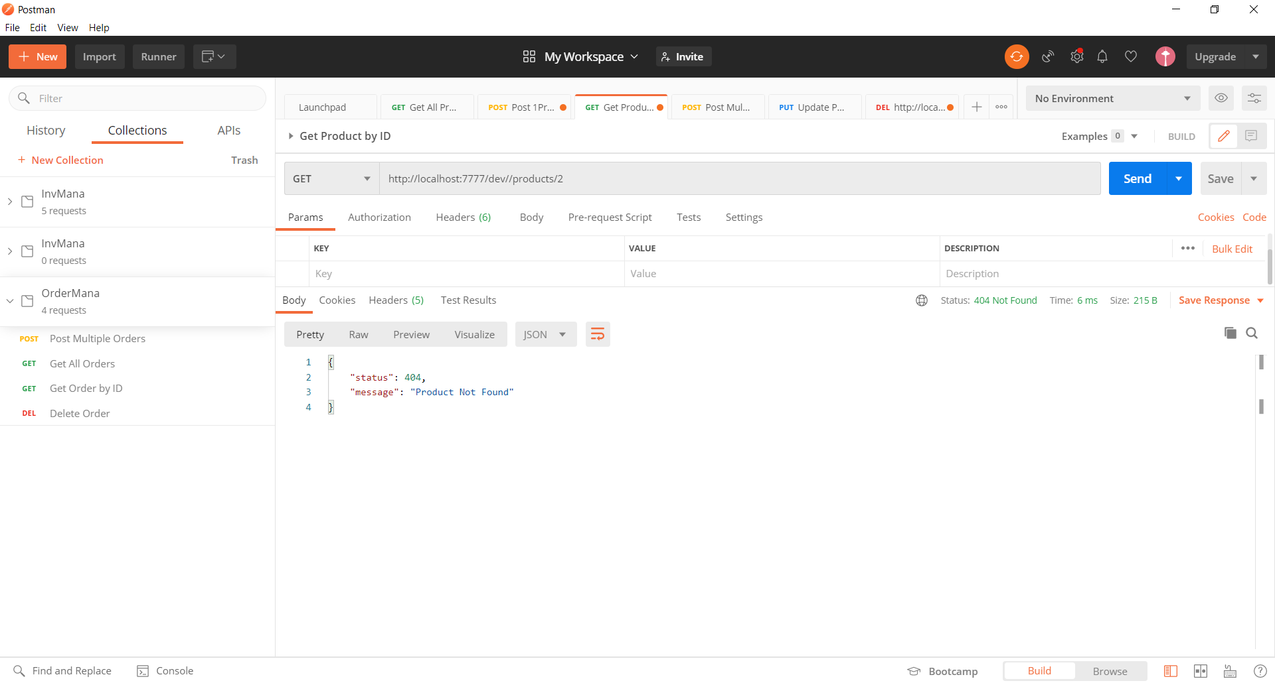

## Maven Build

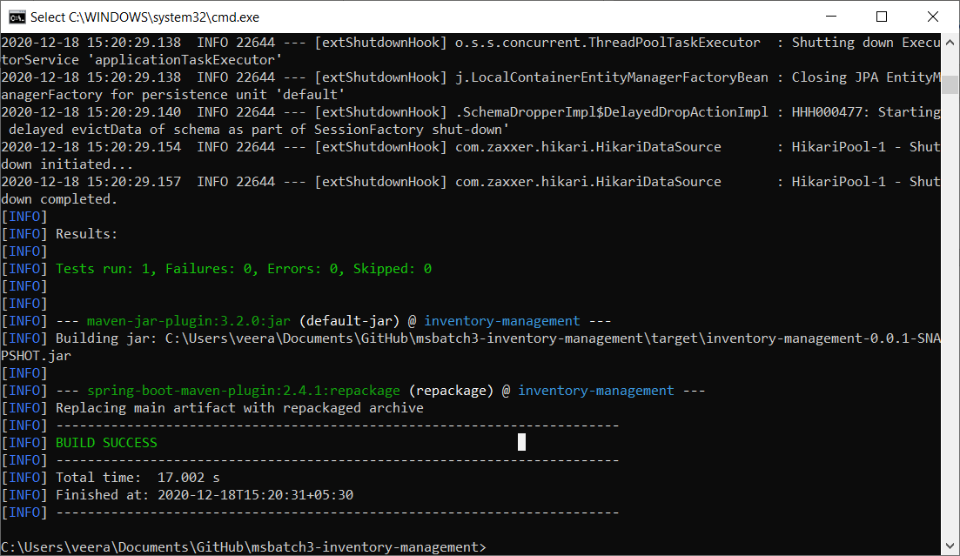

## Yaml

Using dev profile by default and all url with /dev and port as 7777

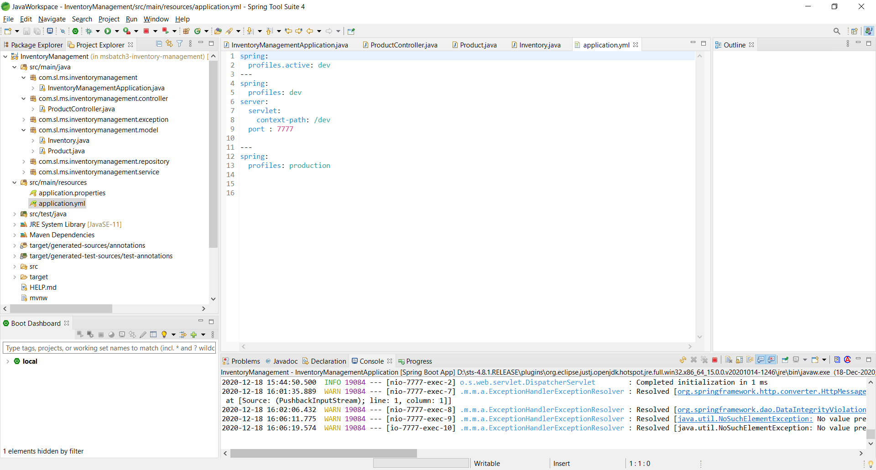

# Global Exception

When there is no product Global exception is triggered

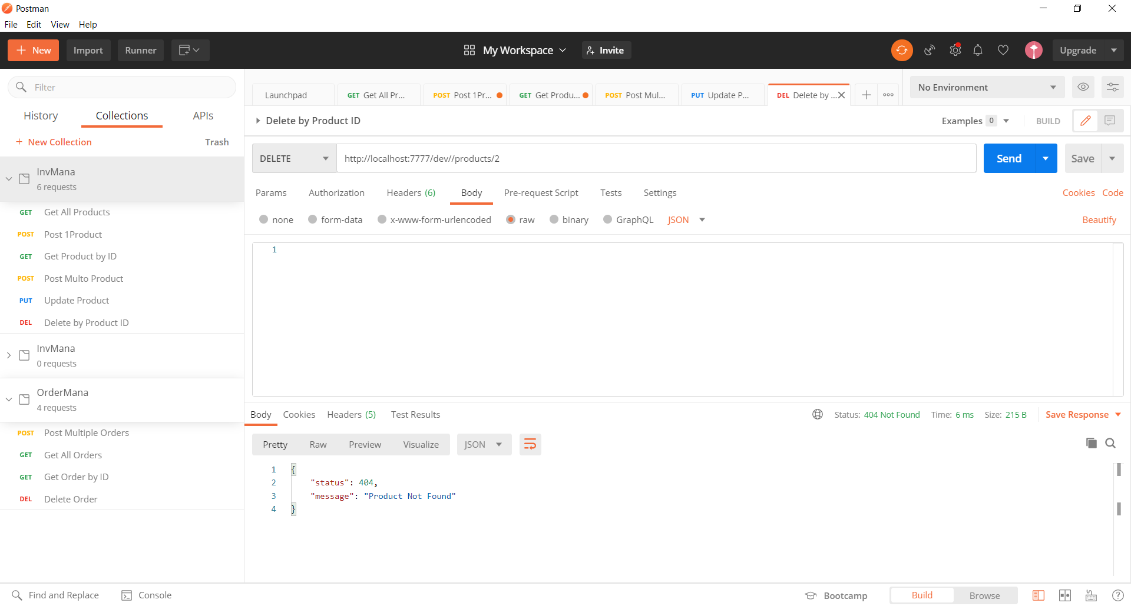

# JWT

# Checking Product inv for Quantity