Screenshot for successful start of services/ execution of services.

3. Evidence screenshot for request to end points from Postman.

4. Build of services should be possible with maven. Provide successful build

screenshot for same.

5. Evidence for caching implementation by showing api fetch before cache and after

cache changes in response time & code/config screenshot.

6. Screenshot for logs generated.

7. Test hystrix by keeping Inventory Api down.

8. Check with logger able to use trace id for request from order api to inventory api.

9. Verify the end point via POSTMAN.

~~10. Code coverage of unit and integration tests is above 80%~~

# Code Coverage

## Order Management

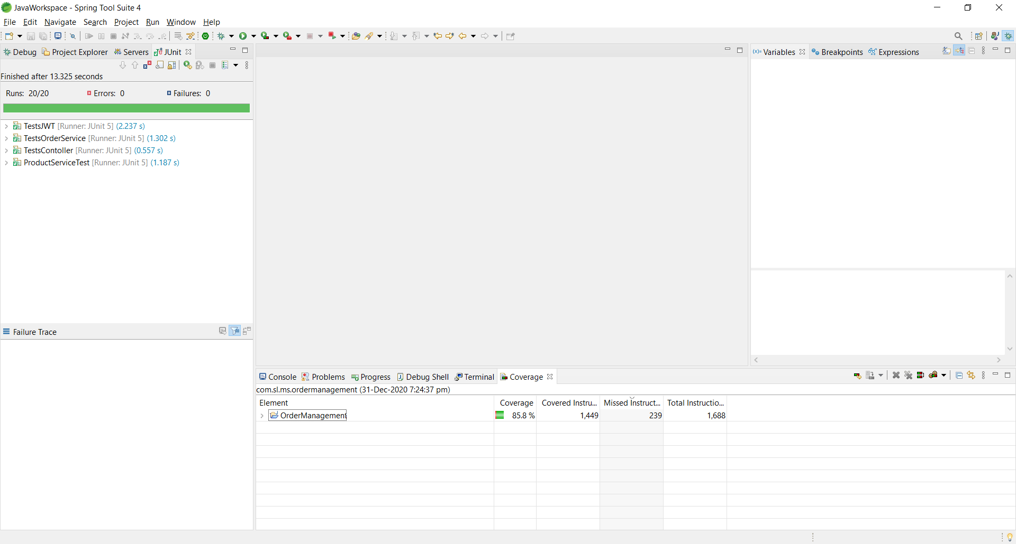

## Inventory Management

