Screenshot for successful start of services/ execution of services.

3. Evidence screenshot for request to end points from Postman.

4. Build of services should be possible with maven. Provide successful build

screenshot for same.

5. Evidence for caching implementation by showing api fetch before cache and after

cache changes in response time & code/config screenshot.

6. Screenshot for logs generated.

7. Test hystrix by keeping Inventory Api down.

8. Check with logger able to use trace id for request from order api to inventory api.

9. Verify the end point via POSTMAN.

10. Code coverage of unit and integration tests is above 80%

# Cache

## Without Cache

First time accessing the URL. Time taken is 152ms

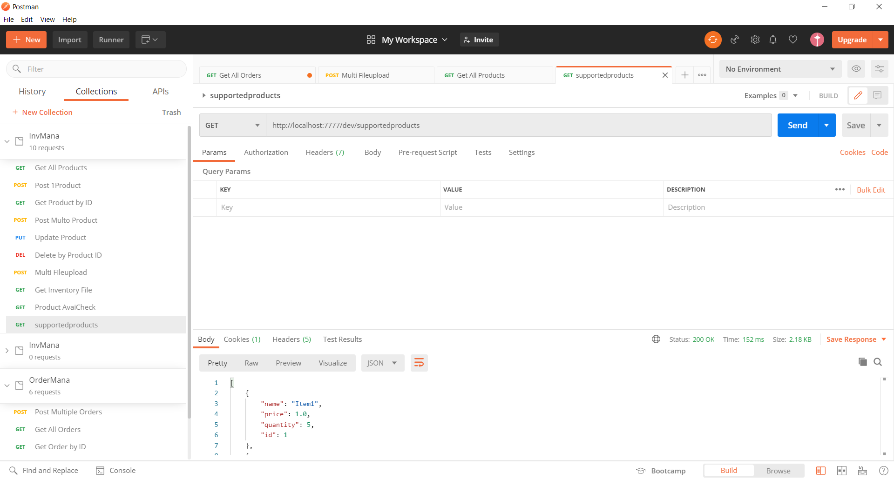

Alert messages in the function. It executed all the code.

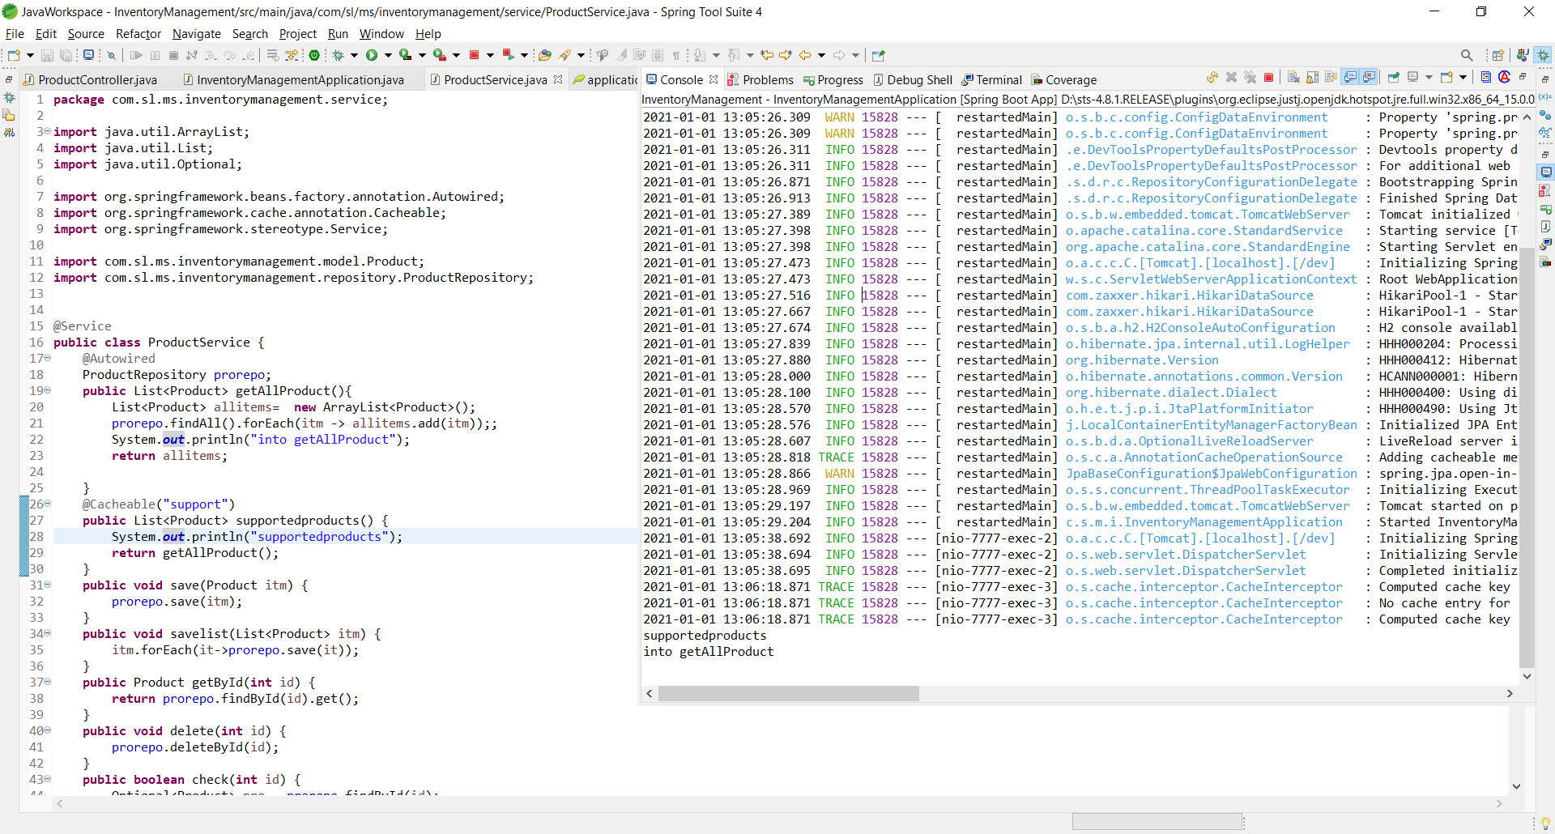

## With Cache

Executing it for the 2nd time. Time is 10ms

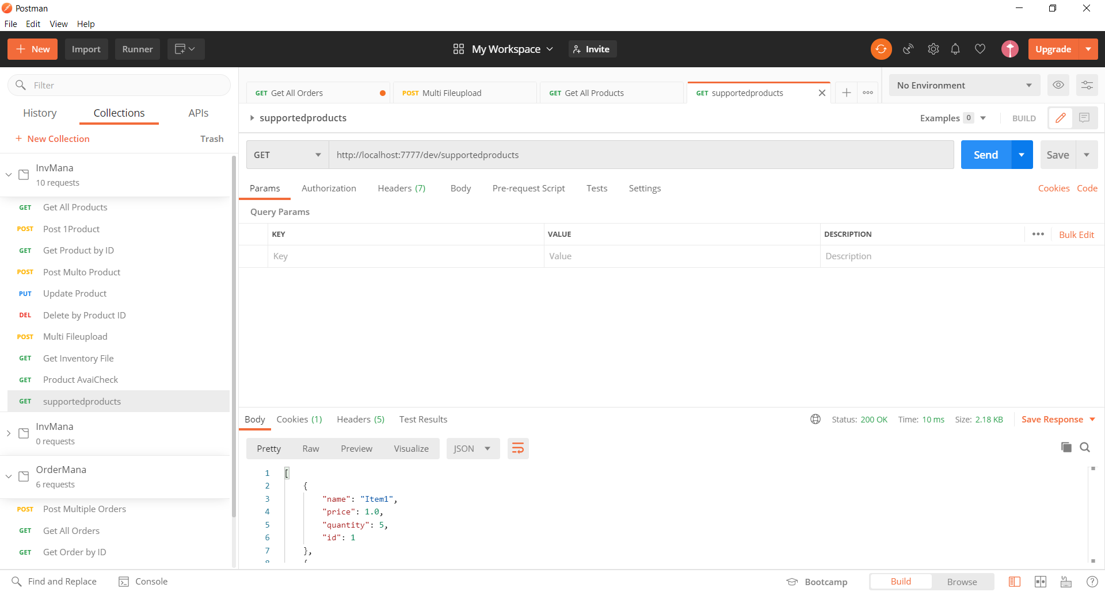

No Alert messages for the 2nd time. Tracing is enabled for Cache and logs can be seen in the console with value as “support”

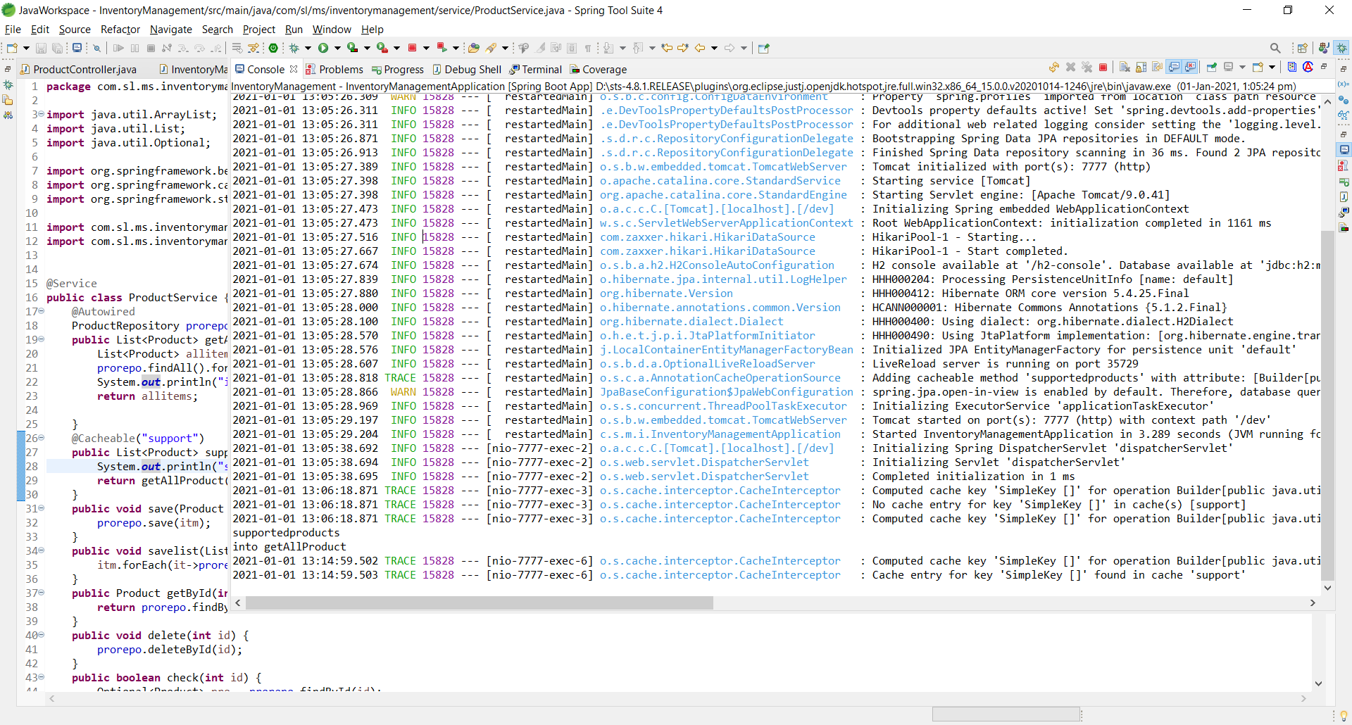

# Hystrix

## Product Service Not Available and Error is displayed

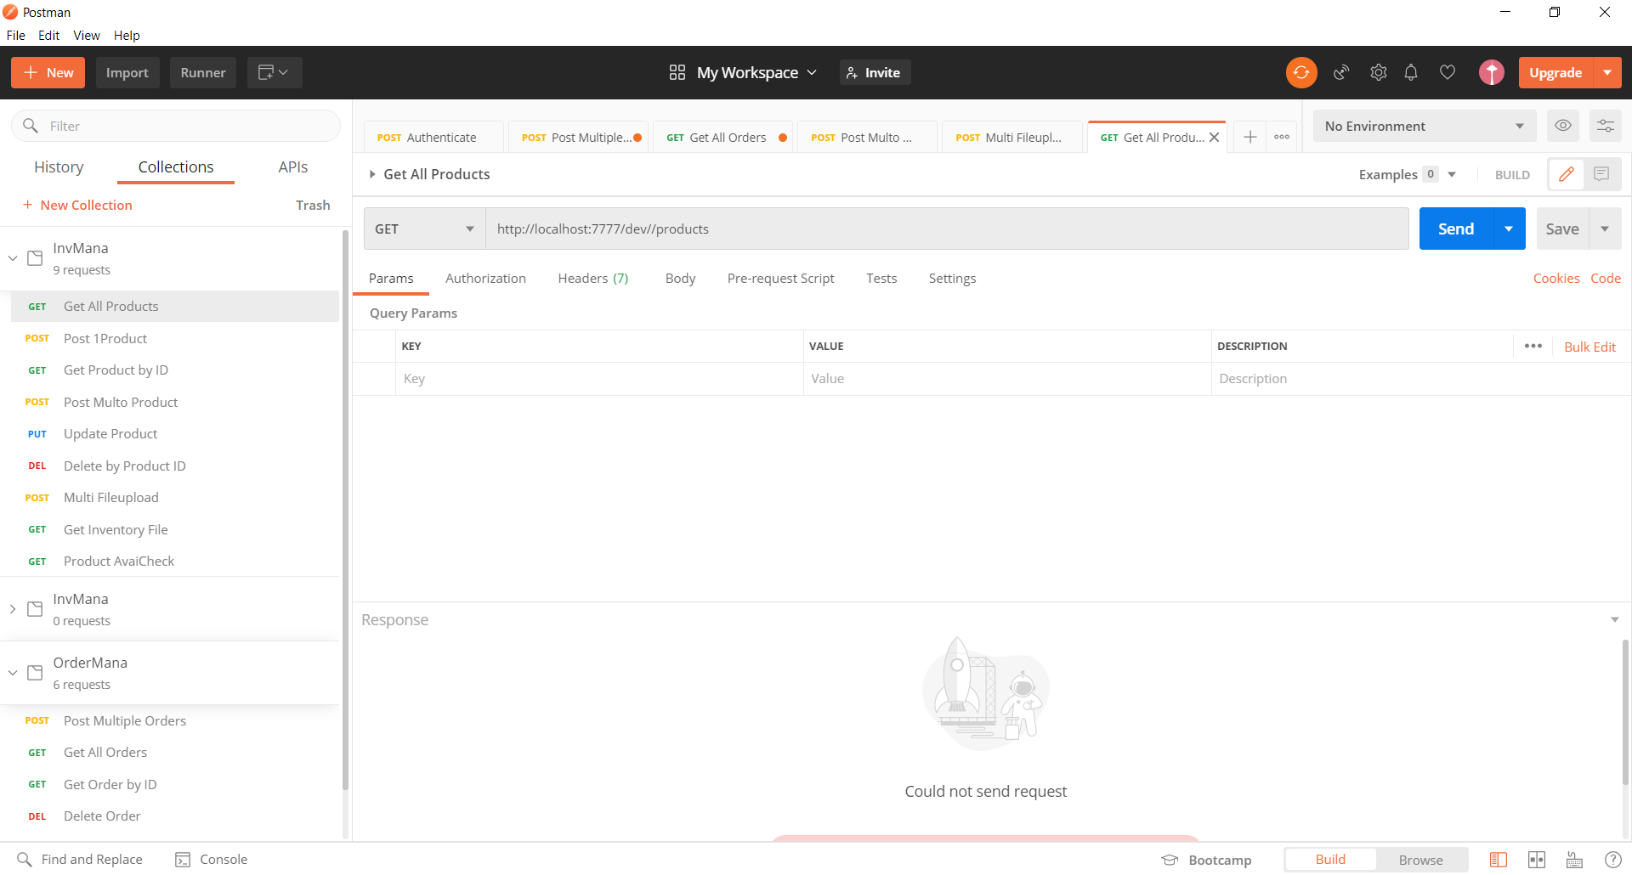

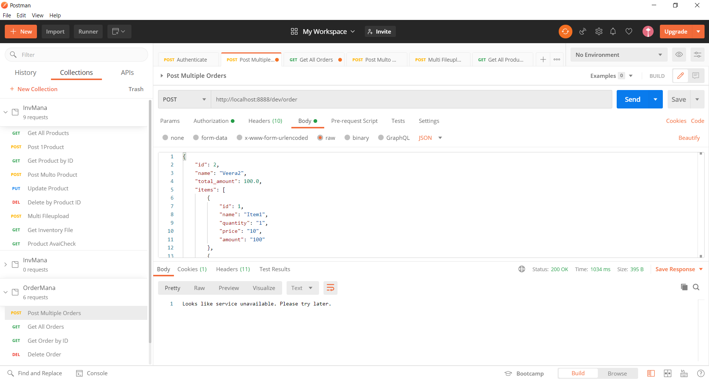

## Product Service Available and order is posted successfully.

