Repo Order 🡪 <https://github.com/veeramanimanoharan/msbatch3-order-management.git>

Inv🡪 <https://github.com/veeramanimanoharan/msbatch3-inventory-management.git>

Table of Contents

• Apigee 2

1. API Proxy 2

2. Add flows and policies 2

3. Add TRACE 2

4. Add API Key verification 2

5. API proxy with API Key 2

6. Analytics 2

• Swagger 2

Order Management 2

Inventory Management 5

# Apigee

## API Proxy

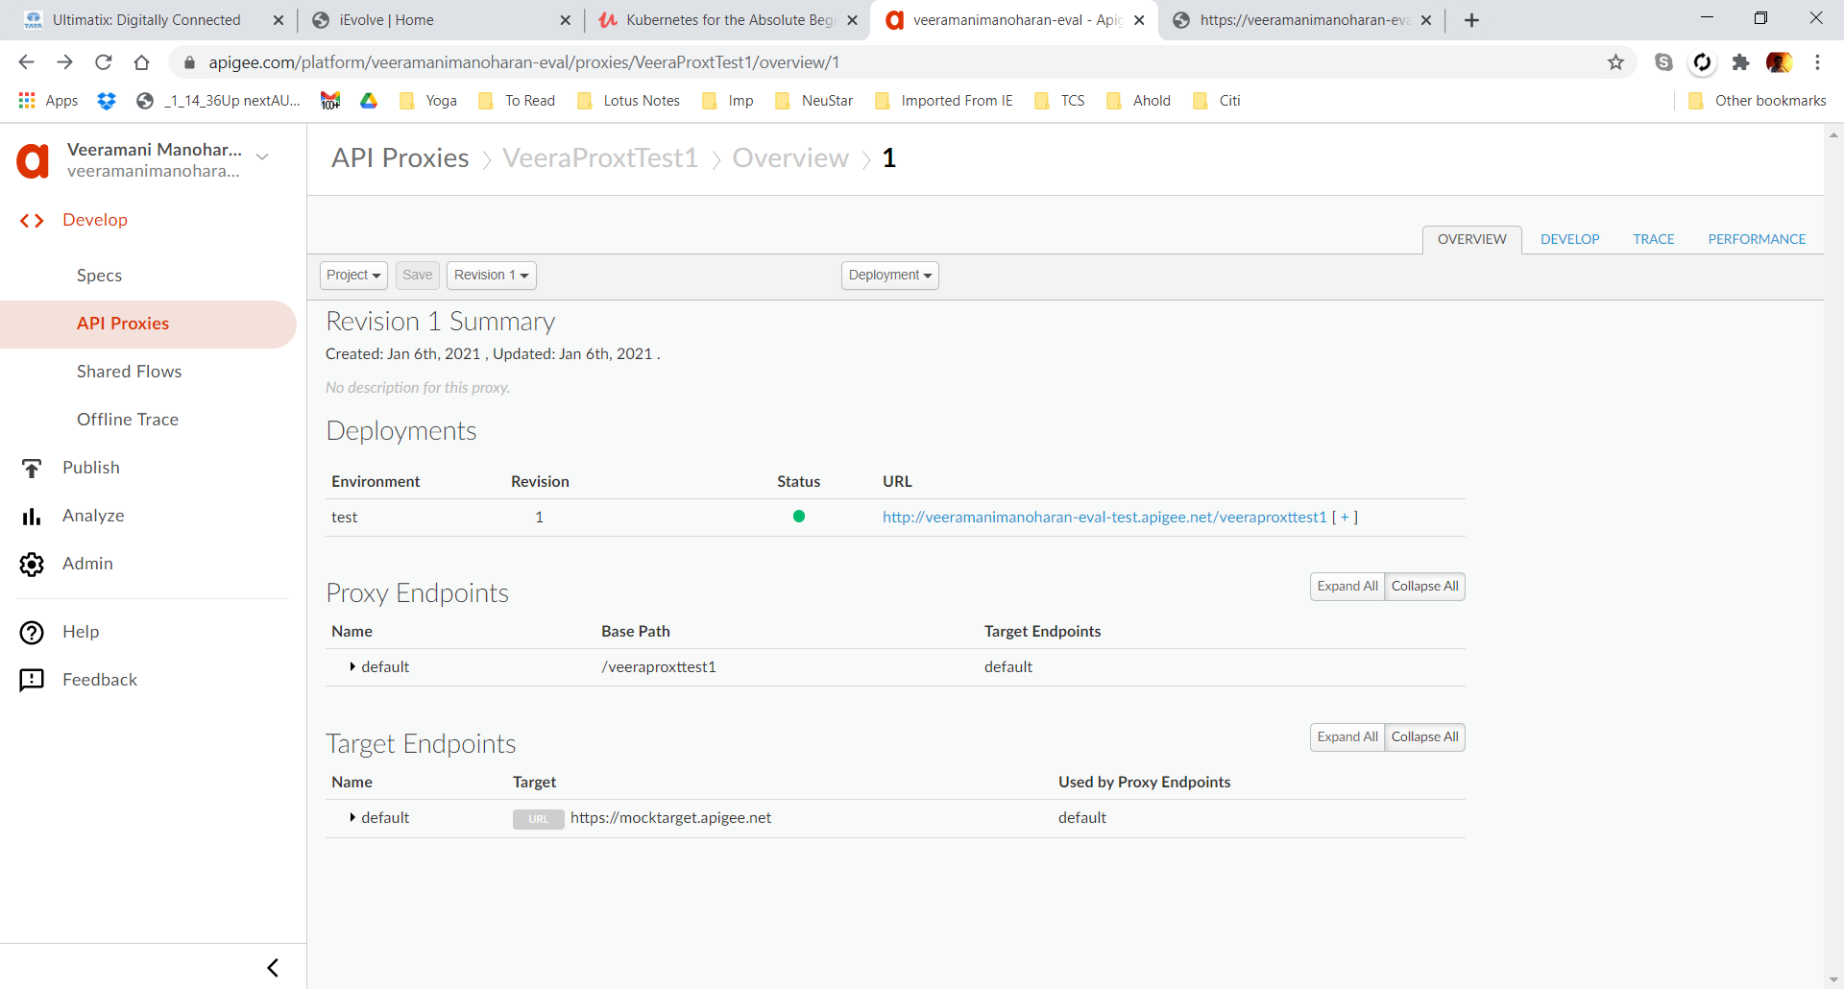

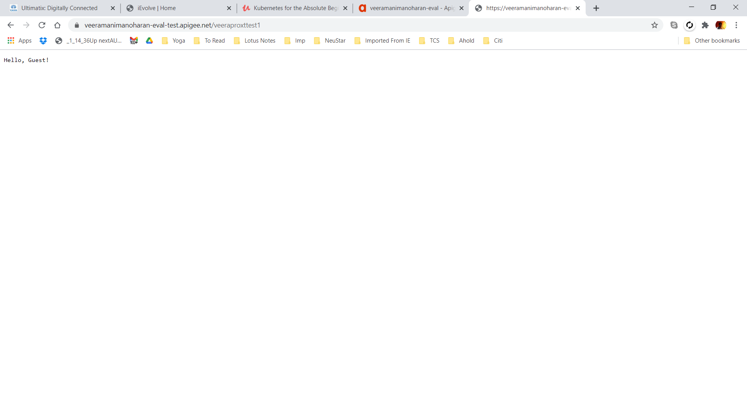

## Add flows and policies

Adding Messaging Policy & Json2XML

Original Request

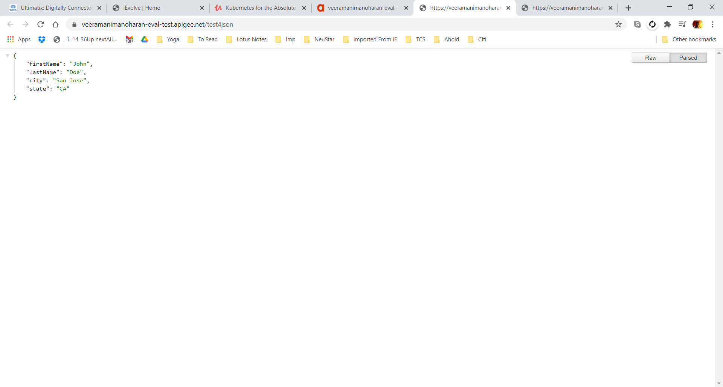

After adding Policy

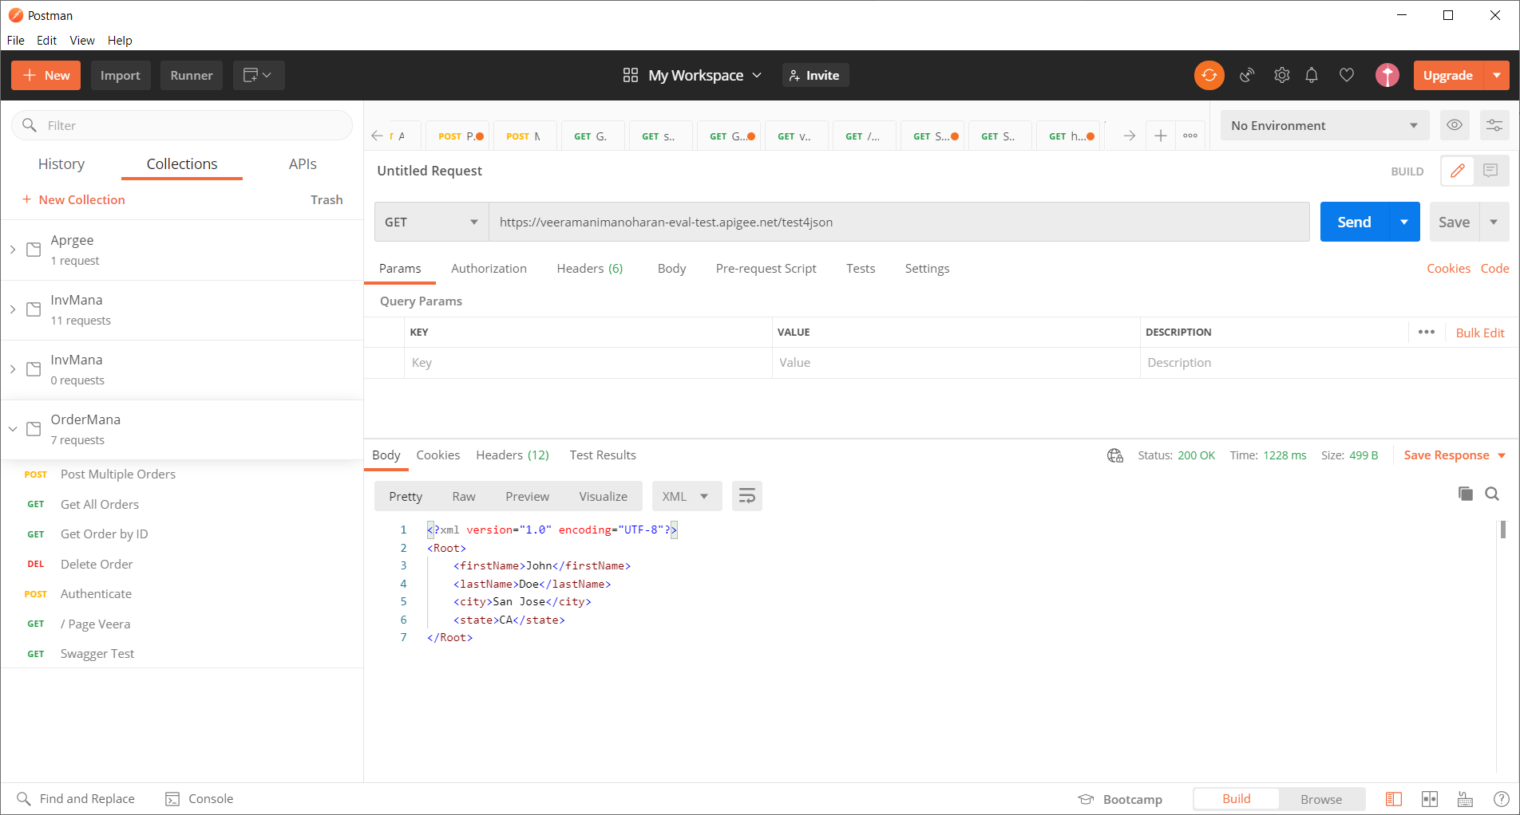

## Add TRACE

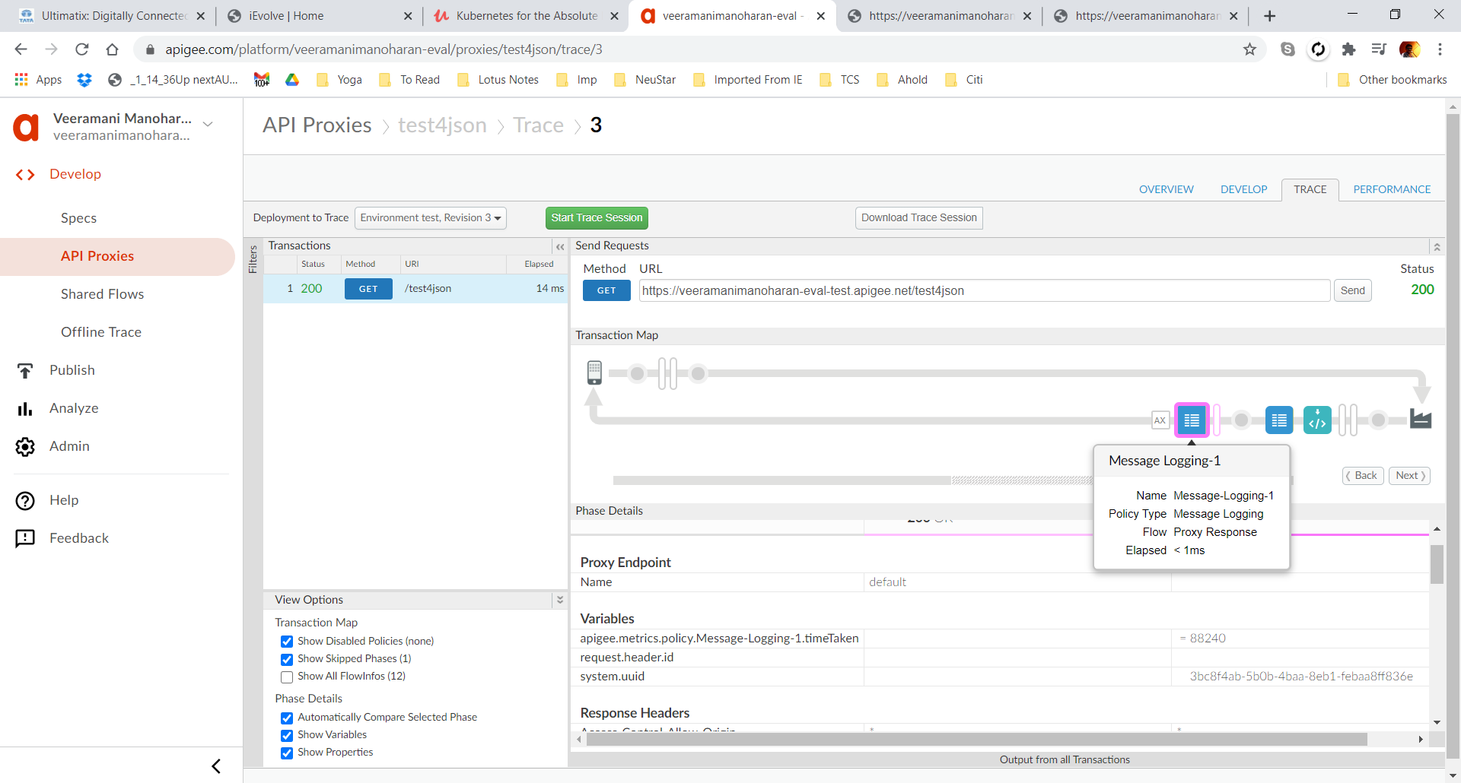

## Add API Key verification

Added API key to the proxy

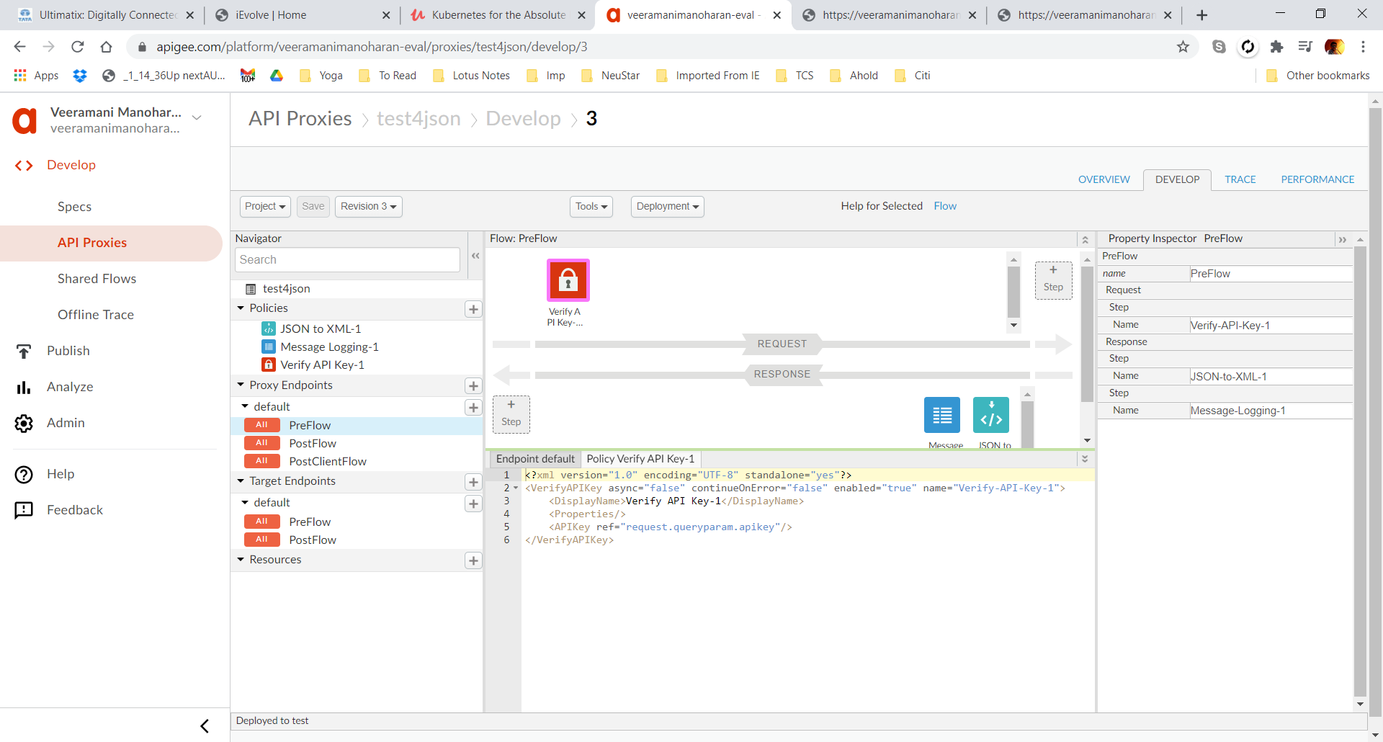

Error without key

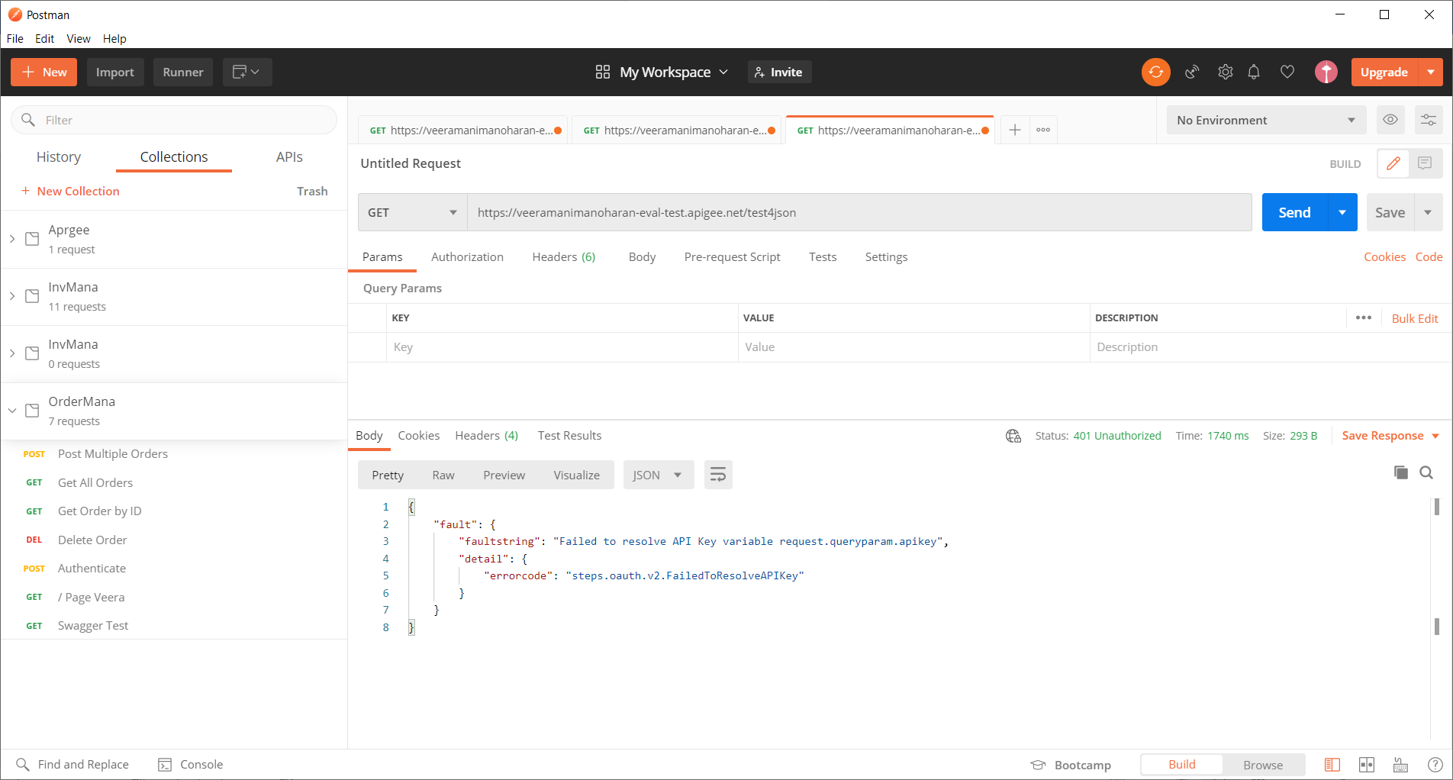

Success with key

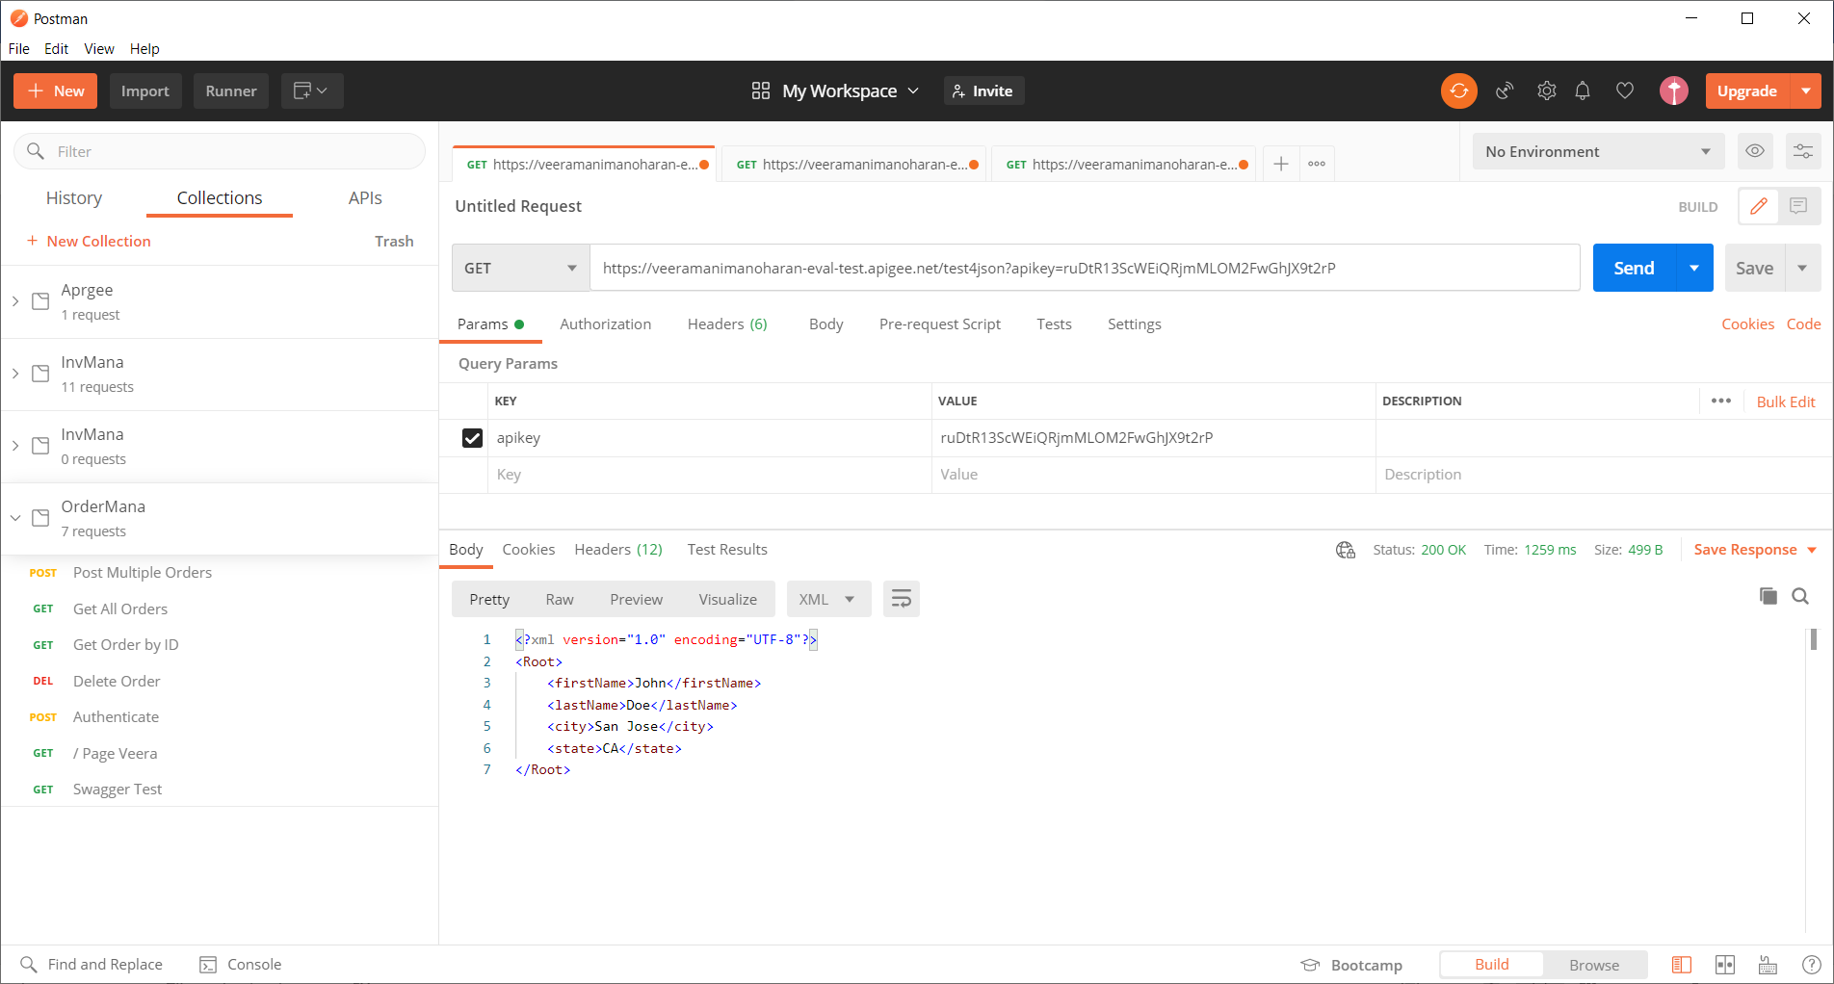

Wrong Key error

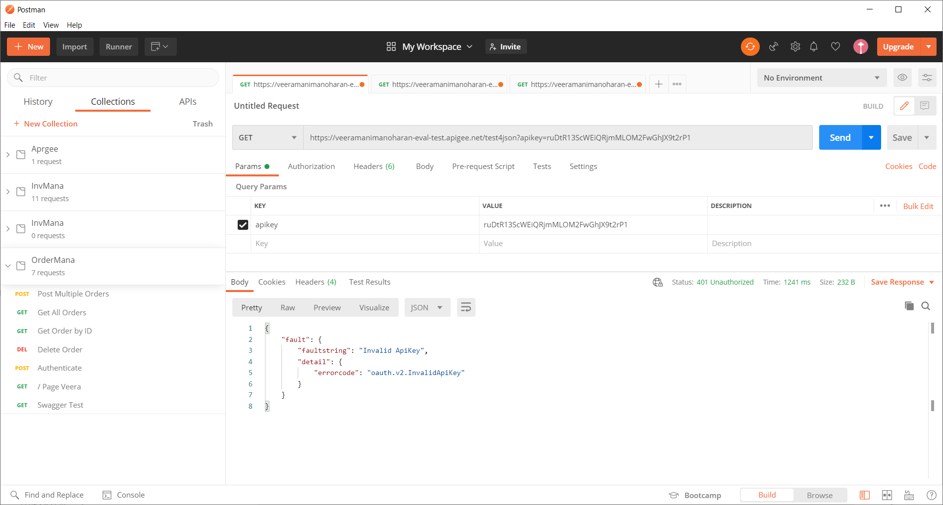

## Analytics

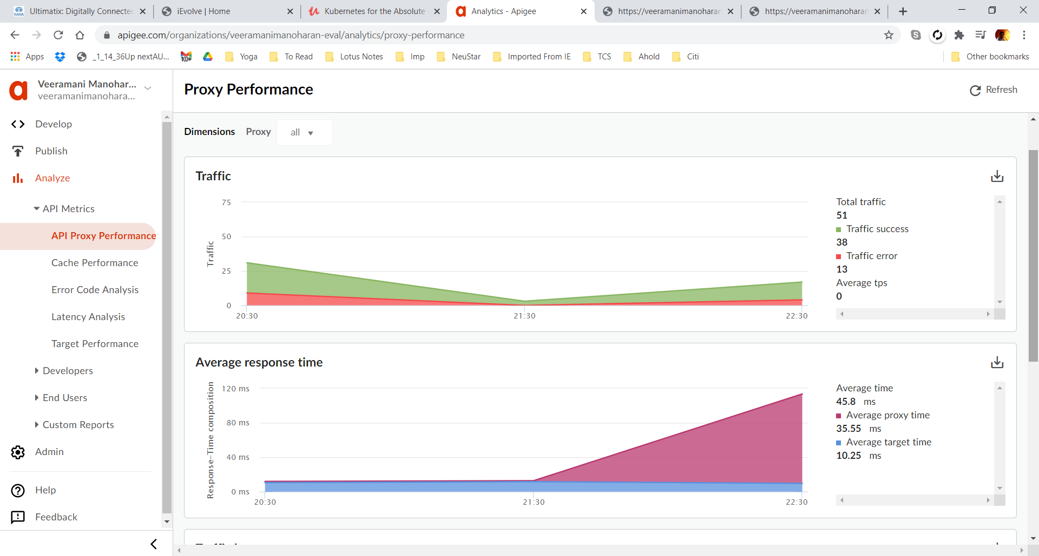

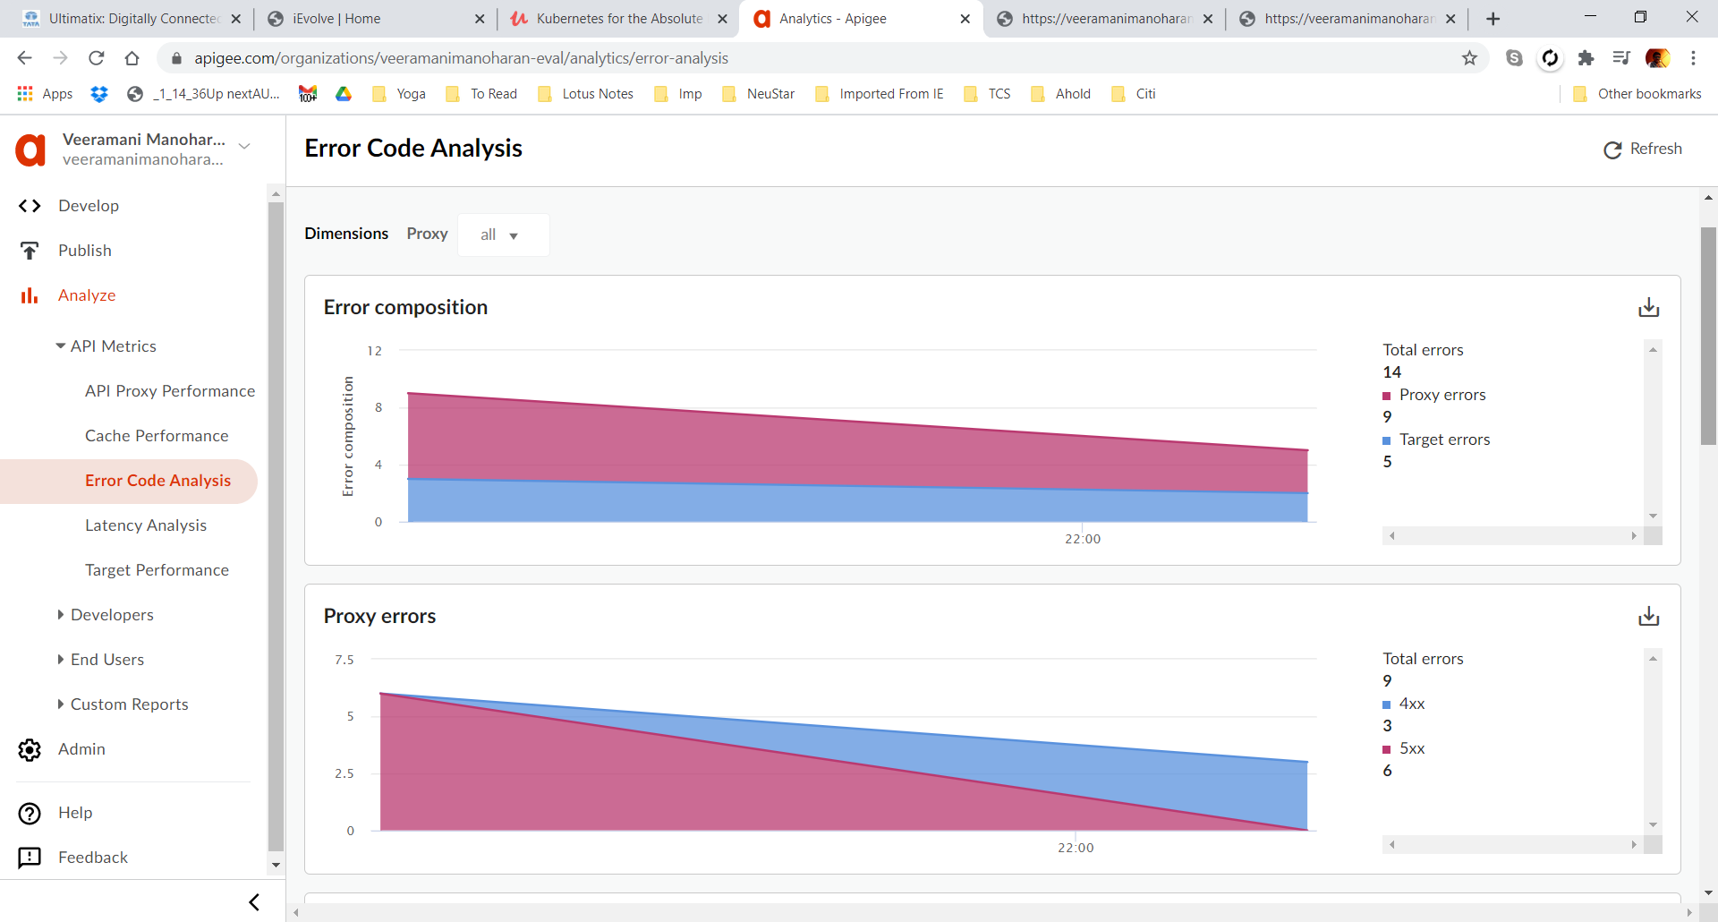

N

**Not able to open the Local Port from the internet. I will include the Apigee for Order & Inventory management when the app is hosted in the Cloud**

# Swagger

## Order Management

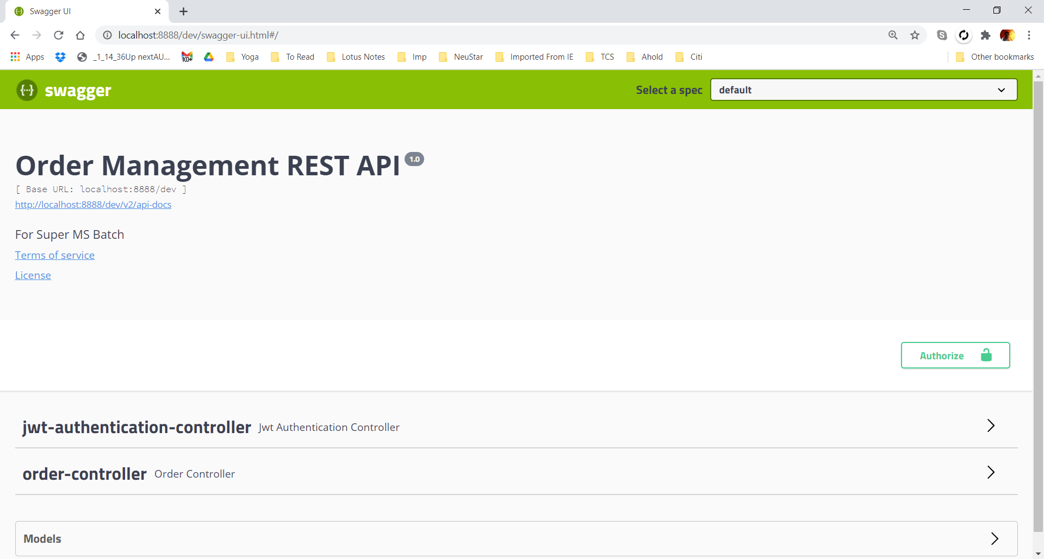

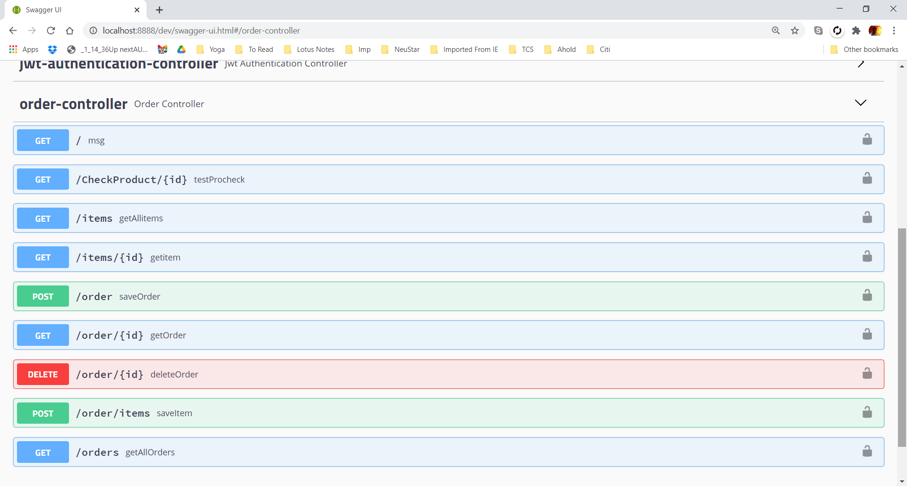

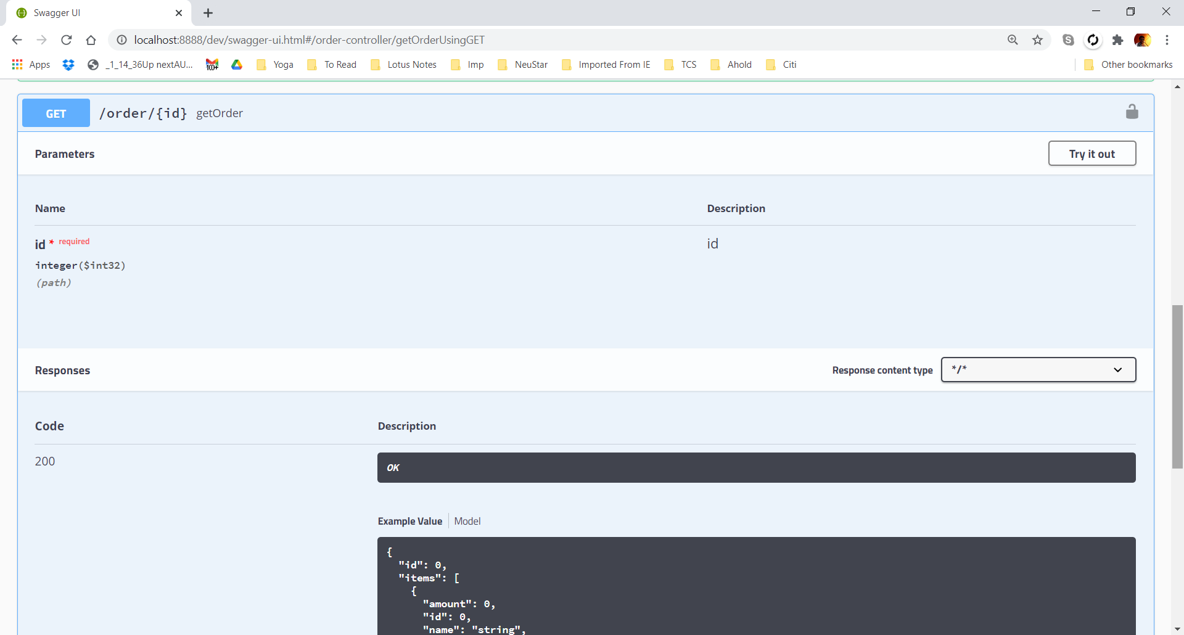

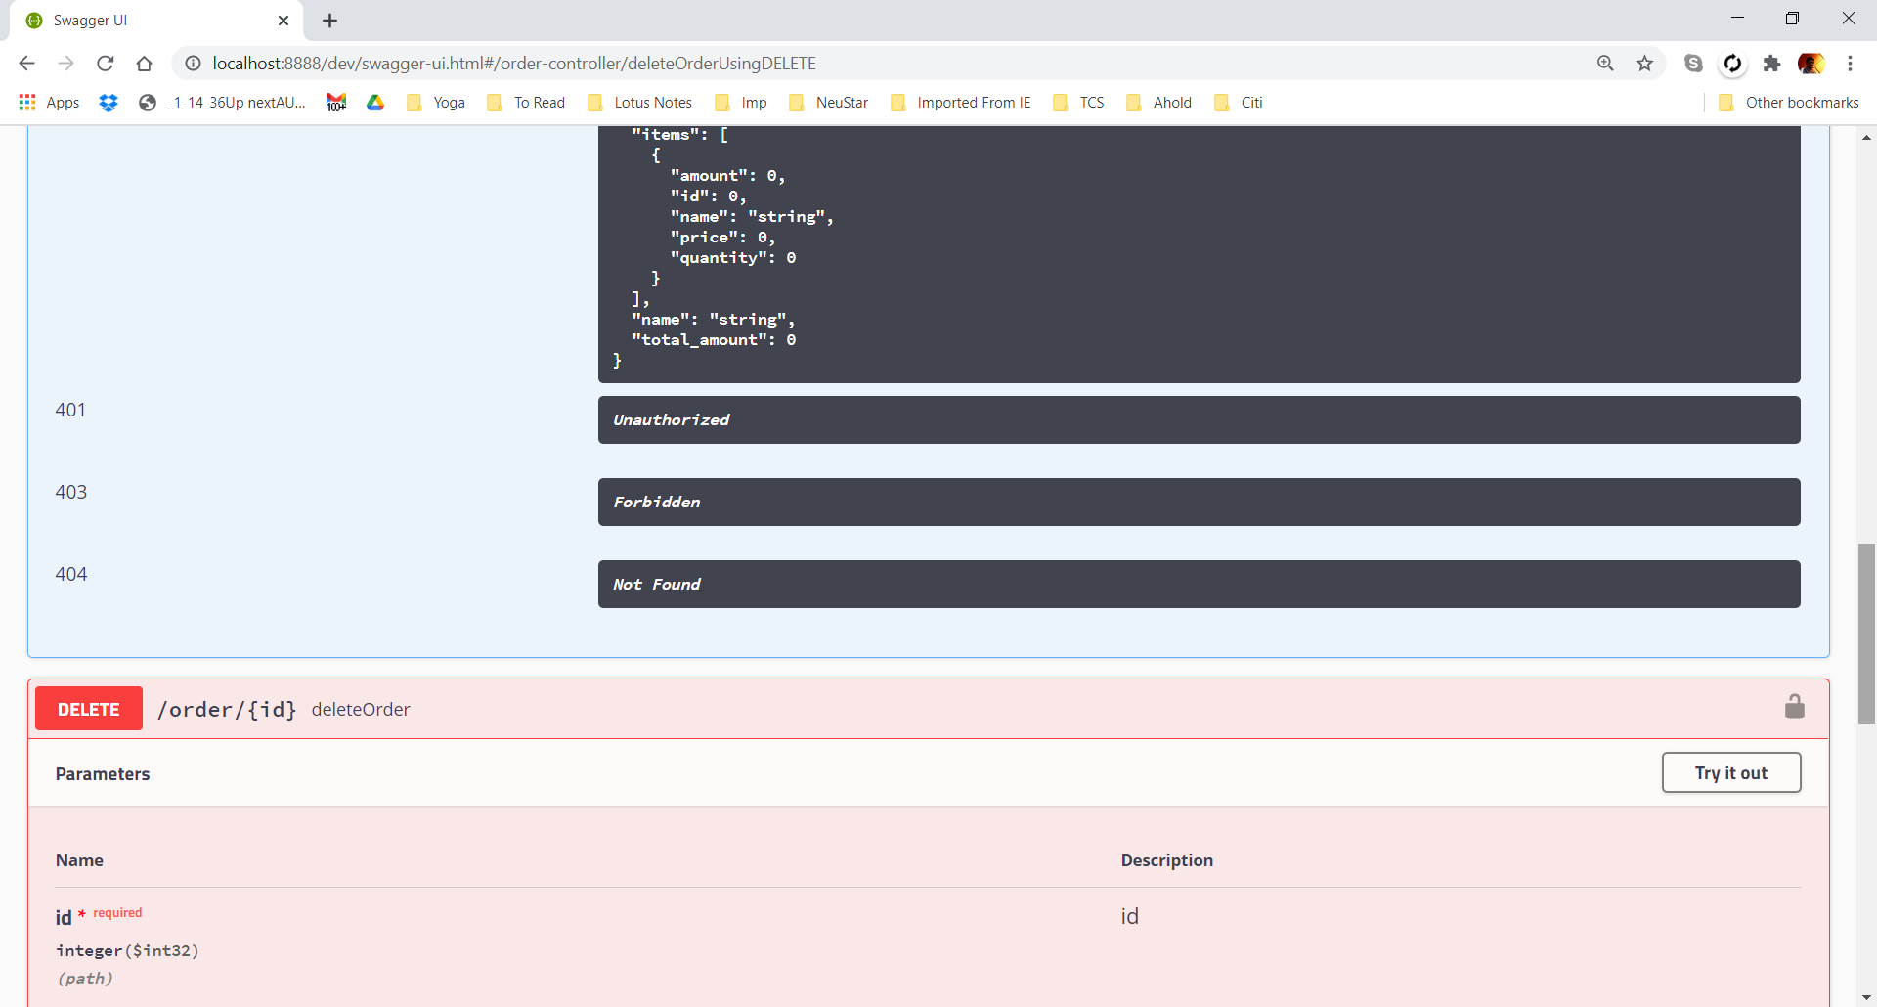

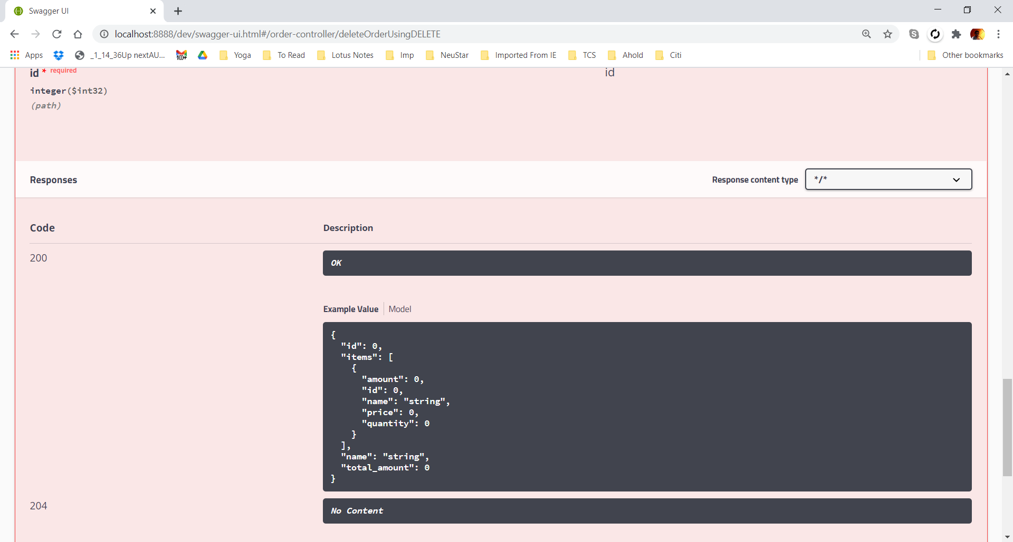

## Inventory Management

