Contents

Start of the Service 1

Maven Build 1

Reports 2

Adding a new Nov file 2

Report generated automatically 2

Adding Dec file 2

Report generated automatically 3

Git Hub URL <https://github.com/veeramanimanoharan/msbatch3-sprint1.git>

# Start of the Service

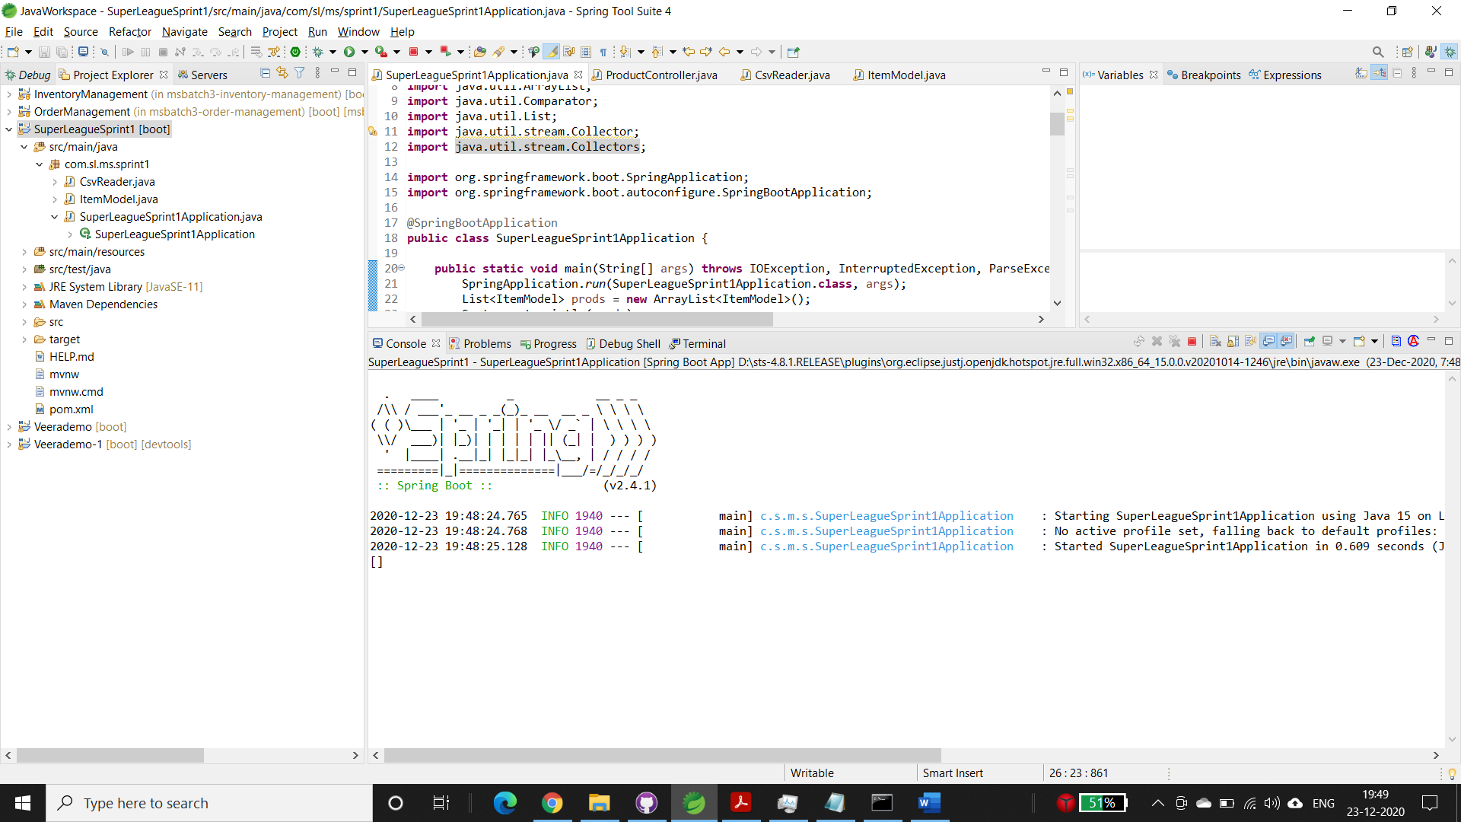

# Maven Build

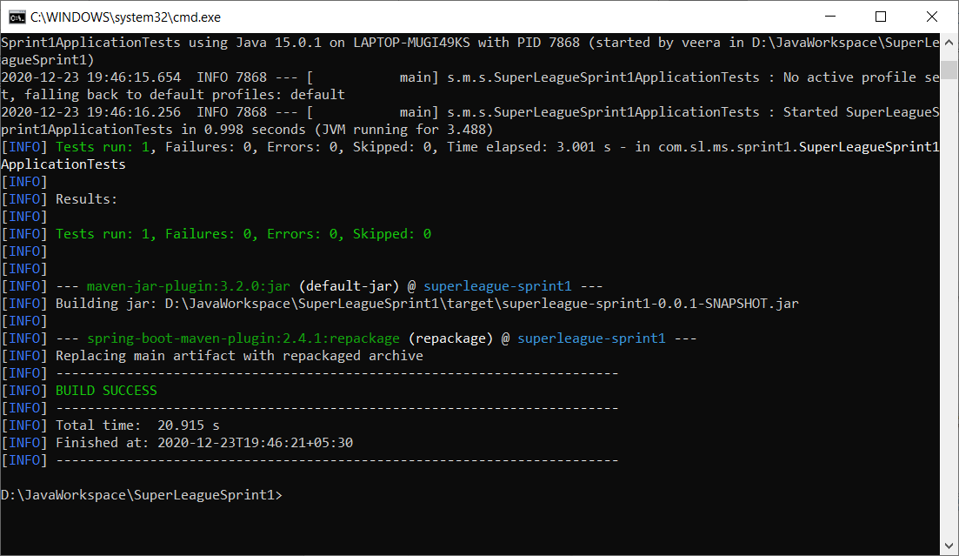

# Reports

## Adding a new Nov file

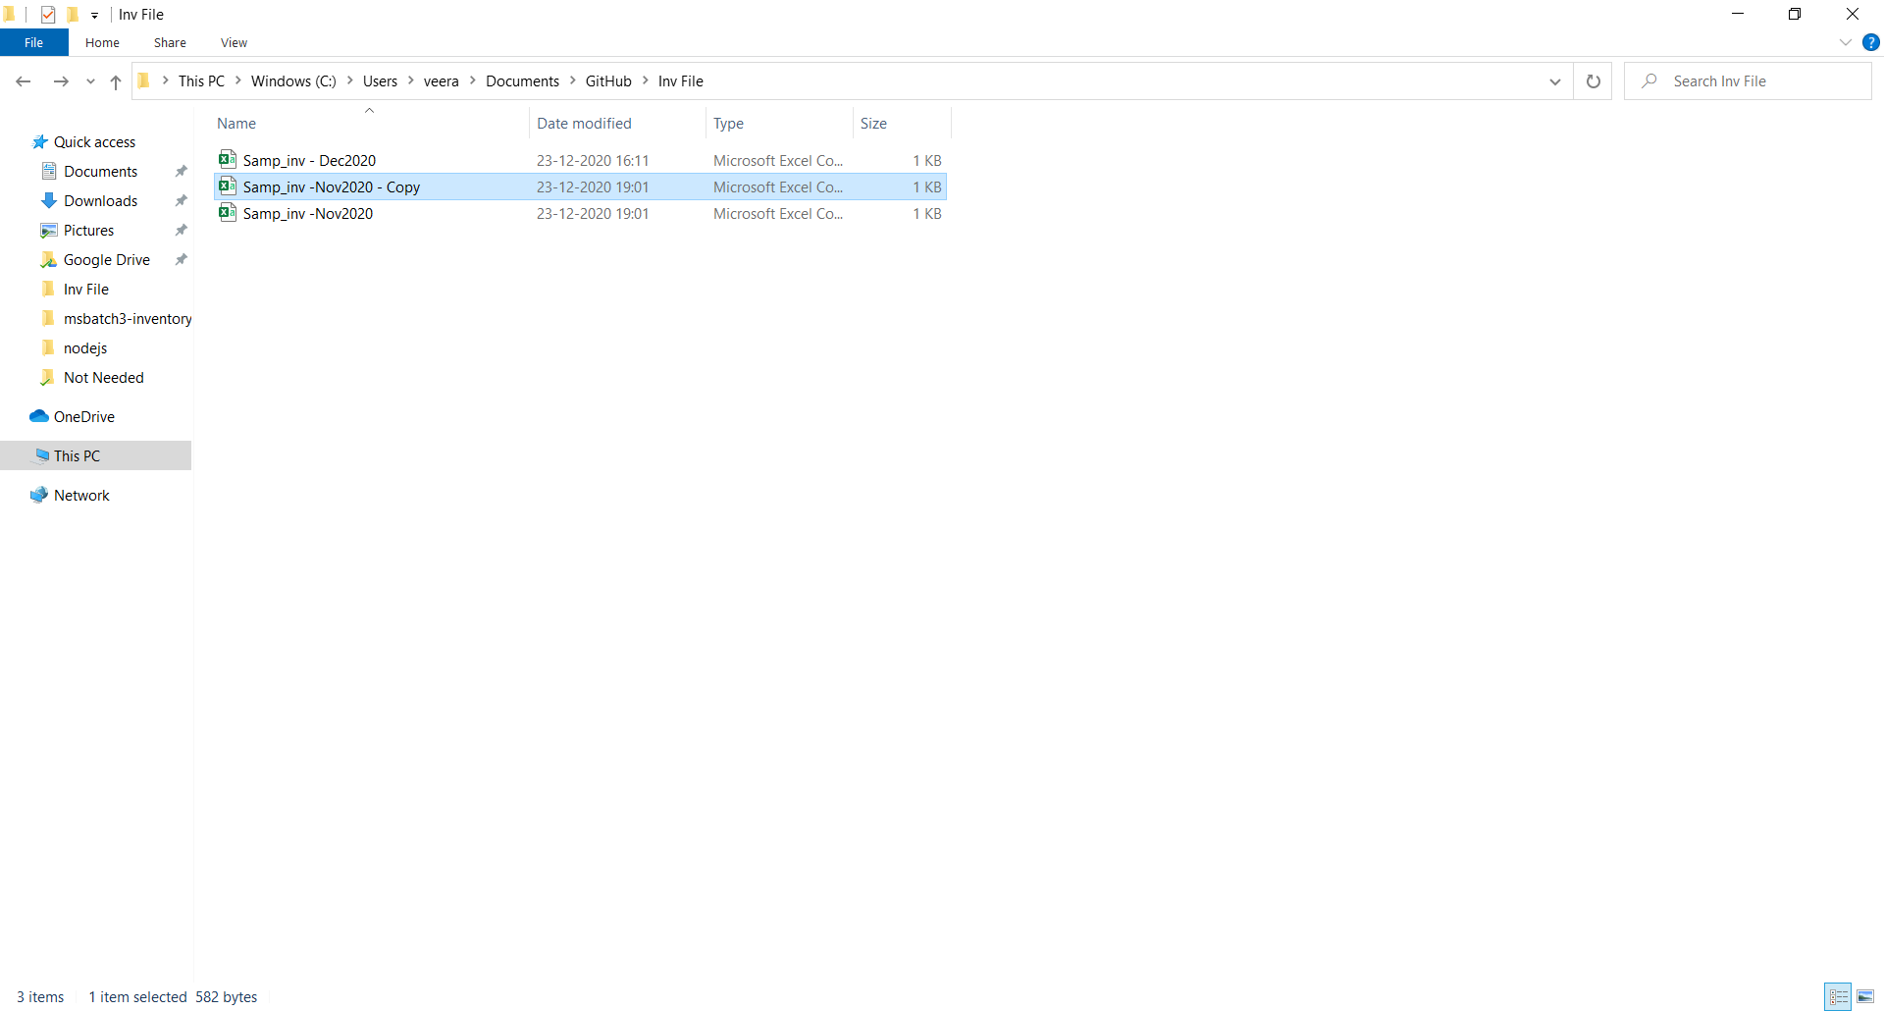

## Report generated automatically

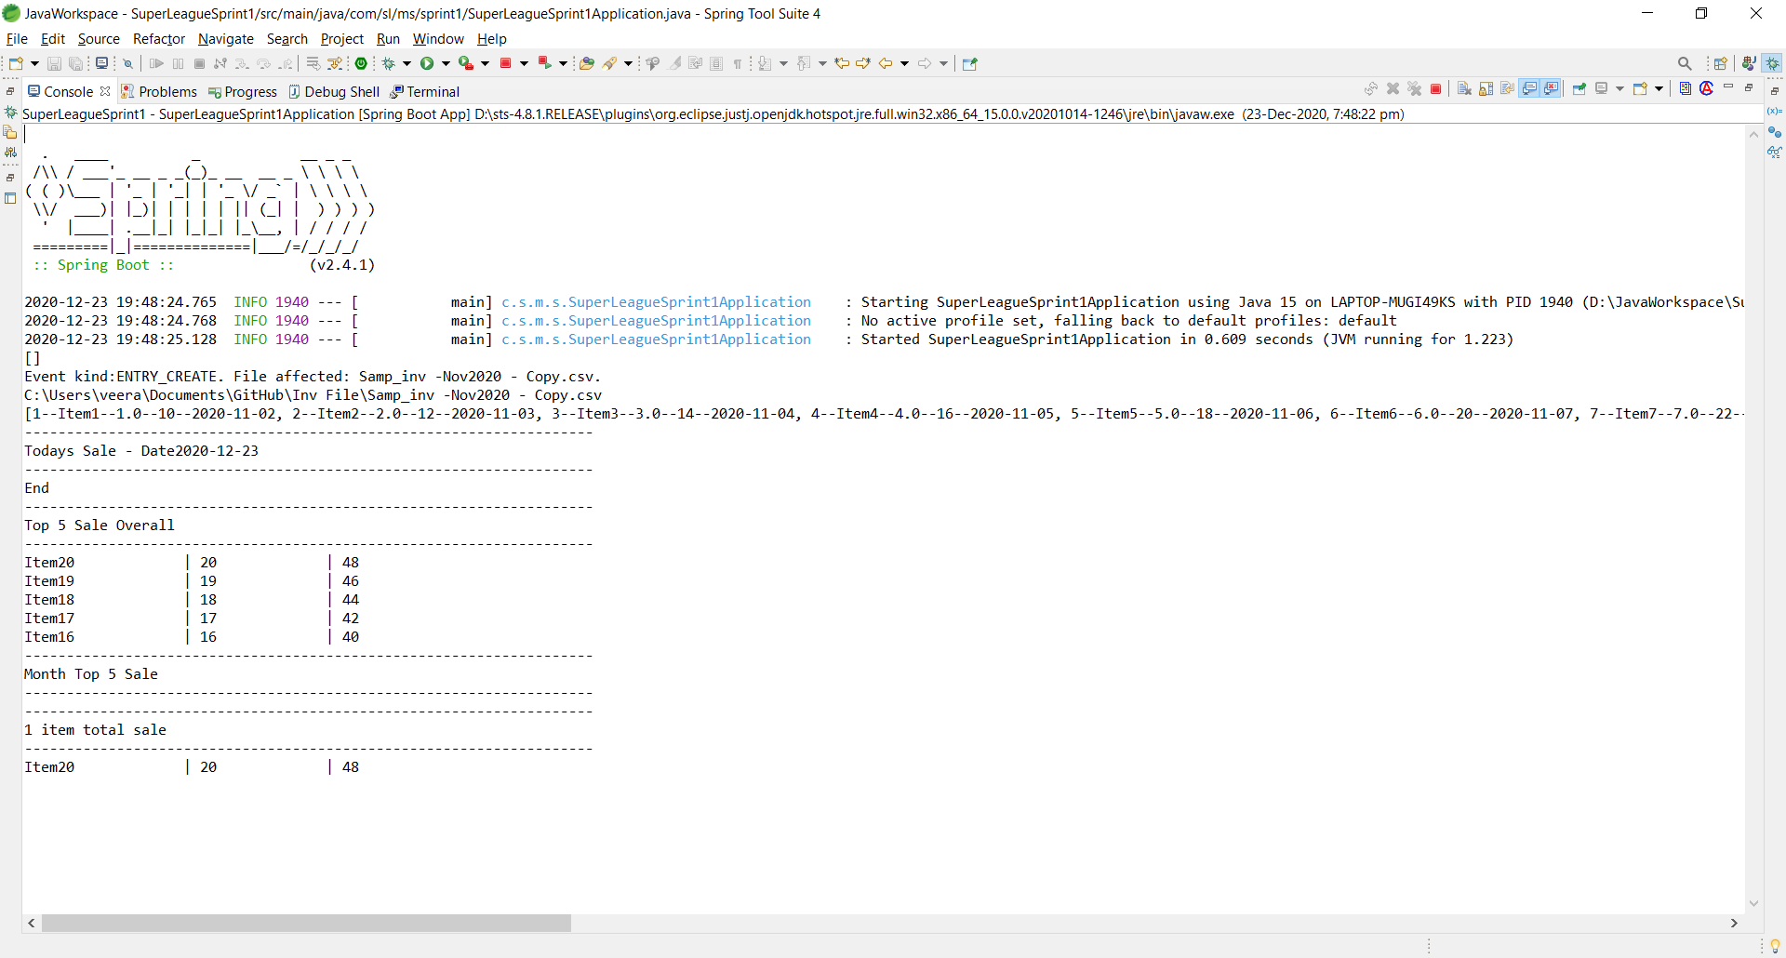

## Adding Dec file

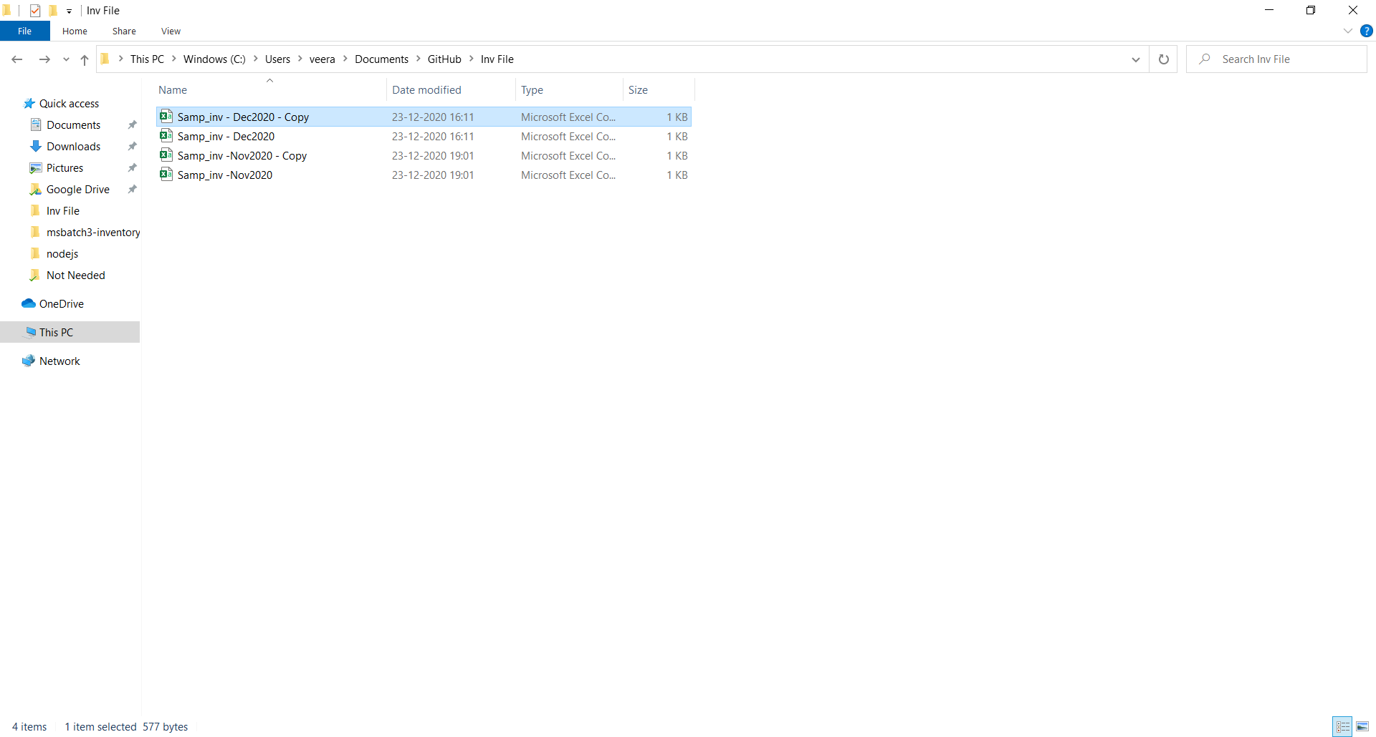

## Report generated automatically

