Assignment-2
Name: G. Sai veera mihir
USN: ENG24CY0107
Section: 3A
Roll no: 18
- Pwd:
- pwd command displays the full path of the current working directory. The output shows the hierarchical structure of directories from the root directory to the user's current location within the file system.
whoami:
- whoami command outputs the effective username of the current user. This is particularly useful when working in environments where user accounts might be switched as it reveals the identity of the user currently executing commands.
hostname:
- hostname command displays the name of the host system (computer) on which the command is executed. This is the network name assigned to the machine, which can be useful for identification in networked environments.

- The command to create a directory project inside the /home/student folder and keep three .txt file into it:
- mkdir /home/jagadeesh/student/project
cd /home/jagadeesh/student/project
touch file1.txt file2.txt file3.txt
ls -l

- Snapshot:
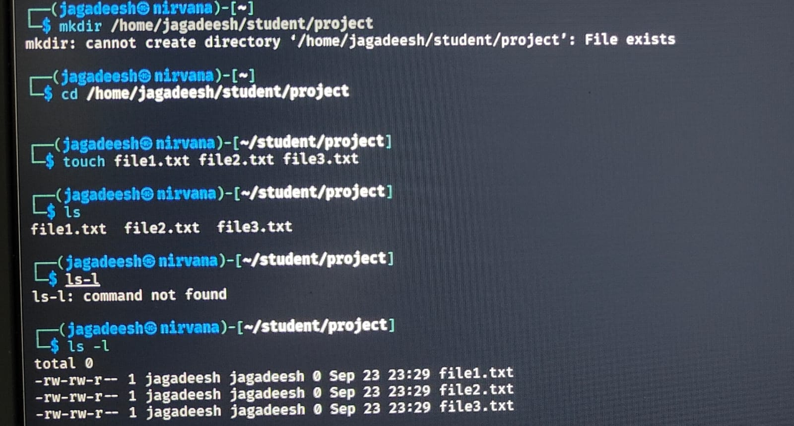

- The difference between absolute path and relative path.
- Absolute path:
- An absolute path provides the complete and unambiguous location of a file or directory, starting from the root of the file system.
- It explicitly states the entire hierarchy of directories from the root to the target item.
- This path will work regardless of the current working directory.
Example:
- /home/student/project/file1.txt
- Relative path:
- A relative path specifies the location of a file or directory in relation to the current working directory.
- It does not start from the root, but rather describes the path from the current location to the target.

Example:
- /home/student
cd project
cat project/file1.txt

- The history command will give the already executed command traces in the terminal. It displays a list of commands that have already been executed in the current terminal session. Each command is shown with a number so you can easily re-run it.
- Snapshot:
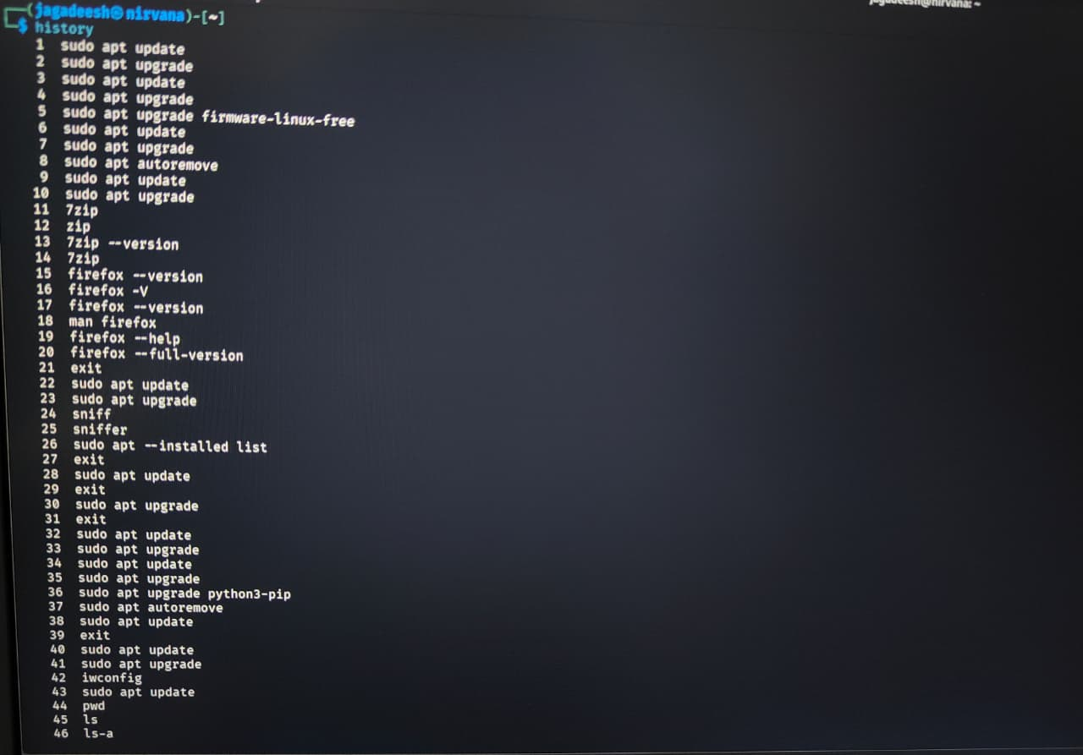

- Comparison of functionality between find and locate command:
Feature | find | locate
Search method | Real-time scan of filesystem | Searches in pre-built database
Speed | Slower | Faster
Accuracy | Always accurate, up-to-date | May be outdated if not run
Use case | When accuracy is critical, or searching with conditions | When you need quick filename lookup
Example | find /home -name file1.txt | locate file1.txt
- locate is faster
- because it doesn’t scan the filesystem in real time.
- It queries a pre-built index/database of files, so results come almost instantly.

- In Linux, the command used to modify file permissions is chmod.
Syntax:
chmod [options] permissions filename
Types of permissions:
- r → read
- w → write
- x → execute
Example:
- Give execute permission to the user for a file named script.sh:
chmod u+x script.sh

- In Linux, file permissions are shown in a 10-character string.
- -rw-r--r—
- First character (-) → File type
- - = regular file
- d = directory
- l = symbolic link
- Next three characters (rw-) → Owner (user) permissions.
- r = read allowed
- w = write allowed
- - = execute not allowed
- Next three characters (r--) → Group permissions.
- r = read allowed
- -- = no write, no execute
- Last three characters (r--) → Others (world) permissions
- r = read allowed
- -- = no write, no execute

- The difference between chown and chgrp:
The chown and chgrp commands in Linux are used to modify ownership attributes of files and directories, specifically focusing on user and group ownership.
chown:
- This command changes the user owner of a file or directory.
- It can also be used to change both the user owner and the group owner simultaneously.
- chown can change both user and group ownership.
- chown offers more flexibility as it can modify both aspects of ownership in a single command.
Example:
- ls -l file.txt
-rw-r--r-- 1 jagadeesh student 0 Sep 24 21:00 file.txt
sudo chown admin file.txt
ls -l file.txt
-rw-r--r-- 1 admin student 0 Sep 24 21:00 file.txt

Chgrp:
- This command changes only the group owner of a file or directory.
- chgrp is limited to changing only the group ownership.
Example:
- ls -l file.txt
-rw-r--r-- 1 admin student 0 Sep 24 21:00 file.txt
sudo chgrp staff file.txt
ls -l file.txt
-rw-r--r-- 1 admin staff 0 Sep 24 21:00 file.txt

- To set file permissions in a way that allows multiple users to access a file but only permits the owner to write to it, you would use the chmod command in a Unix-like operating system. This can be achieved using either symbolic or numeric modes.
Using Numeric (Octal) Mode:
- The octal representation for the desired permissions is 644.
- The first digit 6 (binary 110) grants the owner read and write permissions (4+2).
- The second digit 4 (binary 100) grants the group read-only permission.
- The third digit 4 (binary 100) grants others read-only permission.
To apply these permissions to a file named your_file.txt, execute the following command:
- chmod 644 your_file.txt
Using Symbolic Mode:
- Alternatively, you can use symbolic mode to achieve the same result.
- chmod u=rw,g=r,o=r your_file.txt
- u=rw: Sets read and write permissions for the owner.
- g=r: Sets read-only permission for the group.
- o=r: Sets read-only permission for others.
Both methods achieve the same outcome: the owner can read and modify the file, while members of the file's group and all other users can only read its content.

- To check the manual page for any Linux command, use the man command followed by the name of the command you want to learn about.
Command:
- man <command_name>
When you type man followed by a command name, it retrieves and displays the manual page for that command, offering comprehensive details on how to use it, including all available options and flags. This command is crucial for learning about the tools and commands available in the Linux operating system.

