https://boto3.amazonaws.com/v1/documentation/api/latest/reference/services/ec2.html#EC2.Client.modify_instance_attribute

termination & protection:
-------------------------------
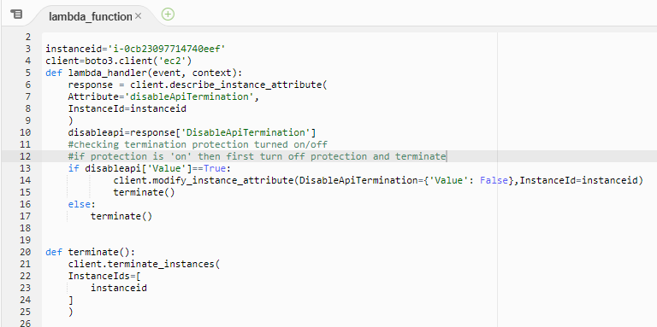
Modified
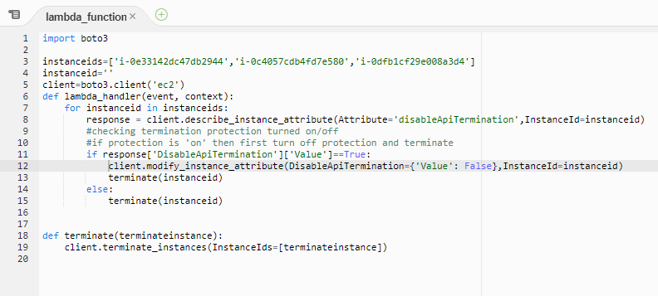

launch_instance_v:
-----------------------
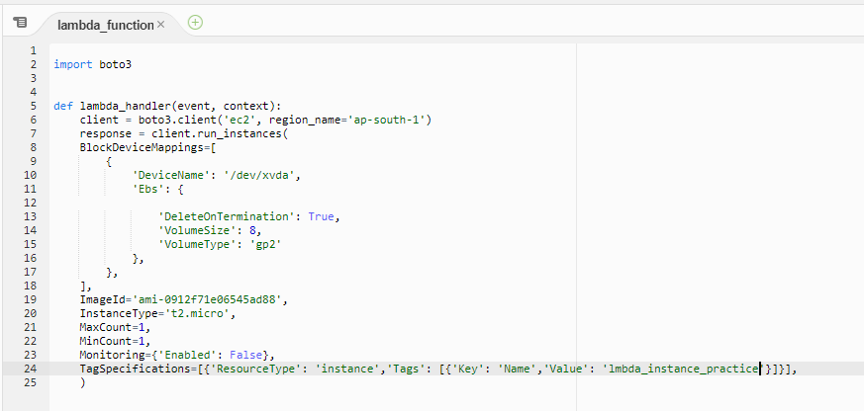

Start_freshers_jenkins:
-----------------------------
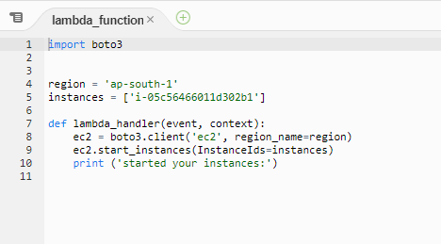
Stop_FreshersJenkins_Instance:
---------------------------------------
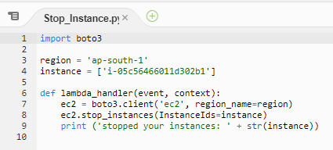
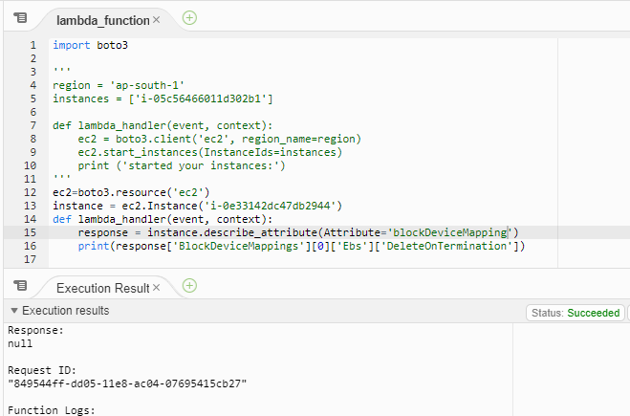
create AMI
Created by CreateImage(i-00ecc378062d6bfc9) for ami-0b28c32987a9b9d0b from vol-0ed8fd4a365efeb90
Created by CreateImage(i-00ecc378062d6bfc9) for ami-0b28c32987a9b9d0b from vol-0af0b265a1bf8f5d3
/dev/sda1=snap-0e5642ce94fa0359a:8:true:gp2, /dev/xvda=snap-0f1e380774861fb11:8:true:gp2

other file: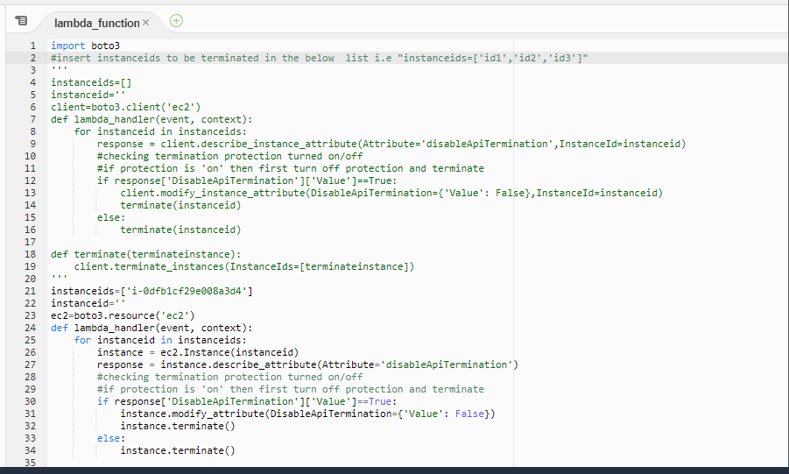
https://boto3.amazonaws.com/v1/documentation/api/latest/reference/services/ec2.html#EC2.Image.modify_attribute

instance.describe_attribute()
instance.modify_attribute()
instance.terminate()
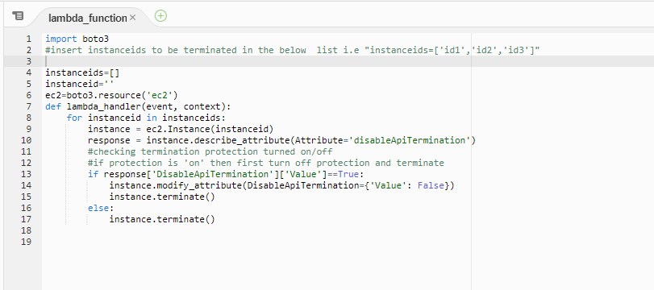
for modifying the attribute "DeleteOnTermination"
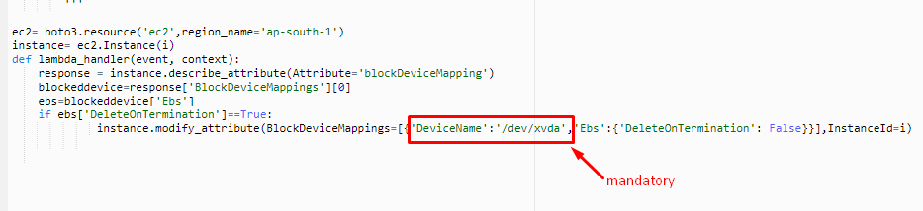

opt/app/ui/app(ang6) -->local backup

