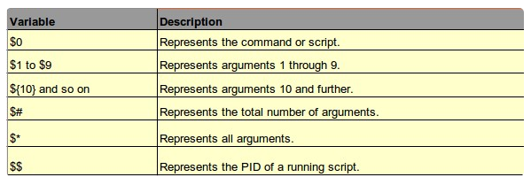
(/root/.ssh/id_dsa)
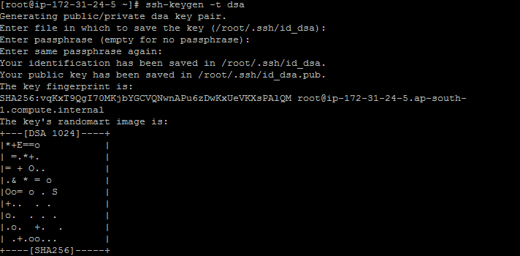

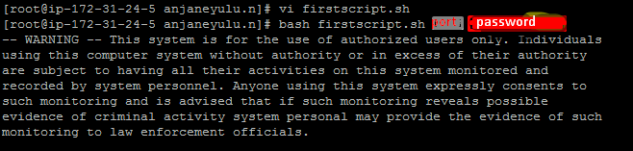

/var/lib/jenkins/

#!/bin/bash
loc=/var/lib/jenkins/jobs/test_demo/workspace/target/*.jar
des=drucaredev@49.207.6.227:/home/drucaredev/example.jar
sshpass -p "$1" scp -P 2233 $loc $des

- In short use any one of the following option to get more information about Linux commands:
man commandName
info commandName
commandName -h
commandName --help
- CTRL + L : Clear the screen.
- CTRL + W : Delete the word starting at cursor.
- CTRL + U : Clear the line i.e. Delete all words from command line.
- Up and Down arrow keys : Recall commands (see command history).
- Tab : Auto-complete files, directory, command names and much more.
- CTRL + R : Search through previously used commands (see command history)
- CTRL + C : Cancel currently running commands.
- CTRL + T : Swap the last two characters before the cursor.
- ESC + T : Swap the last two words before the cursor.
- CTRL + H : Delete the letter starting at cursor.

echo $SHELL
ps $$
ps -p $$

Bash and Command Types
The bash shell understands the following types of commands:
- Aliases such as ll
- Keywords such as if
- Functions (user defined functions such as genpasswd)
- Built in such as pwd
- Files such as /bin/date
- JOB_SPEC &
- (( expression ))
- . filename
- [[:]]
- [ arg... ]
- expression
- alias
- bg
- bind
- builtin
- caller
- case
- command
- compgen
- complete
- continue
- declare
- dirs
- disown
- echo
- enable
- eval
- exec
- exit
- export
- false
- fc
- fg
- for
- getopts
- hash
- help
- history
- if
- jobs
- kill
- let
- local
- logout
- popd
- printf
- pushd
- pwd
- read
- readonly
- return
- select
- set
- shift
- shopt
- source
- suspend
- test
- time
- times
- trap
- true
- type
- typeset
- ulimit
- umask
- unalias
- unset
- until
- variables
- while

