**Building an artifact And deploying it to Remote Server by using Jenkins:**

1. Add “Publish over SSH” plug-in to Jenkins:

1.1 click on Manage Jenkins---->Manage Plugins

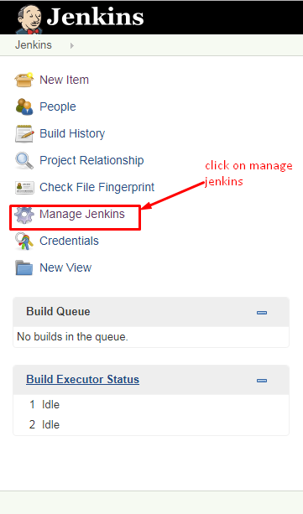

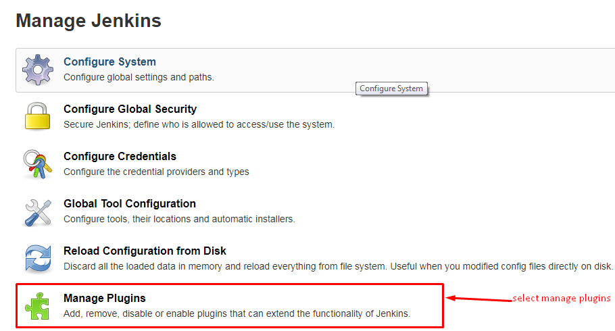

1.2 Now click on Available section and Search for “Publish Over SSH” plug-in.

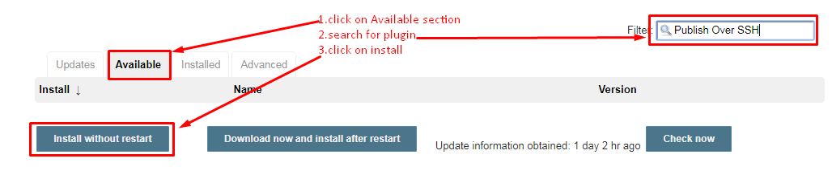

* 1. Go to Installed section and verify weather plug-in is selected or not.

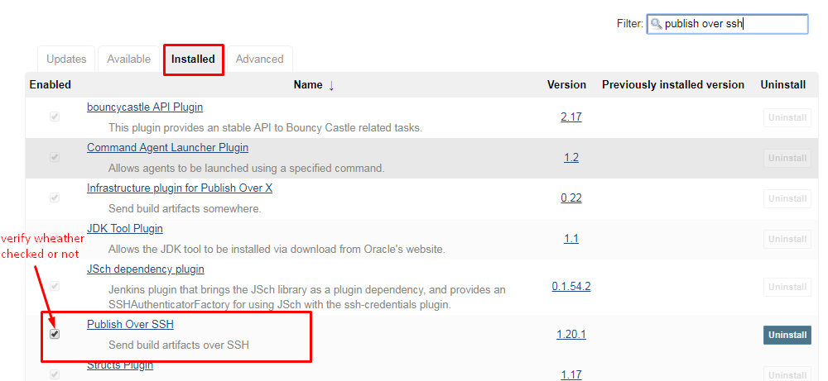

2. Configure the “Publish over SSH” plug-in.

2.1 Click on “manage Jenkins”----->Configure System

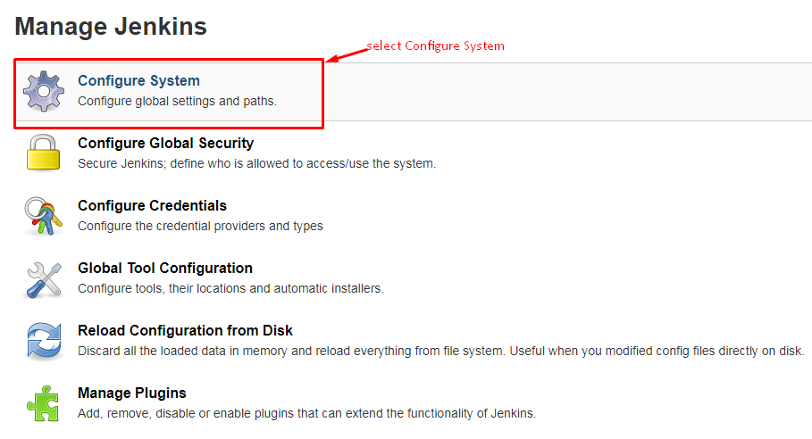

2.2 Scroll down to “Publish over SSH” and Fill the following details.

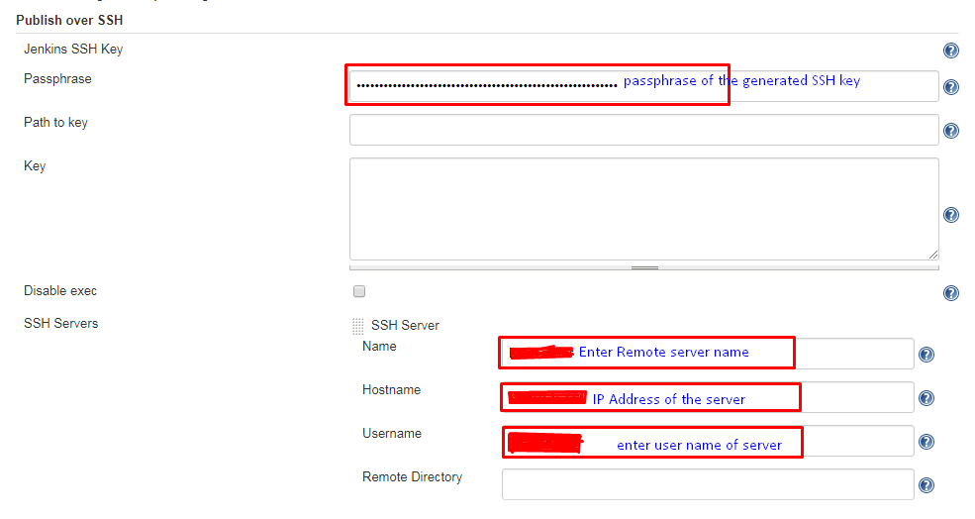

2.3 Click on “Advanced” option and Configure Below Details.

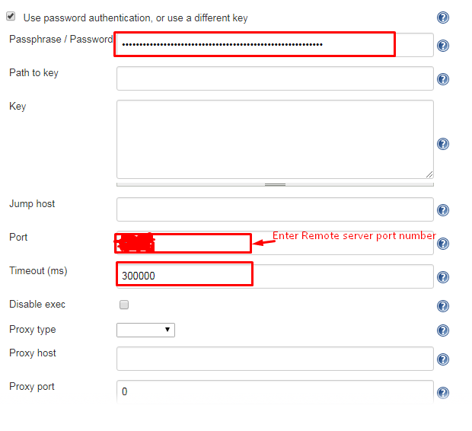

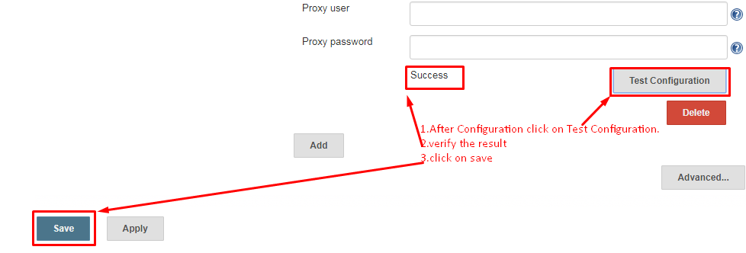

3. Now create a job to build the jar and publish it to remote server over SSH.

3.1 Click on “New Item”.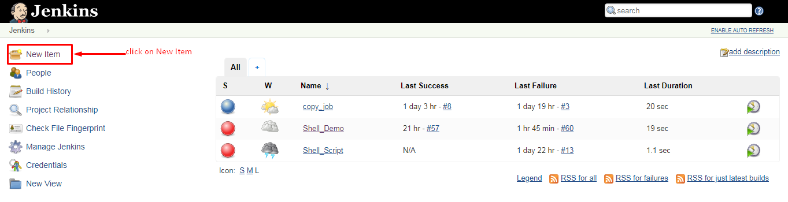

3.2 Now enter your job name, select “freestyle project” and click “ok”

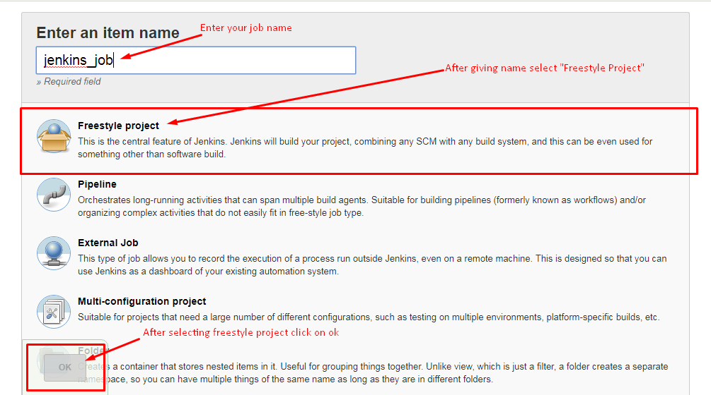

3.3 Go to “Source Code Management”.

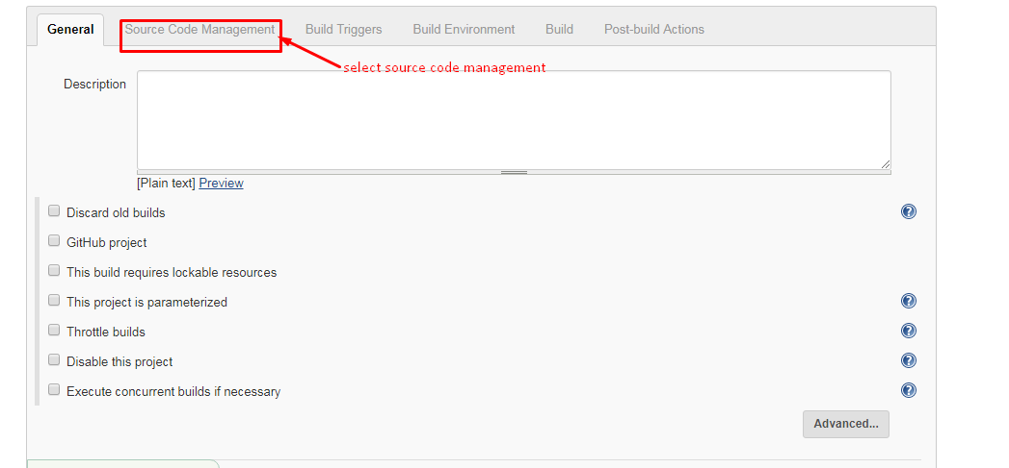

3.4 Select “Git”.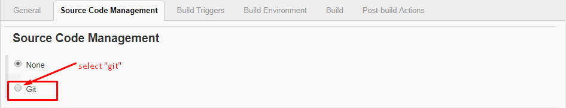

3.5 Enter Repository URL and Git credentials.

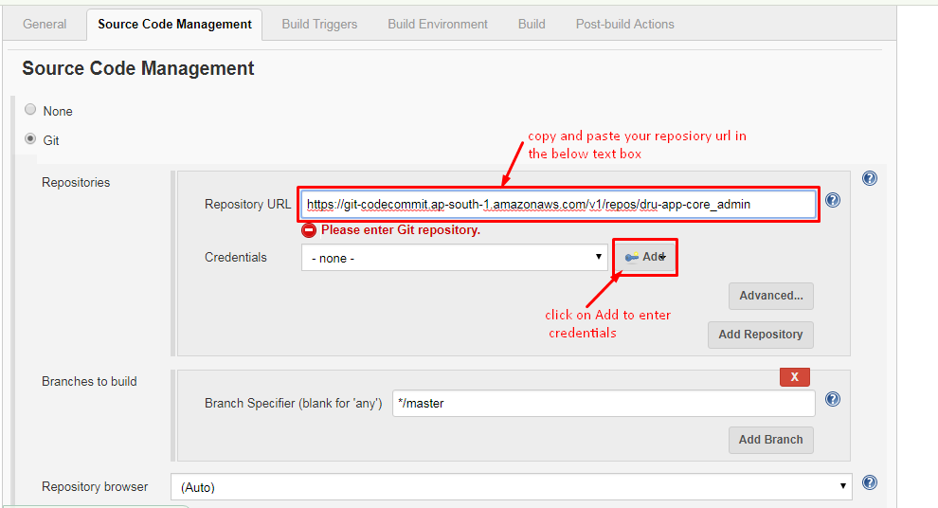

Click on “Add” then we get the following window. here we have to enter Git credentials of IAM user.

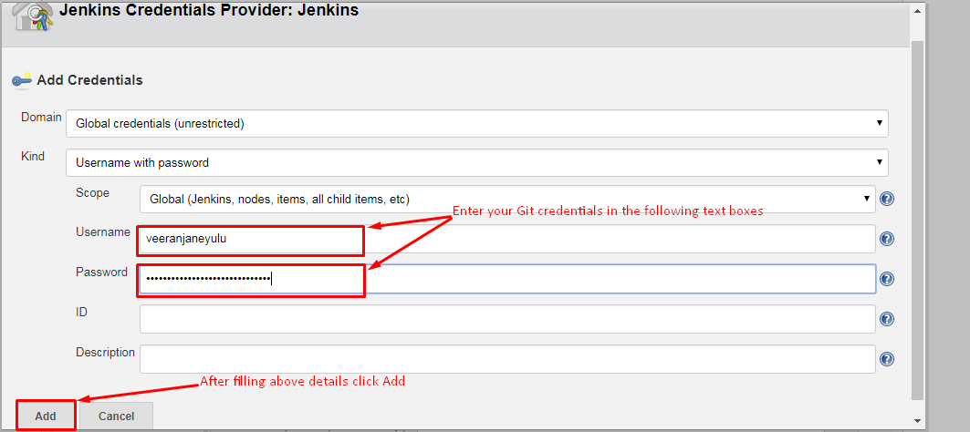

3.6 After adding credentials select your credentials by clicking on dropdown button.

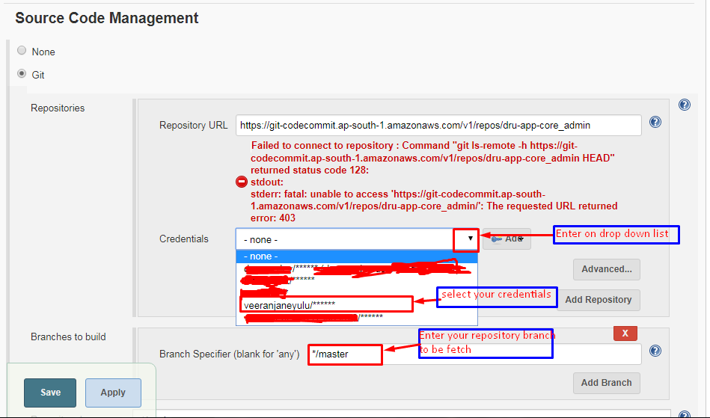

3.7 Now create schedule by selecting “Build Triggers”.

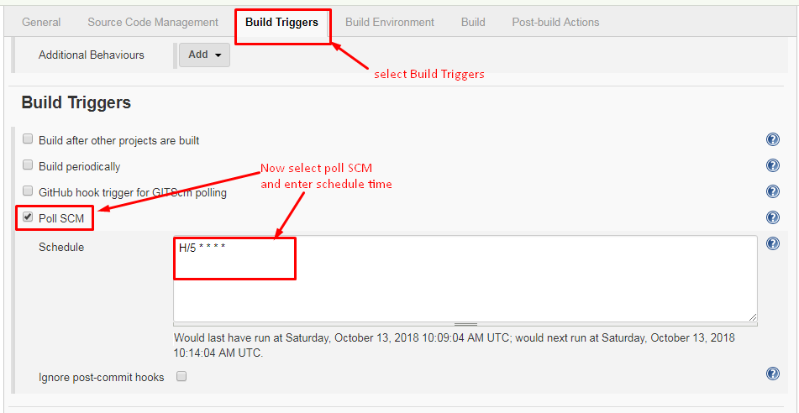

3.8 For building the jar select “invoke top-level maven targets” in Build section.[note:add Maven plug-in to Jenkins].

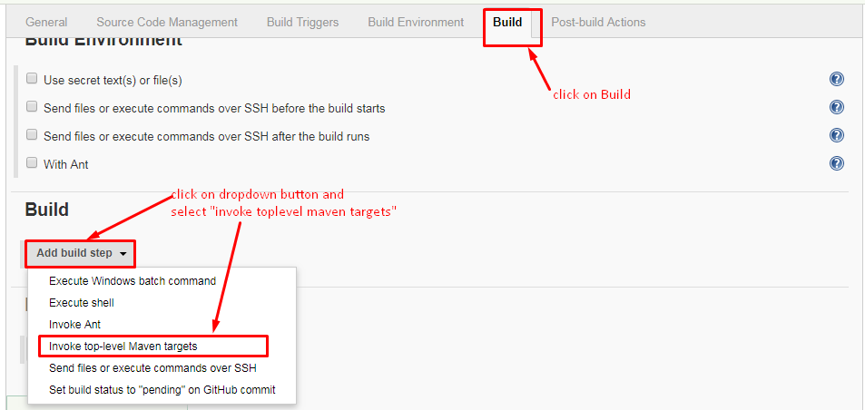

Now enter maven goals in below text box.

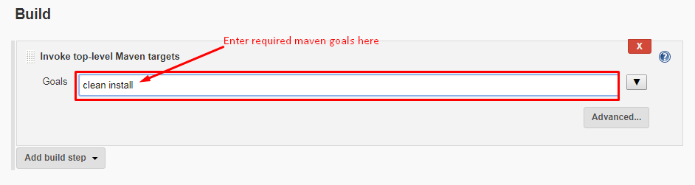

3.9 First we should add “post build plug-in” and then configure post-build action.

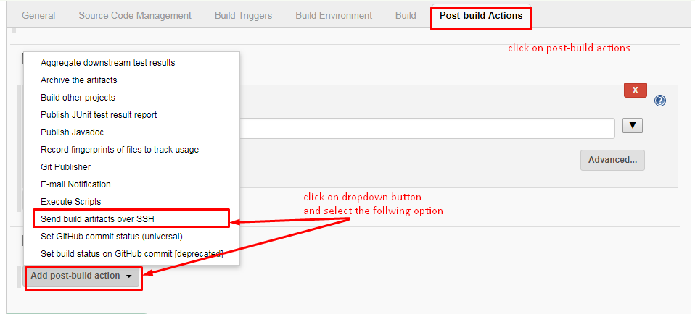

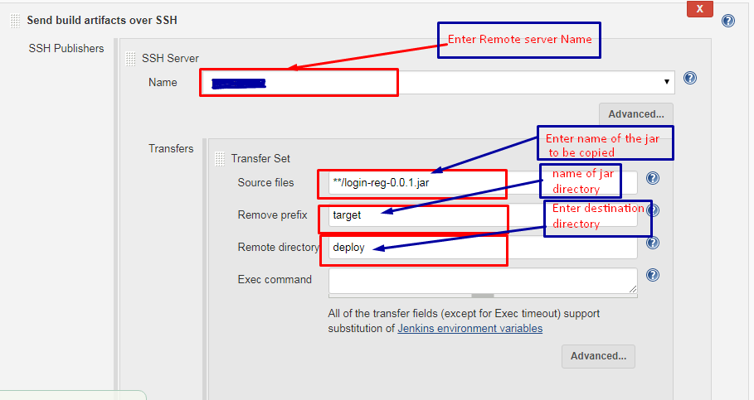

3.10 Now save the job.

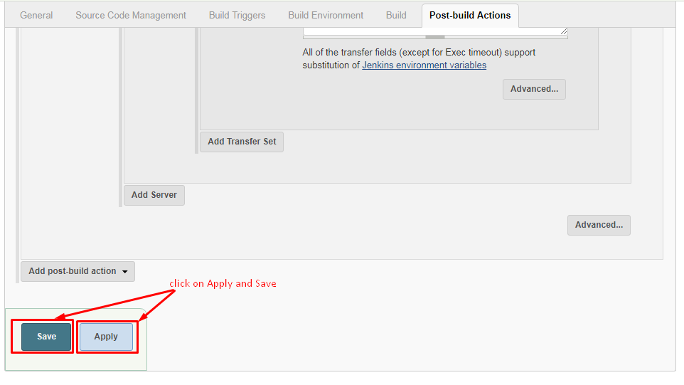

4. After saving click on “Build now”.

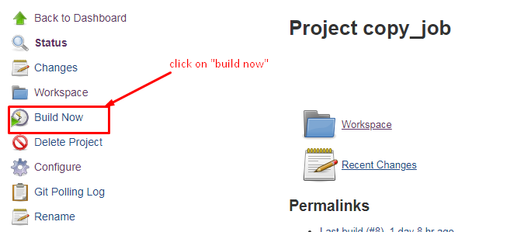

4.1 check the status of build as below.

