Purpose: To help Porter in estimating the delivery time more precisely based on the various features (factors) using Artificial Neural Networks

Experimentation and analysis:
- It was assumed that ANN can capture complex non-linear interactions between multiple variables… With sufficient hyperparameter tuning, ANN can outperform linear and tree-based models.
- But with various experiments done using ANN, it was observed that ANN was not very effective in capturing all possible non linear interactions. Despite of rigorous hyperparameter tuning and all, the highest R-squared achieved was 0.28
- So polynomial features of degree 2 were introduced (squared features and interaction features)… Even the basic ANN model gave R-squared of 0.3. One of the Basic model (model # 19) achieved R-squared of 0.31
- Despite of rigorous hyperparameter tuning the maximum R-squared remained at 0.31
- We could see with hands on experience that ANNs cannot always ensure that best results are achieved. “Feature Engineering” is still important.
- It appears like, it is not possible to achieve better R-squared from this given dataset. With all the experiments, I conclude that the available features in the dataset do not have enough predictive power to achieve better “prediction model”.
- Refer the summary table in the excel (01_ANN_Experiments_00). All the experiments (ipynb notebooks) are made available.

Model 01: ANN_Business_Case_Porter_01.ipynb
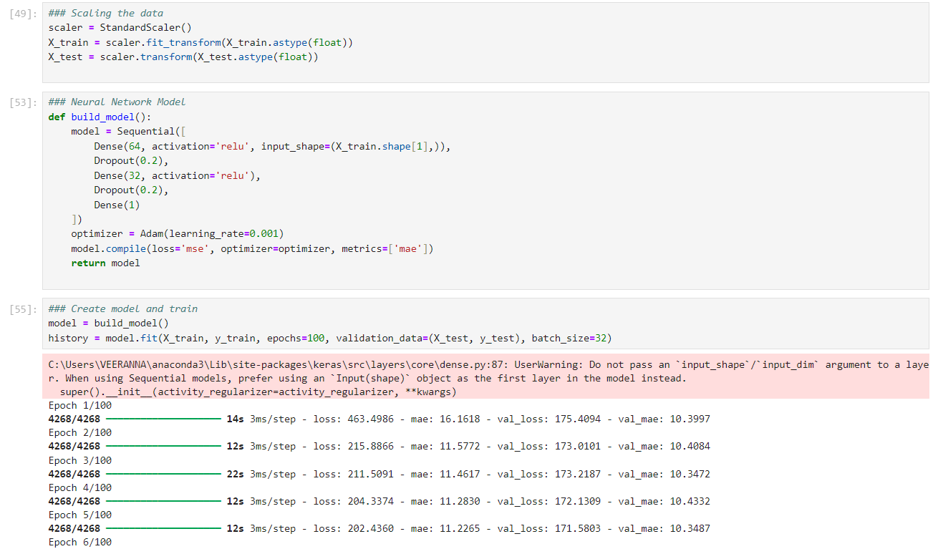

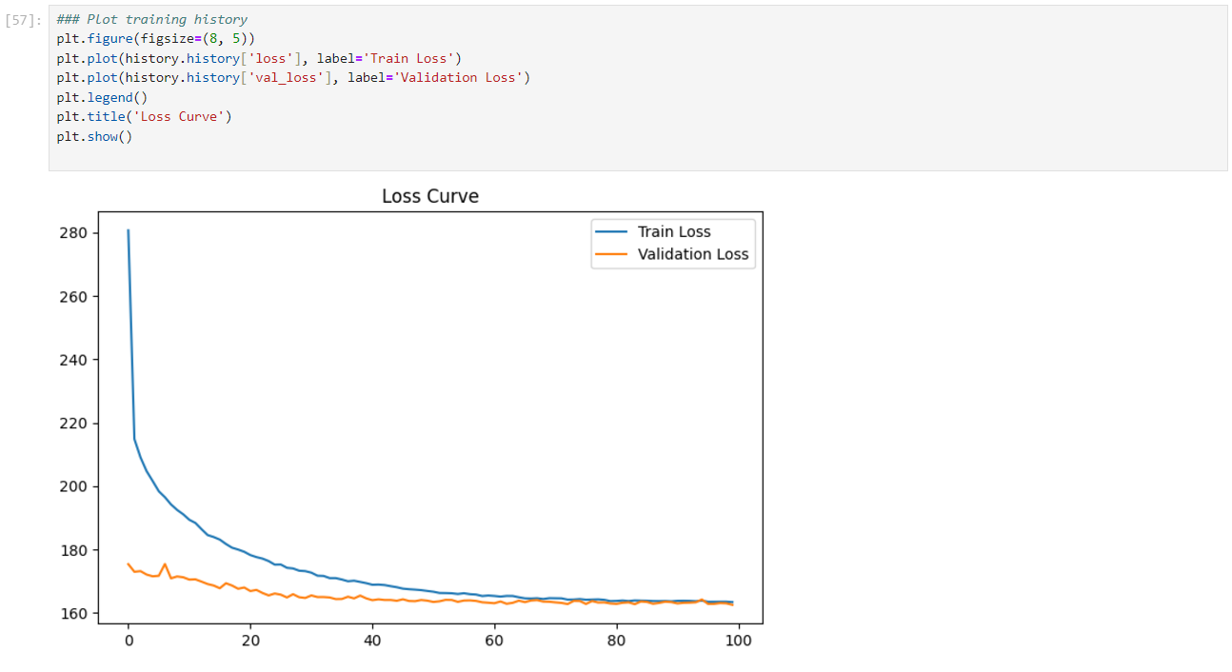

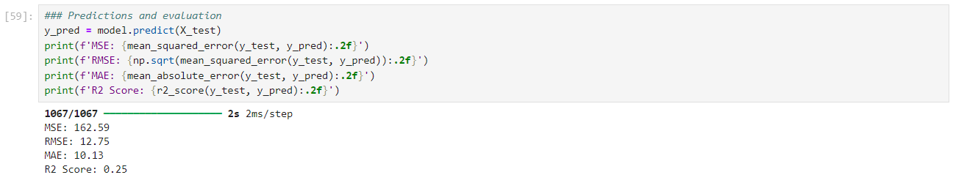

Model 02: ANN_Business_Case_Porter_02.ipynb
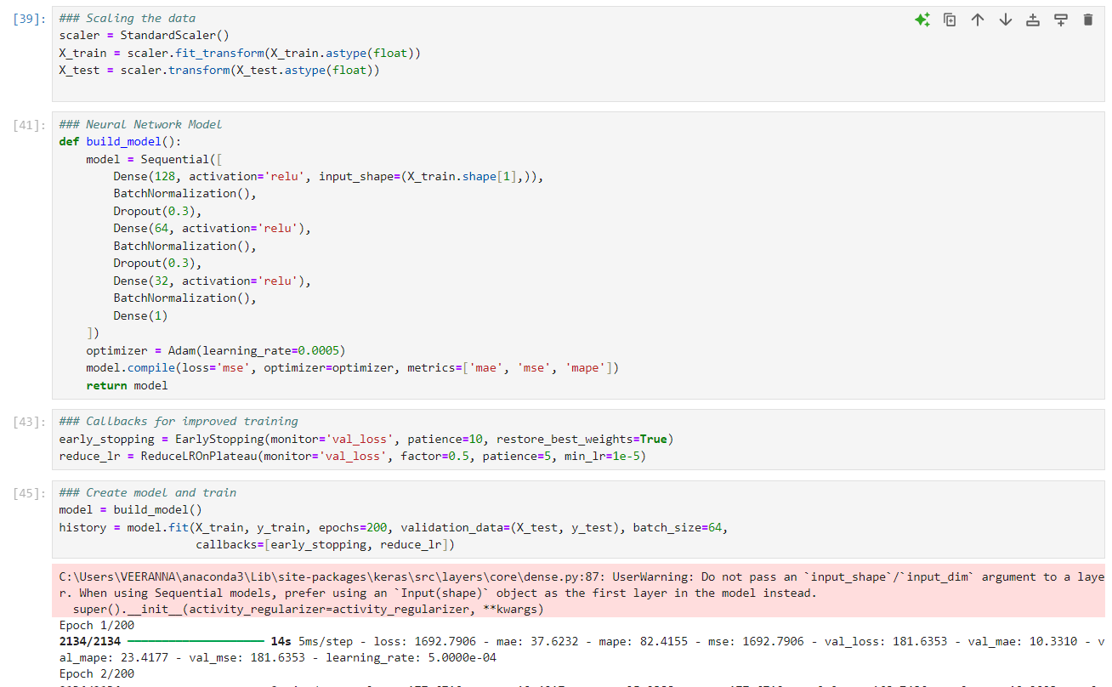

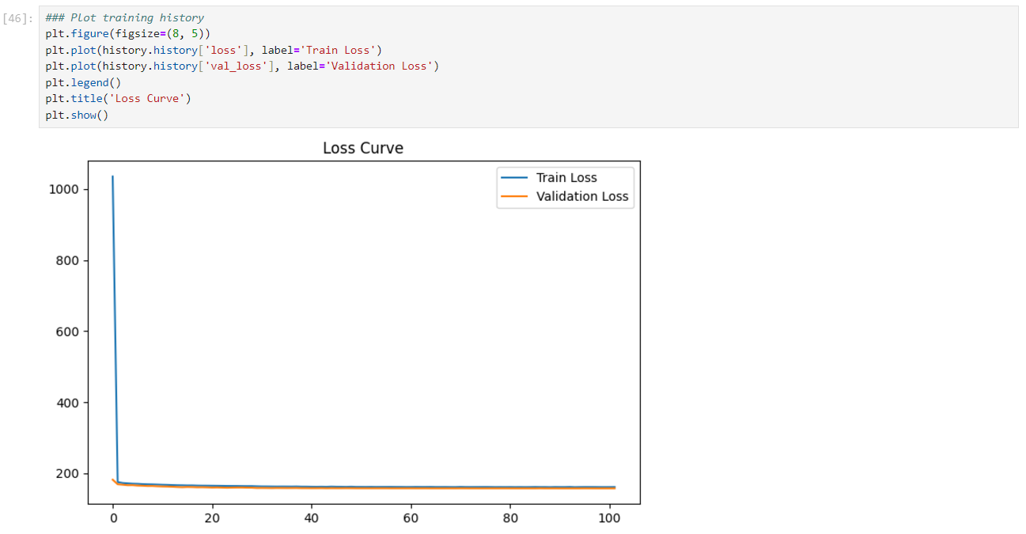

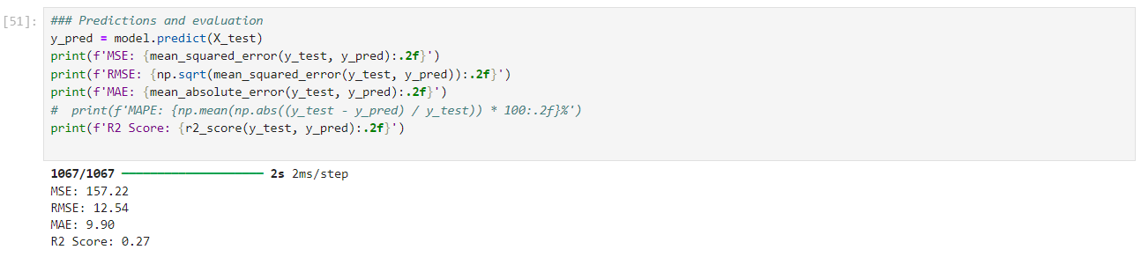

Model 3: ANN_Business_Case_Porter_03_One_Hot_Encoded.ipynb
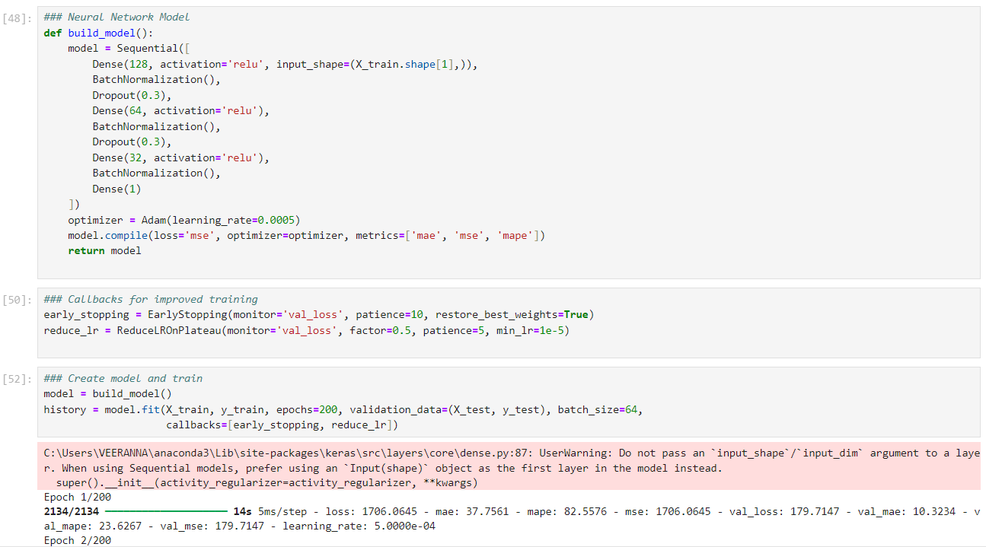

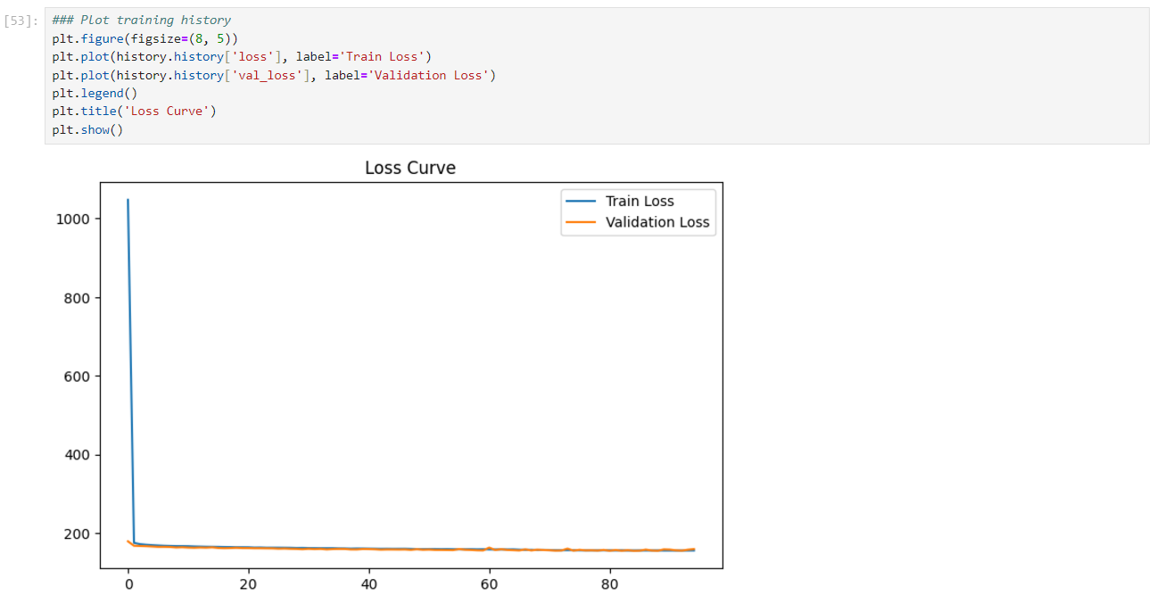

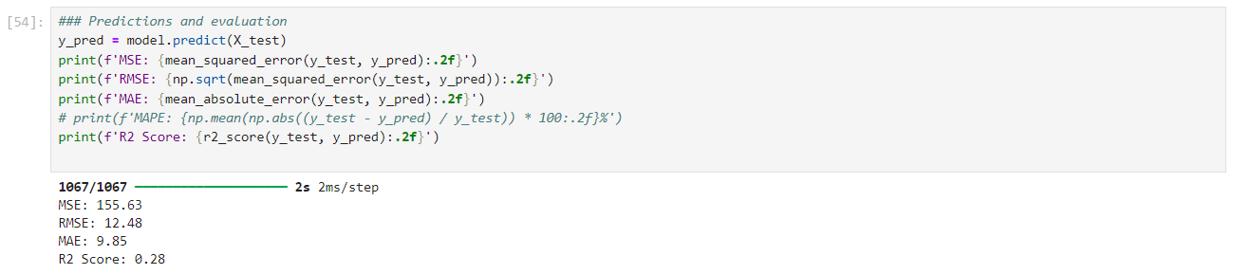

Model 04: ANN_Business_Case_Porter_04_Target_Encoded.ipynb
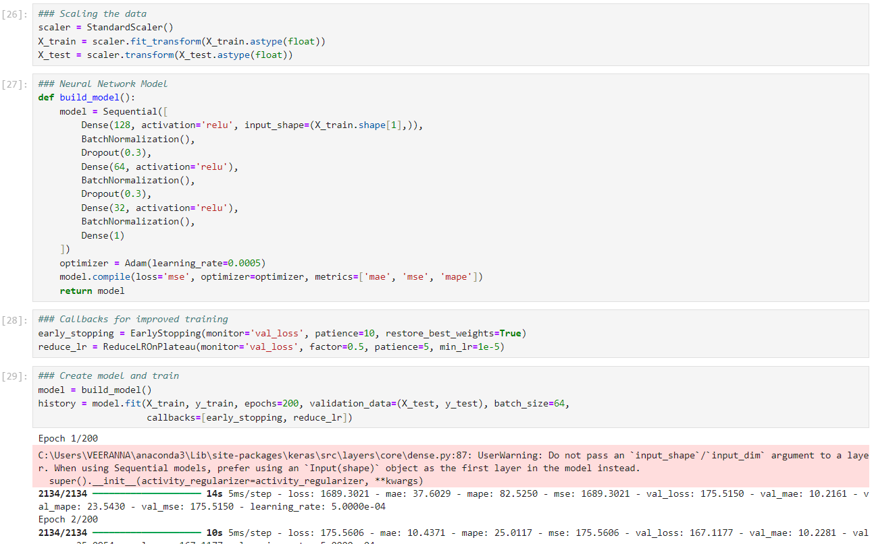

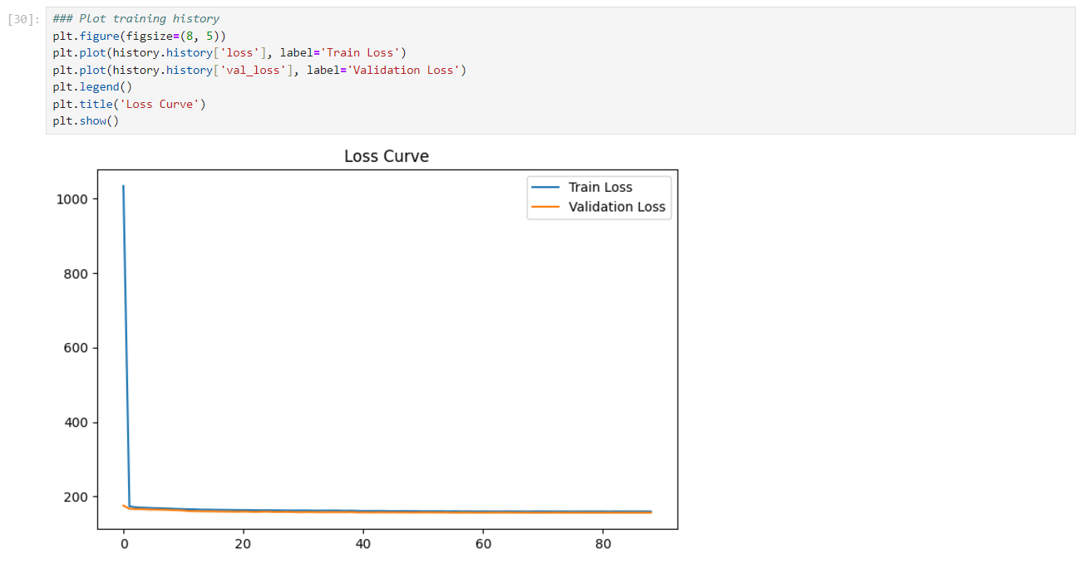

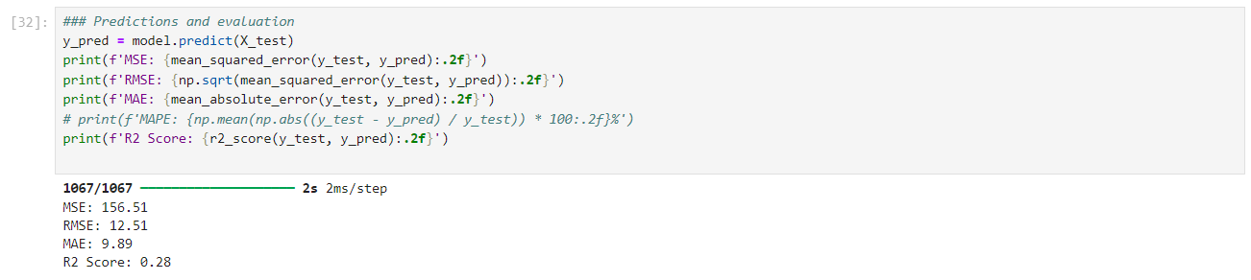

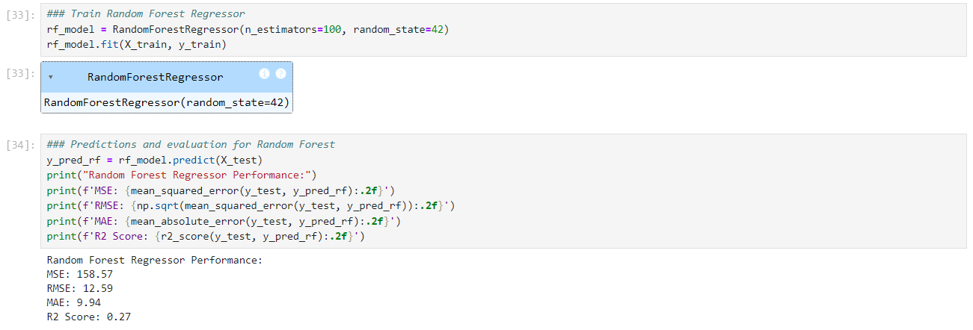

Model 05: ANN_Business_Case_Porter_05_Target_Encoded.ipynb
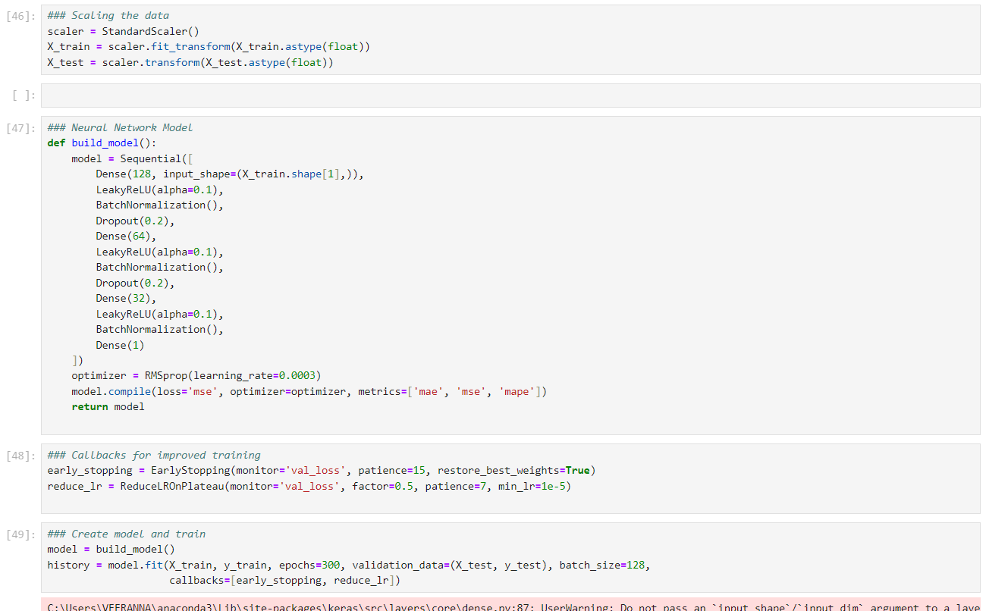

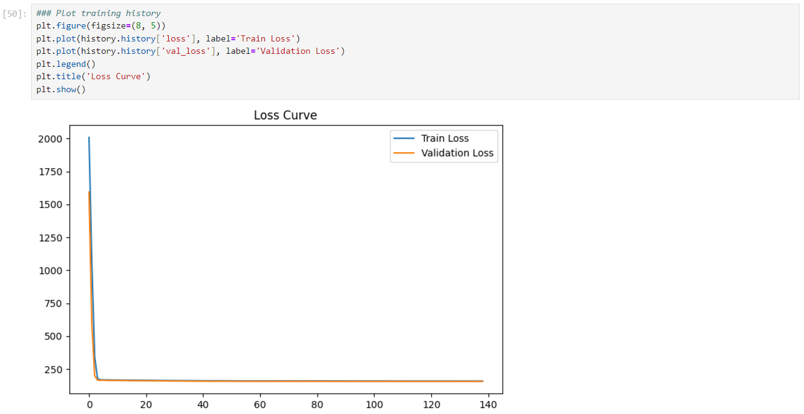

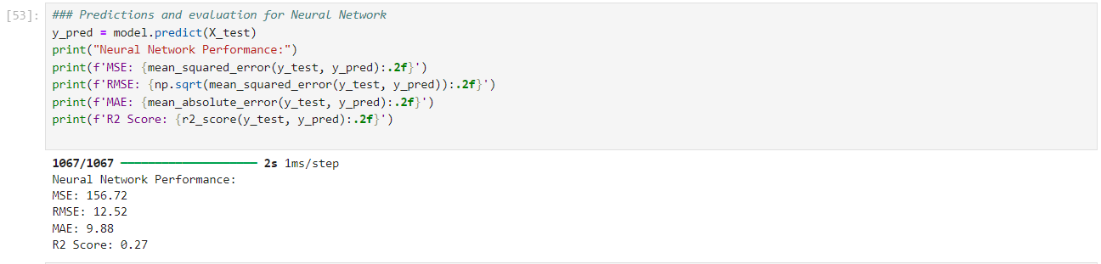

Model 06: ANN_Business_Case_Porter_05.01_Target_Encoded_Sigmoid_activation.ipynb
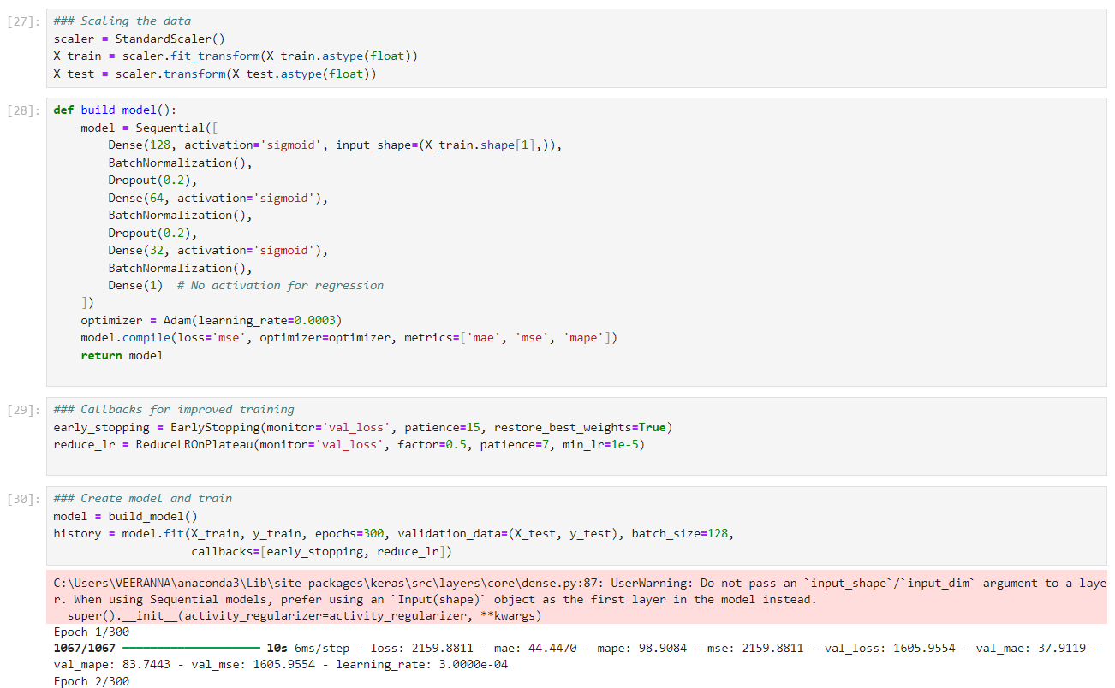

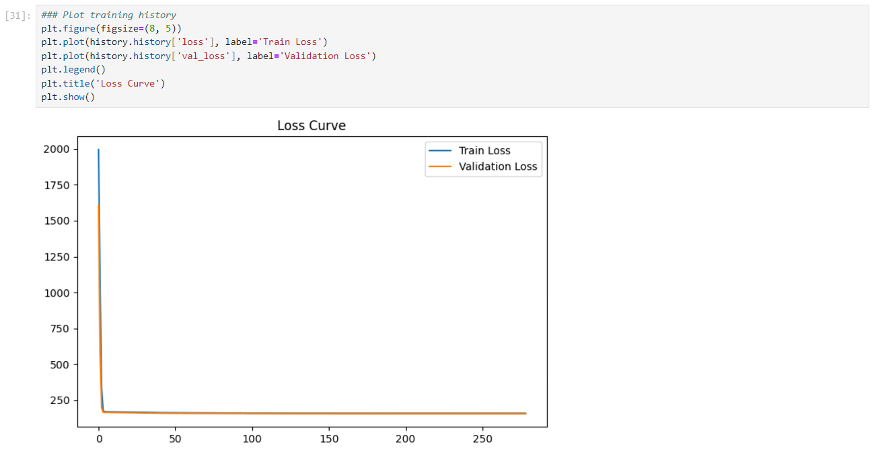

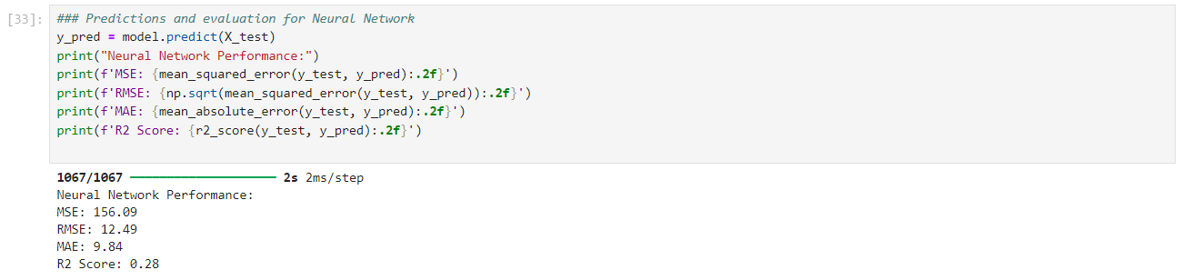

Model 07: ANN_Business_Case_Porter_05.02_B_Target_Encoded_RMSProp.ipynb
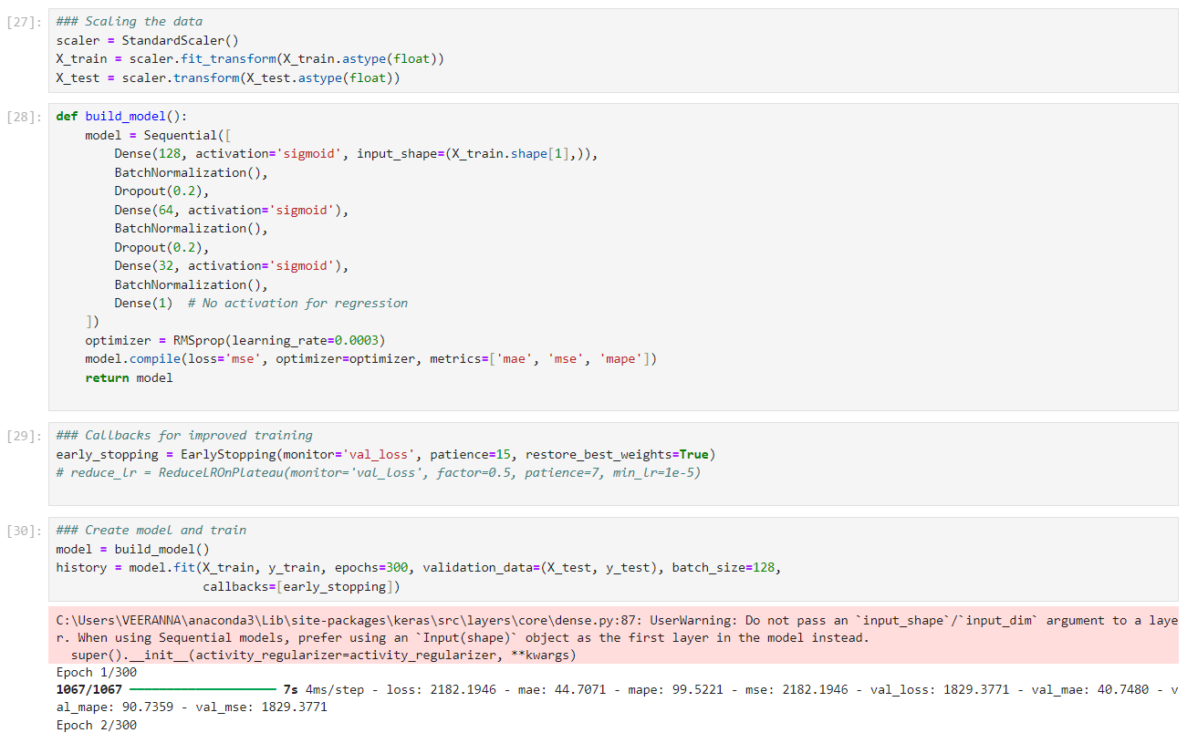

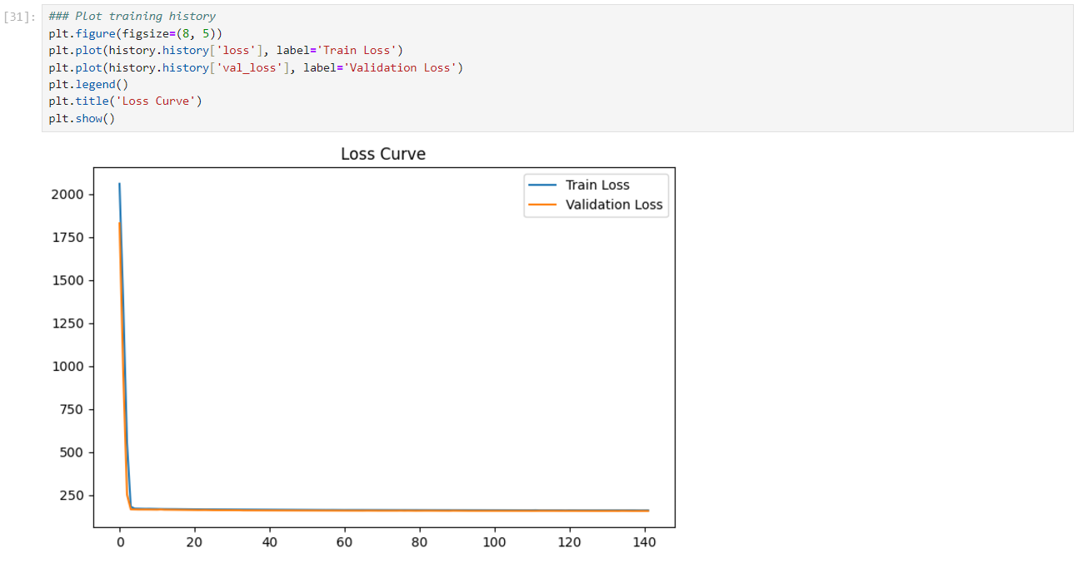

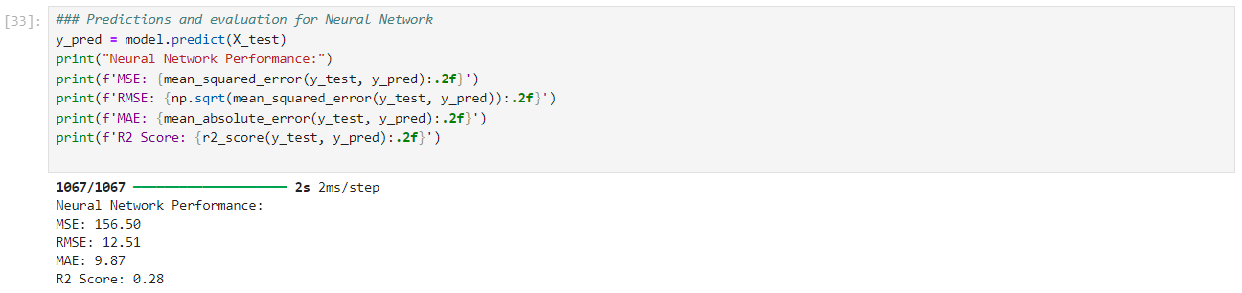

Model 08: ANN_Business_Case_Porter_05.02_Target_Encoded_Sigmoid_RMSProp.ipynb
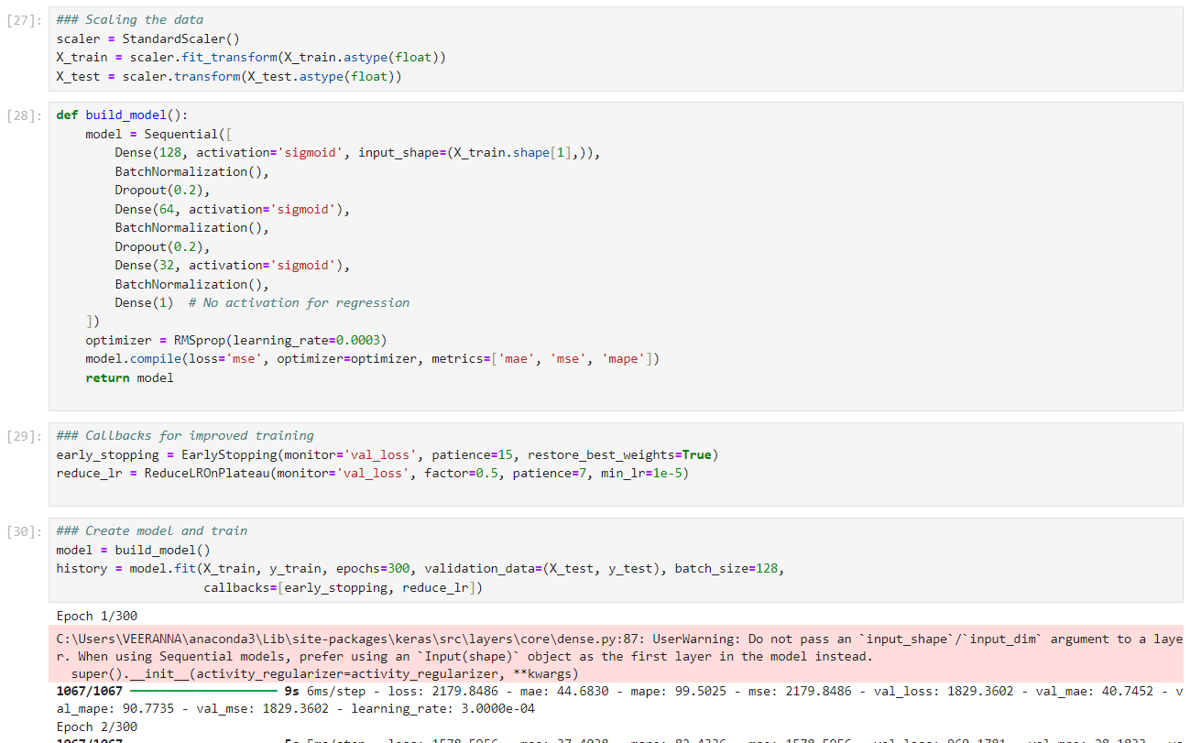

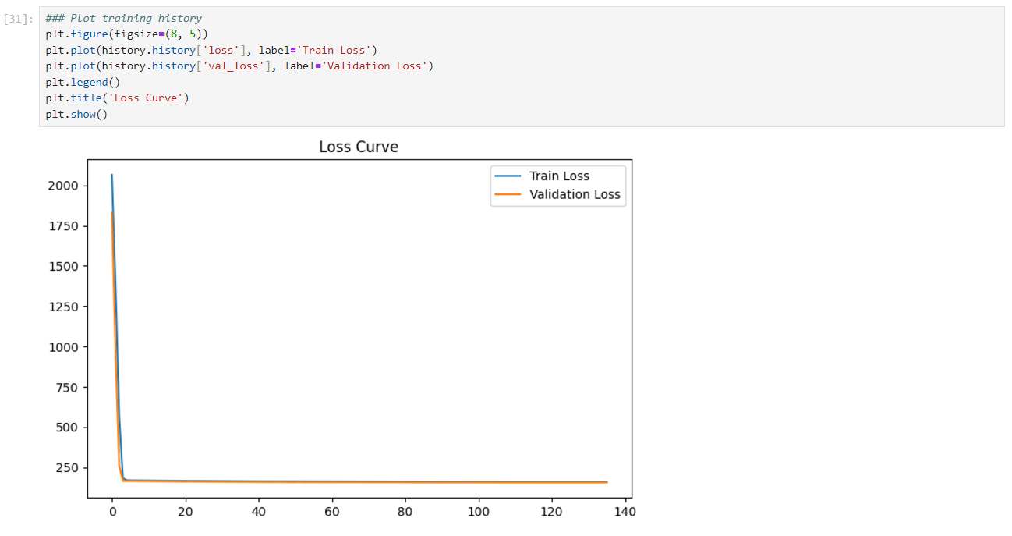

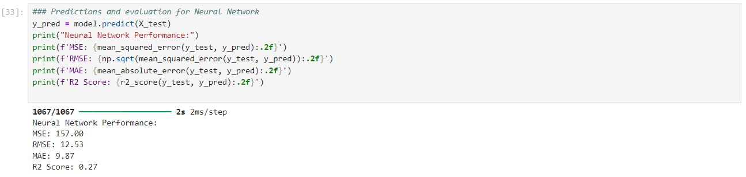

Model 09: ANN_Business_Case_Porter_06_Target_Encoded_HP_Tuning.ipynb
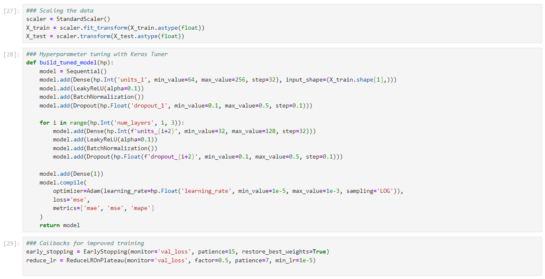

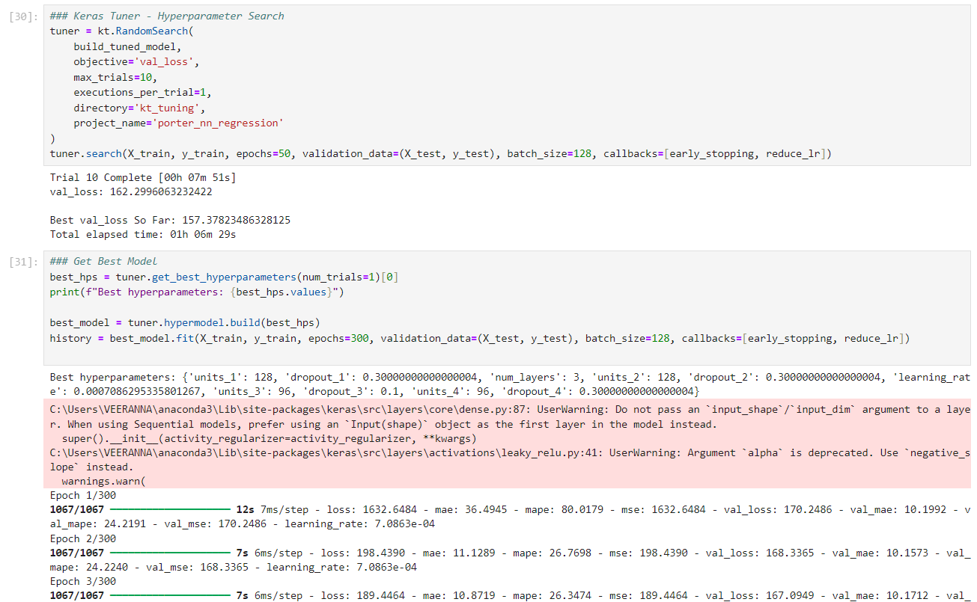

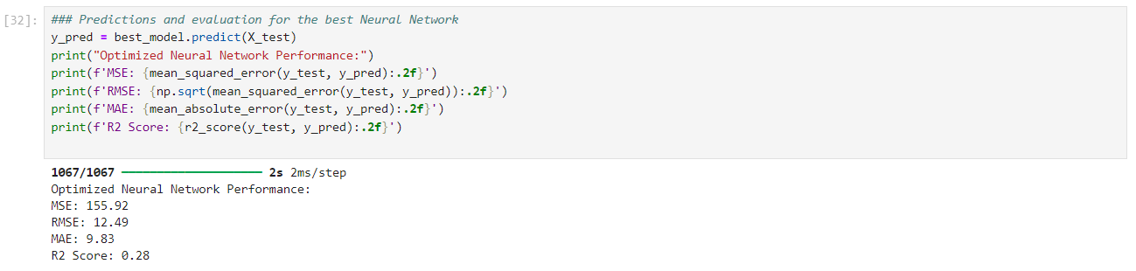

Base model without HP tuning:
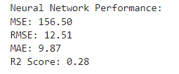

Model with rigorous HP tuning:
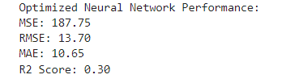

Model 10: ANN_Business_Case_Porter_07B_Target_Encoded_HP_Tuning2.ipynb
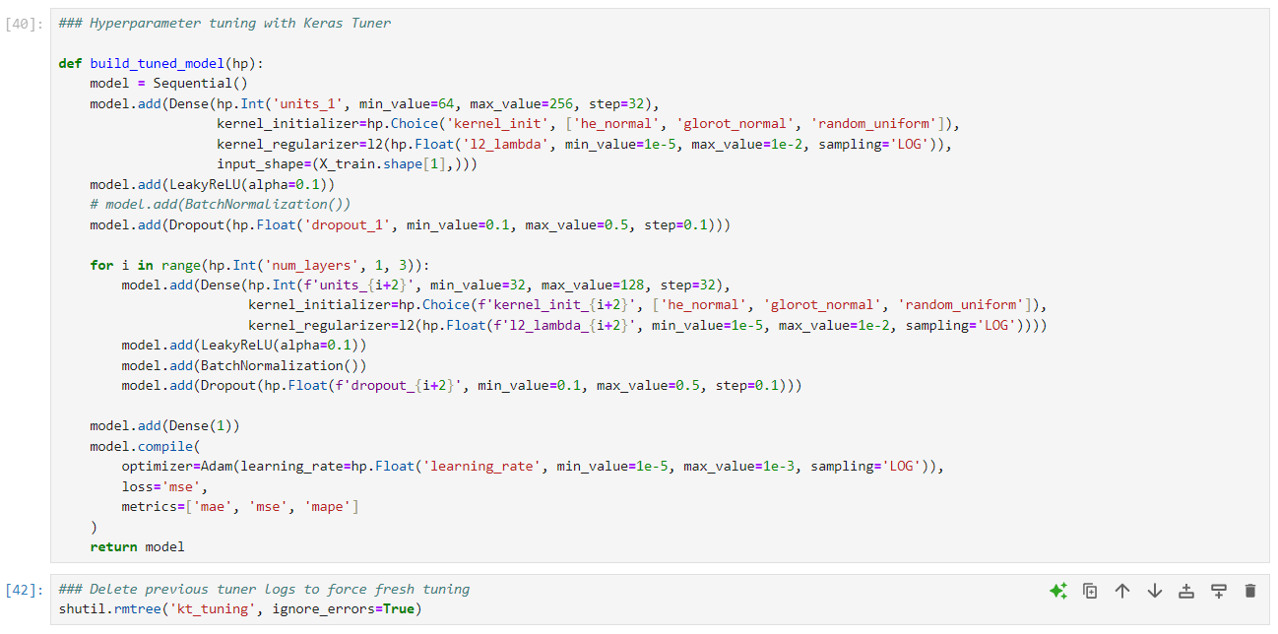

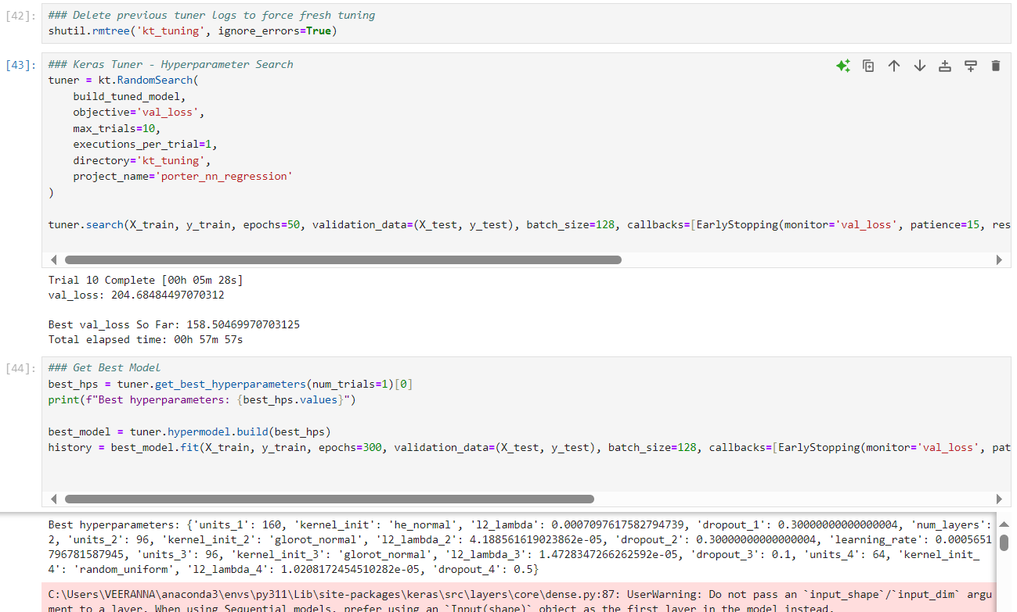

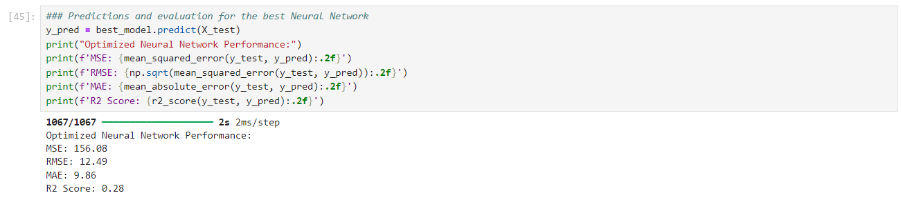

Model 11: ANN_Porter_New_00_adam.ipynb
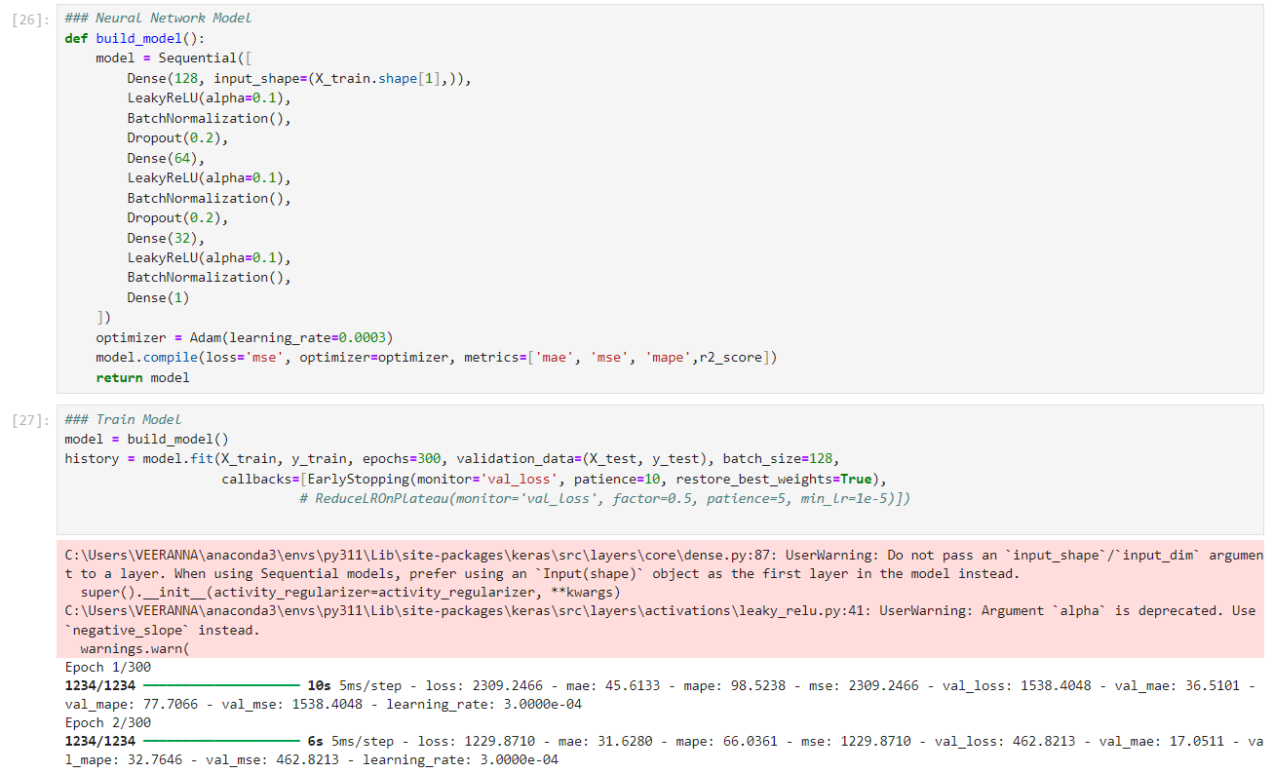

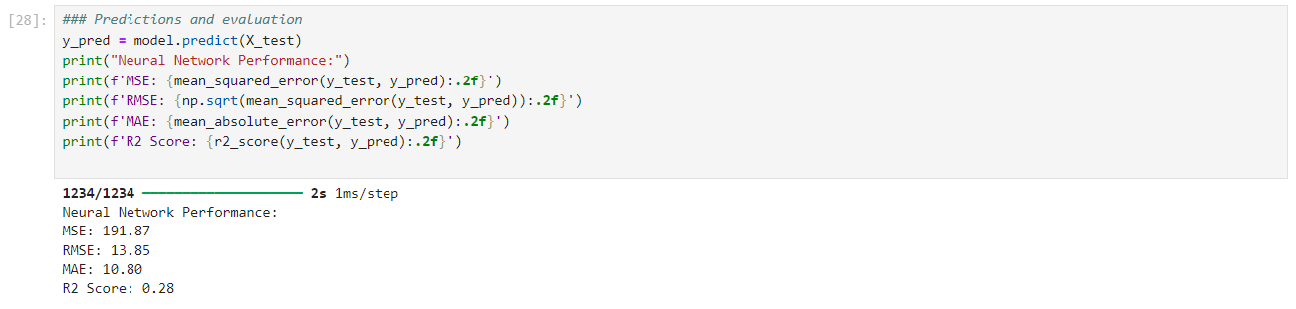
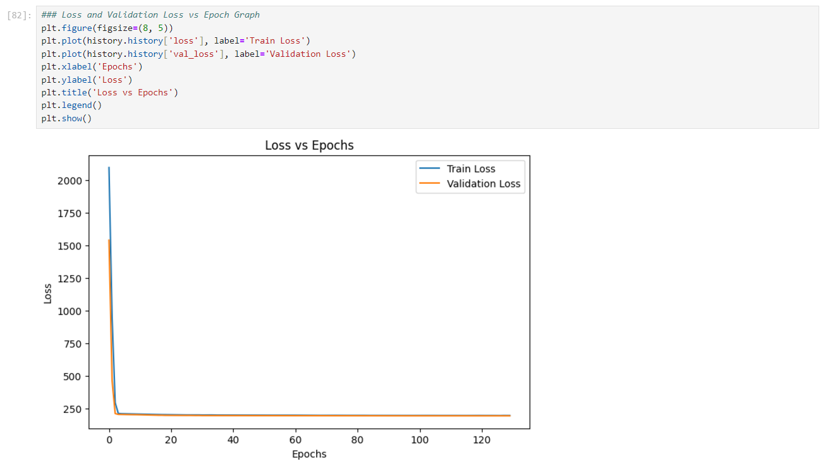

Model 12: ANN_Porter_New_00_RMSProp.ipynb
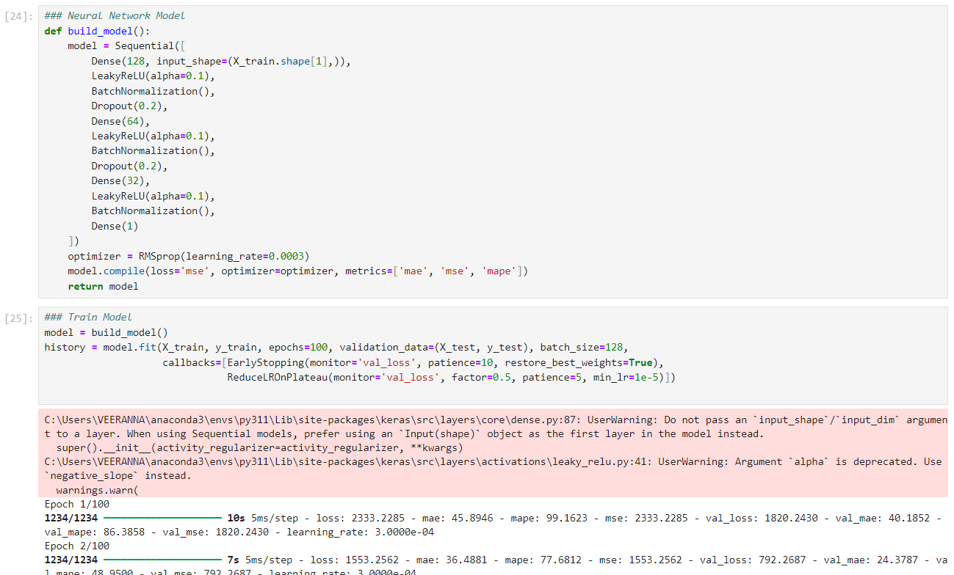

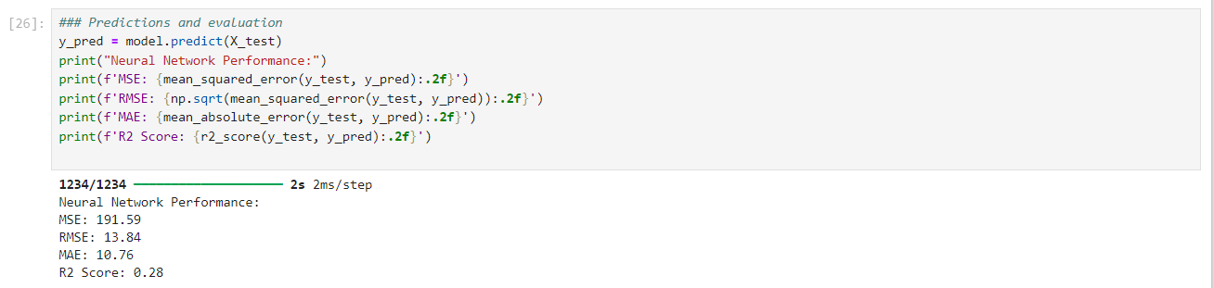

Model 13: ANN_Porter_New_01_adam.ipynb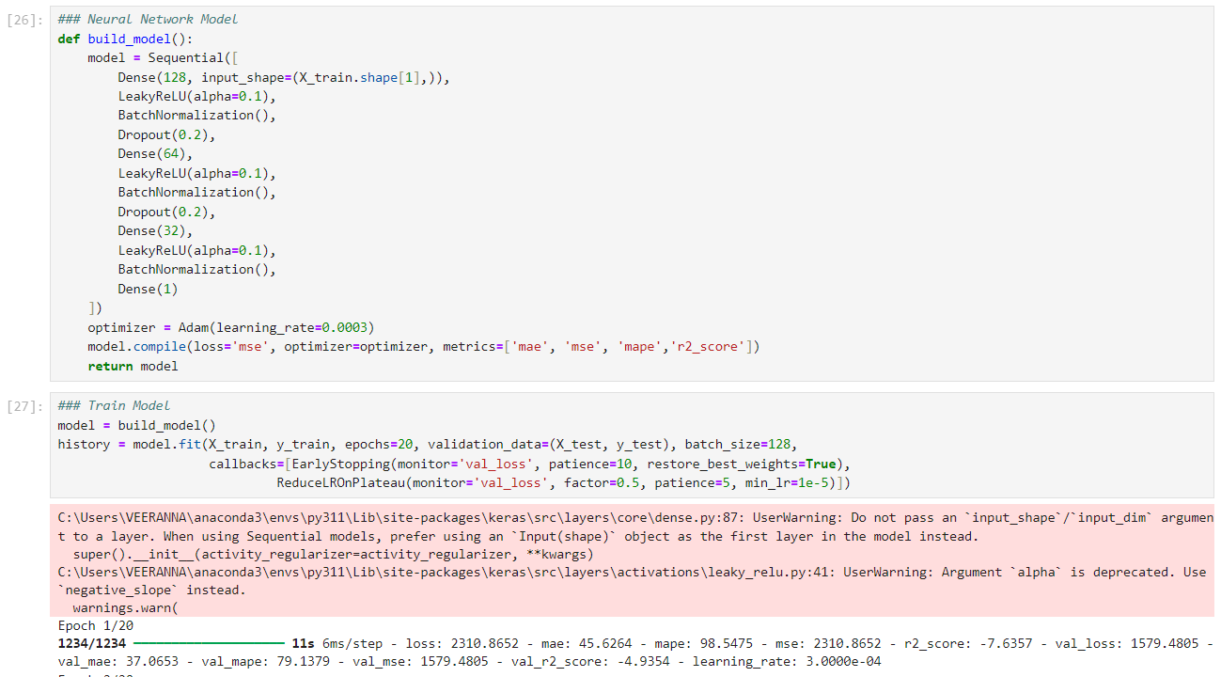

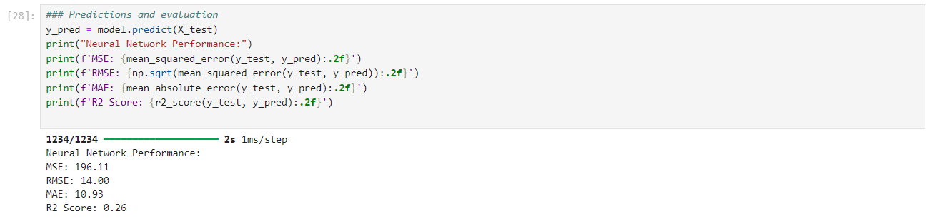

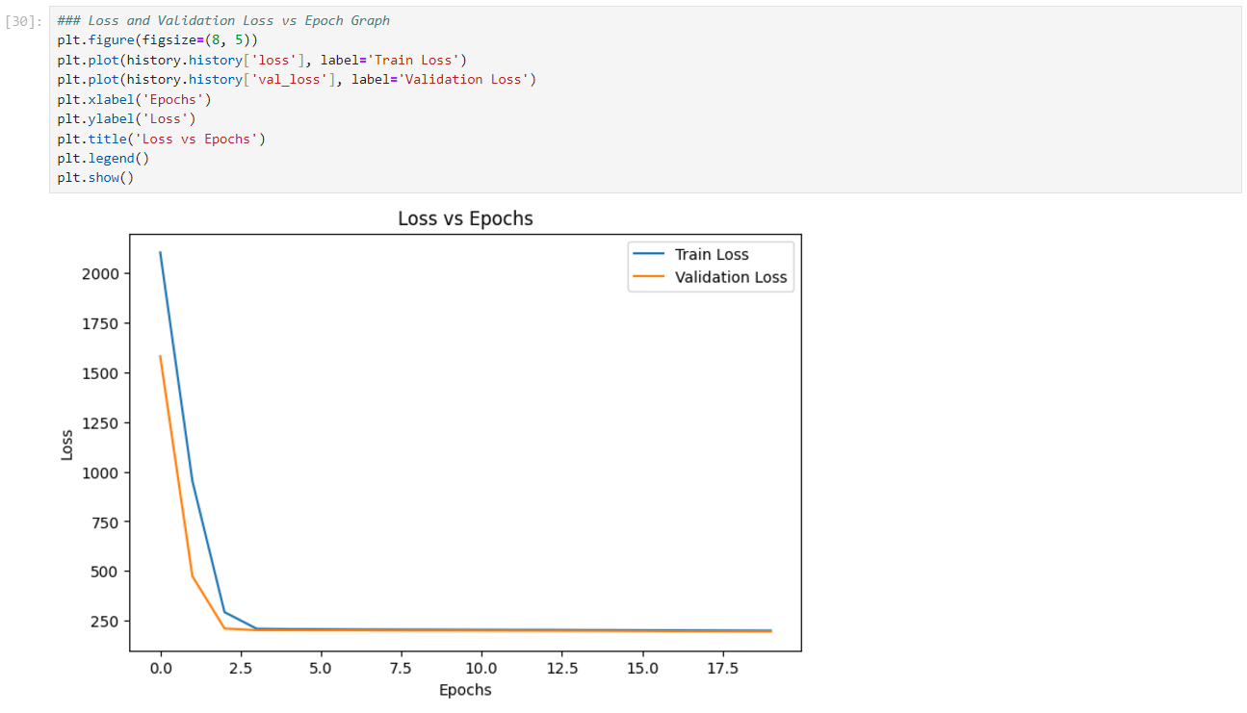

Model 14: ANN_Porter_New_02_adam_6_HL.ipynb
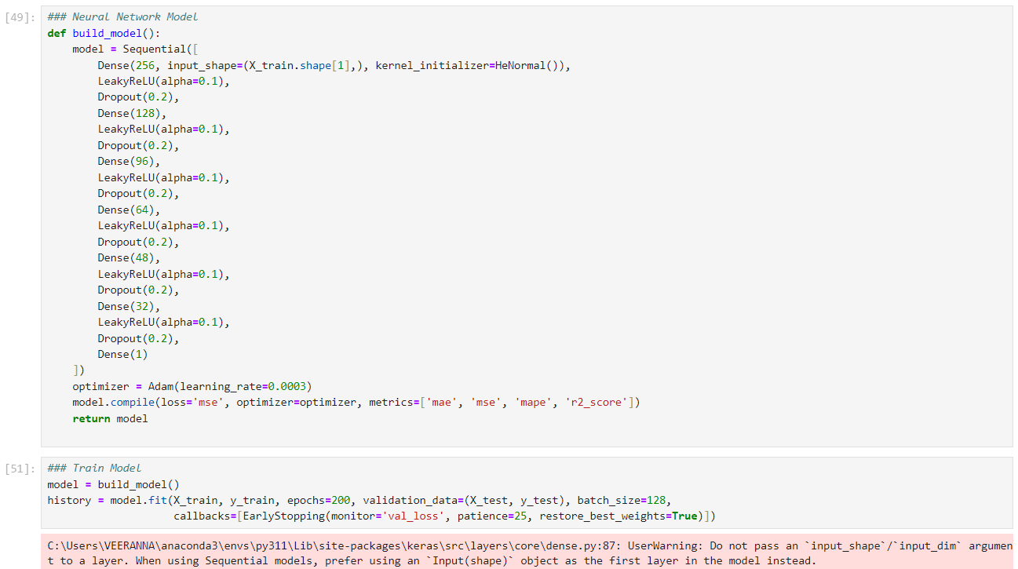

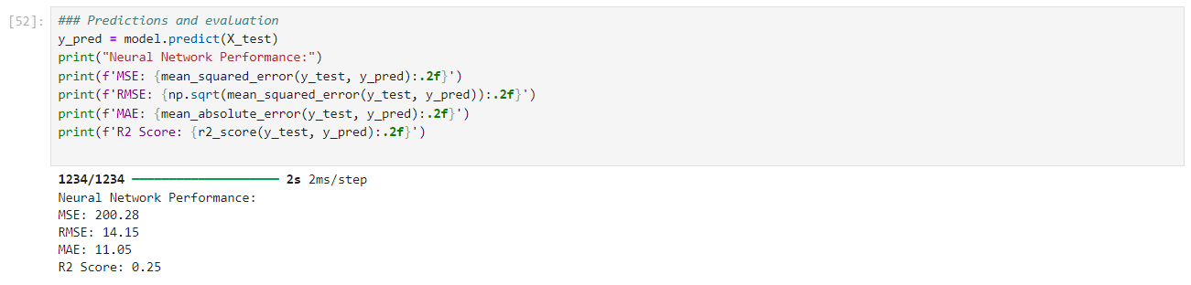

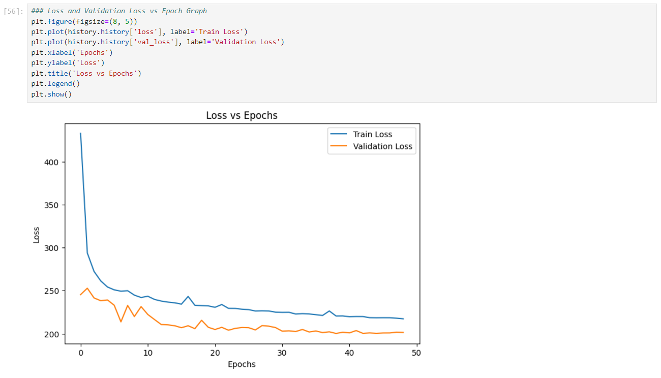

Model 15: ANN_Porter_New_02_adam_6.01_HL.ipynb
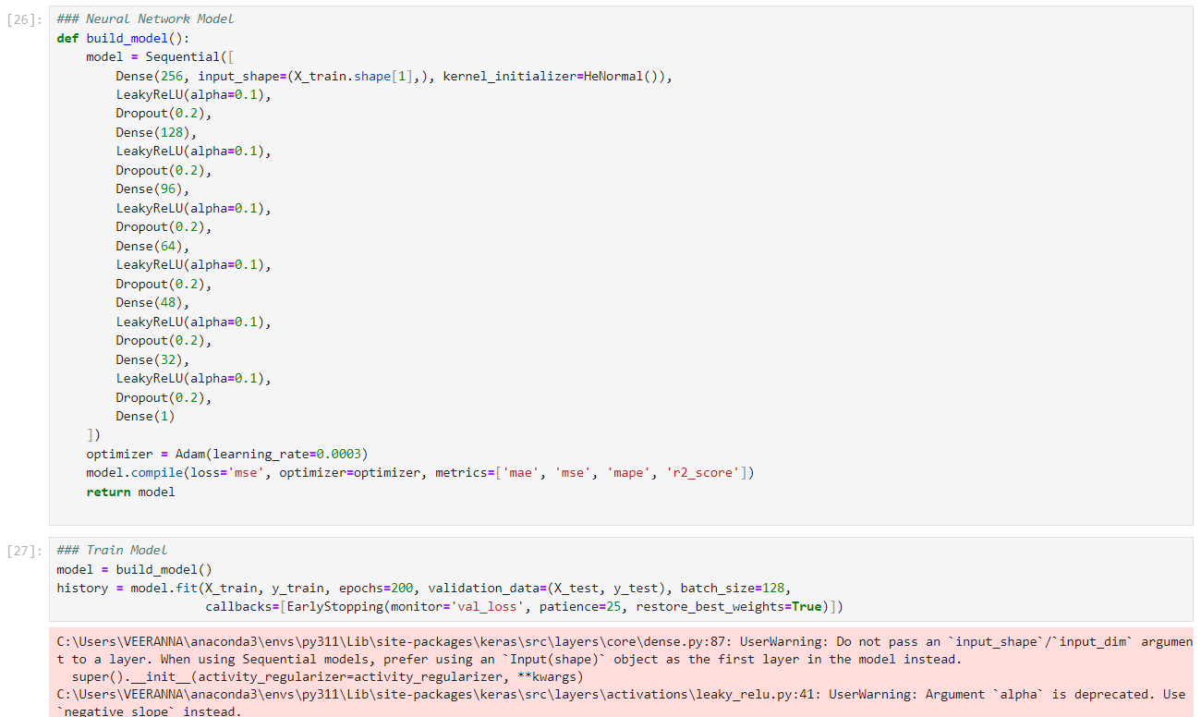

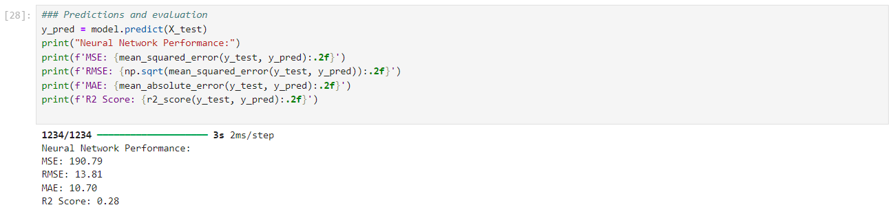

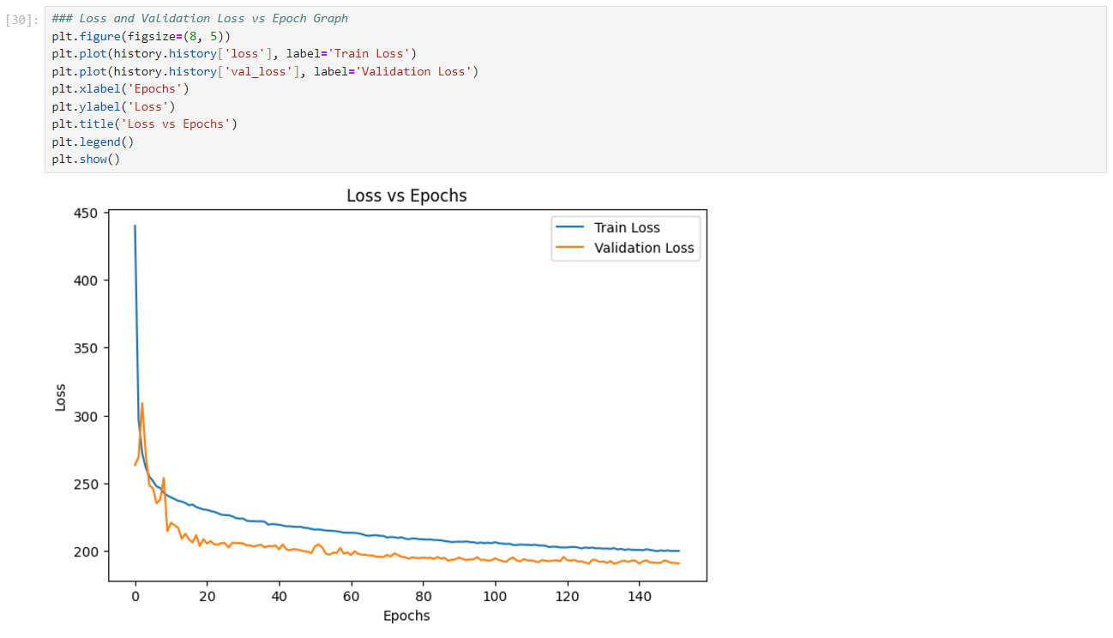

Model 16: ANN_Porter_New_03B_adam_HPT.ipynb
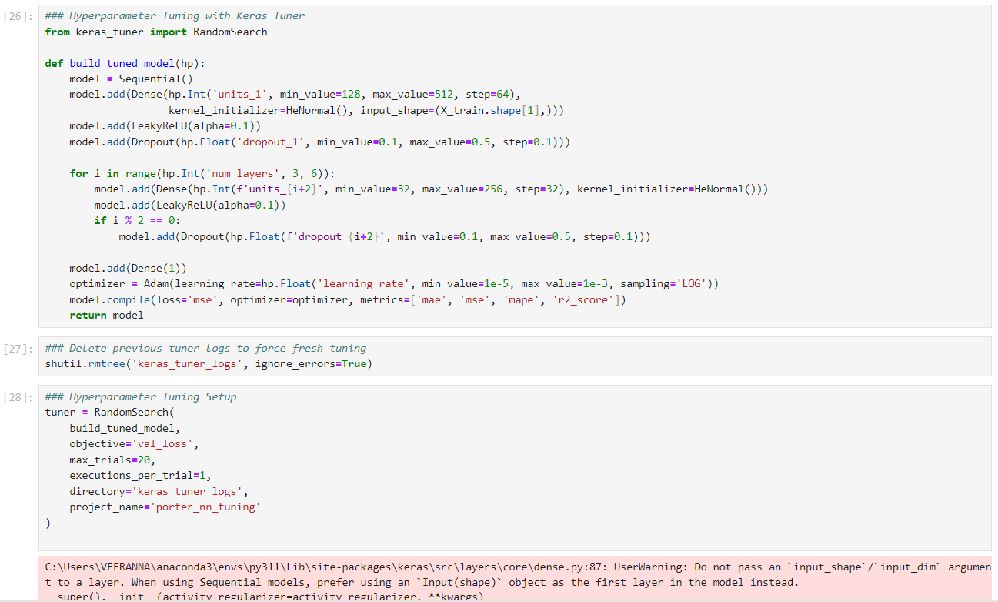

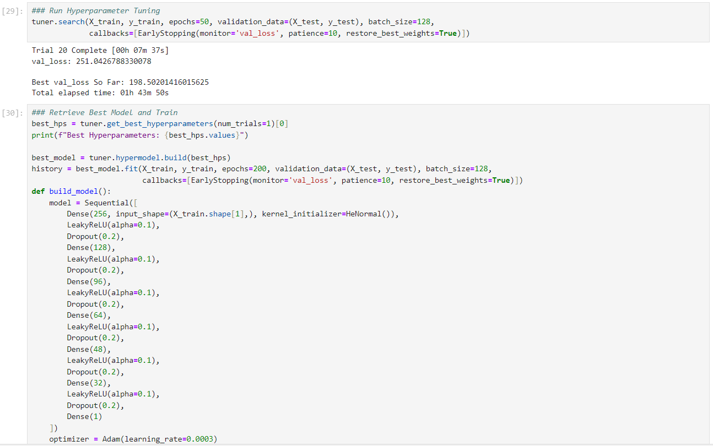

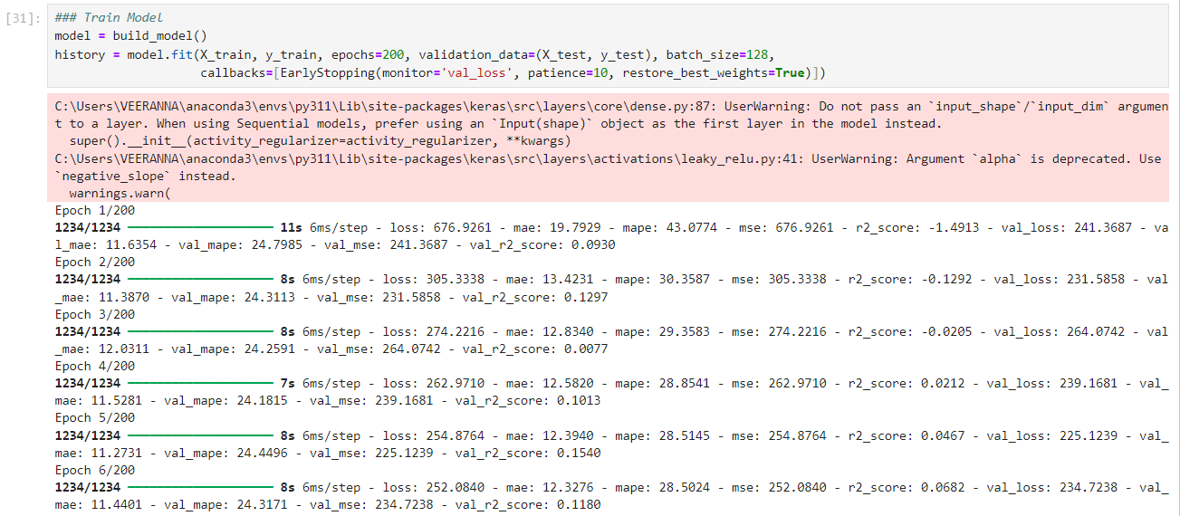

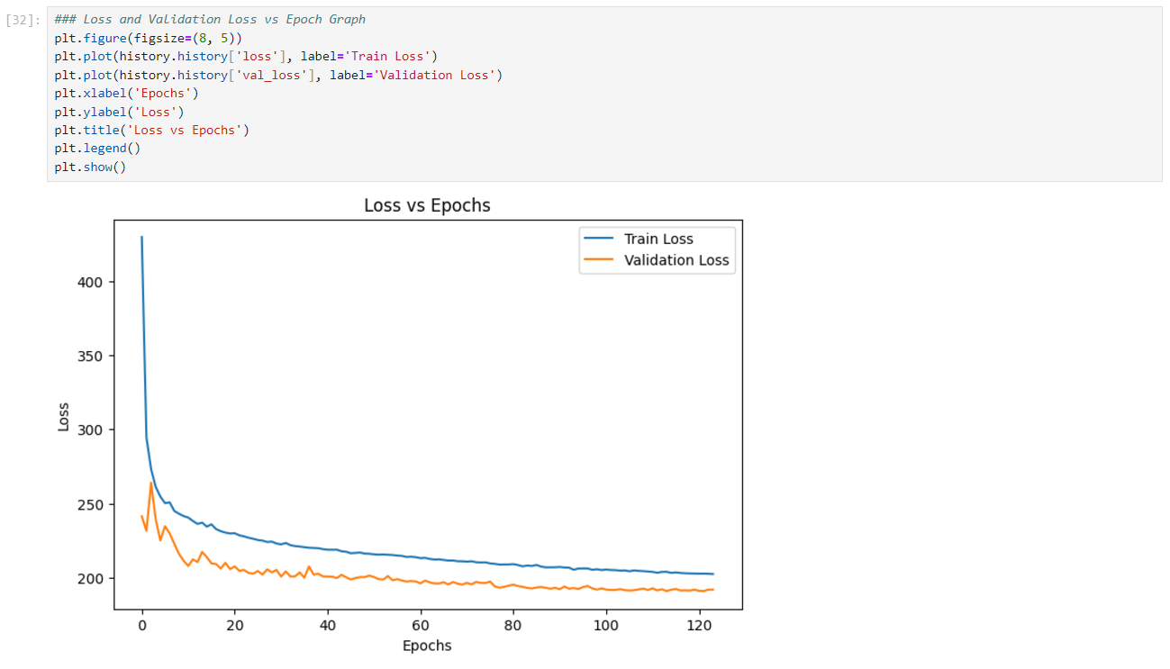

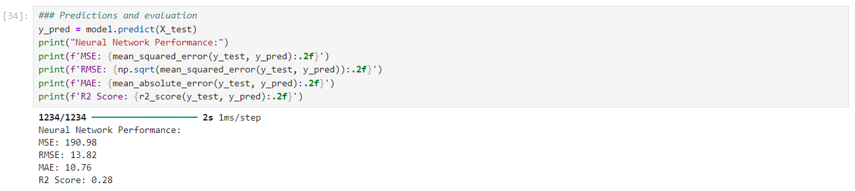

Model 17: ANN_Porter_poly_00_adam.ipynb
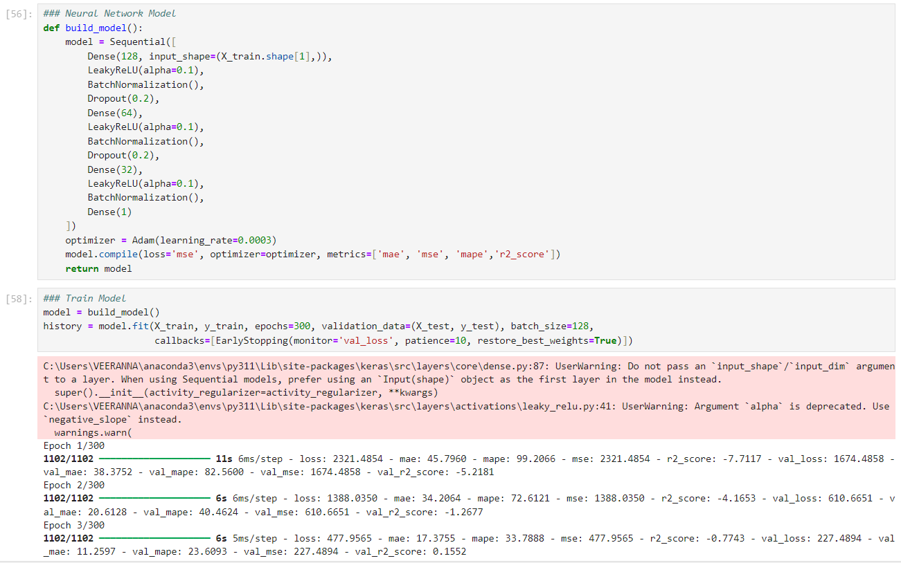

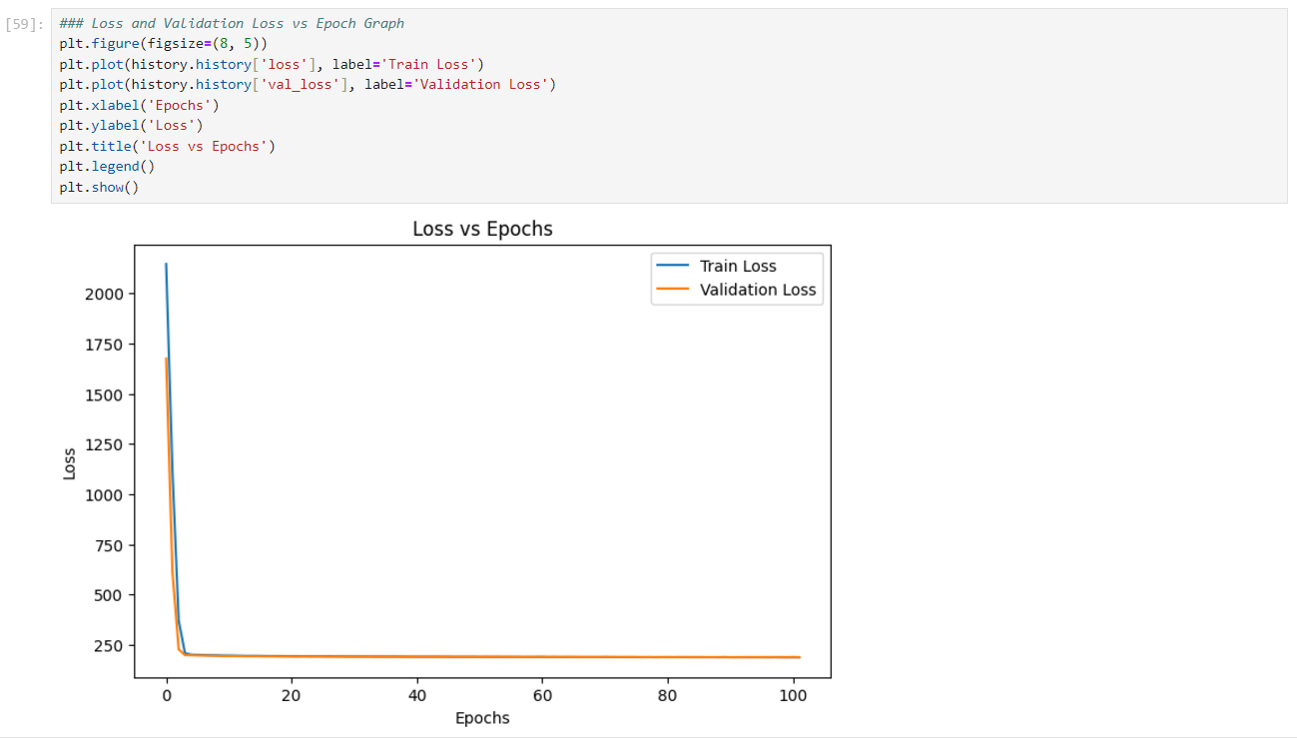

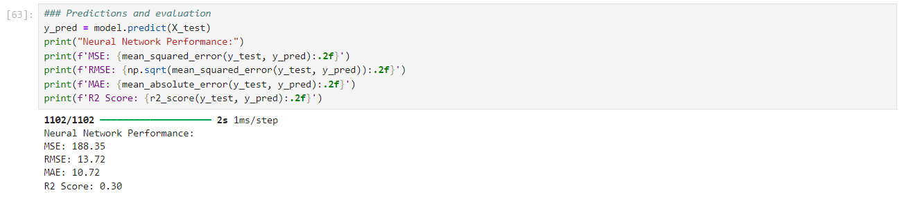

Model 18: ANN_Porter_poly_01_adam.ipynb
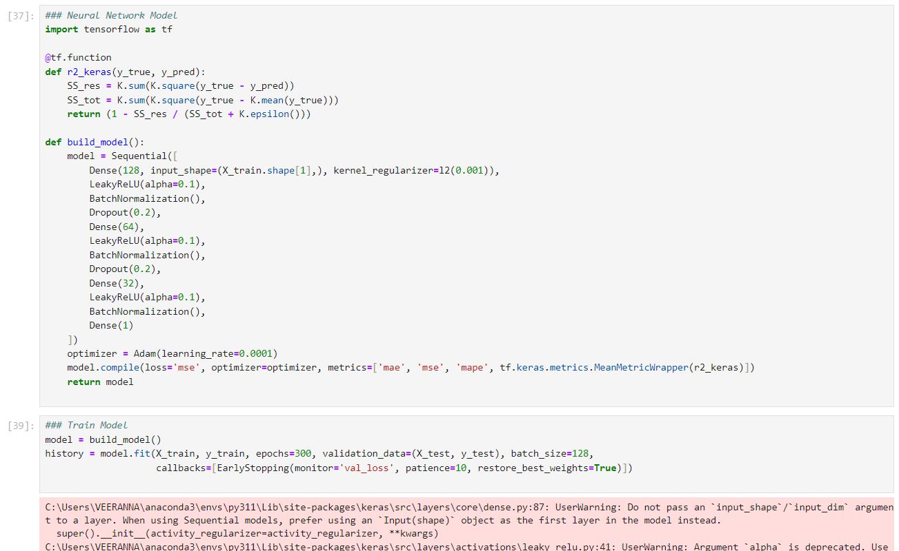

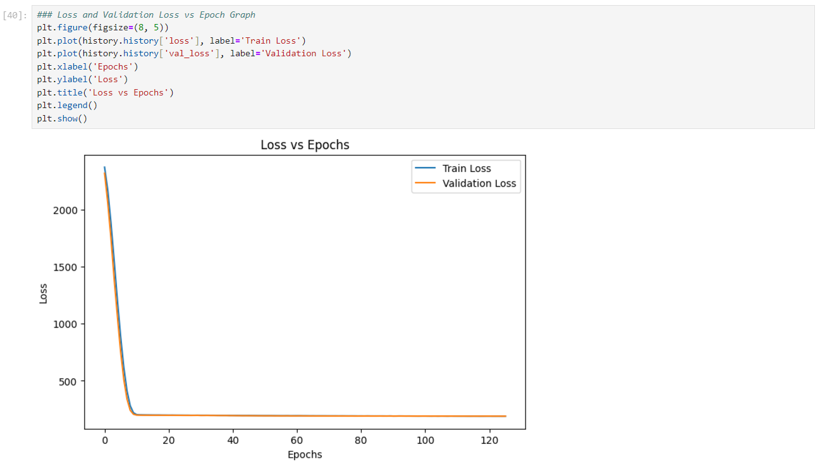

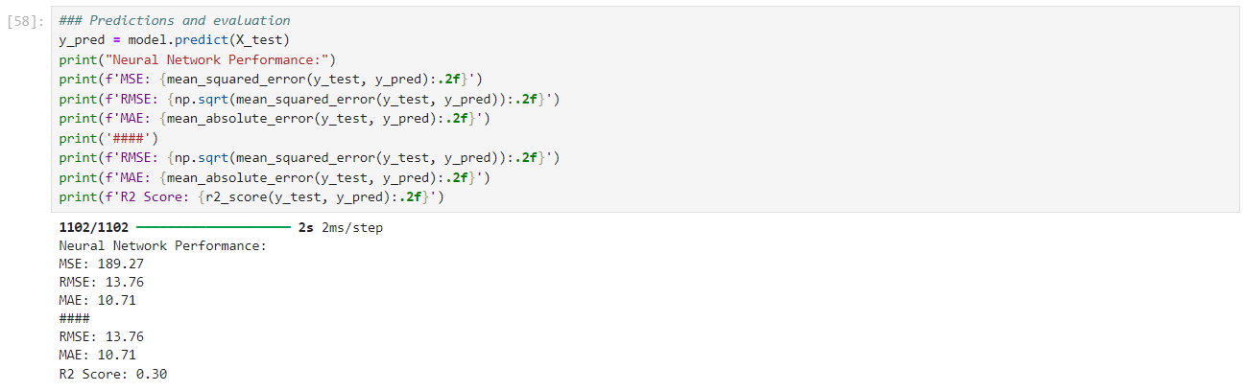

Model 19: ANN_Porter_poly_02_adam.ipynb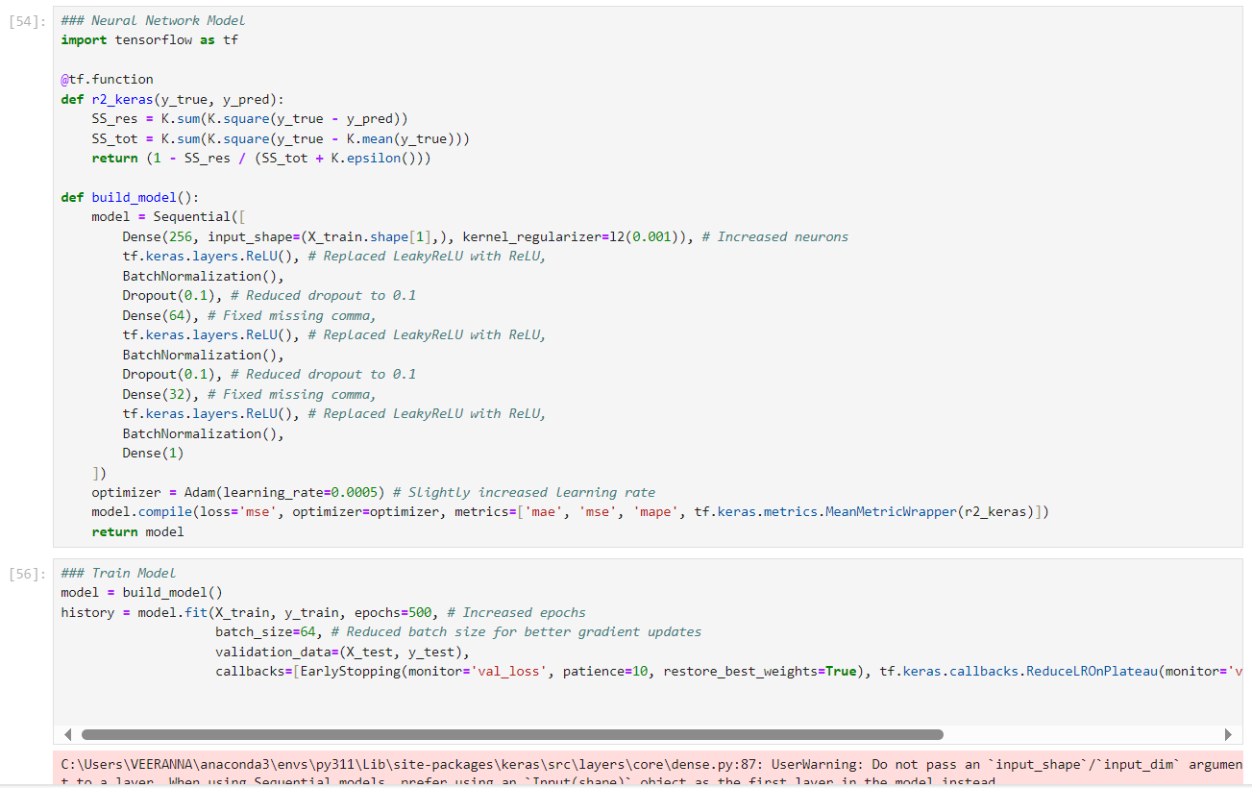

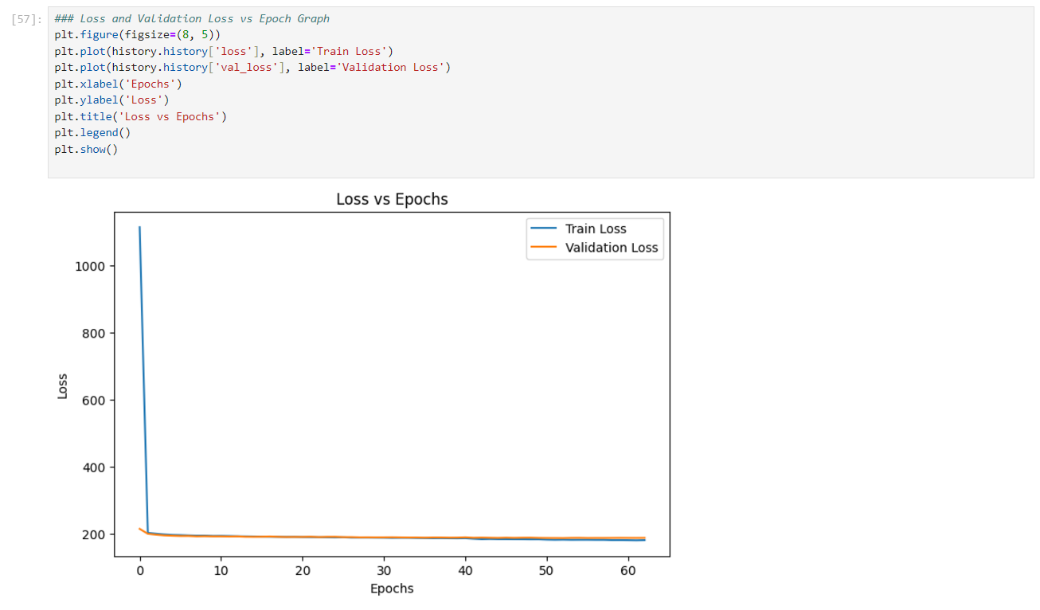

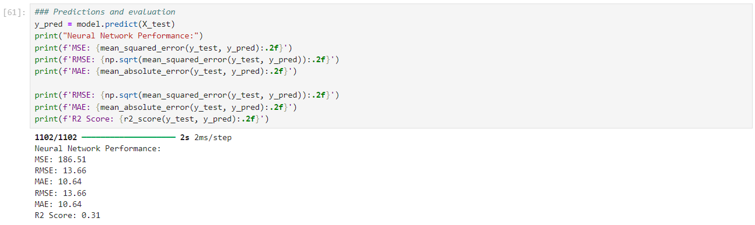

Model 20: ANN_Porter_poly_03_adam.ipynb
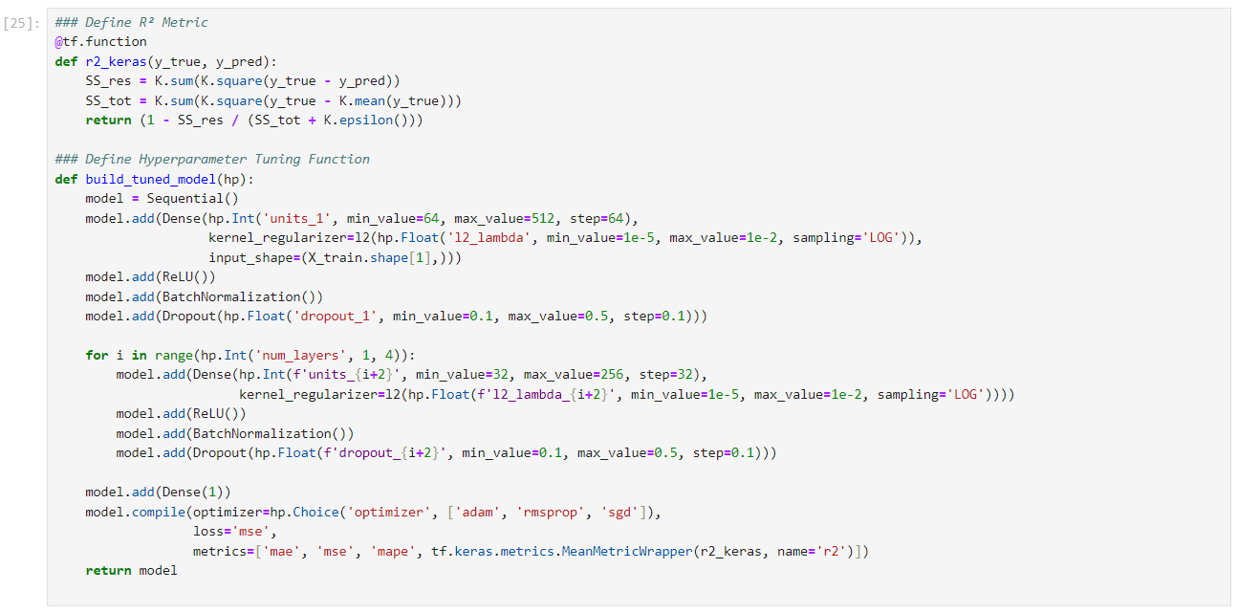

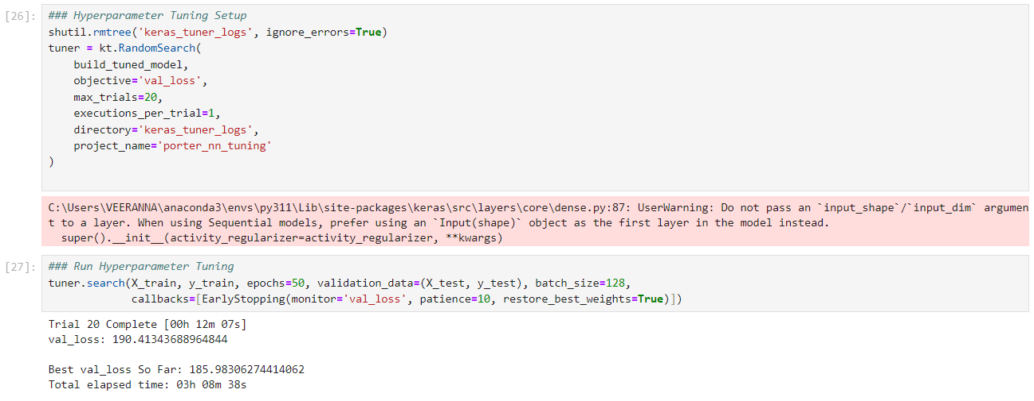

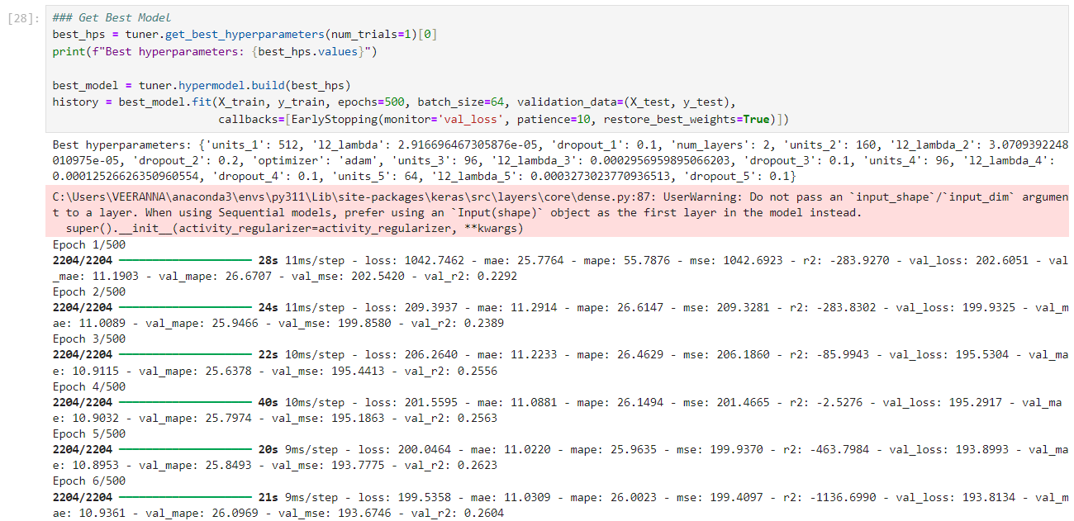

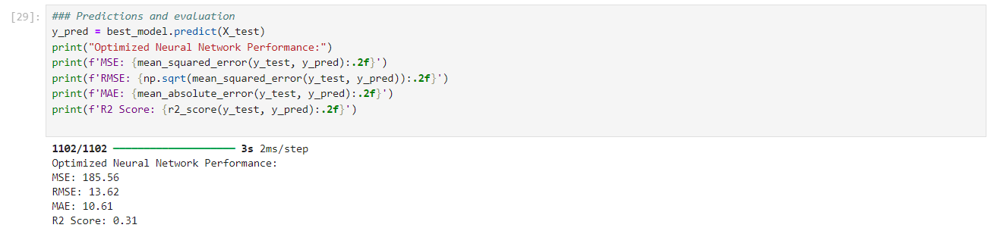

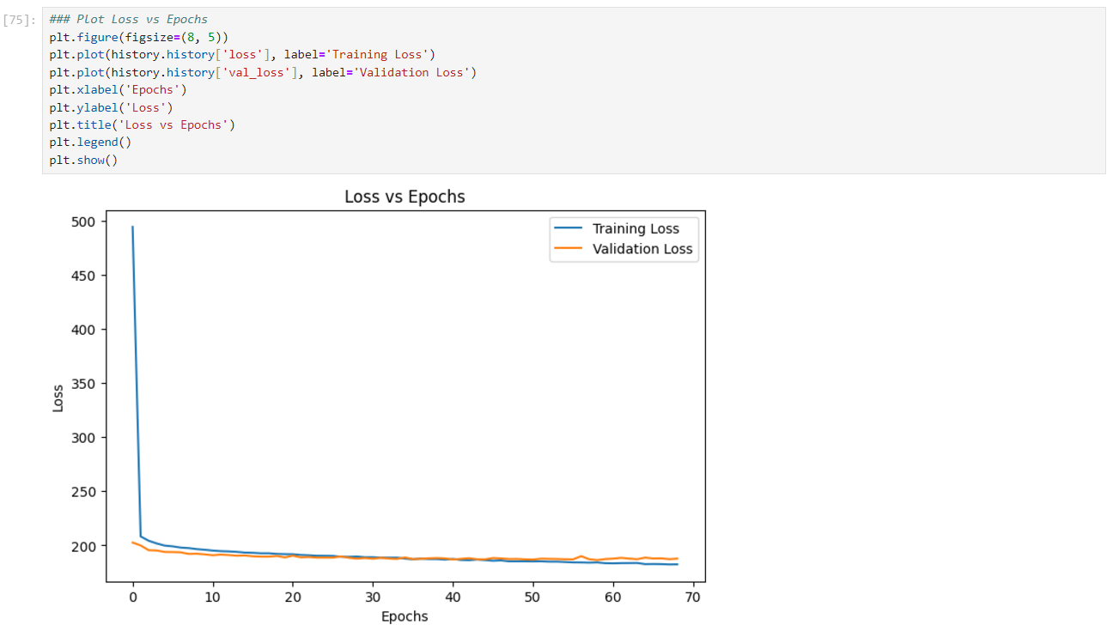

Model 21: ANN_Porter_poly_04_adam.ipynb
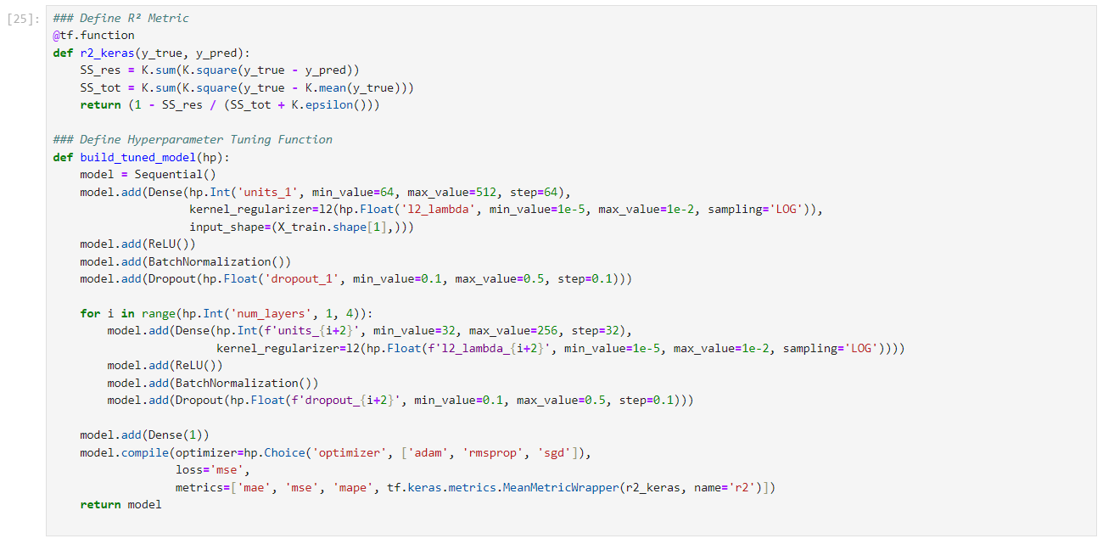

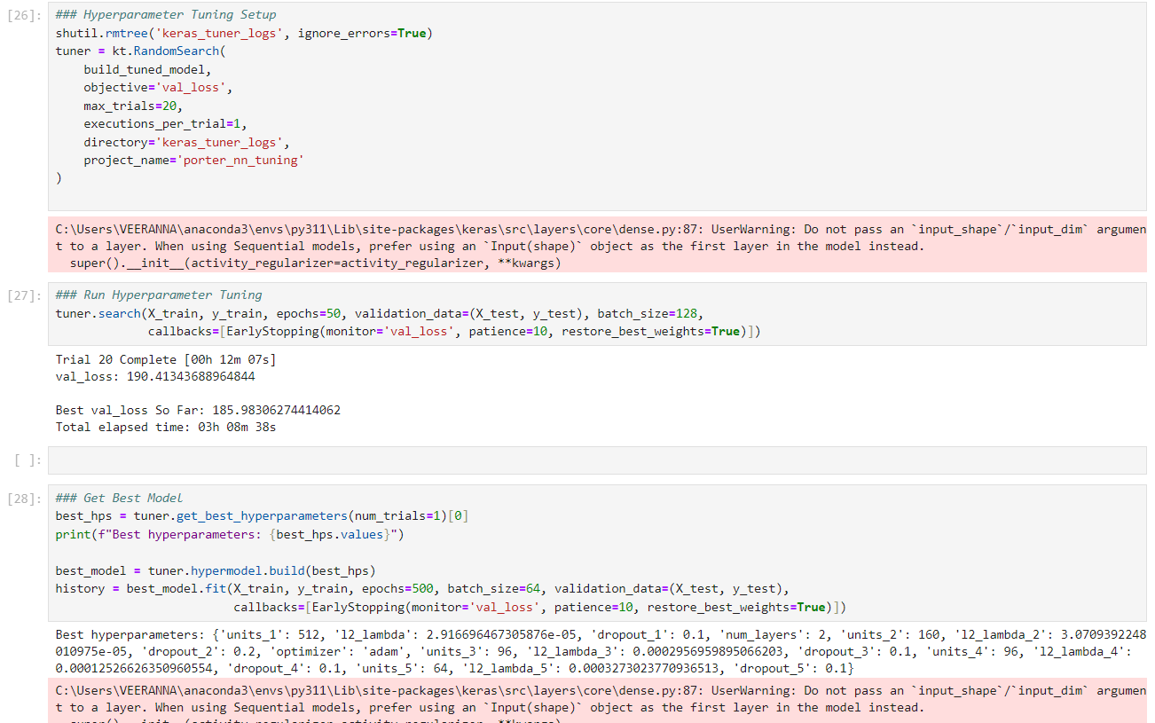

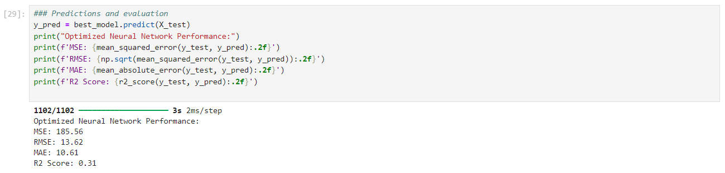
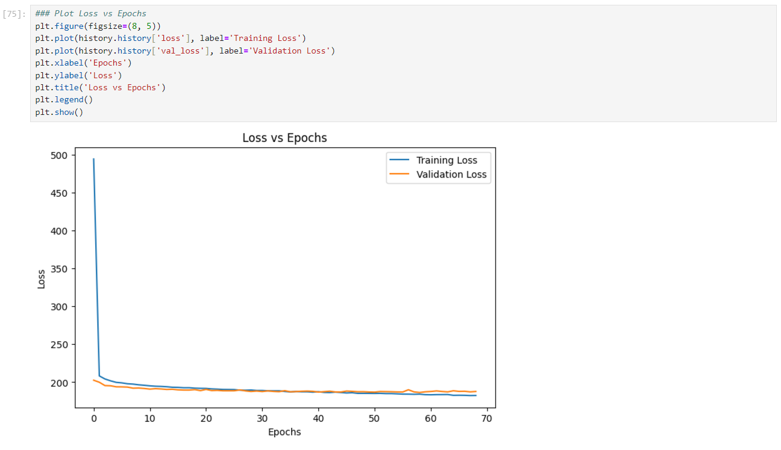

Model 22: ANN_Porter_poly_05_adam.ipynb
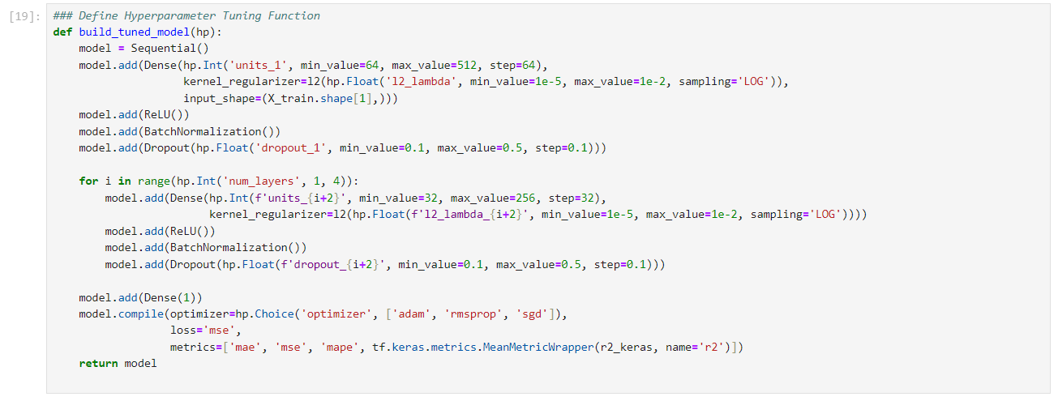

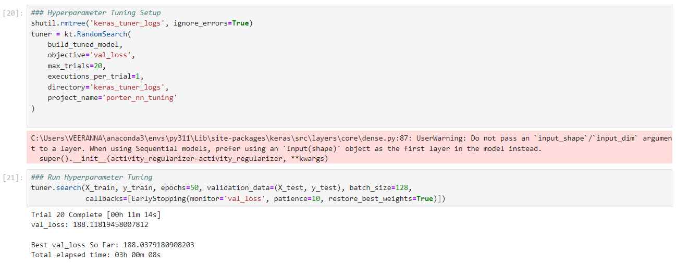

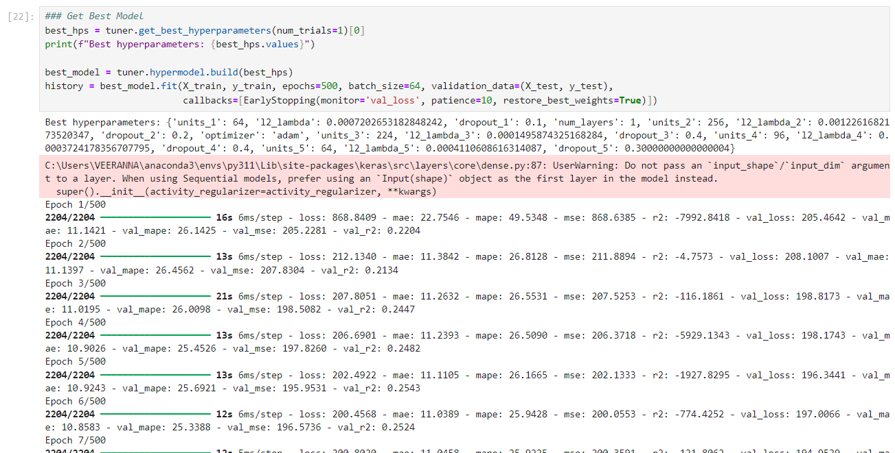

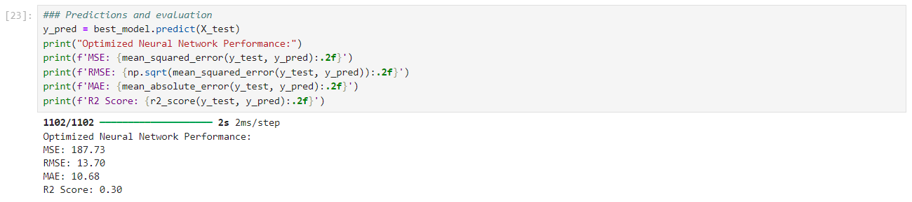

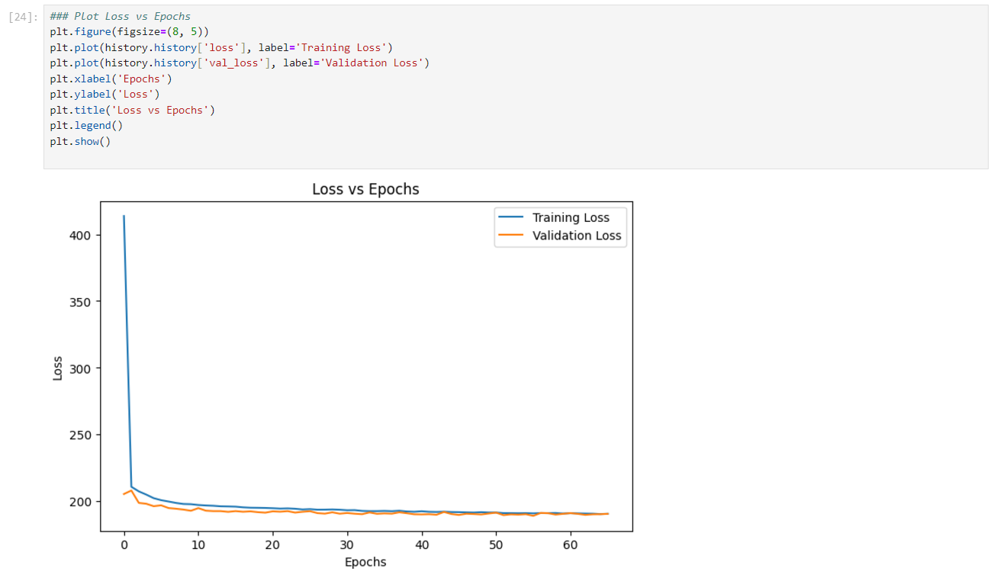

Model 23: ANN_Porter_poly_06_adam.ipynb
