AI2E Scenario Engine
Architecture & Data-Mechanism Specification
for the Ariba Integration Agent (AIA) Chrome Extension
Source: AI2E Tables.xlsx · Date: 2026-05-21 · Status: Architecture proposal
Selected modes: 1c (classify + generate) · 2b (template splice) · 3b (extended mutation) · 4d (unified source adapter)

1. Executive Summary
This document specifies the architecture for the AI2E (AI-to-Execute) Scenario Engine — an in-extension subsystem that ingests retrieved Purchase Orders, classifies them against a curated catalog of 35 cXML order scenarios, and synthesizes valid variant POs for testing buyer/supplier integrations on the SAP Business Network. The engine is grounded in five concrete data assets contained in AI2E Tables.xlsx and is wired into the existing AIA AI tab (Retrieval + Analyzer).
Selected operating modes (per stakeholder decision):
Decision | Selected | Implication
1. Analyzer scope | 1c — Classify retrieved POs AND use them as bases for generation | Engine has both a Detector and a Generator path; classification feeds coverage UI.
2. Incompatible-base handling | 2b — Splice missing structures from the golden cXML template | Generator falls back to template-driven synthesis when XPath-required elements are absent in the base.
3. Mutation surface | 3b — Extend CIG modifiable-fields beyond the original 14 | Original 14 fields kept as a "supplier-editable" subset; an extended set covers all 35 scenarios.
4. Source of retrieved POs | 4d — Unified Source Adapter (upload + REST API + DOM scrape) | A normalization layer presents a single CanonicalPO interface to the Detector and Generator.

2. AI2E Tables.xlsx — file inventory and role mapping
The Excel file is not a flat reference; it is a five-layer specification. Each sheet maps to either a static catalog (bundled JSON), a runtime data store (chrome.storage.local), or a structural reference (golden cXML template).
Layer | Sheets | Engine role | Persistence
Environment & connectivity | Landscape · Lists | Defines runtime endpoints, ANIDs, shared secrets, PII flag, and enums for status/result/purpose. | Runtime — chrome.storage.local (landscapes, lists)
Source PO inventory | Source Transaction · Source Transaction Scenario | Tracks retrieved cXML files and the scenarios identified within each (many-to-many). | Runtime — sourceTransactions, sourceTransactionScenarios
Test management hierarchy | Test Plan · Test Cycle · Test Cycle - Buyer ANID · Test Suite · Test Case · Test Run · Test Data Sample | Five-level test taxonomy (Plan → Cycle → Suite → Case → Run) plus the payload library. | Runtime — flattened JSON in chrome.storage.local; DDL preserved in Others sheet.
Scenario catalog | Test Scenarios | 35 PO scenarios across 5 dimensions, each with a machine-actionable XPath identifier. | Static — data/ai2e/scenarios.json (bundled)
Schema & mutation rules | cXML Order Sample · CIG Modifiable Fields · Fields | Golden cXML template (688 rows) + field-level mutation policy (random/auto/formula/list). | Static — data/ai2e/cxml-template.xml + modifiable-fields.json (bundled)

3. Scenario Catalog — 35 scenarios, 5 dimensions
The Test Scenarios sheet defines a fixed catalog of 35 PO variations. Each row carries an XPath-style predicate in the Unique Identifiers column. This predicate is the machine-readable contract: it works as both a Detector rule (does this PO already match scenario X?) and a Generator constraint (the variant must satisfy this XPath to count as scenario X).

3.1 Dimensional breakdown
Dimension | Count | Example scenarios
Header-Level Variations | 10 | Standard PO, Blanket PO, Change Order, Cancellation, Multi-Currency, Tax-Inclusive, Rush, Scheduled, Shipping Terms, BPO Release
Line-Level Variations | 8 | Single-Line, Multi-Line, Service Line, Catalog/Punch-Out, Free-Text, Subcontracting, Consignment, Configurable/BOM
Delivery & Distribution | 4 | Multi-Ship-To, Drop-Ship, Multi-Account Distribution, Partial Delivery
Financial & Pricing | 4 | Header Charges, Line Allowances, Limit PO, Zero-Value/Free Goods
Special Business Scenarios | 9 | Intercompany, Triangular, Return-to-Vendor, With Attachments, Quote/Contract Reference, Custom Extrinsics, Spot Buy, STO, Asset PO

3.2 Sample of XPath identifier rules (Detector contract)
ID | Scenario | XPath / Identifier
4 | Change Order | OrderRequestHeader/@type='update'
5 | PO Cancellation | OrderRequestHeader/@type='delete'
8 | Multi-Currency PO | Multiple distinct Money/@currency values across the document
11 | Single-Line Item PO | count(//ItemOut) = 1
12 | Multi-Line Item PO | count(//ItemOut) > 1
19 | Multi-Ship-To | Multiple ShipTo elements with different Address/@addressID
25 | Limit PO (Value-Based) | ItemOut/@quantity='1' AND Extrinsic[@name='LimitAmount']
26 | Zero-Value PO | ItemOut/ItemDetail/UnitPrice/Money = '0'
27 | Intercompany PO | OrderRequestHeader/Extrinsic[@name='IntercompanyIndicator']
30 | PO with Attachments | Presence of Attachment or Comments/Attachment with URL elements
A canonical XPath/JS evaluator (e.g. fontoxpath or wicked-good-xpath) loaded in the service worker is sufficient. No Java/XSLT runtime is needed.

4. Mutation Matrix — CIG Modifiable Fields (extended per Mode 3b)
The CIG Modifiable Fields sheet defines the legal mutation surface for the engine. The original sheet contains 14 fields with policy metadata (Editable, Creation, Type, Random Range, Auto Range). Per Mode 3b, this set is extended at runtime with scenario-required fields so that all 35 scenarios are addressable.

4.1 Original 14 fields (the supplier-editable subset)
Field | Level | Editable | Creation | Type / Range
Supplier Part ID | detail | Yes | Automatic | —
Item Unit Price | detail | Yes | Automatic | —
Item Unit of Measure | detail | Yes | Automatic | —
Item Quantity | detail | Yes | Automatic | —
Item Description | detail | Yes | Automatic | List
Item Requested Delivery Date | detail | Yes | Automatic | Formula: TODAY()
Buyer Part ID | detail | Yes | Automatic | —
Manufacture Part ID | detail | Yes | Automatic | —
Manufacture Name | detail | Yes | Automatic | —
OrderHeader Ship-To Address | header | Yes | Automatic | —
OrderHeader Bill-To Address | header | Yes | Automatic | —
Incoterm | header | No | Manual | —
orderID | header | Yes | Automatic | Random 1–10 · Auto 4500000001 → 4500001234 inc 1 (last 4500000003)
lineNumber | detail | Yes | — | —

4.2 Extension per Mode 3b — scenario-required fields
Roughly 20 of the 35 scenarios require mutating fields outside the original 14. The Planner needs access to a wider mutation policy to satisfy them. The proposed extension table below covers the gap. It is stored alongside the original in modifiable-fields.json under a separate "scenarioRequired" namespace so the original CIG-editable subset stays auditable.
Extended field | Level | Type | Used by scenario(s)
OrderRequestHeader/@type | header | list[new|update|delete] | 4 Change Order · 5 Cancellation
OrderRequestHeader/@agreementID | header | static | 2 Blanket PO · 3 BPO Release
MasterAgreementIDInfo/@agreementID | header | static | 3 BPO Release
Money/@currency | header/detail | list[USD|EUR|GBP|JPY|...] | 8 Multi-Currency
Tax / TaxDetail | header/detail | splice | 9 Tax-Inclusive
ShippingTerm / TransportInformation | header | splice | 10 Shipping Terms
Extrinsic[@name=Priority] | header | list[Urgent|Rush|Normal] | 7 Rush/Urgent
Classification[@domain=UNSPSC] | detail | list | 13 Service Line
ItemOut/@itemClassification | detail | list[PunchoutItem|custom] | 14 Catalog · 15 Free-Text
ItemDetail/ComponentGroup | detail | splice | 16 Subcontracting · 18 BOM
Extrinsic[@name=ConsignmentIndicator] | detail | static | 17 Consignment
Multiple ShipTo blocks | detail | splice | 19 Multi-Ship-To · 20 Drop-Ship
Distribution / Accounting | detail | splice | 21 Multi-Account Distribution
ShipControl/@allowPartialShipment | header | list[yes|no] | 22 Partial Delivery
Modifications (header & line) | both | splice | 23 Header Charges · 24 Line Allowances
Extrinsic[@name=LimitAmount] | detail | random | 25 Limit PO
UnitPrice/Money = 0 | detail | static | 26 Zero-Value
Extrinsic[@name=IntercompanyIndicator] | header | static | 27 Intercompany
Attachment / Comments/Attachment | both | splice | 30 With Attachments
DocumentReference (Quote/Contract) | header | splice | 31 Quote Reference
Extrinsic[@name=StockTransportOrder] | header | static | 34 STO
ItemDetail/AssetInfo | detail | splice | 35 Asset PO

5. System architecture
The engine spans five layers. The diagram below shows source ingestion (top), static catalogs (middle left), the Detect → Plan → Generate → Validate pipeline (centre), test management (bottom), and the AIA extension surface (foot).
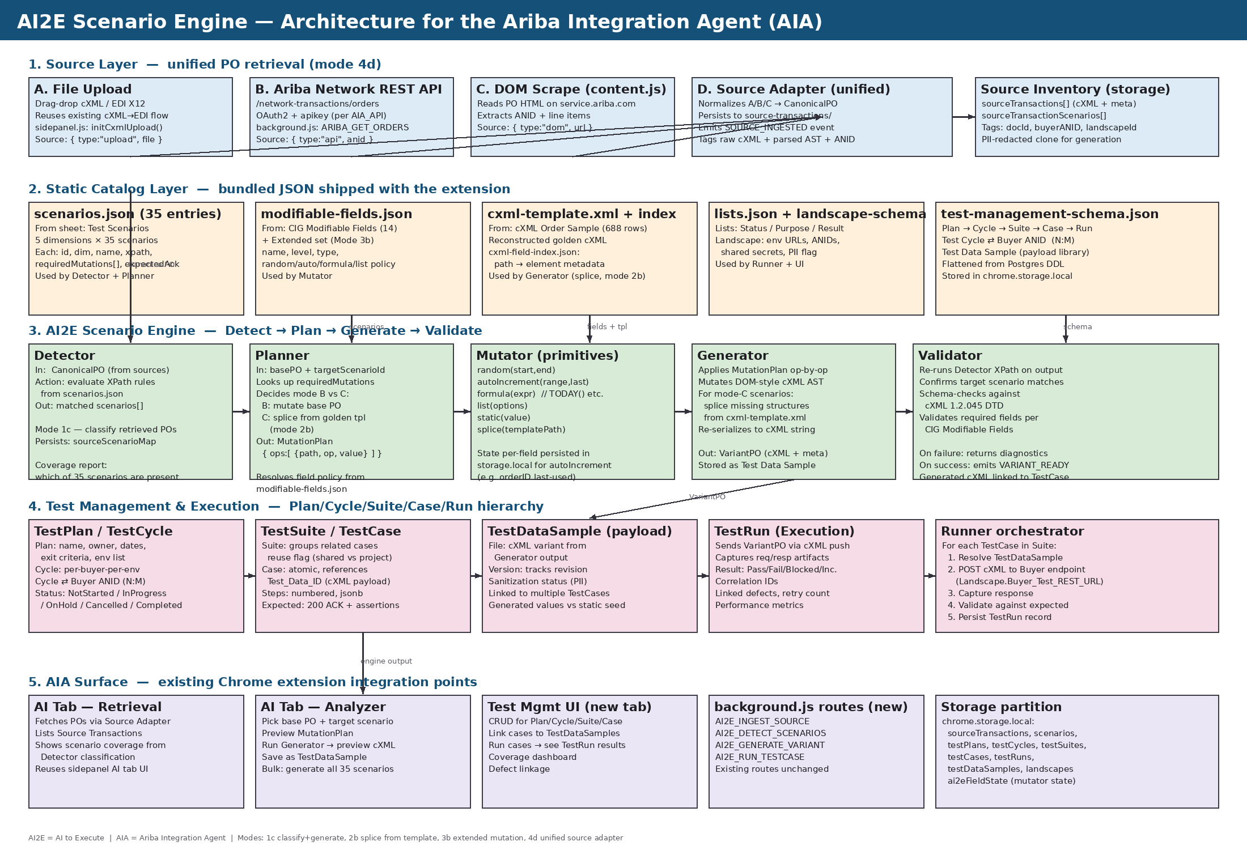
Figure 1 — AI2E Scenario Engine, full system architecture (rotate page or view full-screen for detail).

6. Scenario generation sequence (data flow)
The sequence diagram below traces a single end-to-end generation call. Steps 3, 5, and 9 are storage write points; the remainder are in-memory transitions inside the service worker.
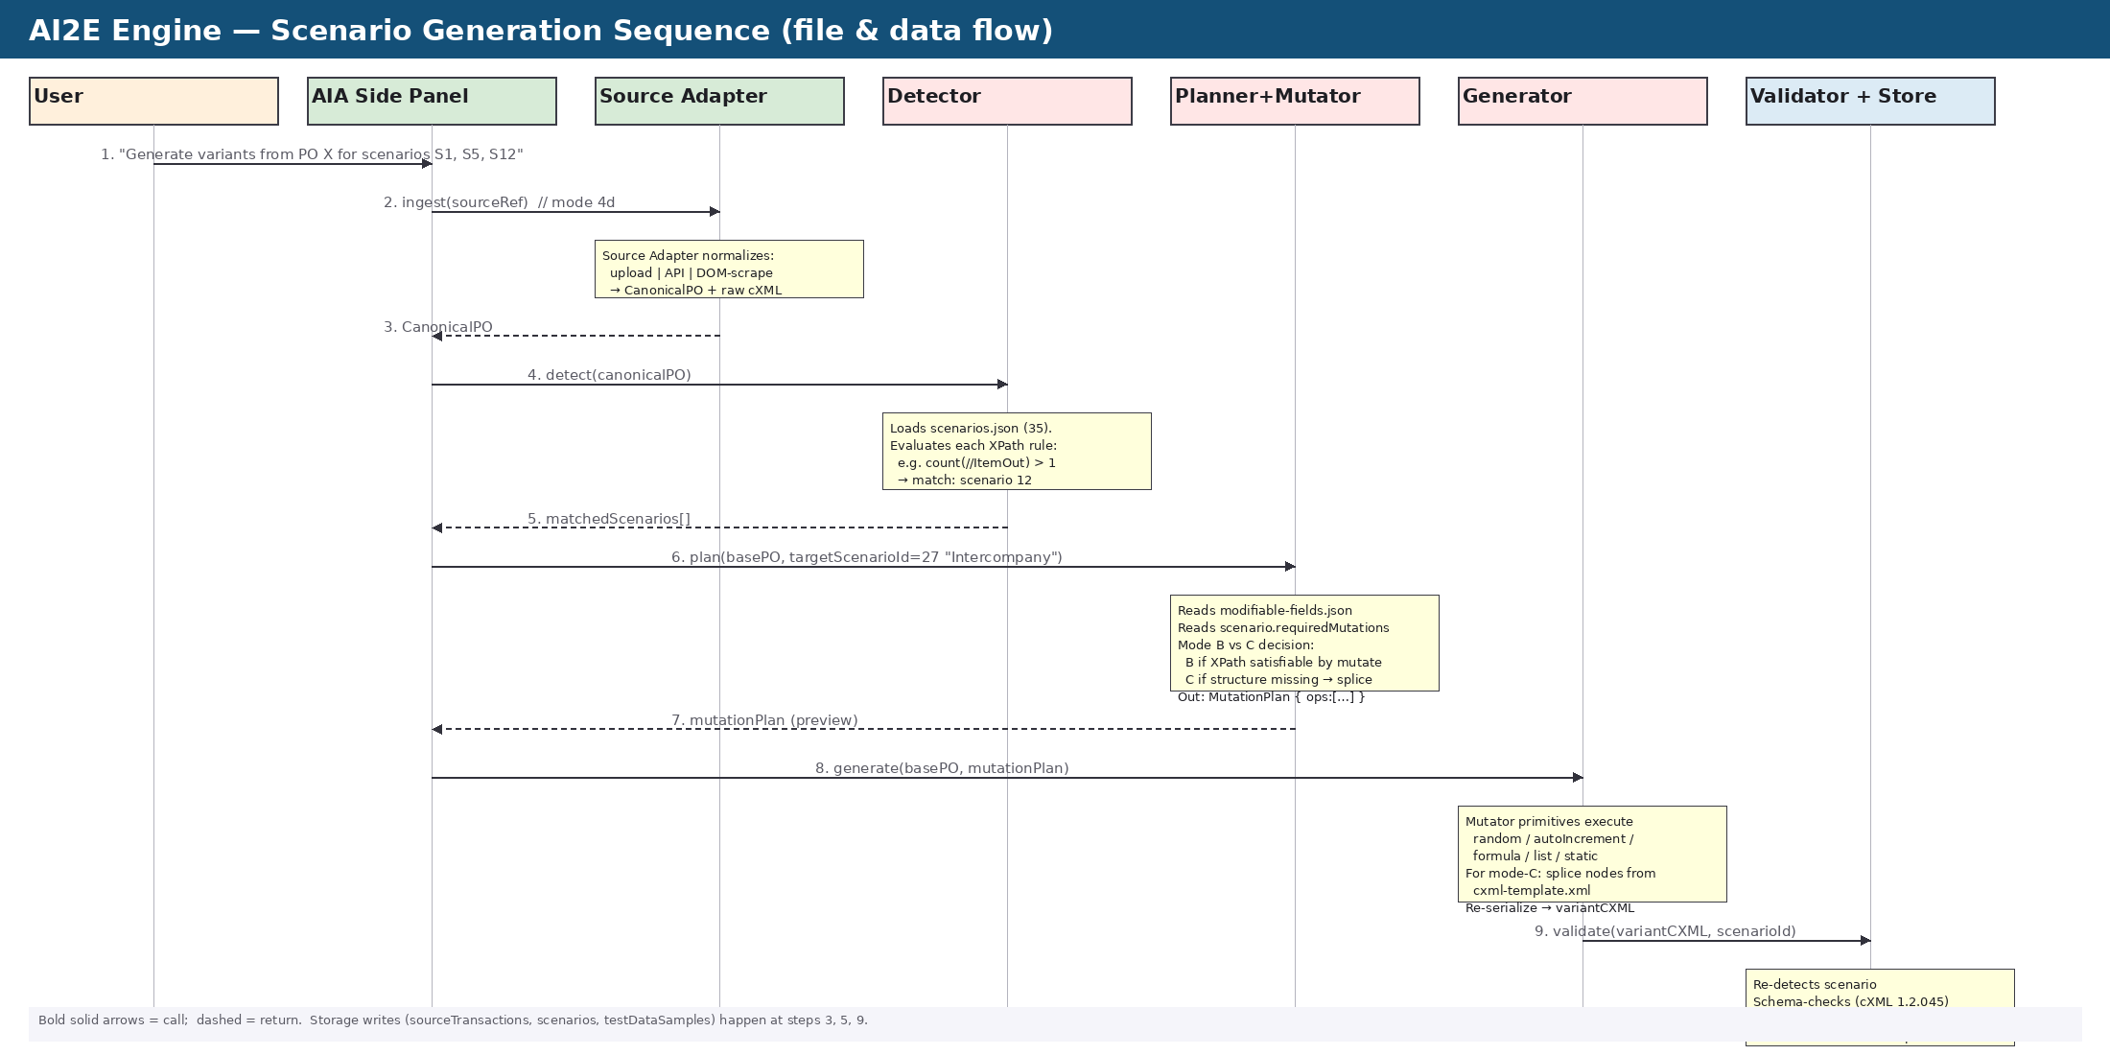
Figure 2 — Detect → Plan → Generate → Validate sequence with file/data hand-offs.

7. File layout — what ships and what lives at runtime
Static catalogs (built from the Excel) ship inside the extension under data/ai2e/. Runtime entities (sources, plans, runs) are stored in chrome.storage.local using a documented partitioning scheme.

7.1 Static catalog files (bundled)
File | Built from Excel sheet | Used by | Why static
data/ai2e/scenarios.json | Test Scenarios (35 rows) | Detector, Planner, Validator | Catalog evolves with cXML standard; versioned with the extension.
data/ai2e/modifiable-fields.json | CIG Modifiable Fields + extended (Mode 3b) | Mutator, Planner | Mutation policy is part of the engine contract; not user-editable.
data/ai2e/cxml-template.xml | cXML Order Sample (688 rows reconstructed) | Generator (Mode 2b splice), Validator | Golden template; canonical structural reference.
data/ai2e/cxml-field-index.json | Derived from cXML Order Sample | Field-path picker, Validator | Provides element/attribute metadata indexed by XPath.
data/ai2e/lists.json | Lists sheet (Status / Purpose / Result enums) | UI dropdowns, Runner result coding | Closed enums; identical across deployments.
data/ai2e/landscape-schema.json | Landscape sheet field definitions | Landscape CRUD UI, Runner endpoint resolution | Schema only; instances are runtime data.

7.2 Runtime entities (chrome.storage.local)
Runtime data uses a flattened JSON model derived from the Postgres DDL in the Others sheet. Each top-level key is a collection.
Storage key | Schema source | Contents
landscapes | Landscape sheet | Per-environment endpoint config (Buyer_Test_REST_URL, ANIDs, secrets, PII flag)
sourceTransactions | Source Transaction sheet | Retrieved POs (raw cXML + parsed canonical AST + provenance: upload/api/dom)
sourceTransactionScenarios | Source Transaction Scenario sheet | N:M map of source PO → matched scenario IDs (output of Detector)
testPlans | Test Plan sheet | Plan records with exit criteria, environments, owner
testCycles | Test Cycle sheet | Cycle records linked to a Plan and a Landscape
testCycleBuyerANIDs | Test Cycle - Buyer ANID sheet | N:M binding between cycles and buyers
testSuites | Test Suite sheet | Grouping of cases with reuse flag, criticality
testCases | Test Case sheet | Atomic cases with steps, expected result, Test_Data_ID, schema version
testRuns | Test Run sheet | Execution instances with artifacts, result, defects, correlation IDs
testDataSamples | Test Data Sample sheet | Variant cXML payloads emitted by the Generator; versioned and PII-tagged
ai2eFieldState | CIG Modifiable Fields (auto-range) | Per-field auto-increment counters (e.g. orderID last-used) for deterministic generation

8. Engine interfaces (extension message routes)
The engine exposes a small set of new message types on the existing chrome.runtime message bus. No existing AIA route is altered; the AI tab and the new Test Management UI consume these routes.
Message type | Payload | Returns | Persists
AI2E_INGEST_SOURCE | { type: upload|api|dom, ref } | CanonicalPO + sourceId | sourceTransactions
AI2E_DETECT_SCENARIOS | { sourceId | inlineCxml } | matchedScenarios[] | sourceTransactionScenarios
AI2E_PLAN_VARIANT | { baseSourceId, targetScenarioId } | MutationPlan { ops:[…], mode: B|C } | — (preview only)
AI2E_GENERATE_VARIANT | { baseSourceId, targetScenarioId | mutationPlan } | VariantPO { cxml, testDataId } | testDataSamples · ai2eFieldState
AI2E_BULK_GENERATE | { baseSourceId, scenarioIds[] } | Array of VariantPOs | testDataSamples
AI2E_RUN_TESTCASE | { testCaseId } | TestRun { id, result, artifacts } | testRuns
AI2E_COVERAGE_REPORT | { landscapeId? } | Per-scenario count + presence map | —

9. Engine pipeline — operational logic

9.1 Detector (classification — Mode 1c)
Iterates the 35 scenarios. For each, runs the XPath identifier against the parsed CanonicalPO. A PO can match multiple scenarios simultaneously (e.g. a Multi-Line Multi-Currency Tax-Inclusive PO matches scenarios 12, 8 and 9). Output is persisted to sourceTransactionScenarios and feeds a coverage dashboard ("which of the 35 do we encounter in real traffic?").

9.2 Planner (Mode B vs Mode C decision)
- Resolves the target scenario's requiredMutations from scenarios.json.
- For each required mutation, looks up policy in modifiable-fields.json (original 14 + extended set).
- If every required mutation can be applied to the base PO without inserting new elements → Mode B (mutate-in-place).
- If any required mutation needs an element that does not exist in the base PO → Mode C (splice from cxml-template.xml).
- Emits a MutationPlan: an ordered list of operations { xpath, op: set|insert|delete|splice, value | sourcePath }.

9.3 Generator + Mutator (variant synthesis)
- Parses base cXML to a DOM AST (browser DOMParser is available in service worker via service-worker-friendly polyfill).
- Applies each MutationPlan op sequentially. Mutator primitives:
- random(start, end) — uniform integer/float in range.
- autoIncrement(range, last) — reads/writes ai2eFieldState; deterministic per-extension session.
- formula(expr) — safe-evals TODAY(), NOW(), UUID(), CURRENCY_CODE().
- list(options) — sample from controlled vocabulary.
- static(value) — fixed override.
- splice(templatePath) — copies a subtree from cxml-template.xml at the given path into the variant.
- Re-serializes via XMLSerializer; preserves attribute order via a deterministic walker.

9.4 Validator (post-generation gate)
- Re-runs the Detector on the generated variant to confirm the target scenario's XPath matches.
- Schema-checks against cXML 1.2.045 DTD (bundled).
- Verifies CIG-editable fields stayed within the supplier-modifiable subset where Mode 3b applies.
- On success, emits VARIANT_READY and the variant is registered as a TestDataSample.
- On failure, returns structured diagnostics (missing element, schema violation, XPath miss) so the UI can show the gap and the user can re-plan.

10. PII, versioning, and idempotency
The Landscape sheet defaults PII to Yes. Retrieved POs typically contain real BillTo / ShipTo names, addresses, and contact details. The engine applies a redaction pass on ingest before persisting any CanonicalPO that the Generator may copy from. Redaction targets:
- BillTo/ShipTo PostalAddress/Name → token "ACME-001" with deterministic hash for traceability.
- Email/Phone elements → masked with realm-correct synthetic values.
- Comments / Description fields scanned for free-text PII patterns (regex on email, phone, SSN-style).
- orderID and supplier part IDs preserved (they are business identifiers, not PII).
cXML version is pinned per scenario (default 1.2.045 from the latest annotated version in the golden template). The engine refuses to splice between mismatched versions; instead it reports a version gap to the UI so the user can pick a same-version base.
Idempotency: every Generator call is keyed on (baseSourceId, targetScenarioId, mutationPlanHash). Identical inputs return the same TestDataSample id, preventing accidental duplicates in the payload library.

11. Scenario → file → mutation traceability matrix
This matrix shows, for a representative subset of the 35 scenarios, which static file supplies the rule, which fields the Mutator touches, and whether Mode B (mutate) or Mode C (splice) is used.
ID | Scenario | Detector source | Mutator fields | Mode
1 | Standard PO | scenarios.json #1 | orderID, line items | B
4 | Change Order | scenarios.json #4 | OrderRequestHeader/@type=update | B
5 | PO Cancellation | scenarios.json #5 | OrderRequestHeader/@type=delete | B
8 | Multi-Currency PO | scenarios.json #8 | Money/@currency (multiple values) | B
9 | Tax-Inclusive PO | scenarios.json #9 | Tax / TaxDetail subtree | C (splice from template)
12 | Multi-Line PO | scenarios.json #12 | ItemOut count > 1; lineNumber auto-inc | B (often) / C (if base has 1 line)
16 | Subcontracting PO | scenarios.json #16 | ComponentGroup | C (splice)
19 | Multi-Ship-To | scenarios.json #19 | ShipTo with distinct addressIDs | C (splice)
25 | Limit PO | scenarios.json #25 | Extrinsic[LimitAmount], quantity=1 | B
26 | Zero-Value PO | scenarios.json #26 | UnitPrice/Money = 0 | B
27 | Intercompany | scenarios.json #27 | Extrinsic[IntercompanyIndicator] | B
30 | PO with Attachments | scenarios.json #30 | Attachment / Comments/Attachment | C (splice)
34 | STO | scenarios.json #34 | Extrinsic[StockTransportOrder] | B
35 | Asset PO | scenarios.json #35 | ItemDetail/AssetInfo | C (splice)

12. AIA extension — concrete integration points
The engine plugs into the existing AIA Chrome extension without disturbing current functionality. Five concrete touchpoints are required:
Existing component | Change required | Reason
manifest.json | Add bundled assets path (data/ai2e/*) and host permissions for the buyer test endpoints if Runner pushes outside service.ariba.com. | Static catalogs must be packaged; cross-origin pushes need host_permissions.
background.js | Register the seven AI2E_* message routes from §8. Bootstrap loads scenarios.json, modifiable-fields.json, lists.json into a memory cache. | All cross-origin work goes through the service worker; existing pattern.
content.js | Add DOM-scrape branch for SourceAdapter mode 4d-C (read PO views on service.ariba.com). | Aligns with existing context detection cascade.
sidepanel.html / sidepanel.js — AI Tab | Add Retrieval pane (list source POs, classification badges) and Analyzer pane (scenario picker, plan preview, generate button, diff view). | This is the user-facing surface for the engine.
data/schema.js | Extend storage schema to include the runtime collections from §7.2. | Existing migration logic handles version bumps cleanly.

13. Risks, constraints, and open items
Item | Type | Mitigation / next step
Service-worker XPath evaluator | Tech | Service workers lack a built-in XPath engine. Bundle fontoxpath (≈250KB) or wicked-good-xpath; verify MV3 size budget.
cXML 1.2.045 vs 1.2.060 drift | Schema | Golden template has both annotations. Pin to 1.2.045 (latest comment date); add a per-scenario version field if buyers diverge.
Auto-increment determinism across reloads | Data | ai2eFieldState persists last-used counters. Guard with chrome.storage.session for ephemeral test runs vs chrome.storage.local for persistent.
Mode 3b extension authority | Governance | Original 14 fields are the "supplier-editable" contract. Extended fields are "test-only" — must be excluded from any production push to live buyer endpoints.
PII redaction false-negatives | Compliance | Combine field-targeted masking with an LLM-pass review before persisting; flag suspicious free-text for manual review.
Buyer-specific overrides | Modeling | Several rows in CIG Modifiable Fields are tagged "Buyer specific". Add per-buyer override layer keyed by Buyer ANID, falling back to global default.
Push to live buyer endpoint from a Chrome extension | Operational | cXML push from a service worker requires host_permissions and shared-secret handling. Use chrome.storage.session for secrets; never persist in local.

14. Recommended build order
Phase | Deliverable | Validation
1. Catalog bake | Convert Excel sheets to scenarios.json, modifiable-fields.json, cxml-template.xml. Bundle in data/ai2e/. | JSON validates against a Zod schema; all 35 XPath rules parse.
2. Detector | Implement XPath evaluator + classify route. Wire AI Tab Retrieval list. | Run against the cXML Order Sample template — expect to match scenario 1 (Standard PO) and others by construction.
3. Source Adapter | Unified ingest for upload + API + DOM (mode 4d). PII redaction. | Round-trip a real retrieved PO through ingest → store → re-fetch → match original hash post-redaction.
4. Planner+Mutator | Implement primitives + Mode B logic. modifiable-fields.json driven. | Generate scenario 4 (Change Order) and scenario 26 (Zero-Value) from the template; Validator confirms.
5. Generator (Mode C) | Add splice from cxml-template.xml. | Generate scenarios 9, 16, 19, 30, 35 (all template-splice cases).
6. Test Mgmt UI | CRUD over Plans/Cycles/Suites/Cases. Link to TestDataSamples. | Create a sample plan, attach 5 test cases, verify round-trip.
7. Runner | Execute test cases against a buyer test endpoint; record TestRuns. | Run scenario 1 against a sandbox buyer; capture 200 ACK; persist artifacts.
8. Coverage UI | Dashboard: which of the 35 scenarios are present in real PO traffic; gaps; trends. | Coverage report aligns with manual classification.

Appendix A. Glossary
Term | Meaning
AI2E | AI-to-Execute — the scenario engine subsystem inside the AIA extension.
AIA | Ariba Integration Agent — the Chrome MV3 extension under build.
ANID | Ariba Network ID, e.g. AN01234567890 — identifies a buyer or supplier on the SBN.
CanonicalPO | The normalized in-memory representation of a retrieved PO (raw cXML + parsed AST + provenance).
cXML | Commerce XML — the SBN document standard. Golden template is version 1.2.045.
Detector | Engine component that classifies a CanonicalPO against the 35 scenarios using XPath rules.
EOR | Electronic Order Routing — the supplier-side AN setting that controls how POs are delivered (Email / Online / cXML).
Generator | Engine component that produces a variant cXML from a base PO + MutationPlan.
Golden template | cXML Order Sample (688 rows) — the most permissive, fully-annotated cXML reference.
Landscape | A row in the Landscape sheet — a named environment with its endpoints, ANIDs, and secrets.
Mode B | Mutation in place: apply mutations to the base PO without inserting new structures.
Mode C | Splice from template: copy missing structures from the golden template into the base PO.
MutationPlan | Ordered list of mutation operations the Generator will apply.
SBN | SAP Business Network — successor name for the Ariba Network.
TestDataSample | A versioned cXML payload, typically the output of a Generator call, referenced by one or more TestCases.
TestRun | A single execution instance of a TestCase against a Landscape; carries result and artifacts.

