Workforce Planning Agent
Approach · Architecture · Evaluation
SAP Business Technology Platform (SaaS) | UI5 Web Components | SAP AI Core | SuccessFactors Employee Central

1. Problem Framing
"Given our business strategy, financial plan, and workforce reality — what specific workforce actions should we take, for which people, in which roles, over the next three years?"

Today, workforce planning in most enterprises is a reporting exercise — organizations produce headcount targets and budgets, but these do not translate into actionable decisions for leaders. SAP SuccessFactors Employee Central (EC) already holds the workforce data: employee profiles, skills, performance ratings, organizational hierarchy, and compensation. The missing piece is not data — it is a system that converts strategic intent into specific, costed, per-role actions.
This agent solves one focused problem: given a natural-language strategic scenario (e.g., 'Double AI/ML capacity while reducing back-office operations by 20% over 3 years'), it returns a prioritized workforce action plan using the Build, Buy, Redeploy, Automate (BBRA) framework — an industry-standard decision model validated by KPMG, McKinsey, and INOP (2025–26).

The BBRA Decision Framework
Action | What It Means | When to Use | Typical Cost
Build (Reskill) | Train existing employees in new capabilities | Strategic skill needed, time available, adjacent skills exist | ~20–30% of external hire cost
Buy (Hire) | Recruit external talent with required skill | Skill scarce internally, timeline is urgent | Full recruitment + onboarding + ramp
Redeploy (Move) | Transfer employees who already have the skill from elsewhere | Capability exists in another department, fastest path | Minimal — internal transfer only
Automate | Replace task/role with AI tooling or process automation | Repetitive, low-judgment, high-volume work | Software license + implementation

Scope boundary: This prototype delivers one high-value outcome — converting a strategic scenario into a costed BBRA action plan. It deliberately does not attempt attrition modeling, succession planning, or organizational design. A focused solution that delivers a clear business outcome is preferable to a broad solution that solves none completely.

2. Decomposition — Three Sequential Phases
The system is structured into three phases, each containing components with a single responsibility. Components are labeled [Deterministic] or [AI Reasoning]. The Uncertainty Engine runs as a parallel side-channel during Phase 2, intercepting uncertain signals before they reach recommendations.
Phase | Components | Mode | Input → Output
PHASE 1  UNDERSTAND  What gap exists? | Strategy Parser  Gap Analyzer | AI Reasoning  Deterministic | IN: Free-text strategic scenario from user  OUT: Gap matrix (role, skill, current, needed, delta) per dept/year
PHASE 2  ASSESS  What options exist? | Employee Assessor  Uncertainty Engine  (4 sub-gates) | AI Reasoning  Deterministic  + AI Reasoning | IN: Employee profiles + gap matrix  OUT: Per-employee scores (reskill fit, redeploy fit, retention risk) + HR Review Queue
PHASE 3  RECOMMEND  What action to take? | Action Recommender  Plan Synthesizer | Rules + AI  AI Reasoning | IN: Scored employees (non-flagged)  OUT: BBRA action per employee with confidence, cost, rationale. Executive summary with 3-year timeline.

3. Deterministic Logic vs. AI Reasoning
The Large Language Model (LLM) never computes numbers directly. It receives only pre-structured facts and reasons over them. This prevents hallucinated costs, fabricated headcount figures, and inconsistent outputs — failure modes that destroy trust in AI-powered HR tools.
Rule: Deterministic for math. AI Reasoning for judgment, interpretation, synthesis. The LLM never receives raw numbers to compute.

Phase | Task | Mode
Phase 1 | Parse free-text scenario into structured targets (roles, skills, timeline) | AI Reasoning
Phase 1 | Calculate skill gap: future_need minus current_inventory per role/skill | Deterministic
Phase 2 | Assess each employee's reskilling and redeployment potential from profile signals | AI Reasoning
Phase 2 | Data quality gate: flag missing skills, stale records (>18 months) | Deterministic
Phase 2 | Confidence threshold: score below 0.6 routes to HR Review Queue | Deterministic
Phase 2 | Contradiction detection: high-performer in role targeted for reduction | Deterministic
Phase 3 | Apply BBRA rule gates (grade, performance rating, tenure thresholds) | Deterministic
Phase 3 | Generate plain-language rationale for each recommendation | AI Reasoning
Phase 3 | Calculate cost: salary band × reskilling cost factor from taxonomy | Deterministic
Phase 3 | Synthesize executive narrative: 3-year plan, risk commentary | AI Reasoning
Cross | Headcount math assertion: future = current + hired − separated ± redeployed | Deterministic
Cross | Hallucination guard: verify all employee IDs exist in source dataset | Deterministic

4. Handling Uncertainty — The Uncertainty Engine
Uncertainty in enterprise HR data is the default state. Employee skill profiles are often incomplete, performance ratings stale, role titles inconsistent. The Uncertainty Engine is a dedicated architectural component running parallel during Phase 2 — not scattered checks.
The Uncertainty Engine intercepts signals and routes uncertain cases to an HR Review Queue before they contaminate Phase 3 recommendations. Visible, traceable, auditable.

Four sub-gates, each handling a specific uncertainty type:
Gate | Mode | Trigger | Output
① Data Quality | Deterministic | Missing skills, stale data (>18 mo), null perf ratings, duplicate roles | DATA_QUALITY flag. Confidence capped at 0.5. Stale field + date surfaced.
② Confidence Threshold | Deterministic | LLM score below 0.6 — insufficient signal for reliable assessment | NEEDS_HR_REVIEW tag. Excluded from cost totals. Count reported in summary.
③ Contradiction Detector | Deterministic | High-perf employee (rating ≥4/5) in role targeted for reduction | STRATEGIC_RISK flag. Contradiction surfaced — not resolved. Human decides.
④ Ambiguity Handler | AI Reasoning | Strategy input too vague (no role/skill/timeline specifics) | Clarifying questions returned to user. Agent never invents specificity.

5. Evaluation — How We Know It's Working
Five automated checks run after every execution. Hard assertions that fail loudly — not dashboards.
Check | Method | Pass Condition
Coverage | Count employees with BBRA action or explicit flag | 100% classified or flagged. Zero silently dropped.
Headcount Math | Assert: future = current + hired − separated ± redeployed per dept | Zero delta violations across all departments.
Consistency | Same scenario × 3 runs with same data | Categorical actions match ≥85% across runs.
Hallucination Guard | Verify all IDs/names/skills in output exist in source data | Zero phantom references. Zero invented skills.
Cost Sanity | Total cost vs. threshold (default 2× annual HR budget) | Within bounds. Flags with breakdown if exceeded.

6. Assumptions
Assumption | Detail
Data in Employee Central | Profiles with skills, performance ratings (1–5), grade, tenure, salary band, org unit, manager. ~15% incomplete skills, ~10% stale ratings in reality.
Strategic input quality | Leaders articulate intent in 2–3 sentences of natural language. If vague, agent asks clarifying questions.
Skills taxonomy available | Maps skills → categories, AI-adjacency scores, reskilling time and cost estimates.
Cost parameters known | Salary bands per grade, reskilling cost per skill, external hire benchmarks from market data.
Human-in-the-loop | Decision-support tool — not autonomous decision-maker. All outputs designed for review and override.

7. Key Tradeoffs
Decision | Tradeoff | Why This Choice
SAP BTP SaaS over local prototype | Higher setup complexity vs. faster local dev | Production-grade multi-tenancy, native SuccessFactors integration, enterprise auth (XSUAA)
UI5 Web Components (MCP) | Smaller community vs. instant enterprise UX | Native SAP Fiori design language, zero custom design, MCP-accelerated development
SAP AI Core over direct API | Additional abstraction vs. calling Anthropic directly | Data governance, audit trail, model switching without code change
LangGraph state machine | More complex vs. simple sequential calls | Auditable phase transitions, state inspection, rollback capability
Focused BBRA scope | Narrower coverage vs. full workforce planning | Completable in 2–4 hours, clear customer-facing outcome, demonstrable value
Imperfect mock data | Harder to get clean results vs. happy-path demo | Proves real-world enterprise data handling, not just clean scenarios

8. Approach → Evaluation Criteria Mapping
Every evaluation dimension addressed by at least two design decisions.
Criterion | How Addressed | §
Problem Framing | BBRA decision engine — one focused decision per gap. Leadership's question, not reporting. Industry-validated. Scope boundary justified. | §1
Product & Eng. Judgment | BTP SaaS (production-grade). UI5 Web Components via MCP (native UX). AI Core for LLM. Imperfect mock data. | §6,§7,§9
Agent Design | 3-phase pipeline. 6 single-responsibility tools. Hard DET/AI split. LLM receives facts only. Uncertainty Engine as named component. | §2,§3,§4
Operate Under Ambiguity | 4 uncertainty gates + HR Review Queue. Clarifying questions for vague input. Confidence scoring. System recommends, humans decide. | §4
Evaluation & Reliability | 5 automated assertions. Confidence gating. Flagged records excluded from totals. Failure modes defined. | §5
Build Quickly | 4-hour plan. UI5 MCP + CAP scaffolding. Focused scope = completable outcome. | §7,§9

9. Feature Comparison by Role
Three distinct role-based experiences. Each role sees a different sidebar navigation scoped to their responsibilities. The Workforce Agent tab is available to all roles with scope-appropriate analysis.

Feature Availability Matrix
Feature | Employee  (4 tabs) | Manager  (10 tabs) | Executive  (7 tabs)
Home Dashboard | Own profile, skills, career tips | Team KPIs, dept overview | Org-wide KPIs
My Team | — | ✓ Direct reports, stats, performance | —
Workforce Agent | ✓ 3 personal scenarios (self) | ✓ 3 team scenarios (team) | ✓ 3 strategic scenarios (org)
Hiring Pipeline | — | ✓ Department requisitions, metrics | —
Reskilling Center | Own skills + programs | ✓ All team candidates + programs | —
Redeployment Hub | Own role matches only | ✓ All team candidates | —
Approvals | — | ✓ Approve/Reject actions | —
Org Design | — | ✓ Department hierarchy | ✓ Full org hierarchy
Scenarios | — | ✓ Scenario comparison | —
Strategic | — | — | ✓ Strategic planning
Talent Health | — | — | ✓ Aggregated risk scores
Board Report | — | — | ✓ Executive summary export
Analytics | — | ✓ Department analytics | ✓ Org-wide analytics

Demo Access
No username/password needed. Click a role button on the login screen:
Role | Employee ID | Department | Data Scope
Employee | EMP01025 | Finance | Own record only (1 row)
Manager | EMP01050 | Technology | Direct reports + self (manager_id match)
Executive | EMP01130 | Operations | All 150 employees

10. Platform Architecture
Four-layer architecture with role-scoped data isolation enforced at the API layer. Employees never receive other employees' data in responses.

Architecture Diagram
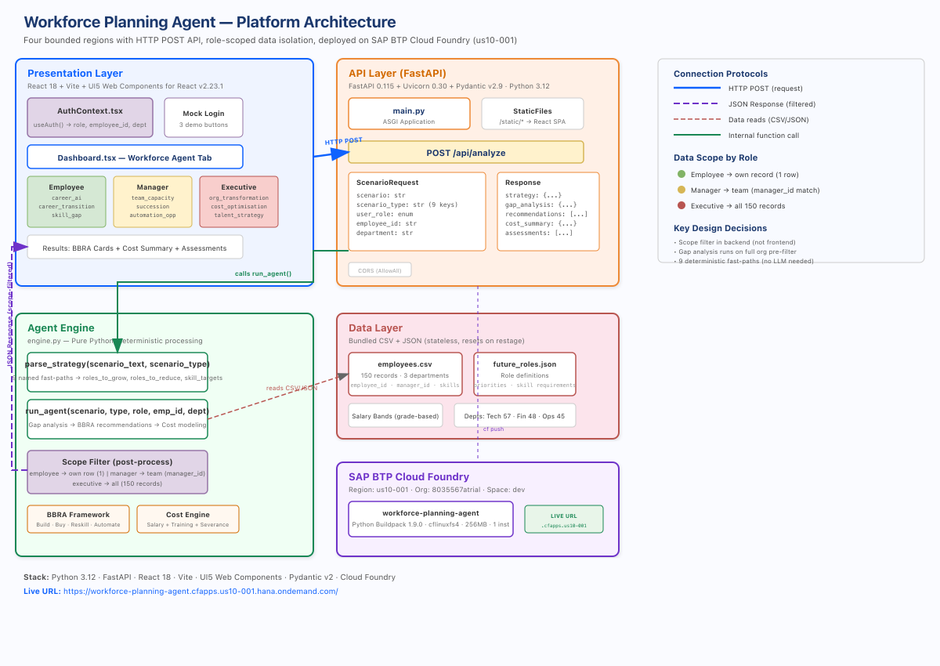
Figure 1: Platform Architecture — 4 layers with scope-filtered data flow.

Architecture Layers
Layer | Technology | Key Files | Responsibility
Presentation | React 18 + Vite + UI5 Web Components v2.23.1 | Dashboard.tsx, AppShell.tsx, AuthContext.tsx | Role-aware UI, 9 scenario chips, sidebar nav
API | FastAPI 0.115 + Pydantic v2.9 + Uvicorn 0.30 | main.py | Validation, routing, static serving, CORS
Engine | Pure Python (deterministic) | engine.py | 9 fast-paths, BBRA, gap analysis, cost model, scope filter
Data | CSV + JSON (bundled, stateless) | employees.csv, future_roles.json | 150 employees, roles, salary bands, departments

Connection Protocols
From | To | Protocol | Payload
Browser | FastAPI | HTTP POST /api/analyze | {scenario, scenario_type, user_role, employee_id, department}
main.py | engine.py | Python function call | run_agent(scenario, type, role, emp_id, dept)
engine.py | Data files | pandas read_csv / json.load | employees.csv, future_roles.json
FastAPI | Browser | JSON Response | {strategy, gap_analysis, recommendations, cost_summary, assessments}

Technology Stack
Component | Technology | Version
Frontend | React | 18.x
UI Library | UI5 Web Components for React | 2.23.1
Build Tool | Vite | 5.x
Backend | FastAPI | 0.115.0
ASGI Server | Uvicorn | 0.30.0
Validation | Pydantic | 2.9.0
Runtime | Python | 3.12
Platform | SAP BTP Cloud Foundry | cflinuxfs4 + python_buildpack 1.9.0

Workforce Agent — Scenario Analysis
9 named fast-paths in parse_strategy() produce distinct strategies. Each scenario_type generates unique roles_to_grow, roles_to_reduce, and skill_targets:
Role | Scenario | scenario_type | Focus
Employee | AI Career Advisor | career_ai | Personal growth, skill recs
Employee | Career Transition | career_transition | Move options + gap analysis
Employee | Skill Gap Analysis | skill_gap | Current vs. required skills
Manager | Team Capacity | team_capacity | Utilisation, hiring needs
Manager | Succession Planning | succession | Key-person risk, successors
Manager | Automation Opps | automation_opportunity | Automatable tasks, reskill
Executive | Org Transformation | org_transformation | Cross-dept restructuring
Executive | Cost Optimisation | cost_optimisation | Headcount efficiency
Executive | Talent Strategy | talent_strategy | Long-term capability build

Data Scope Filter
Applied post-analysis in run_agent(). Gap analysis runs on full org for accuracy; only recommendations and assessments are filtered:
Role | Filter Logic | Result
employee | employee_id == request.employee_id | 1 record
manager | manager_id == request.employee_id (+ self) | Team (2-10)
executive | No filter | All 150

API Reference
POST /api/analyze
Field | Type | Required | Description
scenario | string | Yes | Natural language scenario
scenario_type | string | Yes | 9 fast-path keys
user_role | string | Yes | employee | manager | executive
employee_id | string | Yes | Caller ID (e.g. EMP01025)
department | string | Yes | Caller dept (e.g. Finance)
Response: strategy, gap_analysis, recommendations (BBRA), cost_summary, assessments — all scope-filtered.

Deployment
Parameter | Value
URL | workforce-planning-agent.cfapps.us10-001.hana.ondemand.com
Region | US10-001
Org / Space | 8035567atrial / dev
Buildpack | python_buildpack 1.9.0
Memory / Instances | 256 MB / 1
Deploy | cf push (manifest.yml at project root)
Frontend built via npm run build → copied to backend/static/. Single CF app serves both API and SPA.

Role-Based Views (Screenshots)
Employee View — personal scope, career-focused scenarios:
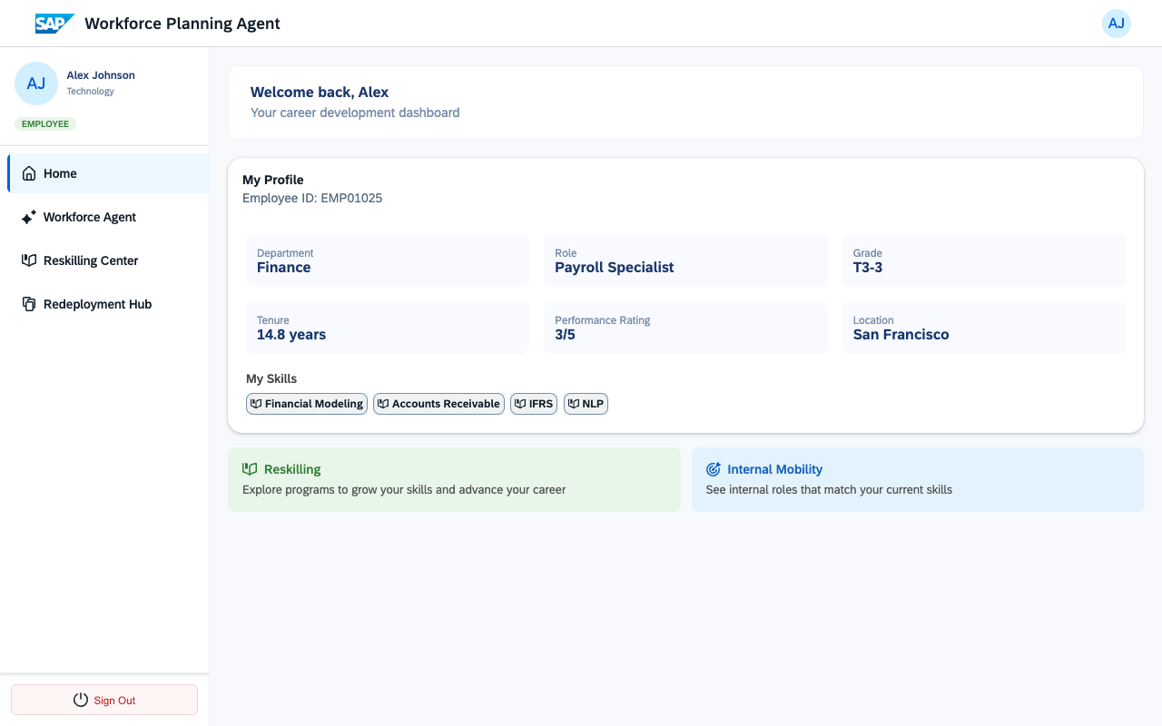

Manager View — team scope, operational scenarios:
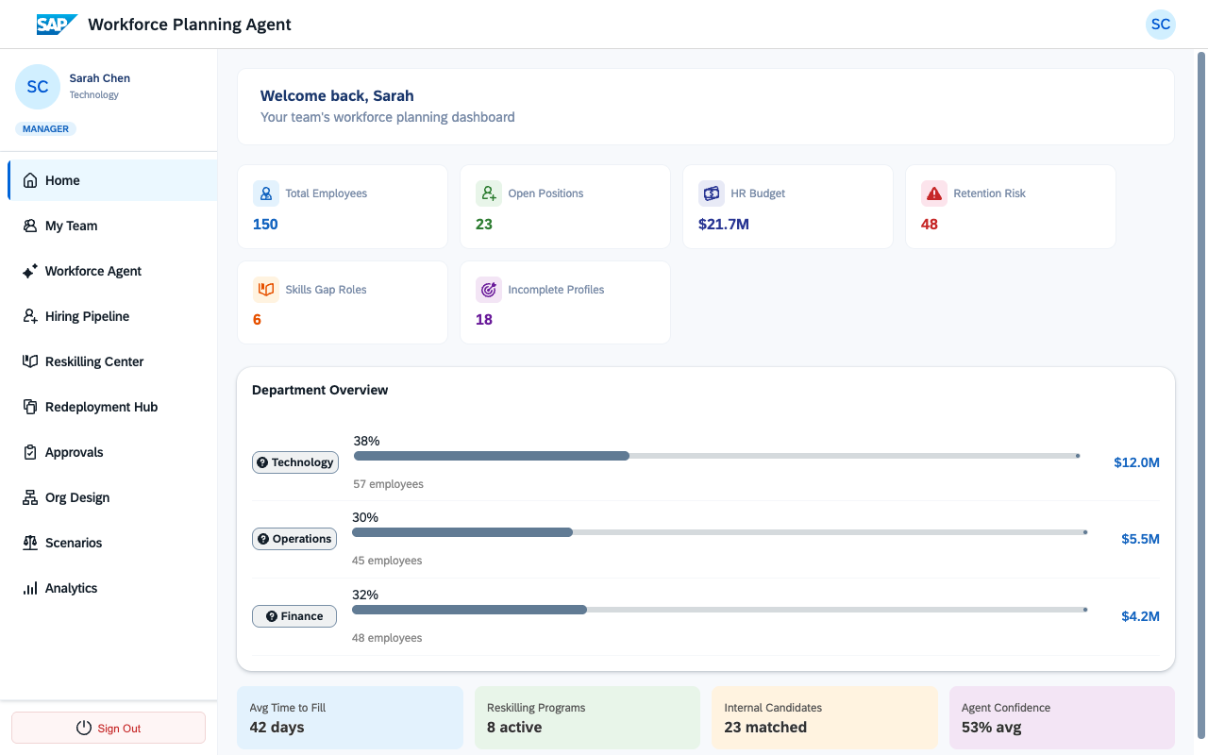

Executive View — org-wide scope, strategic scenarios:
