PROJECT REPORT
BankLedger
A Terminal-Based Banking Ledger built on PostgreSQL
Course: CSE3001 - Database Management Systems
Focus: SQL, PL/pgSQL, Triggers and Transaction Management
Submitted by: [Student Name]
Registration No.: [Reg. No.]
Faculty: [Faculty Name]
Institution: [College / University]
October 2026

Contents
- Introduction
- Problem Statement
- System Architecture
- Requirements
- Database Design (ER Diagram, Schema, Normalization)
- UML Diagrams
- SQL Implementation
- Triggers
- Transaction Management and Concurrency Control
- Testing
- Conclusion and Future Scope
- References
- Appendix A - Syllabus and Lab Coverage
- Appendix B - How to Run the Project

1. Introduction

1.1 Background
Banks, wallets and payment apps all rely on one idea: money must never be created, lost or double-spent, even when many people use the system at the same time and even when a server crashes half-way through an operation. A database management system (DBMS) exists to give exactly these guarantees. It stores data in an organised form, enforces rules on that data, and wraps groups of changes in transactions that obey the ACID properties - Atomicity, Consistency, Isolation and Durability.
This project, BankLedger, is a small but complete banking ledger that demonstrates how those guarantees are achieved in practice. Instead of writing the rules in application code, the project pushes them into the database itself using constraints, stored procedures, functions, triggers and views. The application is only a thin terminal menu.

1.2 Purpose of the project
The purpose is to design, implement and test a real-life database application that covers the main topics of the CSE3001 syllabus: the entity-relationship model, relational schema design and normalization, SQL (DDL, DML, joins, aggregates, sub-queries, views, indexes, sequences), procedural SQL (procedures, functions, cursors, exceptions, triggers) and transaction management (isolation levels, locking, deadlocks, recovery).

1.3 Objectives
- Design an ER model for a banking domain, including a weak entity, and map it to a relational schema.
- Normalize the schema to 3NF/BCNF and justify every design decision.
- Implement the business logic - deposit, withdraw, transfer, interest, batch processing - as PL/pgSQL procedures and functions.
- Use triggers to build a transparent audit trail and to enforce business rules that nobody can bypass.
- Demonstrate atomic transfers, row-level locking, deadlock avoidance, isolation levels, savepoints, backup and crash recovery.
- Keep the whole project lightweight: it must run from a terminal or an IDE console on an ordinary laptop.

1.4 Scope
BankLedger models a single bank with several branches, customers who hold savings or current accounts, and a ledger of deposits, withdrawals, transfers and interest credits. It is a teaching project: it does not include user log-in, multiple currencies, cheques or card processing. These are listed as future scope in Chapter 11.

1.5 Technologies used
Layer | Technology | Reason for choosing it
Database | PostgreSQL 14 or newer | Free, light (about 100-200 MB RAM), supports stored procedures, triggers, views, MVCC and all isolation levels
Procedural language | PL/pgSQL | Equivalent of Oracle PL/SQL: variables, control structures, cursors, exception handling
Client | Python 3.9+ with psycopg2 | Minimal code, runs in cmd, PowerShell, bash and any IDE
Backup | pg_dump | Standard logical backup tool, called from the menu
Diagrams | Graphviz and Matplotlib | Reproducible ER, UML and architecture diagrams (sources are in the repository)

2. Problem Statement

2.1 Problem description
Many small financial applications keep their data in files or spreadsheets, or they scatter their rules across application code. In such systems a transfer of money is usually two separate steps - subtract from one account, add to another. If the program stops between the two steps, money disappears. If two users act on the same account at the same moment, one update can silently overwrite the other. Rules such as "a frozen account cannot send money" or "no more than 50 000 may leave an account in a day" are easy to forget or to bypass, and there is often no reliable record of who changed what.
The problem addressed by this project is to design and implement a lightweight banking ledger in which money movements are always atomic and consistent, concurrent users cannot corrupt the data, every sensitive change is recorded automatically, and the business rules are enforced by the database itself rather than by trust in the application.

2.2 Limitations of a file-based or application-only approach
- Redundancy and inconsistency - the same customer details are repeated in many places.
- No atomicity - a failure between two related updates leaves the data half-changed.
- Concurrency anomalies - lost updates, dirty reads and non-repeatable reads when users work in parallel.
- Scattered rules - integrity checks duplicated (or missing) in every program that touches the data.
- Weak auditing - changes can be made without leaving a trace.
- Poor recovery - after a crash there is no guaranteed way to return to a consistent state.

2.3 Proposed solution
Use a relational DBMS as the single source of truth. The schema carries the structural rules (keys, foreign keys, CHECK constraints). Stored procedures carry the business operations and run each operation as one transaction. Triggers add an audit trail and the rules that must hold no matter which program connects. Views provide ready-made reports and a masked, read-only window for less privileged users. The terminal program only collects input and prints results.

2.4 Assumptions and constraints
- One currency and one bank; amounts have two decimal places (NUMERIC(14,2)).
- The daily outgoing limit is a fixed 50 000 per account, defined as a constant inside the trigger function.
- Authentication is left to the database user; the application does not implement its own log-in.
- The project targets a single PostgreSQL server (distributed commit is shown only as a demonstration).

3. System Architecture

3.1 Architectural overview
BankLedger uses a thin-client, fat-database architecture with three logical layers. The presentation layer (app.py) displays menus and validates input. The logic layer inside PostgreSQL holds stored procedures, functions, triggers and views. The data layer holds the tables, constraints and indexes, which are in turn backed by PostgreSQL's transaction manager, write-ahead log (WAL) and data files.
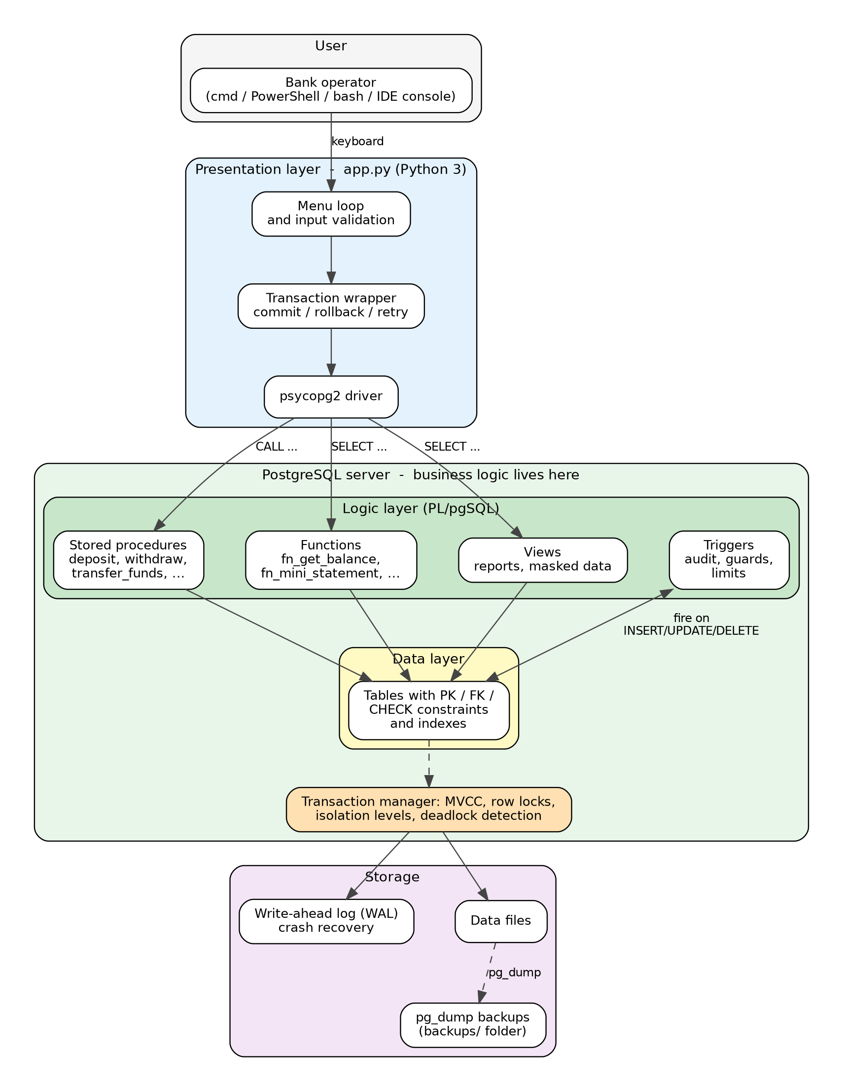
Figure 1: System architecture of BankLedger

3.2 Components
Component | Responsibility | Where
Menu loop | Shows options, reads and validates input (numbers, money amounts) | app.py
Transaction wrapper | Runs each action as one transaction: commit on success, rollback on error, automatic retry on deadlock or serialization failure | app.py (transact)
Stored procedures | deposit, withdraw, transfer_funds, set_account_status, apply_monthly_interest, process_transfer_queue | sql/02_functions_procedures.sql
Functions | fn_open_account, fn_get_balance, fn_account_location, fn_mini_statement | sql/02_functions_procedures.sql
Triggers | Audit trail, frozen-account guard, delete guard, append-only ledger, daily limit | sql/03_triggers.sql
Views and roles | Reports, masked view for tellers, updatable view with CHECK OPTION | sql/04_views.sql
Tables and constraints | Seven tables with PK, FK, CHECK, UNIQUE, identity sequences and indexes | sql/01_schema.sql
Transaction manager | MVCC snapshots, row locks, isolation levels, deadlock detection, WAL-based recovery | PostgreSQL engine
Backup | Logical dump of the whole database | pg_dump (menu option 12)

3.3 Design decision: business logic inside the database
Putting the logic in the database has four advantages. First, every client - the Python app, psql, a future web service - is subject to the same rules, because the rules cannot be skipped. Second, a procedure runs next to the data, so a transfer needs one network round trip instead of several. Third, the procedure and its triggers execute inside a single transaction, which makes atomicity natural. Fourth, the client stays tiny, which keeps the project lightweight. The trade-off is that the logic is tied to PostgreSQL's dialect, which is acceptable for this project.

3.4 Data flow of a transfer
When the operator chooses Transfer funds, the application sends one statement, CALL transfer_funds(from, to, amount, remarks). The procedure locks both account rows in ascending id order, checks status and balance, inserts a ledger row (a trigger checks the daily limit), then debits and credits the accounts (triggers apply the frozen-account guard and write the audit rows). If any step raises an exception, PostgreSQL rolls the whole transaction back; otherwise the application commits. The full sequence is shown in Figure 5 (Chapter 6).

3.5 Deployment
Everything runs on one machine: a PostgreSQL server (or one Docker container) and the Python script. Installation is createdb followed by one psql -f sql/install.sql command. No application server, ORM or web framework is needed.

4. Requirements

4.1 Functional requirements
- The system shall register customers with a unique e-mail address.
- The system shall open savings or current accounts for a customer at a branch, optionally with an opening deposit.
- The system shall record deposits and withdrawals and reject withdrawals that exceed the balance.
- The system shall transfer money between two accounts atomically.
- The system shall show the balance, branch location and a mini statement of any account.
- The system shall allow an account to be frozen, unfrozen or closed (closing only with a zero balance).
- The system shall automatically record every balance or status change in an audit log.
- The system shall reject outgoing payments above the daily limit.
- The system shall process a queue of batch transfers, isolating failures per transfer.
- The system shall credit monthly interest to active savings accounts.
- The system shall provide reports: all accounts, branch summary, customer portfolio, daily volume, dormant accounts, audit log.
- The system shall create a backup of the database on request.

4.2 Non-functional requirements
Requirement | How it is met
Atomicity | Each operation is one transaction; any exception rolls everything back
Consistency | PK, FK, CHECK and UNIQUE constraints plus triggers keep every committed state valid
Isolation | Row-level locks (FOR UPDATE), MVCC, selectable isolation levels, retry on conflict
Durability | Write-ahead logging; committed transfers survive a server crash
Security | Masked view and GRANT for tellers; no table updates through reports; append-only ledger
Lightweight | About 150 MB of RAM for PostgreSQL, one Python file of about 350 lines, no extra services
Portability | Works on Windows, Linux and macOS; plain ASCII output for old consoles
Maintainability | Numbered SQL scripts, one concern per file, comments on every routine

4.3 Software and hardware requirements
Item | Requirement
Operating system | Windows 10/11, Linux or macOS
Database | PostgreSQL 14+ (11+ works for procedures, 14+ recommended)
Language | Python 3.9+ and the psycopg2-binary package
Hardware | Any machine with 2 GB RAM and 500 MB free disk space
Optional | Docker (to run PostgreSQL in one command), VS Code or PyCharm

5. Database Design

5.1 Entity-relationship model
The domain has seven entities. Customer, Branch and Account form the core. Nominee is a weak entity: a nominee has no meaning without its account, and is identified only by the account number together with a nominee number. Transaction is the ledger. AuditLog and TransferQueue are supporting entities for the audit trail and batch processing.
Entity | Attributes (key underlined in the diagram) | Type
CUSTOMER | customer_id, full_name, email, phone, created_at | Strong
BRANCH | branch_id, branch_name, city | Strong
ACCOUNT | account_id, account_type, balance, status, opened_on | Strong
NOMINEE | nominee_no (partial key), nominee_name, relation, share_percent | Weak (owner: ACCOUNT)
TRANSACTION | txn_id, txn_type, amount, txn_time, remarks | Strong
AUDIT_LOG | audit_id, action, old/new balance, old/new status, changed_by, changed_at | Strong
TRANSFER_QUEUE | queue_id, amount, status, error_msg, queued_at, processed_at | Strong

Relationship | Entities | Cardinality | Notes
holds | CUSTOMER - ACCOUNT | 1 : N | A customer holds one or more accounts; every account has exactly one owner
maintained at | BRANCH - ACCOUNT | 1 : N | Every account belongs to one branch
has nominee (identifying) | ACCOUNT - NOMINEE | 1 : N | Identifying relationship of the weak entity; total participation of NOMINEE
sends (from) | ACCOUNT - TRANSACTION | 1 : N (optional) | A deposit has no sender, so the foreign key may be NULL
receives (to) | ACCOUNT - TRANSACTION | 1 : N (optional) | A withdrawal has no receiver, so the foreign key may be NULL
logged in | ACCOUNT - AUDIT_LOG | 1 : N | Logical link only; deliberately no foreign key so history survives deletion
queued for | ACCOUNT - TRANSFER_QUEUE | 1 : N | Each queued item references a source and a destination account
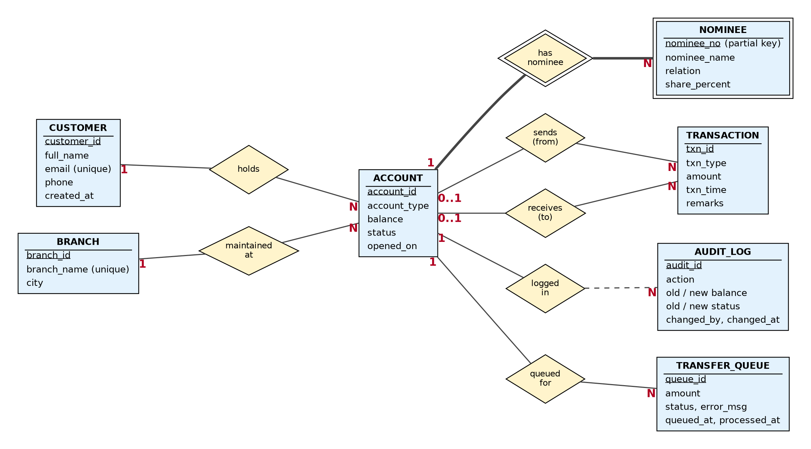
Figure 2: ER diagram of BankLedger (double border = weak entity / identifying relationship)

5.2 Mapping the ER model to relational tables
ER construct | Mapping rule applied
Strong entity | One table; the key attribute becomes the primary key (generated by an identity sequence)
1 : N relationship | Foreign key placed on the N side (accounts.customer_id, accounts.branch_id)
Weak entity | Own table whose primary key combines the owner's key with the partial key: (account_id, nominee_no); ON DELETE CASCADE
Two relationships between the same entities | Two separate nullable foreign keys on transactions: from_account and to_account
Type of transaction | A table-level CHECK links each type to the combination of NULL / NOT NULL accounts it needs

5.3 Relational schema
Primary keys are marked PK and foreign keys FK.
Branch(PK branch_id, branch_name, city)
Customer(PK customer_id, full_name, email, phone, created_at)
Account(PK account_id, FK customer_id, FK branch_id, account_type, balance, status, opened_on)
Nominee(PK,FK account_id, PK nominee_no, nominee_name, relation, share_percent)
Transaction(PK txn_id, txn_type, FK from_account, FK to_account, amount, txn_time, remarks)
AuditLog(PK audit_id, account_id, action, old_balance, new_balance, old_status,
new_status, changed_by, changed_at)
TransferQueue(PK queue_id, FK from_account, FK to_account, amount, status, error_msg,
queued_at, processed_at)

5.4 Table definitions

branches
Column | Data type | Constraints
branch_id | INT | PRIMARY KEY, GENERATED ALWAYS AS IDENTITY
branch_name | VARCHAR(60) | NOT NULL, UNIQUE
city | VARCHAR(40) | NOT NULL

customers
Column | Data type | Constraints
customer_id | BIGINT | PRIMARY KEY, GENERATED ALWAYS AS IDENTITY
full_name | VARCHAR(80) | NOT NULL
email | VARCHAR(120) | NOT NULL, UNIQUE, CHECK (email LIKE '%_@_%._%')
phone | VARCHAR(15) | CHECK (phone ~ '^[0-9+]{7,15}$')
created_at | TIMESTAMPTZ | NOT NULL, DEFAULT now()

accounts
Column | Data type | Constraints
account_id | BIGINT | PRIMARY KEY, identity sequence starting at 1001
customer_id | BIGINT | NOT NULL, FK to customers, ON DELETE RESTRICT
branch_id | INT | NOT NULL, FK to branches, ON DELETE RESTRICT
account_type | VARCHAR(10) | NOT NULL, CHECK IN ('SAVINGS','CURRENT')
balance | NUMERIC(14,2) | NOT NULL, DEFAULT 0, CHECK (balance >= 0)
status | VARCHAR(10) | NOT NULL, DEFAULT 'ACTIVE', CHECK IN ('ACTIVE','FROZEN','CLOSED')
opened_on | DATE | NOT NULL, DEFAULT CURRENT_DATE

nominees (weak entity)
Column | Data type | Constraints
account_id | BIGINT | PK (part 1), FK to accounts, ON DELETE CASCADE
nominee_no | SMALLINT | PK (part 2), CHECK (nominee_no > 0)
nominee_name | VARCHAR(80) | NOT NULL
relation | VARCHAR(30) | NOT NULL
share_percent | NUMERIC(5,2) | NOT NULL, DEFAULT 100, CHECK (share_percent > 0 AND share_percent <= 100)

transactions (ledger)
Column | Data type | Constraints
txn_id | BIGINT | PRIMARY KEY, GENERATED ALWAYS AS IDENTITY
txn_type | VARCHAR(10) | NOT NULL, CHECK IN ('DEPOSIT','WITHDRAWAL','TRANSFER','INTEREST')
from_account | BIGINT | FK to accounts, NULL for deposits and interest
to_account | BIGINT | FK to accounts, NULL for withdrawals
amount | NUMERIC(14,2) | NOT NULL, CHECK (amount > 0)
txn_time | TIMESTAMPTZ | NOT NULL, DEFAULT now()
remarks | VARCHAR(120) | optional
(table check) | ck_txn_shape | Type determines which accounts must be NULL; a transfer needs from_account <> to_account

audit_log
Column | Data type | Constraints
audit_id | BIGINT | PRIMARY KEY, GENERATED ALWAYS AS IDENTITY
account_id | BIGINT | NOT NULL (no FK, so the history outlives the account)
action | VARCHAR(10) | NOT NULL, CHECK IN ('UPDATE','DELETE')
old_balance, new_balance | NUMERIC(14,2) | before / after values
old_status, new_status | VARCHAR(10) | before / after values
changed_by | TEXT | NOT NULL, DEFAULT current_user
changed_at | TIMESTAMPTZ | NOT NULL, DEFAULT now()

transfer_queue
Column | Data type | Constraints
queue_id | BIGINT | PRIMARY KEY, GENERATED ALWAYS AS IDENTITY
from_account, to_account | BIGINT | NOT NULL, FK to accounts
amount | NUMERIC(14,2) | NOT NULL, CHECK (amount > 0)
status | VARCHAR(10) | NOT NULL, DEFAULT 'PENDING', CHECK IN ('PENDING','DONE','FAILED')
error_msg | TEXT | reason recorded when a transfer fails
queued_at, processed_at | TIMESTAMPTZ | queued_at defaults to now()

5.5 Integrity constraints
- Entity integrity - every table has a primary key; identity sequences generate it.
- Referential integrity - foreign keys with RESTRICT protect customers, branches and accounts from deletion while in use; CASCADE removes nominees together with their account.
- Domain integrity - CHECK constraints restrict types, statuses, e-mail and phone formats, and require positive amounts.
- Business integrity - balance >= 0, the transaction-shape check, and the five triggers.

5.6 Normalization
The functional dependencies of each table were examined to confirm that the design is free of redundancy and update anomalies.
Table | Functional dependencies | Highest normal form
branches | branch_id -> branch_name, city; branch_name -> branch_id (candidate key) | BCNF
customers | customer_id -> all attributes; email -> customer_id (candidate key) | BCNF
accounts | account_id -> customer_id, branch_id, account_type, balance, status, opened_on | BCNF
nominees | (account_id, nominee_no) -> nominee_name, relation, share_percent | BCNF
transactions | txn_id -> all attributes | BCNF
audit_log | audit_id -> all attributes | BCNF
transfer_queue | queue_id -> all attributes | BCNF

- 1NF - all attributes are atomic and there are no repeating groups. A customer's several nominees are rows in nominees, not columns such as nominee1 and nominee2.
- 2NF - only nominees has a composite key, and its non-key attributes depend on the whole key; no partial dependencies exist.
- 3NF - no transitive dependencies. The branch city is stored only in branches and the owner's name only in customers; storing them in accounts would create the transitive dependencies account_id -> branch_id -> city and account_id -> customer_id -> full_name.
- BCNF - in every table each determinant is a candidate key.
- 4NF - no table holds two independent multi-valued facts about the same key (nominees and transactions are kept apart), so there are no multi-valued dependencies.
- Intentional redundancy - accounts.balance can be derived from the ledger. It is stored for speed, protected by the transaction logic and the CHECK constraint, and verified by the reconciliation query Q21 (Chapter 7).

5.7 Indexes and sequences
Object | Definition | Purpose
Identity sequences | GENERATED ALWAYS AS IDENTITY on every surrogate key; accounts start at 1001 | Automatic, gap-tolerant unique keys
idx_accounts_customer | accounts(customer_id) | Join customers to accounts; PostgreSQL does not index foreign keys by itself
idx_accounts_branch | accounts(branch_id) | Branch reports
idx_txn_from | transactions(from_account, txn_time DESC) | Statements and the daily-limit trigger
idx_txn_to | transactions(to_account, txn_time DESC) | Statements
idx_audit_account | audit_log(account_id, changed_at DESC) | Audit look-ups
idx_queue_pending | transfer_queue(queue_id) WHERE status = 'PENDING' | Partial index: only unprocessed rows are indexed

6. UML Diagrams

6.1 Use-case diagram
Two actors use the system. The Teller / Operator handles day-to-day customer operations: creating customers, opening accounts, deposits, withdrawals, transfers and enquiries. The Administrator (DBA) performs supervisory tasks: freezing or closing accounts, processing the batch queue, applying interest, viewing reports and the audit log, and taking backups. Deposits, withdrawals and transfers implicitly include the database triggers.
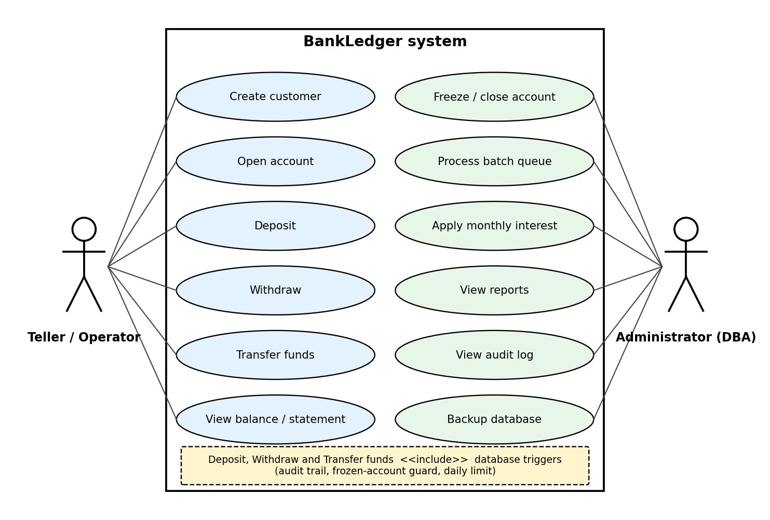
Figure 3: Use-case diagram

6.2 Class diagram
The class diagram shows each table as a class with its attributes, and the stored routines as operations of the class they act on. Stereotypes mark the triggers attached to a table. The composition from Account to Nominee expresses the weak-entity relationship: a nominee cannot exist without its account.
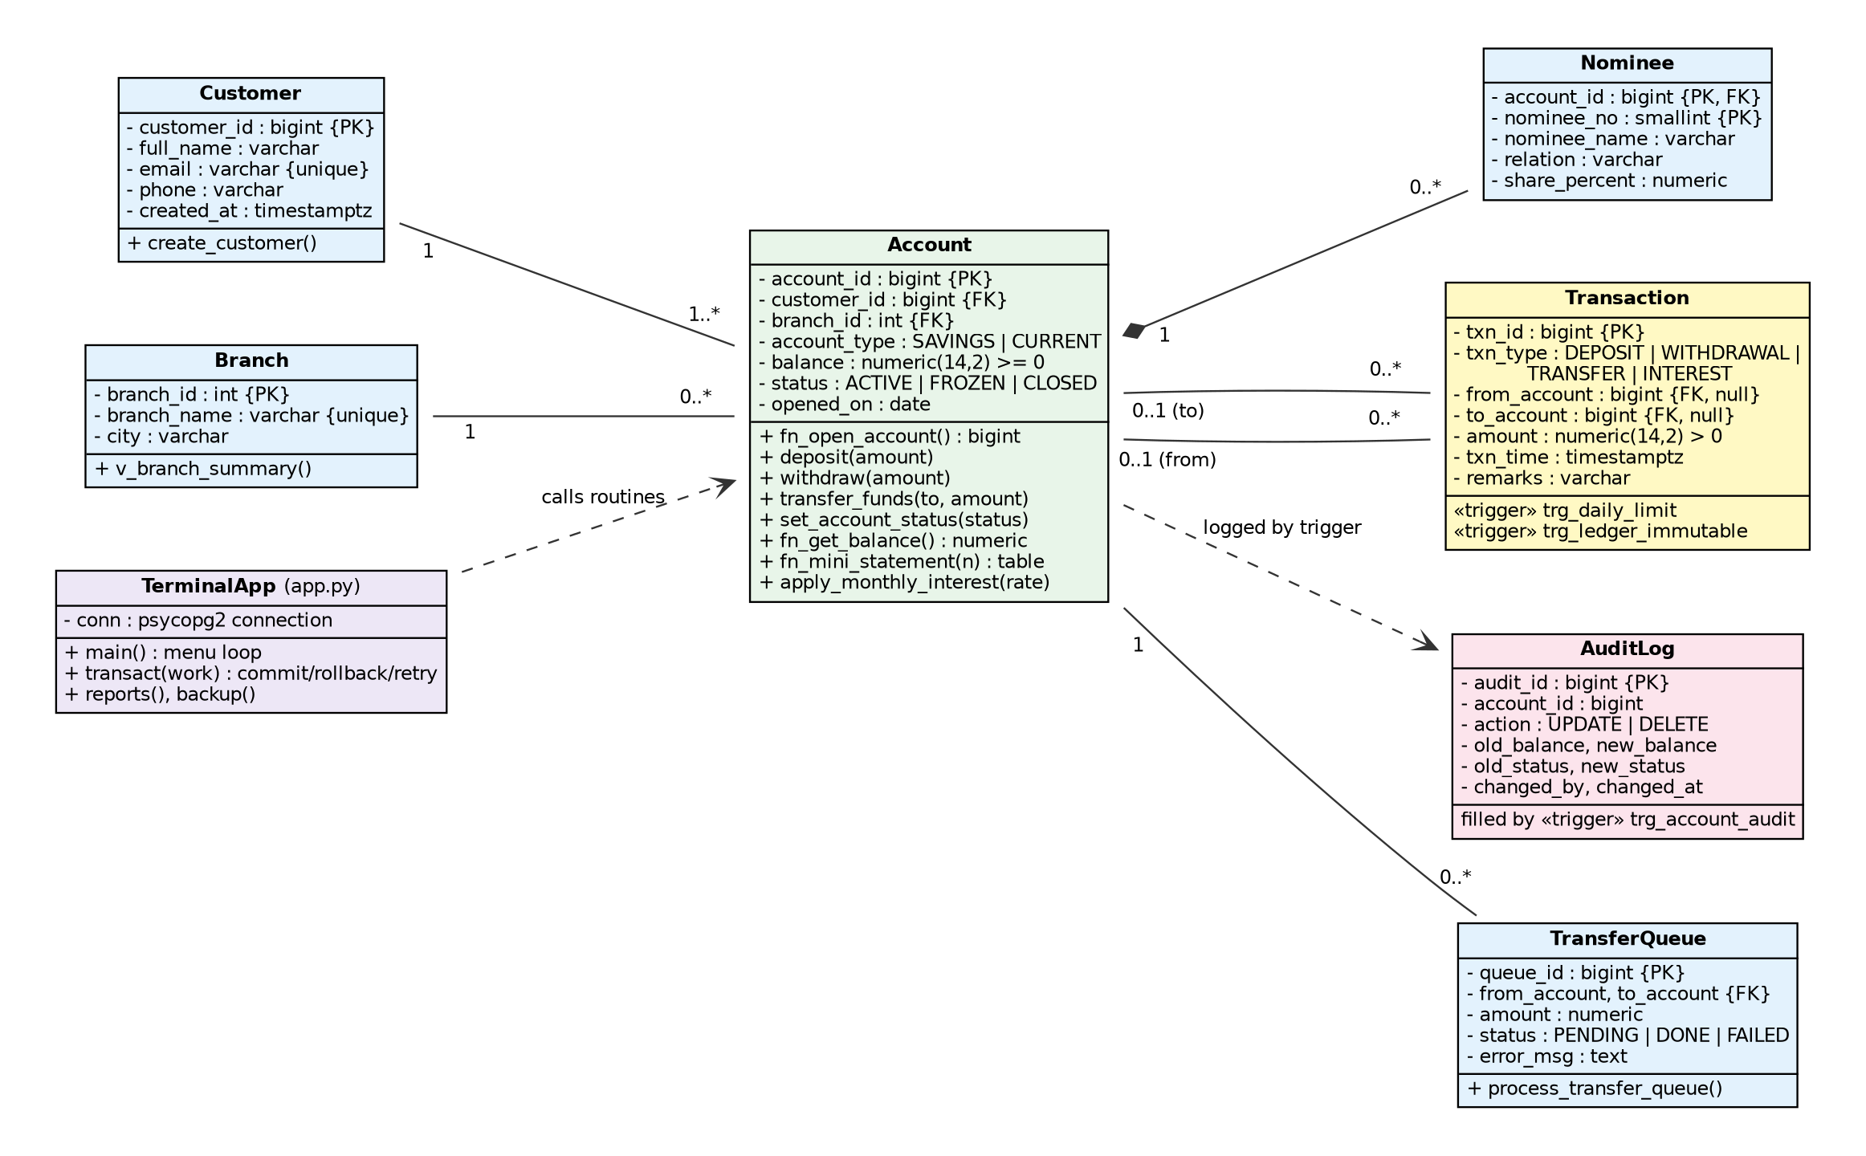
Figure 4: UML class diagram

6.3 Sequence diagram - funds transfer
The sequence diagram follows one transfer from the operator's input to the final message. It shows that the locking, validation, ledger insert, balance updates and trigger checks all happen inside the database, within one transaction that the application commits or rolls back.
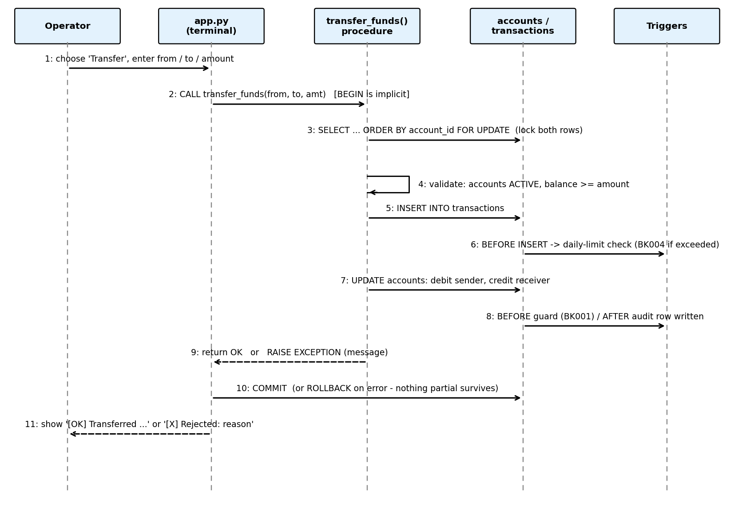
Figure 5: Sequence diagram of a funds transfer

7. SQL Implementation

7.1 Data definition (DDL)
sql/01_schema.sql drops and recreates all tables, then creates them in dependency order: branches, customers, accounts, nominees, transactions, audit_log and transfer_queue. It uses CREATE TABLE with column and table constraints, identity sequences, and CREATE INDEX. Views and a role are created in sql/04_views.sql.

7.2 Data manipulation (DML)
Applications never insert or update money columns directly. Every change goes through a procedure, so DML statements (INSERT, UPDATE, SELECT ... FOR UPDATE) appear inside PL/pgSQL. The sample data in sql/05_seed.sql is also loaded through the procedures, which means the triggers fire and the audit log is filled just as in real use.

7.3 Stored procedures and functions
Routine | Kind | Purpose | Syllabus topic
deposit(account, amount, remarks) | Procedure | Validate, write ledger row, credit the account | Transactions, exceptions
withdraw(account, amount, remarks) | Procedure | Validate funds, write ledger row, debit | Transactions, exceptions
transfer_funds(from, to, amount, remarks) | Procedure | Atomic transfer with ordered row locks | Locking, deadlock handling, atomicity
set_account_status(account, status) | Procedure | Freeze, unfreeze or close (zero balance only) | Control structures
apply_monthly_interest(rate) | Procedure | Explicit cursor with WHERE CURRENT OF | Explicit cursors
process_transfer_queue() | Procedure | Loop over the queue; BEGIN ... EXCEPTION block acts as a savepoint per row | Savepoints, exception handling
fn_open_account(customer, branch, type, initial) | Function | Insert account, return its number | Functions, composite logic
fn_get_balance(account) | Function | Return the balance or raise an error | Functions, exceptions
fn_account_location(account) | Function | Return 'branch, city' using a join (usable inside SELECT) | Functions in SQL, joins
fn_mini_statement(account, n) | Function | Return the last n ledger entries as a table | Table-returning functions

7.4 The transfer procedure
transfer_funds is the centre of the project. Its comments (kept in the listing) show the five steps: validate input, lock both rows in id order, validate on the locked rows, write the ledger entry, then debit and credit.
CREATE OR REPLACE PROCEDURE transfer_funds(p_from BIGINT, p_to BIGINT, p_amount NUMERIC,
p_remarks TEXT DEFAULT NULL)
LANGUAGE plpgsql AS $$
DECLARE
v_from_status TEXT;
v_from_bal NUMERIC;
v_to_status TEXT;
BEGIN
IF p_from IS NULL OR p_to IS NULL THEN
RAISE EXCEPTION 'Both source and destination accounts are required';
END IF;
IF p_from = p_to THEN
RAISE EXCEPTION 'Cannot transfer to the same account';
END IF;
IF p_amount IS NULL OR p_amount <= 0 THEN
RAISE EXCEPTION 'Transfer amount must be positive';
END IF;

-- Step 2: consistent lock order = no deadlocks between opposite transfers
PERFORM 1 FROM accounts
WHERE account_id IN (p_from, p_to)
ORDER BY account_id
FOR UPDATE;

-- Step 3: validate on the locked rows
SELECT status, balance INTO v_from_status, v_from_bal
FROM accounts WHERE account_id = p_from;
IF NOT FOUND THEN
RAISE EXCEPTION 'Source account % does not exist', p_from;
END IF;

SELECT status INTO v_to_status FROM accounts WHERE account_id = p_to;
IF NOT FOUND THEN
RAISE EXCEPTION 'Destination account % does not exist', p_to;
END IF;

IF v_from_status <> 'ACTIVE' THEN
RAISE EXCEPTION 'Source account % is %', p_from, v_from_status;
END IF;
IF v_to_status <> 'ACTIVE' THEN
RAISE EXCEPTION 'Destination account % is %', p_to, v_to_status;
END IF;
IF v_from_bal < p_amount THEN
RAISE EXCEPTION 'Insufficient funds: balance % is less than %', v_from_bal, p_amount;
END IF;

-- Steps 4 and 5
INSERT INTO transactions(txn_type, from_account, to_account, amount, remarks)
VALUES ('TRANSFER', p_from, p_to, p_amount, p_remarks);

UPDATE accounts SET balance = balance - p_amount WHERE account_id = p_from;
UPDATE accounts SET balance = balance + p_amount WHERE account_id = p_to;
END $$;

7.5 Views
View | Definition (summary) | Use
v_account_overview | accounts JOIN customers JOIN branches | Complete account list
v_customer_portfolio | customers LEFT JOIN accounts, GROUP BY customer | Accounts and total balance per customer
v_branch_summary | branches LEFT JOIN accounts, GROUP BY branch | Accounts, total and average balance per branch
v_daily_volume | transactions GROUP BY day and type | Daily activity report
v_dormant_accounts | accounts WHERE NOT EXISTS (any transaction) | Accounts never used
v_public_accounts | Masked owner name, no balance | Security: the only object the bank_teller role may read
v_active_accounts | SELECT from accounts WHERE status = 'ACTIVE' WITH CHECK OPTION | Updatable view; rows cannot be pushed outside the filter

7.6 Showcase queries and their relational-algebra form
sql/06_queries.sql contains 21 queries. Three of them are shown below with the equivalent relational algebra or tuple relational calculus (Unit 2 of the syllabus).
Query A - names of customers who hold an account with a balance above 50 000
SELECT DISTINCT c.full_name
FROM customers c JOIN accounts a ON a.customer_id = c.customer_id
WHERE a.balance > 50000;

Relational algebra: π full_name ( σ balance > 50000 ( Customer ⋈ Account ) )
Tuple calculus: { c.full_name | Customer(c) ∧ ∃a ( Account(a) ∧
a.customer_id = c.customer_id ∧ a.balance > 50000 ) }

Query B - accounts that sent money but never received any (set difference)
SELECT from_account FROM transactions WHERE txn_type = 'TRANSFER'
EXCEPT
SELECT to_account FROM transactions WHERE txn_type = 'TRANSFER';

Relational algebra: π from_account (σ type='TRANSFER' (Txn)) − π to_account (σ type='TRANSFER' (Txn))

Query C - customers with an account in every branch (division)
SELECT c.full_name FROM customers c
WHERE NOT EXISTS (SELECT 1 FROM branches b
WHERE NOT EXISTS (SELECT 1 FROM accounts a
WHERE a.customer_id = c.customer_id
AND a.branch_id = b.branch_id));

Relational algebra: π customer_id, branch_id (Account) ÷ π branch_id (Branch)

Other queries cover three-table joins, GROUP BY ... HAVING, correlated and nested sub-queries, ALL and ANY, UNION and INTERSECT, self joins, window functions (running balance, RANK), a common table expression, CASE, string functions, ROLLUP, EXPLAIN ANALYZE, and Q21, a reconciliation query that proves each stored balance equals the sum of its credits minus its debits in the ledger.

7.7 Security
A role bank_teller (no log-in of its own) is granted SELECT only on v_public_accounts. The view masks the owner's name and omits the balance, so a teller can look up an account's branch and status without seeing sensitive data. Combined with the append-only ledger trigger, even a privileged user cannot silently rewrite history.

7.8 Query cost
Unit 4 of the syllabus covers measures of query cost and cost-based optimisation. Query Q19 runs EXPLAIN ANALYZE on a ledger look-up. With idx_txn_from in place the planner uses an index (or bitmap) scan; after dropping the index it falls back to a sequential scan, which shows the effect of indexing on a growing ledger. PostgreSQL's planner is cost-based and chooses between plans using table statistics.

8. Triggers

8.1 Can triggers be added? Yes - five are implemented
Triggers are the right tool for rules that must hold no matter which program connects to the database. BankLedger uses five, each attached to one table and one event. Together they show BEFORE and AFTER triggers, row-level triggers, WHEN conditions, column-specific UPDATE OF, user-defined SQLSTATE codes, and a transparent audit mechanism.
Trigger | Table | Timing and event | Behaviour | Code
trg_account_audit | accounts | AFTER UPDATE / DELETE | Writes old and new balance and status, current user and time to audit_log | -
trg_block_inactive_update | accounts | BEFORE UPDATE OF balance, WHEN old status is not ACTIVE | Rejects balance changes on frozen or closed accounts | BK001
trg_block_account_delete | accounts | BEFORE DELETE | Rejects deleting an account whose balance is not zero | BK002
trg_ledger_immutable | transactions | BEFORE UPDATE / DELETE | Keeps the ledger append-only | BK003
trg_daily_limit | transactions | BEFORE INSERT, WHEN from_account is not NULL | Rejects outgoing money above 50 000 per account per day | BK004

8.2 Example: the transparent audit trigger
This trigger matches the audit-system lab experiment. When an account row is updated or deleted, the original details are stored in audit_log together with the user and date of the operation, and then the change is allowed to proceed. The application never writes to audit_log.
CREATE OR REPLACE FUNCTION fn_audit_account() RETURNS trigger
LANGUAGE plpgsql AS $$
BEGIN
IF TG_OP = 'DELETE' THEN
INSERT INTO audit_log(account_id, action, old_balance, old_status)
VALUES (OLD.account_id, 'DELETE', OLD.balance, OLD.status);
RETURN OLD;
END IF;

-- UPDATE: log only when something we care about really changed
IF NEW.balance IS DISTINCT FROM OLD.balance
OR NEW.status IS DISTINCT FROM OLD.status THEN
INSERT INTO audit_log(account_id, action, old_balance, new_balance, old_status, new_status)
VALUES (OLD.account_id, 'UPDATE', OLD.balance, NEW.balance, OLD.status, NEW.status);
END IF;
RETURN NEW;
END $$;

DROP TRIGGER IF EXISTS trg_account_audit ON accounts;
CREATE TRIGGER trg_account_audit
AFTER UPDATE OR DELETE ON accounts
FOR EACH ROW EXECUTE FUNCTION fn_audit_account();

8.3 Additional triggers that could be added
Trigger idea | Event | Benefit
Low-balance alert using pg_notify | AFTER UPDATE OF balance on accounts | A monitoring program can listen and warn the customer
updated_at stamp | BEFORE UPDATE on accounts | Automatically records the last change time
Normalise e-mail to lower case | BEFORE INSERT / UPDATE on customers | Prevents duplicates that differ only in letter case
Nominee share check (deferred constraint trigger) | AFTER INSERT / UPDATE on nominees | Ensures the shares of one account never exceed 100 percent
Minimum balance for savings accounts | BEFORE UPDATE OF balance on accounts | Enforces a bank policy without touching the procedures
Fraud flag | AFTER INSERT on transactions | Flags several large transfers from one account within minutes
Auto-create a welcome nominee row or log entry | AFTER INSERT on accounts | Example of an AFTER INSERT trigger that fills a related table

Triggers also have costs: they run on every matching row, they can hide behaviour from a reader of the application code, and a chain of triggers is harder to debug. For that reason BankLedger keeps its triggers few, small and documented in one file.

9. Transaction Management and Concurrency Control

9.1 ACID properties in BankLedger
Property | Mechanism in the project | Demonstration
Atomicity | The caller opens one transaction; transfer_funds raises an exception on any problem and PostgreSQL rolls back everything, including the ledger row and trigger side-effects | Demo 1: failed or rolled-back transfer leaves no trace
Consistency | PK, FK, CHECK, UNIQUE and the five triggers; balance >= 0; the ledger-shape check | Demo 2: each rule rejects an invalid change
Isolation | MVCC snapshots, SELECT ... FOR UPDATE row locks, selectable isolation levels, automatic retry on SQLSTATE 40001 and 40P01 | Demos 3-5
Durability | Write-ahead log is flushed at commit; recovery replays it after a crash | Demo 7

9.2 Concurrency problems and isolation levels
Isolation level | Dirty read | Non-repeatable read | Phantom read | PostgreSQL behaviour
READ UNCOMMITTED | No | Possible | Possible | Treated as READ COMMITTED
READ COMMITTED (default) | No | Possible | Possible | Each statement sees data committed before it began
REPEATABLE READ | No | No | No | One snapshot per transaction; concurrent update raises error 40001
SERIALIZABLE | No | No | No | Serializable snapshot isolation; may abort with 40001, so the client retries

The lost-update problem arises when an application reads a balance, calculates a new value and writes it back. The procedures avoid it by letting the database calculate (balance = balance + amount) after taking a row lock, so concurrent writers are serialised.

9.3 Locking and deadlock handling
A deadlock occurs when two transactions each hold a lock the other needs. For example, a transfer from account A to B and a transfer from B to A, running at the same moment, can lock A and B in opposite order. transfer_funds removes the cause by always locking the account with the lower number first (ORDER BY account_id FOR UPDATE). Because every transaction acquires locks in the same global order, a cycle cannot form. If a deadlock still arises elsewhere, PostgreSQL detects it, aborts one transaction with SQLSTATE 40P01, and the application retries it. demos/TRANSACTION_DEMOS.md reproduces the deadlock by hand and then shows the fix.

9.4 Savepoints and partial rollback
SAVEPOINT and ROLLBACK TO SAVEPOINT undo only part of a transaction. Inside PL/pgSQL, a BEGIN ... EXCEPTION block is an implicit savepoint. process_transfer_queue uses it so that one failed batch transfer is marked FAILED with its error message while the others succeed - a direct answer to the cursor-and-savepoint lab experiment.

9.5 Recovery, durability and backup
Before a commit returns, PostgreSQL forces the transaction's log records to disk (write-ahead logging). After a crash the server replays the log: committed changes are redone and uncommitted ones are discarded. The demonstration stops the server with pg_ctl stop -m immediate and shows that a committed transfer is still present after restart. A logical backup is made with pg_dump (menu option 12), and restored with psql into a new database.

9.6 Two-phase commit
With max_prepared_transactions enabled, PREPARE TRANSACTION 'id' performs phase one: the transaction votes yes and becomes durable but invisible. COMMIT PREPARED 'id' or ROLLBACK PREPARED 'id' completes phase two. This is how a coordinator could keep two databases consistent; the demo shows the mechanism on a single server.

10. Testing
The table lists the test cases to be executed after installing the sample data. The expected results follow directly from the constraints, procedures and triggers; record the outcome in the last column when you run each test. Reinstall sql/install.sql when a test changes data that a later test depends on.
ID | Scenario | Steps | Expected result | P/F
T1 | Valid transfer | CALL transfer_funds(1001, 1002, 500) | Balances change by 500; one TRANSFER row; two audit rows
T2 | Insufficient funds | Transfer more than the balance | Error 'Insufficient funds'; no ledger row; balances unchanged
T3 | Same account | transfer_funds(1001, 1001, 10) | Error 'Cannot transfer to the same account'
T4 | Invalid amount | Deposit or transfer 0 or a negative amount | Error 'amount must be positive'
T5 | Frozen source | transfer_funds(1009, 1001, 10) | Error 'Source account 1009 is FROZEN'
T6 | Direct update on frozen account | UPDATE accounts SET balance = balance + 1 WHERE account_id = 1009 | Error BK001
T7 | Delete funded account | DELETE FROM accounts WHERE account_id = 1001 | Error BK002
T8 | Edit the ledger | UPDATE or DELETE on transactions | Error BK003
T9 | Daily limit | Send 30 000 then 5 000 more from 1001 on the same day | First succeeds; second fails with BK004
T10 | Negative balance | UPDATE accounts SET balance = -5 | CHECK violation ck_balance_non_negative
T11 | Duplicate e-mail | Create two customers with one e-mail | UNIQUE violation on the second
T12 | Audit trail | Freeze an account, then view the audit log | Row with action UPDATE and old/new status
T13 | Batch queue | CALL process_transfer_queue() | Queue row 1 DONE; rows 2 and 3 FAILED with reasons
T14 | Interest | CALL apply_monthly_interest(0.5) | INTEREST rows for active savings accounts only; frozen accounts skipped
T15 | Rollback | BEGIN; transfer; ROLLBACK; | Balances and ledger unchanged
T16 | Opposite transfers | Run 1001->1002 and 1002->1001 concurrently in two sessions | Both complete; no deadlock error
T17 | Repeatable read conflict | Demo 3 (second half) | Error 'could not serialize access'
T18 | Crash recovery | Demo 7 with pg_ctl stop -m immediate | Committed row present after restart; uncommitted row absent
T19 | Reconciliation | Run query Q21 | difference = 0.00 for every account
T20 | Teller privilege | As bank_teller: SELECT from accounts and from v_public_accounts | Table denied; view allowed

11. Conclusion and Future Scope

11.1 Conclusion
BankLedger shows that a small terminal program can be both lightweight and trustworthy when the database does the hard work. The schema is normalized to BCNF, the business operations are stored procedures that run as single transactions, five triggers provide an automatic audit trail and unbypassable rules, and the transfer procedure avoids deadlocks by ordered locking. The accompanying demos show each ACID property in action. The project therefore covers the main learning outcomes of the course: explaining the role of a DBMS, describing the relational model, constructing queries in SQL, designing and implementing a database project, and applying transactions, concurrency control, backup and recovery.

11.2 Future scope
- User authentication with database roles and row-level security, so a customer sees only their own accounts.
- Partitioning the ledger by month and archiving old partitions.
- Scheduled jobs (for example pg_cron) for monthly interest and nightly reconciliation.
- Materialized views for heavy reports.
- Multi-currency accounts and an exchange-rate table.
- A REST or web front end that calls the same procedures.
- Replication and point-in-time recovery using continuous WAL archiving.

12. References
- R. Elmasri and S. B. Navathe, Fundamentals of Database Systems, 7th Edition, Addison Wesley, 2015.
- R. Ramakrishnan and J. Gehrke, Database Management Systems, 4th Edition, McGraw-Hill, 2015.
- A. Silberschatz, H. F. Korth and S. Sudarshan, Database System Concepts, 6th Edition, McGraw-Hill, 2010.
- T. Connolly and C. Begg, Database Systems: A Practical Approach to Design, Implementation and Management, 6th Edition, Pearson.
- PostgreSQL Global Development Group, PostgreSQL Documentation (PL/pgSQL, Triggers, Transaction Isolation, Explicit Locking, Write-Ahead Logging), https://www.postgresql.org/docs/.
- CSE3001 Database Management Systems - course syllabus and indicative list of experiments.

Appendix A - Syllabus and Lab Coverage

A.1 Syllabus units
Unit | Topics | Where covered in BankLedger
1 Introduction, ER model | Purpose of a DBMS, data abstraction, ER model, constraints, weak entity sets | Chapters 1, 2, 5.1; nominees weak entity; ER diagram
2 Relational model, normalization | Keys, integrity rules, relational algebra, tuple calculus, division, 1NF to 4NF, UML | Chapters 5.2-5.6, 6, 7.6
3 SQL | DDL, DML, joins, aggregates, nulls, nested queries, set operators, views, sequences, indexes, triggers | 01_schema.sql, 04_views.sql, 06_queries.sql, Chapter 8
4 PL/SQL, storage, optimisation | Variables, control structures, cursors, exceptions, procedures, functions; indexing; query cost | 02_functions_procedures.sql, Chapters 5.7 and 7.8
5 Transactions, concurrency, recovery | ACID, isolation levels, serializability, locking, deadlocks, two-phase commit, recovery | Chapter 9 and demos/TRANSACTION_DEMOS.md

A.2 Indicative lab experiments
Lab experiment | Related part of the project
1, 2 SQL queries on given schemas | 06_queries.sql (joins, nested queries, ALL/ANY, aggregates, ordering)
3 Design a database (furniture company) | Same design method applied to the banking domain: Chapter 5
4 Backup script and implicit cursor | Menu option 12 (pg_dump); fn_mini_statement; implicit cursors inside FOR loops
5 Transparent audit system | trg_account_audit and the audit_log table
6 Cursor, delete, commit, rollback, savepoint | apply_monthly_interest, process_transfer_queue, Demo 6
7 Detect and raise an exception | RAISE EXCEPTION with user-defined SQLSTATE codes in procedures and triggers
8, 9 Procedure and function with SQL call | transfer_funds, fn_account_location used inside SELECT
10 Trigger with user-defined error | trg_block_inactive_update, trg_ledger_immutable, trg_daily_limit
11 Join queries | Queries Q1, Q2, Q10 and the report views

Appendix B - How to Run the Project
createdb -U postgres bankdb
psql -U postgres -d bankdb -v ON_ERROR_STOP=1 -f sql/install.sql
pip install -r requirements.txt
set PGPASSWORD=yourpassword (Windows cmd)
python app.py

Further instructions, the project structure and troubleshooting tips are in the repository's README.md. The repository can be published on GitHub as it stands.

