PROJECT REPORT
BankLedger
A Terminal-Based Banking Ledger built on SQLite
Course: CSE3001 - Database Management Systems

Submitted by: Group 4
Faculty: Dr. Vijendra Singh Bramhe

Contents
- Introduction
- Problem Statement
- System Architecture
- Requirements
- Database Design (ER Diagram, Schema, Normalization, Dataset Description)
- UML Diagrams
- SQL Implementation
- Triggers
- Transaction Management and Concurrency Control
- Testing
- Conclusion and Future Scope
- References
- Appendix A - Syllabus and Lab Coverage
- Appendix B - How to Run the Project

1. Introduction

1.1 Background
Banks, wallets and payment apps all rely on one idea: money must never be created, lost or double-spent, even when many people use the system at the same time and even when a server crashes half-way through an operation. A database management system (DBMS) exists to give exactly these guarantees. It stores data in an organised form, enforces rules on that data, and wraps groups of changes in transactions that obey the ACID properties - Atomicity, Consistency, Isolation and Durability.
This project, BankLedger, is a small but complete banking ledger that demonstrates how those guarantees are achieved in practice. Instead of writing every rule in application code, the project pushes as many rules as possible into the database itself using constraints, triggers and views. The money-moving operations (deposit, withdraw, transfer, interest, batch processing) are small Python routines that each run as one atomic SQLite transaction. The database engine is SQLite, which needs no server and is built into Python, and the application is only a thin terminal menu.

1.2 Purpose of the project
The purpose is to design, implement and test a real-life database application that covers the main topics of the CSE3001 syllabus: the entity-relationship model, relational schema design and normalization, SQL (DDL, DML, joins, aggregates, sub-queries, views, indexes, auto-increment keys), procedural logic (Python routines that play the role of stored procedures and functions, exception handling, savepoints, triggers) and transaction management (atomic commit, write locking, recovery, backup).

1.3 Objectives
- Design an ER model for a banking domain, including a weak entity, and map it to a relational schema.
- Normalize the schema to 3NF/BCNF and justify every design decision.
- Implement the business logic - deposit, withdraw, transfer, interest, batch processing - as Python functions in ledger.py that each run as one SQLite transaction (SQLite has no stored procedures).
- Use triggers to build a transparent audit trail and to enforce business rules that nobody can bypass.
- Demonstrate atomic transfers, write locking with BEGIN IMMEDIATE, deadlock avoidance, savepoints, backup and crash recovery.
- Keep the whole project lightweight: it must run from a terminal or an IDE console on an ordinary laptop.

1.4 Scope
BankLedger models a single bank with several branches, customers who hold savings or current accounts, and a ledger of deposits, withdrawals, transfers and interest credits. It is a teaching project: it does not include user log-in, multiple currencies, cheques or card processing. These are listed as future scope in Chapter 11.

1.5 Technologies used
Layer | Technology | Reason for choosing it
Database | SQLite 3 (3.25 or newer for window functions; tested with 3.45.1) | Serverless, zero-configuration, single-file database (bankledger.db) with constraints, triggers, views, transactions and window functions; needs only a few MB of RAM
Procedural language | Python 3.9+ (ledger.py) | SQLite has no stored procedures, so the routines are Python functions; the rules that can live in the database stay in sql/schema.sql as triggers and constraints
Client | Python 3.9+ with the built-in sqlite3 module | Minimal code, no pip install, runs in cmd, PowerShell, bash and any IDE console
Backup | SQL dump through iterdump() | Plain-text logical backup written to the backups/ folder from the menu
Diagrams | Graphviz and Matplotlib | Reproducible ER, UML and architecture diagrams (sources are in the repository)

2. Problem Statement

2.1 Problem description
Many small financial applications keep their data in files or spreadsheets, or they scatter their rules across application code. In such systems a transfer of money is usually two separate steps - subtract from one account, add to another. If the program stops between the two steps, money disappears. If two users act on the same account at the same moment, one update can silently overwrite the other. Rules such as "a frozen account cannot send money" or "no more than 50 000 may leave an account in a day" are easy to forget or to bypass, and there is often no reliable record of who changed what.
The problem addressed by this project is to design and implement a lightweight banking ledger in which money movements are always atomic and consistent, concurrent users cannot corrupt the data, every sensitive change is recorded automatically, and the business rules are enforced by the database itself rather than by trust in the application.

2.2 Limitations of a file-based or application-only approach
- Redundancy and inconsistency - the same customer details are repeated in many places.
- No atomicity - a failure between two related updates leaves the data half-changed.
- Concurrency anomalies - lost updates, dirty reads and non-repeatable reads when users work in parallel.
- Scattered rules - integrity checks duplicated (or missing) in every program that touches the data.
- Weak auditing - changes can be made without leaving a trace.
- Poor recovery - after a crash there is no guaranteed way to return to a consistent state.

2.3 Proposed solution
Use a relational DBMS as the single source of truth. The schema carries the structural rules (keys, foreign keys, CHECK constraints). Python routines (standing in for stored procedures) carry the business operations and run each operation as one transaction. Triggers add an audit trail and the rules that must hold no matter which program connects. Views provide ready-made reports and a masked, read-only window for less privileged users. The terminal program only collects input and prints results.

2.4 Assumptions and constraints
- One currency and one bank; amounts have two decimal places (declared NUMERIC; SQLite stores them as REAL, so every update uses ROUND(..., 2)).
- The daily outgoing limit is a fixed 50 000 per account, defined as a constant inside the trg_daily_limit trigger.
- Authentication is not implemented; SQLite has no database users, so anyone who can open the database file and run the application can use it.
- The project targets a single SQLite database file; distributed commit is not demonstrated.

3. System Architecture

3.1 Architectural overview
BankLedger uses a thin-client architecture with three logical layers. The presentation layer (app.py) displays menus and validates input. The logic layer holds the Python routines in ledger.py together with the triggers and views stored in the database. The data layer holds the tables, constraints and indexes of the single file bankledger.db, which are in turn backed by SQLite's transaction manager and rollback journal.
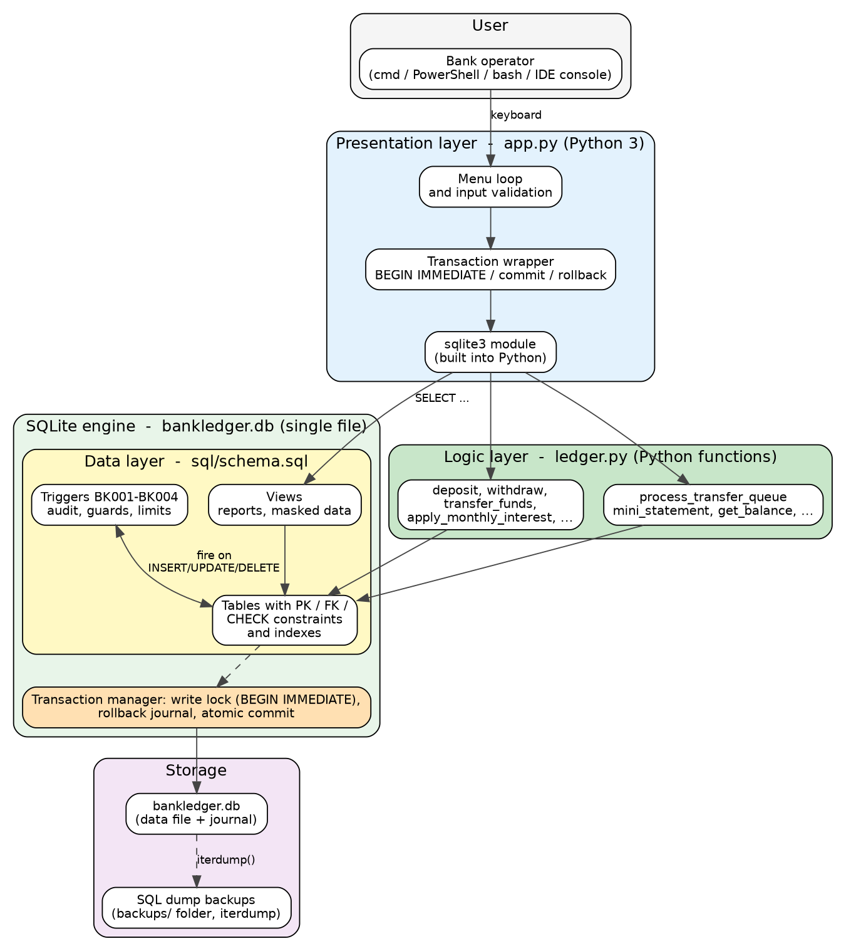
Figure 1: System architecture of BankLedger

3.2 Components
Component | Responsibility | Where
Menu loop | Shows options, reads and validates input (numbers, money amounts) | app.py
Transaction wrapper | Runs each action as one transaction: BEGIN IMMEDIATE, commit on success, rollback on error | ledger.py (transaction)
Business routines | deposit, withdraw, transfer_funds, set_account_status, apply_monthly_interest, process_transfer_queue (Python functions; SQLite has no stored procedures) | ledger.py
Query helpers | open_account, create_customer, get_balance, account_location, mini_statement | ledger.py
Triggers | Audit trail, frozen-account guard, delete guard, append-only ledger, daily limit | sql/schema.sql
Views | Reports, masked public view, updatable view with an INSTEAD OF trigger | sql/schema.sql
Tables and constraints | Seven tables with PK, FK, CHECK, UNIQUE, AUTOINCREMENT keys and indexes | sql/schema.sql
Transaction manager | Write lock (BEGIN IMMEDIATE), rollback journal, atomic commit and crash recovery | SQLite engine
Backup | SQL dump of the whole database | iterdump() (menu option 12)

3.3 Design decision: rules inside the database, routines in a thin Python layer
Putting the rules in the database has three advantages. First, every client - the Python app, the sqlite3 shell, a future web service - is subject to the same constraints and triggers, because they cannot be skipped. Second, each routine runs inside one transaction together with the triggers it fires, which makes atomicity natural. Third, the client stays tiny, which keeps the project lightweight. The trade-off is that SQLite has no stored procedures: the money-moving routines live in ledger.py, so only the structural rules (CHECK, FOREIGN KEY, triggers BK001-BK004) are enforced for a client that bypasses the Python layer.

3.4 Data flow of a transfer
When the operator chooses Transfer funds, the application calls transfer_funds(conn, from, to, amount, remarks) in ledger.py. The routine opens BEGIN IMMEDIATE, which takes the write lock of the database, checks status and balance, inserts a ledger row (a trigger checks the daily limit), then debits and credits the accounts (triggers apply the frozen-account guard and write the audit rows). If any step raises an error, the whole transaction is rolled back; otherwise it is committed. The full sequence is shown in Figure 5 (Chapter 6).

3.5 Deployment
Everything runs on one machine: the Python script and the SQLite database file bankledger.db, which is created with the sample data on the first run. Installation is just python app.py. No database server, pip install, application server, ORM or web framework is needed.

4. Requirements

4.1 Functional requirements
- The system shall register customers with a unique e-mail address.
- The system shall open savings or current accounts for a customer at a branch, optionally with an opening deposit.
- The system shall record deposits and withdrawals and reject withdrawals that exceed the balance.
- The system shall transfer money between two accounts atomically.
- The system shall show the balance, branch location and a mini statement of any account.
- The system shall allow an account to be frozen, unfrozen or closed (closing only with a zero balance).
- The system shall automatically record every balance or status change in an audit log.
- The system shall reject outgoing payments above the daily limit.
- The system shall process a queue of batch transfers, isolating failures per transfer.
- The system shall credit monthly interest to active savings accounts.
- The system shall provide reports: all accounts, branch summary, customer portfolio, daily volume, dormant accounts, audit log.
- The system shall create a backup of the database on request.

4.2 Non-functional requirements
Requirement | How it is met
Atomicity | Each operation is one transaction (BEGIN IMMEDIATE ... COMMIT); any exception rolls everything back
Consistency | PK, FK (PRAGMA foreign_keys = ON), CHECK and UNIQUE constraints plus triggers keep every committed state valid
Isolation | The write lock taken by BEGIN IMMEDIATE allows one writer at a time; transactions are serialized
Durability | Rollback journal; committed transfers survive a crash, unfinished ones are rolled back
Security | Masked view v_public_accounts (SQLite has no roles or GRANT); append-only ledger trigger
Lightweight | No server; a few MB of RAM, two Python files (app.py, ledger.py), no extra services
Portability | Works on Windows, Linux and macOS; plain ASCII output for old consoles
Maintainability | Schema in one file (sql/schema.sql), showcase queries in sql/queries.sql, automated tests, comments on every routine

4.3 Software and hardware requirements
Item | Requirement
Operating system | Windows 10/11, Linux or macOS
Database | SQLite 3.25+ (bundled with the Python sqlite3 module; tested with 3.45.1)
Language | Python 3.9+ (standard library only, no extra packages)
Hardware | Any machine with 1 GB RAM and 50 MB free disk space
Optional | VS Code or PyCharm

5. Database Design

5.1 Entity-relationship model
The domain has seven entities. Customer, Branch and Account form the core. Nominee is a weak entity: a nominee has no meaning without its account, and is identified only by the account number together with a nominee number. Transaction is the ledger. AuditLog and TransferQueue are supporting entities for the audit trail and batch processing.
Entity | Attributes (key underlined in the diagram) | Type
CUSTOMER | customer_id, full_name, email, phone, created_at | Strong
BRANCH | branch_id, branch_name, city | Strong
ACCOUNT | account_id, account_type, balance, status, opened_on | Strong
NOMINEE | nominee_no (partial key), nominee_name, relation, share_percent | Weak (owner: ACCOUNT)
TRANSACTION | txn_id, txn_type, amount, txn_time, remarks | Strong
AUDIT_LOG | audit_id, action, old/new balance, old/new status, changed_by, changed_at | Strong
TRANSFER_QUEUE | queue_id, amount, status, error_msg, queued_at, processed_at | Strong

Relationship | Entities | Cardinality | Notes
holds | CUSTOMER - ACCOUNT | 1 : N | A customer holds one or more accounts; every account has exactly one owner
maintained at | BRANCH - ACCOUNT | 1 : N | Every account belongs to one branch
has nominee (identifying) | ACCOUNT - NOMINEE | 1 : N | Identifying relationship of the weak entity; total participation of NOMINEE
sends (from) | ACCOUNT - TRANSACTION | 1 : N (optional) | A deposit has no sender, so the foreign key may be NULL
receives (to) | ACCOUNT - TRANSACTION | 1 : N (optional) | A withdrawal has no receiver, so the foreign key may be NULL
logged in | ACCOUNT - AUDIT_LOG | 1 : N | Logical link only; deliberately no foreign key so history survives deletion
queued for | ACCOUNT - TRANSFER_QUEUE | 1 : N | Each queued item references a source and a destination account
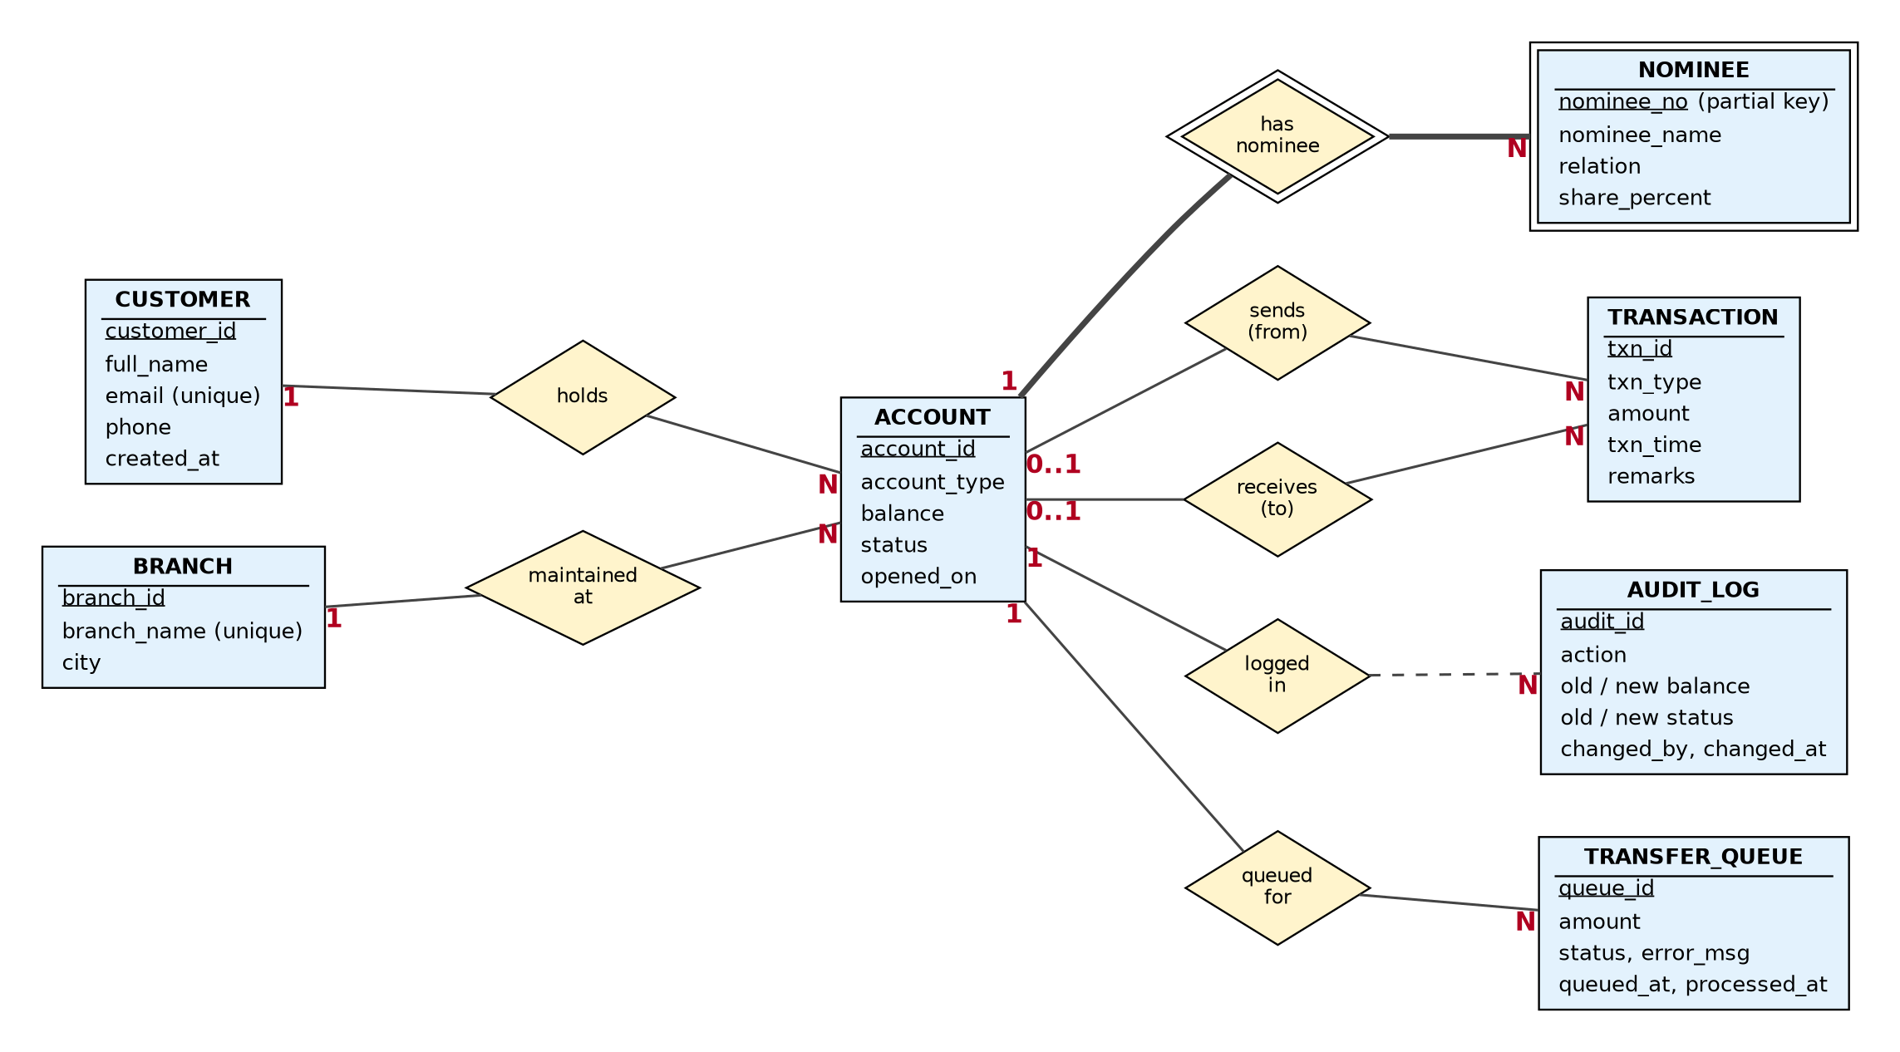
Figure 2: ER diagram of BankLedger (double border = weak entity / identifying relationship)

5.2 Mapping the ER model to relational tables
ER construct | Mapping rule applied
Strong entity | One table; the key attribute becomes the primary key (generated by AUTOINCREMENT)
1 : N relationship | Foreign key placed on the N side (accounts.customer_id, accounts.branch_id)
Weak entity | Own table whose primary key combines the owner's key with the partial key: (account_id, nominee_no); ON DELETE CASCADE
Two relationships between the same entities | Two separate nullable foreign keys on transactions: from_account and to_account
Type of transaction | A table-level CHECK links each type to the combination of NULL / NOT NULL accounts it needs

5.3 Relational schema
Primary keys are marked PK and foreign keys FK.
Branch(PK branch_id, branch_name, city)
Customer(PK customer_id, full_name, email, phone, created_at)
Account(PK account_id, FK customer_id, FK branch_id, account_type, balance, status, opened_on)
Nominee(PK,FK account_id, PK nominee_no, nominee_name, relation, share_percent)
Transaction(PK txn_id, txn_type, FK from_account, FK to_account, amount, txn_time, remarks)
AuditLog(PK audit_id, account_id, action, old_balance, new_balance, old_status,
new_status, changed_by, changed_at)
TransferQueue(PK queue_id, FK from_account, FK to_account, amount, status, error_msg,
queued_at, processed_at)

5.4 Table definitions
The definitions follow sql/schema.sql. SQLite uses type affinity, so columns are declared INTEGER, TEXT or NUMERIC; dates and times are stored as ISO-8601 text, and money columns are rounded to two decimals by every update.

branches
Column | Data type | Constraints
branch_id | INTEGER | PRIMARY KEY, AUTOINCREMENT
branch_name | TEXT | NOT NULL, UNIQUE
city | TEXT | NOT NULL

customers
Column | Data type | Constraints
customer_id | INTEGER | PRIMARY KEY, AUTOINCREMENT
full_name | TEXT | NOT NULL
email | TEXT | NOT NULL, UNIQUE, CHECK (email LIKE '%_@_%._%')
phone | TEXT | CHECK (NULL, or 7-15 characters made of digits and +)
created_at | TEXT | NOT NULL, DEFAULT datetime('now','localtime')

accounts
Column | Data type | Constraints
account_id | INTEGER | PRIMARY KEY, AUTOINCREMENT, first value 1001
customer_id | INTEGER | NOT NULL, FK to customers, ON DELETE RESTRICT
branch_id | INTEGER | NOT NULL, FK to branches, ON DELETE RESTRICT
account_type | TEXT | NOT NULL, CHECK IN ('SAVINGS','CURRENT')
balance | NUMERIC | NOT NULL, DEFAULT 0, CHECK (balance >= 0)
status | TEXT | NOT NULL, DEFAULT 'ACTIVE', CHECK IN ('ACTIVE','FROZEN','CLOSED')
opened_on | TEXT | NOT NULL, DEFAULT date('now','localtime')

nominees (weak entity)
Column | Data type | Constraints
account_id | INTEGER | PK (part 1), FK to accounts, ON DELETE CASCADE
nominee_no | INTEGER | PK (part 2), CHECK (nominee_no > 0)
nominee_name | TEXT | NOT NULL
relation | TEXT | NOT NULL
share_percent | NUMERIC | NOT NULL, DEFAULT 100, CHECK (share_percent > 0 AND share_percent <= 100)

transactions (ledger)
Column | Data type | Constraints
txn_id | INTEGER | PRIMARY KEY, AUTOINCREMENT
txn_type | TEXT | NOT NULL, CHECK IN ('DEPOSIT','WITHDRAWAL','TRANSFER','INTEREST')
from_account | INTEGER | FK to accounts, NULL for deposits and interest
to_account | INTEGER | FK to accounts, NULL for withdrawals
amount | NUMERIC | NOT NULL, CHECK (amount > 0)
txn_time | TEXT | NOT NULL, DEFAULT datetime('now','localtime')
remarks | TEXT | Optional
(table check) | ck_txn_shape | Type determines which accounts must be NULL; a transfer needs from_account <> to_account

audit_log
Column | Data type | Constraints
audit_id | INTEGER | PRIMARY KEY, AUTOINCREMENT
account_id | INTEGER | NOT NULL (no FK, so the history outlives the account)
action | TEXT | NOT NULL, CHECK IN ('UPDATE','DELETE')
old_balance, new_balance | NUMERIC | before / after values
old_status, new_status | TEXT | before / after values
changed_by | TEXT | NOT NULL, DEFAULT 'bankledger_app'
changed_at | TEXT | NOT NULL, DEFAULT datetime('now','localtime')

transfer_queue
Column | Data type | Constraints
queue_id | INTEGER | PRIMARY KEY, AUTOINCREMENT
from_account, to_account | INTEGER | NOT NULL, FK to accounts
amount | NUMERIC | NOT NULL, CHECK (amount > 0)
status | TEXT | NOT NULL, DEFAULT 'PENDING', CHECK IN ('PENDING','DONE','FAILED')
error_msg | TEXT | reason recorded when a transfer fails
queued_at, processed_at | TEXT | queued_at defaults to the current time

5.5 Integrity constraints
- Entity integrity - every table has a primary key; AUTOINCREMENT generates it.
- Referential integrity - foreign keys with RESTRICT protect customers, branches and accounts from deletion while in use; CASCADE removes nominees together with their account. SQLite does not enforce foreign keys unless PRAGMA foreign_keys = ON is set, so ledger.connect() switches it on for every connection.
- Domain integrity - CHECK constraints restrict types, statuses, e-mail and phone formats, and require positive amounts.
- Business integrity - balance >= 0, the transaction-shape check, the audit triggers and the triggers BK001-BK004.

5.6 Normalization
The functional dependencies of each table were examined to confirm that the design is free of redundancy and update anomalies.
Table | Functional dependencies | Highest normal form
branches | branch_id -> branch_name, city; branch_name -> branch_id (candidate key) | BCNF
customers | customer_id -> all attributes; email -> customer_id (candidate key) | BCNF
accounts | account_id -> customer_id, branch_id, account_type, balance, status, opened_on | BCNF
nominees | (account_id, nominee_no) -> nominee_name, relation, share_percent | BCNF
transactions | txn_id -> all attributes | BCNF
audit_log | audit_id -> all attributes | BCNF
transfer_queue | queue_id -> all attributes | BCNF

- 1NF - all attributes are atomic and there are no repeating groups. A customer's several nominees are rows in nominees, not columns such as nominee1 and nominee2.
- 2NF - only nominees has a composite key, and its non-key attributes depend on the whole key; no partial dependencies exist.
- 3NF - no transitive dependencies. The branch city is stored only in branches and the owner's name only in customers; storing them in accounts would create the transitive dependencies account_id -> branch_id -> city and account_id -> customer_id -> full_name.
- BCNF - in every table each determinant is a candidate key.
- 4NF - no table holds two independent multi-valued facts about the same key (nominees and transactions are kept apart), so there are no multi-valued dependencies.
- Intentional redundancy - accounts.balance can be derived from the ledger. It is stored for speed, protected by the transaction logic and the CHECK constraint, and verified by the reconciliation query Q21 (Chapter 7).

5.7 Indexes and sequences
Object | Definition | Purpose
AUTOINCREMENT keys | INTEGER PRIMARY KEY AUTOINCREMENT on every surrogate key; accounts start at 1001 (sqlite_sequence is seeded with 1000) | Automatic, gap-tolerant unique keys
idx_accounts_customer | accounts(customer_id) | Join customers to accounts; SQLite does not index foreign keys by itself
idx_accounts_branch | accounts(branch_id) | Branch reports
idx_txn_from | transactions(from_account, txn_time DESC) | Statements and the daily-limit trigger
idx_txn_to | transactions(to_account, txn_time DESC) | Statements
idx_audit_account | audit_log(account_id, changed_at DESC) | Audit look-ups
idx_queue_pending | transfer_queue(queue_id) WHERE status = 'PENDING' | Partial index: only unprocessed rows are indexed

5.8 Dataset description
BankLedger comes with a small synthetic dataset that the program generates itself. When app.py is started for the first time, or with the --reset option, ledger.setup() runs sql/schema.sql (which drops and recreates every table, index, trigger and view) and then ledger.seed_db() loads the sample data into the SQLite file bankledger.db. The data is fictitious: names, e-mail addresses and phone numbers are invented and no real customer information is used.
The opening deposits, transfers and withdrawals are not inserted as finished balances. They are executed through the same routines as real operations (deposit, transfer_funds, withdraw), so the ledger rows, the account balances and the audit_log are produced consistently and every trigger fires exactly as it would in production. The dataset holds 66 rows in the seven tables.

Dataset summary
Table | Rows | How it is produced | Content
branches | 3 | Inserted by seed_db() | Three branches: Main Branch (Indore), City Center (Bhopal), Tech Park (Pune)
customers | 6 | Inserted by seed_db() | Six fictitious customers with unique e-mail and a 10-digit phone number
accounts | 9 | Inserted with zero balance; balances then change only through the routines | Nine accounts numbered 1001-1009: seven SAVINGS and two CURRENT; account 1009 is FROZEN
nominees | 3 | Inserted by seed_db() | Weak-entity rows: two nominees for account 1001 and one for account 1002
transactions | 17 | Written by deposit, transfer_funds and withdraw | 8 deposits, 7 transfers and 2 withdrawals
audit_log | 25 | Written by the triggers only | One row for every balance or status change of an account
transfer_queue | 3 | Inserted by seed_db() | Three PENDING batch transfers (one valid, two that will fail)

Characteristics of the data
- Money. The nine balances add up to 267 000. The ledger holds deposits of 279 000, withdrawals of 12 000 and transfers of 24 000; transfers only move money between accounts, so deposits minus withdrawals equals the total balance. Query Q21 confirms that every stored balance equals the sum of its credits minus its debits (difference 0.0 for all nine accounts).
- Distribution. Main Branch has 2 accounts (101 500 on deposit), City Center 4 accounts (77 500) and Tech Park 3 accounts (88 000). Rajesh Kumar holds three accounts, one in every branch (1001, 1007, 1008), so the relational division query Q9 returns him; Anita Sharma holds two accounts (1002, 1009); the other four customers hold one account each.
- Built-in test situations. Account 1009 is frozen, empty and never used, so it appears in v_dormant_accounts and exercises trigger BK001. Account 1001 has already sent 19 000 today, which makes the daily-limit trigger BK004 easy to demonstrate. The transfer queue holds one valid item, one with insufficient funds and one from the frozen account.
- Formats. Account numbers are integers starting at 1001; e-mail addresses follow name@example.com; phone numbers have ten digits; dates and times are ISO-8601 text (YYYY-MM-DD HH:MM:SS). Timestamps are the moment the data was loaded, because the columns default to datetime('now','localtime'); the screenshots below were taken on 2026-10-08.
- Scope and limits. The dataset is small and covers a single day of activity. Its purpose is to demonstrate correctness (keys, constraints, triggers, reports and tests) rather than performance. It can be regenerated at any time with python app.py --reset.

Schema objects created by schema.sql
Figure 6 lists the objects that sql/schema.sql creates: the seven tables, six indexes, eight triggers (implementing the five rules of Chapter 8) and seven views.
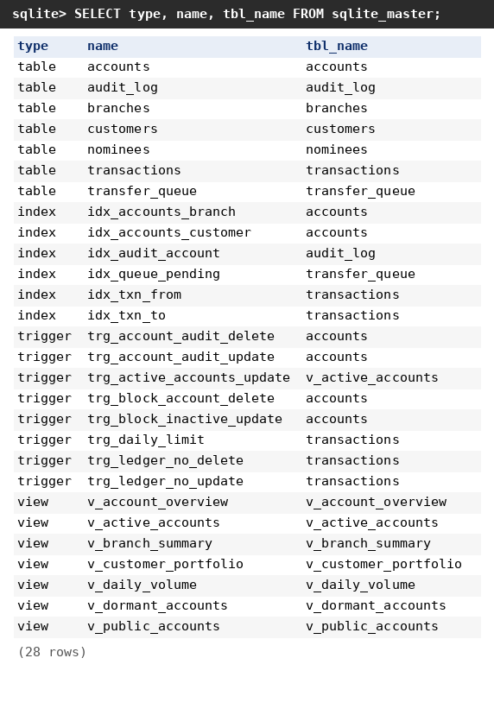
Figure 6: Schema objects in bankledger.db (query on sqlite_master)

branches table
The three branches have identity keys 1-3. branch_name is unique and city is mandatory. Every branch serves at least two accounts, so the branch reports (v_branch_summary) have meaningful totals.
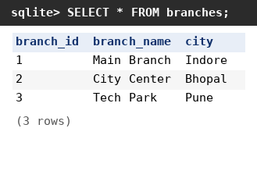
Figure 7: Contents of the branches table

customers table
Six customers with keys 1-6. The e-mail column is UNIQUE and passes ck_customer_email; the phone column passes ck_customer_phone (7 to 15 digits or +). created_at holds the load time.
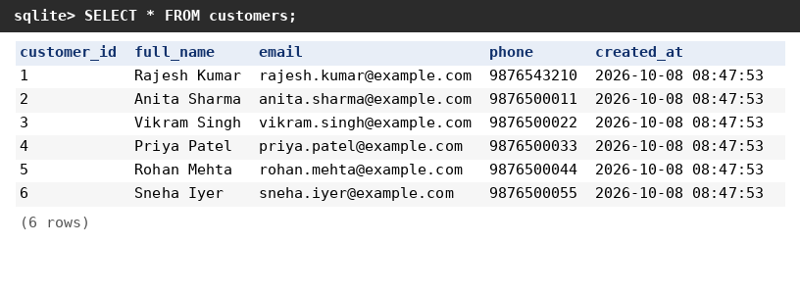
Figure 8: Contents of the customers table

accounts table
Nine accounts with keys 1001-1009. customer_id and branch_id are foreign keys to customers and branches. The balances shown are the result of the opening deposits, seven transfers and two withdrawals; account 1009 was frozen after loading, so its status is FROZEN and its balance is 0.
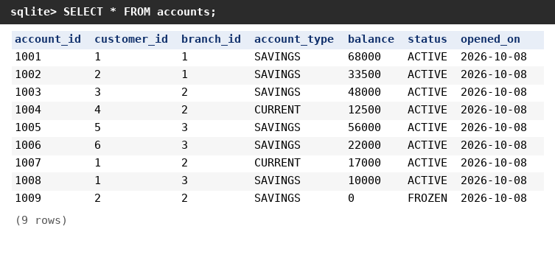
Figure 9: Contents of the accounts table (final balances)

nominees table (weak entity)
The primary key is the pair (account_id, nominee_no). Account 1001 has two nominees (Meera Kumar, spouse, 60 percent; Aman Kumar, son, 40 percent) and account 1002 has one (Ravi Sharma, father, 100 percent). The shares of one account add up to 100 percent. Accounts without a nominee simply have no row here.
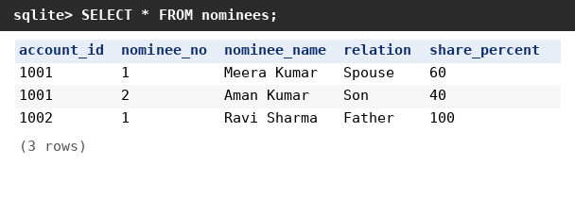
Figure 10: Contents of the nominees table

transactions table (ledger)
Rows 1-8 are the opening deposits of accounts 1001-1008 (from_account is NULL); rows 9-15 are seven transfers between accounts; rows 16-17 are withdrawals (to_account is NULL). The NULL pattern for each type is required by the table check ck_txn_shape. No INTEREST rows exist until the monthly interest routine is run.
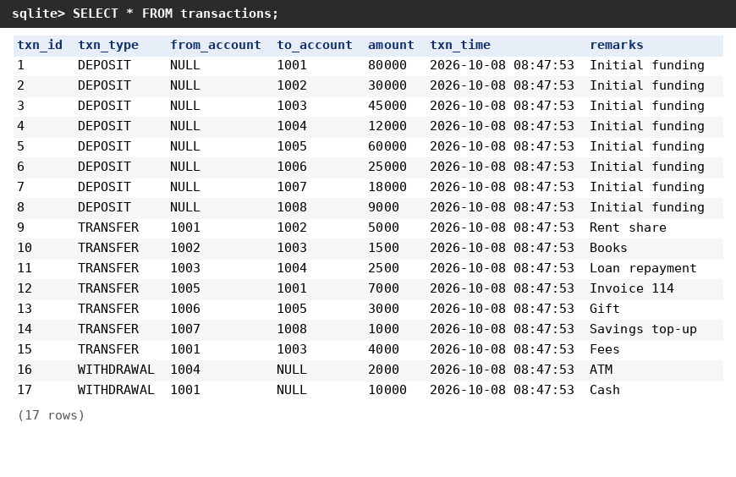
Figure 11: Contents of the transactions table

audit_log table
The 25 rows were written by the trigger trg_account_audit_update, never by the application: 8 rows for the opening deposits (old balance 0), 14 rows for the seven transfers (one debit and one credit row each), 2 rows for the withdrawals and 1 row for freezing account 1009 (status ACTIVE to FROZEN). changed_by holds the default value bankledger_app.
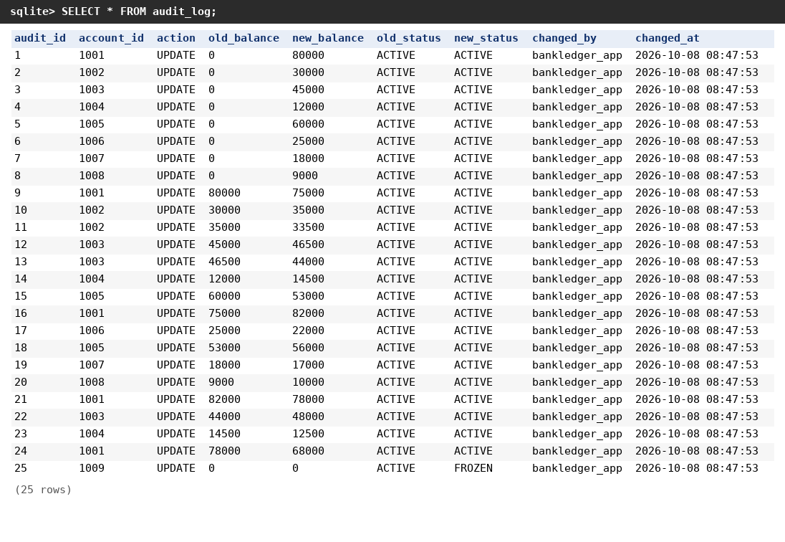
Figure 12: Contents of the audit_log table

transfer_queue table
Three PENDING items prepare the batch demonstration: item 1 (1003 to 1004, 2 000) is valid, item 2 (1005 to 1006, 9 999 999) has insufficient funds and item 3 (1009 to 1001, 10) comes from the frozen account. error_msg and processed_at stay NULL until process_transfer_queue() runs; afterwards item 1 is DONE and items 2 and 3 are FAILED with their reasons (test T13).
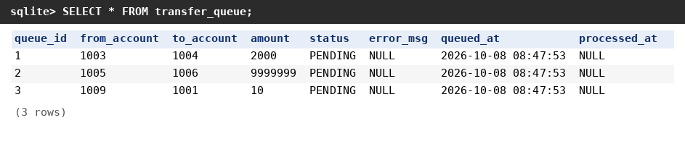
Figure 13: Contents of the transfer_queue table

Checking the dataset
Two queries on the loaded data show that the tables fit together. The reconciliation query Q21 compares each stored balance with credits minus debits from the ledger, and the view v_account_overview joins accounts, customers and branches.
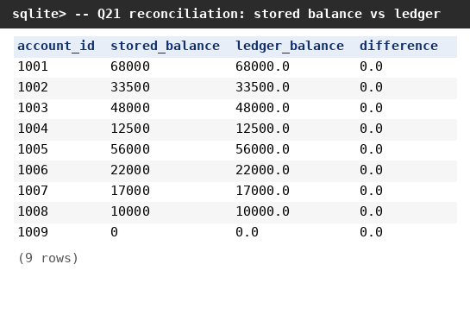
Figure 14: Reconciliation query Q21 (every difference is 0.0)
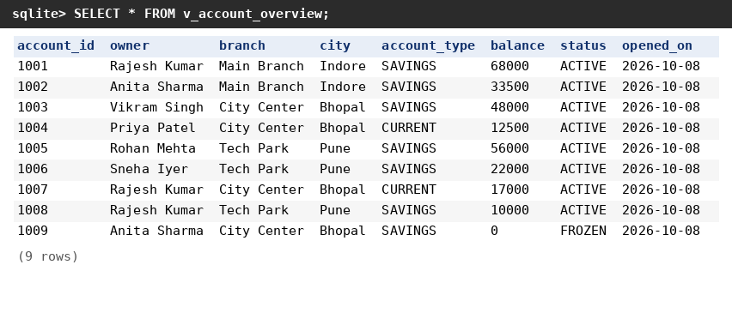
Figure 15: The view v_account_overview on the sample data

6. UML Diagrams

6.1 Use-case diagram
Two actors use the system. The Teller / Operator handles day-to-day customer operations: creating customers, opening accounts, deposits, withdrawals, transfers and enquiries. The Administrator (DBA) performs supervisory tasks: freezing or closing accounts, processing the batch queue, applying interest, viewing reports and the audit log, and taking backups. Deposits, withdrawals and transfers implicitly include the database triggers.
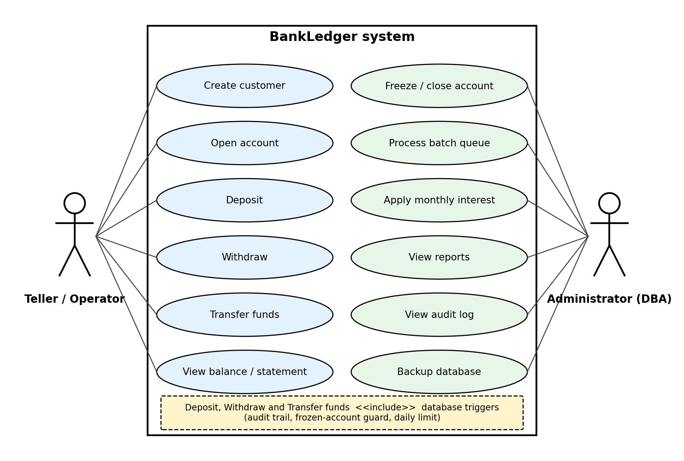
Figure 3: Use-case diagram

6.2 Class diagram
The class diagram shows each table as a class with its attributes, and the Python routines (and views) as operations of the class they act on. Stereotypes mark the triggers attached to a table. The composition from Account to Nominee expresses the weak-entity relationship: a nominee cannot exist without its account.
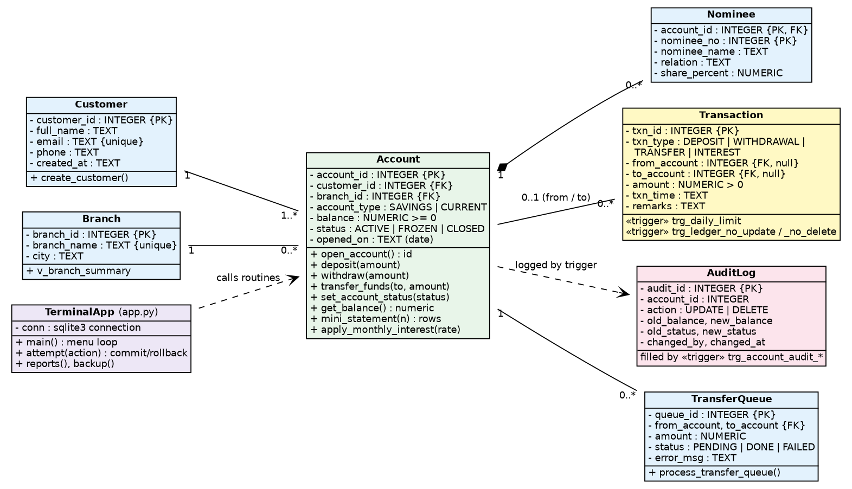
Figure 4: UML class diagram

6.3 Sequence diagram - funds transfer
The sequence diagram follows one transfer from the operator's input to the final message. It shows that the write lock, validation, ledger insert, balance updates and trigger checks all happen inside one SQLite transaction, which the routine commits or rolls back.
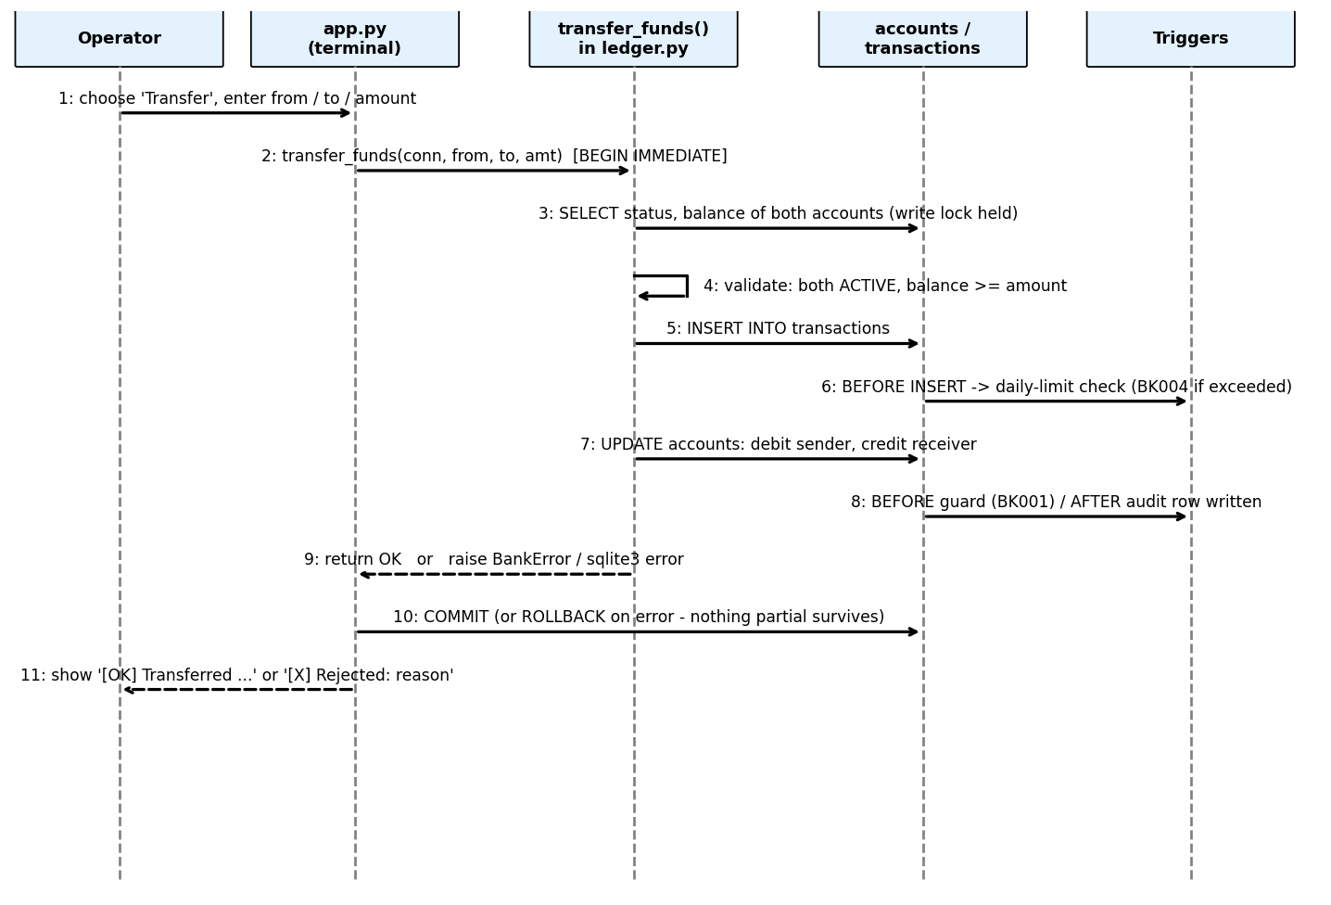
Figure 5: Sequence diagram of a funds transfer

7. SQL Implementation

7.1 Data definition (DDL)
sql/schema.sql contains the whole database definition. It drops and recreates all objects, then creates the tables in dependency order: branches, customers, accounts, nominees, transactions, audit_log and transfer_queue. It uses CREATE TABLE with column and table constraints, AUTOINCREMENT keys and CREATE INDEX, and the same file also defines the triggers and the views. ledger.init_db() runs it with executescript().

7.2 Data manipulation (DML)
Applications never insert or update money columns directly. Every change goes through a routine in ledger.py, so the DML statements (INSERT, UPDATE, SELECT) appear inside Python functions that call conn.execute(). The sample data is loaded by ledger.seed_db() through the same routines, which means the triggers fire and the audit log is filled just as in real use. Section 5.8 describes the resulting dataset.

7.3 Routines (procedures and functions)
Routine | Kind | Purpose | Syllabus topic
deposit(conn, account, amount, remarks) | Python routine | Validate, write ledger row, credit the account | Transactions, exceptions
withdraw(conn, account, amount, remarks) | Python routine | Validate funds, write ledger row, debit | Transactions, exceptions
transfer_funds(conn, from, to, amount, remarks) | Python routine | Atomic transfer under the BEGIN IMMEDIATE write lock | Locking, atomicity
set_account_status(conn, account, status) | Python routine | Freeze, unfreeze or close (zero balance only) | Control structures
apply_monthly_interest(conn, rate) | Python routine | Loop over the active savings accounts and credit interest | Cursors / iteration
process_transfer_queue(conn) | Python routine | Loop over the PENDING queue; a SAVEPOINT per row isolates failures | Savepoints, exception handling
open_account(conn, customer, branch, type, initial) | Python function | Insert account, return its number | Functions, composite logic
get_balance(conn, account) | Python function | Return the balance or raise an error | Functions, exceptions
account_location(conn, account) | Python function | Return 'branch, city' using a join | Joins
mini_statement(conn, account, n) | Python function | Return the last n ledger entries as rows | Result sets

7.4 The transfer routine
transfer_funds is the centre of the project. The internal routine _transfer() shown below follows five steps: validate input, rely on the write lock already taken by BEGIN IMMEDIATE, validate status and balance on the current rows, write the ledger entry, then debit and credit. The public transfer_funds() wraps it in the transaction() context manager, which commits on success and rolls back on any error.
def _transfer(conn, src, dst, amount, remarks):
# 1. validate input
if src is None or dst is None:
raise BankError("Both source and destination accounts are required")
if src == dst:
raise BankError("Cannot transfer to the same account")
if amount is None or amount <= 0:
raise BankError("Transfer amount must be positive")
# 2. (the write lock is already held by BEGIN IMMEDIATE)
# 3. validate status + balance
from_row, to_row = _account(conn, src), _account(conn, dst)
if from_row is None:
raise BankError(f"Source account {src} does not exist")
if to_row is None:
raise BankError(f"Destination account {dst} does not exist")
if from_row[0] != "ACTIVE":
raise BankError(f"Source account {src} is {from_row[0]}")
if to_row[0] != "ACTIVE":
raise BankError(f"Destination account {dst} is {to_row[0]}")
if money(from_row[1]) < amount:
raise BankError(
f"Insufficient funds: balance {money(from_row[1])} is less than {amount}")
# 4. ledger row (trigger BK004 enforces the daily limit)
conn.execute(
"INSERT INTO transactions(txn_type, from_account, to_account, amount, remarks) "
"VALUES ('TRANSFER', ?, ?, ?, ?)", (src, dst, float(amount), remarks))
# 5. debit + credit (triggers write the audit trail)
conn.execute(
"UPDATE accounts SET balance = ROUND(balance - ?, 2) WHERE account_id = ?",
(float(amount), src))
conn.execute(
"UPDATE accounts SET balance = ROUND(balance + ?, 2) WHERE account_id = ?",
(float(amount), dst))

def transfer_funds(conn, src, dst, amount, remarks=None):
with transaction(conn):
_transfer(conn, src, dst, money(amount), remarks)

7.5 Views
View | Definition (summary) | Use
v_account_overview | accounts JOIN customers JOIN branches | Complete account list
v_customer_portfolio | customers LEFT JOIN accounts, GROUP BY customer | Accounts and total balance per customer
v_branch_summary | branches LEFT JOIN accounts, GROUP BY branch | Accounts, total and average balance per branch
v_daily_volume | transactions GROUP BY day and type | Daily activity report
v_dormant_accounts | accounts WHERE NOT EXISTS (any transaction) | Accounts never used
v_public_accounts | Masked owner name, no balance | Security demonstration: masked owner name, no balance (SQLite has no roles, so it restricts nobody)
v_active_accounts | SELECT from accounts WHERE status = 'ACTIVE'; an INSTEAD OF UPDATE trigger replaces WITH CHECK OPTION | Updatable view; rows cannot be pushed outside the filter

7.6 Showcase queries and their relational-algebra form
sql/queries.sql contains 21 showcase queries (run them with python run_queries.py, or one at a time with python run_queries.py Q11). Three of them are shown below with the equivalent relational algebra or tuple relational calculus (Unit 2 of the syllabus). The result on the sample dataset is given after each query.
Query A - names of customers who hold an account with a balance above 50 000
SELECT DISTINCT c.full_name
FROM customers c JOIN accounts a ON a.customer_id = c.customer_id
WHERE a.balance > 50000;

Relational algebra: π full_name ( σ balance > 50000 ( Customer ⋈ Account ) )
Tuple calculus: { c.full_name | Customer(c) ∧ ∃a ( Account(a) ∧
a.customer_id = c.customer_id ∧ a.balance > 50000 ) }
Result on the sample data: Rajesh Kumar, Rohan Mehta.

Query B - accounts that sent money but never received any (set difference)
SELECT from_account FROM transactions WHERE txn_type = 'TRANSFER'
EXCEPT
SELECT to_account FROM transactions WHERE txn_type = 'TRANSFER';

Relational algebra: π from_account (σ type='TRANSFER' (Txn)) − π to_account (σ type='TRANSFER' (Txn))
Result on the sample data: account(s) 1006, 1007.

Query C - customers with an account in every branch (division)
SELECT c.full_name FROM customers c
WHERE NOT EXISTS (SELECT 1 FROM branches b
WHERE NOT EXISTS (SELECT 1 FROM accounts a
WHERE a.customer_id = c.customer_id
AND a.branch_id = b.branch_id));

Relational algebra: π customer_id, branch_id (Account) ÷ π branch_id (Branch)
Result on the sample data: Rajesh Kumar.

Other queries cover three-table joins, GROUP BY ... HAVING, correlated and nested sub-queries, ALL and ANY (written with MAX and MIN), UNION and INTERSECT, self joins, window functions (running balance, RANK), a common table expression, CASE, string functions, ROLLUP (written with UNION ALL), EXPLAIN QUERY PLAN, and Q21, a reconciliation query that proves each stored balance equals the sum of its credits minus its debits in the ledger.

7.7 Security
SQLite has no users, roles or GRANT, so access control is limited to what the view layer can show. The view v_public_accounts masks the owner's name and omits the balance, which demonstrates how a restricted window on accounts is built; in a server DBMS such as PostgreSQL the same view would be granted to a teller role. The append-only ledger trigger still prevents anyone from silently rewriting history, whichever program opens the database file.

7.8 Query cost
Unit 4 of the syllabus covers measures of query cost and cost-based optimisation. Query Q19 runs EXPLAIN QUERY PLAN on a ledger look-up. With idx_txn_from in place SQLite reports a SEARCH using that index; after dropping the index it falls back to a SCAN of the whole table, which shows the effect of indexing on a growing ledger. SQLite's planner chooses between plans using the available indexes (and ANALYZE statistics when they exist).

8. Triggers

8.1 Can triggers be added? Yes - five rules are implemented
Triggers are the right tool for rules that must hold no matter which program connects to the database. BankLedger enforces five rules with eight SQLite triggers (the audit rule needs one trigger for UPDATE and one for DELETE, and the ledger rule one for UPDATE and one for DELETE; an extra INSTEAD OF trigger supports an updatable view). Together they show BEFORE and AFTER triggers, WHEN conditions, column-specific UPDATE OF, RAISE(ABORT, ...) with the error codes BK001-BK004, and a transparent audit mechanism.
Trigger | Table | Timing and event | Behaviour | Code
trg_account_audit_update, trg_account_audit_delete | accounts | AFTER UPDATE (when balance or status changes) / AFTER DELETE | Writes old and new balance and status, current user and time to audit_log | -
trg_block_inactive_update | accounts | BEFORE UPDATE OF balance, WHEN old status is not ACTIVE | Rejects balance changes on frozen or closed accounts | BK001
trg_block_account_delete | accounts | BEFORE DELETE, WHEN balance <> 0 | Rejects deleting an account whose balance is not zero | BK002
trg_ledger_no_update, trg_ledger_no_delete | transactions | BEFORE UPDATE / BEFORE DELETE | Keeps the ledger append-only | BK003
trg_daily_limit | transactions | BEFORE INSERT, WHEN from_account is not NULL | Rejects outgoing money above 50 000 per account per day | BK004
trg_active_accounts_update | v_active_accounts (view) | INSTEAD OF UPDATE | Replaces WITH CHECK OPTION: rejects a row that would no longer be ACTIVE | -

8.2 Example: the transparent audit trigger
This trigger matches the audit-system lab experiment. When an account row is updated or deleted, the original details are stored in audit_log together with the user and date of the operation, and then the change is allowed to proceed. The application never writes to audit_log. SQLite triggers cannot be written as one function, so the UPDATE and DELETE cases are two triggers and the user column defaults to the application name bankledger_app.
CREATE TRIGGER trg_account_audit_update
AFTER UPDATE ON accounts
WHEN NEW.balance IS NOT OLD.balance OR NEW.status IS NOT OLD.status
BEGIN
INSERT INTO audit_log(account_id, action, old_balance, new_balance, old_status, new_status)
VALUES (OLD.account_id, 'UPDATE', OLD.balance, NEW.balance, OLD.status, NEW.status);
END;

CREATE TRIGGER trg_account_audit_delete
AFTER DELETE ON accounts
BEGIN
INSERT INTO audit_log(account_id, action, old_balance, old_status)
VALUES (OLD.account_id, 'DELETE', OLD.balance, OLD.status);
END;

8.3 Additional triggers that could be added
Trigger idea | Event | Benefit
Low-balance alert table | AFTER UPDATE OF balance on accounts | Inserts an alert row that a monitoring program can poll
updated_at stamp | AFTER UPDATE on accounts | Automatically records the last change time
Normalise e-mail to lower case | AFTER INSERT / UPDATE on customers | Prevents duplicates that differ only in letter case
Nominee share check (AFTER trigger that raises an error) | AFTER INSERT / UPDATE on nominees | Ensures the shares of one account never exceed 100 percent
Minimum balance for savings accounts | AFTER UPDATE OF balance on accounts | Enforces a bank policy without touching the procedures
Fraud flag | AFTER INSERT on transactions | Flags several large transfers from one account within minutes
Auto-create a welcome nominee row or log entry | AFTER INSERT on accounts | Example of an AFTER INSERT trigger that fills a related table

Triggers also have costs: they run on every matching row, they can hide behaviour from a reader of the application code, and a chain of triggers is harder to debug. For that reason BankLedger keeps its triggers few, small and documented in one file.

9. Transaction Management and Concurrency Control

9.1 ACID properties in BankLedger
Property | Mechanism in the project | Demonstration
Atomicity | The routine opens one transaction (BEGIN IMMEDIATE); any error triggers ROLLBACK, which undoes the ledger row and the trigger side-effects | T2 and T15: a failed or rolled-back transfer leaves no trace
Consistency | PK, FK (PRAGMA foreign_keys = ON), CHECK, UNIQUE and the triggers; balance >= 0; the ledger-shape check | T6-T11: each rule rejects an invalid change
Isolation | BEGIN IMMEDIATE takes the write lock, so only one writer works at a time; a second writer waits and then fails with "database is locked" | T16 and T17
Durability | Rollback journal is flushed at commit; after a crash the unfinished transaction is rolled back | T18

9.2 Concurrency problems and isolation levels
Isolation level | Dirty read | Non-repeatable read | Phantom read | SQLite behavior
SERIALIZABLE (SQLite default) | No | No | No | Transactions behave as if they ran one after another; a writer holds the database write lock until COMMIT
READ UNCOMMITTED (PRAGMA read_uncommitted, shared-cache mode only) | Possible | Possible | Possible | Rarely used; not used by BankLedger
Snapshot reads (WAL journal mode) | No | No | No | Each reader sees the data as of the start of its transaction; still one writer at a time
BankLedger setting | No | No | No | Default rollback-journal mode; every write routine starts with BEGIN IMMEDIATE

The lost-update problem arises when an application reads a balance, calculates a new value and writes it back. The routines avoid it by taking the write lock first (BEGIN IMMEDIATE) and letting the database calculate the new value (balance = ROUND(balance + amount, 2)), so concurrent writers are serialised.

9.3 Locking and deadlock handling
A deadlock occurs when two transactions each hold a lock the other needs. SQLite locks the whole database file instead of single rows, and BEGIN IMMEDIATE acquires the write lock at the start of every write routine. A second writer therefore waits (up to the 10-second timeout set in connect()) and then fails with 'database is locked'; it never holds one lock while waiting for another. A transfer from A to B and a transfer from B to A can consequently not deadlock in this edition. The price is lower concurrency than row-level locking, which the PostgreSQL edition of BankLedger uses by locking the two accounts in ascending account_id order.

9.4 Savepoints and partial rollback
SAVEPOINT and ROLLBACK TO SAVEPOINT undo only part of a transaction. process_transfer_queue sets a savepoint before every queue row, so one failed batch transfer is rolled back alone and marked FAILED with its error message while the others succeed - a direct answer to the cursor-and-savepoint lab experiment.

9.5 Recovery, durability and backup
SQLite writes the original pages of the database to a rollback journal before it changes them and deletes the journal when the commit is complete. After a crash, the next connection finds the unfinished ("hot") journal and rolls the half-finished transaction back, so committed changes remain and uncommitted ones disappear. Test T18 shows this by killing the Python process in the middle of a transaction. A logical backup is made from the menu (option 12): iterdump() writes an SQL dump into the backups/ folder, which can be restored into a new database file with the sqlite3 shell or executescript().

9.6 Two-phase commit
SQLite has no PREPARE TRANSACTION, so two-phase commit is not demonstrated in this edition. Conceptually, in phase one every participant votes and makes its changes durable but invisible; in phase two the coordinator commits or rolls back all participants. A server DBMS such as PostgreSQL offers this as PREPARE TRANSACTION, COMMIT PREPARED and ROLLBACK PREPARED.

10. Testing
The table lists the test cases run on the sample dataset with SQLite 3.45.1 (tests executed on 2026-10-08). The expected results follow directly from the constraints, routines and triggers, and every case produced the expected result (P = pass). Run python app.py --reset when a test changes data that a later test depends on. In addition, the 17 automated unit tests in test_ledger.py (python -m unittest -v) all pass.
ID | Scenario | Steps | Expected result | P/F
T1 | Valid transfer | transfer_funds(conn, 1001, 1002, 500) | Balances change by 500; one new TRANSFER row; two audit rows | P
T2 | Insufficient funds | Transfer more than the balance (999 999 from account 1006) | Error 'Insufficient funds'; no ledger row; balances unchanged | P
T3 | Same account | transfer_funds(conn, 1001, 1001, 10) | Error 'Cannot transfer to the same account' | P
T4 | Invalid amount | Deposit or transfer 0 or a negative amount | Error 'amount must be positive' | P
T5 | Frozen source | transfer_funds(conn, 1009, 1001, 10) | Error 'Source account 1009 is FROZEN' | P
T6 | Direct update on frozen account | UPDATE accounts SET balance = balance + 1 WHERE account_id = 1009 | Error BK001 | P
T7 | Delete funded account | DELETE FROM accounts WHERE account_id = 1001 | Error BK002 | P
T8 | Edit the ledger | UPDATE or DELETE on transactions | Error BK003 | P
T9 | Daily limit | Send 30 000 then 5 000 more from 1001 on the same day (19 000 was already sent by the sample data) | First succeeds; second fails with BK004 | P
T10 | Negative balance | UPDATE accounts SET balance = -5 WHERE account_id = 1002 | CHECK constraint failed: ck_balance_non_negative | P
T11 | Duplicate e-mail | Create two customers with one e-mail | UNIQUE constraint failed: customers.email | P
T12 | Audit trail | Freeze an account, then view the audit log | Row with action UPDATE, old status ACTIVE and new status FROZEN | P
T13 | Batch queue | process_transfer_queue(conn) (menu option 10) | Queue row 1 DONE; rows 2 and 3 FAILED with reasons | P
T14 | Interest | apply_monthly_interest(conn, 0.5) (menu option 11) | INTEREST rows for the six active savings accounts only; current and frozen accounts skipped | P
T15 | Rollback | BEGIN IMMEDIATE; transfer; ROLLBACK; | Balances and ledger unchanged | P
T16 | Opposite transfers | Run 1001->1002 and 1002->1001 in two sessions | Both complete; no deadlock is possible because the write lock is taken first | P
T17 | Write-lock conflict | Session 1: BEGIN IMMEDIATE; session 2: BEGIN IMMEDIATE | Session 2 waits, then fails with 'database is locked' | P
T18 | Crash recovery | Kill the Python process (kill -9) in the middle of a transaction, then reopen the database | Committed row present; uncommitted row absent; PRAGMA integrity_check returns ok | P
T19 | Reconciliation | Run query Q21 | difference = 0.0 for every account | P
T20 | Masked public view | SELECT * FROM v_public_accounts | Owner name masked (for example R***********); no balance column | P

11. Conclusion and Future Scope

11.1 Conclusion
BankLedger shows that a small terminal program can be both lightweight and trustworthy when the database does the hard work. The schema is normalized to BCNF, the business operations are Python routines that run as single SQLite transactions, eight triggers provide an automatic audit trail and unbypassable rules, and taking the write lock first rules out deadlocks. The sample dataset of 9 accounts, 17 ledger rows and 25 audit rows (Section 5.8), together with the 17 automated tests and the 20 test cases of Chapter 10, shows each ACID property in action. The project therefore covers the main learning outcomes of the course: explaining the role of a DBMS, describing the relational model, constructing queries in SQL, designing and implementing a database project, and applying transactions, concurrency control, backup and recovery.

11.2 Future scope
- User authentication and per-customer access. SQLite has no roles; a server DBMS such as PostgreSQL offers roles and row-level security, so a customer would see only their own accounts.
- Archiving old ledger rows by month into a separate database file.
- Scheduled jobs (for example cron or Windows Task Scheduler) for monthly interest and nightly reconciliation.
- Summary tables refreshed by a scheduled job for heavy reports.
- Multi-currency accounts and an exchange-rate table.
- A REST or web front end that calls the same routines.
- Migration to a server DBMS (the PostgreSQL edition of BankLedger) for row-level locking, roles, replication and write-ahead-log archiving.

12. References
- R. Elmasri and S. B. Navathe, Fundamentals of Database Systems, 7th Edition, Addison Wesley, 2015.
- R. Ramakrishnan and J. Gehrke, Database Management Systems, 4th Edition, McGraw-Hill, 2015.
- A. Silberschatz, H. F. Korth and S. Sudarshan, Database System Concepts, 6th Edition, McGraw-Hill, 2010.
- T. Connolly and C. Begg, Database Systems: A Practical Approach to Design, Implementation and Management, 6th Edition, Pearson.
- SQLite Consortium, SQLite Documentation (Atomic Commit, File Locking and Concurrency, Triggers, Window Functions, EXPLAIN QUERY PLAN), https://www.sqlite.org/docs.html.
- Python Software Foundation, sqlite3 - DB-API 2.0 interface for SQLite databases, https://docs.python.org/3/library/sqlite3.html.
- CSE3001 Database Management Systems - course syllabus and indicative list of experiments.

Appendix A - Syllabus and Lab Coverage
The table shows where each topic of the course is covered in the project.
Topic | Where in the project | Section
ER model and weak entity | Nominee entity, ER diagram | 5.1, 5.2
Relational schema and normalization | sql/schema.sql | 5.3 - 5.6
DDL and DML | schema.sql, ledger.py | 7.1, 7.2
Sample dataset | ledger.seed_db() | 5.8
Joins, aggregates, sub-queries, set operations, division | queries.sql Q1 - Q10 | 7.6
Window functions, CTE, CASE, string functions | queries.sql Q11 - Q16 | 7.6
Views | v_* views in schema.sql | 7.5
Indexes and query cost | idx_* indexes, Q19 | 5.7, 7.8
Triggers and audit system | Eight triggers, BK001 - BK004 | 8
Routines, exceptions, iteration, savepoints | ledger.py | 7.3, 9.4
Transactions, ACID, locking | BEGIN IMMEDIATE, transaction() | 9.1 - 9.3
Recovery and backup | Rollback journal, iterdump() | 9.5

Appendix B - How to Run the Project
BankLedger needs only Python 3.9 or newer (the sqlite3 module is part of Python). Open the project folder in VS Code or any terminal and use the commands below. On Windows use py instead of python if python is not recognised.
Command | What it does
python app.py | Start the menu; the first run creates bankledger.db with the sample data (accounts 1001 - 1009)
python app.py --reset | Delete everything and reload the sample data
python run_queries.py | Run all 21 showcase queries from sql/queries.sql
python run_queries.py Q11 | Run only one query
python -m unittest -v | Run the 17 automated tests

