**Installation Steps**

# Introduction

This document describes steps to install openstack docker container on ubuntu.

# Hardware requirements

Servers

* Jump Server Host
  1. Ubuntu 16.04 Desktop 64 bit
  2. RAM > 32GB
  3. 3-Interfaces

# Software requirements

#> apt-get update

#> apt-get install openvswitch-switch

# Installing Docker

Follow below link to install docker

<https://www.digitalocean.com/community/tutorials/how-to-install-and-use-docker-on-ubuntu-16-04>

# Apllication running in container

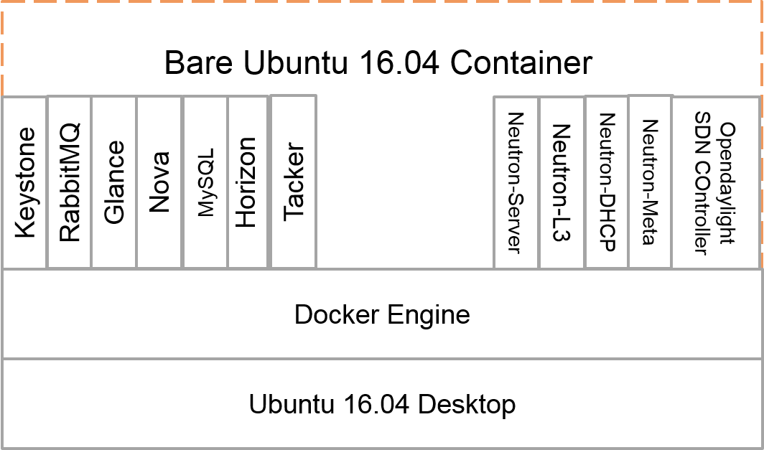

# Bringing up Openstack Controller Container

## Create environment

1. Stop Networking

service network-manager stop # for Ubuntu 16.04 LTS Desktop

## Bringing up Openstack Controller Docker Container

Go to the directory /root

#> cd /root/

#> docker pull veeraready/openstack-opendaylight-controller

#> docker images

Create Docker Network1:

#> docker network create --driver=bridge --subnet=192.168.2.0/24 net1

List bridges and docker networks:

#> brctl show

#> docker network list

Attach Management interface to br-xxxxxxxxxxxx.

#> brctl addif br-xxxxxxxxxxxx ethxxx

***Note:*** *Here, ‘ethxxx’ is the management interface.*

*‘xxxxxxxxxxxx’ is the NETWORK ID of that particular Docker Network1.*

Create Docker Network2:

#> docker network create --driver=bridge --subnet=11.11.0.0/24 net2

List bridges and docker networks:

#> brctl show

#> docker network list

Attach Data interface to br-xxxxxxxxxxxx.

#> brctl addif br-xxxxxxxxxxxx ethxxx

***Note:*** *Here, ‘ethxxx’ is the data interface.*

*‘xxxxxxxxxxxx’ is the NETWORK ID of that particular Docker Network2.*

Create and run the docker:

#> docker run -itd --cap-add NET_ADMIN --cap-add SYS_MODULE -v /lib/modules:/lib/modules --hostname oscontroller.domain.tld --privileged --network net1 --name controller openstack-opendaylight-controller /bin/bash

List the running docker containers:

#> docker ps

Output will be something similar to the below:

CONTAINER ID IMAGE COMMAND CREATED STATUS PORTS NAMES

c398ce7c022e os-controller "/bin/bash" 31 minutes ago Up 24 minutes controller

Attach second network interface to the Docker Container:

#> docker network connect net2 controller

Go to OS Controller Docker console:

#> docker exec -it controller bash

To start the OpenStack/OpenDaylight services in the OS Controller, execute the below script:

root@oscontroller:~#> sh /usr/share/start_services.sh

* To access OS Controller Docker Container, SSH to 192.168.2.2 from JUMPHOST machine with the credentials ‘root/root’
* Wait until login screen appears.
* Access Openstack dashboard web pages from JumpHost machine, using credentials (tacker/password)

[http://192.168.2.2](http://172.16.0.33/)

* Access Open Daylight Controller dashboard (admin/admin)

<http://192.168.2.2:8181/index.html>

**Note : Wait until both (Openstack Controller & Opendaylight) dashboard appears .**