The Spring boot application is configured in the Folder SpringBootApplication

To start the application

You need to have Maven3 and java version
Maven home: D:\apache-maven-3.3.9\bin\..
Java version: 1.7.0_79, vendor: Oracle Corporation

Please use the following commands to build the application
- mvn dependency:tree - This will download the required libraries in the mvn repository
- mvn clean install this will build the application from the start
- mvn spring-boot:run will start the application
- 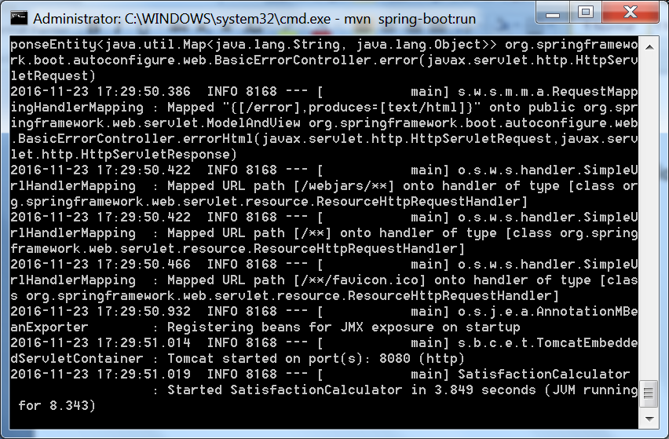
- The application can be accessed with the following URL
- http://localhost:8080/
- This will provide the url using which the application can be invoked
- 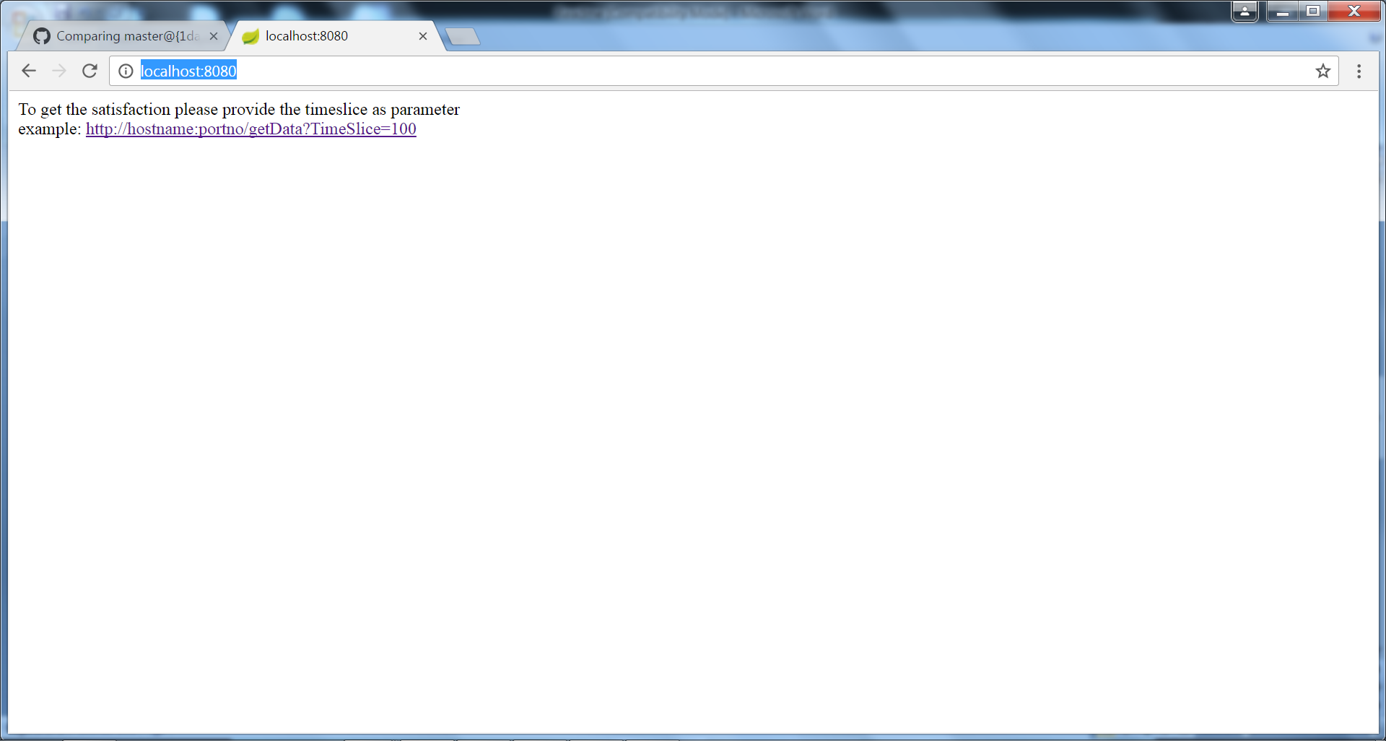
- Access the application with the URL
- http://localhost:8080/getData?TimeSlice=100
The response received is
