
ITA0330-Mobile Computing
Name: P.Veeraswami Reg no: 192311253
Slot: D Course Name:Mobile Computing

Experiment 1: Basic Cellular System Using Figma
Aim: -To create an interactive diagram illustrating the components of a basic cellular system using Figma.

Procedure

- Open Figma and create a new design file.
- Create rectangular boxes to represent the major components of a cellular system.
- Add text labels for Mobile Station, BTS (Base Transceiver Station), BSC (Base Station Controller), MTSO (Mobile Telephone Switching Office), PSTN (Public Switched Telephone Network), and Databases.
- Arrange the components in a horizontal sequence to represent the cellular communication system.
- Use arrows between the components to indicate the direction of communication and their connections.
- Connect the Databases component to the MTSO to show its association with network information and management.
- Adjust the alignment, spacing, colors, and text formatting to make the diagram clear and readable.
- Preview the design and verify that all components and connections are displayed correctly.

Output:
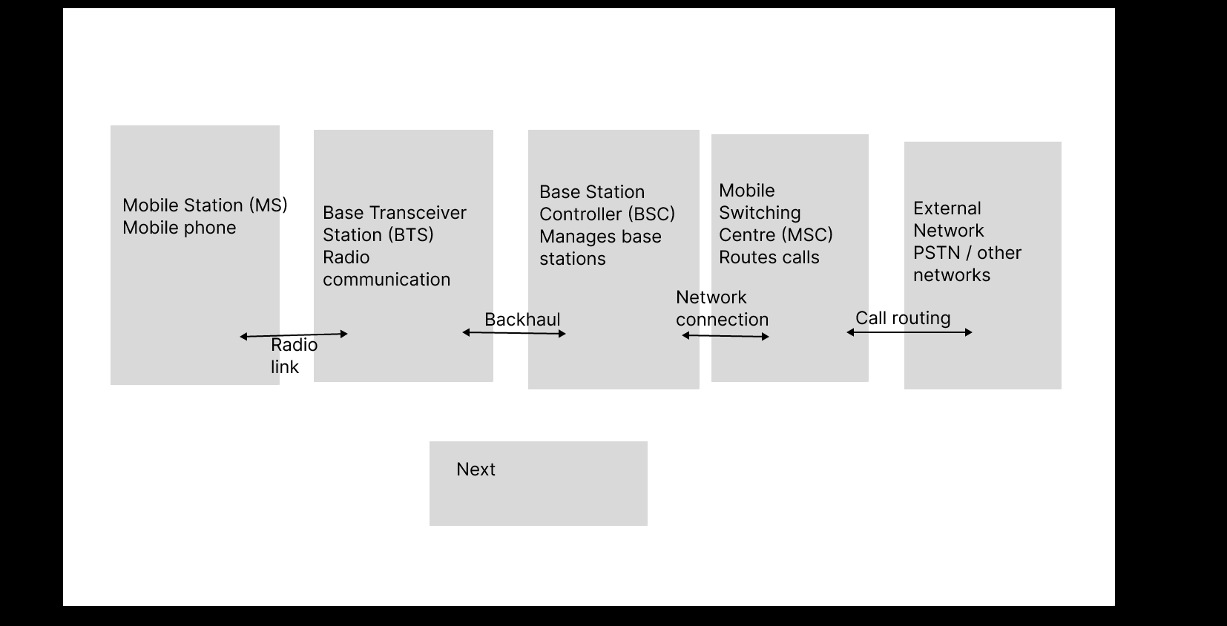

https://www.figma.com/proto/o6o2IzTEIzhvC98FZXUusK/Basic-Cellular-System.?node-id=5-5&p=f&t=7L2MxU9U9a12nK0U-0&scaling=min-zoom&content-scaling=fixed&page-id=5%3A4&starting-point-node-id=5%3A5

Result: -Thus, an interactive diagram illustrating the components of a basic cellular system was created successfully using Figma. The diagram represents the connections between the Mobile Station, BTS, BSC, MTSO, PSTN, and Databases.

