


ITA0330-Mobile Computing
Name: P.Veeraswami Reg no:192311253
Slot: D Course Name: Mobile Computing

Experiment 2: Mobile Station User Interface Prototype
Aim: To design a user interface prototype for a mobile station considering connectivity and convenience.

Procedure:

- Open Figma and create a new design file.

- Select a smartphone frame from the device templates.

- Design the home screen with a simple layout.

- Add signal strength, battery status, and network connectivity indicators.

- Add call, SMS, contacts, and mobile data icons.

- Apply suitable colors, fonts, and buttons.

- Use Prototype mode to connect the screens and test navigation.

Output:

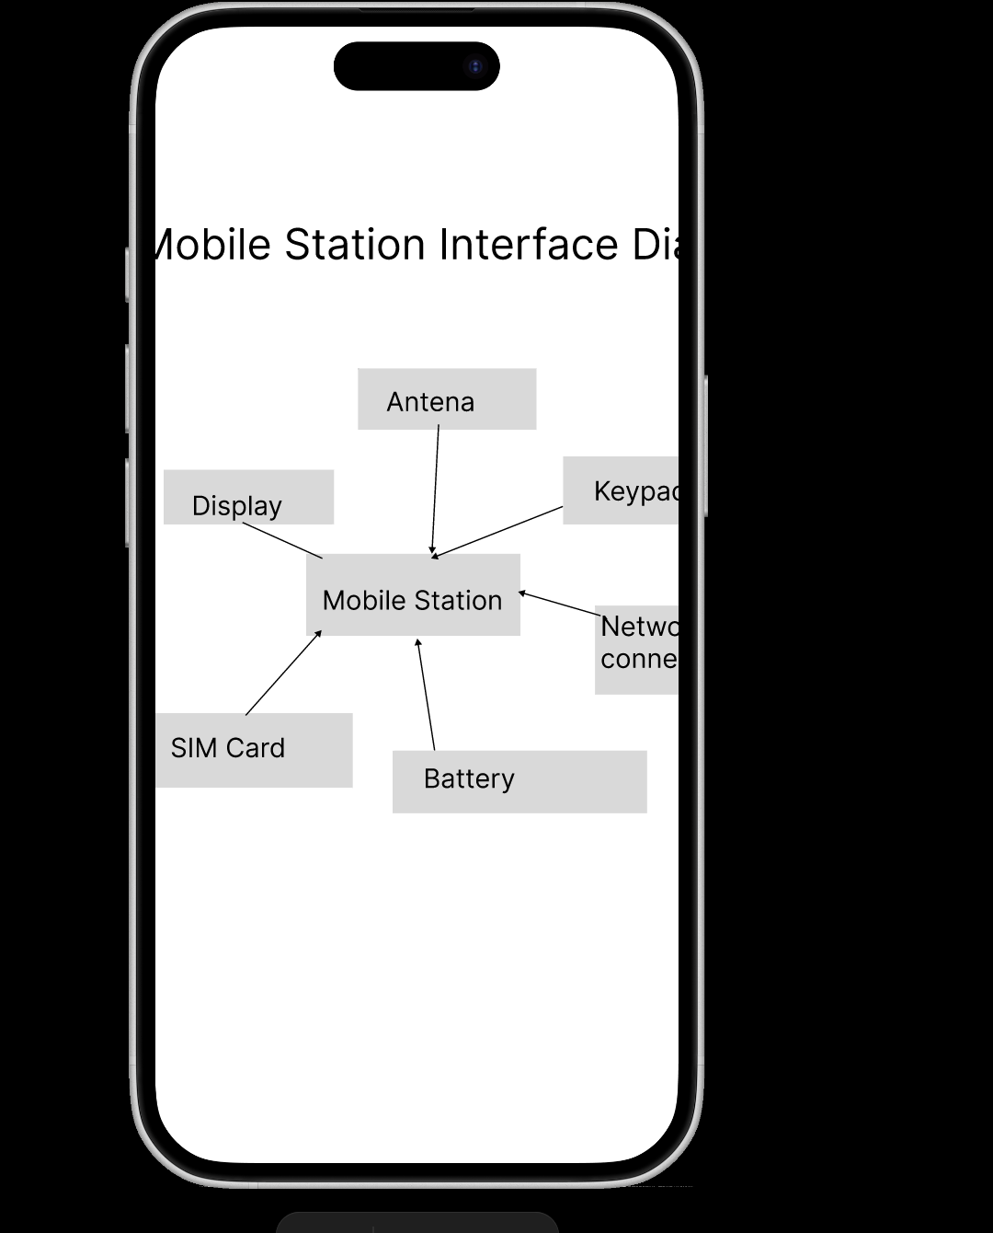

https://www.figma.com/proto/4Vl71S0RMguBw0QMaLwOlo/EXP-2?node-id=1-2&t=PhIQ7mjxg5atl44F-0&scaling=scale-down&content-scaling=fixed&page-id=0%3A1

Result: Thus, a mobile station UI prototype with connectivity features and convenient navigation was designed successfully.

