**Display**

SELECT * FROM ecommerce LIMIT 10;

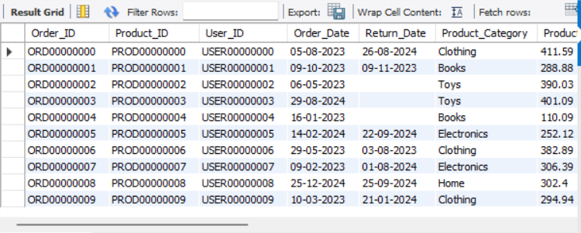

**Display returned orders**

SELECT * FROM ecommerce

WHERE Return_Status = 'Returned';

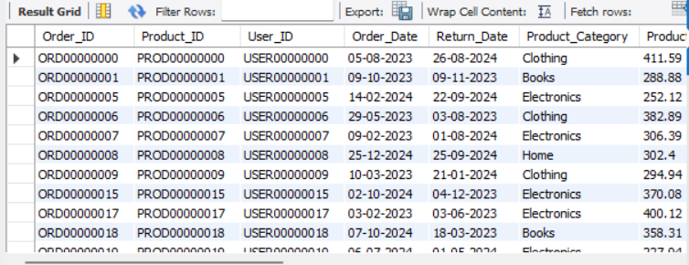

**Display orders by user age group**

SELECT

CASE

WHEN User_Age < 20 THEN 'Under 20'

WHEN User_Age BETWEEN 20 AND 29 THEN '20-29'

WHEN User_Age BETWEEN 30 AND 39 THEN '30-39'

WHEN User_Age BETWEEN 40 AND 49 THEN '40-49'

WHEN User_Age BETWEEN 50 AND 59 THEN '50-59'

ELSE '60+'

END as AgeGroup,

COUNT(*) as OrderCount

FROM ecommerce

GROUP BY AgeGroup

ORDER BY OrderCount DESC;

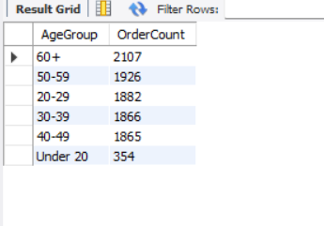

**Total revenue from all orders**

SELECT SUM(Product_Price * Order_Quantity) AS Total_Revenue

FROM ecommerce;

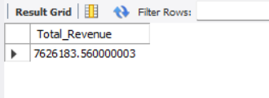

**Average order value**

SELECT AVG(Product_Price * Order_Quantity) AS Avg_Order_Value

FROM ecommerce;

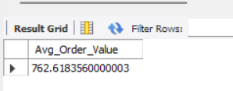

**Category Analysis**

**Revenue by product category**

SELECT

Product_Category,

SUM(Product_Price * Order_Quantity) AS Category_Revenue,

ROUND(SUM(Product_Price * Order_Quantity) /

(SELECT SUM(Product_Price * Order_Quantity) FROM ecommerce) * 100, 2) AS Revenue_Percentage

FROM ecommerce

GROUP BY Product_Category

ORDER BY Category_Revenue DESC;

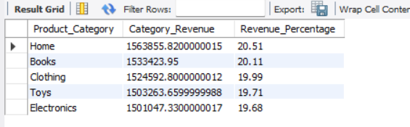

**Average product price by category**

SELECT

Product_Category,

AVG(Product_Price) AS Avg_Price,

MIN(Product_Price) AS Min_Price,

MAX(Product_Price) AS Max_Price

FROM ecommerce

GROUP BY Product_Category;

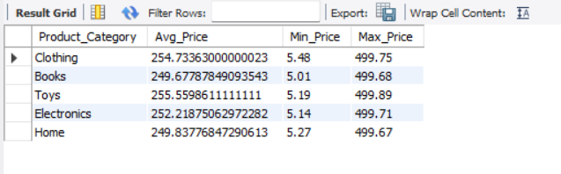

**Return Analysis**

SELECT

Product_Category,

COUNT(*) AS Total_Orders,

SUM(CASE WHEN Return_Status = 'Returned' THEN 1 ELSE 0 END) AS Returned_Orders,

ROUND(SUM(CASE WHEN Return_Status = 'Returned' THEN 1 ELSE 0 END) / COUNT(*) * 100, 2) AS Return_Rate_Percentage

FROM ecommerce

GROUP BY Product_Category

ORDER BY Return_Rate_Percentage DESC;

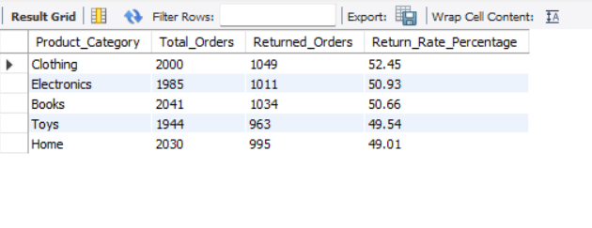

**Gender distribution of orders**

SELECT

User_Gender,

COUNT(*) AS Order_Count,

ROUND(COUNT(*) / (SELECT COUNT(*) FROM ecommerce) * 100, 2) AS Percentage

FROM ecommerce

GROUP BY User_Gender;

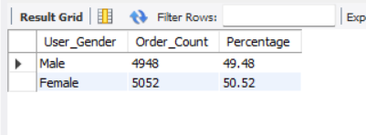

**Correlation between discount and returns**

SELECT

CASE

WHEN Discount_Applied = 0 THEN 'No Discount'

WHEN Discount_Applied < 10 THEN 'Small Discount (<10)'

WHEN Discount_Applied < 20 THEN 'Medium Discount (10-19)'

ELSE 'Large Discount (20+)'

END AS Discount_Range,

COUNT(*) AS Total_Orders,

SUM(CASE WHEN Return_Status = 'Returned' THEN 1 ELSE 0 END) AS Returned_Orders,

ROUND(SUM(CASE WHEN Return_Status = 'Returned' THEN 1 ELSE 0 END) / COUNT(*) * 100, 2) AS Return_Rate

FROM ecommerce

GROUP BY Discount_Range

ORDER BY Discount_Range;

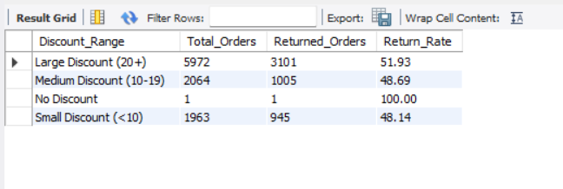

**Payment Analysis**

SELECT

Payment_Method,

COUNT(*) AS Order_Count,

SUM(Product_Price * Order_Quantity) AS Total_Revenue

FROM ecommerce

GROUP BY Payment_Method

ORDER BY Order_Count DESC;

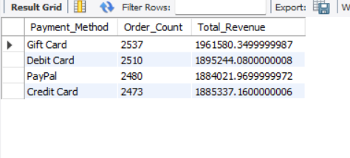

Shippment Analysis

SELECT

Shipping_Method,

COUNT(*) AS Order_Count,

AVG(Product_Price * Order_Quantity) AS Avg_Order_Value

FROM ecommerce

GROUP BY Shipping_Method

ORDER BY Avg_Order_Value DESC;

